BMID4002 Food & Beverage Operations
Poster

PART 1: Restaurant Concept
The poster is about new restaurant which is going to start new business as a part of Hotel Trinity is a 4* city centre hotel. The name of the restaurant is “Trinity Yummy and spicy Kitchen” and this restaurant is located in 23 Blackhorse Road, Walthamstow, London, United Kingdom. This restaurant will run the operations based on the policies of hotel trinity. The key theme of the restaurant is top deliver high quality food which meets the needs of the customers. This restaurant is looking for preparing quality food. It will collect fresh raw materials and ingredients when making food (Brown, 2023).
Trinity Yummy and spicy Kitchen will target all customers where the key target will be young customers as the service system is going to be online delivery and online order system. This restaurant is going to design a new menu for attracting the customers (Erdem, 2021). Menu is the key tool for attracting customers. During designing the menu, this restaurant is going to follow the food types and timing., it will provide starters, main food, beverages, deserts. It will consider sustainability & seasonality when designing food menu. Trinity Yummy and spicy Kitchen will follow the category of food menu based on adult or children.
Pricing strategy is crucial part of designing food menu (Cotterill, 2019). Because customers look at the price and compare with other rivals in the local area. On this point, this restaurant is going to deliver food with lowest possible price. It will focus on competitive pricing strategy and make sure that customers will get food with lowest possible price. It will help this restaurant to attract new customers and increase brand awareness. We are providing discounts on the first visit to the customers for increasing brand awareness. But we are not giving any discount to the customers on drinks and teas.
When designing food menu, this restaurant is considered Nutrition and Special Dietary Requirements which is mandatory for attracting different types of customers (Pei, 2018). There are huge number of customers who look at nutrition and dietary of the food and this restaurant is looking for adding food on the menu (Pallai, 2019). Based on the seasonality, this restaurant will introduce new food which will attract the customers to choose this.

Part 2: Poster

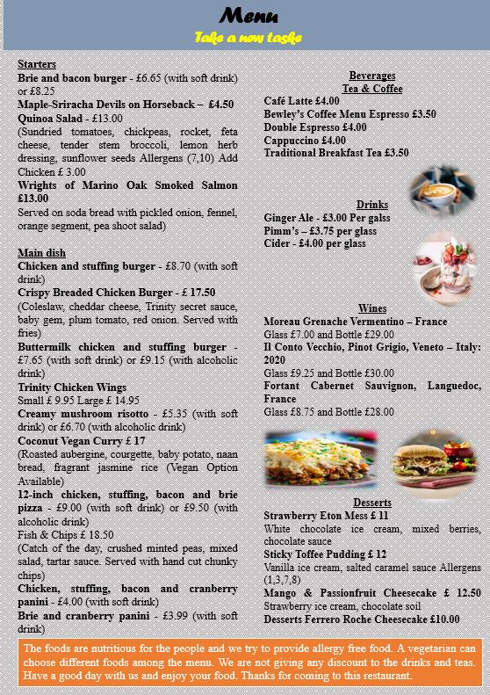

References
- Cousins, J. (2020) Food and beverage service. 9 th ed. London: Hodder Education Group.
- Davis, B et al. (2018) Food and Beverage Management. 6 edn London: Routledge.
- Johnston, R. (2012) Service operations management : improving service delivery. 4th ed. Harlow, England: Pearson.
- Motarjemi, Y and Lelieveld, H (2014) Food safety management : a practical guide for the food industry. Illustrated edition. Amsterdam: Academic Press.
- Zutshi, A. (2019) ‘How to develop well-informed and assured teams to embed food safety compliance in the UK catering and hospitality industry’, Perspectives in Public Health, 139(6), pp. 294–295.
- Brown, D. R., TotalBoox and TBX (2013) The Restaurant Manager’s Handbook : How to Set Up, Operate, and Manage a Financially Successful Food Service Operation. 4th Edition. Atlantic Publishing G
- Boussard, S (2021) Food and Beverage Management in the Luxury Hotel Industry. New York: Business Expert Press group.
- Brown (2023) Starter recipes, Great British Chefs. Available at: https://www.greatbritishchefs.com/collections/starter-recipes (Accessed: 08 June 2023).
- Cotterill, R.W. (2019) Competitive strategy analysis in the food system [Preprint]. doi:10.1201/9780429040900.
- Erdem, S. (2021) ‘Investigating the effect of restaurant menu labelling on Consumer Food Choices using a field experiment’, British Food Journal, 124(11), pp. 3447–3467. doi:10.1108/bfj-04-2021-0432.
- The Food & Drink Federation (2023) Food and drink industry - facts and stats, The Food & Drink Federation. Available at: https://www.fdf.org.uk/fdf/business-insights-and-economics/facts-and-stats/ (Accessed: 08 June 2023).
- Pallai, A. (2019) British food: 20 best dishes, CNN. Available at: https://www.cnn.com/travel/article/classic-british-food/index.html (Accessed: 08 June 2023).
- Pei, L. (2018) ‘A pilot investigation to healthy menu selection attitudes and behaviors among restaurant consumers’, Journal of Business and Hotel Management, 07(02). doi:10.4172/2169-0286.1000184.

