Methods and Search Strategy Academic Poster
Student name: Reema Hussain
Student ID: 2127235
Module name: Independent Project
Module code: BMHP6020

Healthcare Access Barriers for People Experiencing Homelessness in the UK

02. Search Strategy
A search strategy is “a systematic plan for identifying relevant literature using structured keywords, Boolean operators, and database selection” (University of Sheffield, 2024).
How This Was Used
A structured search strategy was applied to gather high-quality secondary research. Keywords included:
- “Homelessness,” “people experiencing homelessness,” “rough sleeping”
- “Healthcare access,” “barriers,” “inclusion health”
- “Primary care barriers,” “policy evaluation”
Boolean operators combined terms:
Homelessness AND healthcare access AND UKRough sleeping OR temporary accommodation
A search-tracking spreadsheet recorded search terms, databases, and included studies, ensuring transparency and replicability (Pleace, Wood & Cairns, 2022).

01. Introduction and Research Aim
A methods chapter explains how research is conducted, outlining the processes used to gather, evaluate, and analyse evidence.
This poster summarises the methodological approach used in the dissertation “Healthcare Access Barriers for People Experiencing Homelessness (PEH) in the UK.”

Research Aim
To critically examine the barriers to healthcare access for PEH in the UK and evaluate the effectiveness of related policies and interventions. This aim is carried through from the dissertation proposal and Chapter 1, and guides the search strategy, selection of sources, and thematic analysis.

05. Research Validation and Analysis

Definition of Validation

Validation in secondary research means ensuring that sources are credible, correct, current, and produced by authoritative authors or organisations (Monash University, 2023).

How Validation Was Ensured
- Applied the CRAAP Test
- Prioritised UK-based evidence from NHS England, Pathway, Crisis, and peer-reviewed journals (Pleace, Wood & Cairns, 2022)
- Cross-checked claims between studies to reduce bias and strengthen reliability. (Healthwatch, 2023).

Benefits of Validation
- Ensures trustworthy evidence.
- Strengthens credibility of conclusions.
- Reduces the risk of including outdated or biased materials.

Limitations
- High-quality UK research on PEH is limited.
- Grey literature varies in methodological rigour.

Secondary Research Analysis
Analysis followed a thematic approach (Braun & Clarke, 2006),
Themes developed included:
- Structural barriers
- Psychosocial barriers
- Policy effectiveness

04. Visual Aid: Pie Chart – Types of Sources Used
This chart illustrates the proportion of source types used in your dissertation:
- 50% peer-reviewed journal articles
- 30% grey literature (charity reports, government publications)
- 20% policy documents
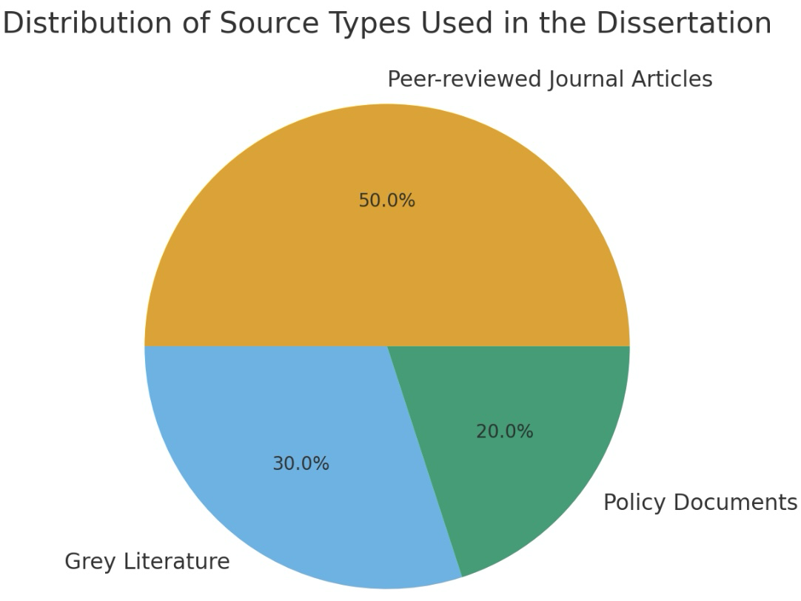

03. Searching for Information

Step-by-Step Search Process

Selected academic databases:
- PubMed, Scopus, Google Scholar, UWTSD Library Catalogue.
- Searched grey literature sources:
- Pathway, Health-watch England, Crisis, NHS England.

Applied filters:
- UK-based
- Published 2012–2025
- Healthcare access for PEH
- Peer-reviewed or reputable organisational reports

Created a source evaluation table summarising:
- Methodology
- Findings
- Relevance to research question
- Included in Appendix A (Eavis, 2018) & (Gunner et al, 2019).

08. Ethical Considerations

Definition
Ethics in secondary research refers to the responsible use, interpretation, and citation of existing data while protecting confidentiality and intellectual property (BERA, 2023).

Ethical Measures Taken
Respect for Intellectual Property
- All sources properly cited using Harvard format.
- No plagiarism: paraphrasing used with correct attribution.
Privacy and Confidentiality
- Sensitive reports (e.g., case studies) handled respectfully.
- Only publicly available data used.
Data Integrity and Reliability
- Used reputable data sources: NHS England, Pathway, Healthwatch.
- Critically evaluated for accuracy.
Compliance with Laws
- Followed principles of UK GDPR regarding use of publicly available data.
Informed Consent
- No primary data collected → consent not required
- Ensured any primary datasets used in secondary form had verified consent in their original publications

06. Inclusion Criteria
Sources were included if they met the following:
- Published within the last 10 years (2015–2025)
- UK-based research or policy
- Peer-reviewed articles and high-quality grey literature
- Fully accessible online
- Direct relevance to healthcare access for PEH
Examples: Gunner et al. (2019); Pathway & CF (2024)

07. Exclusion Criteria
Sources were excluded if:
- Over 10 years old
- Non-UK-based
- Not accessible in full text
- Opinion pieces, blogs, or non-academic sources
- Lacking relevance to PEH healthcare access

References

Braun, V. & Clarke, V. (2006) ‘Using thematic analysis in psychology’, Qualitative Research in Psychology. Available at: https://www.tandfonline.com

Carmichael, C., O’Donovan, S. & Hart, J. (2023) Understanding Barriers for Homeless Populations. Available at: https://www.journalofpublichealth.com

Eavis, A. (2018) Homeless Health Inequality Report. Available at: https://www.pathway.org.uk

Gunner, E. et al. (2019) ‘Access to primary care among homeless populations’, BMJ Open. Available at: https://bmjopen.bmj.com

Healthwatch (2023) Stories from People Experiencing Homelessness. Available at: https://www.healthwatch.co.uk

Pathway & Collaborative Futures (2024) GP Registration and Homelessness Report. Available at: https://www.pathway.org.uk

Pleace, N., Wood, J. & Cairns, S. (2022) The Homelessness Monitor UK. Available at: https://www.york.ac.uk

University of Sheffield (2024) Search Strategy Guidance. Available at: https://www.sheffield.ac.uk/library/study/research-skills/search-strategies

