University of Wales Trinity Saint David

Wales Institute of Science & Art

Engineering Science 1 and Laboratory Skills
Engineering Science 1 and Laboratory Skills (ACMA4033)

Finley Darby-Jones

Wales Institute of Science & Art 1
Introduction 2
Experimental Procedure 3
Results 5
Analysis: 7
Evaluation 10
Further work 11
Conclusion 11
Bibliography 12
Reference list 12

Table of Figures
Figure 1: View of the load nut with a circle indicating the notches used in step 4 4
Figure 2: How to measure the new length, step 7 4
Figure 3 and 4: Standard set up 5
Figure 4: An x-y scatter of stress on strain when acting on steel 5
Figure 5:An x-y scatter of stress on strain when acting on Aluminum 6
Figure 6:An x-y scatter of stress on strain when acting upon Duralumin 6
Figure 7: An x-y scatter of stress on strain when acting PCV 7
Figure 8: Recorded results from Steel 7
Figure 9: Recorded results from Aluminum 8
Figure 10: Recorded results from duralumin 8
Figure 11: Recorded results from PCV 8

Introduction
Throughout this assignment we aimed to practically discover the young’s modulus for four different materials (steel, aluminum, duralumin and PVC). Once completed we compared the results to accurately previously known data to obtain the accuracy and reliability of our assessment. The young’s modulus of a material can be defined as a material's ability to resist deformation when a force is applied or “stiffness” (Birmingham 2026). This number only refers to the ratio between stress and strain whilst the material is within the elastic region (where the force is relatively small enough to allow the material to return to original condition once the force is removed). Outside of this force region, Young's modulus is not applicable. (ScienceDirect, NA)

Experimental Procedure
Equipment:
The equipment was contained and the same throughout each test to ensure no new or different equipment caused different results. As newer and/or more worn equipment may have caused a variation in accuracy.
- PVC sample
- Steel Sample
- More sample
- Verniers set
- Book/Laptop to record results
- Work Panel
- Tensile Tester kit ES6
- People to help
Procedure:
- Choose your first specimen and use the dial caliper to measure the thickness and width at the gauge length and find its cross-sectional area, for reference measure and record the original length.
- Fit the specimen into the Tensile tester and set the Dial indicator to zero.
- Note the reading on the vertical Scale
- Rotate the Load nut 0.2 of a mm (2 notches, see figure 1)
- At each interval record the reading in an appropriate table. (See figure). Important to note that softer samples such as PVC will have readings that will lower over idle time so it’s important to read the data quickly to keep the load nut moving and the sample under load.
- Continue at the same rate until the load nut has made 3 full rotations (3 mm extension), at this point rotate the load nut one full rotation at a time until the sample breaks.
- Record the extension of the material by holding the ends together and recording the new length value. (See figure 2)
- Convert the dial indicator readings into force values
- Convert your force and extension values into force values
- Convert your force and extension values into stress and nominal strain values.
- Plot a graph of stress against strain.
- Repeat for all 4 samples
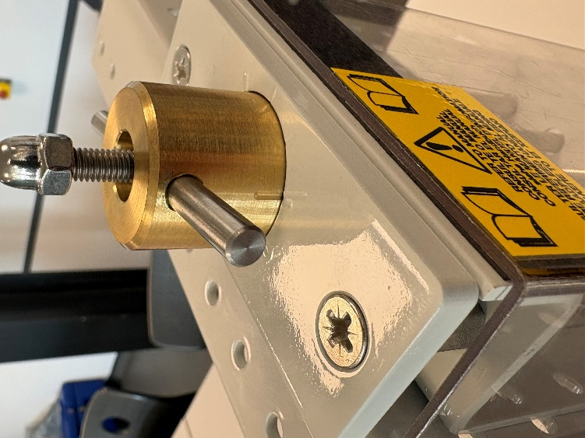
Figure 1: View of the load nut with a circle indicating the notches used in step 4
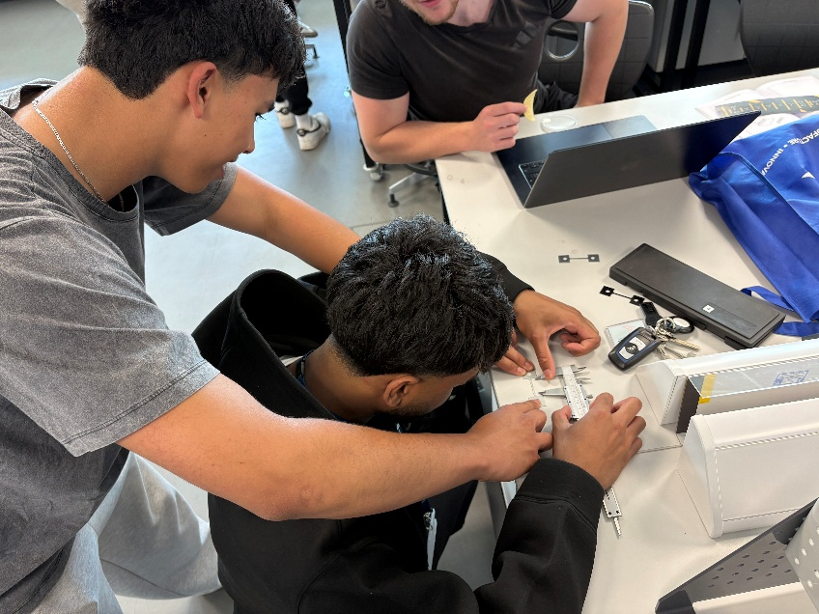
Figure 2: How to measure the new length, step 7

The following figures, images of a standard set-up.
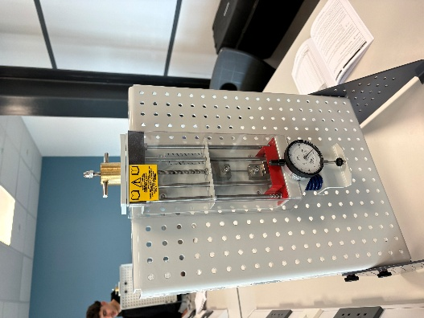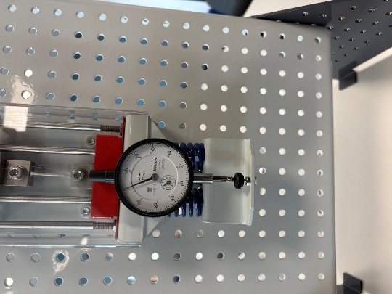
Figure 3 and 4: Standard set up

Results

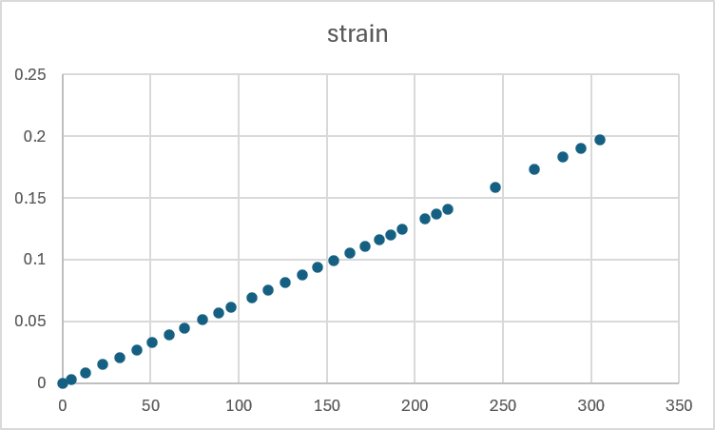
Figure 4: An x-y scatter of stress on strain when acting on steel

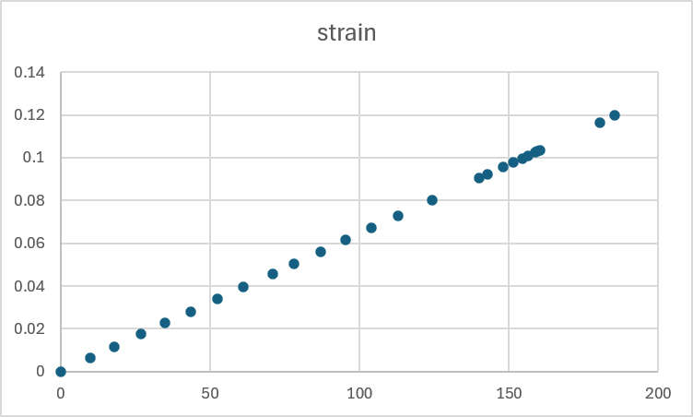
Figure 5:An x-y scatter of stress on strain when acting on Aluminum
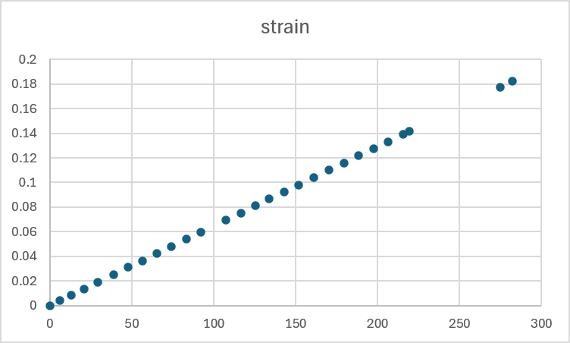
Figure 6:An x-y scatter of stress on strain when acting upon Duralumin
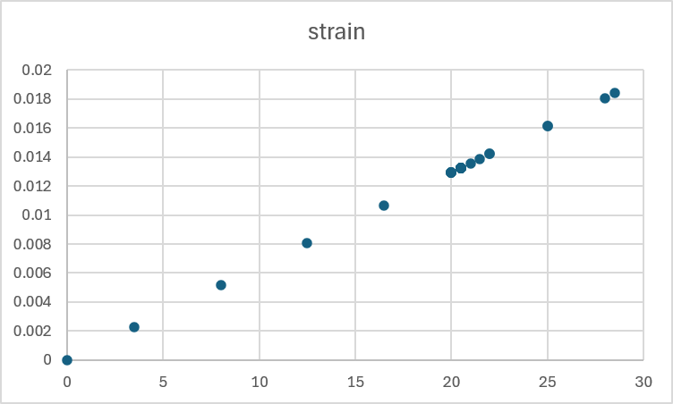
Figure 7: An x-y scatter of stress on strain when acting PCV

Analysis:
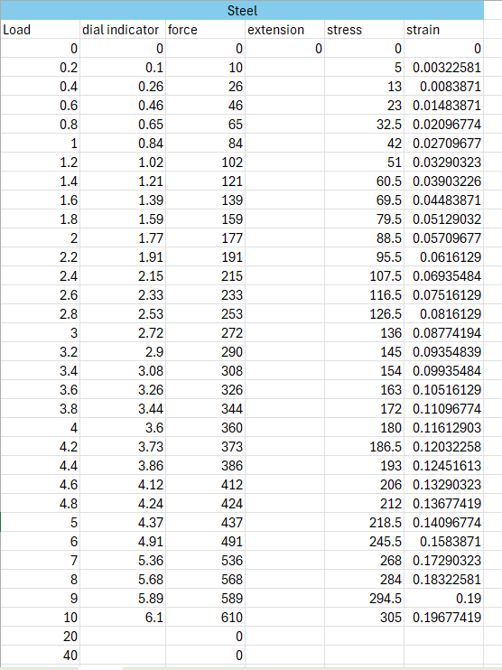
Figure 8: Recorded results from Steel
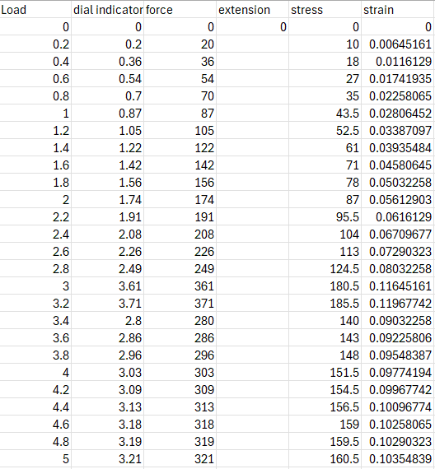
Figure 9: Recorded results from Aluminum
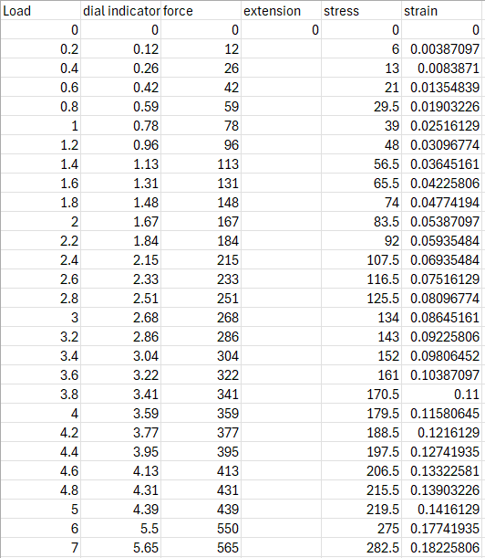
Figure 10: Recorded results from duralumin
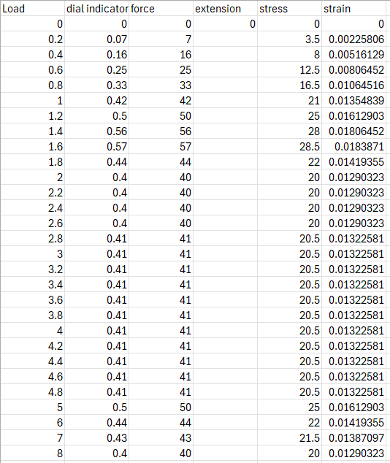
Figure 11: Recorded results from PCV
Young's modulus can be found using the equation (stress divided by strain), which in this case will be the gradient of each graph (Birmingham 2026). Therefore, using the equation for gradient (change in Y divided by the change X) we can calculate the Young's modulus for each material tested. (Bitesize, NA)
Gradient of Steel = 0.000155
Gradient of Aluminum= 0.0000645
Gradient of Duralumin =0.00069
Gradient of PVC = 0.000001
These measurements are recorded newtons per mm, the standard form of young’s modulus is GPA (gigapascals) (Birmingham, 2026). To convert these values x10^6. Therefore, the respective found values of steel, aluminum, duralumin and PVC is 185 GPA, 64.5 GPA, 69 GPA and 1 GPA. Using prior known values, we can compare the discovered values to calculate accuracy. The known values are 200 GPA (for steel), 69 GPA (for aluminum), 71 GPA (for duralumin) and 3 GPA (for PVC). (ToolBox, 2003)
Following on, we can discover that our calculated values were all within 10 percent of real values apart from PVC. PVC calculated to one third of the expected value, inferring that test method, equipment or readings were not correct as the values found were different to that of prior knowledge.
Furthermore, to further validate the exam we can use the data in the spread sheets to find the yield stress (the highest stress value a material can withstand before reaching plasticity). Based on the excel sheets inserted we can see that the recorded yield stress values are as follows
Steel = 305 GPA
Aluminum = 185 GPA
Duralumin = 282 GPA
PVC = 28.5 GPA
Using prior known information, we can see that the pre-recorded values for steel, aluminum, duralumin and PVC are 250-400 GPA, 175-272 GPA, 280-400 GPA and 40-60 GPA respectively. Again, showing that the 3 metals all fell within pre recorded ranges presenting strong evidence to the validity of the exams, however, the PVC reported a yield stress far under the lower limit of expected values.

Evaluation

The tested method clearly showed majority successful determination of the tensile properties of the material, specifically when referencing the extension of the material whilst under a forceful load. Furthermore, the excel graphs demonstrated expected trends and correlations again aiding validity of the test. Even going as far as showing the plastic region in the PVC. Presenting the material to have behaved as expected under test load.
The results present a strong correlation with that of known values for the steel, aluminum and duralumin with both the young’s modulus and yield stress values being inside that of pre-recorded data. However, showed severe differences to the expected values of the PVC. This indicates the test was majorly accurate but lacked minute accuracy for that of softer materials. For example, the compression force was skewed for the PVC when the plastic region was reached. As the force relied on a spring when the softer material began to plasticated the spring was allowed to decompress showing the force to decrease, this led to the test having to be run faster for the PCV to ensure that the values didn’t fluctuate down to excessively. This increased speed made reading the results more challenging and less exact. This likely explains the difference in accuracy between the PVC and “stiffer” materials, as they could be run slower the data could be recorded slower.
Furthermore, despite delivering some very representative results the test method had one major flaw, it depended highly on human input allowing the percentage of human error to increase exponentially, for example the turns had to be precise if the human error allowed the turn to be too much or too little then the recorded extension values would be incorrect, Furthermore, the data recording relied Soley on human eyes, the data was read of a moving gage, indicating that a mistake in reading would cause further fluctuations in accuracy.
However, the 3 metals all recorded expected values for both young’s modulus and yield stress, indicating the test had strong viability. Giving strong results for 3 out of the 4 samples.
To limit errors as much as possible we worked in teams, this allowed the load nut, data readings and data recording to operate separately. As all stations were individually manned there was little lead time waiting for each stage. The data could be read allowed the second the load nut became stationary allowing the load nut to remain in motion for as much time as possible.

Further work
If I had the opportunity to repeat the test, I would ensure that each sample was tested at least 3 times to achieve a mean value. As shown in the difference in Young's modulus values between PVC and its previous data counterparts. It’s accurate to assume a mistake was made during the test process. Given the opportunity to repeat the experiment, a range of values would be used allowing anomalies to be discovered and accordingly ruled out. Creating a wider and more accurate data set. (Studocu, 2023)
More to the point, if I had the opportunity to repeat this exam, I would find some equipment that depended on less human input and removed the possibilities of skewed values. Accordingly, I would change the test procedure to ensure that human run equipment was lowered. This is imperative because it lowers the amount of uncertainty in the results, allowing the tests to be faster and more accurate.

Conclusion
To conclude the test showed accurate and promising results through the materials with a higher young modulus. But the test relied too heavily on human input, allowing human error to compound throughout the exam. Making the test harder for materials with a lower young’s modulus. And accordingly, creating poor results for those materials.

Bibliography

Reference list
BBC Bitesize. (n.d.). How to find the gradient of a straight line in maths. [online] Available at: https://www.bbc.co.uk/bitesize/articles/z4ctng8.
Studocu. (2023). [Solved] Discuss the advantages and disadvantages of a mean in statistics - Counselling psychology (BCP3104) - Studocu. [online] Available at: https://www.studocu.com/row/messages/question/4969458/discuss-the-advantages-and-disadvantages-of-a-mean-in-statistics.
The Engineering Toolbox (2003). Young’s Modulus - Tensile and Yield Strength for common Materials. [online] Engineeringtoolbox.com. Available at: https://www.engineeringtoolbox.com/young-modulus-d_417.html.
University of Birmingham. (2026a). Physics A level revision resource: Introduction to Young’s Modulus - University of Birmingham. [online] Available at: https://www.birmingham.ac.uk/study/undergraduate/schools-and-colleges/resources/a-level-stem/youngs-modulus.
University of Birmingham. (2026b). Physics A level revision resource: Introduction to Young’s Modulus - University of Birmingham. [online] Available at: https://www.birmingham.ac.uk/study/undergraduate/schools-and-colleges/resources/a-level-stem/youngs-modulus.
www.sciencedirect.com. (n.d.). Elastic Region - an overview | ScienceDirect Topics. [online] Available at: https://www.sciencedirect.com/topics/engineering/elastic-region.

