To what extent does Photography affect our understanding of space and humanity’s place within it?

By Daniel Shaw
Photography in the Arts
P147312
Word count: 5213
Tutor: Paul Duerinckx

Photography, within its different mediums and technological advancements, has created alternate places within the mundanity of spaces. From art and documentary practices to Google Earth’s Satellite and Street View, we transport ourselves to new unseen places within a click of a button. The emergence of the virtual world creates a physical and emotional distance from the operator to the subject. With more people than ever viewing space virtually a disconnection from reality arises causing an estrangement from the world. While art and documentary practices are no strangers to producing and distorting spaces, the more personal practices of Robert Frank and William Eggleston give a closer, more subjective look at our surroundings, giving the viewer a chance to make emotional connections to the places that they intuitively capture. With these two opposing uses of photography, this essay will explore through political and philosophical ideas, how the photographic lens with its technological and artistic feats impact on our understanding of space.

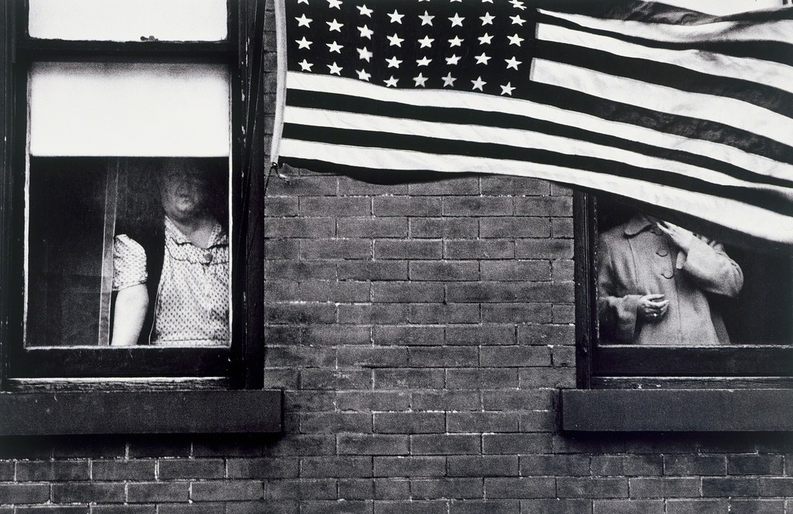Figure 1, Robert Frank, The Americans, Parade-Hobeken, New Jersey, 1955/1956

“Politics shapes the very homes, streets and cities in which we live, defining the spaces and places in which we are able to pursue our lives” (Clewer, Elsey, Certoma, 2012). Through varying spaces political underpinnings contribute to the way we view and live within our man made habitats. Through suburban to inner city layouts, the politicised terrain can be easily missed as it becomes all too familiar.
Robert Frank in his seminal body of work The Americans, traverses a 1950’s America photographing symbolic icons of the time. Flags, jukeboxes, cars and highways symbolise a new era brought by consumerism, but an inescapable past emerges with poverty and racial problems still prominent in the surroundings littered with capitalist propaganda. Controversial for the time with not sitting within the idealized view of the American dream, the aesthetic choices of Frank with his often blurred, grainy images taken quickly and intuitively, complement the content of the publication. As his images are reflective of the terrain, the camera acts as an extension of himself, traversing through a city and reacting to the spaces, he illuminates the politics often hidden or disguised behind places. “recognized as politically charged and formally innovative, although not in ways that fit into a cautious climate of the 1950’s” (Grundberg, 1999)

The Americans described as “a watershed in the medium’s postwar revolution from putatively objective to openly subjective ways of envisioning the world” (Grundberg, 1999) This subjectivity presented within a photograph gives a viewer an opportunity to find meaning in what were everyday moments of a 1950’s America. While we easily become accustomed to viewing in real time, a still image, a stop away from reality engages our intellects. With the studium (context) and punctum, “the in explainable force of the image which stirs emotion” (Barthes, 1980) pierces the preconceived ideas of space that reveals political underpinnings of society. Through the sequencing of The Americans, a feeling of freedom through how Frank moves through the US emerges; he doesn’t adhere to a strict path, his travels from place to place have no immediate meaning. The unorthodox directions of his exploration don’t comply with the infrastructures designated way of being traversed, which is common practice for many street orientated photographers.

“Perception depends upon this pre-existent element of choice, which determines the form in which we perceive not only all geometrical figures but every phenomenon of which we become aware” (Sartre,1946)

Within the philosophy of existentialism, Jean Paul Sartre discusses how choice determines the way in which we see the world. “existence over essence” (Sartre,1946), the belief that we are born first and then it is up to us to find the meaning of our existence, rather than meaning being forced upon us.

In Frank’s work existentialism is prominent, the act of taking a photograph is a choice that is made with infinite possibilities within this he is expressing and determining his own position on the world. The making of The Americans is as much of a political act as the work that was produced from it. The movements on and off the beaten path with the freedom to frame and take a picture of less desirable sights, as well as satirical looks at celebrity and tradition within America, go against the idealized view of society.

“All kinds of materialism leads one to treat everyman including oneself as an object-that is, as a set of pre-determined reactions, in no way different from the patterns of qualities and phenomena which constitute a table, or a chair, or a stone” (Sartre, 1946)

Materialism has a tricky relationship with photography as when making a photo you are contributing to it, casting the occupants within it into a 2d object. This can be problematic for people being represented within a particular space, as it cements them into the background that in turn contributes to the viewers understanding of the subject. Frank’s external examination within The Americans highlights materialism’s effect on society; but inadvertently is materializing the world himself.

The group Situationist International, formed in 1957 of Avant Garde artists and political activists, was interested in the construction of moments of life. The group developed techniques to explore these moments, one of which being the derive (drifting), an exploration of an urban sprawl where unorganised wanderings lead to the beauty and brutality of a supposedly utopian habitat. The ambiances of the many micro atmospheres a city can produce gave insight into how spaces differ from street to street, revealing a political undertone of the areas.

“In a dérive one or more persons during a certain period drop their usual motives for movement and action, their relations, their work and leisure activities, and let themselves be drawn by the attractions of the terrain and the encounters they find there... But the dérive includes both this letting go and its necessary contradiction: the domination of psychogeographical variations by the knowledge and calculation of their possibilities.” (Knabb, 1995)

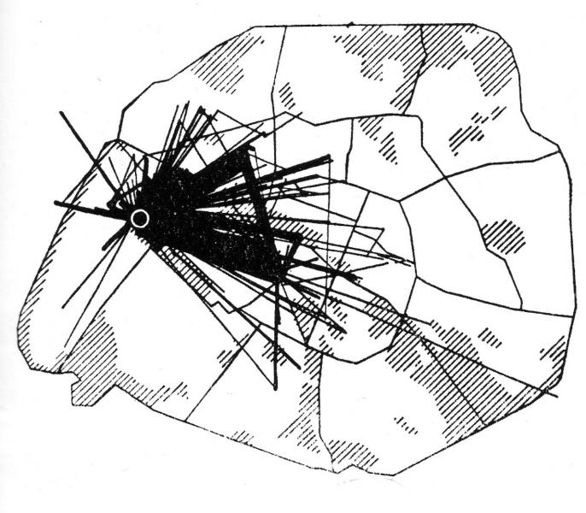
Figure 2, Paul-Henri Chombart de Lauwe and Guy Debord, Untitled, Paris, 1957

Guy Debord a prominent member of the Situationist’s began to create maps of Paris charting avenues of exploration. This map drawn by his friend charts a student’s route from home to university and to her piano teachers dwelling for a year. The map shows straight lines of little deviation, a structured life emerges from the travels, hinting at the control of the cities layout.

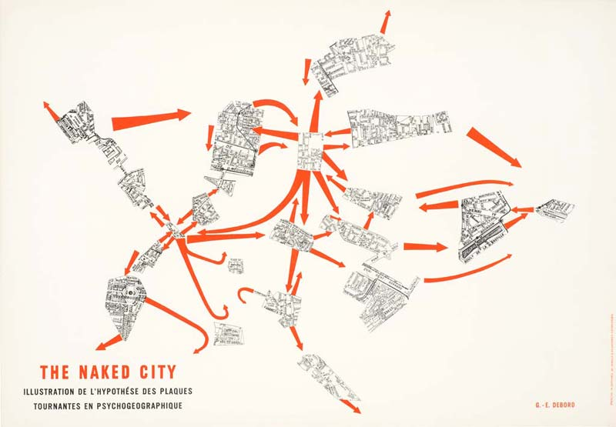
Figure 3, Guy Debord and Asger Jorn’s, The Naked City, Paris, 1957

While in stark contrast Debord and Jorn’s, The Naked City map depicts alternate ways of traversing. Creating routes between areas less touched by capitalism, the curvature of its paths leads the explorer to not only experience events but to generate situations within the metropolis. Becoming less of a factual representation to a more abstracted view of the city. The DIY production of the map consisted of reappropriating and scalping an existing map to form a new unordered way of orientation, mirroring the political activists message of non conformity to the cities ideals.

Barron Hausmann within the 18th century was coined for being one of the first modern urban developers. Within Paris (France) the centre saw a massive redevelopment with the classical architecture of narrow winding streets that had many ways of traversing, producing an area ripe for social exchanges and talks of revolution. The area was demolished to create an infrastructure that could make controlling the masses easier, at a time were popular revolutions and uprising were prominent within the French capital, the widening and gentrifying of the areas meant the army could pen and easily deter demonstrators pursuing social change. The aesthetic change of the area also saw a clear divide of wealth that was once mixed, although it should be noted Hausmann redesign of Paris did bring more hygienic living standards to the area. To this day the impact of Hausmann design is prevalent in Paris shown within the recent riots of 2016 over discontent with the political system. Demonstrators were seen being penned in and beaten due to the shapes of the Parisian landscape. An example of politicized architecture that made the Situationist International technique of urban exploration revolutionary. The psychogeorgraphic exploration was a reclamation of space giving freedom back to the individual, undermining the status quo and creating there own control of the city.

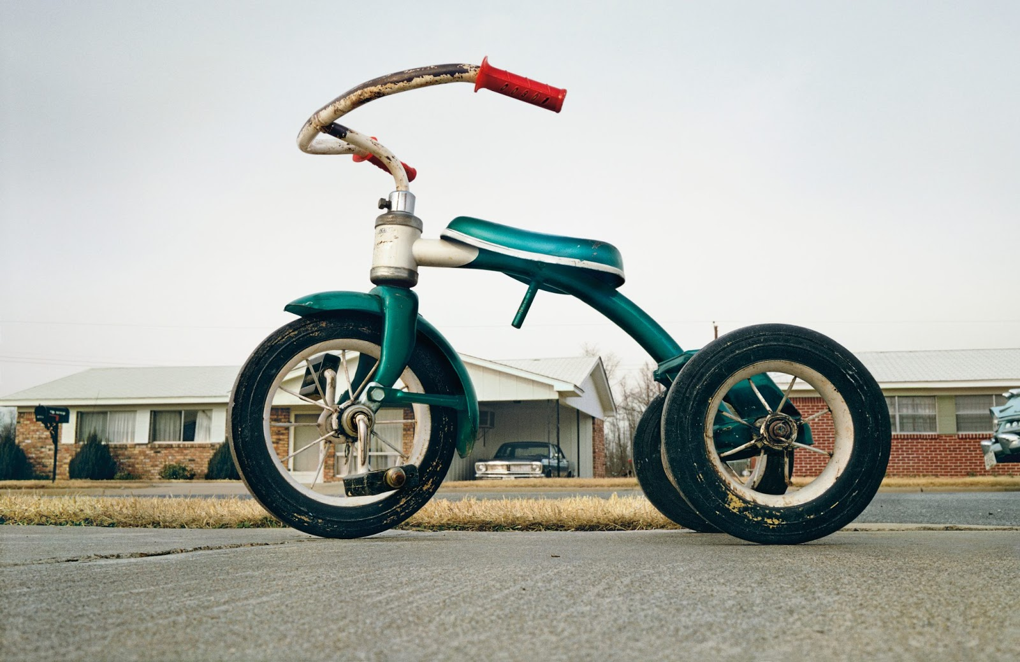
Figure 4, William Eggleston, William Eggleston’s Guide, Untitled, 1970

Within a similar time frame to Frank, William Eggleston was democratically photographing the mundane within Southern USA; the pictures of familiar sights taken without prejudice offer subjectivity. The viewer has to dig deeper past the superficiality of the surface. With the context unclear and the reasons why not revealed, the vibrant color photographs have an intangible sublime quality. Widely regarded as bringing colour photography into the realm of serious art, his pictures taken in and around Memphis are of life as Eggleston lived it.

“One can say then that in these photographs form and content are indistinguishable - which is to say that the pictures mean precisely what they appear to mean. Attempting to translate these appearances into words is surely a fool's errand, in the pursuit of which no two fools would choose the same unsatisfactory words” (Szarkowski,1976)

Eggleston shows the sublime to be behind the most banal of sights, adding further evidence of photography being an intuitive device in finding meaning amongst everything, deciphering the phenomena’s that are indescribable in language, literature or speech. Through Eggleston’s diaristic approach, he initiates a new contemplation into life’s little oddities. The sublime within photography reveals hidden depth and beauty in a world we obsessively try to understand. In this world, we are continually discovering new realities that are too complex for our rational minds to comprehend.

“The sublime experience is fundamentally transformative, about the relationship between disorder and order, and the disruption of the stable coordinates of time and space.”(Morley, 2010)

Within figure 4 we see Eggleston playfully manipulating our perception on size with the tricycle towering in relation to a suburban bungalow from his low field of vision. Bringing the seemly innocent object into an opposing force, that produces an underlying sinister sense. Eggleston’s transcendent view on his world reveals feeling behind the banality of his surroundings. Environments fraught with ideologies, suburbs representing the American dream of green lawns and white picket fences. An ordered environment that can be oppressive underneath the façade of perfection. Gaston Bachelard in his book The Poetics of Space examines in detail our intimate spaces. “A house constitutes a body of Images that give mankind proofs or illusions of stability” (Bachelard, 1958) It is in these illusions where photography stands on a thin line, depending on the context it can help to make aware the political nature behind are structures but it also has the potential to disguise the truth through the aesthetic and emotional pull of pictures.

However in the instance of Eggleston’s pictures he surpasses the superficial surface meanings of his images and creates feeling from within. His images accredited as being sublime, which can be described as, “Something rushes in and we are profoundly altered. And so, in looking at the relevance of the concept to contemporary art, we are also addressing an experience with implications that go far beyond aesthetics.” (Morley, 2010). Photography helps to validate these experiences as a document of a reaction taken from the external world. The thoughts and emotions that stir through the act of looking at his representations of the world cant be described as factual, the distance a image produces from subject to place is fantasy in a way that we have not lived that moment directly but through a lens that was seen through Eggleston’s eye. This distance from reality that photography manifests has changed our perception on spaces and therefore the meanings of the place. Homes and the many varying places of work interconnected by roads that make up urban habitats, have a utilitarian purpose of sheltering, transporting, giving us meaning and the means to survive within modern society. These structures have the tendency to become overly customary to are sight, Eggleston’s subjective photographic eye dissects the mundane which comments socially and politically on our infrastructure, as it brings to question if we are in control or being controlled by the very spaces we create.

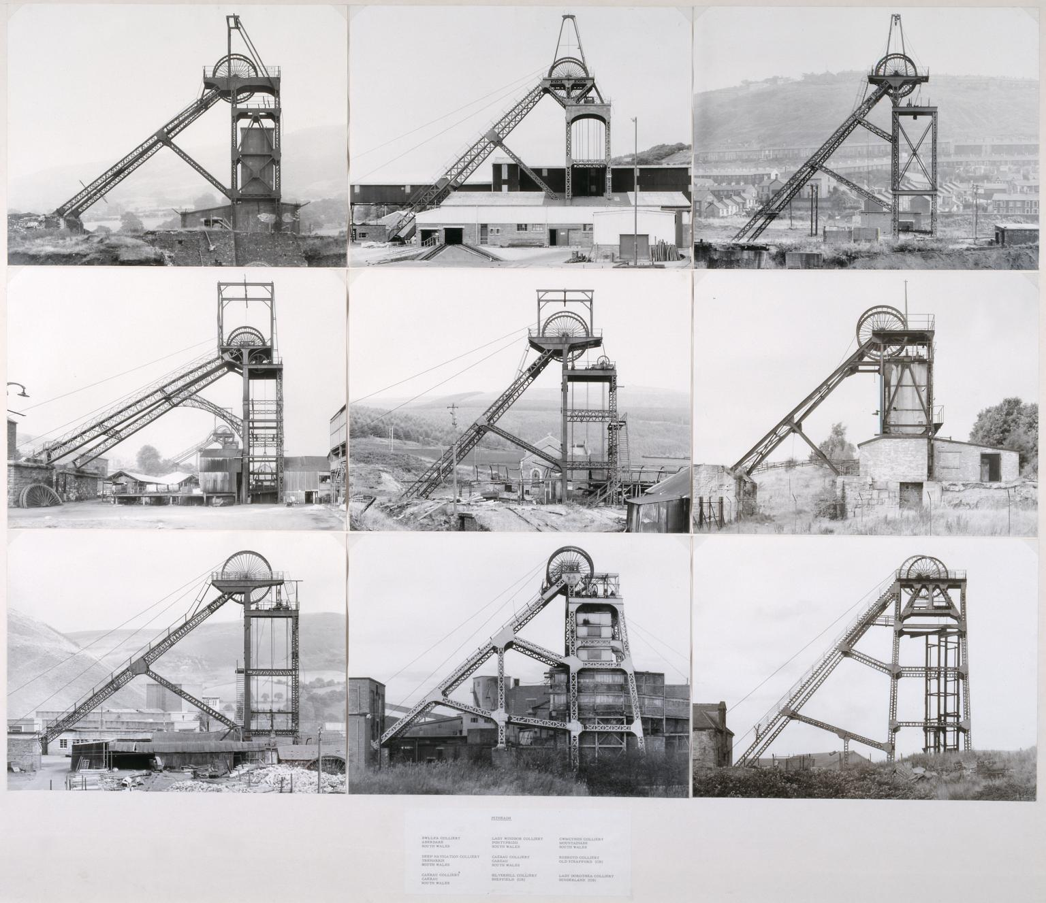
Figure 5, Bernd Becher and Hilla Becher, Pitheads, 1974
The Becher’s a husband and wife duo have an intense interest in the manmade and its industrious mark upon the landscape. They sought to categorically photograph the many structures and present them in a grid for instant comparison. The objective topographies of the Becher’s accentuate the structures acting like a forensic tool to produce images that are a matter of fact. Unlike the subjective images of Frank and Eggleston who see the world as being unordered with little to no absoluteness in meaning. The banal repetitions of the structures become more like sculptures transcending their functional purpose. The monochrome and overcast lighting leave little shadows to add depth to the objects, taking them out of their usual context. A purposeful technique employed by the photographers who wanted to simply capture the buildings as life like as possible. Devoid of emotive aesthetics of cinematic lighting etc, the pictures are cast within a case study context.

“We want to offer the audience a point of view, or rather a grammar, to understand and compare the different structures. Through photography, we try to arrange these and render them comparable. To do so, the objects must be isolated from their context and freed from all association.” (Becher, 2004)

The Becher’s, take a structuralist viewpoint of a semiotic relation between these structures and humanity. The industrial landmarks are in constant flux of change as technology advances; it makes the current industrious modes of production obsolete. Which not only changes the then nature of that space but also inadvertently affects the workers of that industry. Structuralism "the belief that phenomena of human life are not intelligible except through their interrelations. These relations constitute a structure, and behind local variations in the surface phenomena there are constant laws of abstract culture." (Blackburn, 2008). Becher’s documentation of structures reveals the ever-changing systems within 21st century life. The repetitive nature of the images mirrors life’s continuality as it shifts with the needs of humanity. In a interview Becher discusses the poignancy of the objectification of the structures, “that become humanised and destroy one another, as in Nature where the older is devoured by the newer.” (Becher, 1988)

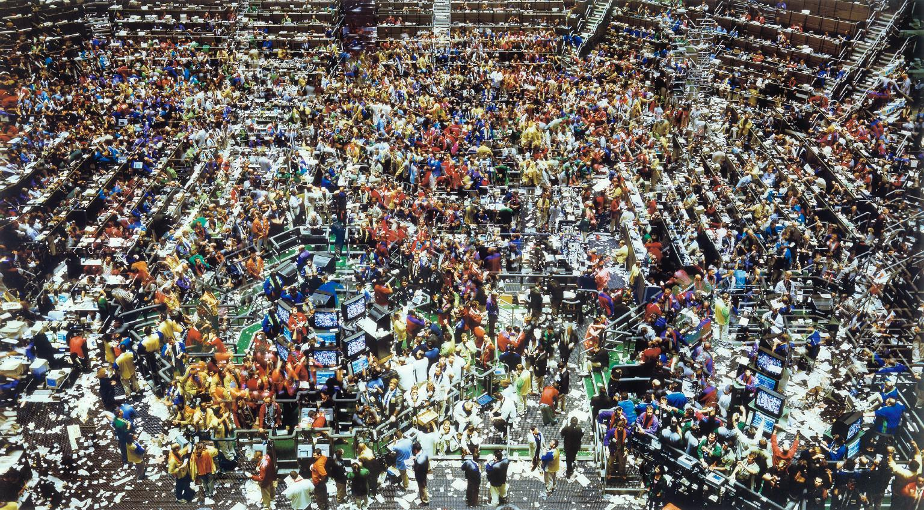
Figure 6, Andreas Gursky, Chicago, Board of Trade II, 1999

The photographer Andreas Gursky who studied under the Becher’s at the school of Dusseldorf, uses the medium of photography to explore space in relation to globalism and consumerism. Gursky’s use of large-scale images distance the viewer from the scene giving a clinical detached representation of the people inhabiting it. Within this areal view they become a collective rather than an individual commenting socially on 21st century work and life, as shown in figure 6 the Chicago Stock Exchange. His pictures produce order within the disorder of the world. The chaos of humanity is rationalized within the stillness of the photograph; his depersonalized images have a familiarity to the viewer of being part of this world however the layering technique of individual images that he employs adds a surreal aesthetic. He produces his own world within his images, creating an alternate reality out of reality. "My preference for clear structures is the result of my desire - perhaps illusory - to keep track of things and maintain my grip on the world." (Gursky) Despite the abstracted view of Gursky’s images there is an uncanny sense of his pictures being of the world.

Gursky’s work is thought of being at the forefront of the contemporary sublime, traditionally people used to find the sublime within the natural world, with its high stature and untamed nature. Within the 21st century there is not much of the natural world left that hasn’t been touched by humanity, our modern world with its city skylines has replaced for many the sublime beauty of nature.
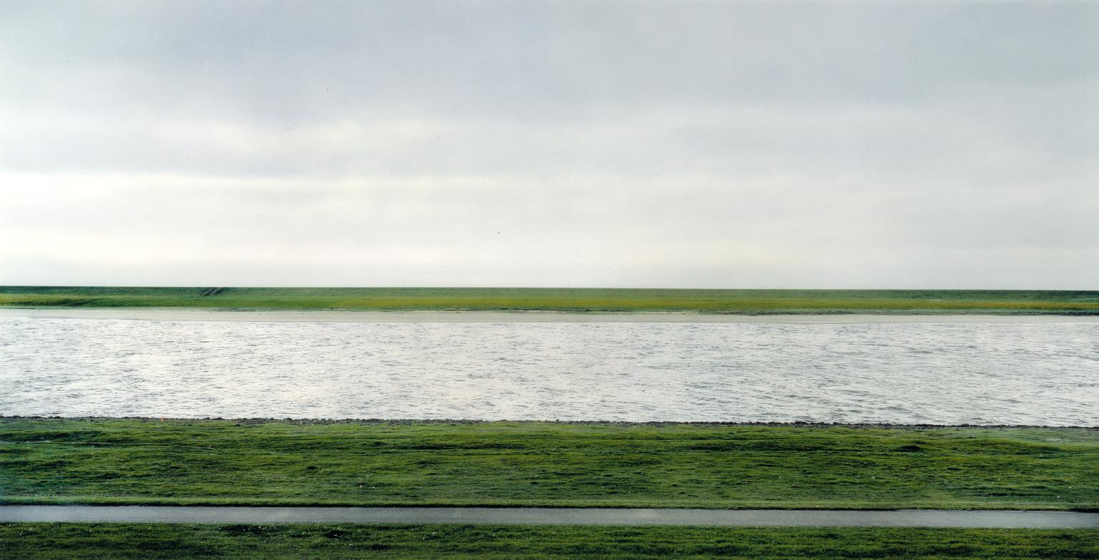Figure 7, Andreas Gursky, Rhine II, Germany, 1999
Within Rhine II, one of the most expensive prints ever sold, Gursky comments on the relationship between romanticism of the natural world and the sublime. Figure 7 depicts a part of the Rhine River in Germany, which once had residential and industrial buildings within the background; Gursky erases the structures presenting a serine horizon of endless green. Hints of modernity live in the straight concrete path at the forefront of the picture and the overall clinical feel of everything in order. The flatness of Gursky’s images that has little depth creates an unusual abstract perspective, emphasising the two dimensional nature of images.
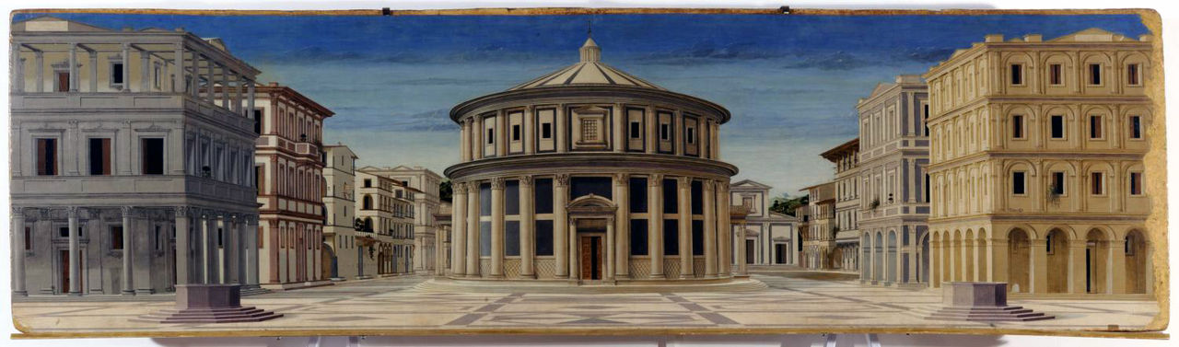
Figure 8, Luciano Laurana, Ideal City, Italy, 1470

This Italian renaissance painting by Luciano Laurana encompasses the idea of an ideal city. It is devoid of people and uses symmetry to apply order to chaos that is our urban habitats. Gursky’s work in a similar way strives for order although he accomplishes it by often incorporating people. The Ideal City’s relevance is ever more prominent today in a world of privatisation and strict barriers the ruling powers seemingly incorporate the ideologies of Laurana’s 1470 city. It can be seen within the vision of Hausmann the redeveloper of Paris with ordered spaces controlling the masses.

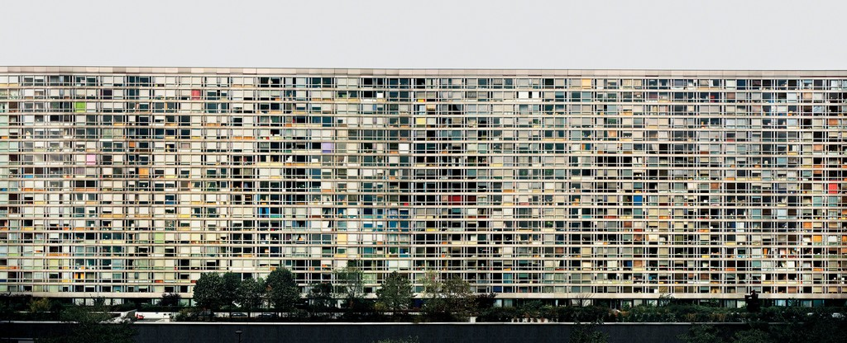
Figure 9, Andreas Gursky, Montparnasse, Paris, 1993

In figure 9 Gursky’s panoramic picture of a Parisian block of apartments has been digitally manipulated and stitched together from multiple shots to create a megalithic monument. Clear straight lines and symmetry add order to a twisted reality reminiscent of Laurana’s Ideal City. Gursky plays with the perception of space and shows humanity to be cramped and devoid of individualism within a building that has no start or end. “Paris, Montparnasse is an example of Gursky’s use of formal compositional strategies to comment on and construct narratives related to the realities of contemporary urban life.” (Blumberg, 2015) The world as we know it has become a product through systems of trade, impenetrable systems that are hidden to the masses. Gursky’s pictures sought to visualize these systems that dictate where and how we live. “Altered photography is a postmodern tool for presenting a postmodern world” (Ohlin, 2012). It is in this postmodern world where understanding of space and place have increasingly become uncertain and needs new methods of representation.

Through the birth of photography, technology has adapted the lens to become a tool for surveillance. Within the 21st Century, many cities operate CCTV cameras that in principle are there to keep the peace and ensure the safety of its citizens. However the incessant watching arises questions on people’s privacy and freedom within these public areas. “Under observation, we act less free, which means we effectively are less free.” (Snowden, 2014) A paranoia of the public surely arises from the photographic eye that seeks to expose individuals that are not inline within society’s expectations. The fixed position of CCTV camera’s that occasionally has the ability to swivel 360 degrees gives a narrowed gaze on a cityscape, it detaches the viewer with an often-elevated position looking down upon the public. Gursky who employs a similar tactic of elevation to his subject gives insight into humanity as a mass. The void in reality that CCTV produces, acts as dehumanising force that begins to see humanity as a mass to be controlled like a flow of a river. “The relationship between those who are constantly watched and tracked and those who watch and track them is the relationship between masters and slaves.” (Hedges, 2014)

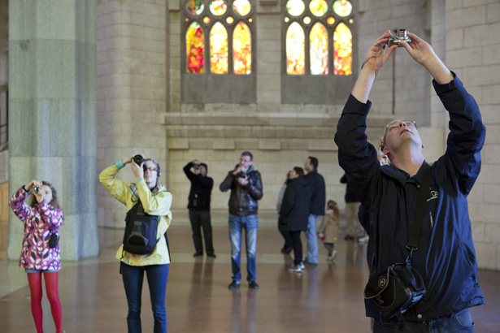
Figure 10, Martin Parr, Too much photography, Spain, Sagrada Familla, 2012

The advent of the mobile phone camera has seen a documentation of space within epic proportions. Millions of images being taken and transmitted within seconds sees the masses rationalizing their lives and surveilling themselves by sharing their locations and thoughts. We the mass have become a self governing force within a virtual world, a far cry from the photographic explorations of Robert Frank or William Eggleston who sought to feel and respond to the world and thus creating there own within them.
‘The mass is forced to contemplate itself (mass meetings, mass demonstrations). The mass is always present to itself and often in the aesthetically seductive form of an ornament or an emotionally moving image.’ Second, ‘with the help of the wireless the living room becomes a public place’. Third, ‘With the intention of underlining to the mass the meaning of the mass, all the mythical powers possible that can be hammered out of it are drawn out. So it can seem to many people as if they are lifted beyond themselves in the mass.’ (Kracauer, 1936)

The mobile image joins the hive of images on social networking sites that contributes to a collective image of society’s ideals. The all in one image making machine that is the camera phone lets the viewer take and manipulate pictures with applications all on one device. An irony exists within tourism, now dominated by pictures to validate the tourist experiences, British photographer Martin Parr explores this in his series Too Much Photography were he takes pictures of tourists taking pictures. “The photographic record of the visit has almost destroyed the very notion of actually looking.” (Parr, 2012) The artificial eye that is the camera seemingly and extremely within tourists has replaced human sight. Giving representations and less individual memories of in this case popular spaces. While souvenirs have existed way before photography, a object that acts like a memento is interesting in that it conjures memories of the space and time, transcending merely sight but other senses of hearing, feeling and tasting etc. While a photograph could be argued to do the same, it is most likely these experiences where missed while the holiday goer was busy photographing them instead of living in the moment.

Artists have adapted with technological advancements using it to create images and simultaneously commenting on the process of the artificial production of images. Mishka Henner is one of the most significant artists working within a post photography spectrum. His works often using Google Earth and Street View reveals a new perspective on space. "He is one of a growing number of artists making savvy use of the surveillance capabilities of satellite imaging and Google Street View in work that reflects the way the Internet age has altered our visual experience." (Gefter, 2015). Henner’s computer generated imagery has allowed him to access often off limit areas, from hidden military bases to oil and agriculture industries.
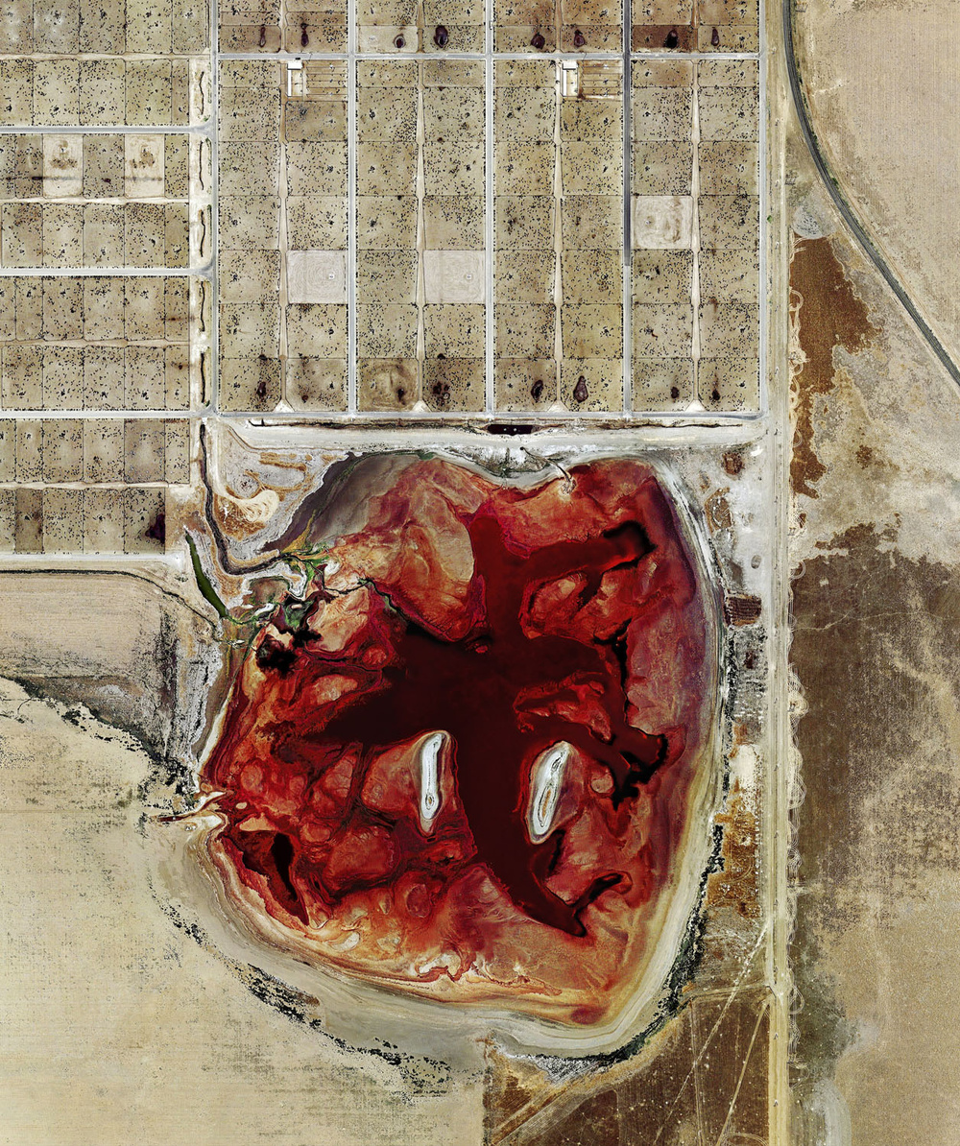
Figure 11, Mishka Henner, Feedlots, USA, 2012
In 2012 Henner made a series of satellite photographs depicting feedlots in America. The view from space shows an open wound on the surface of the world giving insight into the agriculture industries affect on the land. The pictures resembling abstract paintings produce an emotional pull despite the distance and lack of human interaction in the act of making the photographs. An air of the contemporary sublime resides around these images; within the brutality of these strangely beautiful manmade marks it acts as a reminder of humanity’s fragile co-existence with our environments.

Many states within America use ‘Ag-gag’ laws to stop activists or anyone photographing food production, Henners use of satellite imagery bypassed the politics and reveals an industry that is ethically questionable to cattle and the environment. As we see less privacy for the public, corporations are opting to do the opposite to hide their operations for fear of losing profit. This has meant new inventive ways of documenting have arisen as companies draw an iron curtain blocking physical access to their spaces.

“In an era of “ag-gag” laws, in which industrial-scale meat producers have persuaded several compliant state legislatures to make the act of documenting animal facilities with defamatory intent a crime, Earth’s manmade constellation of satellites may yet provide the only documentation of the landscapes that agri-business would rather keep hidden. Redefining the act of photography is not just a philosophical conceit in this instance; it is a necessary progression to continue the photographer’s work of helping us see the world.” ⁽Twilley, 2016)

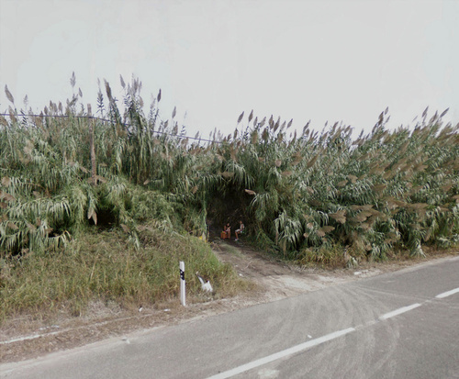
Figure 12, Mishka Henner, No Mans Land, Spain, 2012
Henner’s virtual explorations continue onto street level with the use of Google Street View, an application that provides panoramic pictures from a moving vehicle. In the series No Mans Land he explored prostitution along highways in Europe. The project caused controversy being thought of by some as an atomized look at women, dehumanizing, endangering and reinforcing gender stereotypes. Many critics compared it to other projects by photographers who immersed themselves within the sex industry getting to know the subjects before photographing them. The implication being the contact was important in allowing the viewer to be emphatic to the subject, ‘to feel one must be present’. This presents a dilemma in the method of documentation the pictures lacking a physical presence from the artist mutes the voice of the women. His method of finding his subjects are not incidental like Robert Frank’s imagery of America, Henner trolls forums where details are shared between users of the location of sex workers. The semi-automated images democratically capture what is there but Henner’s re-appropriation and context placed upon the imagery categorizes the women as unconfirmed sex workers. If the women are indeed sex workers the project doesn’t address the complexities of their lives be it economically or emotionally in which may explain why they sell their bodies. However there is an argument to say that if Henner was present in the space photographing the women from a distance, it could be equally exploitative lying in wait to capture aesthetically pleasing pictures of morally questionable transactions.

In regards to space, the street view of Google differs drastically from that of more traditional documentary photographers. Tools like Google Street View now allow a person to traverse roads from computers and mobile devices while physically being detached from the space. As you are stuck on the rails of the road, the world becomes less three-dimensional. You can see what lies on the side but not beyond it and you are therefore within a controlled view of the world. Henner, although he has some freedom to frame his subjects in No Mans Land from again an elevated position of the vehicle, his sight beyond it is stuck by the lack of human interaction. It also brings to the forefront the argument between private and public space. Google through its mapping of are roads and streets is another example (like that of images accumulated by mobile phones), of the hive of information that forms a collective of humanity’s lived experiences in which inadvertently impedes on a individuals privacy. Jean Baudrillard a French philosopher characterises this increase “We live in a world where there is more and more information, and less and less meaning.” (Baurdillard, 1981). Henner describes his images as existing but not being seen, His virtual strolling argues that there is meaning amongst the mass of information, if framed correctly from the bigger picture, it can be used to comment on issues of the world.

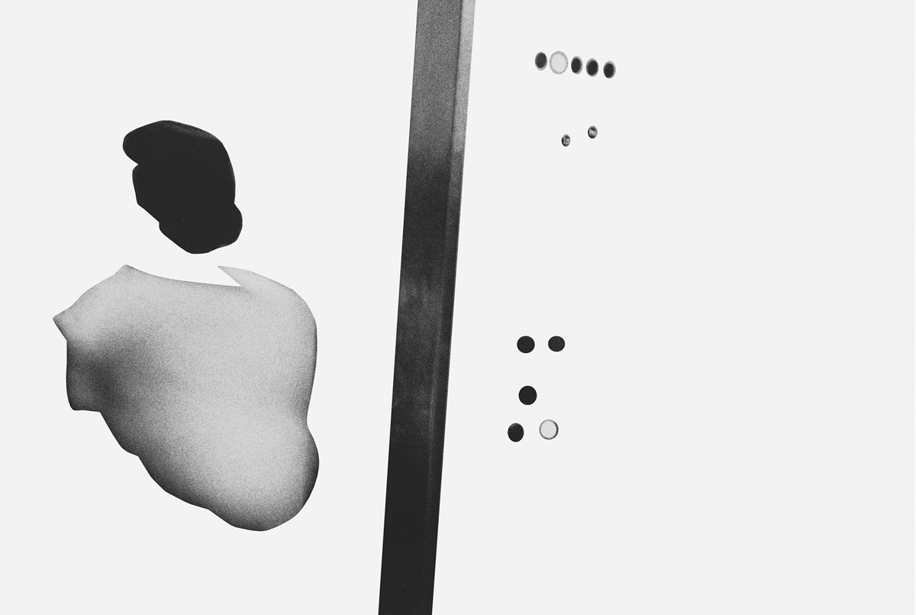
Figure 13, Mishka Henner, Less Americains, Ascenseur, 2013

The virtual world has in defiantly impacted on the methods of photographers within the 21st century. Henner again showcases this in the project Less Americains. Using the famous Robert Frank publication The Americans, Henner digitally erases part of the images creating a new piece of work out of the old. With your eye drawn to the objects within the white void, the images start to reveal more of the materiality of the world. The photoshopping of the classic publication creates new understandings of the space within them.

Controversial with comments hailing it as theft and an insult to the original, questions over copyrighting arise as existing images are manipulated to create a new. This manipulation changes are perception of space within photography, as Frank’s images have an essence of authenticity with no altering of the content, digitally manipulated photos produce a hyper reality, an uncertainty on what is real. Although manipulating photographic images predates digital with Man Ray using analogue techniques to produce surrealist imagery, digitally produced pictures of manipulation can be so subtle as almost unnoticeable creating a simulation of the world. Henner’s Less Americains has layers of simulation being a digitally re-mastered copy of an originally analogue source. “The simulacrum is never what hides the truth, it is truth that hides the fact that there is none. The simulacrum is true” (Baudrillard, 1981). This theory really puts into question the truthfulness of our perceived reality through photography, as pictures are mere simulations of space and time. In world that is now mediated by images through social media, advertising and the media, postmodern traits of distrust and dissection come into existence, as we increasingly become suspicious of the authenticity of images. Photography has lost its innocence or perhaps never had any to begin with, while in some circles to not trust the image is well known, to many it remains a harmless absolute there to serves us while in actual fact enslaving.

Photography throughout the ages has brought insight into the public eye of many topics by publications and digital representations. It has changed are view on the world expanding it in one sense with documentary and artistic practice seeking to expose or relay a message of the world. Despite the immersion into the fantastical world of the artists, where representation slides often towards abstracting the viewers gaze, the objective and subjective messages give greater realisations of our space, more than tends to be conceived in general day to day looking. Through context given or hidden the photographic images of artists has undoubtedly challenged us in our understanding of space, quite literally through its high and low angles, monochrome and vibrant colour aesthetics but also through conjuring philosophical questions of existentialism and opening up new chapters of the sublime presence that resides often hidden in the world.

However it can also be seen as a force shrinking are perception, with the hordes of imagery are own naturalistic sight of surroundings has been tampered with. Through democratising, giving the means to the masses to be image-makers it has created a simulated world. A world obsessed with the self that pays little attention to there surroundings. With more people viewing space virtually through applications like Google Street View and VR (virtual reality) headsets the future is uncertain on how we will connect to are surroundings. Technology is set to increase exponentially year by year; so much so that it is not out of the question that we will only view are space virtually in the far future. Thus photography’s impact has been far reaching in our understanding of the world to a point were we are questioning the authenticity of are perceived reality. Photography as an art form neither has the ability to confirm or deny the idea we live in a matrix of representations compromising the actuality of the world, it however has the possibility to interpret are thoughts and feelings within a more sincere sphere of understanding.

Bibliography

Books

Baudrillard, J. (1994). Simulacra and Simulation, USA, The University of Michigan Press.
Bachelard, G. (1994). The Poetics of Space, New York, Orion Press.

Barthes, R. (1982). Camera Lucida, France, NEW: Hill and Wang.

Blackburn, S. (2008). Oxford Dictionary of Philosophy, 2nd Edition revised, Oxford, Oxford University Press.
Clewer, Elsey, Certoma, (2012). The Politics of Space and Place, Cambridge Scholars Publishing.
Grundberg, A. (1999). The Crisis of the Real, Edition 3, USA, Aperture.
Karen Kurczynski (2005) Beyond Expressionism: Asger Jorn and the European Avant-Garde, 1941–1961, New York, New York University.

Knabb, K. (1995). Situationist International Anthology, Berkley: Bureau of Public Secrets.

Morley, S. (2010) The Sublime, London, Whitechapel Gallery, The MIT Press.

Sartre, J. (2007). Existentialism and humanism. London: Methuen.

Szarkowski, J. and Eggleston, W. (2014). William Eggleston's guide, New York: The Museum of Modern Art.

Websites
Becher, B. (1988), In conversation with Jean-Francois Chevrier, James Lingwood, Thomas Struth, in Another Objectivity: June 10–July 17 1988, Institute of Contemporary Arts, London 1988, p.57. Bernd and Hilla Becher quoted in an exhibition statement for ‘Distance And Proximity (Germany), Available from http://www.photosynkyria.gr/98/ex /ex48_en.html, Accessed: (12/12/2017)
Becher, B. (2004), Author Stimson, B. Tate Papers, Available from: http://www.tate.org.uk/download/file/fid/7229, Accessed: (12/12/2017)
Blumberg, N. (2015). Andreas Gursky, Available: https://www.britannica.com/biography/Andreas-Gursky#ref1203733, Accessed: (30/11/2017)

Gursky, A. (Accessed 08/12/2017)
http://www.theartstory.org/artist-gursky-andreas.htm#important_art_header

Gefter, P. (2015). Mishka Henner Uses Google Earth as Muse, , Available: https://www.nytimes.com/2015/08/30/arts/design/mishka-henner-uses-google-earth-as-muse-for-his-aerial-art.html, Accessed: (01/12/2017)
Hedges, C. “Our Only Hope Will Come Through Rebellion,” Available: https://www.youtube.com/watch?v=TOlg_2qAbUA, Accessed (10/12/2017)

Kracauer, S. (1936). German edition of Das Ornament der Masse, available in English in New German Critique No 5 Spring 1975 pp. 59-66), Available: https://lesleychamberlain.wordpress.com/2015/04/21/siegfried-krakauers-idea-of-mass-ornament/, Accessed: (09/12/2017)

Parr, M. (2012), Too Much photography, Available:
https://www.martinparr.com/2012/too-much-photography/, Accessed: (06/12/2017)
Ohlin, A. (2002). Andreas Gursky and the Contemporary Sublime, Art Journal, Vol. 61, No. 4 (Winter, 2002), pp. 22-35 Published by: College Art Association,
Available: http://www.jstor.org/stable/778148, Accessed: (09/12/2017)

Snowden, E. (2014), Ferenstein, G. (MAY 8, 2014 9:45 PM), NSA spying is causing Americans to self-censor their Internet activity, Available: https://venturebeat.com/2014/05/08/nsa-spying-is-causing-americans-to-self-censor-their-internet-activity/, Accessed (10/12/2017)

Twilley, N. (2016), Feed Lots, Edible Geography, Available: http://www.ediblegeography.com/feed-lots/, Accessed: (05/12/2017)

Illustrations

Figure 1
Frank, R. (1958), The Americans, Parade-Hobeken, New Jersey, 1955/1956, Steidl. Electronic picture available from: https://www.artsy.net/artist/robert-frank, Accessed: (15/10/2017)

Figure 2
Debord, G. and Chombart de Lauwe, PH, (1957), Untitled, Paris Electronic picture available from:
https://jacket2.org/commentary/avant-garde-iii-situationist-maps-take-two, Accessed: (12/12/2017)
Figure 3
Debord, G. and Jorn’s, A. (1957) The Naked City, Paris, Electronic picture available from:
https://paulwalshphotographyblog.wordpress.com/2013/07/08/the-naked-city/, Accessed: (12/12/2017)

Figure 4
Eggleston, W. (1976). William Eggleston’s Guide, Untitled, Memphis, 1970, Electronic picture available from: http://blog.ctnews.com/kantrowitz/2013/03/02/at-war-with-the-obvious-photographs-by-william-eggleston-at-metropolitan-museum/ Accessed: (01/11/2017)

Figure 5
Becher, B, H. (1974), Pitheads, Electronic picture available from:
http://www.tate.org.uk/whats-on/tate-modern/exhibition/cruel-tender/cruel-tender-artists/cruel-tender-artists-bernd-and, Accessed: (12/12/2017)

Figure 6
Gursky, A. (1999) Board of Trade II, Chicago, Electronic picture available from:http://www.tate.org.uk/art/artworks/gursky-chicago-board-of-trade-ii-p20191, Accessed: (20/11/2017)

Figure 7
Laurana, L. (1470), Ideal City, Urbino Italy, Electronic picture available from: https://en.wikipedia.org/wiki/The_Ideal_City_(painting)#/media/File:Formerly_Piero_della_Francesca_-_Ideal_City_-_Galleria_Nazionale_delle_Marche_Urbino_2.jpg, Accessed: (07/12/2017)

Figure 8
Gursky, A. (1993), Montparnasse, Paris, Electronic picture available from: https://www.artsy.net/artwork/andreas-gursky-paris-montparnasse, Accessed: (07/12/2107)

Figure 9
Gursky, A. (1999). Rhine II, Germany, Electronic picture available from:http://www.tate.org.uk/art/artworks/gursky-the-rhine-ii-p78372, Accessed: (03/12/2017)

Figure 10
Parr, M. (2012), Too Much Photography, Spain, Sagrada Familla, Electronic picture available from: https://www.martinparr.com/2012/too-much-photography/, Accessed: (05/12/2017)

Figure 11
Henner, M. (2012). Feedlots, Electronic picture available from: http://mishkahenner.com/Feedlots, Accessed: (06/12/2017)

Figure 12
Henner, M. (2012), No Mans Land, Spain, Electronic picture available from: http://mishkahenner.com/No-man-s-land, Accessed: (07/12/2017)

Figure 13
Henner, M. (2013). Less Americains, Ascenseur, Electronic picture available from: https://mishkahenner.com/Less-Americains, Accessed: (07/12/2017)

References

Books

Baudrillard, J. (1994). Simulacra and Simulation, USA, The University of Michigan Press.
Bachelard, G. (1994). The Poetics of Space, New York, Orion Press.

Barthes, R. (1982). Camera Lucida, France, NEW: Hill and Wang.

Blackburn, S. (2008). Oxford Dictionary of Philosophy, 2nd Edition revised, Oxford, Oxford University Press.
Clewer, Elsey, Certoma, (2012). The Politics of Space and Place, Cambridge Scholars Publishing.
Grundberg, A. (1999). The Crisis of the Real, Edition 3, USA, Aperture.
Karen Kurczynski (2005) Beyond Expressionism: Asger Jorn and the European Avant-Garde, 1941–1961, New York, New York University.

Knabb, K. (1995). Situationist International Anthology, Berkley: Bureau of Public Secrets.

Morley, S. (2010) The Sublime, London, Whitechapel Gallery, The MIT Press.

Sartre, J. (2007). Existentialism and humanism. London: Methuen.

Szarkowski, J. and Eggleston, W. (2014). William Eggleston's guide, New York: The Museum of Modern Art.

Websites
Becher, B. (1988), In conversation with Jean-Francois Chevrier, James Lingwood, Thomas Struth, in Another Objectivity: June 10–July 17 1988, Institute of Contemporary Arts, London 1988, p.57. Bernd and Hilla Becher quoted in an exhibition statement for ‘Distance And Proximity (Germany), Available from http://www.photosynkyria.gr/98/ex /ex48_en.html, Accessed: (12/12/2017)
Becher, B. (2004), Author Stimson, B. Tate Papers, Available from: http://www.tate.org.uk/download/file/fid/7229, Accessed: (12/12/2017)
Blumberg, N. (2015). Andreas Gursky, Available: https://www.britannica.com/biography/Andreas-Gursky#ref1203733, Accessed: (30/11/2017)

Gursky, A. (Accessed 08/12/2017)
http://www.theartstory.org/artist-gursky-andreas.htm#important_art_header

Gefter, P. (2015). Mishka Henner Uses Google Earth as Muse, , Available: https://www.nytimes.com/2015/08/30/arts/design/mishka-henner-uses-google-earth-as-muse-for-his-aerial-art.html, Accessed: (01/12/2017)
Hedges, C. “Our Only Hope Will Come Through Rebellion,” Available: https://www.youtube.com/watch?v=TOlg_2qAbUA, Accessed (10/12/2017)

Kracauer, S. (1936). German edition of Das Ornament der Masse, available in English in New German Critique No 5 Spring 1975 pp. 59-66), Available: https://lesleychamberlain.wordpress.com/2015/04/21/siegfried-krakauers-idea-of-mass-ornament/, Accessed: (09/12/2017)

Parr, M. (2012), Too Much photography, Available:
https://www.martinparr.com/2012/too-much-photography/, Accessed: (06/12/2017)
Ohlin, A. (2002). Andreas Gursky and the Contemporary Sublime, Art Journal, Vol. 61, No. 4 (Winter, 2002), pp. 22-35 Published by: College Art Association,
Available: http://www.jstor.org/stable/778148, Accessed: (09/12/2017)

Snowden, E. (2014), Ferenstein, G. (MAY 8, 2014 9:45 PM), NSA spying is causing Americans to self-censor their Internet activity, Available: https://venturebeat.com/2014/05/08/nsa-spying-is-causing-americans-to-self-censor-their-internet-activity/, Accessed (10/12/2017)

Twilley, N. (2016), Feed Lots, Edible Geography, Available: http://www.ediblegeography.com/feed-lots/, Accessed: (05/12/2017)

https://www.theguardian.com/cities/2016/mar/31/story-cities-12-paris-baron-haussmann-france-urban-planner-napoleon, Accessed:(05/12/2017)

http://circulationexchange.org/assets/pdfs/nomansland.pdf, Accessed: (10/12/2017)

https://jacket2.org/commentary/avant-garde-iii-situationist-maps-take-two:, Accessed: (12/12/2017)

