Apply the principles and practices of Data security, Governance and Compliance based on a given scenario
Abstract
This report provides an in-depth discussion of data security, governance, and compliance obligations of the NatureGarden (NG), a multinational health product firm that is experiencing massive cybersecurity threats. This respective study discusses accepted security models such as ITIL and ISO 27000 series, outlines a context-specific security governance model, and evaluates the role of constantly updated regulations and standards in the changing landscape of cybersecurity. The study shows that a layered security architecture that involves a combination of governance systems, risk management measures, and compliance systems, necessary in ensuring intellectual property of NG, client information, and operational integrity in a deeply integrated, digital world.

Table of Contents
Introduction 4
Security Frameworks and Models 4
Information Technology Infrastructure Library (ITIL) Framework 4
ISO 27001 Information Security Management System 7
NIST Cybersecurity Framework 8
COBIT Framework Comprehensive Analysis 9
Designed Security Approach for NatureGarden 9
Integrated Security Governance Framework Architecture 9
Comprehensive Risk Management Framework 10
Security Policy Framework and Implementation 11
Advanced Risk Management Implementation Strategy 13
Security Management and Best Practices Implementation 16
Critical Analysis of Regulations and Standards Evolution 17
The Dynamic and Evolving Nature of Cybersecurity Threats 17
Comprehensive Regulatory Compliance Evolution 18
Standards Adaptation to Technological Innovation and Industry Evolution 18
References 19

Introduction
Digitalization of contemporary business is a radical transition that has a tremendous amount of implications on the security domain since it brings both unprecedented opportunities and new threats. NatureGardens, as an internationalized brand in the wellness and health market, and with such a large cloud infrastructure and wireless network design, introduces peculiar security issues where an advanced governance system and compliance policies are needed.
Security posture of this company indicates there are fundamental weaknesses in terms of policy formulation and maintenance, risk management, and governance structures. Through recognising the landscape, 95 percent of network infrastructure is wireless-based and growing pressure to support access to personal devices, NG must grapple with the challenging issue of strikes the right balance between operational flexibility and solid security controls. The report outlines the entire analysis of the existing security frameworks and gives a customized approach to suit the needs of the NG and make it compatible to regulatory compliance and safeguarding of valuable intellectual property stores.

Security Frameworks and Models

Information Technology Infrastructure Library (ITIL) Framework
The Information Technology Infrastructure Library (ITIL) is one of the most detailed and well-known information technology service management frameworks, with a strong focus on the importance of properly aligning IT services with business goals through properly managed service lifecycle processes. ITIL offers advanced methodologies and highly tested strategies of security governance with its complete service lifecycle model, including five interrelated major stages in the defined setting of information security management. Service Strategy, Service Design, Service Transition, Service Operation, and Continual Service Improvement.
Service Strategy stage sets out basic security requirements, which are enabled by a thorough analysis of business objectives and a risk assessment process (Al-Mekhlaf et al., 2025). The key phases that this is experienced at NatureGarden entails strategic asset identification and asset cataloging of all critical assets such as intellectual property, customer database, other regular systems of operation and strategic business information, knowledge of complex business dependencies and interconnections as well as setting out of clear security goals that are directly supportive of the general operations of the company in terms of serving customers all over the world and meeting its capabilities and competitive standing in the health and wellness market segment.
The Service Design stage is dedicated to ensuring safe services and general security management practices, with specific emphasis being placed on elaboration of elaborate security policies, uniform operating procedures, and technical controls that will be tailored to meet the needs of the wireless-intensive enterprise infrastructure and widespread use of cloud services (Gunawan et al., 2024).
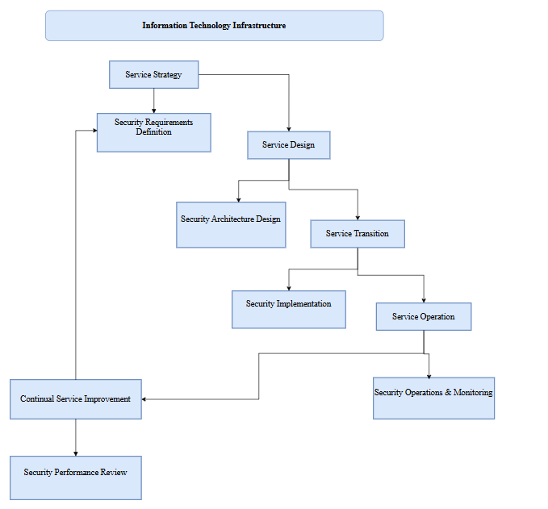
Figure 1:Information Technology Infrastructure
Service Transition ensures that security controls are correctly applied, thoroughly tested, and approved prior to being placed in production environments with detailed change management procedures that reduce the risk of security during technology moves and system upgrades. This stage is especially of importance to NatureGarden because of the difficulty of coordinating security in several cloud service providers and the necessity of ensuring service availability throughout the implementation of security controls. Service Operation includes continuous security monitoring, robust incident response programs and activities, and uninterrupted performance management activities that ensure the security controls are operating effectively throughout their service lifecycle.

ISO 27001 Information Security Management System
The ISO 27000 series is the globally accepted information security management systems (ISMS) standard that offers a structured and thorough approach to managing such sensitive organizational information whilst also guaranteeing the basic security tenets of confidentiality, integrity and availability when managing all business processes. ISO 27001 defines the exact requirements of a successful ISMS implementation and maintenance, and ISO 27002 offers specific security controls and detailed implementation guidance, which could be adjusted to the particular operational circumstances and risk profiles of organizations.
The core of the framework is based on the Plan-Do-Check-Act (PDCA) cycle that will help guarantee constant improvement of the security management practices by means of the specific, repeated mechanisms that allow organizational learning and adaptation. The planning step comprises the development of a detailed definition of the overall ISMS scope, generation of thorough risk audit of all business activities, and creation of measurable, concrete security goals relative to company goals and customer expectations (Putri et al., 2024). The implementation phase is concerned specifically with deploying proper security controls and procedures, thorough employee training and awareness programs and detailed documentation to aid continued security management activities.
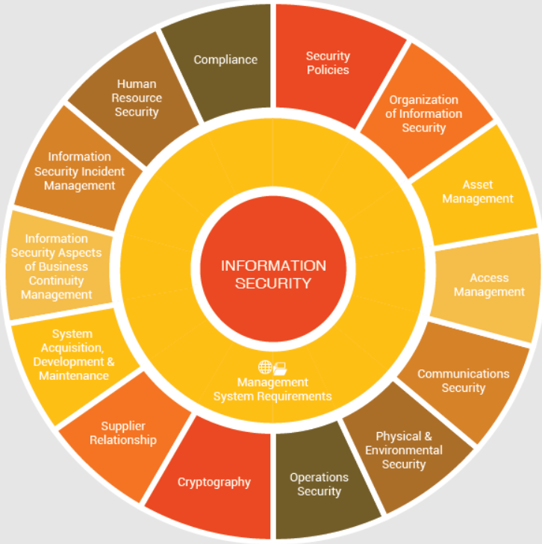
Figure 2: ISO 27001 Information Security Framework
(Source: Skypro.co.id, 2025)
Through monitoring outcomes, performance measures, and perceived shortcomings, the act phase embeds any needed corrective measures and enhancements to help keep the ISMS effective and helps it stay adapted to varying business needs and evolving threats, as well as new technology advancements (Verma and Shri, 2025). In the case of NatureGarden, the ISO 27001 framework would present a comprehensive strategy of managing the elaborate security concerns of an international organisation in an environment dominated with wireless connectivity and a cloud-based scenario.

NIST Cybersecurity Framework
The National Institute of Standards and Technology (NIST) Cybersecurity Framework is a conceptual paradigm of computer security recommendations aimed at assisting organizations in evaluating and enhancing their capabilities to mitigate, monitor, and respond to complex cyber attacks and security issues. This framework comprises five mutually interconnected main functions: Identify, Protect, Detect, Respond and Recover, which, in turn, include different categories and subcategories that have detailed instructions how they should be adopted (Akinade et al., 2025). In the case of NatureGarden, this thorough identification process consists of listing every asset such as intellectual property portfolios, customer databases, operational systems, third-party services, and part of their physical infrastructure, and identifying and evaluating plausible threats, vulnerabilities, and risk scenarios that can affect business operations.
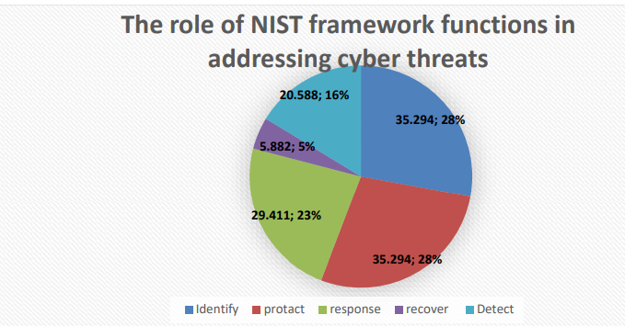
Figure 3: Findings of role of NIST framework functions in addressing cyber threats
(Source: Aljumaiah et al., 2025)
The pie chart demonstrates that there is approximately equal distribution of the five core functions of the NIST framework in dealing with cyber threats, with Identify and Protect functions totaling 28 percent of total effort. Respond is the most important at 23% with functions of Detect and Recover at 16% and 5% respectively, which shows a good coverage of all stages of cybersecurity.
It has full protection measures to deliver key infrastructure services that involve elaborate access control, data protection and safeguarding technologies, which are customized to the wireless and cloud computing environment. NatureGarden is especially dependent on this functionality due to the use of wireless networks and cloud services that demand advanced protection strategies able to protect data and systems impacted by distributed infrastructure elements (Aljumaiah et al., 2025). Respond activities refer to the implementation of suitable actions based on identified cybersecurity challenges, including incident response strategies, communications, and mitigation, which aim to minimize the effects of security incidents on business processes.

COBIT Framework Comprehensive Analysis
Control Objectives for Information and Related Technologies (COBIT) is a comprehensive governance framework that is explicitly geared toward the governance and management of enterprise information technology, with a particular focus on the crucial combination of IT strategy with business strategies as well as the maintenance of the risk management processes and the optimal usage of both resources and activities throughout the enterprise. The framework proposes the solutions to the governance issues using five guiding principles which include addressing stakeholder requirements by delivering value (Fuadi et al., 2025).
In the case of NatureGarden, the importance of stakeholder value creation and sound risk management as set out by COBIT perfectly matches the business imperative of the company to meet the security demands of customers within the context of business fluidity, operating efficiency, and customer service (Sholeh and Pramudya, 2025). The framework offers systematic modes of IT governance which can deal precisely with the intricacies of managing information technology in global organisation with a lot of stakeholders who have different needs and organizational regulatory requirements.

Designed Security Approach for NatureGarden

Integrated Security Governance Framework Architecture
A custom security strategy has to be formulated based on a thorough study of the existing frameworks along with the specific analysis of the operational peculiarities of NatureGarden, which suggests that this approach has to cover the following aspects (Fuadi et al., 2025). It reflects the challenges manifested by a global organization deployed on a wireless-centric infrastructure with a widespread use of cloud services and a complex BYOD scenario but aimed at securing the intellectual property property assets and the adherence to the regulatory frameworks of various jurisdictions.
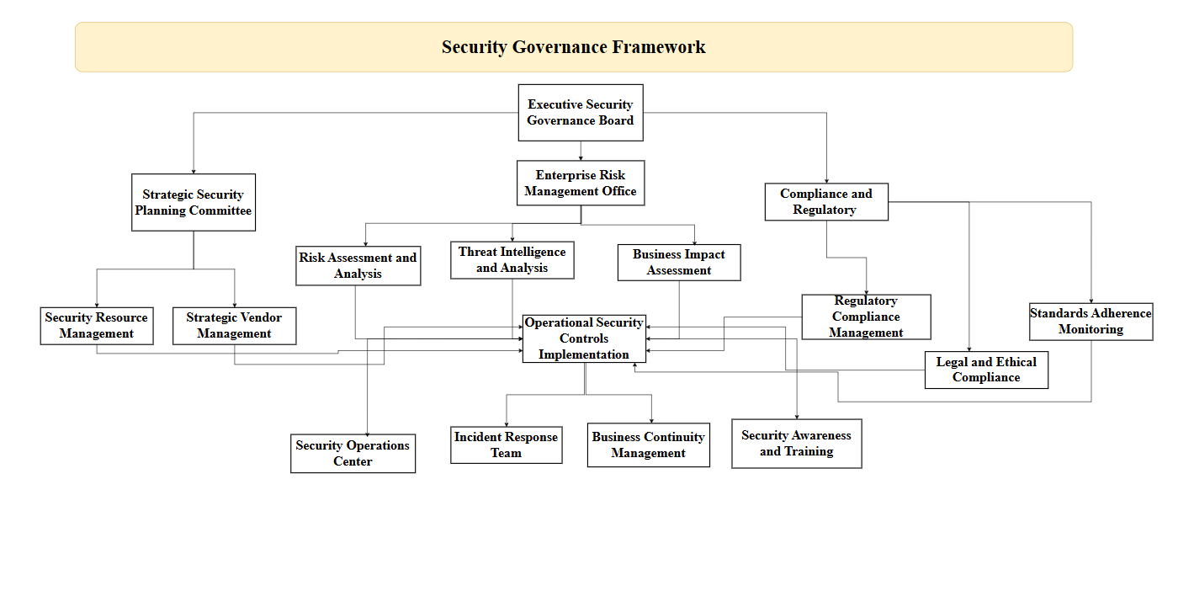
Figure 4: Security governance framework
The integrated security governance framework suggested in this paper introduces a hierarchical system that will provide adequate control, good accountability, and decision-making procedures that will operate throughout the whole organisation. The framework also incorporates the strategic planning, operational management and tactical implementation operations by means of coordinated operations that facilitate consistency, operational efficiency and efficacy in all security operations.

Comprehensive Risk Management Framework
NatureGarden governance structure should define clear accountability chains and end-to-end decision-making processes in information security management at all levels of organizations and across every business area. The executive level should have a Chief Information Security Officer (CISO) reporting to the Chief Executive Officer (CEO) so that security considerations are properly incorporated into strategic business decisions and given appropriate executive attention and resource investment.
Security governance structure is to be developed to include a thorough Information Security Steering Committee with senior executives of all key business areas, in operations, finance, human resource, legal, marketing, and international departments to provide cross-functional support, proper communication, and involvement in security initiatives of the whole enterprise.
The strategic planning of information security is the process of creating a security strategy that meets the entirety of the business objectives and requirements of NatureGarden, as well as risks that NatureGarden is willing to take and their tolerance towards risks, and also taking into consideration business-specific needs like the challenges of being in a wireless-adapted landscape and supporting global business operations and delivering services to customers worldwide.
The governance framework should also define comprehensive roles and responsibilities of security management by all levels of the organization organization and functional areas at the same time should ensure that security account-ability is effectively distributed, and the ability of all employees to comprehend their particular security responsibilities and anticipation (Abdi et al., 2025). Security performance metrics should be regularly reviewed in an orderly fashion, emerging risks and threat intelligence assessed, the effectiveness of existing security controls and procedures analyzed, and strategic choices made on security investments, policy changes, and capability upgrades. Such governance processes must be enforced with thorough reporting capabilities that deliver timely, precise, and actionable information to managing executives regarding security posture, compliance, and emerging threats.

Security Policy Framework and Implementation
NatureGarden needs an all-inclusive and advanced security policy framework that accounts for the entire range of security issues but is realizable, implementable, and compatible with business operational needs. The policy framework must be designed hierarchically, with top-level security policies offering high-level, strategic guidance and supported by longer policy documents covering the fine details of standards, procedures, and implementation guidelines that are specific to particular operational conditions and technical applications (de Sousa et al., 2025).
The policy development process should involve exhaustive stakeholder consultation, rigorous impact assessment processes, and frequent review cycles so that the policies are kept up-to-date, effective, and to reflect the current business needs, changes in technology, and regulations. Policies must be expressed comprehensible language which can be straightforwardly understood by all personnel at the lowest to the highest organization levels and be backed by a widespread system of training, awareness and continued correspondence that discloses understanding and adherence at each level of the organization.
Table 1: Policy devolopment
Policy Category | Organizational Scope | Key Components and Requirements
Enterprise Information Security Policy | All organizational units and personnel | Security objectives definition, roles and responsibilities assignment, compliance requirements specification, governance structure establishment
Data Classification and Handling Policy | All data assets and information systems | Classification level definitions, handling requirements specification, retention and disposal procedures, data sharing protocols
Access Control and Identity Management Policy | All systems, applications, and data resources | Authentication requirements, authorization principles, privilege management procedures, account lifecycle management
Bring Your Own Device (BYOD) Policy | All personal devices accessing organizational resources | Device security requirements, enrollment procedures, acceptable use guidelines, monitoring and compliance protocols
Cloud Security and Service Management Policy | All cloud services and third-party providers | Provider selection criteria, security requirements, data protection measures, service level agreements, monitoring procedures
Incident Response and Crisis Management Policy | All security incidents and business disruptions | Response procedures, escalation protocols, communication requirements, recovery activities, lessons learned processes
Business Continuity and Disaster Recovery Policy | All critical business operations and supporting systems | Recovery objectives, continuity strategies, testing requirements, communication protocols, resource allocation procedures
Privacy and Data Protection Policy | All personal and sensitive information | Privacy principles, data subject rights, consent management, cross-border transfer requirements, breach notification procedures
The overall policy structure will need to deal with the unique issues in the operating environment of NatureGarden such as difficulties in securing wireless networks, cloud service relationships, BYOD controls, and diversified regulatory requirements in multiple jurisdictions. Policies must have implementation guidance, measurement criteria of compliance, and overall enforcement procedures which must be applied essentially in all organizational units and geographical locations.

Advanced Risk Management Implementation Strategy
The organizational-wide security strategy built by NatureGardens is based upon the foundational pillars of risk management and offers procedural and structured mechanisms of identifying, evaluating, examining, and averting security-related risks in all areas of business operations, technological framework, and organizational processes (Surchi, 2024). The risk assessment exercise should be all-encompassing by addressing the various facets of the NatureGardens intricate business operations such as the use of cloud services, wireless connectivity support infrastructure, mobile phone management, intellectual property protection, relations with third-parties, compliance penetrates, and operations handling of the company in different geographic regions with varying threat environments and different regulations.
Risk assessments must explicitly address internal and external threats such as advanced cyberattacks, coordinated data breaches, system downtimes and outages, regulatory non-compliance fines, theft of intellectual property, insider threats, supply chain hacks and natural disasters that may disrupt business service and information security. The threat intelligence, vulnerability analysis and business impact should be integrated into the assessment process to recognise a relevant and actionable risk information that can be made use of in decision making.
Table 2: Risk management matrix
Risk Category | Risk Factor | Likelihood | Impact | Overall Risk Level | Mitigation Strategy
Cyber Security | Sophisticated cyber attacks | High | High | HIGH | Multi-layered security controls, 24/7 monitoring
 | Data breaches | Moderate | High | HIGH | Encryption, access controls, DLP systems
 | Ransomware incidents | Moderate | High | HIGH | Backup systems, endpoint protection, training
Infrastructure | Wireless network vulnerabilities | High | Moderate | HIGH | Strong encryption, continuous monitoring
 | Cloud service failures | Low | High | MODERATE | Multi-cloud strategy, SLA management
 | System outages | Moderate | Moderate | MODERATE | Redundancy, business continuity planning
Intellectual Property | IP theft/espionage | High | High | HIGH | Classification systems, access restrictions
 | Trade secret exposure | Moderate | High | HIGH | Need-to-know access, legal protections
Compliance | Regulatory non-compliance | Moderate | High | HIGH | Compliance monitoring, regular audits
 | Privacy violations (GDPR/CCPA) | Moderate | High | HIGH | Privacy by design, consent management
BYOD & Mobile | Unsecured personal devices | High | Moderate | HIGH | MDM solutions, device encryption
 | Data leakage via mobile | Moderate | Moderate | MODERATE | App controls, remote wipe capabilities
Third-Party | Vendor security breaches | Moderate | Moderate | MODERATE | Vendor assessments, contract requirements
 | Supply chain compromises | Low | High | MODERATE | Due diligence, continuous monitoring
Operational | Insider threats | Moderate | Moderate | MODERATE | Background checks, activity monitoring
 | Natural disasters | Low | Moderate | LOW | Disaster recovery, geographic distribution
The strategies of risk treatment must be designed critically according to the particular risk tolerance levels of NatureGarden, business needs, and operational limits, so that security investments can combine the best security protection and operational performance and business growth goals. The medium and low-risk areas should be addressed with cost-effective control measures that afford reasonable protection without needlessly limiting the business but also inflicting excessive administrative burdens (Abdi et al., 2024). The risk management process must have review and update practices, so that risk assessments are pertinent and that the treatment approaches are effective in offering protection to business needs as might shift, threats environments, and technology environments change.

Security Management and Best Practices Implementation
Comprehensive security management practices implemented at NatureGarden should be based on key industry best practices but should be highly customized based on the unique operating environment, technology infrastructures, and business needs used in the firm. The security management model must fit perfectly into the current way that businesses run and must include well-defined boundaries with other sets of management functions such as project management, change management, service management, vendor management functions and processes.
The security management practices must have security evaluation on a routine manner and periodically as well as wide-ranging penetration tests, and proactive vulnerability management which highlighted the weakness of security and serves before malicious entities can consider exploiting (Zheng et al., 2025). Such activities should be assisted by the right tools, technologies and expertise that will not only be able to monitor and defend the highly-distributed, complex wireless and cloud-based infrastructure of NatureGarden but would be able to gain clear visibility into the security and compliance posture. The security management model should include comprehensive security awareness and training programs to not only create awareness on the security roles of every individual but also to provide them with the required knowledge and skills in order to carry out their respective duties and to ensure that they keep in touch with emerging threats, technologies and organizational needs.

Critical Analysis of Regulations and Standards Evolution

The Dynamic and Evolving Nature of Cybersecurity Threats
The modern environment of cybersecurity threats is highly dynamic and advanced, which requires constant and proactive changes in regulations, standards, and security frameworks to keep up with new attack vectors, changing capabilities of threat actors, and the growing complexity of technology infrastructures (Manyara et al., 2023). Cyber threats have evolved dramatically such that what were relatively basic malware infections and simple intrusion efforts have progressed to highly complex, multi-faceted attacks involving state-sponsored campaigns, advanced persistent threats, and complex supply chain attacks, as well as Artificial Intelligence driven attack tools and techniques.
Due to this, the dynamic threat environment and associated evolving threats necessitate a continuous evolution of security structures, regulatory mandates and industry standards in line with emerging vulnerabilities, changing attack patterns and the sophistication of threat actors with their advanced technical capabilities and access to significant financial reserves and strategic interests that might include intellectual property theft, competitive intelligence and disruption of essential business process and operations.

Comprehensive Regulatory Compliance Evolution
Information security, data protection, and privacy have become increasingly recognized as a core human right alongside critical business requirement deserving high-level legislative structures and enforcement regimes, with associated changes in the regulatory landscape (Sayers et al., 2021). The actualization of the General Data Protection Regulation (GDPR) in Europe, the California Consumer Privacy Act (CCPA) in the United States, and other comprehensive privacy laws around the rest of the world is regarded as a paradigm shift in tighter data protection standards, individual rights, and hefty fines associated with non-compliance.
Such emerging regulations mandate organizations to apply privacy-by-design concepts across their operations, perform thorough privacy impact assessments on new programs and technological implementations, build a strong data governance framework that cuts across all business activities, and offer individuals considerable control over their personal data including access, correction, and deletion rights.

Standards Adaptation to Technological Innovation and Industry Evolution
Security standards are regularly revised and improved by international standards organizations such as the International Organization for Standardization (ISO), National Institute of Standards and Technology (NIST), and industry-specific standards bodies to reflect changes in technology, threats to security, and best practices learned over the course of implementing security across the varying environments of different organizations.
ISO 27001 standard has been revised several times with the latest revision including new security controls, security challenges of cloud computing, and improvements to risk management strategies, in additional to offering greater implementation details to work with complex and distributed systems (Nawagi et al., 2023). These updates incorporate all the knowledge and experience of thousands of organizations worldwide and can be helpful in gaining insights on the best practices of security management.
Respective frameworks can be seen to have evolved to formulate answers to cybersecurity issues such as protection of critical infrastructure, security of supply chains, privacy protection and integration of cybersecurity with the wider enterprise risk management activity. These evolutionary changes have made standards relevant and efficient given the evolution of technology and threat space.

References
Abdi, A.H., Audah, L., Salh, A., Alhartomi, M.A., Rasheed, H., Ahmed, S. and Tahir, A., 2024. Security control and data planes of sdn: A comprehensive review of traditional, ai, and mtd approaches to security solutions. IEEE Access, 12, pp.69941-69980.
Akinade, A.O., Adepoju, P.A., Ige, A.B. and Afolabi, A.I., 2025. Cloud security challenges and solutions: A review of current best practices. Int J Multidiscip Res Growth Eval, 6(1), pp.26-35.
Aljumaiah, O., Jiang, W., Addula, S.R. and Almaiah, M.A., 2025. Analyzing cybersecurity risks and threats in IT infrastructure based on NIST framework. J. Cyber Secur. Risk Audit, 2025(2), pp.12-26.
Al-Mekhlaf, Z.G., Saare, M.A., Altmemi, J.M.H., Al-Shareeda, M.A., Mohammed, B.A., Alshammari, G., Alkhabra, Y.A. and Alreshidi, I., 2025. A quantum-resilient lattice-based security framework for internet of medical things in healthcare systems. Journal of King Saud University Computer and Information Sciences, 37(6), pp.1-19.
de Sousa, M.A.F., da Silva, D.C. and Soares, H.D., 2025, July. Prioritization Strategy for Measures in the Brazilian Security Framework. In Latin American Symposium on Digital Government (LASDiGov) (pp. 261-272). SBC.
Fuadi, D., Harsono, H., Syah, M.F.J., Susilo, A., Suhaili, S. and Wahyono, B., 2025. Self-Governance: Internationalization management of distinctive higher education towards the world class university. Indonesian Journal on Learning and Advanced Education (IJOLAE), pp.96-113.
Gunawan, H., Irianto, A.B.P. and Negara, J.G.P., 2024. Implementation of sustainable service improvement in organizations using framework information technology infrastructure library (ITIL). Procedia Computer Science, 234, pp.748-755.
Manyara, P., Raubenheimer, K., Sadan, Z., Manyara, P., Raubenheimer, K. and Sadan, Z., 2023. Legal and policy frameworks to address marine litter through improved livelihoods. The African Marine Litter Outlook, 137.
Nawagi, F., Kneafsey, R., Modber, M., Mukeshimana, M., Ndungu, C. and Bayliss-Pratt, L., 2023. An overview of nursing and midwifery leadership, governance structures, and instruments in Africa. BMC nursing, 22(1), p.168.
Putri, S.R.M., Bernandy, M.P., Aulia, C., Fikri, M.G.R. and Jasmine, J., 2024. Cyber Security Risk Management Practices: Insights From an ISO 27001 Certified Organization. Journal of Digital Business and Innovation Management, 3(2).
Sayers, P., Gersonius, B., den Heijer, F., Klerk, W.J., Fröhle, P., Jordan, P., Ciocan, U.R., Rijke, J., Vonk, B. and Ashley, R., 2021. Towards adaptive asset management in flood risk management: A policy framework. Water security, 12, p.100085.
Sholeh, M.B. and Pramudya, N.D., 2025. Comparative Study of Information System Governance Frameworks: Foundations for IT Risk Management Using COBIT 2019 and ITIL. Jurnal Transformatika, 22(2), pp.73-80.
Skypro.co.id, 2025, ISO 27001 Information Security Framework, Accessed from: https://skypro.co.id/wp-content/uploads/2018/12/ISO_27001_ISMS.png Accessed on 28.07.2025.
Surchi, A., 2024. Factors Shaping Organizational Contingency Plans: Insights into Risk Management and Preparedness. OTS Canadian Journal, 4(3), pp.1-10.
Verma, A. and Shri, C., 2025. Cyber security: A review of cyber crimes, security challenges and measures to control. Vision, 29(4), pp.478-492.
Zheng, L.J., Islam, N., Zhang, J.Z., Behl, A., Wang, X. and Papadopoulos, T., 2025. Aligning risk and value creation: a process model of supply chain risk management in geopolitical disruptions. International Journal of Operations & Production Management, 45(5), pp.1178-1210.

