Name: Ravisen Ramma
Student ID: 1715880

Module Name: Work-Based Learning Project
Module Number: BMPF 4008/9/10
Date Submission: 25th April 2019
Word Count: 3,318

Ascertaining the value of a Building Management System to drive efficient energy usage

Contents
Section 1: PROJECT PROPOSAL 2
Section 2: PROJECT REPORT 4
2.1 INTRODUCTION 4
2.2 LITERATURE REVIEW 4
2.3 METHODOLOGY 6
2.3.1 Survey 6
2.3.2 Interview and benchmarking 7
2.3.3 Research ethics 7
2.4 FINDINGS 8
Fig 1: Energy awareness among team members 8
Fig 2: Working habits of team members 10
Fig 3: Location of BMS equipment at Tamassa 12
2.5 CONCLUSION 14
2.6 RECOMMENDATIONS 14
2.6 REFERENCES LIST 15
Section 3. Appendices 16
3.1 Appendix I 16
3.1.1 Energy awareness questionnaire 16
3.1.2 Questionnaire 17
Section 4. Ethics form 19
Outline any anticipated risks that may adversely affect any of the participants, the researchers and/or the University, and the steps that will be taken to address them. 29
Full risk assessment completed and appended? 29

Section 1: PROJECT PROPOSAL

The hotel industry is energy and resource-intensive in terms of providing comfort and services to guests. This has a great impact on the environment
1.0 Justification: The organisation is putting more emphasis is on a sustainable tourism future. One often ignores how much energy it takes to operate commercial buildings and the high expenditure which subsequently occurs. As a maintenance manager, to lower cost, importance must be placed on analysing if the building is operating efficiently and if the team members are aware of their role in energy efficiency and conservation.
1.1 The intended impact: This research study will help to ascertain whether energy conservation through a Building Management System will help to improve the level of comfort and guest satisfaction, reduce maintenance costs and system failure, help extend the operating life of equipment and value of facilities, increase awareness and help to reduce harmful gas emissions which affect climate change as proposed by Coombs (2018).
1.2 The outlined intention: Both quantitative and qualitative approach has been used for data collection. To obtain quantitative data, one research instrument was a structured questionnaire distributed to 100 team members of the hotel, based on simple random sampling and cluster sampling across 10 department of the resorts.
1.3 Interview and benchmarking: To benchmark building management system implementation, a focus group interview has been conducted with the maintenance managers of the companies who have already implemented smart meters in Mauritius. The purpose of the interview is to obtain a more detailed qualitative data of the system implementation, importance, benefits on the short term and long term period.
1.4 Ethics and Insider research: The questionnaire was accompanied by a covering letter which emphasized that participation is voluntary and that collected data would be dealt in strict confidentiality. A creole version of the questionnaire was produced in order to obtain reliable data from team members.
1.5 Expected time line: The focus group interview and the structured questionnaire was conducted in February 2019 .Implementation, after taking the feedback into consideration, will be carried out in one year.
1.6The Expected Learning Outcomes: The researcher will gain more insight on the value of smart meter deployment, cost and energy reduction measures and identification of life time of equipment.
References (A.G. Coombs) site (2018). Innovation and sustainability. [Online]. Available from URL: www.agcoombs.com.au [accessed 2nd December 2018]

Section 2: PROJECT REPORT

2.1 INTRODUCTION

Energy management is vitally important to address severe energy problems and to reduce the consumption of scarce and valuable resources. The saved amount of energy obtained from those management activities is proven to be the most economical source of “new” energy. The saved energy not only eases the strain on the environment, but also provides time to develop new energy sources. All energy management program contributes in lowering the costs of heat, light and power while minimising the impact on the environment.

2.2 LITERATURE REVIEW

One of the main pillars of our economy is the Tourism Industry with total contribution to GDP of 110 bn rupees with creation of 131,000 jobs for the year 2017 (WTTC, 2018). The Tourism Industry in Mauritius relies on a beautiful, clean scenic environment with emphasis on Sun, Sea and Sand (the 3 S’s) and the ecology. (MTPA, 2018)

However, the hotel industry is also energy and resource intensive in terms of providing comfort and services to guests and has a great impact on the environment such as depletion of the ozone layer, rise in the surface temperature due to Green House Effect leading to Global Warming. The effects of the environment are caused by excessive consumption of water, food, waste products, electricity and fuel as well as emissions released to air, water and soil. (Global Carbon Emission Report, 2018)

In a hotel, energy flows in three distinct zones such as the guest room area (bedroom, bathroom/showers, and toilets) the public area (reception, lobby, bar, restaurants, swimming pools, sauna, conference room and the service area (kitchen, store room, office, laundry, staff facilities, machine rooms, technical sections). These three distinct zones vary from extensive glazing, spaces with a high rate of heat exchange with the outdoor environment to energy in extensive areas typically requiring advance air handling such as ventilation, cooling and reheating. (Wang, 2012)

Heating, air conditioning, ventilation account for the largest, portion of the energy consumed in a hotel. Other significant end-uses include domestic hot water production, lighting, Food and Beverage (F&B) catering.
The organisation is putting more emphasis is on a sustainable tourism future with zero percent carbon emission and energy efficiency and conservation. In addition, one often ignores how much energy it takes to operate commercial buildings and the high expenditure which subsequently occurs. To lower cost, importance must be placed on ensuring if the building is operating efficiently if the team members are aware of energy efficiency and conservation. Energy conservation through BMS will help to improve the level of comfort and guest satisfaction, reduce maintenance costs and system failure; help to reduce maintenance costs and system failures, help extend the operating life of equipment and value of facilities, increase awareness and help to reduce harmful gas emissions which affect climate change (Skelhon, 1998)

2.3 METHODOLOGY
Both quantitative and qualitative approach was used for data collection.

2.3.1 Survey
To obtain quantitative data, one research instrument that was used was a structured questionnaire that was distributed to 100 team members of the hotel. The 100 team members were selected based on simple random sampling and cluster sampling across 10 department of the resorts which were administration, Food and beverage, kitchen, maintenance, spa, entertainment, kids club, stewarding among others as shown below:

Department | Number of questionnaire
Maintenance | 10
Spa | 10
Kitchen | 10
Food and Beverage | 10
Housekeeping | 10
Entertainment | 10
Kids Club | 10
Admin | 10
Front Office | 10
Security | 10

The questionnaire aimed to measure the awareness of energy efficiency and conservation best practices among team members. Simple random sampling was used to allow each single team member the equal chance of being selected for the survey.
With this method every employee in the selected department from the cluster sampling method had the chance to participate in the survey (Saunders et al,2003)
The questionnaire consists of 16 questions. The first five questions were generic questions which set the tone for the respondents to gain interest in the survey. The questions were of dichotomous Yes/No questions and category questions were used in order to obtain valid and reliable data from the respondents.
Survey instrument was chosen over interview to allow confidentiality and reliable results. The survey was distributed to team members from respective department randomly.

2.3.2 Interview and benchmarking

To benchmark building management system implementation, a focus group interview was conducted with the maintenance managers of Sotratech and Schneider who have implemented already the smart meter in Mauritius. The purpose of the interview was to obtain a more detailed qualitative data of the system implementation, importance, benefits on the short term and long term period and loopholes if any as far as energy efficiency is concerned. Focus group interview was favoured over face to face as it allowed a brain storming session which was more enriching, reliable and efficient. The focus group interview questions were as follows.
- What is the role, function and specificity of the BMS?
- What are the benefits of its correct implementation?
- What will be the average saving done and energy consumption value after its correct implementation?

2.3.3 Research ethics
As suggested by Wells (1994), it was decided that a cover letter should be used. For instance, the cover letter gave personal information about the researcher the title and purpose of the study and stated clearly that the participant is not forced to answer questions which they are not comfortable with. Moreover the participants were guaranteed that the information gathered in the survey will be kept in strict confidentiality.

2.4 FINDINGS

81 team members (81%) have responded to the survey out of the 100 distributed questionnaires. The following objectives will be met through the findings. 74 % of the respondents are aware that we are actually in an energy crisis. 78% of the respondents feel that they should save energy and practice energy saving at home such as using energy saving bulbs, switching off light when not in use and making use of energy saving appliances.
Energy awareness among team members.
This shows that they recognise energy as a non-renewable source of energy which will eventually run out. They are aware that natural resources such as coal, gas and oil are a major source of energy for the global economy. They do practice energy saving techniques at home which means that they are sensitised about energy conservation practices and they will automatically follow energy conservation practices at work as shown below.

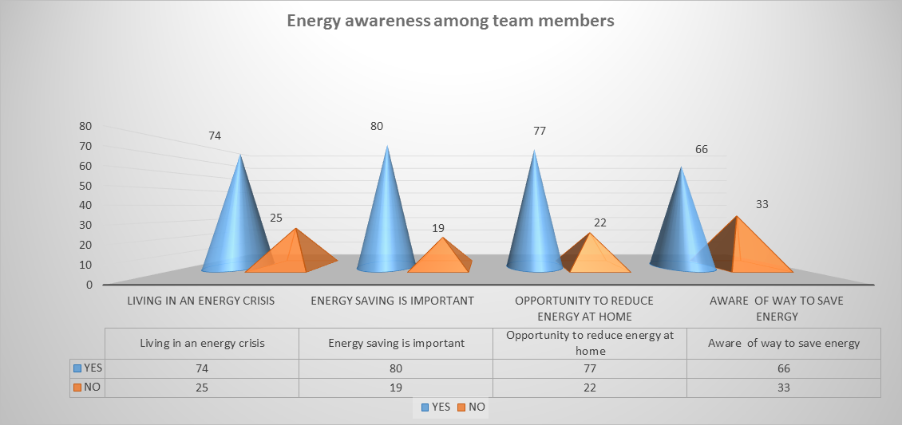

Fig 1: Energy awareness among team members

67% respondents are aware about the efficient use of key tags switch for energy saving practices. The role of key tag switch is to reduce energy when leaving rooms.
83% of the housekeeping respondents are well aware of the opening of curtains when cleaning rooms for maximum daylight. They are aware to make well use of natural light which helps to use less heat, less air conditioning and eliminate the need of using artificial light, thus reducing electricity and HVAC (heating, ventilation and air conditioning costs). In the laundry, 80 % of the laundry attendants are aware that washers and dryers should run fully loaded in order to optimize energy consumption. 70 % of the kitchen & stores team members know that they should avoid opening chiller and under counter chiller doors several times during operations to avoid absorption of increased energy use. It has been deduced that 20 to 30 % of the respondents are not in the loop of energy conservation awareness initiatives as they are new to the operations and will take time to adapt to the energy conservation practices.
69 % of the respondents are motivated by the behavior of saving energy due to environmental protection awareness reasons. They are aware of the negative impacts of global warming causing an increased number of greenhouse gases as they trap more heat which results in an average temperature of the earth as the earth becomes hotter. Sustainable development has to do with promoting an economic development which does not only cater for the existing generation but for the future generation as well. 89 % of the team members are aware of the sustainability goals and of the need of saving the planet. They are also ready to participate in energy awareness and conservation campaign in the future. Based on the Kyoto Protocol and with the Accord de Paris, The Ministry of Environment (2019) has subcontracted the AFDaction de France to measure the risks and impact of global warming in respect to the conservation of our resources, sea level rise and flood risks in Bel Ombre. They have found that due to climatic change, there is an increase in temperature of the earth causing an increase in number of carbon dioxide gas trapped in the atmosphere, rise in sea level due to expansion of the ocean water and expansion of the riverbanks that of river St Martin and River citronniers causing flood risks which could be alarming for the future of Bel Ombre.They also made mentioned that yearly average 18000 mm of rainfall will decrease by 30% by 2030.Therefore awareness of energy conservation practices and implementation of an energy management programme such as BMS will help minimize the impact of the environment and reduce costs.
88.9 % of the respondents are not aware of the increased in costs of electricity because of the fact that they are young, are not conscious about electricity consumption and billing. The maintenance team members are aware that Air conditioning unit, chillers refrigerator, extractor, ice machine and electric pump in respective order consume more energy. As mentioned by (Wang,2012) Heating, air conditioning, ventilation account for the largest, portion of the energy consumed in a hotel. Other significant end-uses include domestic hot water production, lighting, F&B catering as shown below.

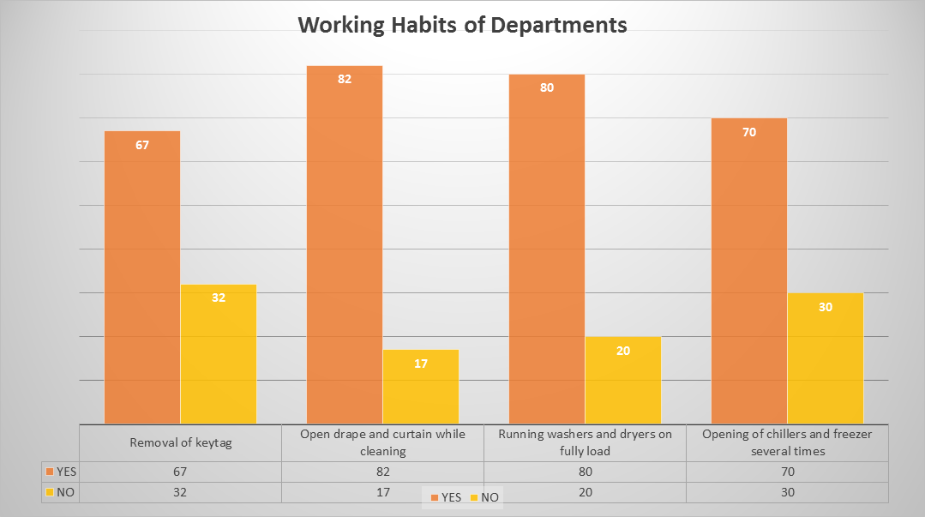

Fig 2: Working habits of team members

Maintenance Team members are also aware of the benefits of energy efficiency. 100 % of the respondents are aware that energy saving equipment improves level of comfort and guest’s satisfaction and aesthetic presentation of facilities. For example they know that use of halogen bulb in room will heat more the guest room rather than a LED light. They have acquired the learning by continuously replacing halogens and incandescent lights in all guest rooms and outlets. 70 % of the respondents know that energy efficiency leads to extension of operating life time of equipment and reduce maintenance costs. This is because the team is aware already about smart meters. This will help Tamassa to implement about energy efficient technology which is the (BMS) Building Management System. As defined by (Waqar et al, 2012) BMS system is an intelligent microprocessor based controller network, monitor and control a building technical systems and services such as air conditioning, ventilation, and lighting. The role of BMS is to control the building, heating, ventilation and Air Conditioning systems (HVAC) and help extend equipment operation life time and reduce maintenance costs. Moreover 60 % of the respondents are aware that energy efficiency will help to reduce harmful gas emissions such methane and nitrous oxide. The BMS being implemented will help monitor carbon dioxide emission monitoring and air quality.
Based on the focus group interview with the specialized consultant in electrical engineering, the BMS system will help to improve the operating reliability of plant and equipment at Tamassa by enabling the maintenance department to carry out routine checks and adjustment from a supervisory control point. The system will also help to indicate problems and provide information which will allow the maintenance team members to respond rapidly and rectify any situation before it gets critical. The system will be controlled in house by the maintenance department and will be installed and serviced by the external company which has installed the system. The BMS automatic information feed system will enable maintenance team members to be more productive as they will be more efficient as they do not need to spend time taking automatic meter readings. Therefore the use of the BMS will enable significant man power savings to be achieved through providing control adjustments from a central point and automatically taking meter readings. Moreover the BMS system will provide managers with a tighter hold over environment and comfort conditions and achieve a greater guest satisfaction, by preventing overheating and overcooling. At the same time energy saving can also be achieved. (BMS for Higher Education, 1998)
The BMS system will also help to identify planned preventive maintenance programme to avoid sudden and unforeseen breakdown of plants, thereby eliminating costly repairs and inconvenience due to plant failure. The BMS will also help to benefit the environment by reducing emissions of the principal greenhouse gas, carbon dioxide (CO2), thereby helping to reduce the risk of global warming. It will also help to conserve the world’s finite energy resources and water supplies.
The BMS will also allow budget control when appropriate sub meters will be installed as it will automatically monitor and record the energy use.
For the correct implementation of the BMS at Tamassa, the focus group with specialised consultants of electrical engineering, that is Sotratech, Manser Saxon and Ecosaic, the day to day function of BMS is to help in day to day building operations, measure and monitor general building performance such as rooms, outlets, technical rooms and plants, boiler rooms, kitchen, Spa and well ness centre among others. The energy boxes and devices will be placed on several electric panel in the hotel in order to set up the system.

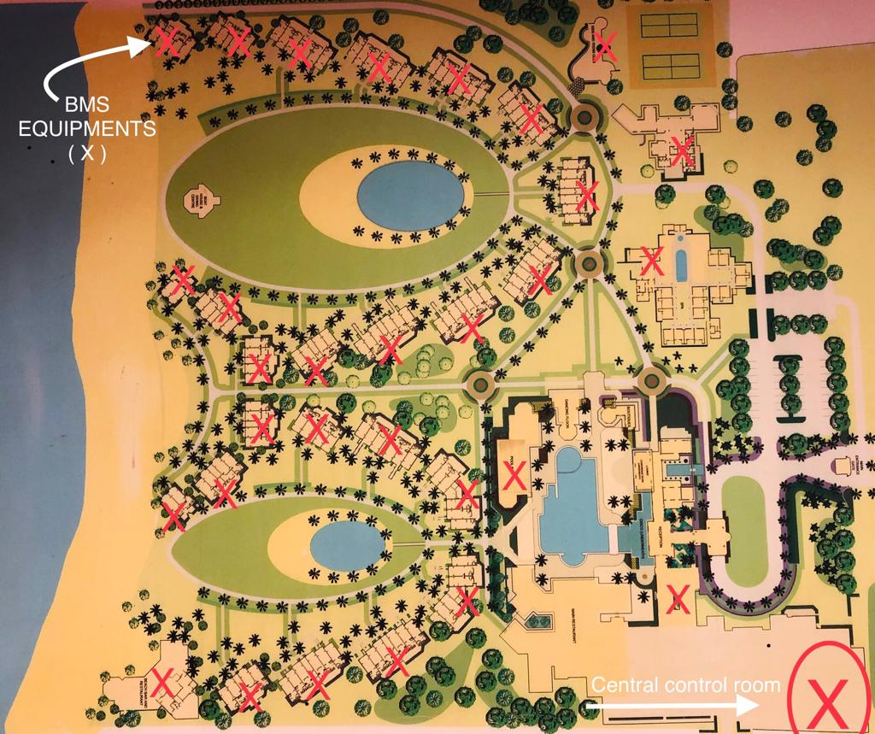

Fig 3: Location of BMS equipment at Tamassa

However, as per Manser Saxon, it is sometimes possible to reduce installation costs such as optimisers into the BMS.
Focus group interview findings from Sotratech specialised consultant mentioned that a BMS at Tamassa can operate effectively as our building are separated into zones so that the areas with different requirements such as plants, outlets, rooms among others can be controlled appropriately and independently. They also agreed to do a free survey of installation that will be ready in two months’ time. The system will be fully documented, including a full set of installation drawings and comprehensive details of the supervisor interface software and graphics. Training to the maintenance team will be given on the BMS functioning and system. For example, team members will need to ensure that not only the system works correctly but also that the supervisor's computer interface is as comprehensive and user friendly as required. They will also have to learn about the computer and services aspects of the system. As a minimum, the team member should be able to understand the supervisor displays and be able to operate all necessary commands. They will need to know how to make necessary minor programme changes. They will carry out minor manual adjustments to control points. They should also be able to install basic additional points. In addition, for the correct operation and maintenance of the existing plant, preventive maintenance of existing plant is necessary to allow effective performance of the BMS. Furthermore team member involvement and commitment are necessary. In order for a BMS to operate to its potential, the team member closely involved in its operation will have to be committed to its success and must be willing to incorporate it into their existing ways of working. The sustainability department at LUX* can provide funding and management expertise for installation of the system. BMS system at Tamassa as the focus group interview with specialised consultants will help to achieve 75 % operational efficiency.

2.5 CONCLUSION
Therefore, as majority of the team members at Tamassa are sensitised about energy conservation practices, the implementation of BMS as part of an energy management programme will be possible and will help to reduce heat, light and power and minimise the impact on the environment. It has been observed that team members do practice energy saving at home; so they will automatically have the habit of practicing energy saving at work in their respective departments such kitchen operations, housekeeping and laundry, offices among others. However the new team members and existing team for the housekeeping department still need to be sensitised about energy conservation practices not to defeat the purpose of the BMS implementation at Tamassa. It has also been observed that maintenance team members have a thorough knowledge of smart meters, so it will easy for them to adapt to the BMS system. They are also aware of the appliances that consume most energy in the resort such as AC unit among others and they are also sensitised about the benefits of energy efficiency. Actually team members have to walk to the site; for example, the boiler and take the temperature manually, but with BMS implementation, reading will be automated to help measure and monitor general building performance such as rooms, outlets, technical rooms and plants, boiler rooms, kitchen, Spa and wellness centre among others.

Therefore, the objectives of this research have been met. This research study has allowed me to innovate in my field of study in terms of improving maintenance system in a green, prompt, accurate and automated way. In addition, by writing this research project, I have been able to be a researcher and put my maintenance practical expertise into writing.

2.6 RECOMMENDATIONS
Specialised consultants suggest that for the correct implementation, the energy boxes and devices have to be placed on several electric panel in the hotel in order to set up the system. Training on BMS expertise for maintenance team members is a must. All machinery or building which is aging, under wear and tear has to be refurbished to allow optimum use and accurate results of BMS. BMS correct implementation will help to reduce costs by 15 %.

2.6 REFERENCES LIST

A.G. Coombs site (2018). Innovation and sustainability. [Online]. Available from URL: www.agcoombs.com.au [accessed 2nd December 2018]
Mauritius Tourism Promotion Authority site (2019). About Mauritius. [On-line]. Available from URL: https://www.tourism-mauritius.mu/trade/en-uk/about-us, [accessed 28th January 2019].
Saunders, M., Lewis, p., & Thornhill, A. (2003). Research Methods for Business Students (3rd ed.).Harlow: Pearson Education Limited.
Skelhon,J. (1998). Chartered Institution of Building Services Engineers: Building Management Systems Further and higher Education [Online]. Available from URL: www.cibse.org [accessed 28th March 2019]
UN Environment(2018).Emission Gap Report. [Online].Available from URL: www.unenvironment.org [accessed 4th February, 2019]
Wang , C. (2012). A study on Energy performance of hotel in Taiwan. Volume 49 Copyright Elsevier 2012
World Travel & Tourism Council site (2018). Travel & Tourism Economic Impact. [On-line]. Available from URL: https:// www.wtt.org/-/media/files/reports/economics-impact research/countries-2018/Mauritius2018pdf, [Accessed 5th february, 2019)

Section 3. Appendices

3.1 Appendix I

3.1.1 Energy awareness questionnaire

Dear Team Member,
I will request you to complete a short survey based on energy awareness. As a Team member, your opinion is important in helping the organisation to optimise energy efficiency for a better sustainability future. All collected data will be dealt in strict confidentiality. The survey will take approximately five minutes to complete. Participation is voluntary and if you feel uncomfortable about any of the questions you can withdraw at any time.

Yours sincerely,

Ravisen Ramma,

3.1.2 Questionnaire

1. At the moment we are being presented with a picture that we are living in an energy crisis.
Do you agree?
□Yes
□No

2. Is energy saving is important to you? *
□Yes
□No

3. Have you ever had an opportunity to reduce energy use at home? *
□Yes
□No

5. Are you aware of ways of saving energy?
□Yes
□No

6. Do you practice energy saving techniques at home?
□ Yes
□ No
If yes, so tick as many as are relevant to you
□ a) I use energy saving bulbs
□ b) I turn off light and control that equipment is turned off before I go home
□ c) I use energy saving appliances
□ d) I try to change my daily habits to save energy Keep windows and outside door while AC in operation in guests’ rooms

7. Anybody leaving guest’s room should remove the key tag card to allow saving of energy?*
□ Yes
□ No

8. Open drape and curtain when cleaning rooms in order to let the day light in
□ Yes
□ No
If you work in the laundry, please answer question 9
9. For maximum efficiency, ensure washers and dryers run only when fully loaded
□ Yes
□ No
If you work in the kitchen and stores, please answer question 10
10. In kitchen and stores, avoid opening of chillers and freezers for several times
□ Yes
□ No

11. What would motivate you to change your behavior to reduce the energy use? Tick as many as are relevant to you *
□ Increasing costs
□ Global warming (Rise in temperature of the earth surface)
□ Depletion of ozone layer
□ Awareness that resources on earth are non-renewable
□ Any other……………….

If you work in the maintenance department, please answer questions 12 and 13.

12. According to you what equipment and apparatus in your department consume lots of energy?*
□ Air conditioning unit
□ Refrigerator
□ Chillers
□ Lighting
□ Gas equipment
□ Ice machine
□ Extractor
□ Any other………………

13. Accordingly to you what are the benefits of energy efficiency at work
□ Improve level of comfort and guest satisfaction
□ Contribute to the aesthetic presentation of facilities
□ Reduce maintenance costs and system failure
□ Extend operating life of equipment and value of facilities
□ Reduce harmful gas emissions which affect climate change

14. Would you be interested in participating in energy saving activities in the future? *
□ Yes
□ No

15. Would you be interested in participating in energy awareness campaign in the future? *
□ Yes
□ No

Section 4. Ethics form

APPLICATION FOR ETHICAL APPROVAL

In order for research to result in benefit and minimise risk of harm, it must be conducted ethically. A researcher may not be covered by the University’s insurance if ethical approval has not been obtained prior to commencement.

The University follows the OECD Frascati manual definition of research activity: “creative work undertaken on a systematic basis in order to increase the stock of knowledge, including knowledge of man, culture and society, and the use of this stock of knowledge to devise new applications”. As such this covers activities undertaken by members of staff, postgraduate research students, and both taught postgraduate and undergraduate students working on dissertations/projects.

The individual undertaking the research activity is known as the “principal researcher”.

Ethical approval is not required for routine audits, performance reviews, quality assurance studies, testing within normal educational requirements, and literary or artistic criticism.

Please read the notes for guidance before completing ALL sections of the form.

This form must be completed and approved prior to undertaking any research activity. Please see Checklist for details of process for different categories of application.

SECTION A: About You (Principal Researcher)

Full Name: |  |  | Ravisen Ramma
Tick all boxes which apply:
Member of staff: | ☐ | Student: |  | ☒ | Honorary research fellow: | ☐

Faculty/School/Centre: | WIWBL
Campus: | Carmarthen
E-mail address: | ravisen.ramma@tamassaresort.com  rvsnramma@gmail.com
Contact Telephone Number: | 52577352
For students:
Student Number: | 1715880 | Undergraduate | ☒
Programme of Study: | Cert HE in Professional Practice | Taught Postgraduate | ☐
Director of Studies/Supervisor: | Tessa Oosthuizen | Research | ☐

SECTION B: Approval for Research Activity

Has the research activity received approval in principle?  (please check the Guidance Notes as to the appropriate approval process for different levels of research by different categories of individual) |  | YES | ☒ | NO | ☐
 |  |  |  | Date
If Yes, please indicate source of approval (and date where known): | Research Degrees Committee |  | ☐
 | Faculty Research Committee |  | ☐
 | Other (write in)  WIWBL Ethics Board Representative |  | ☒
Approval in principle must be obtained from the relevant source prior to seeking ethical approval.

SECTION C: External Ethical Guidance Materials

Please list the core ethical guidance documents that have been referred to during the completion of this form (including any discipline-specific codes of research ethics, and also any specific ethical guidance relating to the proposed methodology). Please tick to confirm that your research proposal adheres to these codes and guidelines.
LUX *Code of ethics | ☒
 | ☐
 | ☐

SECTION D: External Collaborative Research Activity

Does the research activity involve collaborators outside of the University? |  | YES | ☐ | NO | ☒
If Yes, please provide the name of the external organisation and name and contact details for the main contact person:
Institution
Contact person name
Contact person e-mail address

Where research activity is carried out in collaboration with an external organisation
Does this organisation have its own ethics approval system? | YES | ☐ | NO | ☐
If Yes, please attach a copy of any final approval (or interim approval) from the organisation

SECTION E: Details of Research Activity

Indicative title: | Ascertaining the value of a Building Management System to drive efficient energy usage
Proposed start date: | MAY 19 | Proposed end date: | DEC 19
Purpose of research activity (including aims and objectives)
Outline the purpose, aims and objectives of the research activity, including key research questions. Show briefly how existing research has informed the proposed activity and explain what the research activity will add and how it addresses an area of importance. (Maximum 300 words)
Tamassa is a four star plus All Inclusive Resort on a surface area of 91,888,78m2; which opened in 2007.
One often ignores how much energy it takes to operate commercial buildings and the high expenditure which subsequently occurs. To lower cost, importance must be placed on ensuring if the building is operating efficiently.

Aims & objectives
The aims and objectives of the research will therefore be :

Energy Management and Reduce Operational Costs

- To define new parameters for heat, light and power consumption in regards to Tamassa renovation
- To review a Building Management software system so that we can obtain information in an automated way about optimal start and stop of the plant
- To evaluate sensitization of energy efficiency among team members

Previous Research
Automatic power meter reading using GSM network The 8th International Power Engineering Conference
H.G.Rodney Tan,C.H. Lee,V.H.Mok, “Automatic power meter reading using GSM network ", The 8th International Power Engineering Conference.

References
(A.G. Coombs) site (2018). Innovation and sustainability. [Online]. Available from URL : www.agcoombs.com.au [ accessed 2nd December 2018 ] (this box should expand as you type)
Proposed methods
Provide a brief summary of all the methods that may be used in the research activity, making it clear what specific techniques may be used. If methods other than those listed in this section are deemed appropriate later, additional ethical approval for those methods will be needed. (Maximum 600 words)
Methodological Position

The Building Management system software which consists of the data interface module, database management module, reliability prediction module, results output module (Coombs,2018) will be researched before being implemented.
The study will ascertain whether the software will be able to help in shortening the development cycle and reducing the research and development cost of smart meters and will become a useful tool in achieving the reliability growth of smart meters.
1. Survey
To obtain quantitative data, one research instrument that will be used is a structured questionnaire that will be distributed to 100 team members of the hotel. The 100 team members will be selected based on simple random sampling and cluster sampling across 10 department of the resorts which are administration, Food and beverage, kitchen, maintenance, spa, entertainment, kids club, stewarding among others.
The questionnaire aims to measure the awareness of energy efficiency best practices among team members.
2. Interview and benchmarking
To benchmark building management system implementation, a focus group interview will be conducted with the maintenance managers of the companies who have implemented already the smart meter in Mauritius. The purpose of the interview is to obtain a more detailed qualitative data of the system implementation, importance, benefits on the short term and long term period and loopholes if any as far as energy efficiency is concerned.
Analysis
Data will be analysed through qualitative and quantitative data survey through structured questionnaire and interview and represented through charts and tables on an excel sheet.
The research project will help to identify the status of energy conservation best practices among team members across the areas of the resort. The research project will give way to obtaining understanding of the value of Smart meter deployments and optimising energy around the property.

Location of research activity
Identify all locations where research activity will take place.
This will base in specific places around the property such as Food and Beverages Outlets, Kitchens, Laundry, Fitness Centre, Boat house, Spa, Technical Plant Rooms and 24 Blocks of 214 Rooms of Tamassa resort.

Research activity outside of the UK
If research activity will take place overseas, you are responsible for ensuring that local ethical considerations are complied with and that the relevant permissions are sought. Specify any local guidelines (e.g. from local professional associations/learned societies/universities) that exist and whether these involve any ethical stipulations beyond those usual in the UK (provide details of any licenses or permissions required). Also specify whether there are any specific ethical issues raised by the local context in which the research activity is taking place, for example, particular cultural sensitivities or vulnerabilities of participants.
Mauritius

SECTION F: Scope of Research Activity

Will the research activity include: | YES | NO
Use of a questionnaire or similar research instrument? | ☒ | ☐
Use of interviews? | ☒ | ☐
Use of diaries? | ☐ | ☒
Participant observation with their knowledge? | ☐ | ☒
Participant observation without their knowledge? | ☐ | ☒
Use of video or audio recording? | ☐ | ☒
Access to personal or confidential information without the participants’ specific consent? | ☐ | ☒
Administration of any questions, test stimuli, presentation that may be experienced as physically, mentally or emotionally harmful / offensive? | ☐ | ☒
Performance of any acts which may cause embarrassment or affect self-esteem? | ☐ | ☒
Investigation of participants involved in illegal activities? | ☐ | ☒
Use of procedures that involve deception? | ☐ | ☒
Administration of any substance, agent or placebo? | ☐ | ☒
Working with live vertebrate animals? | ☐ | ☒
Other primary data collection methods, please explain in this box | ☐ | ☒

If NO to every question, then the research activity is (ethically) low risk and may be exempt from some of the following sections (please refer to Guidance Notes).

If YES to any question, then no research activity should be undertaken until full ethical approval has been obtained.

SECTION G: Intended Participants

Who are the intended participants: | YES | NO
Students or staff at the University? | ☐ | ☒
Adults (over the age of 18 and competent to give consent)? | ☒ | ☐
Vulnerable adults? | ☐ | ☒
Children under 18? | ☐ | ☒
Prisoners? | ☐ | ☒
Young offenders? | ☐ | ☒
Those who could be considered to have a particularly dependent relationship with the investigator or a gatekeeper? | ☐ | ☒
People engaged in illegal activities? | ☐ | ☒
Others (please identify): | ☐ | ☒

Participant numbers and source
Provide an estimate of the expected number of participants. How will you identify participants and how will they be recruited?
100 Team members will be selected based on simple random sampling and cluster sampling across 10 department of the resorts which are administration, Food and beverage, kitchen, maintenance, spa, entertainment, kids club, stewarding among others.

Information for participants: | YES | NO | N/A
Will you describe the main research procedures to participants in advance, so that they are informed about what to expect? | ☒ | ☐ | ☐
Will you tell participants that their participation is voluntary? | ☒ | ☐ | ☐
Will you obtain written consent for participation? | ☐ | ☐ | ☒
Will you explain to participants that refusal to participate in the research will not affect their treatment or education (if relevant)? | ☒ | ☐ | ☐
If the research is observational, will you ask participants for their consent to being observed? | ☐ | ☐ | ☒
Will you tell participants that they may withdraw from the research at any time and for any reason? | ☒ | ☐ | ☐
With questionnaires, will you give participants the option of omitting questions they do not want to answer? | ☒ | ☐ | ☐
Will you tell participants that their data will be treated with full confidentiality and that, if published, it will not be identifiable as theirs? | ☒ | ☐ | ☐
Will you debrief participants at the end of their participation, in a way appropriate to the type of research undertaken? | ☒ | ☐ | ☐
If NO to any of above questions, please give an explanation

Information for participants: | YES | NO | N/A
Will participants be paid? | ☐ | ☒ | ☐
Is specialist electrical or other equipment to be used with participants? | ☐ | ☒ | ☐
Are there any financial or other interests to the investigator or University arising from this study? | ☐ | ☒ | ☐
Will the research activity involve deliberately misleading participants in any way, or the partial or full concealment of the specific study aims? | ☐ | ☒ | ☐
If YES to any question, please provide full details

SECTION H: Anticipated Risks

Outline any anticipated risks that may adversely affect any of the participants, the researchers and/or the University, and the steps that will be taken to address them.

If you have completed a full risk assessment (for example as required by a laboratory, or external research collaborator) you may append that to this form.

Full risk assessment completed and appended?

Yes ☐
No ☒

Risks to participants
For example: emotional distress, financial disclosure, physical harm, transfer of personal data, sensitive organisational information
No Risk anticipated

If research activity may include sensitive, embarrassing or upsetting topics (e.g. sexual activity, drug use) or issues likely to disclose information requiring further action (e.g. criminal activity), give details of the procedures to deal with these issues, including any support/advice (e.g. helpline numbers) to be offered to participants. Note that where applicable, consent procedures should make it clear that if something potentially or actually illegal is discovered in the course of a project, it may need to be disclosed to the proper authorities
No Risk anticipated
Risks to investigator
For example: personal safety, physical harm, emotional distress, risk of accusation of harm/impropriety, conflict of interest
No Risk anticipated
University/institutional risks
For example: adverse publicity, financial loss, data protection
No risk anticipated

Adverse outcomes
List measures put in place to limit any adverse effects or outcomes of research activity where appropriate. Include any emergency protocols.
Use of team leaders to distribute survey and data collection in functional department.

Disclosure and Barring Service
If the research activity involves children or vulnerable adults, a Disclosure and Barring Service (DBS) certificate must be obtained before any contact with such participants. | YES | NO | N/A
Has a DBS certificate been obtained? | ☐ | ☐ | ☒

SECTION I: Feedback, Consent and Confidentiality

Feedback
What feedback will be provided to participants, how will this be done and when?
Feedback will not be provided
Informed consent
Describe the arrangements to inform potential participants, before providing consent, of what is involved in participating. Describe the arrangements for participants to provide full consent before data collection begins. If gaining consent in this way is inappropriate, explain how consent will be obtained and recorded.
Not applicable as team members will have a choice to complete the surveys or not.
Confidentiality / Anonymity
Set out how anonymity of participants and confidentiality will be ensured in any outputs. If anonymity is not being offered, explain why this is the case.
All data will be documented and secured and will be password protected accessible only by investigator. No personal information is required.

SECTION J: Data Protection and Storage

In completing this section refer to the University’s Research Data Management Policy and the extensive resources on the University’s Research Data Management web pages (http://uwtsd.ac.uk/library/research-data-management/).
 | YES | NO
Does the research activity involve personal data (as defined by the Data Protection Act)?  “personal data” means data which relate to a living individual who can be identified—  (a) from those data, or  (b) from those data and other information which is in the possession of, or is likely to come into the possession of, the data controller, and includes any expression of opinion about the individual and any indication of the intentions of the data controller or any other person in respect of the individual. | ☐ | ☒
If YES, provide a description of the data and explain why this data needs to be collected:
Does it involve sensitive personal data (as defined by the Data Protection Act)?  “Sensitive personal data” means personal data consisting of information as to –  (a) the racial or ethnic origin of the data subject,  (b) his political opinions,  (c ) his religious beliefs or other beliefs of a similar nature,  (d) whether he is a member of a trade union (within the meaning of the Trade Union and Labour Relations (Consolidation) Act 1992),  (e) his physical or mental health or condition,  (f) his sexual life,  (g) the commission or alleged commission by him of any offence, or  (h) any proceedings for any offence committed or alleged to have been committed by him, the disposal of such proceedings or the sentence of any court in such proceedings. | ☐ | ☒
If YES, provide a description of the data and explain why this data needs to be collected:

Will the research activity involve storing personal data on one of the following: | YES | NO
Manual files (i.e. in paper form)? | ☒ | ☐
University computers? | ☐ | ☒
Private company computers? | ☒ | ☐
Home or other personal computers? | ☐ | ☒
Laptop computers/ CDs/ Portable disk-drives/ memory sticks? | ☐ | ☒
“Cloud” storage or websites? | ☐ | ☒
Other – specify: | ☐ | ☒
For all stored data, explain the measures in place to ensure data confidentiality, including details of password protection, encryption and anonymisation:
All data will be documented and secured and will be password protected accessible only by investigator(GDPR,2018)
All data collection from structured questionnaire and interview will remain anonymous and will be dealt in strict confidentiality and will used solely academic educational purpose. Respondents filling the questionnaire will not be forced to fill in questionnaire and will be allowed to withdraw any time during the process.

Will the research activity involve any of the following activities: | YES | NO
Electronic transfer of data in any form? | ☐ | ☒
Sharing of data with others at the University? | ☐ | ☒
Sharing of data with other organisations? | ☐ | ☒
Export of data outside the European Union or importing of data from outside the UK? | ☐ | ☒
Use of personal addresses, postcodes, faxes, emails or telephone numbers? | ☐ | ☒
Publication of data that might allow identification of individuals? | ☐ | ☒
Use of data management system? | ☒ | ☐
Data archiving? | ☒ | ☐
If YES to any question, please provide full details, explaining how this will be conducted in accordance with the Data Protection Act (and/or any international equivalent):
All data will be documented and secured and will be password protected accessible only by investigator.

List all who will have access to the data generated by the research activity:
Researcher

List who will have control of, and act as custodian(s) for, data generated by the research activity:
Researcher

Give details of data storage arrangements, including where data will be stored, how long for, and in what form. Will data be archived – if so how and if not why not.
All data will be documented and secured and will be password protected accessible only by the researcher. One the assignment is complete, all surveys will be destroyed.

SECTION K: Declaration

The information which I have provided is correct and complete to the best of my knowledge. I have attempted to identify any risks and issues related to the research activity and acknowledge my obligations and the rights of the participants.

In submitting this application I hereby confirm that I undertake to ensure that the above named research activity will meet the University’s Research Ethics and Integrity Code of Practice
Signature of applicant: Ravisen Ramma |  | Date: | 05.12.18

For students:
Director of Studies/Supervisor: | Tessa Oosthuizen
Signature:
Date: | 10-12-2018

For staff:
Head of School/Assistant Dean: | Annette Fillery-Travis
Signature: | Annette Fillery-Travis
Date: | April 2019

Checklist: Please complete the checklist below to ensure that you have completed the form according to the guidelines and attached any required documentation:
☒ | I have read the guidance notes supplied before completing the form.
☒ | I have completed ALL RELEVANT sections of the form in full.
☒ | I confirm that the research activity has received approval in principle
☒ | I have attached a copy of final/interim approval from external organisation (where appropriate)
☒ | I have attached a full risk assessment (and have NOT completed Section H of this form) (where appropriate)
☒ | I understand that it is my responsibility to ensure that the above named research activity will meet the University’s Research Ethics and Integrity Code of Practice.
☒ | I understand that before commencing data collection all documents aimed at respondents (including information sheets, consent forms, questionnaires, interview schedules etc.) must be confirmed by the DoS/Supervisor, module tutor or Head of School.

RESEARCH STUDENTS AND STAFF ONLY
All communications relating to this application during its processing must be in writing and emailed to pgresearch@uwtsd.ac.uk , with the title ‘Ethical Approval’ followed by your name.
You will be informed of the outcome of your claim by email; therefore it is important that you check your University and personal email accounts regularly.

STUDENTS ON UNDERGRADUATE OR TAUGHT MASTERS PROGRAMMES should submit this form (and receive the outcome) via systems explained to you by the supervisor/module leader.

This form is available electronically from the Academic Office web pages: http://www.uwtsd.ac.uk/academic-office/

Application Process

All staff research projects and all research students must submit the Ethical Approval Form to the University Ethics Committee via the Academic Office (pgresearch@uwtsd.ac.uk). Staff research directly in relation to personal study for taught undergraduate or Masters programmes should be submitted via the Faculty procedures explained below.

Taught masters and taught undergraduate research Ethical Approval Forms are considered within Faculties. Faculties will provide details of the specific processes for this. Where the Ethical issues within any single ethical application are of particular concern the Faculty will refer these to the University Ethics Committee. Any student activity that involves the collection of primary data needs to undergo Ethical approval, this includes assignment work as well as dissertations.

Notes for guidance in completion of this form

Section A: About You
Please complete all relevant sections

Section B: Approval for research activity
Research proposals must be approved in principle before applying for Ethical Approval. The proposal approval only becomes final when the ethical approval is received.

The process for proposal approval varies according the individual and programme of study:
- Research students, by application on form PG1 to the Research Degrees Committee
- Taught students by review of research proposal within Faculties (Faculties provide specific details of these processes)
- Staff, by agreement by the Head of School/Assistant Dean

Section C: External Ethical Guidance materials
Many discipline areas are required to operate with the discipline specific codes of research ethics (for example health, psychology, education etc.), any such codes must be listed and you must tick to confirm that you have consulted with these.

Section D: External Collaborative Research Activity
Provide details of the external collaborative partners, where appropriate you might want to submit a copy of the external collaboration agreement with the Ethical Approval Form. If the partner requires the research to be subject to its own internal Ethical approval process then please provide details of that process and a copy of any final (or interim) approvals received from the organisation.

Section E: Details of Research Activity
Remember that the individuals reviewing this Ethical Approval Form may not have seen your research proposal, and also may not be experts in the specific area of your research. The information provided should therefore be jargon free and clearly stated.
Indicative Title: please use the same title as used on the research proposal.
Purpose: the Ethical approval process will want to ensure that the methods you propose are adequate and appropriate to address the research aims and objectives. Excessive additional data collection can be seen as unethical.
Proposed Methods: the Ethical approval process seeks to ensure that you understand the methods that are intended, and that the implementation of those methods will be appropriate and without unnecessary impact on respondents. Please be specific.
Location: this needs to mention geographical location and also local situation (for example, within Local Authority Offices in Cardiff, using a private room but close to other individuals). If you are collecting data within an organisational setting then you need to explain the permissions that you have obtained to do this.
Research Activity outside of the UK: please complete this section in detail, and note any guidance you have received. Also describe your own familiarity (or not) with the location that you will be utilising.

Section F: Scope of Research Activity
Please tick ALL of the research activities that might be undertaken. If any additional types of activity are intended then please add an extra box and describe these.
If you have answered no to all questions in F then sections G and J do not need to be completed. Section H should be considered, and may be completed. Signatures are still required in section K.

Section G: Intended Participants
Please tick all categories that might apply.
Numbers & Source: if you are using a series of different methods or research activities please list numbers for each stage/phase. Be clear about how you will find respondents. Will you use intermediaries, and if so how? How will you ensure compliance with your sampling strategy?
Information for participants: all participants should be appropriately informed about the research, what is expected of them and what will happen to the information that they provide. The Ethical review process does not ask to see this documentation, but requires this to be reviewed and approved by the Director of Studies in the case of research students, the supervisor/module tutor in relation to students on taught programmes and the Head of School/Assistant Dean in relation to staff research.

Section H: Anticipate Risks
All research carries some level of risk. The answers you provide to questions in this section will be reviewed to ensure that you have an appropriate understanding of the type of risks involved and how you can mitigate against these risks. If you have completed a full risk assessment, as required for example for laboratory work, field work, clinical tests, diving operations, or by a collaborative partner, you may append that to this form. In that case, please tick the box indicating this has been provided. You will not then be required to complete Section H.
Risk to participants Think very carefully about how your actions/questions/discussions might affect the people you are involving as participants. You might identify the risk as small but it would still be a risk. Many types of question have the potential to make respondents less content with their life / job; you need to recognise and try to ameliorate any such effects
If these are business owners, time with you may reduce profit.
In some locations physical risk is very real to both participants and yourself, please consider this.
Risk to you, the researcher Think about where you will meet people, if there are any dangers involved in the location. If you are meeting people as individuals think about using a public place. In general do not visit people in their own homes or remote locations. If you are talking to individuals about certain issues think about how their responses might affect you emotionally. What about the risk of collecting insufficient data?
Risk to the University When undertaking your research, you are acting as a member of the University (student or staff). Professionalism is important, so it is important to be well organised and well prepared. Punctuality, clarity etc. are all part of this. What will you do to ensure this? You must ensure you do not harm the good name of the University in any way and do nothing to undermine the reputation of the research it conducts and sponsors. Upholding high standards of conduct and integrity are vital in this regard. You must also conduct the research in such a way to minimise the potential for claims of negligence made against the University, its researchers and any collaborating individual or organisation. In this respect you should always comply with ethical, legal and professional frameworks, obligations and standards as required by statutory and regulatory authorities, as well as the university’s Research Integrity and Ethics Code of Practice. Research misconduct in this respect can take many forms, including:
- fabrication: making up results or other outputs (eg, artefacts) and presenting them as if they were real
- falsification: manipulating research processes or changing or omitting data without good cause
- plagiarism: using other people’s material without giving proper credit
- failure to meet ethical, legal and professional obligations: for example failure to declare competing interests; misrepresentation of involvement or authorship; misrepresentation of interests; breach of confidentiality; lack of informed consent; misuse of personal data; and abuse of research subjects or material
- improper dealing with allegations of misconduct: failing to address possible infringements such as attempts to cover up misconduct and reprisals against whistle-blowers

Adverse Outcomes. Think carefully about the possibilities, and cover here

Section I: Feedback, Consent and Confidentiality
Feedback to participants: outline your approach. Will interview transcripts be shared with respondents to check accuracy? Will summaries of questionnaire analysis be made available to respondents in some way? Will an overview report be provided? How and when?
Informed consent: Draft letter / e-mail / or heading (or footer) section of questionnaire must be approved by DoS/supervisor (if research student), supervisor/module tutor if taught student, or Head of School / Assistant Dean if a member of staff.
Confidentiality/Anonymity. Explain clearly how you will ensure confidentiality and anonymity.

Section J: Data Protection and Storage
Before completing this section it is necessary to read the University’s Research Data Management information. The questions that follow are designed to ensure compliance with the Data Protection Act as well as established research protocols.

Many research activities will involve electronic transfer of data and use of data management systems in the summarisation and analysis of data. You will need to explain these in relation to compliance with the Data Protection Act.
Think carefully about who will have access to your data, this will include supervisors and examiners. Also that a thesis will be made available via the University library and the British Library system. If you are seeking an access bar for a period of time after completion then mention it here. If you will provide a copy of your findings, or intend to give a presentation, to a facilitating/ supporting/accessing organisation then explain that in this section. But also think about the general principle of data sharing, as explained in the Research Data Management information.
In terms of storage of data please ensure security, and also mitigate against loss of data.

Section K: Declaration
Ensure the appropriate countersignatures have been provided
Look carefully at the checklist and ensure that you comply with and tick all that are relevant to your research.

