LEGAL RISKS FOR THE HOSPITALITY INDUSTRY
Student name: Livia Zmuncila
Student Code: 1905565
Lecturer: Dale Clarke
Module code: M4X01017

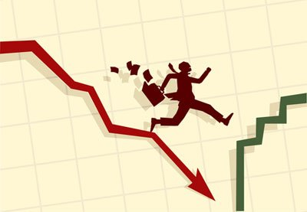

Table of contents
- Introduction……………………………………………………………………………… 3
- Data Protection…………………………………………………………………………… 3
- Food hygiene………………………………………………………………………………3
- Risk management………………………………………………………………………… 4
- Health and safety……………………………………………………………………….4,5
- Licensing………………………………………………………………………………………5
- The hotel proprietors act 1956……………………………………………………….5
- Conclusion……………………………………………………………………………………… 5
- References……………………………………………………………………………………...6


Introduction
Through this assignment legislative risks such as risk management, health and safety, licensing, food hygiene, hotel proprietors act 1956, liability and data protection. The mentioned aspects are key elements when working in a hospitality and tourism environment because they are keeping most of the bad things away from happening. If unwanted things are happening because risks are not well prevented then the only ones that have to suffer and support all the court are the ones in charge of the hotel and this because it is normal to have everything under control before allowing people to use services.
Hotels in the last years started to be the ones that are supporting economy in the most effective way regarding to the profit they make with their products, rooms, services and facilities after all the investments they made to turn the hotels and inns to what they are now. Therefore, such aspects need to be prevented all the time and well-trained people must be in charge of the risk management because otherwise the hotel will be constantly going down from all the aspects including economy because the members of staff will continuously have to pay for people health condition that occurred during they stood in the hotel and also damaged equipment must be replaced as well.
Data protection
Is an aspect that plays such an important role in the hospitality and tourism industry and even if it is an important aspect for any other type of businesses, for H&T industry it is something that can never be left behind. Considering the Data Protection Act 1998, data protection is a marketing tool that is a key that maintains the relationship within its employers and customers (guests) as well. There are specific systems that are protecting important data such as customer’s personal information and also system that keeps data linked with the changes and prices made in the hotel. Another type of data they may be kept by the hotel’s systems is the one based on rules and regulations that must be followed when working and when staying in the hotel.
About data protection, there is not only written data that needs to be protected and this because there are CCTV operations working that must save and protect all the records made because there is no one to know how much one of those records could change situations by proving such actions.
In charge of the data protection in a hotel is the hotel owner which controls and use management agencies, but still, the owner is the one with the duty of compliance with the data protection act.
Food hygiene
Food hygiene has a massive importance in the hospitality and tourism environment because of so many factors. As mentioned by Griffith, 2006), food hygiene comprises anything in the process of preparation or process of handling of food to ensure it is safe to deliver and eat. Food technology became a factor that brings market opportunities and food safety perils. This is why food safety is the one that plays a massive role in the hospitality environments, processing food industry, government institutes and health services companies.
During the food preparation, hygiene is vital, and this is why such rules and procedures must be followed to make sure that food is prepared and delivered in a safe way. Critical conditions may occur to people if health and safety preventions are not taken well into consideration and if bad things are happening, again, the hotel owner is the one to suffer the most because he is the one to investigate and pay for people’s injuries. Involved into discussion, very important is the food transport as well, because there may be some cases when members of staff are not completely in charge of the injuries that occurred and sometimes, the storage and transportation of the food before getting through the hotel’s members of staff hands, could have been done in a way that is not respecting and food contamination may appear as well as bacteria.
Risk management
Risks always needs to be carefully managed by well-trained people because otherwise there will take place so many problems which normally should be protected. Companies tend to adopt three stages method to risk management (Bringham and Gapenski 2000) and this because it is easier for them to observe what needs to be under control and what is causing bad situations, how they could
be prevented, everything. The three-stage method looks just as the following:
- Identification- The observing of sources and activating factors/ taking consequences into consideration
- Assessment- Classifying of factors / Purpose of tolerable limits/ Categorization
- Control- Pick up the implementation of control methods
All the risks must be taken into consideration and when working in the hospitality and tourism industry aspects such as slips, trips and falls, lifting and manual handling, the touch of hot surfaces/ hazardous elements, cuts, upper limb disorders.

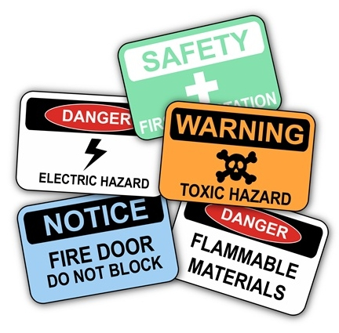

Anyway, if the training of the people in charge is a training that helps in effective working then all the things will be kept away from risks.
Health and safety
People working in a hospitality and tourism industry must be aware of all the health and safety rules and procedures they may follow and this is why, the experienced ones are obligated to provide information about health and safety and how to work together to provide health and safety in a efficient way in order to prevent and keep away guests from risks and unwanted situation during their experience in our company. Considering the Health and Safety at work ACT 1974, employers will not be always supervised and therefore it is the employer’s responsibility to conduct undertaking activities in specific ways to make sure that there is a relatively practicable action because there should be no people affected by risks to their health or safety.
Anyway, the health and safety authority in the hospitality industry is very important and it needs to be very well organised because otherwise such injuries will occur and it would be less comfortable for guests in the first place and then for the company which is responsible to take care of people’s cases. To reduce risks and injuries the people in charge of health and safety stuff promotes the following techniques:
¬Use a safe and healthy working environment ¬ Share information and suggestions ¬Use inspections and investigations ¬They check legislative proposals
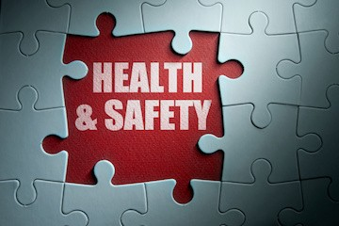
Licensing
When working in a hospitality and tourism industry, legislative requirements must be taken into consideration and therefore there is the Liquor control and licensing act, which has in its hand the way the alcohol can be made, transported, purchased and then consuming. The license comes with specific standards as well and the hotel’s members are in charge of respecting them fully. Also, the people in charge of the hotel when they are looking at the licenses, they must consider the idea of them changing all the time.
Licenses are helping the hotel itself as a business to be fully protected and safe. Next to the hotel as a bussines, the guests and the employers are protected as well because they are not selling or buying products that are not licensed in the specific hotel. For example, when selling alcohol, the Licensing Act 2003 must be considered because it is very important, and it says that the purpose of supplying alcohol is the supply of alcohol by a club of for another member of the club.
The hotel proprietors act 1956
Is an act that is very much linked with the liability in a hotel industry, but the only difference is that the act is based on the loos and damages of the guests good while the liability itself is based on everyone taking their responsibilities into consideration to hesitate probable arguments between people in the hotel.
As mentioned in the hotel’s proprietors act, “the administrator of and hotel must be under the like liability, if any, to make virtuous to any guests of his any injury to land brought in the hotel.” (Hotel Proprietors Act 1956). This is why, before opening any sort of hospitality and tourism building, owners must be aware of all the rules and the regulations they have to follow in order to respect the law and to offer a safety and protected business.
Conclusion
Knowing that the aim or the report was to analyse specific aspects of the legislative risks, there is a confidence in saying that all the included things in this report are very important in the hospitality industry and they are all playing a vital role in the development of the hotel. Also, aspects such as health and safety and food hygiene are the ones that are attracting customers as well in order to develop the economy and the reputation of the hotel. Therefore, it is very important to minimise risks and overcome with different solution because otherwise people will feel unprotected while staying in the hotel and bad feedback could appear.
Next to the customer opinions, there is the law which is constantly checking different bussines in order to discover if they are using all the regulations and procedures when offering services and facilities.

Reference page

Bringham E. F., Gapenski L. C. (2000), Zarzqdzanie finansami, PWE, Warszawa
Griffith, C. J. (2006). Food safety where from and where to. British Food Journal, 108, (1), pp. 6-15.
Health and Safety at Work etc. Act 1974, c.37
https://www.cms-lawnow.com/ealerts/2006/07/personal-data-and-the-hotel-industry?cc_lang=en
http://www.legislation.gov.uk/ukpga/1998/29/contents
http://www.legislation.gov.uk/ukpga/2003/17/section/14



