Peredur Llyr Owen Williams
1702804
Games Design and Critical Analysis
(M6X02045)
Lecturer
Jessica LaCombe
Richard Morgan

Contents
Different Playtesting methods 2
Aims 3
Results 4
Conclusion 8

Different Playtesting methods
I found that there are quite a few different ways of playtesting games some are better than others, but it depends on what type of results you want to get from the playtesting.
First method of playtesting is One to One Playtesting, this is when one of the members of the team would sit with the individual that is testing the game and help them if they are stuck and ask questions about the feel, look, controls etc. this is a good way of testing as you can see their reaction when playing the game and also you can take notes if you see the individual struggling with a particular mechanic or level. One of the negatives for this type of playtesting is that the individual that is testing the game might not want to be completely honest about how they feel about certain aspects of the game as they might not want to offend you even though we want to know what is bad about the game.
Another way of testing the game would be group testing but this would be quite pointless for us as only one person can use the Oculus so group testing wouldn’t really work. Group testing can be good as it is a lot quicker than doing a one to one test as you are getting multiple testers to test your game at the same time, the only negative to doing it this way is that you might have a few of the testers giving you feedback about the game and some of the others might just agree with them or say nothing.
Using feedback forms like a questionnaire is another way of playtesting, this is a good way of playtesting as the individuals that fill in the forms don’t have to put their name on the forms so they can be as honest as they want to, after collecting the result you can put them in a pie chart to see what features players preferred in the game.
Another way of getting feedback is by giving an interview to each game tester, this would involve sitting one to one with an individual that tested the game and ask them questions that you have prepared for the game. This can be a good way of getting answers to questions that you have about certain aspects of the game, but it can be quite formal and might make the individual uncomfortable which is why a questionnaire is probably a better approach.
Another way of getting results for play testing would be to do a group discussion where the play testers would discuss with each other what they liked and disliked about the game, this can be a good way to get different views about certain parts of the game at the same time.

As we are using one to one testing and feedback forms for the playtesting of the game, I think that I will use the feedback form method of playtesting as most of my work is visual and cant really be interacted with so I think by making some sort of questionnaire alongside the presentation I have done of my work for the game would be the best way to achieve my aims.

Aims

For this analysis document I aim to research different ways of playtesting and finding out which one is best to achieve my aims. I will only use 1 playtesting method to achieve my aims as most of the aims I have on the list are similar in what feedback I would like to get from them.

Aim1
Weapons
I will create a questionnaire to get some feedback for the weapons I have created for the game, by creating a questionnaire I aim to get some input on how the weapons feel in the players hand so that I know if I need to change any of the grips for any of the weapons. I also want to get some feedback on what the player thinks of the look of each weapon without textures so I can find out if I need to soften any of the edges on the models or redo the whole model.

Aim 2
Environment
My second aim is to get some feedback on how the environment assets look so that I can find out if players think the assets are too simple or don’t suit the theme of the game or the rest of the environment. In order to achieve this goal I have rendered some of the environment assets and put them on a power point presentation, some of the assets have textures as well so that you can see the comparison between the un-textured model and the textured model. The environment assets are really low poly so I want to find out if the assets look good enough with the low poly and textures so that I know if I need to change any of the assets or bump up the poly count a little.

Aim 3
Textures
For my third aim I would like to get some feedback so that we can decide on a final style for the textures. In order to achieve this goal, I have made some test textures for some of the assets and rendered the scenes and put them in a PowerPoint presentation.
Some of the weapons I have made are low poly and some have double the poly count but still fairly low poly, I have done some higher poly than others so I can find out if the low poly models look as good as the higher poly weapons when I add textures to them. By doing this I aim to show that textures really help finalize the models and that low poly models can still look as good as higher poly models.

Results
For the questionnaire I made I split the questions in to three different sections to represent each of my aims. The first section was about the weapons and how the weapons look and feel in the game and how they look in the slideshow I made. By creating this part of the questionnaire, I aimed to find out what type of style the weapons would suit best and if there were any changes I needed to make in the process.
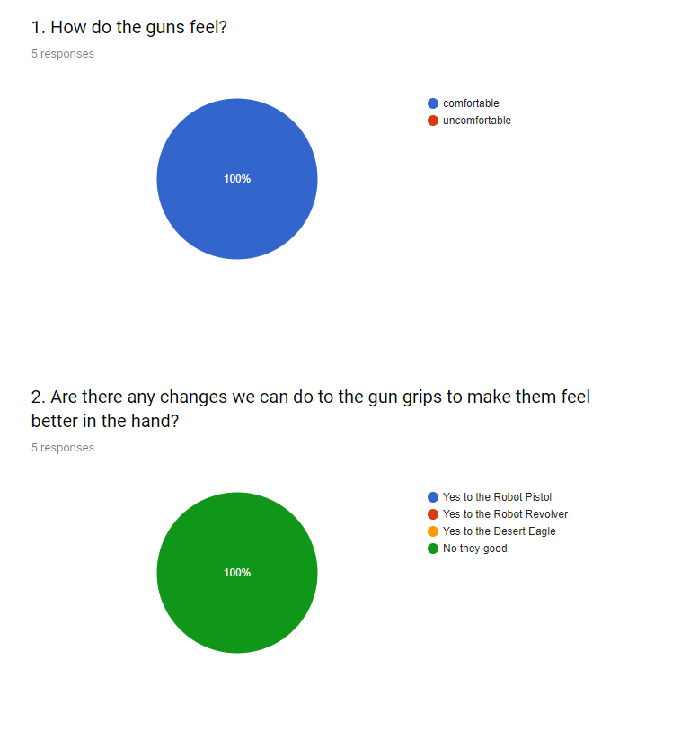

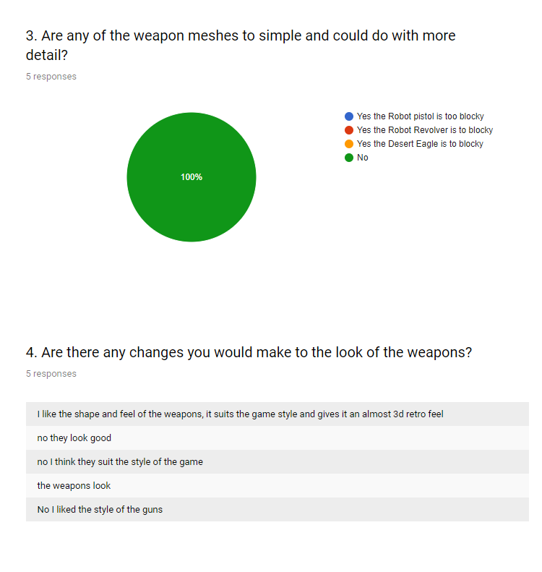

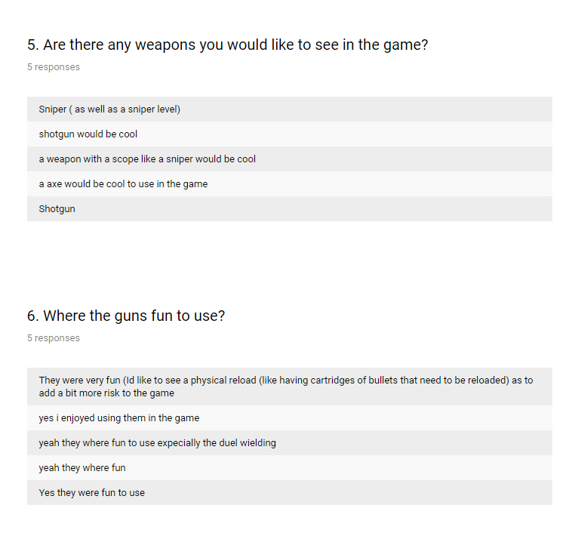

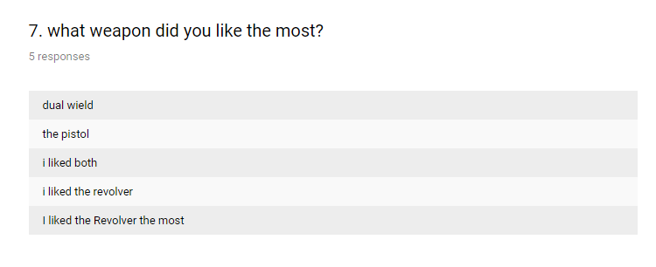

The second half of the questionnaire focused on the environment assets that I had made for the game, from the questionnaire I was hoping to find out if the environment assets looked to simple for the game as I think some of them do but I don’t really want to increase the poly count to high. I also wanted to find out if I could use textures to add some detail to the low poly assets, so I don’t have to increase the poly count for each asset.
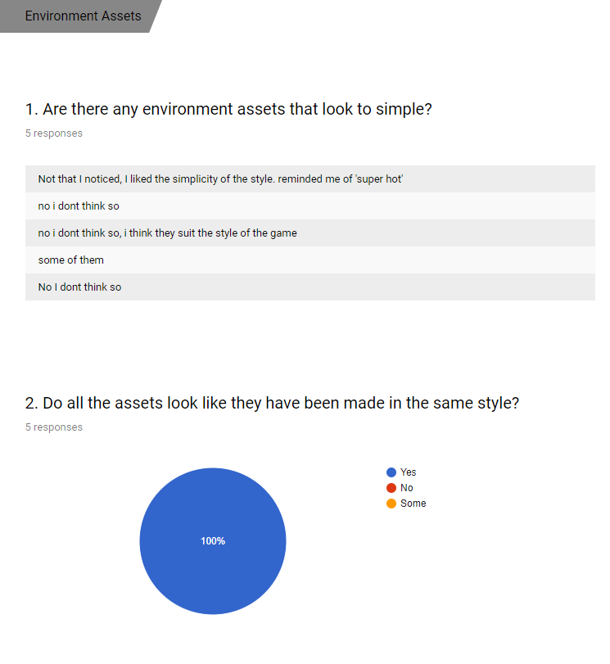

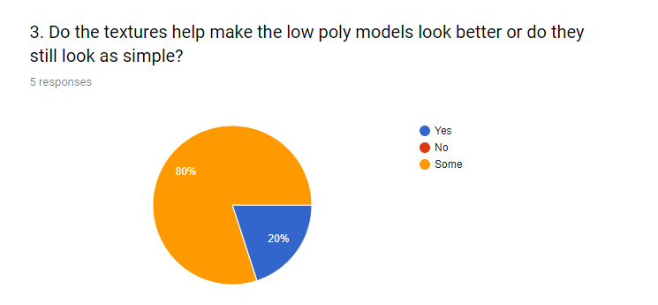

The final section in the questionnaire was about the textures I had used for some of the assets, I wanted to find out what style was preferred for example if game testers preferred the modern or futuristic textures for the weapons

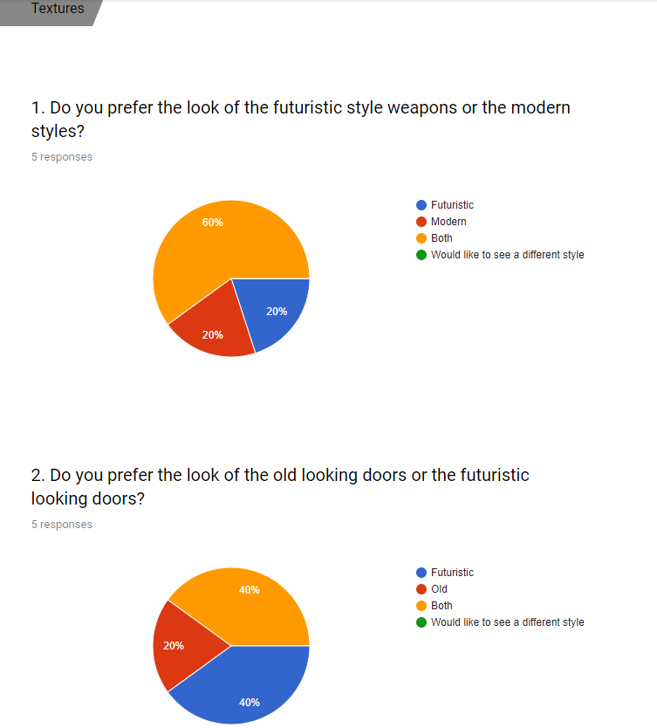

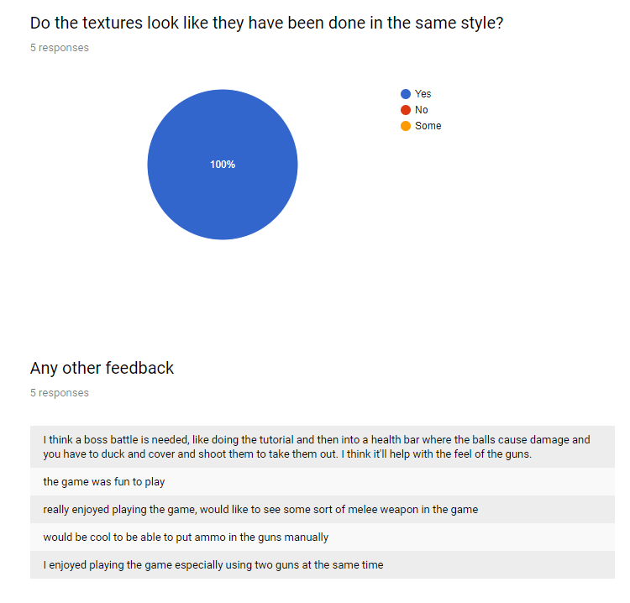

Conclusion

Weapons
From the results of my questionnaire I think that most of the game testers that tested the game where happy with how the guns functioned and looked, some people asked for some other weapons for the game like the shotgun but we already have that for the game but we didn’t have a sniper for the game which is a weapon we were considering to add to the game but didn’t make one in till now as a long ranged weapon is a good idea to have in the game.
The only problem I had with the questionnaire is that I made it so that the individuals filing in the questionnaire had to have played the game in order to answer some of the questions so I didn’t get as many results as I would have liked, if I was to do it again I would just focus on the visual side of the game.
Environment assets
A lot of the environment assets for the game I thought where to simplistic but game testers seemed to like the simplicity of them so I think I might just soften some of the edges on some of the assets and then just add textures to them. From the results I can see that some of the textures helped make the models less simplistic, but I think the ones that it didn’t help is the ones that need to be softened and tweaked a little bit.
Textures
For the textures a lot of the game testers liked both styles of textures with a few preferring the futuristic looking textures. From the feedback I got of the textures I think I will mainly focus on making futuristic looking weapons and environment assets as they suit the theme and feel of the game that we are trying to make.

Reference list
Book
Game Design Workshop: Designing, Prototyping, & Playtesting Games (Gama Network Series)

