
Programme Name: Master of Business Administration (MBA)
Module Name and Code: Human Capital Management (LCMB7023)
Title of Submission: Designing a Human Capital Architecture for Strategic Renewal: The Case of Helios Urban Mobility (HUM)
Lecturer's Name: Vasilios Tavlaridis, Gladius Kulothungan, Eno Maycock, Hoang Nguyen
Student Name : Ritika Rastogi
Student ID : 2536680
Word Count: 2587
Submission Date: 17-07-2026

Table of Contents
Introduction 2
1.0 TASK A: Socialisation, Identity and Business Activism 2
1.1 Critical Evaluation: Traditional Onboarding vs. Strategic Socialisation 2
1.2 The 360-Day Strategic Socialisation Architecture for Helios 3
1.3 Cultivating Identification, Ethical Professionalism and the “Business Activist” Mindset 5
2.0 TASK B: Job Design Strategy and Intrinsic Motivation Engine 7
2.1 The Integrated Job Design Framework 7
2.2 Stimulating Intrinsic Motivation and Disruptive Urban Mobility Innovation 10
3.0 Task C: Reflective report 14
3.1 Introduction 14
3.2 Discussion by applying Gibbs Reflective model 14
3.3 Conclusion 16
References 17

Introduction
The report is focused to analyse the human resource management issues faced by Helios Urban Mobility (HUM), specifically its 54% workforce engagement deficit and high graduate erosion across London, Singapore and Berlin. This becomes crucial to mention that without proper strategic management of human resources, it can be tough for an organisation to redesign their internal operational process. Task A is focused to evaluate the transition from traditional unloading to 360-day strategic socialisation model, whereas Task B is developing a detail on integrated job design along with the job characteristics model, Job Crafting and Skills-Based Organisation (SBO) frameworks. Lastly, the Task C is a reflection based on using AI as a strategic tool for optimizing workforce.

1.0 TASK A: Socialisation, Identity and Business Activism

1.1 Critical Evaluation: Traditional Onboarding vs. Strategic Socialisation
The Theoretical foundation
It has been analysed that the traditional onboarding at Helios Urban Mobility (HUM) primarily operates as a compliance-driven orientation and transactional mechanism. This functional reality is separated directly into the module limits in the form of a root cause for the failure of workforce involvement to approximately 54% as well as mounting graduate erosion (Groysberg et al., 2011). By contrast, the strategic organizational socialization represents the multifaceted procedure via which people obtain the anticipated behaviours along with particular social values and knowledge required to assume their organizational roles efficiently. As per Rousseau’s Psychological Contract Theory (1995), Helios’s present approach activates a serious breach at the time of meeting stage. Furthermore, high-potential graduate step into an interpersonal psychological agreement developed on anticipations of quick personal growth and environmental drive. Nevertheless, they are being met with a localized and fragmented throughout London, Singapore and Berlin (Yusuf, 2020). This inconsistency infringes the initial expectations by converting their involvement into driving intentional turnover and morally transactional link.
Application of Van Maanen and Schein’s taxonomy
In order to eradicate the present 8-month ramp-up as well as uniformize engineering abilities throughout all international hubs, Helios should pivot from familiar and individual tactics methodically towards the Institutionalised Socialisation Strategies (Mukhalipi, 2018). Thus, by institutionalising the above presented pathways, Helios serve a well-organized cognitive presenter (Flagstad and Johnsen, 2022). This communal experience power social identity in order to restructure an outsider’s personal identity methodically within an organizational identity emphasized upon green-tech and sustainable modernisation.
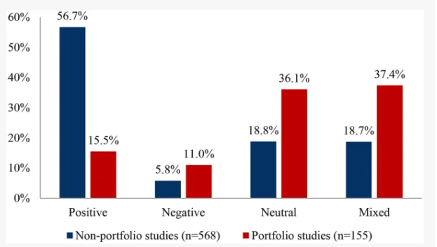
Figure 1: Effect of Sustainable studies on new entrants
(Source: CIPD, 2026)

1.2 The 360-Day Strategic Socialisation Architecture for Helios
The 360-Day Strategic Socialisation Architecture for Helios facilitates an inclusive, long-year framework for developing a combined corporate culture and deep organisational consistency (Conti et al., 2025). In order to convert isolated independent contributors, it highlights a well-organized 4-phase journey into highly communicative, collaborative and aligned teams. In order to compare the 8-month ability ramp-up time recognized within the case file, the below mentioned organized architecture familiarizes a phased timeline, which is directly planned against Bauer’s (2010) Four C’s (Compliance, Clarification, Culture, Connection) (Conti et al., 2025).
Phase 1: Pre-boarding (The anticipatory stage, Days: 30-0)
Emphasis: Psychological connection, foundational development of relationship and individual alignment.
Action: Introducing access to the Helios Internal Talent Marketplace (ITM) portal. Launching novel hires to their group peers throughout Singapore, Berlin and London through digital introductions (Dempsey, 2026).
Tactical justification: Lowers preventive anxiety prior to day 1 and developing early interpersonal psychological agreements.
Phase 2: The initial 90 days (The assimilation and encounter stage) Days 1-30 (Clarification and compliance)
Emphasis: Converting towards small-group collaboration from individual learning.
Action: Accomplish deep-drive and standardized technical modules which covers local municipal safety compliance regulations and self-directed municipal transportation architectures (Toker and Tekarslan, 2024).
Metric: Attain 100% legal and technical evaluation pas rates within the initial 30 days.
Days 31-60 (Connection and culture)
Emphasis- Long-term cultural evangelism, leadership growth and community sustainability.
Action: Organise cross-hub engineering races. The group graduates within London with peers into Singapore and Berlin towards co-author micro-features for the green-mobility network (Cieslak and Valor, 2025).
Support: Entrench a Serial Mentorship program which couples every novel hire with a senior systems engineer who take action in the form of a professional role model.
Phase 3: First year (The Metamorphosis stage, Days 91-360)
Emphasis: Long-lasting maintenance, role mastery, developing an organization-wide support system and dividing down inter-departmental silos.
Action: Introducing formal Job Crafting protocols and conducting quarterly milestone analysis. This enables the developers to bring into line their emerging engineering competencies openly with the dynamic green-tech infrastructure initiatives (Galais et al., 2025).
Strategic outcome: This organized path focuses towards a solidity of the 8-momth ramp-up time down to 4 months, by overcoming the abrasion metrics outlined into the module brief.

1.3 Cultivating Identification, Ethical Professionalism and the “Business Activist” Mindset
Organisational Identification (OID)
In order to converse the attrition of employee involvement from 54% back to leading tech norms, Helios should reinforce the OID. This is being completed by associating data analytics tasks and routine software debugging straight to the wider environmental mission of the organization (Garcia et al., 2025). Moreover, novel hire must take part into monthly “Green Impact Reviews”, where the real-world carbon counterbalance metrics through Singapore, Berlin and London are directly converted into the productivity data of team engineering.
Ethical Professionalism and AI Guardrails
Based on the dependence of Helios’s cutting-edge municipal agility framework, the socialization framework should entrench structural feedback loops about data privacy and AI ethics (Galais et al., 2025). With this, the novel hires need appropriate training on municipal safety compliance standards in order to direct the ethical pressures among public safety regulations and destructive algorithmic optimization.
The “Business Activist” Mindset
Helios is required to nurture what Dave Ulrich describes as the modern growth of the tactical partner: the Business Activist. It states that developing a system which converts novel entrants into committed organizational citizens by utilizing a business activist mindset indicates treating staffs in the form of authorised co-creators instead of inactive customers of business policies (Garcia et al., 2025). This requires pairing senior leaders with the novel entrants for the initial 30 days. The focus must be upon shifting away from compliance-heavy boot camps. Rather, utilize interactive simulations where the novel hires resolve live and hypothetical business challenges which are faced by the organization (Purucker, 2026). It has been evaluated that graduates could not execute simply in the form of a separated technical specialist. Therefore, the socialization curriculum should provide appropriate training to the engineers in order to apply the principles of Stakeholder Capitalism (Cieslak and Valor, 2025). This in turn makes sure that each of the fleet expansion or software release algorithm balances financial profitability with civic performance as well as clear environmental metrics.

2.0 TASK B: Job Design Strategy and Intrinsic Motivation Engine

2.1 The Integrated Job Design Framework
In order to address the acute 54% workforce involvement shortage and mitigate high graduate erosion throughout Singapore, Berlin and London, it becomes important for Helios Urban Mobility (HUM) to abandon rigid legacy job description (Gilmore and Williams, 2013). Along with this, the organization is required to convert into an incorporated framework which synthesizes a dynamic skills-based architecture, Job crafting theory and Hackman and Oldham’s Job characteristics model (JCM).
Overhaul of Hackman & Oldham’s Job Characteristics Model (JCM)
Currently, the analyst and engineering roles at Helios experience mechanical immobility leading into an extended 8-month ability ramp-up timeline (Jones and Saundry, 2011). Moreover, by applying the JCM needs methodical re-engineering the five major job dimensions in order to change the psychological conditions of the staffs and also drive positive work upshots.
Skill variety: Instead of separating the graduate engineers into localized data collection cycles or repetitive debugging, the roles are being re-organized to a wider combination of intellectual talents (Taylor, 2014). In addition, the engineers alternate among involving into multi-hub carbon offset modelling, conducting localized municipal regulatory assessments and writing algorithmic routing code.
Task identity: Helios will eradicate uneven micro-tasks. Staffs will own a whole and recognisable piece of work through the architectural outset towards ultimate disposition. For instance, a graduate analysts will convert towards owning the end-to-end telemetry dashboard for a particular fleet development within Berlin from merely preparing ad-hic data tables.
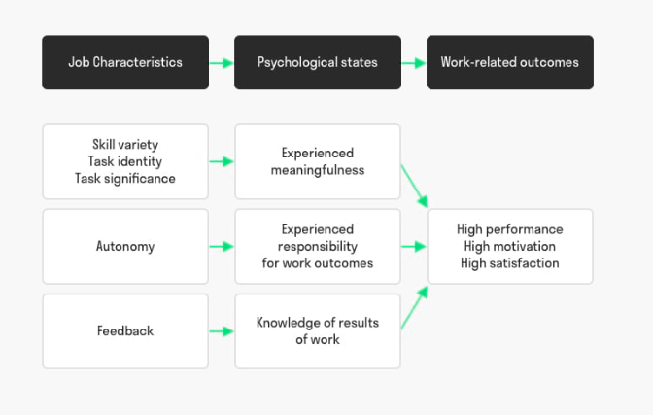
Figure 2: Job Characteristics Model
(Source: Class materials)
Task significance: In order to develop a clear connection to the wider purpose of the organization, engineering tasks will be charted clearly towards the real-world green urban transformation objectives (Collings et al., 2014). With this, code optimization is no longer considered to be just an internal software requirement, rather it is being mounted along with the assessable minimizations into carbon emissions into compact urban centers.
Autonomy: Helios will convert away from compliance-heavy and micro-managed oversight structures. The organization will sanction engineers clear self-sufficiency in order to choose their own problem-solving approaches, system outline and own technical methodologies.
Feedback from the job: Real-world system and automated telemetry performance loops will be directly incorporated within the developer setting (Wolniak and Turoń, 2025). This makes sure that the engineers acquire objective and clear data on the practical impact of their work without the need to wait for delayed administrative cycles.
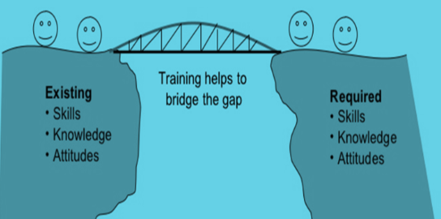
Figure 3: Training and Development
(Source: Class materials)
Job Crafting theory
While the JCM sets a prescribed top-down structure, Helios should also allow bottom-up adjustments by enabling greater-potential graduates in order to restructure their roles actively (Pavlović and Slavković, 2024). Thus, this agentic customization is highly compelled by three different forms of job crafting.
Internal Talent Marketplaces (ITM) and skills-based architecture
For converting towards a fluid, dynamic workforce from rigid job titles, Helios will adopt an inclusive Skills-Based Architecture (SBO). According to research, skills-based organizations possess 63% more chances to attain target business outputs. While, 98% possess more chances to retain greater-performing talent in comparison to the traditional role-bound organizations (Aljumah, 2023). Static and legacy job descriptions will be de-structured into a granular and living taxonomy of verified technical abilities (for example, municipal compliance auditing, real-time data orchestration, predictive telemetry modelling) along with human-centric skills (for example, planned cross-cultural collaboration).
This taxonomy will influence an AI-driven Internal Talent Marketplace (ITM) (for example, platforms same as Fuel50 or Gloat). Here, the ITM counterpart’s accessible talents with the mentorship roles, short-term assignments and cross-functional project requirements throughout the globe on the basis of verified skills, instead of environmental location or corporate hierarchy. For instance, at the time when a smart-infrastructure initiative is being launched into Singapore, the platform could recognize an engineer located into London mechanically, who comprises of the essential analytical modelling skills (Liu et al., 2023). This in turn facilitates the engineer a greater-perceptibility stretch assignment without the need for a permanent physical transfer.
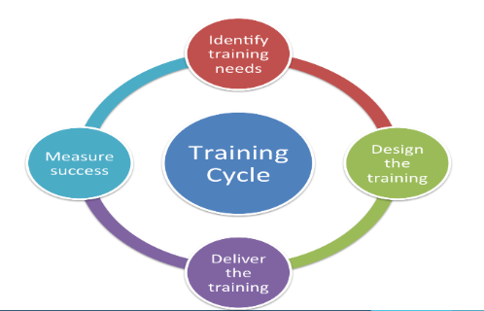
Figure 4: Training cycle
(Source: Class Materials)

2.2 Stimulating Intrinsic Motivation and Disruptive Urban Mobility Innovation
By connecting the major job characteristics highlighted directly into the JCM to the three significant psychological conditions determined by Hackman and Oldham (1976) (Dishon-Berkovits et al., 2024). Thus, Helios generates a consistent device for developing constant intrinsic motivation.
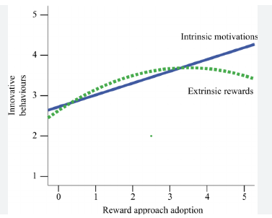
Figure 5: Relation between intrinsic and extrinsic motivation
(Source: Kluge et al., 2025)
Experienced relevance of the work: Mixing clear task significance with robust task identity and high skill variety makes sure that the staffs consider their regular contributions as focussed and treasured. When a graduate developer controls the whole software feature and determines its real-world carbon minimization metrics, then the work shifts beyond the routine agreement (Kluge et al., 2025). This movement mitigates the actual causes of the decline in involvement from 54% by facilitating internal and clear motivation drivers.
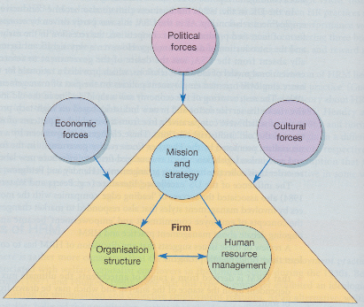
Figure 6: Matching model of HRM
(Source: Class Materials)
Experienced accountability for work outputs: Autonomy serves staffs with a clear intellect of personal responsibility for their deliverables. At the time when the engineers possess the liberty to develop solutions without micro-management, thy build a proprietorship mindset (Dishon-Berkovits et al., 2024). This intellect of accountability motivates innovative problem-solving and nurtures revolution creativity needed to lead the competitive green agility market.
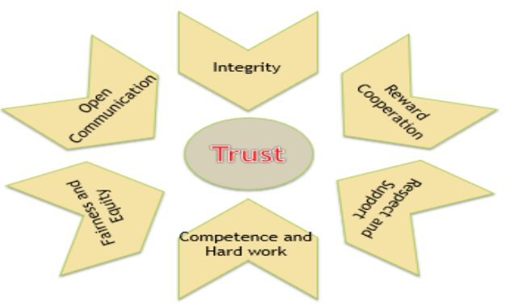
Figure 7: Building trust among the team members
(Source: Dishon-Berkovits et al., 2024)
Knowledge of exact outcomes: Incorporating real-time and automated feedback loops provides staffs with clear visibility into their work performance. This instant analysis assists them in reducing the requirement for continuous intervention and role ambiguity (Dishon-Berkovits et al., 2024). It also wraps and reduces the 8-month capability ramp-up timeline to approximately 4 months.
Strategic impact on innovation
Moving the culture towards intrinsic motivation from controlled compliance changes the ways in which the workforce addresses multifaceted challenges. Therefore, by combining independent self-sufficiency with the mobility of an internal talent marketplace, Helios could undo traditional functional silos. With this, the high-potential graduates are being empowered to apply their exceptional skills in order to address the cross-border as well as emergent technical challenges (Liu et al., 2023). This internal agility makes sure that Helios could deploy cross-functional teams rapidly for capitalizing on the disruptive green-tech growth by driving tactical revitalisation throughout its international hubs. Thus, implementing shared and clean mobility could significantly minimize urban emissions.

3.0 Task C: Reflective report

3.1 Introduction
The reflection is developed based on my understanding as a six-stage framework which allows in critically evaluating the actions, examine mental well-being and plan for upcoming personal and professional growth.

3.2 Discussion by applying Gibbs Reflective model
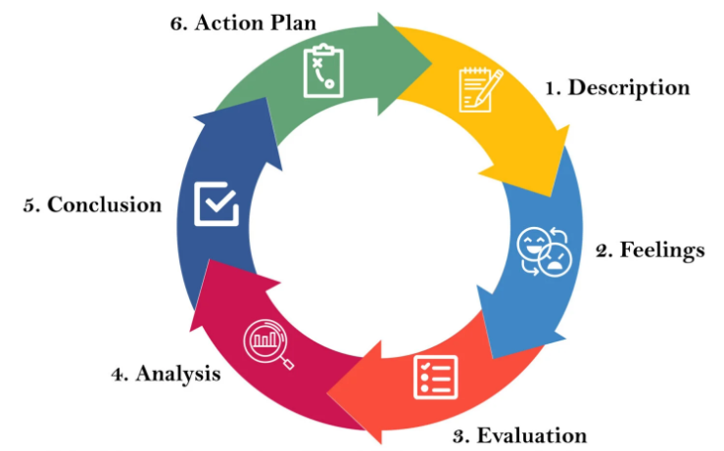
Figure 8: Gibbs Reflective Model
(Source: Tanjay et al., 2026)
Description: AI provides a powerful cognitive engine in order to surface hidden patterns and accelerate data analysis, but it must act strictly as a decision-support tool instead of an autonomous decision-maker (Tanjay et al., 2026). In the future, I will use AI to process multi-dimensional and massive datasets in order to outline correlations, trends and anomalies. It will help in managing the heavy lifting of data evaluation which enables humans to emphasize upon the tactical understanding of those outcomes.
Feelings: I feel that Rather than depending upon AI to choose the finest path, I will use to simulate numerous “what-if” scenarios. This will allow me to quantify risks throughout variables and stress-test my logic. AI could be planned to challenge human expectations dynamically. Moreover, by acting in the form of a devil’s supporter, the AI shells blind spots, historical models and substitute viewpoints which a human team might have missed.
Evaluation: I have evaluated the fact that being a decision-maker I demand clear and concise visibility into the ways in which AI model develops its recommendations. However, if the fundamental logic and data could not be demonstrated, than the output of the AI must be reduced highly (Cabitza et al., 2023).
Analysis: I will excel the conversion of raw people-analytics into tactical and actionable insights. The focus will be towards learning ways to fine-tune generative AI tools for HR procedures such as personalizing development plans, accelerating initial screening and drafting ole profiles (Jackson et al., 2022).
Conclusion: It is concluded that, I will be emphasized upon enrolling into stakeholder alignment and communication programs like as those offered by Harvard Business Publishing in order to learn ways to power C-suite decision-making. The focus will be upon combining the data insights with compelling narrative structures to create an impact on business leaders on tactical workforce planning (Mahajan et al., 2022).
Action plan: A personal capability development plan to enhance my future employability capabilities is presented below:
Phase 3: Cultural agility and global mobility (Months 1-4)
In the future, I will attend seminars or acquire certifications on international employment law, managing globally distributed, remote workforces and global compensation structuring. I will develop strong connections on LinkedIn actively with international HR leaders in order to remain updated on remote work mobility trends and immigration. I will also build strategies to support diversity, equity, and inclusion (DEI) initiatives throughput different regulatory and geographical settings.
Phase 4: ROI measurement and capstone execution (Months 5-8)
In the future, I will take ownership of a high-impact initiative into the current organization, like automating a manual HR workflow or AI-driven internal mobility program. The focus will be upon quantifying the outcomes of the initiatives like maximized internal mobility rates, measuring minimizations in time-to-hire or time saved (Stephen and Festus, 2022).

3.3 Conclusion
Thus, it can be concluded that I will treat AI-generated perceptions in the form of assumptions instead of gospel. Critical judgment needs constant cross-referencing AI outputs against real-world authentication and domain proficiency. With this, I will uphold up-to-date knowledge by pursuing internationally documented certifications.

References
Aljumah, A., 2023. The impact of extrinsic and intrinsic motivation on job satisfaction: The mediating role of transactional leadership. Cogent Business & Management, 10(3), p.2270813. https://www.tandfonline.com/doi/pdf/10.1080/23311975.2023.2270813
Cabitza, F., Campagner, A., Angius, R., Natali, C. and Reverberi, C., 2023, April. AI shall have no dominion: on how to measure technology dominance in AI-supported human decision-making. In Proceedings of the 2023 CHI conference on human factors in computing systems (pp. 1-20). https://dl.acm.org/doi/pdf/10.1145/3544548.3581095
Cieslak, V. and Valor, C., 2025. Moving beyond conventional resistance and resistors: an integrative review of employee resistance to digital transformation. Cogent Business & Management, 12(1), p.2442550. https://www.tandfonline.com/doi/pdf/10.1080/23311975.2024.2442550
CIPD. 2026. The Profession Map. https://www.cipd.org/en/the-people-profession/the-profession-map/
Collings, D., Wood, G., & Caligiuri, P. M. 2014. The Routledge companion to international human resource management.
Conti, S., Wang, Y. and Ravazzani, S., 2025. From Voice to Action? A Survey on Organizational and Individual Factors Impacting Employee Activism Intentions. International Journal of Business Communication, p.23294884251384721. https://pure.eur.nl/files/219427704/From_Voice_to_Action.pdf?__cf_chl_rt_tk=fYuKbVAj5WEafs7snK86ivZL6bCEhhIDF8Ha4RQeXVQ-1783045386-1.0.1.1-zvBide33TqDWf0NJj2ZYWprkZhHhBmHLwrUUNed5X8E
Dempsey, S., 2026. Mobilizing Potential: Pathways to Engaged Citizenship. Qualitative Sociology, 49(1), pp.137-159. https://link.springer.com/content/pdf/10.1007/s11133-025-09622-z.pdf
Dishon-Berkovits, M., Bakker, A.B. and Peters, P., 2024. Playful work design, engagement and performance: the moderating roles of boredom and conscientiousness. The International Journal of Human Resource Management, 35(2), pp.256-283. https://www.tandfonline.com/doi/pdf/10.1080/09585192.2023.2227920
Flagstad, I. and Johnsen, S.Å.K., 2022. The psychology of green entrepreneurship: Founder-driven development of green climate in small-scale companies. Cogent Business & Management, 9(1), p.2079245. https://www.tandfonline.com/doi/pdf/10.1080/23311975.2022.2079245
Galais, C., Mateos, A. and Anduiza, E., 2025. The socializing nature of protest events. Consequences of the 15-M protests on participants’ political engagement over time. Social Movement Studies, 24(6), pp.746-764. https://gredos.usal.es/bitstream/10366/166356/1/Socializing_nature_protestEvents_%2015-M.pdf
Garcia, A., Rebelo, D., Diógenes-Lima, J., Fernandes-Jesus, M. and Malafaia, C., 2025, January. Intersectionality in youth climate activism as educational practice: Political, pragmatic, and pedagogical dimensions. In Frontiers in Education (Vol. 9, p. 1491387). Frontiers Media SA. https://www.frontiersin.org/journals/education/articles/10.3389/feduc.2024.1491387/pdf
Gilmore and Williams. 2013. Human Resource Management (ch.9 and ch.13).
Groysberg, B, Nohria, N and Herman, K. 2011. Case Study: The Expat Dilemma. https://hbr.org/2011/09/case-study-the-expat-dilemma [Accesed: 03/07/2026]
Jackson, D., Shan, H. and Meek, S., 2022. Employer development of professional capabilities among early career workers and implications for the design of work-based learning. The International Journal of Management Education, 20(3), p.100692. https://ro.ecu.edu.au/cgi/viewcontent.cgi?article=2137&context=ecuworks2022-2026
Jones and Saundry. 2011. The practice of discipline: evaluating the relationship between managers and HR professionals, Human Resource Management Journal.
Kluge, M., Kachel, J. and Knodt, M., 2025. Digital co-creation in urban mobility planning: what motivates people to participate?. Local Government Studies, 51(1), pp.24-49. https://www.tandfonline.com/doi/pdf/10.1080/03003930.2024.2310213
Liu, W., Bakker, A.B., Tse, B.T. and Van der Linden, D., 2023. Does playful work design ‘lead to’more creativity? A diary study on the role of flow. European Journal of Work and Organizational Psychology, 32(1), pp.107-117. https://www.tandfonline.com/doi/pdf/10.1080/1359432X.2022.2104716
Mahajan, R., Gupta, P. and Misra, R., 2022. Employability skills framework: a tripartite approach. Education+ Training, 64(3), pp.360-379. https://www.researchgate.net/profile/Richa-Misra-2/publication/359065468_Happiness_at_work_through_spiritual_leadership_a_self-determination_perspective/links/633d7993ff870c55ce025d07/Happiness-at-work-through-spiritual-leadership-a-self-determination-perspective.pdf
Mukhalipi, A., 2018. Human capital management and future of work; job creation and unemployment: A literature review. OALib. https://www.academia.edu/download/66586333/ddd389cf4aa5384c87a109fba2d25a3bdc60.pdf
Pavlović, G. and Slavković, M., 2024. Does employer brand fuel job satisfaction? The role of intrinsic motivation. BizInfo Blace, 15(1), pp.11-18. https://www.bizinfo.edu.rs/index.php/bizinfo/article/download/348/267
Purucker, D., 2026. Reviving the mass organization for social movements? The meaning of membership in the Democratic Socialists of America. pre-print in Interface, 15(1), p.1. https://www.interfacejournal.net/wp-content/uploads/2024/11/Interface-15-1-Purucker-pre-print.pdf
Stephen, O.O. and Festus, O.O., 2022. Utilization of work-based learning program to develop employability skill of workforce (craftsmen) in construction industry towards industrial development. Indonesian Journal of Educational Research and Technology, 2(3), pp.179-188. https://ejournal.upi.edu/index.php/IJERT/article/download/43970/18252
Tanjay, T., Chauhan, J.K., Upadhayay, A.D., Chandegara, A.K., Chauhan, S., Kaur, K. and Kumar, V., 2026. Digital decision-support tools (AI) for sustainable and equitable policy making. Indian Res. J. Ext. Edu, 26(2), pp.151-163. https://www.researchgate.net/profile/Tripti-Tanjay/publication/405273094_Digital_Decision-Support_Tools_AI_for_Sustainable_and_Equitable_Policy_Making_Digital_Decision-Support_Tools/links/6a155e1bd5678132a88ce78d/Digital-Decision-Support-Tools-AI-for-Sustainable-and-Equitable-Policy-Making-Digital-Decision-Support-Tools.pdf
Taylor, S. 2014. Resourcing and Talent Management, CIPD.
Toker, K. and Tekarslan, E., 2024. Shaken Bases: Impact of Changing Paradigms on Organizational Commitment and Organizational Citizenship Behavior. Istanbul Management Journal, (97), pp.30-39. https://dergipark.org.tr/en/download/article-file/3886165
Wolniak, R. and Turoń, K., 2025. Between Smart Cities Infrastructure and Intention: Mapping the Relationship between Urban Barriers and Bike-Sharing Usage. Smart Cities, 8(4), p.124. https://www.mdpi.com/2624-6511/8/4/124
Yusuf, S. 2020. Building human capital lessons from country experience. https://documents1.worldbank.org/curated/en/960921595409441570/pdf/Building-Human-Capital-Lessons-from-Country-Experiences-Singapore.pdf [Accessed: 03/07/2026]

