

RESULT

HND/HNC ASSIGNMENT SPECIFICATION

Student name: |  | Student P number:
Programme: | HND/BSc Automotive Engineering  HND/BSc Motorsport Engineering  HND/BSc Motorcycle Engineering
Module: | Engineering Design | Module Level (4 or 5): | Level 4
Module code: | M1X8653 | Contribution to Overall  Module Assessment (%): | 50%
Lecturer: | Richard Morgan | Internal Verifier: | Andrew Thorn
Assignment Title: | The Production of 3D Solid Modelled Components and Assemblies | Assignment No (x of x): | 1 of 1
Hand Out Date: | 12/02/13 | Submission deadline: | 19/02/13
Referencing: | In the main body of your submission you must give credit to authors on whose research your work is based. Append to your submission a reference list that indicates the books, articles, etc. that you have read or quoted in order to complete this assignment (e.g. for books: surname of author and initials, year of publication, title of book, edition, publisher: place of publication).
Disclosure: | I declare that this assignment is all my own work and that I have acknowledged all materials used from the published or unpublished works of other people. All references have been duly cited.
Student’s Signature: | Assignments will not be accepted without a signature here | Date:
Turnitin: Lecturer to tick to indicate if an electronic version of the assignment must be submitted to Turnitin. Note: the Turnitin version is the primary submission and acts as a receipt for the student. Both electronic and paper versions MUST be submitted by the same deadline. No marks will be released until both submissions are received. Late submission of the electronic version will result in a late penalty grade. Penalties for late submission: Up to one week late, maximum mark of 40%. Over one week late, Refer. | YES
 | NO | x

Learning Outcomes tested  (from module syllabus) | Assessment Criteria To achieve each outcome a student must demonstrate the ability to:
Use computer technology in the design process. | - identify the key features of a computer-aided design system  - use computer-aided design software to prepare a design drawing  - demonstrate an understanding of the principles of computer-aided design.

- Please submit the assignment parts in a suitable report folder– not in polypockets.
- This form (ALL PAGES) MUST be at the front of the paper submission. Assignments will not be accepted without this form as it is a requirement that you sign the disclosure regarding referencing convention.
- DO NOT put this form into Turnitin or it will match many similarities with other students’ submissions.
Introduction
Computer Aided Design (CAD) is used extensively throughout many mechanical and manufacturing industries. Although two-dimensional CAD software is still appropriate for some applications, three dimensional solid modelling is becoming increasingly prevalent. In this assignment you will gain experience in using a Computer Aided Engineering Solid Modelling package in the production of three dimensional solid models of components and assemblies.

TASK DESCRIPTION

(Lecturer – please insert task(s) / questions / what the student must do, here)

Using the Siemens NX 8 Computer Aided Engineering software, you are required to construct an assembly of the following parts:

- Crankshaft
- Gudgeon Pin
- Connecting Rod (Con Rod)
- Piston

The Crankshaft, Gudgeon Pin and Piston geometry have already been modelled and should be downloaded from Moodle as separate part (.prt) files. You are required to position and constrain each of the components within the assembly in order that the inter-part assembly geometry is correct.

You are required to build the Connecting Rod geometry around the other parts, paying due regard to their position, dimensions and form. The distance between centres of the Connecting Rod ends should be 100mm. You are free to establish appropriate dimensions for the remaining undefined Connecting Rod geometry. It is therefore expected that each student will produce a unique model.

You are to begin and finish your modelling activity in a single, session lasting one hour and 50mins. However, you may practice and prepare for your assessment exercise beforehand. Completed models/assemblies will be collected and the end of the assignment session. Please note that the assessment Lab session will take place during your usual timetabled lecture period.

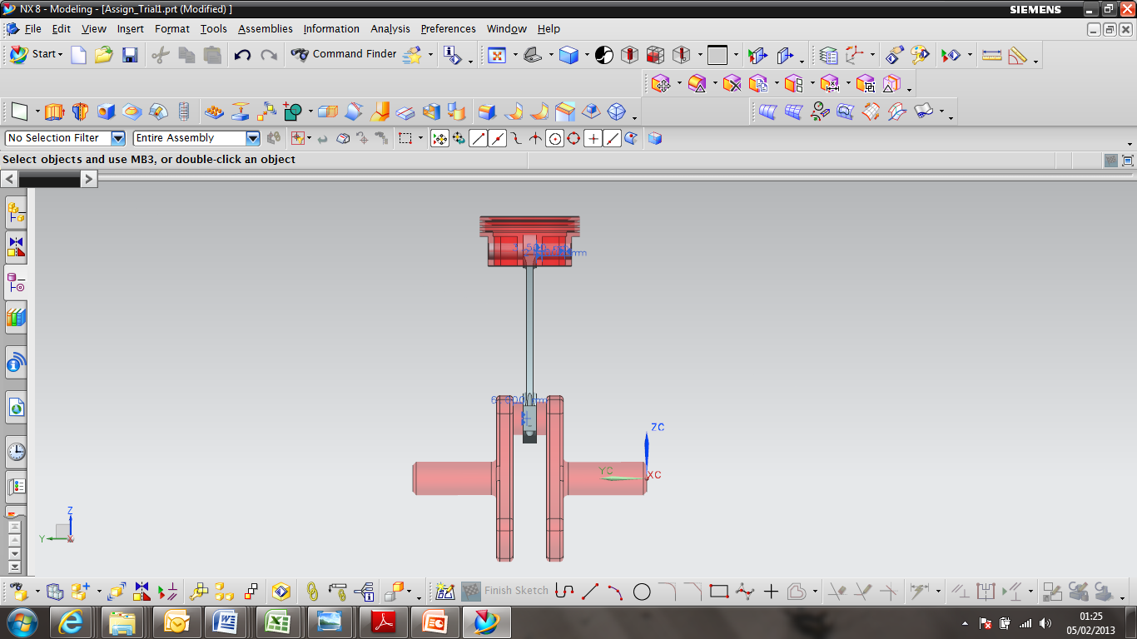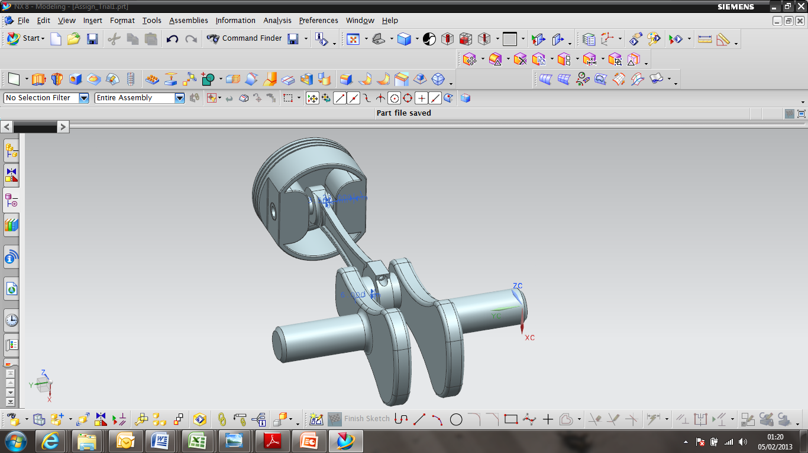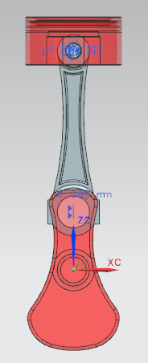

The Suggested Assembly Configuration

GUIDANCE FOR Students IN THE COMPLETION OF TASKS

You will be marked on your ability to:

- Create correct Part Geometry
- Use a range of appropriate tools when modelling
- Manage and organise the part structure
- Create a design that is driven by key, named parameters using ‘expressions’
- Create a suitable assembly structure

marking criteria and Student FEEDBACK

This section details the assessment criteria. The extent to which these are demonstrated by you determines your mark. The marks available for each criterion are shown. Lecturers will use the space provided to comment on the achievement of the task(s), including those areas in which you have performed well and areas that would benefit from development/improvement.

Common Assessment Criteria Applied | Marks available | Marks  awarded
1. Create correct Part Geometry | 20
2. Use a range of appropriate tools when modelling | 20
3. Manage and organise the part structure | 20
4. Create a design that is driven by key, named parameters using ‘expressions’  . | 20
5. Create a suitable assembly structure | 20

Assignment Mark (Assessment marks are subject to ratification at the Exam Board. These comments and marks are to give feedback on module work and are for guidance only until they are confirmed. ) | Late Submission Penalties (tick if appropriate) |  | %
 | Up to one-week late |  | %
 | Over one week late |  | %

Student Self Evaluation Form
Student name: |  | Student P number:
Programme: |  | Year of programme
Assignment Title:

This section repeats in brief the common assessment criteria detailed on previous pages. The extent to which these are demonstrated by you determines your mark. Using these criteria, tick the box that best indicates the level of achievement you feel you have achieved with regard to each of them.

Common Assessment Criteria Applied | Level of Achievement
Common Assessment Criteria Applied | REFER |  |  | 3rd |  | 2:2 |  | 2:1 | 1st | 1st
 | OUTRIGHT FAIL | UNSATISFACTORY | SATISFACTORY |  | GOOD |  | VERY GOOD |  | EXCELLENT | EXCEPTIONAL
1. Create correct Part Geometry | 0-29% | 30-39% | 40-49% |  | 50-59% |  | 60-69% |  | 70-79% | 80-100%
2. Use a range of appropriate tools when modelling | 0-29% | 30-39% | 40-49% |  | 50-59% |  | 60-69% |  | 70-79% | 80-100%
3. Manage and organise the part structure | 0-29% | 30-39% | 40-49% |  | 50-59% |  | 60-69% |  | 70-79% | 80-100%
4. Create a design that is driven by key, named parameters using ‘expressions’ | 0-29% | 30-39% | 40-49% |  | 50-59% |  | 60-69% |  | 70-79% | 80-100%
5. Create a suitable assembly structure | 0-29% | 30-39% | 40-49% |  | 50-59% |  | 60-69% |  | 70-79% | 80-100%

PLEASE COMMENT ON AREAS IN WHICH YOU FEEL THAT YOU HAVE PERFORMED WELL | PLEASE COMMENT ON AREAS you feel that you need TO DEVELOP

Student’s Name |  | Date
Student’s Signature

