Fundamentals of construction techology

Site Investigation Case Study
Module: ACBA4022
Student: Rhys Cosker-2513065
Lecturer: Alan Nantel
Assignment 2

Introduction 2
Site Photos 3
Preliminary Desktop Survey 4
The contents of a detailed site investigation 6
Ground conditions and made ground 7
Existing structures and obstructions 8
Groundwater influence 9
The risk significance 10
Investigation Methods 11
Borehole logs 11
Soil Sampling 14
Building regulations 15
Codes of Practice 16
Local Authority Contact Details 16
The most appropriate foundation choice 17
Bored Pile Foundation Design 18
Appendices 20
References 21

Introduction
This preliminary study will delve into a full site investigation for the construction of a proposed multi-use building, situated between County Hall and the Marriot Hotel. A desktop survey will be utilised for the historical background of the chosen site with references provided via photographs and plans. In addition, advice will be given on areas of the site investigation where there’s more risk given the historic data provided. Building regulations will be stated as well as any necessary involvement from the local authorities. Finally, the most appropriate type of foundation, given all the information and evidence, will be identified with justifications.
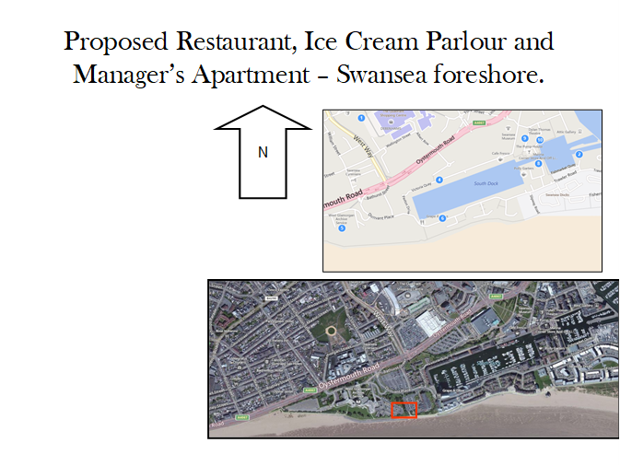Figure one
Figure one portrays the proposed site and the surrounding areas accessed via Google Maps, N.D
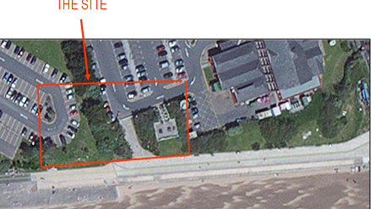Figure two
Figure two above dictates the location of the proposed site

Site Photos
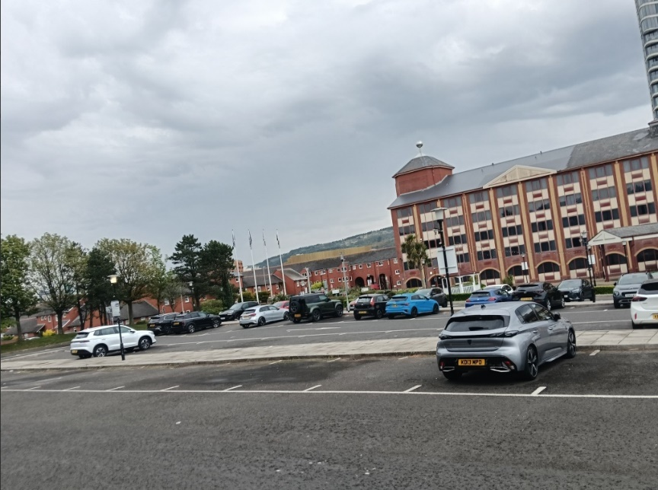
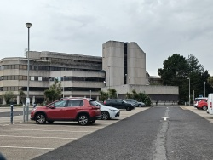
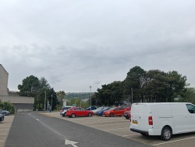
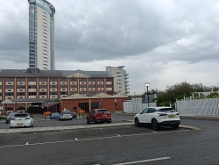
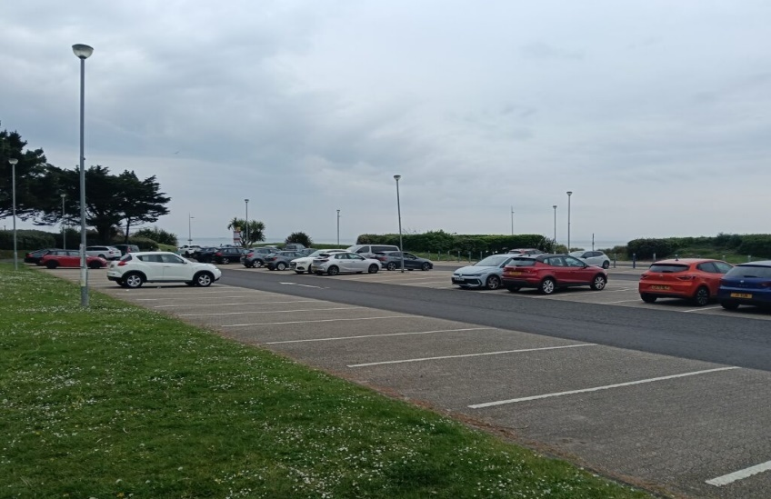
Figure three

Figure three showcases first-hand site photos of the proposed site and surrounding areas

Preliminary Desktop Survey
According to sources provided by the British Geological Survey, the type of strata located within the site is Made Ground, meaning it comprises of anthropogenic, man-made deposits.
This strata’s variability for either compaction or composition may result in uneven bearing capacity for foundations, including differential settlement Speedeck, 2024.
Previous borehole records for the Swansea County Hall indicate the strata consists of loose ashes, bricks and steel from previous industrial use on the site. In addition, beneath these artificial fill lays very dense cobbles, large gravel, sand and clay, which is typically found in coastline areas such as this one.
The historical background for Swansea is mostly industrial works, dominating in the production of copper, zinc and steel during the industrial revolution, which lead to the proposed site to become anthropogenic ground.
As seen in historical maps of the site during the 1870s, a hospital for contagious diseases was present. This could've led to chemicals leaching into the ground from improper disposal, causing environmental contamination. This must be investigated before construction begins as many chemicals such as sulphates can negatively impact concrete foundations, weakening the structural integrity Earth environmental & geotechnical,2026.
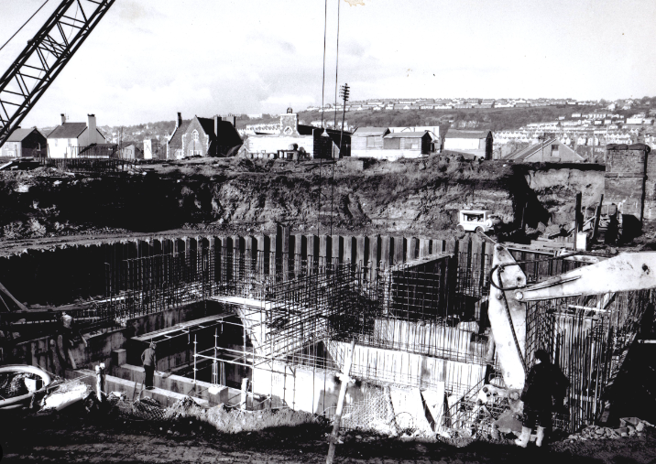Figure four
Figure four above depicts the County Hall excavation works during the 1980s

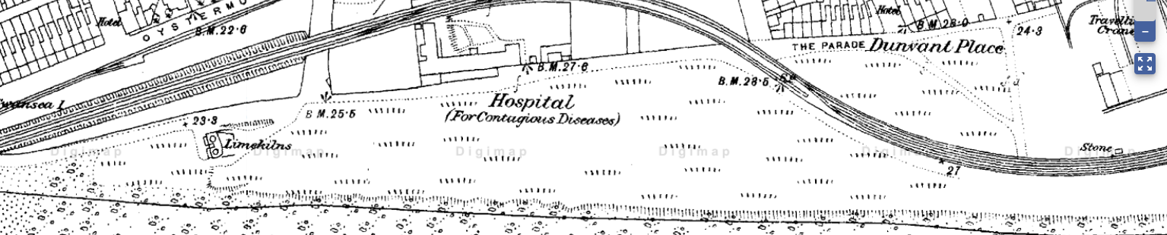Figure five
Figure five above shows a historic map of the proposed site in the 1870s ( Digimap, N.D)
During the periods of 1890s through to the 1950s the proposed site incorporated an engine shed, chemical works, tanks and railway lines. This has led to the soil containing previous materials such as steal, as indicated in the previous borehole report for the Civic Centre and surrounding area, weakening the strata.
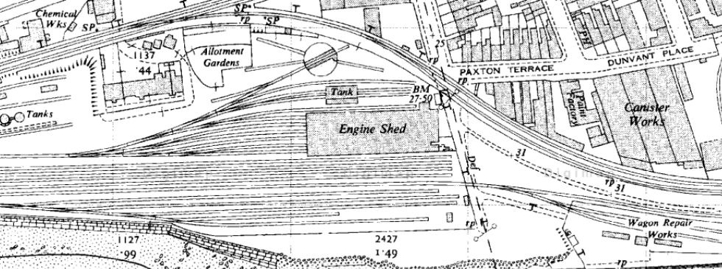Figure six
Figure six above shows a historic map of the proposed site during the 1950s before the engine shed is removed, (Digimap, N.D)

The contents of a detailed site investigation
The purpose of a site investigation is to determine the engineering properties and the type of strata within the soil, including the geology of the site. The main properties required are the strength of the ground, the hydrological characteristics and the deformation potential. Site investigations are incredibly important before any construction commences and the reports need to have a significant amount of information.
The site investigation is split up into 4 phases. Phase one covers the desk studies and the history of the site. Phase two involves intrusive investigation such as soil sampling through the use of boreholes, followed up by analysis of the geotechnical conditions. Phase 3 focuses on the design and how to combat the defects of the strata. Finally, phase 4 focuses on the validation and the monitoring of the construction.

Ground conditions and made ground
According to the BGS borehole report observed by figure two and that the location of the proposed site is next to coastline, this has resulted in the strata profile consisting of natural marine deposits including artificially placed made ground from previous industrial works on the site.
Investigation requirements include trial pits to identify near surface materials and deposits such as steel and concrete, cable percussion and rotary boreholes, the logging of made ground composition including the thickness, and finally the sampling and laboratory tests of these strata to ensure appropriate foundations. (See appendix A for more information on trial pits)
As referenced, the ground consists of granular fill, man-made materials, industrial by-products and organic materials. Furthermore, due to the history of industry works and the dockside history, the fill potentially may have been end-tipped instead of engineered, leading to no controlled placement, no quality assurance and no compaction layers. The greatest risks lay with the differential settlement impacting the soundness of the structure.
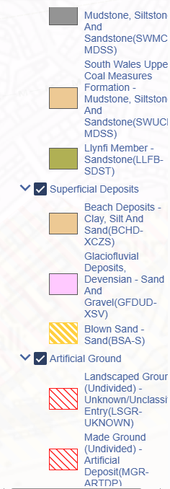
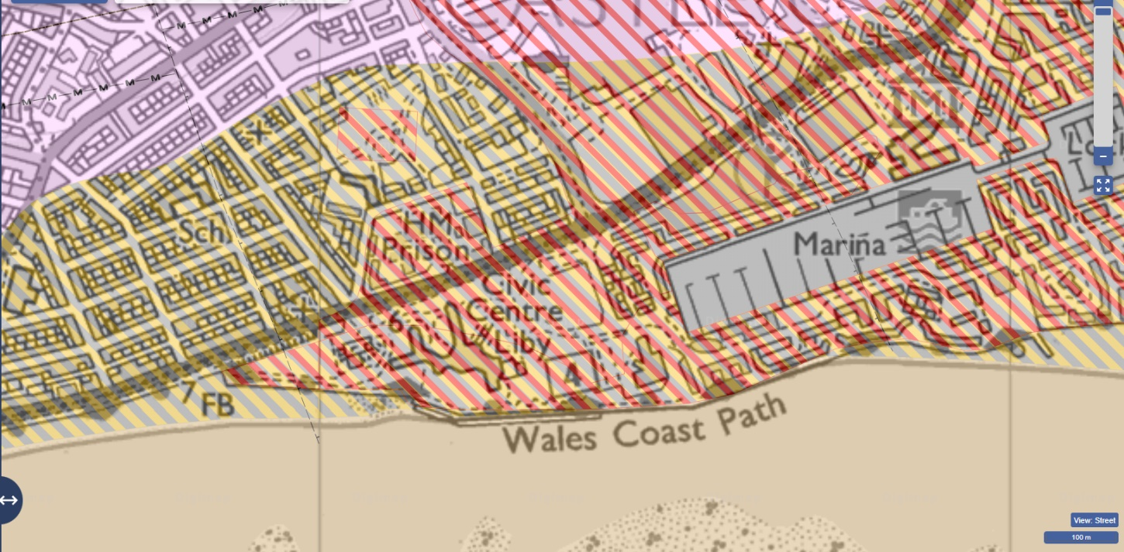
Figure seven
Figure seven above showcases a geology map accessed via Digimap to highlight the variety of strata located in and around the proposed site, (Digimap, N.D)

Existing structures and obstructions
As seen in figure 5, the engine shed could’ve left behind old foundations and structural remains of other previous structures. These foundations are often unmapped and irregularly distributed.
Additionally, the location of the proposed site is next to the Swansea Civic Centre and is to be constructed where the existing car park is situated, including on top of flora. This affects what foundations are to be utilised and must have minimum vibrations.
The investigation will require ground penetrating radar surveys and utility mapping. This leads to there being a medium risk mainly due to the buried services, old foundations and the previous infrastructure. The Geotechnical Contractor must be aware of unexpected construction delays. (See appendix B for more information of archaeological findings)

Groundwater influence
As previously mentioned, the site is positioned immediately opposite Swansea Bay, meaning the area prone to flooding when levels rise. This could have engineering impacts such as the excavations may look stable at low tide however could become flooded at high tide. Furthermore, the soil strength is affected from the pore water pressures changing and the strata is already verified as being unstable soil. This poses a high-risk significance for the GCs as they must employ structural reinforcement techniques for the foundations as well as possible active dewatering or exclusion.
This can be carried out with a sump pump, involving digging a shallow hole in the excavation for water to collect. Furthermore, the GC must ensure the groundwater remains protected as the groundwater could be contaminated from previous industrial works (BGS, 2018)

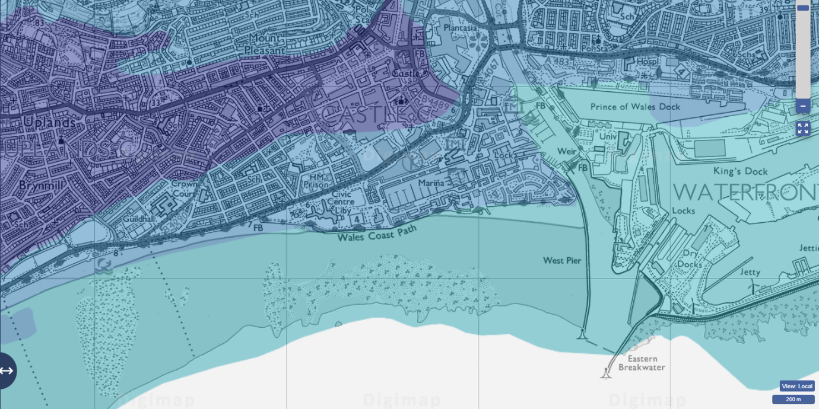
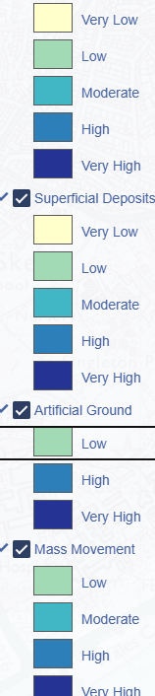
Figure eight
Figure eight highlights the groundwater influence and how it may impact the site (Digimap, N.D)

The risk significance
The location of the proposed site presents many risks due to the historical industrial activity that may have left behind contaminants and other manmade materials such as from the engine shed that was once situated there. This has damaged the soundness of the strata and potentially caused a risk of differential settlement.
A major impact on the site is the groundwater level since the site is located opposite Swansea foreshore. This has a chance to cause water ingress and could weaken the strength of the soil particularly when excavating.
Overall, this leads to the greatest risk of the entire ground investigation, and the Geotechnical Contractor is advised to accurately map the thickness and the variability of the made ground and following this, must identify the zones of weakness and contamination. This creates many issues that could delay the project, and additional costs may arise for remediation works.
It is vital that these defects are investigated and identified in the site investigation before construction work begins to ensure the best structural strength for the building.

Investigation Methods

Borehole logs

Borehole logs provide detailed information on the components within the strata of a site including the properties and characteristics of the materials found with the measurements of the depth of each section.
Boreholes are incredibly beneficial for a site investigation located in Swansea since they allow data to be collected on the groundwater condition, potential contamination as well as further geotechnical and environmental properties which is vital due to the location and historical activities on site (Geo Integrity, 2024)
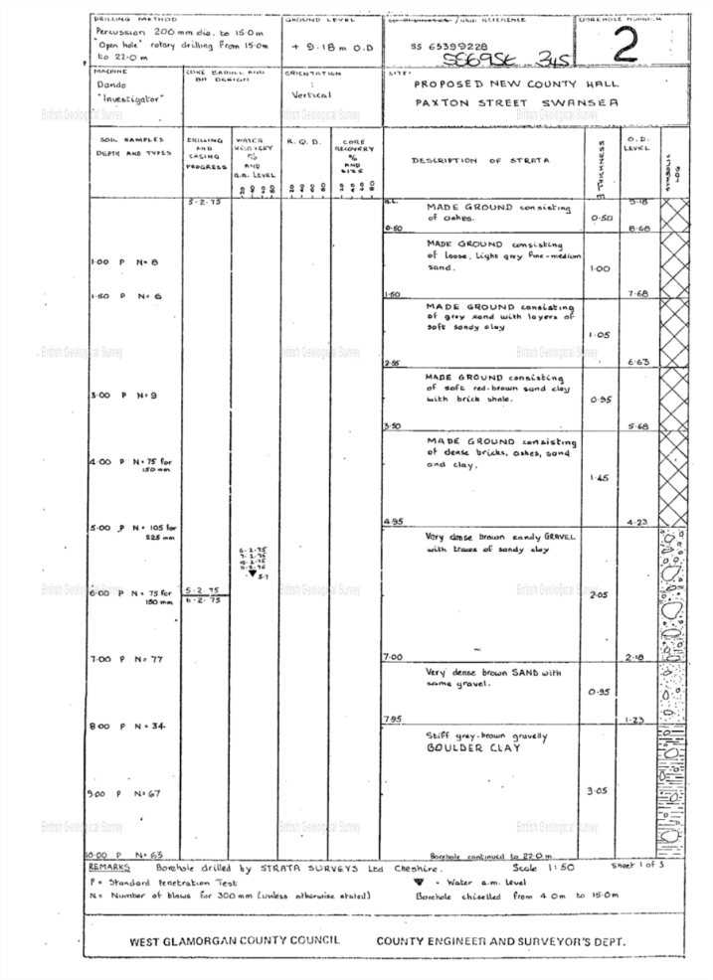
The BGS provides detailed reports of existing borehole records dating back to around 1790

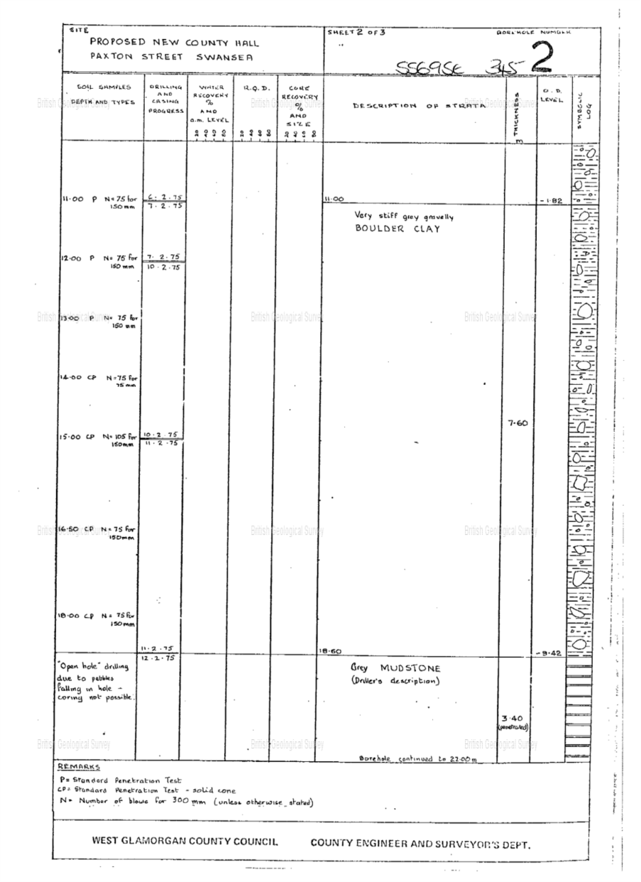

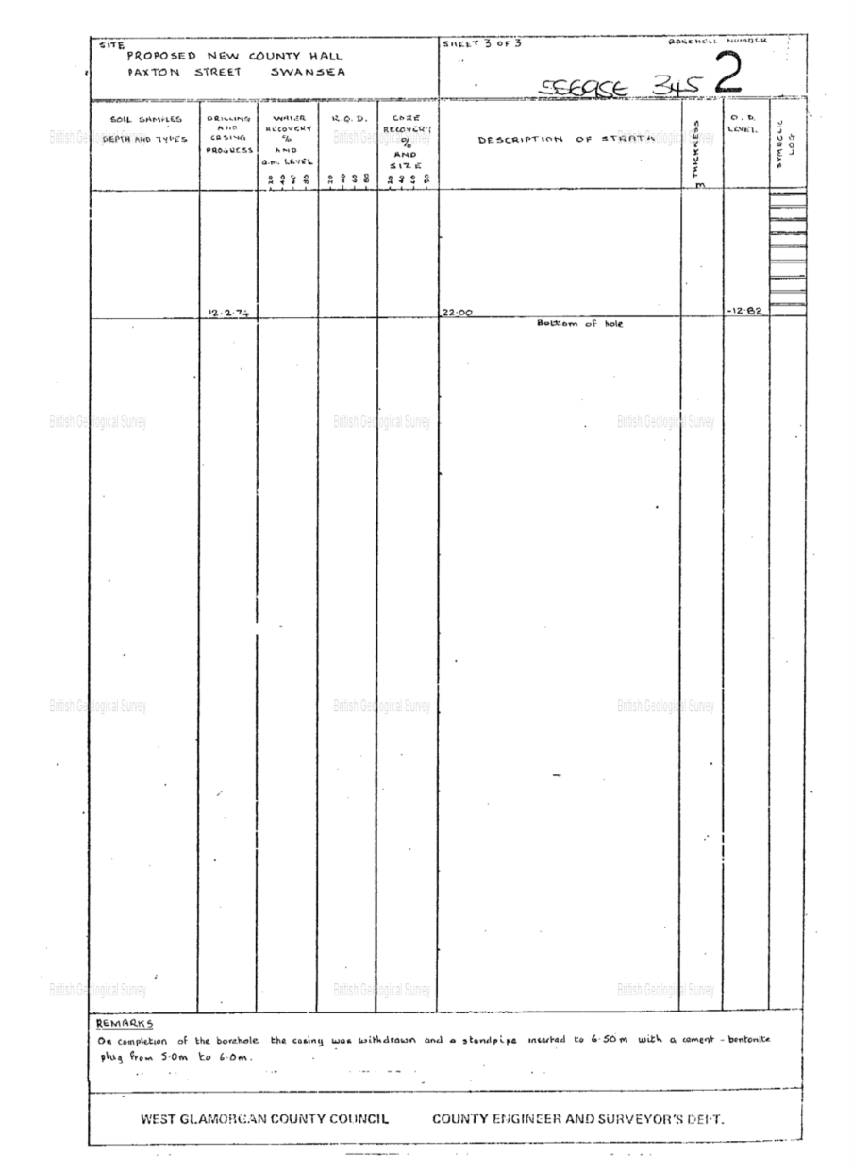Figure nine
BGS ID: 370246 : BGS Reference: SS69SE345
Figure nine above references a borehole record for the County Hall site

Soil Sampling
Soil sampling is a crucial part of the ground investigation in order to determine the geotechnical makeup of the soil while also identifying contaminants, moisture levels and ensuring the best structural stability.
A well conducted soil sampling investigation allows the engineers to choose and design the best structural foundations for the specific strata, reducing the chances of failure and additional costs.
Furthermore, the building codes of practice and the building regulations state that soil investigations are mandatory as a part of the approval process for the construction project. Producing reports of the makeup of the soil showcases compliance and eludes legal complications.
There are many field and laboratory techniques to utilise in order to gather soil samples. The simplest investigation is a visual site inspection, by checking the compactness of the soil. However, the most common ways of identifying the components within the strata to by mechanical excavation such as boreholes or trial pits (Encardio Rite, unknown date)

Building regulations
In Wales building regulations fall to the responsibility of the Welsh Government. These regulations are the minimum standards in the construction industry, with the inclusion of the soundness of the structure, accessibility and the use of the building.
Explanations of how the building regulations are followed are found in the Approved Documents, particularly Approved Document A, which highlights the structural stability, which are available from the Welsh Government website, (Swansea Council, 2026)
Site preparation is covered in Approved Document C, which highlights toxic substances or contaminants. These issues must be identified to ensure they don’t impact health and safety.
Furthermore, the Swansea Local Authority has an involvement in the management and improvement for the ground conditions using several policies and initiatives.
The Welsh Government website provides advice and guidance on the most appropriate foundations for the specific strata to ensure that the loads of the structure are equally distributed. However, it is advisable to contact a structural engineer or contact building control for further guidance, (Welsh Government, n.d)
The ground conditions and made ground situation falls to the Building Safety Regulator under the Building Safety Act 2022, whom is responsible for advising on updates for the Approved Documents which cover the treatment and clearance of material that is found to be unsuitable, resistance to contaminations and the drainage of subsoil., which is important since the site is noted to contain weak strata.

Codes of Practice
Codes of practice are provided by the British Standards Institution and the utilisation of these codes for ground investigation would allow the clients to receive the most efficient outcomes and avoidance of potential delays, additional costs and failures.
According to the British Standards Institution, codes of practice are listed for ground investigations, and these codes can be accessed via the BSI website. For many years, the BSI code for the site investigation is BS 5930, which goes into detail on the suitability for the operations of the construction project that could influence design and construction, ( BSI 2020)
Following adjustment to European Standards in 2010, the UK now is situated within a number of British Standards, such as BS EN 1997-2-2007, (socotec, 2018)
The reporting and planning for ground investigations is portrayed in BS EN 1997-2, which highlights a number of aspects to consider when planning ground investigations including groundwater measurements and materials, (bsi, 2007)
The main key standards and codes include:
- BSI (2018) BS 1377-3:2018+A1:2021 – Methods of test for Soils for Civil Engineering Purposes – Chemical and electro-chemical testing – British Standard Institution
- BSI (2015) BS 5930:2015+A1:2020 – Code of Practice for Ground Investigation
- BSI (2017) BS 10175:2011+A2:2017 – Investigation of Potentially Contaminated Sites- Code of Practice
- BSI (2007) BS EN1997-2:2007 – Geotechnical Design: Part 2 Ground Investigation and Testing
- BS 8004:2015+A1:2020 – Code of practice for foundations.
(Tensar, 2021)

Local Authority Contact Details
The Local Authority can be contacted for site investigations and contaminated land. Swansea council can be contacted via the email planning@swansea.gov.uk or by dialling 01792 635701 for site investigation queries. Regarding pollution control and contaminated land, the email provided is pollution@swnasea.gov.uk or 01792 635600

The most appropriate foundation choice
As observed from the borehole logs and other geotechnical data, the type of foundation for this specific building would have to support the building from differential settlement caused by the anthropogenic ground and would have to withstand potentially high moisture levels from the groundwater influence while also resisting corrosion.
Common foundations are prone to fail in these conditions. For example, strip foundations are suitable for firm soil that has a minimum risk of the excavation collapsing, however due to the groundwater and made ground, it has a low bearing capacity and could cause the building to sink in places, which is also found with pad foundations.
This leaves raft and pile foundations for the most suitable. A raft foundation offers load spreading, distributing the weight of the structure over a wider area and reduces the pressure of the industrial fill. Rafts are also found to control groundwater levels by creating a barrier. However, due to the nature and size of the building, the raft foundation would need to be much thicker and still poses the risk of sinking in the long-term, leading to additional costs.
Due to these issues, it has been decided that pile foundations would be the best choice for this proposed site. However, due to the building being constructed next to the Swansea Civic Centre, these piles would have to be bored piles, which are cast in-situ with minimum vibrations compared to driven piles, which could potentially weaken the foundations of the Swansea Civic Centre from being drilled into the ground.
Pile foundations involve being constructed deep into the ground while bypassing the weakened anthropogenic ground until they reach a more stable strata to sit upon, reducing the chances of differential settlement and improving the soundness of the structure even with the groundwater conditions, (speedeck, 2024)

Bored Pile Foundation Design
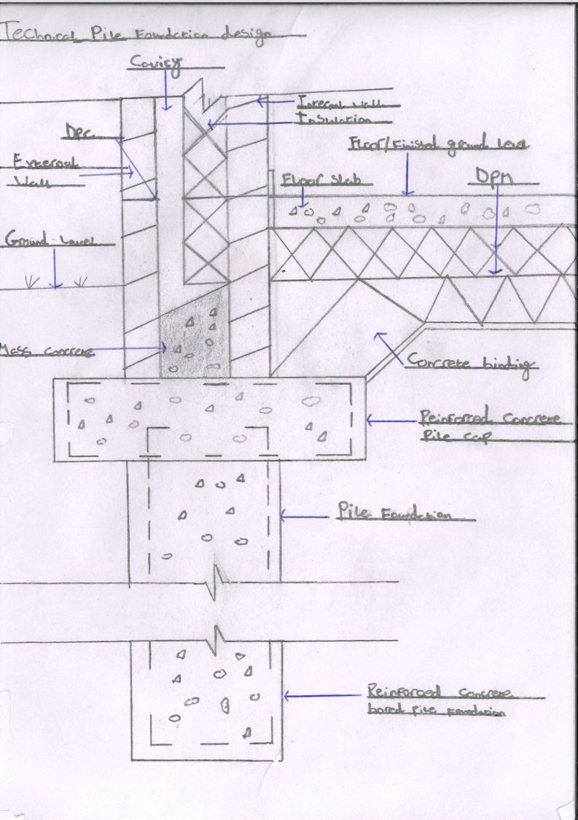Figure 8
Figure 8 showcases a drawn technical drawing of a bored pile foundation

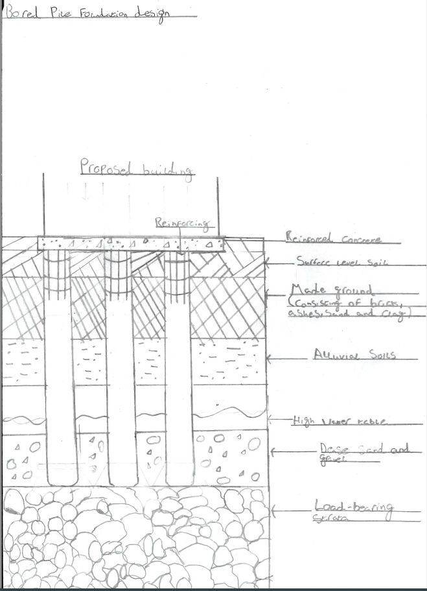Figure ten
Figure ten above depicts a bored pile foundation located within the proposed site, including the relevant information on the materials present according to the Swansea Civic Centre borehole log.
As observed in the drawing, the pile foundation is depicted to reach a depth of a more stable strata to sit upon, while bypassing the weakened made ground and maintaining structural integrity against the groundwater table.

Appendices

Appendix A-Trial pits are an additional method of site investigation to identify the conditions of the soil and groundwater. They involve digging out an excavation in the ground that can then be analysed and inspected in-situ.
In terms of cost trial pits are a much cheaper option compared to boreholes while also taking far less time to conduct. They can’t, however, reach the same depth that boreholes can go, which could prove to be pivotal for this site
However, trial pits are mostly only ever conducted where the soil and ground is stable and firm, allowing the excavation to stand unsupported, and as viewed in the previous borehole reports and the geographical location of the site, the soil is proven to be too weak to strongly support an excavation, resulting in the utilisation of boreholes instead (Earth Environmental & Geotechnical, 2023)
Appendix B-Due to the location and previous activities of the proposed site, there is a potential for archaeological findings on the site, which could result in the project being delayed. In fact, according to sources, recent discoveries have been buried machine pits, remains of engine houses and previously unknown copper rolling machinery in nearby locations, (Wales247, 2026)
If archaeological findings are present on site, the GSC must act with extreme. strictness in order to follow with the legal and environmental obligations. The site must be closed off and secured, however if this is not done, could result in financial or reputational consequences, (Stevens & Bolton, 2025)

References
Andrew Lees. (2021). Site Investigations: Definition, Stages & Benefits. [Online]. Tensar. Last Updated: December 02, 2021. Available at: https://www.tensar.co.uk/resources/articles/site-investigations#:~:text=BSI%20(2018)%20BS%201377%2D, [Accessed 23 April 2026].

Anon. (1870s). Historic Digimap. [Map]: Digimap.

Anon.. (Unknown). Proposed New County Hall. [Online]. BGS. Available at https://api.bgs.ac.uk/sobi-scans/v1/borehole/scans/items/370250. [Accessed 25 February 2026].

BGS press. (2018). Assessing potential groundwater contamination in the pursuit of new energy sources. [Online]. BGS. Last Updated: 23/07/2018. Available at: https://www.bgs.ac.uk/news/assessing-potential-groundwater-contamination-in-the-pursuit-of-new-energ [Accessed 12 April 2026].

British Standards Institute. (2020). Code of practice for ground investigations has been updated. [Online]. BSI. Last Updated: 7 July 2020. Available at: https://www.bsigroup.com/en-GB/insights-and-media/media-centre/press-releases/2020/july/code-of-prac [Accessed 16 April 2026].

bsi knowledge. (2007). BS EN 1997-2:2007. [Online]. bsi knowledge. Last Updated: 30 Apr 2007. Available at: https://knowledge.bsigroup.com/products/eurocode-7-geotechnical-design-ground-investigation-and-test [Accessed 23 April 2026].

Earth Environmental & Geotechnical. (Unknown). Comprehensive Contaminated Land & Site Investigations. [Online]. Earth Environmental & Geotechnical. Last Updated: Unknown. Available at: https://www.earthenvironmental.co.uk/comprehensive-contaminated-land-site-investigations/#:~:text=Ex [Accessed 25 February 2026].

Earth Environmental & Geotechnical. (2023). What are Trial Pits used for?. [Online]. Earth Environmental & Geotechnical. Last Updated: 13 September, 2023. Available at: https://www.earthenvironmental.co.uk/what-are-trial-pits-used-for/ [Accessed 18 April 2026].

Encardio Rite. (unknown). Importance of Soil Investigation in Construction. [Online]. Encardio Rite. Last Updated: unknown. Available at: https://www.encardio.com/blog/soil-investigation-construction-guide [Accessed 18 April 2026].

Geo Integrity. (2024). Types and Purpose of Site Investigation Boreholes. [Online]. Geo Integrity. Last Updated: 05. January 2024. Available at: https://www.geo-integrity.co.uk/2024/01/05/types-and-purpose-of-site-investigation-boreholes/ [Accessed 16 April 2026].

Rhys Gregory. (2026). Archaeologists reveal internationally significant finds in Swansea. [Online]. Wales247. Last Updated: February 24, 2026. Available at: https://www.wales247.co.uk/archaeologists-reveal-internationally-significant-finds-in-swansea [Accessed 11 April 2026].

Socotec. (2018). Standards and Sample Quality for Ground Investigations. [Online]. Socotec. Last Updated: 06/12/2018. Available at: https://www.socotec.co.uk/media/blog/standards-and-sample-quality-for-ground-investigations#:~:text= [Accessed 23 April 2026].

Speedeck. (2024). The best foundation solution for a high water table. [Online]. Speedeck. Last Updated: 28 May, 2024. Available at: https://speedeck.uk/news/all-articles/the-best-foundation-solution-for-a-high-water-table/#:~:text=T [Accessed 17 April 2026].

Speedeck. (2024). When are Strip Foundations no Longer Suitable?. [Online]. Speedeck. Last Updated: 21/02/2024. Available at: https://speedeck.uk/news/all-articles/when-are-strip-foundations-no-longer-suitable/#:~:text=Strip%2 [Accessed 25 February 2026].

Stevens & Bolton. (2025). From ruins to regulations: Roman discovery highlights construction challenges. [Online]. Stevens & Bolton. Last Updated: February 24, 2025. Available at: https://www.stevens-bolton.com/insights/102k12a/from-ruins-to-regulations-roman-discovery-highlights [Accessed 11 April 2026].

Swansea Council. (2026). Building regulations guidance. [Online]. Swansea Council. Last Updated: 08 April 2026. Available at: https://www.swansea.gov.uk/buildingregulationsguidance?lang=en [Accessed 16 April 2026].

Welsh Government. (unknown). Building regulations: outbuildings. [Online]. Welsh Government. Last Updated: unknown. Available at: https://www.gov.wales/building-regulations-outbuildings/foundations [Accessed 16 April 2026].

