Name- Keshia Colvin
Student number- 2424654
Module- introduction to health and social care
Module code- LCHS4003
Lecturer- dr Raheela sheikh
Task 1- poster

Ambulance services
Saving lives-every second counts

What is the ambulance service?
The ambulance service is a frontline part of the healthcare system designed to reach people quickly in an emergency. it provides
. emergency medical care
. lifesaving treatment at scenes
. safe transport to hospitals or specialist centres.
They are staffed by paramedics who are highly trained in advanced emergency care , EMTs ( emergency medical technicians) who are provide essential treatment and support and care assistants they operate 24/7 responding to all life threating events such as
. sudden illness
. heart attacks and strokes
. road traffic accidents
. falls and serious injuries
. emergences in homes, workplaces and public spaces
Beyond all emergencies ambulance services also transport patients paitents with chronic conditions According to NHS England (2023) ambulance services form a crucial link between paitents and the wider healthcare syste ensuring timely and effective medical interventions
When someone dials 999 the ambulance crew are usually the first medics on scene.
History of the ambulance service
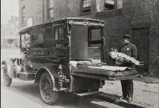
Throughout times the ambulance service has evolved to create good care of people in need.
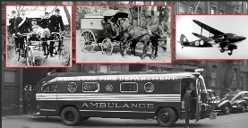
Ancient times: soldiers wounded in battle would be carried on stretchers, carts or wagons to safety
1487- first recorded military ambulance service was introduced
1790- flying ambulance designed to quickly move the injured
1800s- civilian ambulances
Early 1900s – motorised ambulances replaced horsedrawn vehicles allowing faster response times
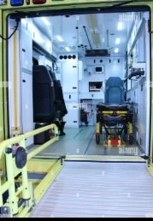
World war 1+2 -ambulance services expanded and improved under the pressure of mass casualties
Mid 20th century- paramedicine developed allowing ambulance crews to begin to provide treatment not just transport.
Today – modern ambulances services include road, air and specialist ambulances equipped with advanced lifesaving tech and highly trained staff
In just over 200 years the ambulance service has evolved from horse drawn carts into a global network of mobile emergency healthcare teams, providing lifesaving treatment before patients even reach the hospitals

Current functions
There are plenty of functions that are involved within the ambulance crews job roles these include
Emergence responses;
Attending life threating cases like
.cardiac arrests,strokes,seizures
.major trauma ,stab wounds , falls ,car crashes
. severe allergic reactions
Paramedics carry advance equipment so they can deliver on the spot interventions like
. defibrillators that restart the heart
.oxygen and ventilation devices that help patients breathe
.iv medication for pain relief to treat critical illness
Ambulance services stabilise patients at the scene often making life or death decisions in minutes before transferring them to hospital
Patient transfer
Transferring patients safely between different locations like home, hospital and specialist care .however not all journeys are emergencies they Provide non-emergency transport for those with long term illness or mobility needs. These include
. people who need medical supervision during travels
. can not travel safely by car or public transport
. need transfer from different hospitals for special treatment. Ie cancer care, surgery , cardiac units.
An example of this would be taking dialysis paitents to hospital three times a week or moving someone from intensive care in one hospital to another.
Specialist care
Critical care paramedics and neonatal transfer teams
Air ambulances that reach remote or difficult locations
Community roles
Modern day ambulance services are not just about emergencies they support the hospital by taking pressure of them and treating individuals at home when possible and is safe to do so. they also offer reassurance and advice to vulnerable people. They can also refer patients to GPs, community nurses or social services. Paramedics can also asses patients, discharge them all without hospital admissions.

Overall ambulance services are hospitals on wheels or the air! Delivering care wherever and whenever it is needed.

Key challenges
Ambulances services face plenty of hard challenges all day every day and hear are just 2 of the key challenges that they face.
- Growing demand
Calls to ambulance services have risen very quickly over the years due to serval factors including
. ageing population with complex needs
. difficulty with gp appointments
. the pressure on hospital emergency departments
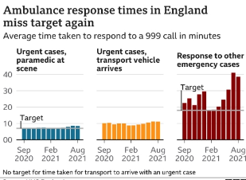
These contributing factors results in longer waiting times and delays at hospital while causing a strain on each ambulance crew
An example of this an increase in the call volume demand mant ambulance services have reported a survge of over 30% in recent years
- Staff shortages and retention
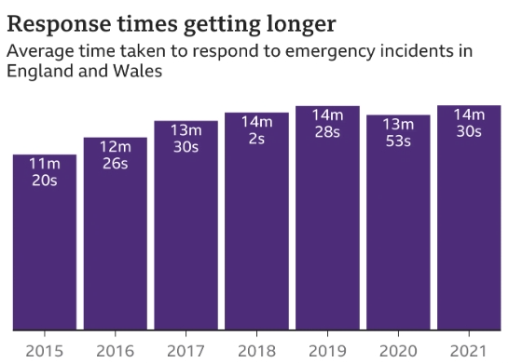
- Ambulance crews face high stress long hours and trauma exposure each time they attend their job. Growing staff shortages mean increased pressure on their current and existing workers. Consequences of this include:
. burnout of their mental health and physical health
. higher sickness levels
. reduced capacity to respond

Support, training and investments are needed to keep services like ambulances sustainable

Ambulance services are the backbone of emergency health care they have evolved over time from the battlefield stretchers to advanced mobile treatment units. They have plenty of functions that saves peoples lives although they face there challenges of the rising demand , staff shortages , longer wait times and plenty more every day. With ongoing support and innovation ambulance services will continue to be a lifeline for communities worldwide providing care, hope and reassurance to everyone in need. The ambulance crew bring nothing but compassion, comfort and dignity in any moment of crisis .
Ambulance services save lives, they need resources staff and the community to keep supporting them to continue to keep answering the call- every second every day.

Task 2- essay

The origin and developments of the national health services

The NHS is one of the most important social reforms in British history established in 1948. The NHS was founded on based on the vision of universal healthcare which is accessible to all British citizens regardless of their income or social status. The nhs emerged from a interplay of historical,social,and political forces along with the economic transformations that followed on from the second world war. According to webstar (2002) the creation of NHS marked a key step in building a modern welfare state based on equality and collective responsibility.
Historical context
Before 1948 Britain’s healthcare system was fragmented and very largely dependant on an individual’s financial circumstances. Wealthier people would be able to afford private medical care, while poorer citizens often relied on charitable hospitals or the limited local services. The 1911 national insurance act introduced a form of health insurance for working men which granted them access to general practitioners however it did not include dependants, women and the unemployed which left many people without coverage. This inequality led to growing calls for reform throughout the early twentieth century.
The outbreak of the second world war marked a turning point within the nhs as the wartime organisation required the government to take control of hospitals and coordinate emergency medical services. The sacrifices of war also reinforced a sense of social solidarity and a belief that he state should ensure citizens welfare. The report proposed by William Beveridge 1942 provided a national system of social insurance and health services available to regardless of income. The labour government elected in 1945 led by clement Attlee adopted these ideas and pursued the establishment of the national health services.

Establishment of the NHS
Health minister aneurin Bevan was instrumental in implementing the NHS. Despite opposition from doctors and conservative politicians, Bevans vision prevailed. On the 5th of July 1948 the NHS was officially lunched with the promises to provide healthcare that was free at the point of delivery and funded through general taxation. The founding principles were clear and included, the NHS would be universal meaning it is available to everyone, comprehensive meaning it would cover all necessary medical services and free at the point of use meaning they are paid for taxation and not direct charges. These ideals reflected a broader postwar consensus that social welfare was both a moral duty and a practical necessity for rebuilding the nation.
Evolution and current structure
Over decades the NHS has evolved in the response to demographic, technological and financial pressures. Today it remains publicly funded and largely free, but the structure has become more complex. England Scotland Northern Ireland each manage their own systems, in England healthcare is overseen by the health and social care department delivered through NHS England which commissions services from local integrated care systems. These systems coordinate hospitals, general practitioners and the community services to improve efficiency and patients’ outcomes. According to the department of health and social care (2021),this structure allows for more localised decision making and greater integration of services
The NHS continues to face massive challenges which include an ageing population, rising cost of medical technology, workforce shortages and the pressure around fundings. Despite these challenges it remains one of the largest publicly funded healthcare systems in the world and source of national pride. Its commitment to equality of access and comprehensive coverage has endured although the debates about privatisation and reform continues

To conclude the NHS emerged from a period of immense social change reflecting Britain’s determination to create a fairer society after the devastation of war. Founded on principles of universality, equality, and free access to care, it transformed the relationship between citizens and the state. Thought it has adapted to meet new demands the nhs continues to embody its founding ethos that the healthcare is a right not a privilege. Its ongoing evolutions highlights the enduring relevance of its original vision and the challenges of sustain that vision in a modern complex world
References
NHS England (2023) ambulance services. Available at; https://www.england.nhs.uk/ambulance/ (accessed 5th October 2025)
Webster.c (2002) the national health service: a political history. 2nd edn.ofxord: oxford university press. ( Accessed the 9th October 2025)
Department of health and social care (2022) structure of the NHS in England. Available at : https://www.gov.uk/government/organisations/department-of-health-and-socail-care (accessed on the 10th October)

