Mind Map – Exploring Horse-Human Entanglement in the Celtic World Through Coin Iconography
Kira Webb 2306722
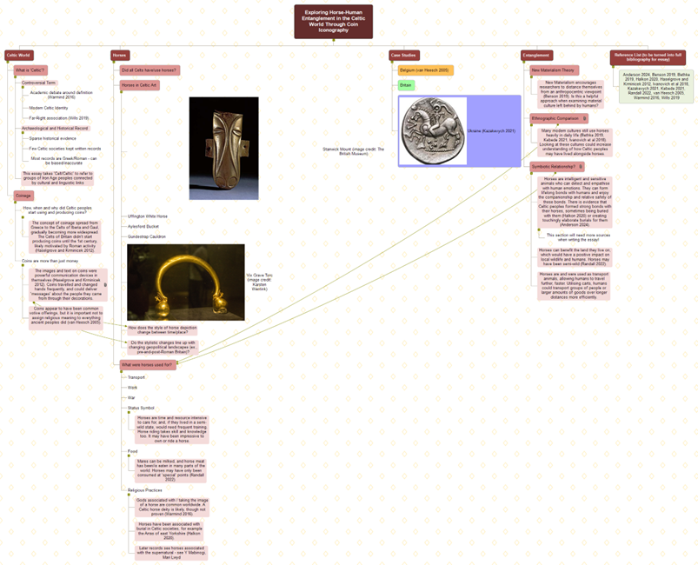

First Column: The Celtic World

- What is ‘Celtic’?
- Controversial Term
- Academic debate around definition (Warmind 2016)
- Modern Celtic Identity
- Far-right association (Wills 2019)

- Archaeological and Historical Record
- Sparse historical evidence
- Few Celtic societies kept written records
- Most records are Greek/Roman – can be biased/inaccurate

- This essay takes ‘Celt/Celtic’ to refer to groups of Iron Age peoples connected by cultural and linguistic links

- Coinage

- How, when and why did Celtic peoples start using and producing coins?
- The concept of coinage spread from Greece to the Celts of Iberia and Gaul, gradually becoming more widespread. The Celts of Britain didn’t start producing coins until the 1st century, likely motivated by Roman activity (Haselgrove and Krminicek 2012).
- Coins are more than just money
- The images and text on coins were powerful communication devices in themselves (Haselgrove and Krminicek 2012). Coins travelled and changed hands frequently, and could deliver ‘messages’ about the people they came from through their decoration.
- Coins appear to have been common votive offerings, but it is important not to assign religious meaning to everything ancient peoples did (van Heesch 2005).

Second Column: Horses

- Did all Celts have/use horses?

- Horses in Celtic Art (examples to look into):
- The Stanwick mount
- Uffington White Horse
- Aylesford Bucket
- Gundestrup Cauldron
- Vix Grave Torc

- How does the style of horse depiction change over time/place? Do the stylistic changes line up with changing geopolitical landscapes (ex., pre- and post-Roman Britain)?

- What were horses used for?
- Transport
- Work
- War
- Status Symbol: horses are time and resource intensive to care for, and, if they lived in a semi-wild state, would need frequent training. Horse riding takes skill and knowledge too. It may have been impressive to own or ride a horse.
- Food: mares can be milked, and horse meat has been/is eaten in many parts of the world. Horses may have only been consumed at ‘special’ points (Randall 2022).
- Religious practices: gods associated with/taking the image of horses are common worldwide. A Celtic deity is likely, though not proven (Warmind 2016). Horses have been associated with burial in Celtic societies, for example the Arras of East Yorkshire (Halkon 2020). Later records see horses associated with the supernatural – see Y Mabinogi, Mari Lwyd

Third Column: Case Studies

- Belgium (van Heesch 2005)
- Britain
- Ukraine (Kazakevych 2021)

Fourth Column: Entanglement

- New Materialism Theory
New Materialism encourages researchers to distance themselves from an anthropocentric viewpoint (Benson 2019). Is this a helpful approach when examining material culture left behind by humans?

- Ethnographic Comparison
Many modern cultures still use horses heavily in daily life (Bethke 2019, Kebede 2021, Ivanovich et al 2018). Looking at these cultures could increase understanding of how Celtic peoples may have lived alongside horses.

- Symbiotic Relationship? (More research needed for essay)
- Horses are intelligent and sensitive animals who can detect and empathise with human emotions. They can form lifelong bonds with humans and enjoy the companionship and relative safety of these bonds. There is evidence that Celtic peoples formed strong bonds with their horses, sometimes being buried with them (Halkon 2020) or creating touchingly elaborate burials for them (Anderson 2024).
- Horses can benefit the land they live on, which would have a positive impact on local wildlife and humans. Horses may have been semi-wild (Randall 2022).
- Horses are and were used as transport animals, allowing humans to travel further, faster. Utilising carts, humans could transport groups of people or larger amounts of goods over longer distances more efficiently.

Bibliography

Anderson, Sonja. “These 28 Horses Were Buried in an Ancient Mass Grave. How Did They Die?” Smithsonian Magazine. 3rd June, 2024.
Bethke, Brandi. Revisiting the Horse in Blackfoot Culture: Understanding the Development of Nomadic Pastoralism on the North American Plains. Int J Histor Archaeol 24, 44–61 (2020). https://doi.org/10.1007/s10761-019-00502-1
Benson, Melinda H. “New Materialism: An Ontology for the Anthropocene.” Natural Resources Journal 59, no. 2 (2019): 251–80. https://www.jstor.org/stable/26800037
British Museum, The. “Mount.” The British Museum. Museum number: 1847,0208.82 https://www.britishmuseum.org/collection/object/H_1847-0208-82
Creighton, John. “Visions of Power: Imagery and Symbols in Late Iron Age Britain.” Britannia 26 (1995): 285–301. https://doi.org/10.2307/526880
Halkon, Peter, ed. The Arras Culture of Eastern Yorkshire – Celebrating the Iron Age: Proceedings of “Arras 200 – Celebrating the Iron Age." Royal Archaeological Institute Annual Conference. Oxbow Books, 2020. https://doi.org/10.2307/j.ctv138wskk.
Haselgrove, Colin, and Stefan Krmnicek. “The Archaeology of Money.” Annual Review of Anthropology 41 (2012): 235–50. http://www.jstor.org/stable/23270709
Ivanovich, Stepanov Aiaal, Popova Natalia Innokentevna, Romanova Ekaterina Nazarovna, Ivanov Revorii Vasilevich, Boyakova Sardana Ilinichna, and Khompodoeva Uigulana Viktorovna. 2018. “The Horse in the Life and Culture of Northern Nomads”. Mongolian Journal of Agricultural Sciences 23 (01):47-51. https://doi.org/10.5564/mjas.v23i01.1021.
Kazakevych, Gennadii. “Horse Rider Image on the Coins of the Eastern Celts and the Cult of War Goddess.” The Ukrainian Numismatic Annual 5 (2021): 81-92. https://doi.org/10.31470/2616-6275-2021-5-81-92
Alemu Alene Kebede (2023) “A short history of Awi Agew horse culture, Northwestern Ethiopia.” Cogent Arts & Humanities, 10:1, 2231705, DOI: 10.1080/23311983.2023.2231705
Mays, Melinda. “Inscriptions on British Celtic Coins.” The Numismatic Chronicle (1966) 152 (1992): 57–82. http://www.jstor.org/stable/42667833
Nimura, Courtney, Helen Chittock, Peter Hommel, and Chris Gosden, eds. Art in the Eurasian Iron Age: Context, Connections and Scale. Oxbow Books, 2020. https://doi.org/10.2307/j.ctv13gvh20
Randall, Clare. “Horse Country: Keeping – and eating – Iron Age horses at Ludgershall.” Cotswolds Archaeology. 7th June 2022.
Religion, Atlantic. “Symbolism on Celtic Coins.” The Atlantic Religion. Photograph of coin. 28th March, 2018. https://atlanticreligion.com/2014/03/28/horse-symbolism-on-celtic-coins/
Van Heesch, Johan. “Celtic Coins and Religious Deposits in Belgium.” In Ritual and Iron Age Coinage in North-West Europe, edited by C. Haselgrove and D. Wigg. Philipp von Zabern, 2005.
Warmind, Morten. “Once More the Celtic Horse-Goddess.” Proceedings of the Harvard Celtic Colloquium 36 (2016): 231–40. http://www.jstor.org/stable/26383351
Wentink, Karsten. “Vix.” Photograph of artefact. 14th September, 2018. https://www.flickr.com/photos/vankarsten/44622470792/in/album-72157698103601872/
Wills, Matthew. “What Does it Mean to be Celtic?” JSTOR Daily. 19th June 2019. https://daily.jstor.org/what-does-it-mean-to-be-celtic/

