Banking Financial Management and Financial Markets
LCMB7012 | Theodoros Panagiotidis
Financial Crisis 2008: what made the difference
Matthew Kelleher (1710425)
2021
Contents
1.0 Introduction 2
2.0 US 2
Troubled Asset Relief Program (TARP) 2008 2
Stimulus package 2009 3
The Dodd-Frank Act 3
Securities Act of 1933 3
Investment Advisers Act of 1940 3
Volker Rule 4
2.2 Uk rules, regulations. Laws and contracts enacted post 2008 financial crisis 4
The Uk government package 4
Interest Rates Slashed 5
Quantitative Easing Policy 6
The Financial Services (Banking Reform) Act 2013 6
2.3The EU laws, rules, regulations, and contracts enacted post financial crisis 6
Corporate Governance 6
Hedge Funds and Private Equity Regulation 7
Bank Tax to set up Resolution Funds 7
3.0 Boom and Bust: Residential Housing Prices 7
3.1 Deterioration of Financial Institutions’ Balance Sheets 9
3.2 Run on the Shadow Banking System 9
3.3 Global Financial Markets 10
3.4 Failure of High-Profile Firms 10
4.0 Company Background of Northern Rock 11
4.1 The 2007 Financial Crisis and initial response on Northern Rock 11
4.2 Nationalisation of Northern Rock 12
4.3 Northern Rock purchased by Virgin Money 12
References 13

1.0 Introduction
The financial crisis in 2008 was an experience that was educational for the global banking sector. According to Sironi (2018), the global banking sector became more cautious and introduced various models relating to issues of importance such as liquidity buffers, insufficient capital, and excessive risk taking in the industry. Regulators and government acted to the financial crisis with stronger supervision, standardisation in liquidity, more capital, and extra specific solutions. According to Sengul (2020), changes within the globalisation tendency on the economy due to the lack of economic growth and the interest at low rates in developing countries, the banking working area has significantly changed. External powers have been discovered by the advance of technology while the scrutiny of banks shareholders has increased. This created a competitive pressure in the market to emerge.
The financial crisis costs were humongous. According to Senegul (2020), in total the global financial crisis cost the International Monetary Fund $11.9 trillion in 2009, however, new studies have shown that the amount was closer to $14 trillion after considering the richness, production, caused effect from the trauma to the nation and the precautions which the government took. The crisis immediately influenced banks to respond to the environment of the post-crisis market and financial crisis. According to Gallagher (2020), banks decided to go global in order evaluate and reorganise their balance sheet positions, organisational structure, growth plans geographical presence and scope of operations. The factor of risk has since been inherited particularly to the financial sector. According to Marom and Lussier (2018), businesses usually grow through risk taking, risks that riskier intend to yield profit naturally higher. Thus, indicates that growth is achieved through risks taken in the business world. From risks taken previously, banks can learn from the mistakes and previous financial crisis in the past to open new innovative ways to function. However, new situations bring new risk and banks should measure these risks so they can be overcome.

2.0 US
Early in 2007 the subprime crisis begun and evolved by 2008 into a full-scale financial crisis. According to Malpezzi (2017) problems within the sector in the US that issued subprime mortgage loans developed into a credit crunch on a wide-spread scale across multiple assets markets globally, making this situation the worst economic crisis since the 1930’s of the time of the great depression. Subprime mortgages that were backed by assets and other financial instruments which were structured complexly were largely exposed by the financial institutions. The financial institutions took on write-downs at the cost of billions of dollars once the risk started to unravel between 2007-2008 (Carmona et al, 2019). This was the main reason why various rules, regulations, and contracts were enacted to decrease the strain in the US financial crisis. Below are several changes which were enacted during and after the financial crisis.

Troubled Asset Relief Program (TARP) 2008
According to Abbott (2018), the Troubled Asset Relief Program (TARP) was signed into law on the 3rd October 2008 alongside the Emergency Economic Stabilization act (EESA). TARP was designed by treasury secretary, Henry Paulson to prevent the crisis from worsening. The main purpose of TARP was to increase liquidity within second mortgage markets and monetary markets through the purchase of mortgage-backed securities (MBS), reducing potential losses for the institutions which owned them (Davydov et al, 2020). However, TARP aim was slightly modified so that equity within financial institutions and banks could be purchased by the government. This allowed the treasury to initially have $700b of purchasing power, this was later reduced to $475b when the Dodd-Frank act was reformed (Miezala, 2019). The funds from TARP purchased such things as insurance companies, auto-makers, and stocks in banks, also to loan funds to homeowners and financial institutions. The US government purchased preferred stocks in multiple banks which included J.P. Morgan Stanley, Goldman Sachs, Wells Fargo, and more (Grosse, 2017). According to Segal (2020), it was required by the banks to pay a dividend fee of 5% which increased to 9% to the government, thus encouraged banks to purchase stocks back within a period of five years. Between 2008-2010, the TARP programme issued $245b stabilising banks, increased credit availabity through programmes costing $27b, $80b was invested into companies such as Chrysler and GM within the auto-industry, AIG was stabilised with an investment of $68b, also foreclosure-prevention programmes to make homes affordable were designed at the cost of $46b.

Stimulus package 2009
According to Chen et al (2020), the American Recovery and Reinvestment Act 2009 (ARRA), also known as the recovery act was a stimulus package that was designed in response to the financial crisis. Some of the key objectives were to save jobs that existed while creating new jobs in quick recession, also to provide short-term relief programs to individuals and companies who were affected by the financial recession (McBeth et al, 2018). Infrastructure, renewable energy, health, and education were also invested into. The foundation of ARRA was created based on the theory of Keynesian Economics, which claims that during recessions and times of a financial crisis that the government should decrease the cost of private spending and increase public spending to protect jobs and prevent further economic deterioration (Makin, 2019). Approximately the stimulus package for the economy has been estimated at a cost of $800+ billion between 2009-2019 (Infogolactic, 2019).

The Dodd-Frank Act
According to Allen et al (2018), the Dodd-Frank Act (DFA) was designed and enacted with the purpose of avoiding a reoccurring financial crisis, which almost destroyed the financial system within the US. Advocates of the law claim there has been extraordinary progress regulating the US financial institutions, this included institutes deemed as “too big to fall”. The development of innovative regulatory agencies such as the Consumer Financial Protection Bureau (CFPB) and the Financial Stability Oversight Council (FSOC) have made monitoring closely the operations of the banks in order to protect the consumer (Bailey et al, 2017). Discussed below are key acts that were amended and enacted courtesy of the DFA.

Investment Advisers Act of 1940
According to Johnson (2018), the Investment Advisory Act (IIA) 1940. IIA defines and regulates the responsibility role for investment advisors. IIA provides the framework to monitor those who recommended pension funds, institutes, and individuals on the substances of investing while specifying who should register with the federal and state regulators. Agencies vary on who advisors should register with as this depends on the managed asset value, alongside who they advise, for example, only individuals or corporate clients. According to Lach et al (2019), prior the reform in 2010, advisors who managed assets of the value of $25m or offer advice to companies/individuals who invest are obliged to register with the Securities and Exchange Commission (SEC). Whereas smaller amounts managed by advisors register with the State Securities Authority (SSA). Amounts have changed due to the amendment of the DFA and Consumer Protection Act (CPA) in 2010. This allowed numerous advisors to now be able to register with the SSA rather than the SEC due to the management and handling of monetary that is lower than the required law implemented. The DFA also introduced the requirements for regulations to those who recommend and advise funds which are private, these include private equity funds and hedge funds. The Securities and Exchange Commission (2010), the changes impacted in a 10% decrease of registered advisers and a 13% increase in managed total assets registered advisors (Ross, 2020).

Volker Rule
Volker Rule (VR) is another regulation that was enacted and prohibits the investment activities of banks relating to their own accounts and hedge fund dealings and equity private funds, known as covered funds (Niebank and Walker, 2020). The VR declines insured depository funs and banks form retaining or obtaining ownership interests within private equity funds or hedge funds which are subject to exemptions. According to Sy and Tinker (2017), VR aims to prevent banks tanking so much risk through disabling them from using the banks funds to purchase investments to enhance profits. This is emphasised by Ross (2020), who claims VR relies on that the banks customers do not profit from trading activities. At present, the VR allows the banks to continue hedging, trading government securities, market-making, underwriting, engage in insurance activities, offer private equity funds, and hedge funds, and act as agents, custodians, or brokers (Niebank and Walker, 2020). According to Sy and Tinker (2017), banks can generate profits for their customers by offering these services at present. However, banks may not engage in certain activities if they expose the institute to trading strategies or assets of high risk or produce uncertainty within US financial systems or banks, requirements for disclosing details must be met by banks on trading activities that have been covered to the government (Ross, 2020). Institutions which are larger must ensure compliance of new rules through new programmes which are related to the independent analysis and testing, while small institutions have less reporting or compliance requirements.

2.2 Uk rules, regulations. Laws and contracts enacted post 2008 financial crisis
According to Ismail (2020), In 2007 the financial crisis hit the UK with the collapse of the bank known as Northern Rock This was the first time that the government in the UK took intervention relating to the negative affect of the financial crisis on the financial systems and the economy. It became aware that Northern Rock was in financial funding problems when the bank made it public in an announcement (Ross, 2020). On hearing the financial struggle that Northern Rock was facing the government announced that deposits in Northern Rock would be provided and guaranteed (Ahmed et al, 2020). The UK government also wadded in rescuing numerous financial institutions that were vulnerable and the economy through enacting various economic and financial policies. Below will provide some of the different policies that were implemented to restore the financial systems and economy by the UK government.

The Uk government package
In 2008, the UK government issued a package with the aim at rescuing the financial and banking system by making fresh money available at the value of £400b. At the time the package issued by Brown and the Uk government made available extra capital for 8 building societies and banks in the return for preference shares in banks/building societies.
According to BBC News (2008), at this time shares of several banks fluctuated for instance Lloyds dropped by 7%, HBOS rose 24.5%, Barclays fell by 2.4%, and more. The FTSE also fell and was down 5.18% regardless of the interest cut rates from the major banks such as the Bank of England (BOE), the Federal Reserve and the European Central Bank. Key points of the plan were to increase capital by £25m which could be borrowed from the government, an additional £25m in preference stocks, Bank of England issued £100b in short-term loans on top of the £25b already existing, and offer £250b loans guaranteed by the BOE at commercial rates to entice the lending between banks. Below is an image of the UK rescue plan for the 2007 banking crisis.
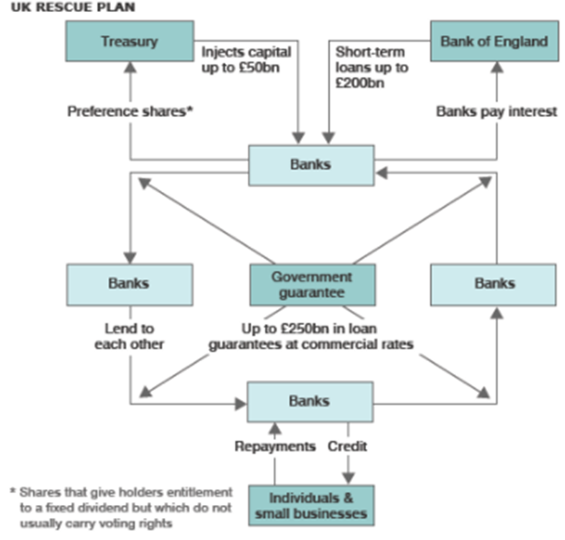
UK rescue plan (BBC News, 2008).

Interest Rates Slashed
Interest rates in the UK were also slashed from 5% in 2008 to 0.5% in 2009 (shown below), by the Bank of England Monetary Policy Committee (MPC) (Deleidi and Mazzucato, 2018). According to Ariccia et al (2018), interest rates were slashed to decrease excess reserves of the individual banks and to increase the purchasing and financing of other financial assets. This highlights that the policy was enacted to decrease the rates of lending, boost prices, and increase the supply of credit across the Uk financial markets. According to the Bank of England (2021), the change of interest rates affects individuals spending and this influences the cost of products due to people spending more overall. This indicates that the change in bank rates has an influence on inflation and prices, at present the UK inflation rate is currently 2.4% (Office of National Service, 2021).
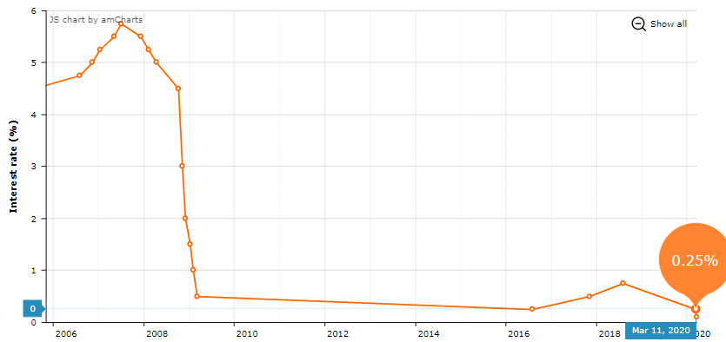
UK Interest rate between 2006-2020 (Property Investment Project, 2021).

Quantitative Easing Policy
Quantitative Easing (QE) policy was introduced in the UK by the bank of England in response to the financial crisis in 2009. According to Ariccia et al (2018) QE involves the purchasing of securities at a large-scale by central banks which is usually implemented through the purchase of government bonds which is financed through the increase of the commercial reserve accounts held by the central bank. According to Fatouh et al (2021), the main reason for this, is that if the policy rate and yield are zero on short-term bonds the central bank will still have funds available to provide support for prices of long-term bonds, this will lower yields long term.

The Financial Services (Banking Reform) Act 2013
According to Legislation.gov.uk (2021), The Financial Services Act 2013 (Banking Reform Act) was enacted to implement recommendations from the commission (Independent Commission of Banking) and was originally introduced in 2010. The Banking Reform Act focuses on the structure of the financial industry, recommended structure regulations alongside strategies which control and command such as ringfencing. According to Campbell and Moffatt (2019), ringfencing is a firewall between riskier investment banking, deposit-taking banking, and retail. This is emphasised by Kilapakkam and Wang (2019) who claims that retail banks are different and separated from investment banking and wholesale within any banking group. The main principle of the introduction of the banking reform was to make it easier and more Cost effective (lower cost) to convey resolutions for banks during financial difficulties through determining the activities that are allowed to be continued of failing banks (Cullen, 2018). This regulatory strategy by the government ensures the provision continuously to vital services that will impact the economy and customers of the band due to the constant and continuous monitoring. The banking reform act is to restrict moral hazard and allow banks the guarantee of government support for those banks who are too big to fail (Schoemaker, 2018). Thus, means the government will lend funds to failing banks as a last resort to prevent banks from failing.

2.3The EU laws, rules, regulations, and contracts enacted post financial crisis
As an impact of the financial crisis in 2008, a sovereign debt crisis spread across numerous countries in the Eurozone due to governments not having the available funds to rescue banks that were insolvent. According to (Afonso et al, 2018), this issue highlighted that the monetary union was operating alone and was not attended by the banking union this left governments liable for rescuing and regulating banks from negative and bad debts. The size of debt in certain countries such as Portugal, Greece, Cyprus, and Ireland had accumulated to an all-time high and governments could not raise the funds on the financial market. This is emphasised by (Larsen and Klemmensen, 2019) who claims, bailouts became less costly for the government due to the defaults and returns on national currencies which caused uncontrollable contagion effects and bank losses. However, according to Afonso et al (2018) , planning bailouts taxed decision making capacities within the EU and also exposed fears regarding the absence of democratic legitimacy. Due to the reasons above the government of the EU enacted numerous regulations, contracts, and laws to prevent extra pressure of the financial crisis from getting any worse, some of the key policies are discussed below.

Corporate Governance
In order to prevent further financial crisis in the future, the European Commission adopted a variety of regulations to improve shareholders rights through imposing requirements which are stricter relating to corporate governance on the operations of corporations in the EU (Legislation.gov.uk, 2021). According to, at present, the proposal of an individual should not be registered to three separate corporate boards or boards of compensations or restrictions. To be eligible for the board there are requirements which much be met such as expertise in operations of the corporation. According to, the board would be required by the commission to regulate the risk management functions of the corporation and separate functions such as the CEO and chairman.

Hedge Funds and Private Equity Regulation
Both the EU member countries and the European parliament simultaneously approved versions of plans to acquire private equity and hedge funds to seek authorisation from the government to function, hold adequate funds, and design disclosures to investors and regulators (Repiquet, 2018). According to Deslandes et al (2019), the proposal involves controversial differences between the exemption clause and third country. The EU passed the third country clause within the Council of Economic, the regulation indicates that financial ministers would now require private equity groups to be approved by each of the EU countries that they would like to operate (Margerit et al, 2017). However, according to Lannoo (2017), the clauses previously mentioned above brought objections from both the United States and the United Kingdom. According to Legislation.gov.uk (2021) on the exemption clause, private equity groups and hedge funds would be exempt by the European parliament if the company has under 50 employees, member countries would be exempt if under 250 employees as this is considered more acceptable to equity groups and hedge funds.

Bank Tax to set up Resolution Funds
Another solution to the financial crisis was taken by the European Commission in 2010, where an outline plan was proposed for tax to be imposed on banks by individual EU member countries (Barrios, 2018). The reason for the tax being imposed on the banks was to generate funds that could be used to support financial institutions that needed funds instead of the taxpayer bailing out the financial institution (Pulawska, 2021). According to Howarth and Quaglia (2018), to prevent tax-payers from bailing out the banks and financial systems, 27 member countries in the EU were called upon by the European Commission to raise national funds alongside establish a pan European fund for future transitions. According to Kleftouri (2017), the aim of the commission plan is to evaluate the tax on investment firms and deposit taking banks, however, the plan did not make no decision on whether or not tax should be levied on liabilities, assets, and profits. It was made clear by the EU Commission that the funds generated from tax will not be spent on the recapitalisation of troubled institutions or for be part of the company’s general revenue.

3.0 Boom and Bust: Residential Housing Prices
According to Thomas (2017), post the 2001 recession the subprime mortgage market rose and became a $1trillion market by 2007. At the time politicians encouraged the expansion of subprime mortgages as this raised the homeownership rates in the US to its peak level in history and enticed a democratisation of credit. As shown in the graph below the housing asset-price boom, the recession ended in 2001 and this influenced the stimulation of growth on the market for subprime mortgages (Mishkin and Eakins, 2018).
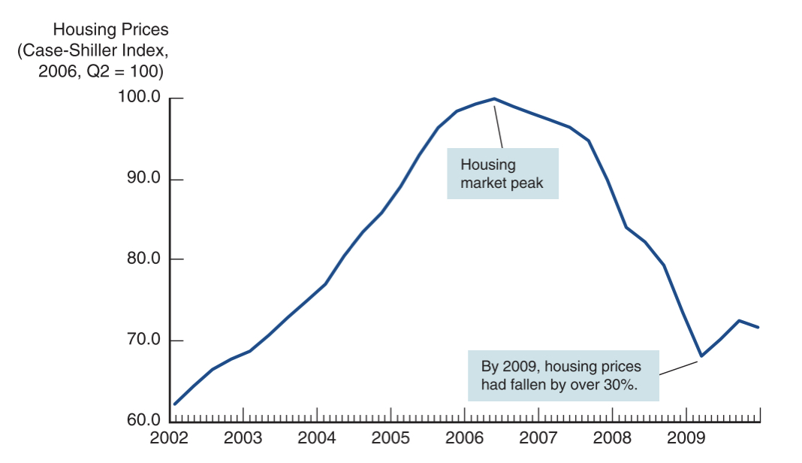

Housing prices from 2002-2009 (Mishkin and Eakins, 2018)

According to Thomas (2017), due the rise in property value, larger loans could be acquired by subprime borrowers through refinancing their property If the property value appreciated. This was due to the property values increasing, subprime borrowers were in a position to sell their property and were less likely to default payments of the loan, this made investors happy due the securities being backed through cash flows from the subprime mortgage which has high returns at less risk. According to Walters and Djokic (2019), due to the increase in the property market the increase in property demands rose which injected the boom in property values, this resulted in a “housing price bubble”. Further inducement to the property market were caused by the low interest rates on property mortgages, as a result from several forces that were different. According to Mishkin and Eakins (2018), firstly, countries such as India and China invested huge capital inflows into the US. Secondly, mortgage-backed securities at the value of trillions of dollars were purchased by Fannie Mae and Freddie Mac after being encouraged by the congressional legislation (Tribbitts, 2018). Thirdly, lower interest rates as a result of the Federal Reserve Monetary Policy caused property purchases by finance at low costs which stimulated property demand which increase the price of properties (Jiang and Wang, 2017). According to Barari and Kundu (2019), there has been highly controversial issues relating to who’s to blame of the housing price bubble with the blame pointing at the Federal Reserve. As property prices increased and the profitability was high for mortgage lenders and originators the standards of subprime mortgages lowered and fell. This is emphasised by Thomas (2017) who states, there was an increase in the loan-to-value ratio due to mortgages could be obtained by high-risk borrowers with the amount of mortgage relating to the property value. According to Levitin et al (2020), borrowers were able to receive piggybanks with a second and third mortgage to boost the original loan-to-value mortgage. This meant that borrowers had to place hardly any funds down. According to Mishkin and Eakins (2018), when the increase in asset prices increase and do not correlate with the fundamentals, prices must come down. For example, in the case of the property market, the price of cost of the property must be relative to the renting cost of the property or the property price must be relative to median income of the household. Ultimately, this caused the property price bubble to burst. Due to the property prices decreasing in 2006 after their peak (graph above), the decay within financial systems was caused by the lending practices which were revealed after the crisis. According to Adelino et al (2018), this led to mortgages becoming underwater for subprime borrowers who found out their property value was declining, and that the value of the property was below the mortgage amount. This gave the incentive to homeowners to send their property keys back to lenders and walk away from properties. According to Adelino et al (2018), there was an increase in market defaults which eventually led to foreclosure of mortgagaes at the value of millions, with foreclosures of mortgages increasing by 20% and mortgage rates decreased by 67%.

3.1 Deterioration of Financial Institutions’ Balance Sheets
According to Kim (2020), due to the decline in property prices in the US the amounts of defaults increased on mortgages. This resulted In CDO’s and the values of mortgage-backed securities to collapse which left the financial institutions and banks with a decreased asset value, thus resulted in a declining net worth. This caused balance sheets to weaken and impacted in financial institutions and banks having to deleverage. This can be emphasised by Mishkin and Eakins (2018), who claims that financial institutions and banks started to restrict availability of credit to businesses and households and started to sell owned assets off. According to Igan et al (2017), loans could not be issued and information collected due to no one stepping in. with the bank lending reduced the financial markets were increased by the financial frictions

3.2 Run on the Shadow Banking System
According to Murau (2017), A shadow run on the banking system was triggered due to the sharp decline of mortgage values and financial assets, composed of non-depository firms, hedge funds, and investment banks due to these financial systems not being as tightly regulated banks. Shadow banks generated funds from the financial systems supporting for many years, auto loans and insurance on of mortgages at low interest rates. Such securities were primarily funded through repurchasing agreements, known as repos. These were short-term borrowings which could be used as collateral such as mortgage-backed securities. According to Gorton et al (2020), there was an increasing concern relating to the quality of the balance sheet of the financial institution led to larger amounts of collateral to be required, this is know as haircuts. For example, if the borrower receives a loan at £200 million in repo agreements, £220 million as collateral may have to be posted of mortgage-backed securities, this means the haircut is 5%. Due to the increase in mortgage defaults there was a decrease in mortgage-backed security values, this the reason for the increase in haircuts. With rising defaults on mortgages, the value of mortgage-backed securities fell, which then led to a rise in haircuts. Haircuts were close to zero at the beginning of the financial crisis but increased to almost 50% during the crisis (Mishkin and Eakins, 2018). The result was financial institutions had to use the same collateral and could only borrow half as much. In order for financial institutions to raise funds, assets had to be sold off rapidly. Thus, caused financial institutes to lower the price of assets to receive a quick sale, this caused a decline in the asset values of financial institutions (Murau, 2017). The decline decreased collateral value further which increased haircuts and forced financial institutions to order more liquidity. Similar results were run on banking systems during the Great Depression which caused enormous deleveraging which resulted in restricting lending and the decline on economic activity. As illustrated the graph below, there was a decline in the price of the assets on the stock market which decreased by 50% between October 2007 and March 2009 also property prices dropped by 30% (Mishkin and Eakins, 2018). Alongside the rapid sales of assets as a consequence of the run on the shadow banking systems, thus weakened balance sheets of both households and firms. Due to financial friction worsening a widening credit spread manifested causing increase costs for credit for businesses and households with tighter standards when lending. With the decline in lending resulted in both the failure of the investment and consumption expenditure, this caused a contract in the economy.

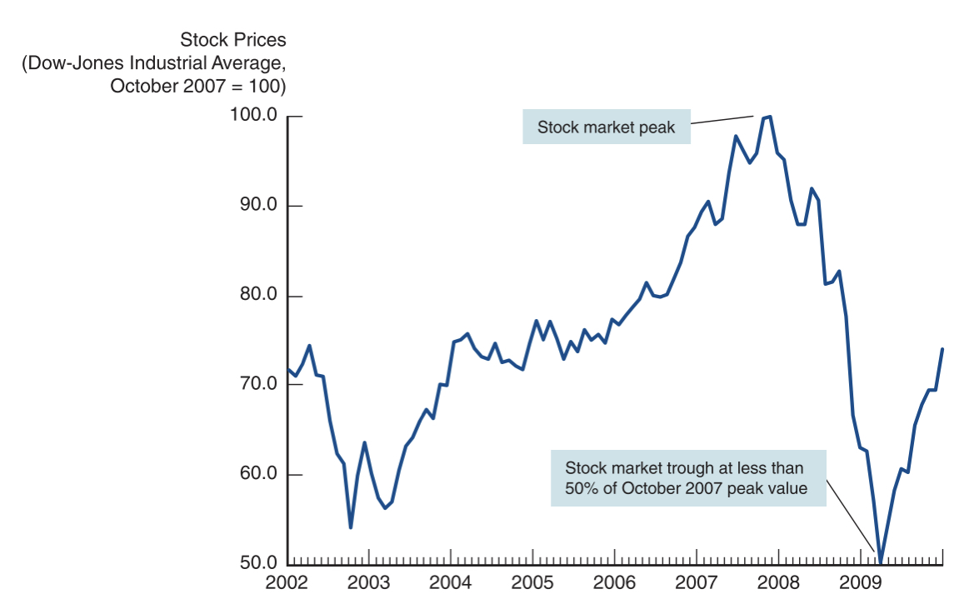
Stock Prices between 2002 and 2009 (Mishkin and Ekins, 2018)

3.3 Global Financial Markets
The problem originally developed in the US although it was in Europe that the financial crisis indicated it was time to wake up, due to the extensiveness globalisation of financial markets. In 2007, Fitch and Standard and Poor’s announcement of downgraded ratings on CDOs and mortgage-backed securities which totalled in excess of $10 billion (Mishkin and Eakins, 2018). This grew concern from the French investment house who suspended redemption of the shares which were held in certain monetary funded markets which at the time suffered large losses. Over time the run on the shadow banking systems became worser as the time passed. Despite the efforts by the Federal Reserve and European Central Banks to inject huge liquidity within the financial systems, banks started to hold cash and restricted lending to one another (Slepov et al, 2019).

Due to credit drying up banks begun to fail in the UK for the first time in 100 years (Mishkin and Eakins, 2018). The first major bank that collapsed was Northern Rock in 2007 due to the bank relying heavily on borrowing short-term from repo markets instead of generating funds from deposits (Ismael, 2020). This was followed by a string of collapsed financial institutes in Europe. Countries such as Portugal, Italy, Spain, Ireland and Greece where particularly hit hard and this impacted in a sovereign debt crisis, described as the global box and known as the European Sovereign Debt Crisis (Marco, 2019).

3.4 Failure of High-Profile Firms
Firms balance sheets were impacted by the financial crisis which forced major players to take drastic action in the financial markets. According to Mishkin and Eakins (2018), during 2008, the US fifth largest investment bank Bear Stearns who had heavily invested in related subprime securities had to be operated by repo funding and had to sell to J. P Morgan for a 5% cut of the price from the previous year. For the deal to be brokered, hard-to-values assets of $30 billion of Bear Stearns were taken over by the Federal Reserve. According to Thompson (2021), Fannie Mae and Freddie Mac, two government-sponsored enterprises which were privately owned, had a combined issued insurance mortgage-backed assets or mortgages of a value of $5 trillion were bolstered by the Federal Reserve and US Treasury after suffering losses which were sustainable due to holding huge amounts of subprime securities. However, later in the year Fannie May and Freddie Mac were took over and run by the US government (Thompson, 2021). Lehman Brothers an investment bank which was rated fourth largest in the US also suffered losses due to the subprime market . Lehman Brothers had assets worth in access of $600 billion and employed approximately 25,000 employees end up filling for bankruptcy, this was the largest filling for bankruptcy in the history of the US (Miezala, 2019). The US third largest investment bank, Merrill Lynch was another casualty that suffered due to the losses on subprime securities held and was sold at a 60% decrease in value from the year before to the Bank of America (Choe and Ki, 2018). AIG an insurance company suffered from extreme liquidity crisis once its credit rating declined owned assets in the access of $1 trillion. AIG wrote off insurance contracts (credit default swaps) in excess of $400 billion which had to be paid out on losses accumulated from subprime mortgage securities. To keep AIG afloat the Federal Reserve offered a $85 billion, with the loan increasing to $173 billion (Choe and KI, 2018).

4.0 Company Background of Northern Rock
According to Mishra (2021), Northern Rock was a Bank in the UK who specialised in mortgage lending. However, Northern Rock heavily relied on wholesale funding short-term which included commercial papers instead of core retail deposits. Northern rock’s balance sheet allowed the bank to produce increased rates and net interest margins, but made the bank subject to significant liquidity risks. During 2007, commercial paper investors and instruments similar started to refuse investing in investments maturing and this caused the market to freeze. Also, in 2007, Northern rock management had to turn to the Bank of England to be bailed out with an emergency loan (Ismail, 2020). Retail depositors became fearful of losing their funds as a conciquence of the banks failure and lined up to demand and withdraw funds that were held by Northern Rock. At the time of this financial failure Northern were unable to entice or find a buyer, so the bank became nationalised and took over by the British Government. This caused taxpayers (Government) to fork out the subsequent losses.

4.1 The 2007 Financial Crisis and initial response on Northern Rock
In 2007, the Bank of England received and accepted a request from Northern Rock and issued a liquidity support facility to raise money from markets for the funds that Norther Rock was unable to afford (Ismail, 2020). Depositors became panicked on the news of this complex scenario and feared for their savings as if Northern rock goes into receivership their savings may not be available. This resulted in a bank run on Northern Rock the first for 50 years in the UK. Depositors lined outside of Northern Rock banks to withdraw funds that were saved in the quickest way possible as many depositors were withdrawing at a rapid pace. According to Tuckman (2017), a liquidity support facility was provided by the UK government to Northern Rock and pressure was applied to the bank to develop a recovery plan for the long-term. During this time, multiple changes were made the executive team and board of directors, chairman Matt Ridley resigned from his post and was replaced by former BP Managing Director Bryan Sanderson. Shortly after Adam Applegarth the Chief Executive announced that he would resign but would remain with Northern Rock until the bank was purchased or established independent funding. There were also four non-executive directors who resigned such as Rosemary Radcliffe, Nichola Pease, Sir Derek Wanless, and Adam Fenwick. This was followed by the departure of Adam Applegarth with Andy Kuipers promoted from Marketing Director to Chief Executive. Kuipers was a key member of Northern Rock having worked there since the 1990’s. According to Companies List (2021), the Group Finance Director during the financial crisis, David Jones, had only recently filled the role in early 2007 when Bob Bennet retired. Bennet and Applegarth were architects to floatation of the bank during 1997, helping the bank develop and substantially grow. He had been wary of its continued aggressive growth strategy, which would continue up until summer 2007, despite the increasing volatility in the markets on which Northern Rock relied. Commentators later suggested that with Bennett's retirement, the executive board was dominated by Applegarth. In 2008, the Financial Service Authority issued a report that stated considering Northern Rock low risk was wrong and this resulted in the bank receiving little scrutiny. Northern rock became under fire and was criticised when it came to knowledge that over 150 staff members were receiving substantial retention bonuses. According to Ismail (2020), Northern Rock claimed that the bonus were put in place to retain valuable members to prevent other companies from poaching them. A similar situation happened in 1998 when the bank was criticised for paying the executive team which led floatation at the time 40% higher wages. Towards the end of 2007, several bidders showed interest in taking over the bank with Virgin Money the preferred bidder, Olivant Group also should interest in the takeover and more (BBC, 2021).

4.2 Nationalisation of Northern Rock
In 2008, Northern Rock were placed in state ownership due to several bids which were unsuccessful to take over the bank this was due to the bank not being able to repay the money to taxpayers (Hannam, 2018). This meant that Northern Rock were managed from arm’s length through financial investments by the UK government. A Plan was developed by Northern Rock to payback the debt issued by the government in the timespan of three to four years, by primarily encouraging and convincing customers to take owned mortgages to other lenders (Mishra, 2021). Northern Rock cut and reduced staff members in order reduce costs. In 2009, Northern rock were ahead on repayments of the loan and owed a net balance to the value of £8.9 billion which previously stood at £26.9 billion in 2007 (Mishra, 2021). During 2009, Customers of the bank begun to regain their confidence when it was announced that there was a huge increase in new open accounts. Individuals started to believe that money invested in the bank would be safe due to the bank being owned by the government. However, according to Peachy (2017), Northern Rock were issued no extra guarantee that compensation would be topped up if the bank failed as the Financial Service Scheme offered £85,000. According to O’Connell (2017), hedge funds and shareholders wanted to be compensated for shares owned and took legal action against Northern Rock in 2009, which the shareholders later lost their appeal in court. Northern Rock in 2009 announced new mortgages would be offered over a two-year period as part of Northern Rocks new business plan (Ahmed et al, 2020). However, the new mortgage lending was funded by the loans issued by the government and was a backward move to what was proposed in the previous strategy. In the previous strategy mentioned the idea was to pay of the bank loans in minimal time through the encouragement of getting mortgage customers to exit once the mortgage matured.The main reason behind this was a change in government policies to increase credit availability. According to Hanna (2018), the government were in no rush to hand the bank back to the private sector and split Northern Rock into two, one for banking and one for assets. In 2011, Northern Rock was announced to be sold in the sector to a single buyer by the end of the year.

4.3 Northern Rock purchased by Virgin Money
According to the BBC (2021), Virgin Media was announced as the buyer of Northern Rock in 2011, for the value of £747 million. The completed sale took place in 2021 and almost immediately Virgin paid £73 million deferred consideration. In 2014, Virgin Money paid back £154.5 million to the government for the refinancing package the bank had received.

5.0 Conclusion
The subprime mortgage crisis evolved into a global financial crisis between 2007-2008, causing multiple key players in the banking and financial industry to collapse. Key players which include Lehman Brothers and Northern Rock felt the pressure the most due to heavily investing in mortgages and issuing loans that the banks could not account for. Several key laws, regulations and contracts were enacted post the crisis to help banks reorganise bank balance statements and assure customers that their money was save. Key laws that were enacted were the Dodd-Frank act which changed multiple laws and acts to release the pressure on banks and help improve the banks balance sheet. In addition to this banks and financial institutes were restructured with taxes lowered to entice banks to loan from one another and improve the industry. However not all banks could be saved, some were nationalised and some collapsed. One major thing that was learnt from this assignment is that the banks did not address the financial situation and became greedy heavily investing in mortgages.

References
Abbott, B. (2018)‘’A widespread loss of confidence: TARP, presidential rhetoric, and the crisis of neoliberalism’, Communication Quarterly, 66 (5), pp. 463-480.
Adelino, M. Scholar, A. Severino, F. (2018) ‘The role of housing and mortgage markets in the financial crisis’, Annual Review of Financial Economics, 10, pp. 25-41.
Ahmed, S. Bangassa, K. Akbar, S. (2020) ‘A study on trust restoration efforts in the UK retail banking industry’, The British Accounting Review, 52 (1), p.100871.
Afonso, A. Arghyrou, M. G. Gadea, M. D. Kontonikas, A. (2018) ‘“Whatever it takes” to resolve the European sovereign debt crisis? Bond pricing regime switches and monetary policy effects’, Journal of International Money and Finance, 86, pp. 1-30.
Allen, K. D. Cyree, K. B. Whitledge, M. D. Winters, D. B. (2018) ‘An event study analysis of too-big-to-fail after the Dodd-Frank act: Who is too big to fail?’, Journal of Economics and Business, 98, pp. 19-31.
Ariccia, G. D. Rabanal, P. Sandri, D. (2018) ‘Unconventional monetary policies in the Euro Area, Japan and the United Kingdom’, Journal of Economic Perspective, 32 (4), pp. 147-172.
Baily, M. N. Klein, A. Schardin, J. (2017) ‘The impact of the Dodd-Frank Act on the Financial Stability and economic growth’, The Russell SAGE foundation Journal of the Social Science, 3 (1), pp. 20-47.
Bank of England (2021) ‘Interest rates and bank rates. Available at: https://www.bankofengland.co.uk/monetary-policy/the-interest-rate-bank-rate [Accessed: 11th August 2021].
Barari, M. Kundu, S. (2019) ‘The role of the Federal Reserve in the U.S. housing crisis: A VAR analysis with endogenous structural breaks’, Journal of Risk and Financial Management, 12 (125), pp. 1-20.
Barrios, S. Moscorola, F. C. Figari, F. Gandullia, L. (2019) ‘Size and distributional pattern of pension-related tax expenditures in European countries’, International Tax and Public Finance, 27, pp. 1287-1320
BBC (2021) Northern Rock sold to Virgin Money. Available at: https://www.bbc.co.uk/news/business-15769886 [Accessed: 27th August 2021].
BBC News (2008) Rescue plan for UK banks unveiled. Available at: https://web.archive.org/web/20081010162154/http:/news.bbc.co.uk/1/hi/business/7658277.stm#chart [Accessed: 9th August 2021].
Campbell, A. Moffatt, P. (2019) ‘Bank insolvency: the introduction of ring-fencing in the UK: an example to be followed?’, Journal of Business Law, (4), pp.241-261.
Carmona, P. Climent, F. Momparler, A. (2019) ‘Predicting failure in the US banking sector: An extreme gradient boosting approach’, International Review of Economics & Finance, 61, pp. 304-323.
Chen, Z. Marin, G. Popp, D. Vona, F. (2020) ‘Green stimulus in a post-pandemic recovery: the role of skills for a resilient recovery’, Environmental and Resource Economics, 76, pp. 901-911.
Choe, Y. S. Ki, H. J. (2018) ‘A new perspective on causes of the global financial crisis’, The Business & Management Review, 9 (4), pp. 230-240.
Cullen, J. (2018) ‘Securitisation, ring-fencing and real estate bubbles: financial stability implications of UK and EU bank reforms, Journal of Financial Regulations, 4 (1), pp. 73-118.
Davydov, D. Vahamaa, S. Yasar, S. (2020) ‘Bank liquidity creation and systemic risk’, Journal of Banking and Finance, 123, pp. 1-17.
Deleidi, M. Mazzucato, M. (2018) ‘The effectiveness and impact of post- 2008 Uk monetary policy’, Institute for Innovation and Public Purpose, pp. 1-4.
Fatouh, M. Markose, S. Glansante, S. (2021) ‘The impact of quantitative easing on UK Bank lending: why banks do not lend to businesses?’, Journal of Economic Behaviour and Organisation, 181, pp. 928-953.
Gallagher, S. (2020) Banking performance and socio economic development. Ed Tech Press: United Kingdom.
Gorton, G. Laarits, T. Metrik, A. (2020) ‘The run on repo and the FEDS response’, Journal of Financial Stability, 48, pp. 1-14.
Grosse, R. (2017) ‘The global financial crisis – market misconduct and regulation from a behavioural view’, Research in International Business and Finance, 41, pp. 387-398.
Hanna, T. M. (2018) ‘The return of public ownership’, Renewal: A Journal of Labour Politics, 26 (2), pp.17-32.
Hannam, M. (2018) ‘Blaming Ourselves’, Midwest Studies in Philosophy, 42, pp. 213-228.
Howarth, D. Quaglia, L. (2018) ‘The Difficult Construction of a European Deposit Insurance Scheme: a step too far in Banking Union’, Journal of Economic Policy Reform, 21 (3), pp. 190-209.
Igan, D. Kabundi, A. De Simone, F. N. Tamirisa, N. (2017) ‘Monetary policy and balance sheets’, Journal of Policy Modeling, 39 (1), pp. 169-184.
Infogolactic (2019) American recovery and reinvestment act of 2009. Available at: https://infogalactic.com/info/American_Recovery_and_Reinvestment_Act_of_2009 [Accessed: 8th August 2021].
Ismail, N. (2020) ‘Rolling back the prison estate: the pervasive impact of macroeconomic austerity on prisoner health in England’, Journal of public health, 42 (3), pp. 625-632.
Jiang, Y. Wang, G. (2017) ‘Monetary policy surprises and the response of asset prices: An event study analysis’, SocioEconomic Challenges, 1 (3), pp. 22-44.
Johnson, J. (2018) ‘Direct Regulation of Hedge Funds: An Analysis of Hedge Fund Regulation After the Implementation of Title IV of the Dodd-Frank Act’, DePaul Business and Commercial Law Journal, 16 (2), p. 3.
Kilapakkam, S. Wang, X. (2018) ‘Systemic thinking in financial regulation: A conversation with Professor Steven Schwarcz, distinguished visiting professor, UCL faculty of laws’, UCL Journal of Law and Jurisprudence, 7 (2), pp.101-109.
Kim, J. (2020) ‘How unsecured credit policies influence mortgage and unsecured loan defaults’ Journal of Money, Credit and Banking, 52 (5), pp. 1271-1304.
Kleftouri, N. (2017) ‘European union bank resolutions framework: can the objective of financial stability ensure consistency in resolution authorities decisions’, ERA Forum, 18 (2), pp. 263-279.
Lach, P. A. Flynn, L. R. Kelly, G. W. (2019) ‘Brokers or Investment Advisers? The US Public Perception’, Financial Analysts Journal, 75 (3), pp. 125-131.
Legislation.gov.uk (2021) Corporate insolvency and governance act 2020. Available at: https://www.legislation.gov.uk/ukpga/2020/12/contents/enacted [Accessed: 15th August 2021].
Legislation.Gov.UK (2021) Financial Services (Banking Reform) Act 2013. Available at: https://www.legislation.gov.uk/ukpga/2013/33/introduction/enacted [Accessed: 15th August 2021].
Levitin, A. J. Lin, D. Wachter, S. M. (2020) ‘Mortgage risk premiums during the housing bubble’, Journal Real Estate Finance and Economics, 60, pp. 421-468.
Makin, A. J. (2019) ‘Lessons for macroeconomic policy from the global financial crisis’, Economic Analysis and Policy, 64, pp. 13-25.
Malpezzi, S., (2017) ‘Residential real estate in the US financial crisis, the Great Recession, and their aftermath’, Jing Ji Lun Wen Cong Kan, 45 (1), pp. 5-56.
Marom, S. Lussier, R. N. (2018) ‘Developing a small business management concentration within a business degree’, Small Business Institute Journal, 13 (2), pp. 15-30.
Mazola, R. (2019) ‘Impact of the collapse of the Lehman bothers bank and the 2008 financial crisis on global economic security’, Scientific Journal of the Military University of Land Forces, 51 (1), pp. 146-154.
McBeth, M. K. Tokie, R. J. Schaefer, S. (2018) ‘Media narratives versus evidence in economic policy making: the 2008-2009 financial crisis’, Social Science Quarterly, 99 (2), pp. 791-806.
Mieszala, R. (2019) ‘Impact of the collapse of the Lehman Brothers bank and the 2008 financial crisis on global economic security’, Scientific Journal of the Military University of Land Forces, 51, pp. 1-9.
Mishkin, F. S. Eakins, S. G. (2018) Financial Markets and Institutions. 9th Ed. United Kingdom: Pearson.
Niebank, K. Walker, J. (2020) ‘Evolving regulation and the role of compliance since the 2008 financial crisis’, Journal of Financial Compliance, 4 (1), pp. 83-94.
O’Connell (2017) The collapse of Northern Rock: Ten years on. Available at: https://www.bbc.co.uk/news/business-41229513 [Accessed: 27th August 2021].
Office of National Service (2021) Inflation and price indices. Available at: https://www.ons.gov.uk/economy/inflationandpriceindices [Accessed: 11th August 2021].
Peachey, K. (2017) Northern Rock: How the crisis improved savers protection. Available at: https://www.bbc.co.uk/news/business-41226937?intlink_from_url=&link_location=live-reporting-story [Accessed: 27th August 2021].
Property Investment Project (2021) UK interest rate history / graphs and facts. Available at: https://www.propertyinvestmentproject.co.uk/property-statistics/uk-interest-rate-history-graph/ [Accessed: 14th August 2021].
Ross, S. (2020) What major laws were created for the financial sector following the 2008 crisis?. Available at: https://www.investopedia.com/ask/answers/063015/what-are-major-laws-acts-regulating-financial-institutions-were-created-response-2008-financial.asp [Accessed: 20th August].
Securities and Exchange Commission (2010) Rules implementing amendments to investment advisers act of 1940. Available at: https://www.sec.gov/rules/final/2011/ia-3221.pdf [Accessed: 9th August 2021].
Sengul, S. (2020) ‘Financial regulations and risk in the context of the global recession’, Journal of Business, Economics and Finance, 9 (4), pp. 320-335.
Segal, T. (2020) Trouble Asset Relief Programme (TARP). Available at: https://www.investopedia.com/terms/t/troubled-asset-relief-program-tarp.asp [Accessed: 8th August 2021].
Sironi, A. (2018) ‘The evolution of banking regulation since the financial crisis: A critical assessment’, BAFFI CAREFIN Centre Research Paper, 103, pp. 1-61.
Slepov, V. A. Kоsov, M. E. Burlachkov, V. K. Grishina, O. A. Sakharov, D. M. (2019) ‘Shadow banking: Reasons of emergence and directions of development’, International Journal of Civil Engineering and Technology, 10 (2), pp. 1747-1754.
Sy, A. Tinker, A. (2017) ‘Regulating financial crises in the USA, the dialectic and beyond part A’, International Journal of Critical Accounting, 9 (1), pp. 1-17.
Thomas, J. E. (2017) ‘Lessons learned in management, marketing, sales, and financial incentive practices a decade after subprime mortgage crisis’, International Journal of Business and Management, 12 (3), pp. 19-26.
Tribbitts, L. (2018) ‘Change is coming to the TBA market’, American Bankers Association Journal, 110 (2), pp. 28-29.
Tuckman, B. (2017) ‘Survive the droughts, I wish you well: Principles and cases of liquidity risk management’ Financial Markets’, Institutions and Instruments, 26 (3), pp. 153-172.
Walters, E. Djokic, B. (2019) ‘No real estate bubble proceeding global financial crisis: Eddison Walters risk expectation theory of the global financia crisis of 2007 and 2008’, Journal of International Business and Economics, 7 (2), pp. 1-11.

