

EVALUATING FORENSIC READINESS IN AWS IAAS:

CHALLENGES AND SOLUTIONS FOR CLOUD-BASED DIGITAL FORENSICS

by
Rajnik Radadiya

Supervisor: Renuga jayakumar

Project submitted as part of the requirements for the award of
MSc in Cyber Security and digital forensics

May 2026

Appendix 1: Declaration and Form of Consent

DECLARATION

I, ............................................Radadiya Rajnik Pravinbhai………………………………… declare that I am the sole author of this Project; that all references cited have been consulted; that I have conducted all work of which this is a record, and that the finished work lies within the prescribed word limits.

This work has not previously been accepted as part of any other degree submission.

Signed: ……….Rajnik Radadiya.............

Date: ......03/06/2026.......................................

FORM OF CONSENT

I _______Radadiya Rajnik Pravinbhai_____________________ hereby consent that my Project, submitted in candidature for the M.Sc. Applied Computing, if successful, may be made available for inter-library loan or photocopying (subject to the law of copyright), and that the title and abstract may be made available to outside organisations.

Signed _____Rajnik Radadiya_____________________

Date ______03/06/2026______________________

Abstract
Cloud computing has radically changed the nature of digital infrastructure today, as it offers scalable and flexible computing resources platforms like Amazon Web Services (AWS) offer. Nonetheless, the disseminated and abstracted character of the cloud environments presents major issues when conducting digital forensic research, specifically, volatility of evidence, restricted visibility of infrastructure, multi-tenancy, and reliance on provider-emitted telemetry. In cloud infrastructures, traditional forensic tools are frequently inadequate due to investigators lack of direct access to physical hardware or access to all of their network traffic. This means that due to this, organisations need active forensic preparedness systems that will be able to continuously digitise, store, and match digital evidence prior to security breaches taking place. In this study, forensic preparedness in AWS Infrastructure-as-a-Service (IaaS) settings was assessed by designing and deploying a multi-layer forensic monitoring architecture. The study has thoroughly explored the shortcomings of metadata only forensic logging systems and quantified how much evidential visibility and investigative fidelity can be gained by integrating the collection of packet and telemetry from the infrastructure into AWS-native service offerings. The architecture that has been implemented is based on using AWS CloudTrail, AWS Config, VPC Flow Logs, immutable storage on S3 Object Lock, VPC Traffic Mirroring, and packet analysis by Tshark in an isolated forensic clean-room environment. They were automated with Terraform Infrastructure-as-Code to provide consistency and reproducibility to the deployment. A controlled experimental approach was used, simulated potentially suspicious activities were made (such as unauthorised IAM operation or metadata service probing) in the AWS environment. Forensic artefacts were gathered at management, network, and packet-analysis layers and then correlated with each other to re-establish attacker behaviour. The results indicated that AWS-native services like CloudTrail and VPC Flow Logs offer good attribution, visibility of network metadata, but lack depth of evidence since they lack access to packet payloads and application-layer behavior. Traffic Mirroring, coupled with Tshark, was instrumental in improving the visibility of forensic data since it made it possible to view packets at the application level and trace protocols. As well, S3 Object Lock storage that is immutable in nature was effective in preserving evidentiary integrity and enhancing chain-of-custody, as well. The study provides a practical forensic preparedness model of AWS infrastructures deployed on clouds and shows the significance of integrating cloud-native telemetry with network-wide packet capture to facilitate more thorough and defensible digital forensic examinations.

Table of Contents
CHAPTER 1: INTRODUCTION 11
1.1 Introduction 11
1.2 Background of the Study 11
1.3 Problem Statement 12
1.4 Aim of the Research 13
1.5 Research Objectives 13
1.6 Research Questions 14
1.7 Significance of the Study 14
1.8 Scope of the Research 15
1.9 Structure of the Dissertation 15
1.10 Chapter Summary 16
Chapter 2: Literature Review 17
2.1 Introduction 17
2.2 Cloud Digital Forensics 19
2.3 Forensic Readiness in Cloud Environments 21
2.4 Challenges in Cloud Forensics 23
2.5 AWS-Native Logging and Monitoring Services 24
2.6 Network Forensics and Packet-Level Visibility 26
2.7 Evidence Integrity and Chain of Custody 28
2.8 Multi-Layer Forensic Correlation 30
2.9 Research Gap 31
2.10 Chapter Summary 32
CHAPTER 3: RESEARCH METHODOLOGY 33
3.1 Introduction 33
3.2 Research Philosophy and Approach 33
3.3 Research Design 34
3.4 Experimental Environment 35
3.4.1 EC2 Infrastructure 35
3.4.2 VPC and Network Configuration 35
3.5 Forensic Readiness Architecture 35
3.5.1 Immutable Evidence Vault 36
3.6 Logging and Monitoring Configuration 36
3.6.1 AWS CloudTrail 36
3.6.2 AWS Config 37
3.6.3 VPC Flow Logs 37
3.7 Traffic Mirroring and Packet Capture 37
3.7.1 Traffic Mirroring Configuration 37
3.7.2 Tshark/Wireshark Deployment 37
3.8 Attack Simulation 38
3.8.1 IAM Activity Simulation 38
3.8.2 Metadata Service Probing 38
3.9 Data Collection Methods 38
3.10 Data Analysis Techniques 39
3.11 Ethical Considerations 39
3.12 Justification for Selecting AWS 39
3.13 Limitations of the Methodology 41
3.14 Chapter Summary 41
CHAPTER 4: FORENSIC ARCHITECTURE DESIGN 43
4.1 Introduction 43
4.2 Design Objectives 43
4.3 Architectural Overview 44
4.4 EC2 Forensic Infrastructure Design 45
4.5 VPC and Network Architecture 45
4.6 Evidence Preservation Architecture 46
4.7 CloudTrail Logging Architecture 47
4.8 AWS Config Integration 47
4.9 Traffic Mirroring and Packet Analysis Architecture 47
4.10 IAM and Access Control Design 48
4.11 Attack Simulation Design 49
4.12 Architectural Strengths 49
4.13 Chapter Summary 49
CHAPTER 5: IMPLEMENTATION AND EXPERIMENTATION 50
5.1 Introduction 50
5.2 AWS Environment Implementation 51
5.2.1 EC2 Instance Deployment 51
5.3 Network setup and VPC 52
5.3.1 VPC Segmentation 52
5.3.2 Traffic Mirroring Configuration 52
5.4 Evidence Collection Infrastructure 53
5.4.1 CloudTrail Implementation 53
5.4.2 AWS Config Integration 53
5.4.3 Immutable S3 Evidence Vault 54
5.5 Implementation of Packet Capture and Tshark 54
5.5.1 Tshark Installation 54
5.5.2 Live Packet Capture 55
5.6 IAM and Access Control Implementation 56
5.6.1 IAM User Configuration 56
5.7 Experimental Attack Simulation 56
5.7.1 Metadata Service Probe Simulation 56
5.7.2 Multi-Layer Evidence Correlation 57
5.8 Experimental Findings 58
5.9 Chapter Summary 58
CHAPTER 6: EVALUATION AND ANALYSIS OF RESULTS 60
6.1 Introduction 60
6.2 The limitations of AWS-Native Forensics 60
6.3 EC2 Forensic Infrastructure assessment. 61
6.4 Evaluation of CloudTrail Logging 61
6.5 Evaluation of Traffic Mirroring 63
6.6 Packet Analysis with Tshark. 64
6.7 Evaluation of Metadata Service Probe Detection 64
6.8 Evaluation of IAM and Access Control 65
6.9 Multi-Layer Correlation Analysis 66
6.10 Limitations of the Research 66
6.11 Chapter Summary 67
CHAPTER 7: CONCLUSIONS AND RECOMMENDATIONS 68
7.1 Introduction 68
7.2 Summary of the Research 68
7.3 Key Findings 69
7.4 Research Contributions 69
7.5 Limitations of the Research 70
7.6 Recommendations and Future Research 70
7.7 Chapter Summary 71
CHAPTER 8: REFLECTION 72
8.1 Introduction 72
8.2 Reflection on the Research Process 72
8.3 Reflection on Technical Challenges 73
8.4 Skills Developed 73
8.5 Chapter Summary 74
Reference List 75

List of Tables

Table No. | Title
Table 1 | Structure of Dissertation
Table 2 | Comparative Analysis of Cloud Forensic Studies
Table 3 | AWS vs Azure vs GCP Forensic Capability Comparison
Table 4 | Comparative Justification for Selecting AWS
Table 5 | Comparative Evaluation of Metadata-Based Logging vs Packet-Level Monitoring

List of Figures

Figure No. | Title
Figure 1 | Cloud Forensics Diagram
Figure 2 | Cloud Forensic Readiness Lifecycle
Figure 3 | Forensic Readiness in Cloud Environments
Figure 4 | Cloud Forensic Challenges
Figure 5 | AWS Logging Architecture Diagram
Figure 6 | Network Forensics and Packet-Level Visibility
Figure 7 | Digital Evidence Preservation Workflow
Figure 8 | Research Onion
Figure 9 | AWS CloudTrail
Figure 10 | AWS EC2 Instance Infrastructure
Figure 11 | AWS Traffic Mirror Session Configuration
Figure 12 | IAM User and Role Configuration
Figure 13 | EC2 Auto Clean Room Forensics
Figure 14 | AWS VPC Segmentation
Figure 15 | AWS CloudTrail
Figure 16 | Tshark Packet Capture Monitoring
Figure 17 | Metadata Service Probe Activity
Figure 18 | CloudTrail Event History

CHAPTER 1: INTRODUCTION

1.1 Introduction
The dynamic growth of cloud computing has fundamentally changed the internet deployment, scaling, and governance of the digital infrastructure. The complexity of cybersecurity management and digital forensic investigation has been escalating as organisations are moving vital workloads and sensitive information to cloud-based solutions in greater volumes [1]. Cloud environments unlike the traditional on-premise systems, are created in virtualised, distributed, and provider-controlled systems and architectures that radically change the way evidence is generated, accessed and preserved [2]. Those structural variations present new investigation challenges to be resolved with new forensic preparedness approaches. This chapter provides the scholarly and the real world setting of forensic preparedness in Amazon Web Services (AWS) Infrastructure as a Service (IaaS) setting. It states the research problem, the aim and objectives of the research, and the research questions and the importance and scope of the research [3].

1.2 Background of the Study
IaaS providers like Amazon Web Services (AWS) allow organisations to use a scalable compute, storage, and network infrastructure without managing physical infrastructure. AWS has become a leading cloud platform with its elasticity, breadth of its services, and resilience in its operations [2], [3]. Although the qualities of architecture that give it scalability and flexibility also cause complexity in the digital forensic processes. Conventional digital forensic investigations were designed to be used in a physical environment where investigators could take over hardware, disk images, and make hard-copy network captures. Conversely, the cloud infrastructures are abstraction layers with the physical environment being managed by the cloud provider [1], [4]. Investigators thus employ logical artefacts like logs, API traces, and virtualised telemetry to a considerable extent instead of gathering tangible evidence. Cloud systems are dynamic in nature. It is possible to spin up and spin down virtual machines quickly, storage can be made regionally distributed, and multi-tenancy makes evidential isolation harder [2], [5]. By circumventing improperly configured Identity Access Management (IAM) policies, Application Programming Interfaces (API), and cloud metadata service, attackers have used these services to perform privilege escalation or subsequent lateral movement in AWS environments [11]. These features make the problem of evidential volatility more probable and limit the usefulness of more reactively oriented types of investigations. Forensic investigation is the post incident process of identification, collection, analysis and presentation of digital evidence. Forensic readiness, in contrast, is active. It entails planning infrastructure ahead of time to maximise availability of evidence and integrity as well as minimise investigative disturbance [1], [6]. Preparedness In cloud settings especially, readiness is the most important factor since evidence can vanish or even turn unreadable unless correctly set up beforehand. AWS offers some services that could help maintain forensic preparedness: CloudTrail, AWS Config, Virtual Private Cloud (VPC) Flow Logs, and S3 Object Lock. While these services offer management level visibility and network level visibility, they will mostly offer metadata and NOT full content network captures [12], [15]. Existing sources are widely concerned with cloud forensic frameworks and issues [1], [2], but relatively little empirical research has been done to assess how infrastructural packet capture technologies can be used to augment AWS-native logging to increase evidential granularity. This research paper fills that void by planning and deploying a multi-layer forensic architecture in AWS that combines a cloud-native-based telemetry solution with VPC Traffic Mirroring and Tshark/Wireshark packet capture. The goal is not to record what happened, but to enforce the completeness, integrity and reliability of the investigations in AWS IaaS settings.

1.3 Problem Statement
AWS logging services are available, but the digital forensic investigation in the cloud can harm the lack of evidence granularity, fast-volatilizing evidence, and the abstraction of architecture. Traditional investigations allow the acquisition of disk images, volatile memory, and complete packet captures by the forensic practitioners themselves. AWS systems are usually relied upon by pre-fledged logging services and provider-operated infrastructure by the investigator [1], [2]. AWS CloudTrail logs management-layer API, whereas VPC flow Logs logs network communication metadata, such as IP addresses and connection states [11]. These services are useful in providing contextual information, but fail to record packet payloads, encrypted handshake behaviour, and interactions at the application-layer [12]. Consequently, attacker behaviour can be identified, and exfiltration can be verified in a much less invasive way, allowing investigators to notice suspicious API activity even before reconstructing attacker behaviour. Moreover, cloud infrastructure is elastic and makes the loss of evidence more likely. The instances can be terminated or overwritten quickly, or reconfigured, causing the volatile artefacts to disappear [2], [16]. Poor retention policies or improperly set logging also worsen the situation [6]. The research gap thus lies in the lack of empirical research on the implementation of combined, multi-layer forensic preparedness structures on AWS IaaS infrastructure. The question of whether or not there exists an incremental value of integrating AWS-native monitoring with infrastructure-level packet capture, in terms of enhancing evidential visibility and investigative resilience needs to be evaluated.

1.4 Aim of the Research
The main objective of this study is to consider the concept of forensic preparedness in AWS Infrastructure as a Service (IaaS) system and suggest effective strategies that may be implemented to enhance cloud-based digital forensic investigations by means of incorporating cloud-native logging services and vendor-provided infrastructure-level packet analysis.

1.5 Research Objectives
To address the research aim, the following objectives were set:
- To critically examine issues that influence digital forensic investigations in the context of AWS IaaS.
- To establish and design an AWS architecture, which is forensic ready, through AWS-native monitoring, logging, and evidence preservation services.
- To determine the efficacy of AWS CloudTrail, AWS Config, and VPC Flow Logs to collect forensic evidence and recreate incidents.
- To explore the hypothesis that VPC Traffic Mirroring usage, along with Tshark Wireshark packet capture, can enhance forensic visibility over the customary metadata-driven logging.
- To determine the performance of immutable S3 evidence storage and forensic clean-room isolation regarding maintaining evidential integrity.
- To make suggestions on how to enhance forensic preparedness in AWS cloud infrastructures.

1.6 Research Questions
Main Research Question
- How to practically implement forensic preparedness in AWS IaaS environments in order to have seamless and complete DF investigations?
Sub-Research Questions
- What are the issues with digital forensics of AWS IaaS?
- How well AWS native logging services helps to acquire forensic evidence?
- What drawbacks are there in the metadata based Forensic Logging Systems?
- What is the value in packet capture in the infrastructure layer for investigations in a cloud environment?
- What are a few answers to help maintain integrity and preserve forensic evidence in the AWS world?

1.7 Significance of the Study
The growth of cloud computing has led to more and more focus on cloud-based infrastructures as they are scalable in nature and centralised [3], [5]. Organisations are thus in need of a forensic strategies that do not just stop at simple logging but go further to organised evidences preparedness. The study presents empirical analysis of a layered forensic architecture that brings together the management, network, and packet-level telemetry in AWS IaaS environments. Although earlier research concentrates on theoretical models and tracking dilemmas [1], [2], an insufficient number of research works implementations and evaluations of multi-layer evidential correlation in live cloud underpinnings. In practice, the research offers a blueprint that can be deployed to enhance AWS forensic preparedness. Based on the correlation of CloudTrail activity, VPC Flow Log metadata, and packet-level capture, the proposed architecture offers a deeper investigation, and evidence retention under S3 Object Lock compliance mechanisms.

1.8 Scope of the Research
The study is limited to the forensic preparedness in AWS IaaS contexts. The architecture implemented has EC2 instances, separation of IAM roles, CloudTrail logging, AWS Config monitoring, VPC Flow Logs, VPC Traffic Mirroring, Tshark/ Wireshark analysis of packets, and immutable evidence storage in S3. A loose forensic clean-room was configured into its own subnet, with the assistance of only Systems Manager administrative privileges. To create artefacts such as suspicious IAM activity and metadata service probing, simulated attack scenarios were run. The research paper is an assessment of how well the architecture has been supportive in helping to attain evidence acquisition, maintenance, and correlation across layers. The study is also not comprehensive to multi-cloud deployment, memory forensics, malware reverse engineering and distributed deployments at the enterprise scale [10].

1.9 Structure of the Dissertation
Chapter | Title | Overview
Chapter 1 | Introduction | Introduces the research problem, aims, objectives, research questions, and significance of the study.
Chapter 2 | Literature Review | Reviews existing research on cloud forensics, forensic readiness, AWS security services, and network forensics.
Chapter 3 | Research Methodology | Explains the research methods, experimental approach, data collection, and analysis techniques used in the study.
Chapter 4 | Forensic Architecture Design | Presents the design of the AWS forensic readiness environment and forensic monitoring architecture.
Chapter 5 | Implementation and Experimentation | Describes the implementation of the AWS environment, traffic mirroring, logging systems, and simulated attacks.
Chapter 6 | Evaluation and Analysis of Results | Analyses the forensic evidence collected and evaluates the effectiveness of the implemented forensic controls.
Chapter 7 | Conclusions and Recommendations | Summarises the findings, conclusions, recommendations, and future research opportunities.
Chapter 8 | Reflection | Reflects on the project experience, challenges faced, and skills developed during the research.
Table 1: structure of dissertation
Source: Self developed

1.10 Chapter Summary
This chapter has laid the theoretical and practical foundation of forensic preparedness in AWS IaaS environments. It recognized shortcomings of metadata-based logging and apparent evanescent nature of evidence in dynamic cloud-based infrastructures and one clear gap in the research on multi-layer forensic integration. The chapter stated the purpose, goals and research questions that inform the research and defined its scholarly and practical implications. The next chapter critically examines available literature about cloud digital forensics and forensic readiness frameworks as the foundation of the conceptual basis of the implemented architecture.

Chapter 2: Literature Review

2.1 Introduction
Cloud computing has had a tremendous impact in revolutionising how organisations operate infrastructure, applications and digital services. Amazon web services (AWS) are among the cloud platforms that are highly adopted due to its economical nature, flexibility, and scalability [11]. Still, cloud environments pose significant challenges to digital forensic investigations due to their dynamic and distributed nature, such as evidence volatility, physical access, multi-tenancy, or reliance on provider-generated telemetry [5]. Conventional forms of forensics do not always work in cloud environments, where logs and metadata have played an essential role compared to resourceful evidence retrieval. The current literature emphasizes the drawbacks of metadata-based investigations and a shortage of applicable forensic preparedness projects in operational AWS settings. Hence, this dissertation explores how AWS IaaS can be prepared with forensic applications assessing the cloud-native logging measures, packet-level monitoring, and immutable evidence preservation tools to enhance forensic visibility and evidence integrity.
Comparative Analysis of Cloud Forensic Studies
Study (Author) | Method Used | Key Findings (Results) | Critical Analysis
Raj Patel [16] | Conceptual analysis of cloud forensic models | Identified lack of direct control over evidence in cloud environments | Lacks empirical validation and practical implementation within real-world cloud infrastructures
Ram Patel [17] | Case study and experimental simulation | Demonstrated difficulties in tracking evidence handling due to limited transparency | Findings are limited to specific cloud configurations and lack scalability evaluation
Bird [18] | Comparative analysis of traditional and cloud forensics | Highlighted risks of multi-tenancy and evidence contamination | Does not propose practical mitigation mechanisms for forensic preservation
Egho-Promise et al. [19] | Analytical study of forensic standards | Emphasised importance of evidence integrity in distributed systems | Lacks cloud-specific chain-of-custody implementation guidelines
Wu et al. [20] | System design and experimental validation | Proposed integrated cloud evidence tracing architecture | Complex implementation may reduce adoption feasibility for smaller organisations
Pichan [21] | Framework-based analysis | Identified deficiencies in forensic custody frameworks | Primarily theoretical with limited AWS-based validation
Ahmed et al. [22] | Automated forensic logging architecture | Demonstrated benefits of centralised evidence collection | Heavy reliance on automation may introduce security risks
Zaman & Rani [23] | Security and forensic issue analysis | Highlighted jurisdictional and legal challenges | Limited technical discussion regarding evidence preservation mechanisms
Akilal & Kechadi [24] | Conceptual forensic readiness framework | Suggested proactive evidence management improves investigations | Does not fully address verification challenges in multi-tenant systems
Tandale et al. [26] | Critical review of forensic techniques | Identified absence of standardised forensic procedures | Broad theoretical review with limited implementation analysis
Tysk [27] | Systematic literature review | Highlighted volatility of cloud evidence | Does not provide concrete evidence preservation solutions
Liu et al. [21] | Network forensic investigation analysis | Demonstrated importance of packet-level visibility in cloud investigations | Limited evaluation in AWS operational environments
Panahnejad & Mirabi [30] | Advanced cloud attack behaviour analysis | Identified stealth communication techniques used by attackers | Does not integrate forensic monitoring architectures for mitigation
Table 2: Comparative Analysis of Cloud Forensic Studies
Source: self developed
The comparative study reveals that available cloud forensic research offers valuable information on evidence management, multi-tenancy, evidence integrity, legal issues, forensic preparedness, and packet level visibility. Nevertheless, a majority of the research is highly theoretical and does not warrant tangible validation in the actual cloud setup like in AWS. A number of authors note that there exist a range of significant issues, such as the volatility of evidence, a lack of transparency, chain-of-custody vulnerabilities, and a lack of standardisation, but few are likely to provide practical technical solutions. Little empirical studies on Traffic Mirroring, packet capture and preservation of immutable evidence are also shown in the table. Thus, the study serves to fill these gaps, creating and assessing a viable AWS-based forensic readiness architecture.

2.2 Cloud Digital Forensics
Cloud digital forensics is the application of forensic investigations to the cloud computing context. Cloud investigations also mainly use logical artefacts, such as logs, telemetry, the state of virtual machines and metadata generated by the provider unlike traditional types of digital investigations which are based on the physical acquisition of devices [1]. The point of intersection between the digital investigation processes and cloud computing as well as highlighted forensic capability, availability of evidence, and admissibility in court. Their work is still seen as influential due to its realization that cloud environment changes the established assumptions of ownership, control, and acquisition of evidence.
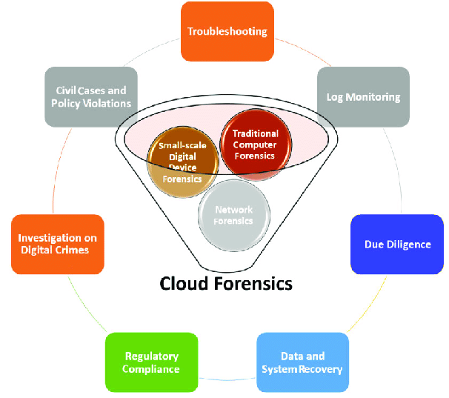
Figure 1: Cloud Forensics Diagram [16].
The later studies were elaborating on these issues, bringing to the point the technical constraints that were added because of virtualisation and abstraction of providers. Cloud infrastructures make it challenging to acquire evidence since the investigators cannot access directly the hypervisors, storage media or underlying physical resources [16]. In the same manner, Cloud studies are increasingly relying on logging mechanisms operated by providers, which degrade the transparency of the investigation and prevent investigation of evidence by third parties. This dependency presents a structure imbalance where organisations have to place their trust in telemetry produced by providers but without full infrastructure visibility.
Some other studies also maintain that the current cloud forensic frameworks are still too abstract. It is found that the evidence volatility, multi-tenancy and distributed storage are the key challenges on forensic aspects but they reported little about the deployable mitigation strategies [18]. A similar result was reached by Tanveer et al. when the authors investigated that most suggested models of cloud forensics fail to be practically verified in the framework of working cloud infrastructures [5]. As a result, a systematic disconnect between hypothetically achievable forensic capability and practice is evidenced in the literature.
Despite the fact that the field of cloud forensic research has reached its maturity, current researches are still extremely focused on metadata evidence gathering and general conceptual models. The amount of research that has evaluated layered forensic architectures that can incorporate both network-level and packet-level evidence in live AWS is relatively limited. This weakness considerably impairs evidential completeness when intricate investigations are conducted about stealth related attacks or encrypted communication links [10].

2.3 Forensic Readiness in Cloud Environments
Forensic readiness is pre-emptive preparation of systems and infrastructure and monitoring procedures to optimize the availability and integrity of digital evidence ahead of security incident [6]. Forensic preparedness entails data creation, maintenance, and accessibility as opposed to reacting to an attack, as is the case with many reactive forensic investigation procedures. In a cloud environment, this technique is especially significant due to the volatility of evidence, its spatial distribution, or the inaccessibility of evidence in the case of monitoring mechanisms not being set up in advance [2], [13].
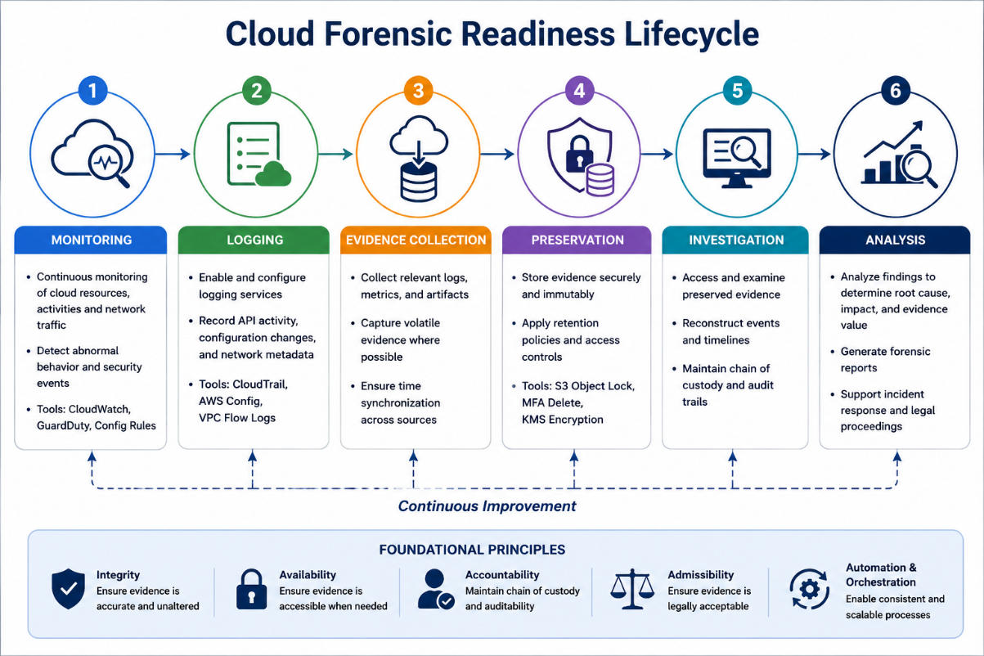
Figure 2: Cloud Forensic Readiness Lifecycle. [6]
Current literature goes on to show growing appreciation of forensic preparedness as an imperative aspect of cloud security governance. A federated forensic preparedness framework that functions to enhance evidence coordination on distributed clouds [6]. They focused their model on perpetual logging, safe preservation of evidence, and the aggregation of evidence through a centralized system. Nonetheless, the research was rather high conceptual and did not offer a lot of empirical data confirmation in the operational AWS infrastructures. Big cloud service providers are gradually providing forensic-ready services like logging, monitoring and retention controls, but most organisations did not deploy these functions effectively [13]. This implies that failures in forensic preparedness are frequently caused by architectural misconfiguration and not the fact that there is no such thing as forensic tooling.
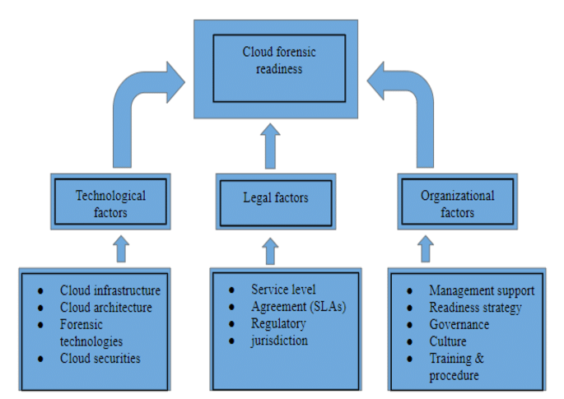
Figure 3: Forensic Readiness in Cloud Environments [5]
Cloud forensic preparedness must be automation linked and scaled orchestration of evidence to enhance the efficiency of investigation. As much as their work adds rich debate on evidence management, it discusses more procedural preparedness as opposed to evidential visibility. A majority of current readiness frameworks still put metadata gathering in the form of logs and telemetry at a high priority and receive relatively little focus on packet-based evidence gathering [3], [5].
This restricts the evidential coverage since metadata can flag potential suspicious behaviour without showing attacker motivation, the content transmitted, or behaviour of the application layer. Therefore, existing research on forensic preparedness is inadequately geared towards supporting the ongoing increase in multi-layered forensic presence requirements in AWSs.

2.4 Challenges in Cloud Forensics
Cloud forensic investigations have various technical issues and operational challenges that greatly make them very different to the conventional digital investigations. Evidence volatility is one of the most popular issues. Cloud architecture is a very dynamic one where the virtual machines, containers, and storage devices can be created or modified, migrated, or terminated very quickly [2], [5]. Volatile cloud artefacts play a role in raising the chances of loss of evidence during incident response since volatile system states may be lost before it can be acquired [33]. This issue is especially acute in elastic IaaS architecture where resources are automatically rescaled and reconfigured.
The other critical issue is multi-tenancy. Evidential isolation is particularly a challenge in shared physical infrastructures, which are common with public cloud providers, hosting multiple customers [16], [18]. Investigators are not able to just seize physical storage devices or network equipment without possibly impacting tenants who are not of interest. This leads to the operational impracticability of the traditional methods of acquiring data, like direct disk imaging, in the public cloud. Such reliance on provider-operated infrastructure curtails the transparency of investigative processes and the independence to validate evidence in the forensic system [3].
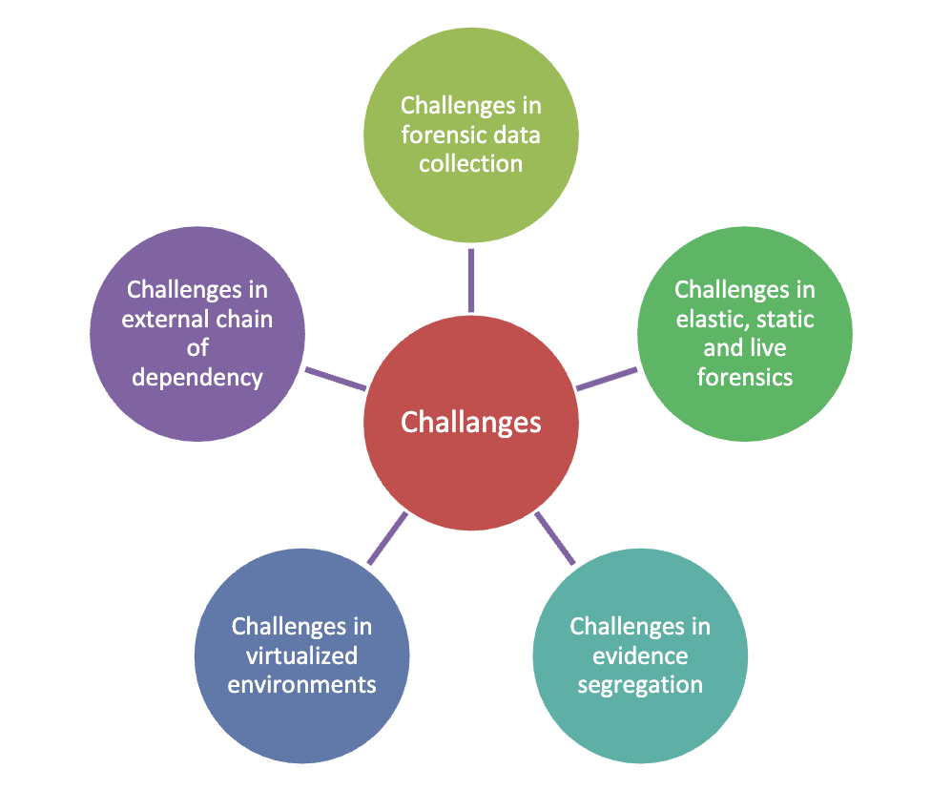
Figure 4: Cloud Forensic Challenges [20]
Legal and jurisdictional complexity is also a chronic problem. Evidence stored in the clouds can be spread under different regulatory jurisdictions in various geographic regions [25]. Consequently, investigators might not be able to access or preserve evidence outside their jurisdiction due to legal limitations. This makes it difficult to conduct chain-of-custody and can become a major hindrance in conducting an investigation.
Also, the existing methods of cloud forensics are still largely reliant on metadata-driven logging solutions like CloudTrail and VPC Flow Logs [10], [20]. Even though such services offer important contextual telemetry, full payload-level or attacker interaction data cannot be collected. This restriction compromises completeness of evidence when performing sophisticated investigations that focus on encrypted traffic, stealth behaviour, or insider threats. Therefore, the current cloud forensic processes still have significant visibility constraints despite the current advancements in cloud-native monitoring technologies.

2.5 AWS-Native Logging and Monitoring Services
AWS offers multiple native logging and monitoring services which assist in cloud security operation and forensic investigations. Some of the most important ones are AWS CloudTrail, AWS Config, VPC Flow logs and CloudWatch. All of these services offer management-layer and network-layer visibility of AWS environments, tracking API usage, configuration updates, and metadata of network communications [9], [10]. They are not a new concept in cloud security architectures and yet their forensic utility is a highly contested topic in literature.
Collectively, one of the most investigated AWS forensic services is CloudTrail due to its ability to capture account activity, API interactions across AWS resources [10]. Ojo and Benmubarak [10] showed that CloudTrail logs could be used to assist in identifying suspicious IAM activity, privilege escalation attempts, and resource manipulation, as part of investigating advanced persistent threats. Nevertheless, although CloudTrail offers good contextual visibility of management operations, it logs only metadata level network activity relating to API events, and makes no attempt to document network communication at payload level. As a result, investigators can spot suspicious behaviour, with little knowledge of attacker intent or conveyed content.
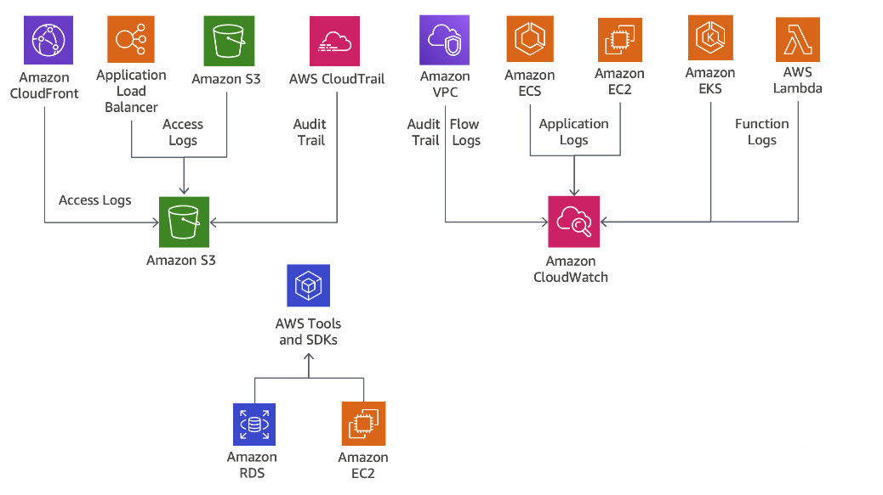
Figure 5: AWS Logging Architecture Diagram [20]
AWS Config works in conjunction with CloudTrail to track changes in infrastructure configuration and keeping historical records of configuration [9]. By combining Config with the centralised evidence architectures, it is possible to enhance forensic reconstruction through the matching of resource changes and security events. However, Config still relies on metadata correlation unlike procuring evidence itself. Equally, VPC Flow Logs capture network communication information including the source IP addresses, destination IP addresses, protocols and direction of the traffic [20]. Flow Logs is also not capable of capturing application-layer data and encrypted session contents, whereas it is handy in identifying suspicious traffic patterns.
Various authors claim that these constraints highlight one of the key weaknesses of AWS-native forensic telemetry [3], [5]. The currently available logging services offer a good visibility of events with inadequate evidential granularity to do a full reconstruction on a forensic basis. As such, using AWS-native metadata logs on their own can give partial investigations, especially when using advanced attacks involving secret communication or exploits via payloads. Such a shortcoming continues to fuel the need to incorporate the use of packet-level network forensic monitoring into the context of conventional cloud telemetry systems.
AWS vs Azure vs GCP Forensic Capability Comparison
Feature | AWS | Microsoft Azure | Google Cloud Platform
Native Logging | CloudTrail, CloudWatch | Azure Monitor, Activity Logs | Cloud Audit Logs
Packet Capture Support | Traffic Mirroring | Network Watcher | Packet Mirroring
Immutable Storage | S3 Object Lock | Immutable Blob Storage | Bucket Lock
Identity Monitoring | IAM + CloudTrail | Azure Active Directory | Cloud IAM
Network Monitoring | VPC Flow Logs | NSG Flow Logs | VPC Flow Logs
Infrastructure Automation | Terraform, CloudFormation | ARM Templates | Deployment Manager
Forensic Readiness Capability | High | Moderate to High | Moderate
Evidence Preservation Support | Strong | Moderate | Moderate
Suitability for This Research | Highly suitable | Suitable | Suitable but less integrated
Table 3: AWS vs Azure vs GCP Forensic Capability Comparison
Source: Selfdeveloped

2.6 Network Forensics and Packet-Level Visibility
Network forensics has since gained relevance in cloud investigations since it allows investigators to examine communication behaviour, protocol activity as well as the data transmitted over network infrastructures. Packet-level is used to give a concept of the actual content within relevant traffic of the network, unlike metadata-based logging in which only a context of the traffic is captured [20]. This is a paramount difference since contemporary attackers often employ the use of encrypted communication channels, stealth techniques, and cloud-native attack paths that cannot be completely recreatable with metadata by itself [14], [21].
Enumerated packet analysis as one of the most detailed methods of digital network investigations since it allows forensic reconstruction of sessions of communication, protocol interactions as well as application-layer behaviour [20]. Network forensics at scale gains more and more importance in the context of a public cloud as the methods of cyberattacks against virtualised infrastructures develop [14]. Their analysis indicated that metadata-based monitoring frequently detects suspicious traffic patterns but does not provide the details of the intentions of the attacker, the content being transferred, or the details of the execution of the exploits.
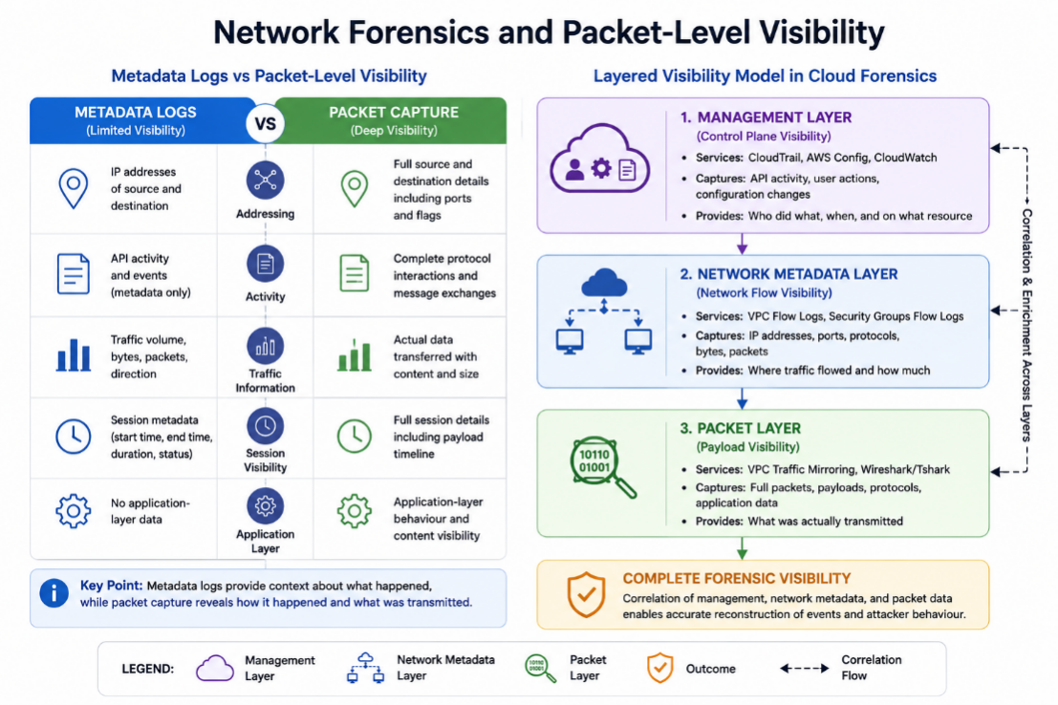
Figure 6: Network Forensics and Packet-Level Visibility [20].
Although to these observations, relatively small literature on cloud forensics assesses viable packet level monitoring in the AWS landscape [2], [3]. The majority of research is still based on management logs and network metadata, with very little comments on infrastructure-level traffic capture. Sophisticated threat actors often use low-observable methods of communication, which are intended to reduce the amount of detectable telemetry [21]. Advanced attackers on clouds develop more and more resistance to traditional detection methods by adopting stealth-based communication techniques. Such observations justify the need of increased awareness of network during the forensic investigation.
AWS VPC Traffic Mirroring is a solution to this problem to some degree that allows to copy traffic carried across the network by target instances to separate monitoring systems. Nevertheless, literature does not offer much empirical study on the combination of Traffic Mirroring with the packet capture tools like Wireshark or Tshark. As a result, there is a research gap to bridging when it comes to how effectively AWS-native telemetry can be used alongside packet-level evidence retrieval to enhance the completeness of evidence and attack re-creation in the clouds.

2.7 Evidence Integrity and Chain of Custody
Evidence integrity is one of the key demands of the digital forensic investigation as evidence needs to be authentic, verifiable, and unchanged during the investigation lifecycle. In cloud system environments, upholding the integrity of evidence is much more complicated because of distributed storage structures, reliance on providers, and unpredictability of cloud services [12], [23]. In turn, cloud forensic investigations demand a strong preservation framework that would be able to guarantee chain-of-custody guarantee even with the limitation of physical control over infrastructure.
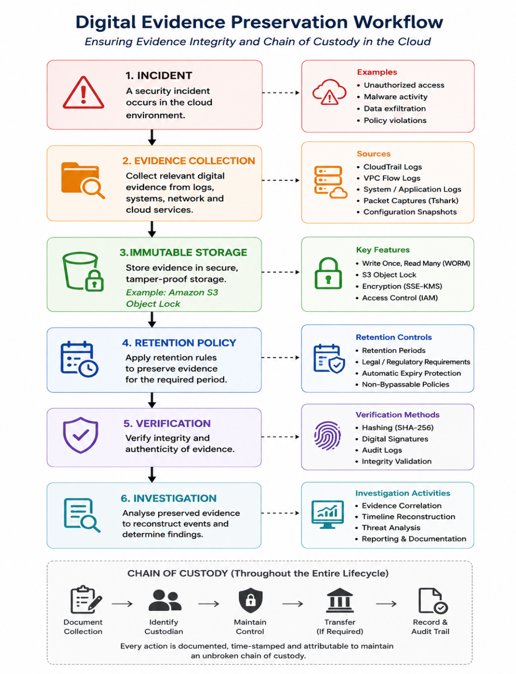
Figure 7: Digital Evidence Preservation Workflow [12].
Reliable digital evidence is one of the unresolved problems of utmost importance in the cloud computing settings [23]. Investigators frequently take advantage of provider-managed telemetry and centralised logging systems and, as such, decrease the ability to independently validate and raise issues about evidence authenticity. No standardised procedure has existed to regulate the preservation and validation of evidence in cloud forensic tests [12]. Such non-standardisation poses inconsistency in the methodological approaches used in investigations and could undermine the defensibility of the evidence in court cases.
Various works offer blockchain-based strategies on chain-of-custody assurance [24]. Distributed ledger technologies may offer a solution to evidence tracking by offering tamper proof evidence handling records. In spite of blockchain architectures having excellent prospects of theoretical integrity, their operational complexity and scalability weaknesses decrease feasible adoption in enterprise clouds. As a result, simplified forms of immutability are still largely relied upon by many organisations as direct offerings by cloud service providers.
AWS S3 Object Lock is one of such mechanisms which allows retention policies and compliance-mode restrictions to protect write-once-read-many (WORM) evidence. As conceptual evidence preservation is extensively discussed in the existing literature, there is relatively less concrete empirical research that assesses immutable cloud storage in practice in forensic-ready AWS solutions [13], [23]. This weakness is relevant because the immutability of evidence has a direct impact on chain-of-custody and reliability of investigation. In the absence of sound preservation measures, criminals can alter or destroy forensic pieces of evidence, leading to a loss of investigative integrity and a loss of trust in the evidence yielded during post-incident investigations.

2.8 Multi-Layer Forensic Correlation
The use of the telemetry sources in investigations is heavily divided as one of the greatest constraints in the existing research in cloud forensics. Current forensic architectures tend to deduce on individual evidence stream, e.g. API log, configuration records or network metadata instead of relating several layers of evidence to form a single investigative model [3], [5]. This discontinuous methodology makes forensic visibility lower since no individual telemetry source can enable us to have full context of attacker behaviour in cloud environments.
AWS-native services (like CloudTrail and AWS Config) are mostly used to offer management-layer visibility by capturing API activity and infrastructure changes [9], [10]. VPC Flow Logs bring visibility to the network layer with communication metadata containing source addresses, destination addresses, ports and protocols [20]. Nonetheless, such services are still largely based on metadata, as opposed to complete-content evidence-gathering. Would this mean that investigators can track down suspicious activity or communications patterns without being aware of the payload or application-layer behaviour or even exact attacker intent of those activities?
Centralised evidence architectures that could coordinate telemetry generated by distributed settings in order to enhance the effectiveness of the forensic analysis process [9]. Universal cloud-based evidence tracing model aimed at aiding investigations that are at an upscale level [8]. Despite these studies enhancing evidence coordination and aggregation, neither of them offered much of analysis on the integration of forensic at the packet level or payload reconstruction. This reflects an ongoing insistence of telemetry centralisation and not evidential depth.
The need to have multi-layer forensic visibility is most pronounced in advanced persistent threats investigations. The advanced cyber attackers tend to reduce sample traceable activity in the management logs as they exploit hidden network communication tools [21]. Metadata may not be enough to the forensic reconstruction in such situations. As a result, the integration of management telemetry and network metadata with the analysis of packets is becoming more strongly defended by a number of researchers as the means of enhancing the dependability of investigations [14], [20]. Nevertheless, the application of layered forensic architectures in the context of AWS is relatively understudied empirically. The gap in research is a direct impetus to the current study that assesses integrated forensic visibility by means of correlated AWS telemetry and packet-level network capture.

2.9 Research Gap
The literature examined illustrates that cloud digital forensics has changed significantly due to the fast pace of the use of cloud computing infrastructure. The available literature offers in-depth consideration of forensic issues, forensic preparedness models, evidence transformation, and cloud-native surveillance solutions [1], [2], [18]. Nevertheless, even with this expanding research, there are still a number of major shortcomings that have not been addressed in existing research and practice in cloud forensics.
Firstly, there is a considerable amount of literature that is theoretical without being substantiated by empirical evidence. Many authors suggest forensic preparedness models, evidence frameworks, and architectures of cloud investigations without executing them in operational clouds infrastructures [5], [6], [19]. As such, little is known about the performance of these theoretical methods in the context of live AWSs under real attack scenarios. This inadequacy undermines the usefulness of most of these suggested forensic models in practice.
Second, current research in cloud forensics is still greatly reliant on metadata-driven telemetry systems, including AWS CloudTrail and VPC Flow Logs [9], [10]. These services, though very useful in the provision of contextual information about API activity and network communication, do not record packet payloads or application-layer behaving in detail [20]. Consequently, investigators can detect suspicious activity without the evidential depth required to recreate the intent of attackers and verify exfiltration activity in its entirety.
Third, the development of the integration of AWS-native telemetry with the use of the packet-level one-to-many forensic monitoring technologies includes comparatively very few studies that analyse VPC Traffic Mirroring and Wireshark/Tshark packet analysis [14], [20]. Current research often recognizes the shortcomings of metadata-based investigations but seldom realizes layered forensic architecture that has the capacity to link management to network, as well as payload evidence all at once.
Lastly, evidence preservation technologies, including stored immutable S3 Object Locks, have comparatively little empirical investigation despite the significance of evidential integrity and ensure the chain of custody [23]. Thus, there is an evident gap in the research in terms of practical usage and testing of multi-layer forensic-ready architectures in AWS IaaS infrastructures. This gap is filled by this dissertation, where AWS-native telemetry is incorporated, a packet-level network-monitoring tool, and immutable evidence preservations are merged into a single forensic investigation framework.

2.10 Chapter Summary
This literature review critically analysed previous studies in the field of cloud digital forensics, forensic preparedness, AWS-native monitoring technology, network forensics, evidence integrity, and multi-layer forensic correlation. The review found that despite mature research ideas under cloud forensics, most of the proposed frameworks are theoretical, without practical validation in real operational AWS contexts. Current research heavily depends on metadata-driven telemetry like CloudTrail and VPC Flow Logs that offers little visibility at a payload level when performing advanced investigations. Moreover, there has been a paucity of studies to investigate the use of packet-level forensic monitoring and immutable evidence preservation in AWS forensic restructurings. These limitations demonstrate the need for more practical and experimentally validated forensic readiness approaches. This dissertation thus fills the identified research gap by deploying and testing a layered AWS readiness framework of forensic preparedness that integrates cloud-native telemetry, packet capture and immutable evidence preservation systems.

CHAPTER 3: RESEARCH METHODOLOGY

3.1 Introduction
The chapter presents a research methodology used in evaluating targets the forensic preparedness aspect of Amazon Web Services (AWS) Infrastructure-as-a-Service (IaaS) environments. The study was narrowed down to designing and experimentally testing a forensic-ready AWS architecture to enhance evidence acquisition, preservation and attack reconstruction with AWS-native telemetry and packet level monitoring. The advantage of adopting AWS was the availability of a mature forensic platform framework, with features like CloudTrail, VPC Flow Logs, Traffic Mirroring, AWS Config, and S3 Object Lock, which give greater forensic visibility and evidence integrity than other cloud platforms like Azure and GCP [3] [10] [20].

3.2 Research Philosophy and Approach

Figure 8: Research Onion [36]
The research philosophy used in this research was pragmatic since the research was aimed at solving realistic cloud forensic problems and not formulating a purely theoretical forensic model. Pragmatism was suitable since the study aimed at examining the operational efficiency of forensic preparedness mechanisms that have been put in place in a real AWS setting [7]. The research thus placed an emphasis on pragmatic testing, implementation of infrastructure and empirical review. They were implemented using qualitative case-study and an experimental implementation of cloud infrastructure. The case-study approach provided an opportunity to specifically discuss forensic preparedness controls using a controlled AWS background, whereas the experimental element of the approach facilitated the creation and interrogation of forensic artefacts in a simulated attack environment [8]. The integrated method gave the flexibility in assessing the technical implementation as well as the investigation effectiveness. The study was conducted in an applied engineering approach of cybersecurity deployment, forensic-logging setup, network traffic monitoring, evidence-gathering, and forensic-analysis. This is in line with more recent developments in cloud forensic studies which are increasingly focusing more on practical implementation and validation of forensic frameworks instead of conceptual analysis [2], [5].

3.3 Research Design
The study was to be an experimental study on controlled forensic preparedness in the context of AWS. The environment had been set up in a conscious attempt to emulate attributes of operation that are commonly prevalent in an enterprise cloud infrastructure [10]. The design aimed to determine the potential to use management-layer telemetry and network metadata in conjunction with packet-level traffic analysis to enhance cloud forensic investigations. The deployed environment was comprised of various AWS services such as EC2 and IAM, Virtual Private Cloud (VPC), AWS CloudTrail, AWS Config, VPC Flow Logs, VPC Traffic Mirroring, and Amazon S3 [12]. These services have been part of a layered forensic architecture that is to provide support to evidence acquisition, preservation, and analysis. There were four significant layers in the architecture. The innermost level was evidence preservation that was done in the form of immutable S3 storage. The second layer introduced the use of monitoring and logging mechanisms. The third tier created a forensic investigation environment that was isolated to examine evidence. The fourth layer was an identity and access control by separation of IAM roles and least-privilege access. The experimental design aimed to test the hypothesis of AWS-native logging services having enough evidential visibility to aid cloud investigations and a hypothesis of infrastructure-level packet capture enhancing the attack reconstruction capabilities. The research also investigated the role of irreversible storage of evidence in providing chain-of-custody assurance and evidential integrity.

3.4 Experimental Environment
The experimental setup was implemented as fully in AWS as possible since AWS is currently one of the most widely used public cloud services in the world and offers a wide range of native telemetry and monitoring solutions that would be used in forensic studies [3].

3.4.1 EC2 Infrastructure
The AWS environment had two major EC2 instances. The first example is known as Compromised-Target, and was the main location used during simulated suspicious activity and reconnaissance drills. The second case was called Forensic-Clean-Room and was a closed forensic work station focused on only handling evidence and packet inspection. The clean-room case was specifically isolated out of the external network access to reduce the possibilities of contaminating evidence in case of an investigation. Instead of having to access the forensic instance directly via SSH, the server was controlled using AWS Systems Manager (SSM). This minimized exposure to external risks with a management mechanism of auditable accountability. Forensic analysis software such as Tshark, Wireshark CLI, tcpdump, Python and Git were also installed in the clean-room environment to assist with analyzing packets and reviewing evidence [3].

3.4.2 VPC and Network Configuration
The environment of a forensic infrastructure and network traffic was isolated in a separate Virtual Private Cloud (VPC). VPC architecture comprised of public subnet and private subnet, route tables, and security groups. Security groups were set on the basis of least-privilege philosophy to reduce the unwarranted lines of communication. The case of forensic clean-room was implemented in a private subnet where inbound internet connectivity was not allowed. Outbound communications were limited to software updates and critical access to AWS services. This design minimized the chances of compromising the forensic environment itself when conducting investigations.

3.5 Forensic Readiness Architecture
The forensic architecture that was implemented aimed at providing continuous forensic preparedness as opposed to reactive evidence gathering [3]. This was to ensure that evidence being acquired and monitoring mechanisms were in place prior to occurrence of suspicious activity.

3.5.1 Immutable Evidence Vault
An Amazon S3 bucket was created in hardened mode to serve as the forensic evidence storage. S3 Object Lock was switched on in Compliance Mode as a means to make something immutable. After evidence files were written to the bucket, it was not possible to delete them or alter them during the retention period, even when the administrative accounts used were privileged. This enhanced evidential integrity and chain-of-custody guarantee. The versioning of buckets was turned-on to save the state of the historical objects and avoid the possibility of overwriting evidence. AES-256 encryption at rest was set up to ensure the evidence is confidential. Public access settings were completely turned off to guarantee that forensic artefacts would not be tampered with by unauthorised external access. CloudTrail logs, VPC Flow Logs, AWS Config snapshots, and exported forensic artefacts were put in S3 evidence vault and were created during experimentation [10].

3.6 Logging and Monitoring Configuration

3.6.1 AWS CloudTrail
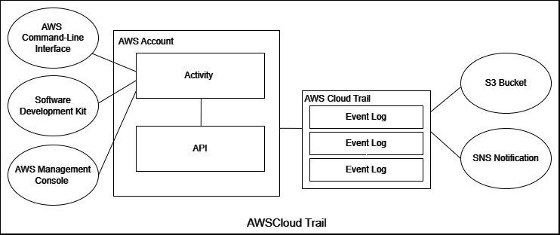
Figure 9: AWS CloudTrail [10].
AWS CloudTrail was set up to record management events and API activity continuously throughout the AWS account [10]. CloudTrails helped to document activities like the creation of IAM users, role changes, credential activities, and changes in infrastructure configuration. Log file validation was also enabled to aid integrity checking and deterring unauthorised attempts of modifying log files. CloudTrail offers forensic visibility at the management-layer, whereby logs captured the person who performed a certain action, the time of the action, and the impacted resource in AWS.

3.6.2 AWS Config
AWS Config was put in place to keep track of configuration changes in an on-going fashion on resources in AWS. Changes in the service were registered on EC2 instances, VPC configurations, IAM resources, S3 buckets. AWS Config played a successful role as a historical state reconstruction tool to allow the investigators to examine the development of infrastructure configurations with respect to their time [15].

3.6.3 VPC Flow Logs
VPC Flow Logs were enabled to record network traffic information in the AWS setup. These logs captured source and destination IP addresses, ports, protocols, direction of traffic and count of packets. Flow Logs offered an insight on communication patterns between the AWS resources and other systems. As much as VPC Flow Logs helped in detecting any suspicious network traffic and possible patterns of data exfiltration, they failed to retain the content and protocol payloads of the individual packets [3]. This shortcoming has been a critical analytical area of interest in the study.

3.7 Traffic Mirroring and Packet Capture

3.7.1 Traffic Mirroring Configuration
AWS VPC Traffic mirroring was set up to mimic real time network traffic of the attacked EC2 machine straight to the forensic clean-room setup. Traffic Mirroring has provided passive network monitoring without having intrusive changes to the target instance. Mirror sources, mirror targets and mirror filters were used to develop mirror sessions. VXLAN was used to encapsulate the mirrored traffic and it was transported over UDP port 4789.

3.7.2 Tshark/Wireshark Deployment
The Tshark and Wireshark CLI were configured to give a packet-level analysis of the mirrored traffic in the forensic clean-room case. Tshark was set up to track VXLAN traffic with: sudo tshark -i eth0 -f "udp port 4789". This setup allowed a packet capture and protocol inspection to proceed continuously. In contrast to CloudTrail and VPC flow logs, Tshark enabled payload visibility on HTTP requests, metadata service probing requests, TCP flows, and protocol activity.

3.8 Attack Simulation
Tasks simulation was carried out in controlled attacks and created forensic artefacts to analyse and correlate.

3.8.1 IAM Activity Simulation
CloudTrail forensic evidence was simulated to deal with suspicious IAM activities. These operations involved IAM user creation, session manipulation, and operations pertaining to credentials. Specific IAM users like Suspicious-Analyst were established to model unauthorised administrative behaviour.

3.8.2 Metadata Service Probing
Simulated metrics attacks (71) against the AWS Instance Metadata Service (IMDS) were performed with references to it via the following requests: http://169.254.169.254/latest/meta-data/. This operation was an emblematic cloud-native reconnaissance method that is usually related to credential harvesting and privilege lifting endeavors in AWS surroundings [10]. The simulation produced correlated data with CloudTrail, VPC Flow logs, and Tshark packet captures.

3.9 Data Collection Methods
Simultaneously, across various layers of telemetry, within the AWS environment, forensic evidence was gathered. CloudTrail logs gave management-layer logs of activity, AWS Config logs of configuration logs, VPC Flow Logs logs of network logs, and Tshark logs of packet-level logs. The multi-layered evidence gathering approach allowed thorough forensic coordinate between management activity, network traffic, and packet-based behaviour. All artefacts gathered were kept in the unalterable S3 vault of evidence to be analysed in the future.

3.10 Data Analysis Techniques
The assembled forensic artefacts were examined with the help of qualitative forensic analysis techniques, which were aimed at the correlation of events, reconstruction of an attack, visible evidence, and completeness of the investigation. Network metadata and Tshark captures were mapped to CloudTrail API events to reverse engineer attack timelines, as well as detect and track patterns of suspicious behaviour. To identify metadata service probing attempts and the HTTP requests as well as suspicious traffic activity, packet analysis was done. Evidential integrity was also assessed in the study with the effectiveness of S3 Object Lock, retention policies and immutable storage controls measured to eliminate evidence tampering.

3.11 Ethical Considerations
The study was carried out in full control condition of an AWS of the researcher who is also the owner of the said environment. Experimentation was not on any outside system or third-party network. Any attack simulations have been limited deliberately to guide analysis activities in the form of controlled forensic validation that is specifically used to conduct academic research.

3.12 Justification for Selecting AWS
Amazon Web Services (AWS) were chosen for the experimental cloud platform as AWS has a well-established and active forensic community, has widespread adoption and provides robust integration of cloud-native monitoring and evidence collection tools. Advanced forensic tools like CloudTrail, VPC Flow Logs, AWS Config, Traffic Mirroring, Systems Manager, and AWS S3 Object Lock, all of which provide features for managing-layer monitoring, network visibility, packet-level acquisition, and immutable evidence preservation. The services have features that are ideal for a pragmatic forensic readiness architecture. AWS becomes an attractive option over Microsoft Azure, and Google Cloud Platform (GCP), as it provides more powerful integration amongst infrastructure monitoring, packet acquisition, and evidence preservation mechanisms. Of particular interest, AWS Traffic Mirroring now allows you to passively capture all traffic directly from the packet level in an Elastic Network Interface (ENI), making network investigations easier to perform with improved forensic visibility. Moreover, by offering immutable evidence retention, Compliance Mode gives powerful chain-of-custody capabilities with Amazon S3 Object Lock. The other significant reason is due to AWS being the major competitor in the cloud market with a wide range of enterprise applications in use, and thus being relevant for real-life forensic investigation scenarios. The growing discovery that AWS resources can be managed through an automation tool like Terraform and that most AWS forensic resources are compatible with third-party security tools only enhance that fact that it is a great place to conduct experimental forensic research.
Comparative Justification for Selecting AWS
Evaluation Criteria | AWS | Microsoft Azure | Google Cloud Platform (GCP)
Market Adoption | Highest global cloud market share | Strong enterprise adoption | Lower enterprise adoption
Native API Logging | CloudTrail | Azure Activity Logs | Cloud Audit Logs
Network Metadata Logging | VPC Flow Logs | NSG Flow Logs | VPC Flow Logs
Packet-Level Monitoring | Traffic Mirroring | Limited packet capture integration | Packet Mirroring
Immutable Evidence Storage | S3 Object Lock | Immutable Blob Storage | Bucket Lock
Infrastructure Configuration Monitoring | AWS Config | Azure Policy / Monitor | Cloud Asset Inventory
Terraform Integration | Extensive support | Supported | Supported
Forensic Tool Ecosystem | Highly mature | Moderate | Moderate
Packet Analysis Compatibility | Strong Tshark/Wireshark integration | More limited implementation support | Moderate support
Chain-of-Custody Support | Strong through immutable S3 storage | Moderate | Moderate
Suitability for This Research | Highly suitable | Suitable but less integrated | Suitable but less mature for forensic readiness
Table 4: Comparative Justification for Selecting AWS
Source: Self developed
Eventually, AWS was chosen due to its more extensive and truly integrated forensic ecosystem compared to Azure and GCP. CloudTrail, Traffic Mirroring, VPC Flow Logs, and S3 Object Lock provide multi-layer forensic visibility of the management, network, and packet layers. Moreover, AWS provides more effective evidence preservation and infrastructure-level monitoring, needed for pursuing realistic and hands-on forensic readiness experiments in the cloud, respectively.

3.13 Limitations of the Methodology
The study had a number of limitations. The study only considered AWS IaaS environments and made no multiclosure forensic interoperability assessment. Also, the payloads of encrypted traffic cannot be deciphered in all cases when analyzing all packets. Network and management-layer evidence acquisition also were the main priorities of the study and did not involve memory forensics advanced techniques or malware reverse engineering.

3.14 Chapter Summary
In this chapter, the research design applied to measure forensic preparedness in AWS IaaS settings was given. To operate a multi-layer forensic architecture comprised of AWS-native telemetry, packet-level monitoring, and immutable evidence preservation, a pragmatic experimental case-study approach was embraced to implement and evaluate it. The approach included the deployment of a monitored AWS forensic setup that is inclusive of CloudTrail, AWS Config, VPC Flow Logs, VPC Traffic Mirroring, Tshark packet analysis, and secure S3 evidence storage. Forensic artefacts were simulated as a result of attack simulation, gathered, stored, correlated, and analysed to test the investigative visibility and investigative integrity. In the next chapter, the design of the implemented AWS forensic readiness architecture is provided in great detail.

CHAPTER 4: FORENSIC ARCHITECTURE DESIGN

4.1 Introduction
This chapter describes the design of the AWS forensic preparedness architecture which was carried out in this study. The architecture was created with the aim of enhancing forensic visibility, preservation of evidence and reliability of investigation in AWS cloud environments. The current cloud forensic methods make costly use of metadata-based logs, which do not offer much information on the behaviour of attackers [10]. Moreover, cloud infrastructures are highly dynamic, and, unless evidence collection mechanisms are introduced proactively, collection artefacts might be altered, or even lost. The architecture has provided solutions to these restrictions by introducing AWS-native monitoring services, immutable evidence storage, traffic mirroring and packet level analysis as a single forensic ecosystem [21]. The design emphasized on the continuous evidence acquisition, forensics isolation, integrity of evidence, and multi-layer forensic correlation.

4.2 Design Objectives
The architecture was conceptualized based on some of the forensic-readiness goals that were found in the literature review. The initial goal was to create a continuous monitoring on the management, network, and packet levels in the AWS environment. The AWS CloudTrail, VPC Flow logs, AWS config, and Traffic mirroring were stacked to make sure that forensic artefacts would be gathered prior to the happening of suspicious activity. The second was on preservation and integrity of evidence [15]. There is high risk of evidence alteration by attackers who acquire administrative privileges in cloud environments since they may seek to alter or destroy forensic logs. To curb this issue, the architecture adopted in place Amazon S3 Object Lock storage in Compliance Mode. The third targeted to enhance greater forensic visibility than metadata recording. There is no standard cloud telemetry that is able to capture the payloads in packets or protocol level behaviour. Thus, AWS Traffic Mirroring and Tshark were incorporated to support the capability of obtaining infrastructure level packet acquisition and protocol inspection [10]. The last objective was to have a secure forensic analysis environment unrelated to production infrastructure. This was done by introducing a special forensic clean-room instance with AWS Systems Manager instead of SSH.

4.3 Architectural Overview
The hardware architecture was made up of four cohesive layers forensic infrastructure, monitoring and telemetry collection, evidence preservation and identity and access management. Collectively, these elements formed a proactive forensic-ready ecosystem which can continuously gather, store and analyze forensic evidence in AWS [10]. This environment was implemented in the AWS us-east-1 area with the principles of the Infrastructure as Code with the help of Terraform automation. Terraform maintained consistency and repeatability in configurations, and standardised deployment of forensic controls. Two EC2 instances were used in the architecture. The initial one titled Compromised-Target was our observed workload in the case of experimenting. The second one is referred to as the Forensic-Clean-Room and served as the closed forensic laboratory where packet capturing and evidence analysis were done.
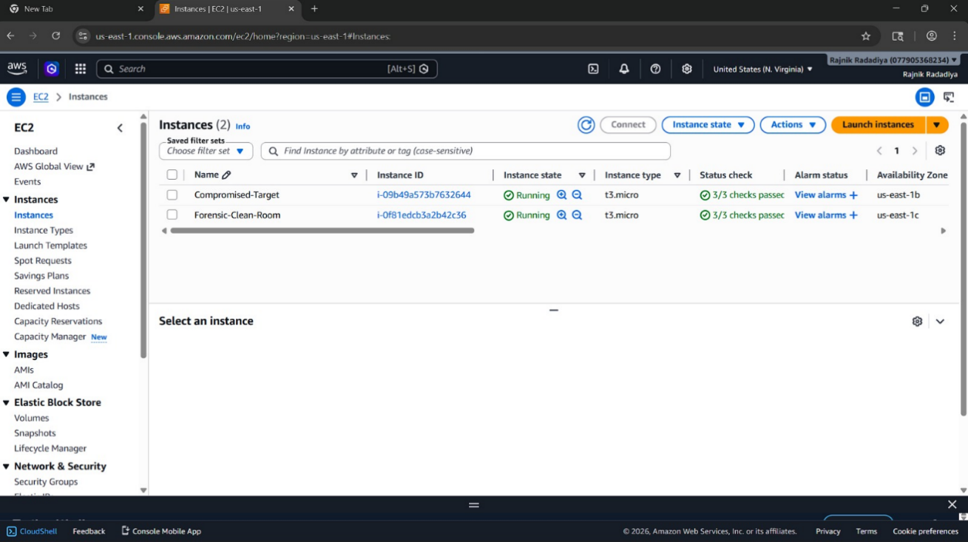
Figure 10: AWS EC2 Instance Infrastructure [AWS]
CloudTrail, AWS Config, VPC Flow Logs, Traffic Mirroring and Tshark packet analysis were incorporated in the monitoring layer. The immutable S3 storage layer was used as evidence and the IAM layer implemented role separation and least-privilege access controls.

4.4 EC2 Forensic Infrastructure Design
EC2 architecture created the operational base of the forensic architecture. Compromised-Target case that was experienced during the experimentation produced a suspicious activity, management operations, and network traffic. This example was the monitored system where forensic artefacts were obtained. The “Forensic-Clean-Room” example was the isolated forensic workstation to check mirrored traffic and analyse evidence. The clean-room design was created with forensic isolation principles which aim at reducing the risk of contamination during the investigation process. The forensic clean-room was configured to use only AWS Systems Manager Session Manager, unlike the traditional cloud administration environments which required the use of SSH. This eliminated the requirement of the inbound SSH exposure and minimized the attack area of the forensic setting substantially. The clean-room example also involved the Tshark, Wireshark CLI, and tcpdump, as well as Python 3 and Git. These tools facilitated packet analysis, inspection of traffic and evidence parsing in the isolated environment. The clean-room was inside a single subnet with limited outgoing communications. This enhanced investigative security as well as limited chances of exfiltration of evidence during analysis operations.

4.5 VPC and Network Architecture
AWS Virtual Private Cloud (VPC) was used to implement the network architecture. The VPC environment offered separation of watched machines and forensic examination facilities and limited connectivity structure to allow supervision operations to work. The least-privilege principles were used to set up security groups. Inbound communication had been severely curtailed and only necessary outbound communication has been allowed. This minimized on the unwarranted exposure and enhanced containment measures in the environment. It was also through the architecture that AWS Traffic Mirroring was incorporated so that passive packet acquisition can be made on the compromised-target instance itself.
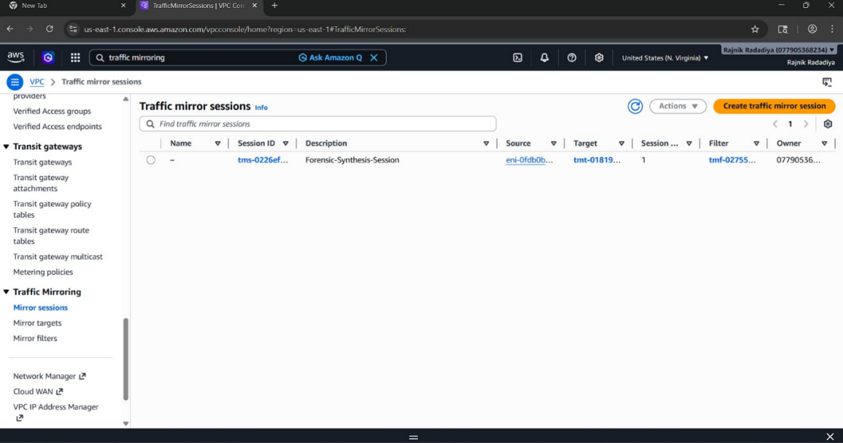
Figure 11: AWS Traffic Mirror Session Configuration [AWS]
The mirror session structure was composed of a mirror filter (MF), a mirror target and a mirror source (MS). The monitored EC2 network interface was the source of the mirror and the forensic clean-room was the target of the mirror. UDP port 4789 was used to encapsulate mirrored traffic using VXLAN. This design enhanced forensic visibility as the investigators were in a position to view network traffic in real-time, without having to change the workload being monitored.

4.6 Evidence Preservation Architecture
The immutable forensic evidence vault was among the most significant elements that were employed in this study. The layer is the evidence preservation which is Amazon S3 set up with Object Lock activated in Compliance Mode. Compliance Mode allowed forensic artefacts to be removed or edited during the valid period of the configured period even by the administrators or the root accounts. This was a direct response to one of the key cloud forensic issues that were detected in the literature body, namely evidential volatility. S3 vault also provided lifecycle retention policies, AES-256 server-side encryption, bucket versioning, and Block Public Access policies. These mechanisms enhanced integrity and confidentiality of evidence. CloudTrail logs as well as VPC Flow Logs, AWS conf snapshots, and exported packet captures were retained in the evidence vault. The design thus provided a legally justifiable evidence preservation system in accordance with the chain-of-custody highlights.

4.7 CloudTrail Logging Architecture
The management-layer telemetry of the forensic architecture was made up with AWS CloudTrail. CloudTrail monitored the AWS account at all times, capturing all calls and management activity. Some of the events observed during experimentation were the creation of sessions, the activity of a heartbeat, IAM actions, credential management, and changes of the infrastructure. CloudTrail log validation was also activated to enhance evidential integrity by ensuring that the attempts to modify log unauthorised are noticed before archival can take place. CloudTrail was the main source of management-layer attribution in the architecture as it empowers the investigator to find out who took an action, when the action was taken and which AWS service has been impacted. Nevertheless, CloudTrail was insufficient to tell what packets contain, or anything about application-layer behaviour, and this illustrates the constraints of metadata-only cloud logging.

4.8 AWS Config Integration
AWS Config was added to offer the reconstruction capabilities of historical infrastructure. The rapidly changing environment of dynamically provisioned clouds can pose a challenge in the case of security incidents where the states of resources in the past are unknown. AWS Config monitored the resource configuration state all through the AWS account such as the EC2 instances, IAM policies, security groups, S3 buckets, and VPC infrastructure. This was used effectively as a time machine in the cloud so far as it offered the opportunity to investigators to rebuild historical infrastructure states whenever they were investigating a crime case. The integration increased the completeness of investigations since investigators could examine not only suspicious actions but also examine the infrastructure changes that relate with suspicious actions.

4.9 Traffic Mirroring and Packet Analysis Architecture
Conventional AWS logging solutions are not typically used to offer packet-level communication visibility, but instead metadata visibility. In order to eliminate this drawback, the architecture incorporated AWS Traffic Mirroring and Tshark packet analysis. Live network traffic between the compromised-target instance and the forensic clean-room was mirrored by Traffic Mirroring. Mirrored VXLAN traffic sent on UDP port 4789 was then inspected using tshark. The following was used to initiate packet acquisition: sudo tshark -i eth0 -f "udp port 4789". This setup allowed researchers to scan TCP sessions, HTTP requests, protocol headers and mirrored network traffic. Compared to CloudTrail and VPC Flow Logs, the packet analysis offered application-layer insights into the behaviour of the attackers. The implementation thus covered the content gap in forensics that is usually recognized in cloud forensics where metadata records do not provide any insight into the true nature of network communication.

4.10 IAM and Access Control Design
The implementation of Identity and Access Management controls was based on the principles of least-privilege and role-separation. Separated IAM users, groups and roles were established to provide a distinction between operational administrative and forensic investigation duties. The architecture applied also suppressed forensic analyst privileges, and operation administrative privileges.
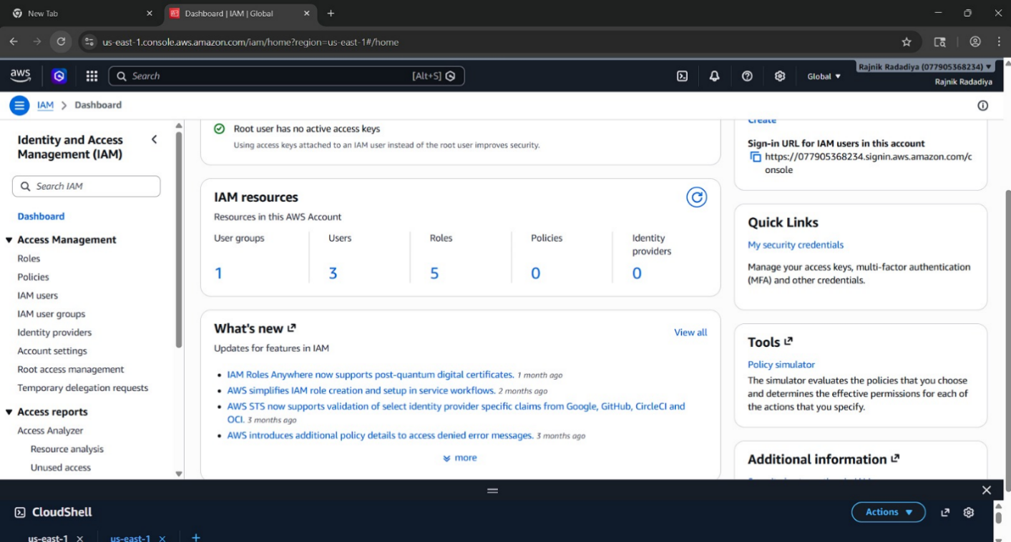
Figure 12: IAM User and Role Configuration [AWS]
Forensic Analyst position was specifically restricted to access to evidence and access to forensic clean-rooms. Investigators were not able to alter resources of production infrastructure. This minimized pollution threats in the course of the investigation and enhanced accountability in the whole of the environment.

4.11 Attack Simulation Design
The architecture was tailored to enable the simulation of suspicious activities under control that can establish forensic artefacts at several layers of telemetry. The study modeled metadata service probing, management activity, session creation and suspicious IAM operations. Probing metadata service: http://169.254.169.254/latest/meta-data/. This was a simulated behaviour of cloud-native reconnaissance that corresponded to the attempts of credential harvesting and privilege escalation. Evidence produced by a simulated activity was made visible in both CloudTrail, VPC Flow logs and Tshark packet traces in real time, allowing multi-layer forensic correlations to be made during analysis.

4.12 Architectural Strengths
The architecture implemented solved a number of limitations that were experienced during cloud forensic literature. First, the architecture enhanced the forensic visibility of the management, network, and packet-level telemetry that were turned into a complete monitoring ecosystem. Second, immutable S3 Object Lock largely enhanced the integrity of evidence and chain-of-custody guarantee. Third, Traffic Mirroring and Tshark minimized reliance on metadata-based telemetry since they provided infrastructure-level access to packets. Fourth, enhanced investigative protective measures as well as minimizing risks of contamination were enhanced by the isolated forensic clean-room. Lastly, deployment based on Terraform enhanced the consistency of deployment and reproducibility across clouds.

4.13 Chapter Summary
In this chapter the design of the AWS forensic readiness architecture was outlined which was conducted during this research. It enabled the architecture to combine AWS-native telemetry services, immutable evidence storage, detached forensic infrastructure, Traffic Mirroring and packet-level analysis into a stacked forensic ecosystem. The architecture also tackled significant issues in the field of cloud forensic usage such as evidential volatility, a lack of visibility, and severely weak preservation. The next chapter shows the implementation process and experimentation activities that validate the usefulness of the forensic architecture.

CHAPTER 5: IMPLEMENTATION AND EXPERIMENTATION

5.1 Introduction
The chapter introduces implementation of AWS forensic readiness environment and experiments involved in measuring the effectiveness of proposed forensic architecture. Its implementation was geared towards establishing a proactive forensic ecosystem that is able to gather, store, and examine cloud-based forensic evidence on a real-time basis. In contrast to the use of a standard forensic investigation, which starts once a circumstance has transpired, in this study a forensic-by-design was adopted wherein evidence collection mechanisms were directly incorporated into the cloud infrastructure before attack simulation exercises were carried out. These implementations combined various AWS-native services such as EC2, IAM, VPC, CloudTrail, AWS Config, VPC Flow Logs, Amazon S3, Traffic Mirroring and AWS Systems Manager. Also, packet-level traffic analysis was conducted with Tshark in an isolated forensic clean-room scenario. Light suspicious activities were then modeled to test the capability of the architecture to capture, store, and cross-relate forensic data across multiple telemetry tiers.
Comparative Evaluation of Metadata-Based Logging vs Packet-Level Monitoring
Evaluation Criteria | Metadata-Based Logging (CloudTrail / Flow Logs) | Packet-Level Monitoring (Traffic Mirroring + Tshark)
Visibility Level | Management and network metadata only | Full packet and protocol-level visibility
Payload Inspection | Not supported | Supported
Detection of Suspicious API Activity | Strong | Limited
Reconstruction of Attacker Behaviour | Partial | Detailed
Network Communication Analysis | Limited metadata visibility | Comprehensive traffic analysis
Evidence Granularity | Moderate | High
Encrypted Traffic Visibility | Limited | Partial visibility to headers and sessions
Storage Consumption | Low | High
Investigative Reliability | Moderate | High
Forensic Completeness | Incomplete for advanced attacks | More comprehensive forensic reconstruction
Table 5: Comparative Evaluation of Metadata-Based Logging vs Packet-Level Monitoring

5.2 AWS Environment Implementation

5.2.1 EC2 Instance Deployment
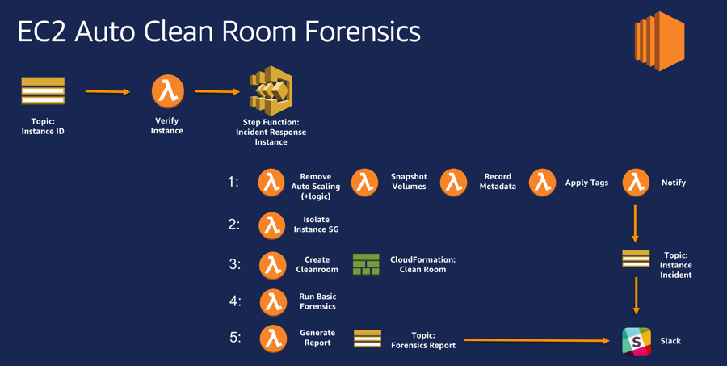
Figure 13: EC2 Auto Clean Room Forensics [36]
The experimental setup was implemented in AWS AWS onto Amazon EC2 virtual machines. There were two instances of EC2 that were developed at the same instance in order to provide a functional separation between operational infrastructure and the forensic analysis infrastructure. The initial one was called Compromised-Target, which was the workload being monitored in production. This case created management traffic, network traffic, and simulated suspicious behaviour when experimenting. The second case is called Forensic-Clean-Room and was an environment used as an isolated forensic environment tasked with capturing packets and analysing evidence.
The two cases utilized t3. micro hardware that could be used in experimental forensics cloud analysis but is affordable. Monitored infrastructure and forensic infrastructure separation was purposely made to reduce the possibilities of contaminating evidence during investigations. The forensic clean-room was developed based on the forensic isolations. Rather than an insecure SSH-based administration, the forensic instance was securely managed using AWS Systems Manager Session Manager. This method did not need the inbound SSH exposure and lessened the attack surface of the administrative access. The clean-room also contained built-in forensic technologies such as Tshark, tcpdump, Python 3, Git, and Wireshark CLI tools. These were services that assisted the inspection of packets, protocol analysis and processing of evidence during the investigation process.

5.3 Network setup and VPC

5.3.1 VPC Segmentation
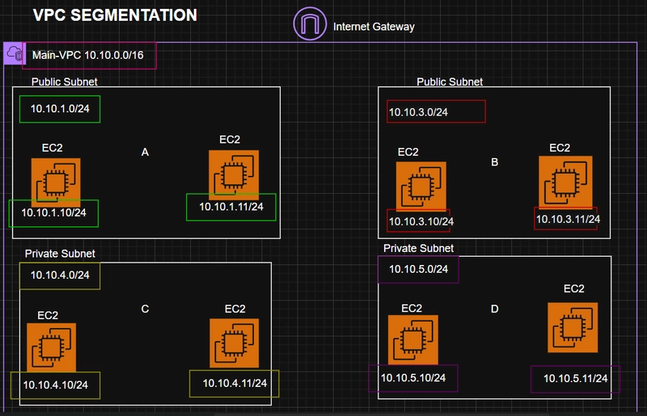
Figure 14: AWS VPC Segmentation [37]
The AWS environment was deployed in a specific Virtual Private Cloud (VPC). Network isolation was set up to separate forensic infrastructure and operational loads, and still ensure a controlled communication to monitor activity. Security group became ready based on the least-privileged principles. Inbound communication was blocked and restrict the outbound communication to essential update and management traffic. This lessened the chances of unapproved access and augmented confinement within the experimental setup. The implementation also incorporated the use of private networking options to enhance security in investigation. The case of the forensic clean-room was in a restricted network setup that it could not be exposed directly to the outside.

5.3.2 Traffic Mirroring Configuration
One of the primary elements of the work was AWS VPC Traffic Mirroring. Traffic Mirroring allowed a direct passive copying of network traffic flowing through the EC2 being monitored straight onto the forensic clean-room.
The traffic mirroring system had three key elements:
- Mirror source
- Mirror target
- Mirror filter
The elastic network interface that was connected to the compromised-target instance was set up as the mirror source. The forensic clean-room interface was incorporated as the mirror target. AWS captured mirrored traffic with VXLAN on port 4789 over UDP and then forwarded it to the forensic analysis environment. This implementation enabled a non-invasive, non-modifying, inspection of live network traffic by the investigators. In contrast to host-based packet capture methods, Traffic Mirroring offered infrastructure level visibility, which was quietly efficient even in the event the instance being monitored was corrupted.

5.4 Evidence Collection Infrastructure

5.4.1 CloudTrail Implementation
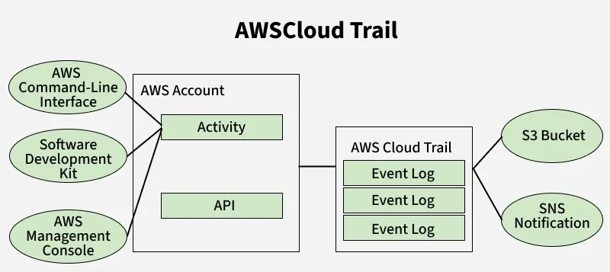
Figure 15: AWS CloudTrail [38]
AWS CloudTrail was adopted to constantly capture the activity of the management-layer within the AWS environment. CloudTrail logged API calls, authentication, IAM activity, session vehicle creation and infrastructure alteration.
In experimentation, CloudTrail has been able to capture the management actions such as:
- CreateSession
- SendHeartbeat
- PutCredentials
- DeleteSession
Such incidents allowed researchers to create the management activity timelines and establish suspicious administrative behaviour. The CloudTrail log validation was also turned on to enhance integrity of evidence. Such a feature enabled cryptographic validation features that are able to identify any effort that attempts to compromise the CloudTrail logs prior to the eventual logging into the forensic storage. Although it was very effective, CloudTrail proved to have a number of limitations as it was being experimented with. Though it was able to pinpoint management activity and attribution information, it was not able to reveal actual packet contents, protocol payloads, and attacker communication behaviour. This limitation confirmed the need to have traffic capture at the packet level using Traffic Mirroring and Tshark analysis.

5.4.2 AWS Config Integration
AWS Config was introduced to deliver historical visibility to the infrastructure changes within the AWS environment. The service was used to record the state of resource configuration, such as EC2 instances, security groups, IAM resources, S3 buckets, and VPC configurations, continually. This deployment served as a forensic reconstruction tool, which could be used to detect configuration drift and infrastructure changes in case of suspicious activity. AWS Config contributed greatly to the retrospective investigative capability since investigators were able to know, not just what actions were taken but also the extent to which the environment in the clouds had changed with time.

5.4.3 Immutable S3 Evidence Vault
The S3 bucket of Amazon was deployed as the main forensic evidence vault. CloudTrail logs, VPC Flow Logs, AWS Config snapshots, and any exported artefacts of the experimentation were kept in the vault. The evidence vault used multiple controls of forensic preservation such as:
- S3 Object Lock (Compliance Mode)
- AES-256 encryption
- Bucket versioning
- Public access blocking
- Retention enforcement
A specific feature, Compliance Mode Object Lock was essential as it avoided the manipulation or destruction of evidence files within the retention period even by the administrator with privileged access. This realization specifically tackled one of the most prominent cloud forensic issues to be discovered in the literature: evidential volatility in cloud infrastructures.

5.5 Implementation of Packet Capture and Tshark

5.5.1 Tshark Installation
The Tshark packet analysers had been installed right into the forensic environment of clean-room. The AWS CloudShell and Amazon Linux package repositories were used to install. Implementation of the Tshark also allowed command line entry of packet capture and protocol analysis compatible with a remote forensic examination.

5.5.2 Live Packet Capture
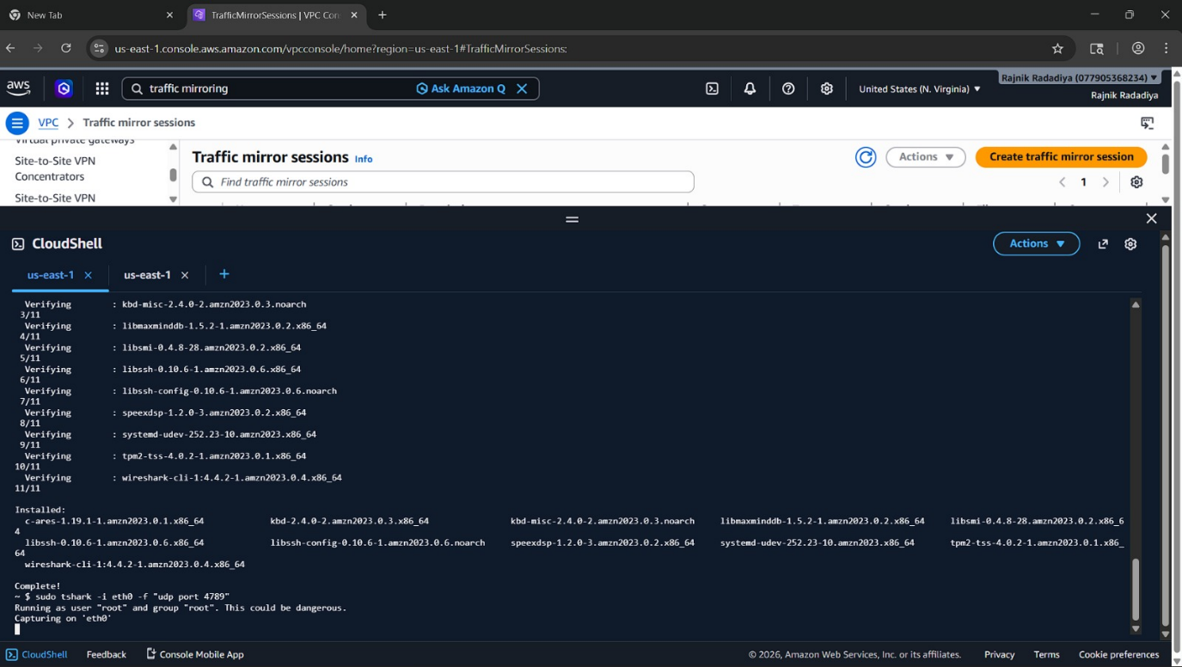
Figure 15: Tshark Packet Capture Monitoring [AWS]
The process of acquiring packets was started with: sudo tshark -i eth0 -f "udp port 4789"
The capture filter was tracking traffic encrypted by VXLAN which was created because of AWS Traffic Mirroring sessions. After the mirroring was switched on, the replicated packets containing the compromised-target instance were mirrored directly into the forensic clean-room. The experiment proved that Tshark was capable of monitoring infrastructure-level traffic without depending on the workload being monitored. This was much better than metadata-only logging since the actual protocol behaviour could be examined by the investigator and the summaries of connections would not be considered as the sole basis.
Captured traffic included:
- TCP communications
- HTTP requests
- Metadata service probes
- Session traffic
- Protocol headers
Such implementation significantly enhanced forensic visibility when simulating attacks.

5.6 IAM and Access Control Implementation

5.6.1 IAM User Configuration
Role separation and least-privilege access controls were established using IAM resources.
Various IAM roles and users were developed such as:
- NewUserName
- SecondUser
- Suspicious-Analyst
During the activities of the simulation of the attacks, to create suspicious IAM events that could be monitored in the CloudTrail logs, the usage of the Suspicious-Analyst account was intentionally applied. The architecture also employed limited forensic investigator privileges. The ForensicAnalyst position allowed accessing forensic evidence, the clean-room but was not allowed to modify production resources. This minimized the risk of contamination in the investigational process.

5.7 Experimental Attack Simulation

5.7.1 Metadata Service Probe Simulation
The experimental situation was a simulated suspicious cloud-native reconnaissance behaviour of the AWS metadata service. The following command was executed: curl http://169.254.169.254/latest/meta-data/
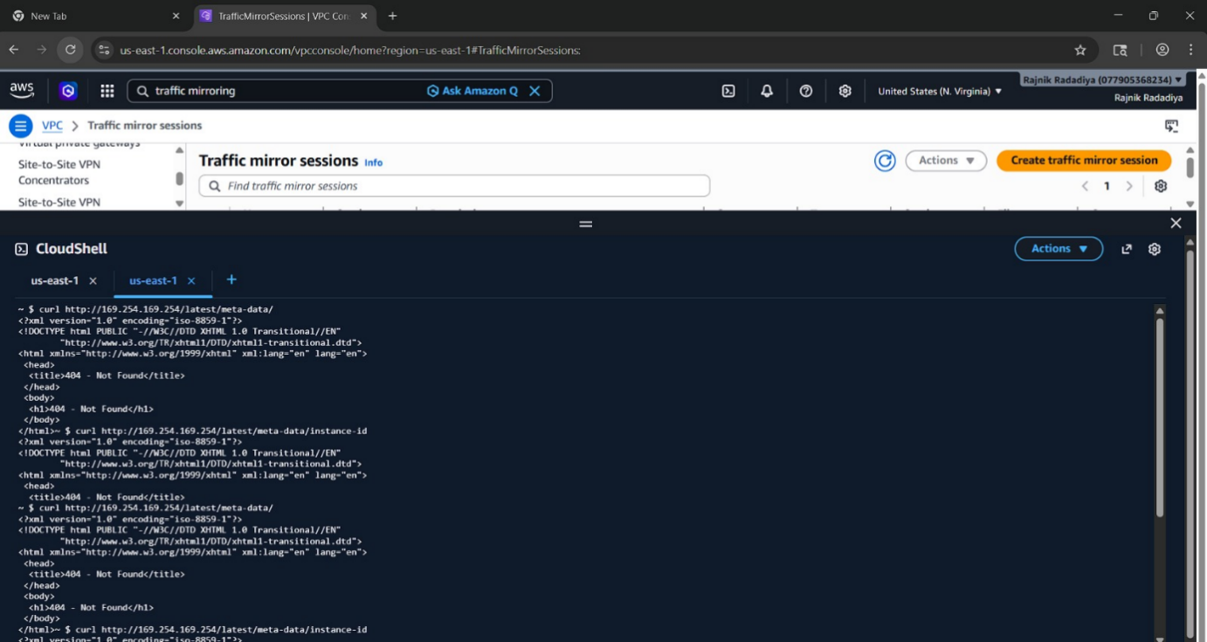
Figure 16: Metadata Service Probe Activity [AWS]
Metadata service probing is a plausible attack method which frequently comes with credential harvesting and privilege escalation attempts by attackers in the cloud. A common attack is on the metadata service by the attackers to gain the broken IAM credentials of EC2 instances. The simulated attack spread forensic artefacts deliberately and concurrently among various layers of telemetry:
- CloudTrail management events
- VPC Flow Logs
- Mirrored packet traffic
- Tshark packet captures
This facilitated overall forensic match all through the evaluation process.

5.7.2 Multi-Layer Evidence Correlation
Among the most significant results of the experimentation stage was the successful operation of multi-layer forensic correlation. At the management tier, CloudTrail detected suspicious events of API activity and session activity related to the simulated attacker actions. VPC Flow logs included metadata of traffic at the network layer such as source and destination communication details. In the payload layer, Tshark packet captures showed original protocol behaviour relating to metadata service probing. This showed that the use of one source of forensic telemetry would only have given a biased visibility. Rather, the integration of several telemetry layers drastically enhanced the completeness of investigations and assurance of evidence.

5.8 Experimental Findings
This implementation was effective enough to show that proactive occurrence of evidence and infrastructure-level visibility of packets can play a great role in enhancing AWS-native forensic preparedness. The training of Traffic Mirroring and Tshark dealt with one of the most significant constraints to forensics recognized in the literature of cloud forensics, which is that standard cloud logs do not provide any information about the contents of packet payloads or communication purpose. CloudTrail was found to be very helpful in attribution and management visibility but not helpful in packet-based forensic analysis. VPC Flow Logs enhanced network visibility yet at the same time no payload level inspection. The introduction of Tshark and mirrored traffic therefore helped filling a forensic content gap that was present before because it has made it possible to observe the traffic behaviour directly within the AWS environment. The evidence vault that is not modifiable (S3) also exhibited excellent preservation of evidence. Object Lock Compliance Mode even allowed an attacker to get administrative privileges but the stored evidence could not be deleted or modified. The implementation also demonstrated the operation challenges related to cloud forensics. The timelike discrepancies between telemetry layers are sometimes introduced by cloud trail event propagation. Moreover, ciphertext also restricted the ability to see direct payloads in certain packet captures. Mainly due to these limitations, the overall forensic architecture proved to be highly effective to be used in forensic preparedness and incident investigation.

5.9 Chapter Summary
This chapter outlined the implementation and experimentation procedures to prove the proposed AWS forensic readiness architecture. Its implementation incorporated EC2 infrastructure, VPC division, Traffic Mirroring, CloudTrail, AWS Config, unchangeable S3 evidence storage, separated IAM roles, and Tshark packet analysis into a single dissemination of forensic tools. Simulations of controlled suspicious activities showed that the architecture was able to effectively gather, store and correlate forensic evidence at management, network and packet-analysis layers. The deployment also highlighted the need to leverage the use of metadata logging along with platform packet acquisition to enhance forensic visibility in a cloud deployment. The next chapter assesses the forensic evidence obtained and critically assesses the actuality of the applied forensic controls.

CHAPTER 6: ANALYSIS OF RESULTS AND EVALUATION

6.1 Introduction
This chapter analyses the forensic readiness architecture implemented and evaluates its effectiveness, and the forensic evidence gathered during the experiment. The analysis revolves around assessing the claim that the suggested architecture enhanced forensic visibility, evidential integrity, confirmation of evidence and reliability of investigations in AWS Infrastructure-as-a-Service (IaaS) setups. The study has managed to overcome some of the shortcomings that were found during the literature study such as lack of visibility in cloud research, reliance on metadata based- logging, volatility of evidence, and challenges in recreating attacker behaviour within dynamic cloud environments. In order to examine how these constraints were overcome, the architectural that was applied to the network was analysed at the management, network, and packet-analysis layers. In the chapter, AWS CloudTrail, VPC Traffic Mirroring, Tshark packet capture, IAM role separation, and immutable S3 storage are critically assessed in the situation of simulated suspicious activity. It also analyzes whether in comparison to using standard AWS-native telemetry only, multi-layer forensic correlation enhanced investigation ability.

6.2 Multi-Layer Correlation Analysis
The greatest impact of the study was that the multi-layer forensic correlation was implemented successfully. The architecture correlated evidence across:
- CloudTrail management logs
- VPC Flow Logs
- Tshark packet captures
This stacking feature enhanced the investigative abilities greatly in contrast with the use of ASW-native metadata services only. CloudTrail determined the perpetrator(s) of suspicious activities. A flow log called VPC Flow Logs was used to detect communication patterns and endpoints. Tshark displayed protocol behaviour and communication intent. The combination had the effect of significantly enhancing forensic reconstruction potential and diminishing the clouds of investigation. The analysis thus established that packet-level capture at the infrastructural level could play an important role in enhancing forensic preparedness in AWS settings.

6.3 The limitations of AWS-Native Forensics
While AWS-native forensic services like CloudTrail, AWS Config, VPC Flow Logs, and Traffic Mirroring drastically enhance forensic readiness within the cloud, there are some limitations. Most of the AWS-native logging services are mainly for metadata rather than for payloads or application-layer communications, thus limiting the ability to detail the attacker's behaviour. In addition, cryptographic traffic on the network makes it more difficult for the network to perform deep packet inspection and to see the contents of malicious payloads. AWS infrastructure's dynamic and elastic nature also means that evidence may be lost due to the termination of instances and ephemeral artifacts prior to acquisition. Also, storage and monitoring overhead, and computational requirements can be significant in large environments with Traffic Mirroring and continuous packet capture operations. Lastly, AWS forensics are still a big reliance on provider managed telemetry, which means those aspects of the underlying infrastructure that are happening are all but impossible to verify independently, as are the physical acquisitions.

6.4 EC2 Forensic Infrastructure assessment.
The EC2 forensic infrastructure was able to support attack simulation activities and the process of conducting a forensic investigation. Monitored workload and forensic analysis instances were then deployed separately on EC2, providing a distinct separation between operational infrastructure and investigative infrastructure. Compromised-Target case produced management activity, metadata service requests and network traffic throughout the experimentation. At the same time, the case of the Forensic-Clean-Room was a virtual lab that was being utilized in packet capture and analysis. One of the strongest aspects of the infrastructure was the implementation of AWS Systems Manager Session Manager instead of traditional SSH access. The default configurations of SSH administration often involve exposing port 22 to the external networks with the exposure of attack surface. The architecture eliminated all the administrative exposure to the inbound traffic by substituting SSH with the Session Manager but still allowed accessibility to the forensic environment in a secure manner. The clean-room example was also implemented in a private subnet to enhance forensic isolation. This minimized unnecessary communication and minimized risk of contamination in the course of analysis undertaking. The setting was thus well fit to forensic-readiness principles as determined during literature review. But there were still some shortcomings. The forensic environment was fully based on the availability of AWS infrastructure as well since the investigators had no direct physical access to hardware resources. As a result, low-level acquisition techniques like physical disk imaging or memory extraction were not in the implementation plan.

6.5 Evaluation of CloudTrail Logging
During experimentation, AWS CloudTrail was found to be very useful in achieving management-layer level forensic visibility. CloudTrail was used to constantly write API calls, IAM activities and session activity along with management events throughout the AWS ecosystem.
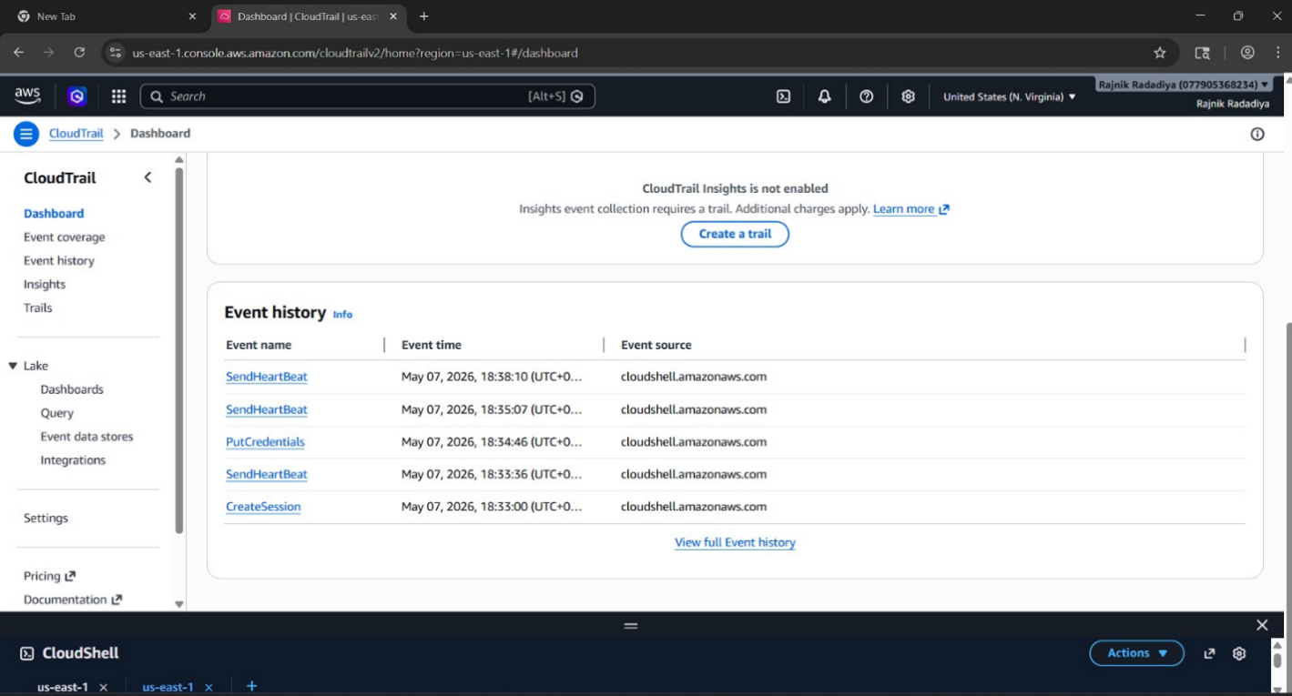
Figure 17: CloudTrail Event History [AWS]
The analysis showed that the CloudTrail was effective in capturing a number of important forensic artefacts such as:
- CreateSession events
- SendHeartbeat operations
- PutCredentials requests
- DeleteSession activity
These logs could allow the investigator to know who executed an action, at what time it happened and with which credentials it was executed, and which AWS resources were involved. This greatly enhanced the accountability and attribution in the course of investigations. CloudTrail was highly useful with simulated suspicious IAM activity. The account of events involving the Suspicious-Analyst was observable on the logs at a glance allowing investigators to order and re-create the administrative behaviour. Another strength was the fact that CloudTrail log validation was implemented. This enhanced evidential integrity by identifying attempts to modify logs without authorisation before it is archived into the forensic evidence vault. Nevertheless, the analysis also revealed some critical shortcomings. Even though CloudTrail gave great visibility on the management aspect, it was not able to display the contents of packets or the contents of communication. It was possible to discover that data communication took place, but the nature of data transmitted could not be identified. It has been argued in earlier literature in cloud forensics that metadata-based logging is a limited support that cannot be used to fully investigate the cloud. This limitation confirms earlier studies that have discussed this issue. CloudTrail consequently enhanced attribution tremendously but was unable to grant full visibility of behaviours alone. Delays in minor ingestion were also noted during experimentation. A few events in CloudTrail were a couple of tens of seconds behind related evidence on the packet-capture, which resulted in minor timing inconsistencies when used in correlation tasks. Irrespective of these shortcomings, CloudTrail was still among the most useful sources of evidence of the management layer within the architecture.

6.6 Evaluation of Traffic Mirroring
One of the most powerful elements of the adopted forensic architecture was the AWS VPC Traffic Mirroring. Traffic Mirroring made it possible to replicate live network traffic passively, resulting in immediate copying of the traffic between the EC2 instance under monitoring to the forensic clean-room. The testing established that mirrored traffic was effectively encapsulated with VXLAN over the UDP port 4789 and sent to the forensic analysis platform. A significant strength that could be recognized during the evaluation was that Traffic Mirroring did not depend on the workload that it was monitored on. Conventional host-based tools of packet capture can be turned off or controlled when attackers gain access to the system under observation. Conversely, mirroring at the infrastructure level continued to work, since the replication of packets took place directly in AWS network infrastructure. The Implementation also facilitated non-intrusive acquisition of traffic. Observations were made in a non-interventionist manner and did not affect the workload performance or necessary a modification in the target instance. Traffic Mirroring got a great bonus due to the increased visibility of forensics since the investigators could see real behaviour of communication as opposed to. This directly responded to the noted content gap in cloud forensics literature. Nonetheless, operational constraints were also found during the assessment. VXLAN encapsulation added complexity to packets and necessitated further filtering when analyzing with Tshark. There are also mirrored traffic, which resulted in volatilities of evidence which consumed more storage and processing needs.

6.7 Packet Analysis with Tshark.
The Tshark packet analysis was instrumental in enhancing visibility in applications layer during testing. The following were used to perform packet acquisition: sudo tshark -i eth0 -f "udp port 4789"
Through the evaluation, it was identified that Tshark has been able to capture:
- VXLAN traffic
- TCP sessions
- HTTP requests
- Packet headers
- Metadata service communication
As opposed to CloudTrail or VPC Flow Logs, Tshark offered first hand visibility to communication behaviour within the AWS environment. The investigators were able to scan protocol-level activity and study suspicious requests that were produced in attack simulation. This was one of the key findings in the study as it showed that the use of packet-level monitoring is much more effective in enhancing forensic visibility than metadata-based methods. The implementation was successful in that it filled the content gap in forensics as it allowed the inspection of communication behaviour, rather than intuitively estimating activity based on metadata logs. Some challenges were however brought up by the analysis at the packet level as well. Some scenarios were providing reduced payload visibility due to the use of encrypted traffic, making it difficult to analyze content in detail. Packet capture also produced large volumes of evidence, relative to metadata logging systems.

6.8 Evaluation of Metadata Service Probe Detection
The metadata service probe simulation was a useful test of the architecture to correlate evidence between various layers of telemetry evidence.
This was the command that was run in the experimentation: curl http://169.254.169.254/latest/meta-data/
Credential harvesting and attempts at privilege escalation in AWS environments are often related to metadata service probing. The metadata service is often an attack target to gain temporary EC2 instance-assigned IAM credentials. The assessment verified that the architecture was able to record the metadata probe activity on multiple levels of forensic architecture at a time. CloudTrail was used to log related management event and session activity. VPC Flow logs were the metadata of the communication such as the source and destination. Tshark packet captures displayed the Http requests that related to the metadata service access attempts. This multi-layered acquisition of evidence has greatly enhanced the completeness of investigations since no single source of telemetry could provide adequate visibility to perform a full analysis of the attack sequence. The analysis thus sharply endorsed the research thesis that successful cloud forensic preparedness entails stratified telemetry assimilations as opposed to data analytics separation.

6.9 Evaluation of IAM and Access Control
The least-privilege access control and role separation in investigations were achieved by implementing the IAM architecture in the course of experimentation.
Simulators of forensic artefacts under the guise of attack simulation were dedicated IAM users such as Suspicious-Analyst. The management events are associated and cloudTrail was able to record that indicating the efficiency of IAM monitoring. The ForensicAnalyst position was thoroughly limited to access to evidence and clean-room work. Investigators were not able to manipulate production infrastructure resources and diminish the chances of contamination during analysis processes. The assessment established that the division of IAM roles enhanced accountability and governance in the forensic setting. IAM effectiveness was, however, still based on the appropriate administrative set-up. Over privileges or loosely set policies may continue to erode the integrity of investigations. In turn, ongoing IAM auditing is a necessity in operational AWS settings. The preservation of evidence is one of the criteria evaluated. The unchanging S3 evidence vault was one of the most powerful forensic controls applied in course of the research.
The test run proved that the S3 Object Lock was set to Compliance Mode and was effective in preventing alteration or erasure of forensic artefacts throughout the retention period. This greatly strengthened the integrity of evidence and chain-of-custody guarantee. Other options such as versioning of bucket, AES-256, retention of lifecycle and Block Public access settings extended further to improve evidence preservation. The execution directly responded to one of the greatest forensic issues that were determined during the literature review: the evidential volatility in cloud infrastructures. The test proved that even a privileged administration would not have been able to provide any modifications to preserved evidence, once the evidence is stored in the immutable evidence vault. This greatly enhanced the trustworthiness and dependability of gathered forensic artefacts.

6.10 Limitations of the Research
Though the architecture dramatically increased transparency to the forensics and preservation of evidence, we still had quite a number of limitations. To start with, the study was limited to AWS IaaS infrastructure and failed to examine the interoperability of multi-clouds. Second, encrypted traffic made the payload unreadable when analysing packets. Third, this study did not include extra memory forensics and malware reverse engineering. Also, the storage and processing overheads of packet capture were higher than those of metadata-only logging methods. Ingestion lag times at CloudTrail also introduced slight discrepancies in time when correlating evidence. Regardless of these limitations, the architecture significantly enhanced cloud forensic preparedness and reliability of investigations.

6.11 Chapter Summary
This chapter has been used to test the efficiency of the adopted AWS forensic readiness architecture and to analyse the forensic evidence obtained when the architecture was being experimented. The analysis showed that the implementation of AWS-native telemetry together with Traffic Mirroring and Tshark packet analyser yielded a much better forensic visibility, evidential integrity and investigative reliability under AWS conditions. The architecture was able to capture evidence at both management, network and packet-analysis levels with immutable S3 storage enhancing evidence archaeology and chain-of-custody. This was confirmed by the results that metadata-based cloud logging systems offer insufficient forensic visibility and infrastructure-based packet capture can significantly enhance cloud forensic investigations.

CHAPTER 7: CONCLUSIONS AND RECOMMENDATIONS

7.1 Introduction
This chapter is the conclusion of the study and a review of the main findings achieved through the design, implementation and evaluation of the AWS forensic readiness architecture. The chapter describes also the contributions made by the study, limitations, recommendations, and potential research opportunities in the future. The study examined the methods of enhancing forensic readiness in AWS Infrastructure-as-a-Service (IaaS) setting by combining AWS-native monitoring offerings, immutable evidence conservation systems and packet-level inspection of infrastructure. The paper covered significant cloud forensic issues that were perceived during the literature review such as a lack of visibility, volatility of evidence, reliance on metadata, and constraints highlighted by the rebuilding of attacker behaviour in cloud environments.

7.2 Summary of the Research
Cloud computing has revolutionised the organisation deployment and management of digital infrastructures. Nevertheless, growing usage of cloud services have also posted significant problems to the digital forensic investigations. The cloud infrastructures are dynamic, virtualised and mostly have control by the cloud service providers as compared to traditional on-premises systems. This leads to a lack of visibility by the investigators, access to infrastructure, and reliance on telemetry control operated by providers. The study targeted AWS in particular since it is currently among the popular cloud services in the world. Current literature found that most of the cloud forensic investigations largely depend on metadata-informed pieces of evidence like CloudTrail and VPC Flow Logs. Though these services will offer valuable management and network visibility, they do not reveal packet payloads or application-layer behaviour. This leaves an important forensic content gap which restricts investigative reconstruction. To handle these limitations, the proposed research incorporated and deployed a forensic-ready AWS architecture that combined CloudTrail, AWS Config, VPC Flow Logs, Traffic Mirroring, Tshark packet analysis, immutable S3 Object Lock storage, separation of IAM roles, and an isolated forensic clean-room environment. The implementation of the environment was Terraform Infrastructure-as-Code that was deployed to promote repeatability and consistency when deploying the environment. The forensic controls were then tested to determine the effectiveness of the controls by carrying out simulated suspicious activities that comprised metadata service probing and suspicious IAM operations.

7.3 Key Findings
There were a few significant findings that were made during the study. The initial significant discovery was that by relying only on the metadata logging offered by AWS the deriving forensic visibility is incomplete. CloudTrail was able to capture API activity, IAM operations, and session events, and VPC Flow Logs gathered metadata of network communications. Neither service did capture either packet payloads or communication content. This restricted the capability of investigators to get a full picture of attacker behaviour. The second key observation was that Traffic Mirroring and Tshark packet analysis enhanced forensic visibility significantly. Packet acquisition at infrastructural level allowed investigators to examine protocol behaviour containing HTTP requests and metadata service probing activity in such a way that it could be inspected. This has been able to bridge the forensic content gap that was found in all the literature on cloud forensics. The third crucial discovery was the preservation of evidence. The introduction of S3 Object Lock in Compliance Mode greatly enhanced the evidencing integrity since alteration or eradication of forensic artefacts was impossible at the time of retention in spite of caring administrators. This specifically tackled one of the most considerable issues in cloud forensics evidential volatility. The additional revelation was that forensic seclusion enhanced the security of investigations. The special clean-room conditions, created with the help of separate subnet and exclusive access of Systems Manager, minimized the risk of contamination and did not require the use of unsecure SSH administration. Lastly, the study revealed that investigative capability with regards to multi-layer forensic correlation is significantly enhanced. Using CloudTrail logs, VPC Flow logs, and Tshark packet captures, investigators were then able to recreate suspicious activity more accurately than when using independent telemetry sources.

7.4 Research Contributions
This study has contributed to the cloud digital forensics in a number of significant ways. Firstly, the study offers a practical accomplishment of forensic preparedness in AWS IaaS circumstances, instead of utilizing only theoretical frameworks. A lot of the past research makes conceptual argumentation about cloud forensic issues without deploying complete forensic architectures in practice. Second, the study supports the usefulness of positioning Traffic Mirroring and the analysis of packets at the packet level in the context of cloud forensic investigation. The current body of literature outlines metadata constraints quite often but with very few examples and applications of infrastructure-level packet acquisition as one of the components of forensics readiness frameworks. Third, the work develops a layered forensic monitoring paradigm that integrates management-layer telemetry, network metadata, packet-level analysis. Such a layered process enhances the visibility of investigations and minimizes cling on to disconnected sources of evidence. Lastly, the implementation will show how the immutable S3 Object Lock storage could enhance the strong evidential integrity and chain-of- custody guarantee in cloud environments.

7.5 Limitations of the Research
Though the research was successful in its objectives, there are various limitations to the research. This research only targeted AWS IaaS setups and did not analyze interoperability between multi-cloud and hybrid-cloud systems. Therefore, the results might not be directly applicable in other cloud services like Microsoft Azure or Google Cloud Platform. Network and management-layer forensic readiness were also the main focus of the research. The scope of the study did not cover advanced memory forensics, malware reverse engineering and endpoint forensic acquisition. The encrypted traffic also minimized visibility of some payloads of packets during Tshark analysis. Although the metadata of the protocols was still visible, the application-layer content could not be easily analysed because it was encrypted. Lastly, environment was introduced into a controlled laboratory-type AWS deployment as opposed to a large enterprise production infrastructure. Increasing Internet deployments can add further operational and performance considerations.

7.6 Recommendations and Future Research
There are a number of suggestions that can be suggested out of the results of this study. Any organisation with AWS environment must implement forward-thinking forensic preparedness, as opposed to acting on reactive investigations into data breaches. Pre-incident continuous monitoring and preservation of evidence ought to be enforced. The default should be to enable CloudTrail, AWS Config and VPC Flow logs in cloud environments to facilitate constant telemetry recording. Nevertheless, organisations must be aware that metadata logging cannot be relied on to conduct thorough inquiries. Organisations need to adopt Traffic Mirroring, and packet level monitoring where operationally possible to enhance the level of forensic visibility and investigative reconstruction. S3 Object Lock should also be used to preserve immutable evidence protection mechanisms to protect forensic artefacts against tampering or deletion. Future studies may consider forensic preparedness in multi-cloud contexts, address AI-intended forensic automation, and consider scalable packet-capture systems that may be utilized to conduct forensic investigations at enterprise scales.

7.7 Chapter Summary
This chapter was a conclusion and recommendation of the research. The research indicated that forensic preparedness in AWS IaaSs spaces can be greatly enhanced by incorporating AWS-native telemetry, AWS-native Traffic Mirroring, packet-level inspecting, immutable evidence holding, and segregated forensic systems. The results established that metadata-based cloud logging systems offer partial visibility with regards to investigation and a significant enhancement of forensic reconstruction is gained by having infrastructure level access to packet capture. Generally, the study adds a viable and multi-layered forensic-readiness architecture that can enhance investigations of clouds in AWS server setups.

CHAPTER 8: REFLECTION

8.1 Introduction
This chapter recalls the general experience of working on the research project, as well as the creation of the AWS forensic readiness architecture. The reflection addresses technical and academic issues that were experienced during the research, the competencies gained in the course of the work, and the experience gained by applying and testing the practical cloud forensic environment. The project balanced out theoretical lessons of cloud forensics with practical implementation of the AWS, which offered a good pull on understanding the intricacies of real-world cloud investigations. During the research, a number of technical challenges emerged, in specifics, the part of AWS networking, monitoring at a packet level, setup of the infrastructure, and preservation of the evidence [10]. The successful handling of such obstacles greatly enhanced research confidence and technical capabilities.

8.2 Reflection on the Research Process
The interpretation of how traditional forensic principle can be applied within the cloud was one of the key challenges at the outset of the project. The past experience in the academic field was predominantly based on the traditional digital investigations of forensics that concerned tangible hardware and local networks. Nevertheless, cloud infrastructures have a different scheme since investigators lack the direct physical access to hardware resources. This posed an initial learning problem in the area of AWS architecture, cloud-native telemetry, and infrastructure level monitoring. The services that have to be understood, like CloudTrail, VPC Flow Logs, AWS Config, IAM, and Traffic Mirroring, require vast research and experimentation of their own. The study procedure also indicated that cloud forensics is a not merely an expansion of conventional forensics but a niche science that has its own set of difficulties [22]. Things like the instability of evidence, reliance on metadata, and infrastructure under the control of providers became far more evident during implementation. The other significant area of the project was the critical analysis of existing literature. Numerous literature works presented cloud forensic issues on an abstract level, but without detailed implementation. This not only helped focus the dissertation, but also provided the incentive to create a functional forensic-ready AWS environment as opposed to generating a simple conceptual framework.

8.3 Reflection on Technical Challenges
Implementation stage involved a number of technical problems. Among the most challenging tasks was to make the AWS Traffic Mirroring and Tshark packet analysis work effectively. Traffic Mirroring, unlike the typical AWS AWS logging services, needed an understanding of the AWS networking terminology (Elastic Network Interfaces (ENIs), VXLAN encapsulation, and mirror sessions). First, mirrored traffic was not observable in Tshark captures, and a tremendous amount of troubleshooting was needed with security group rules, network interfaces and packet filters. The VXLAN traffic transported over UDP port 4789 was specifically difficult to comprehend since it was vastly different as compared to conventional packet-capture settings. The other task was the difficulty of having a secure clean-room environment using AWS Systems Manager rather than SSH access. This did enhance security, but it also added some complexity in configurations that involved the IAM permissions, SSM agents, and instance roles [16]. Use of S3 Object Lock as an immutable evidence preservation method also needed some planning since Compliance Mode retention policies are crafted to be limiting. This phase of the project showed the value of evidence integrity and governance in forensic research. Another learning activity was the use of terraform automation. Before the project, there was no familiarity with the concepts of Infrastructure-as-Code. The EC2, IAMs roles, logging systems, and S3 storage Terraform configuration writing necessitated trial and error. Nevertheless, studying Terraform helped to greatly become familiar with cloud infrastructure implementation and automation.

8.4 Skills Developed
The project aided in the improvement of technical as well as academic skills. Technically, the study enhanced the operational expertise of AWS cloud architecture, Virtual Private Cloud setup, Identity and Access Management security, CloudTrail analysis, Traffic Mirroring, Tshark packet capture and Amazon S3 evidence preservation. These competencies were cultivated with the help of the implementation of the forensic-ready AWS environment in practice and testing of the simulated investigation conditions. Skills in solving problems and troubleshooting were also developed. There were a number of configuration problems encountered during implementation especially as far as networking and packet capture, access control and evidence storage were concerned. It took some systematized debugging, trial and error testing, technical research and thorough validation of every forensic component to resolve these issues. This assisted in building trust in approaching the unfamiliar technical issues in a systematic and trustworthy way [16].
Moreover, planning of projects and time management were improved in the project. The study necessitated alignment of literature study, implementation of AWS, and forensic testing, evidence analysis, documentation and report writing within a given academic timeline constraint. The control of these activities helped to distribute tasks prioritising, plan technical work and achieve milestones during research. Academic research and writing were also developed. These involved the study of academic literatures, critical analysis of the past and identification of research gaps, the use of IEEE style referencing and presentation of technical results in a format that is highly structured with respect to academia. Additionally, the procedure enhanced analytical abilities by necessitating the matching of CloudTrail logs, VPC Flow Logs and Tshark packet captures among various layers of evidence.

8.5 Chapter Summary
The project was a great academic, technical, and professional development. The study was able to effectively integrate the theoretical aspects of cloud forensics with hands-on AWS application and illustrate the necessity of taking the proactive forensic preparedness into cloud ecosystems [22]. Despite various technical and research issues that appeared during the project, the successful completion of these difficulties contributed greatly to the better understanding of cloud security architecture, forensic monitoring, preservation of evidence, and investigations analysis. It also enhanced independent research and technical confidence and analytical problem-solving competencies. The project eventually proved that in order to achieve a proper cloud forensic preparedness appropriate architecture design, unremitting observation, indestructible evidence integrity and multi-level forensic correlation are essential. The research was a great practical experience in terms of the practical relevance to current cloud security practices, as well as digital forensic investigation practices.

Reference List
[1] K. Ruan, J. Carthy, T. Kechadi and I. Baggili, “Cloud forensics definitions and critical criteria for cloud forensic capability: An overview of survey results,” Digital Investigation, vol. 10, no. 1, pp. 34–43, 2013. [Online]. Available: https://www.academia.edu/download/90760803/s1_1.pdf
[2] M. M. Alshabibi, A. K. Bu Dookhi and M. M. Hafizur Rahman, “Forensic investigation, challenges, and issues of cloud data: A systematic literature review,” Computers, vol. 13, no. 8, p. 213, 2024. [Online]. Available: https://www.mdpi.com/2073-431X/13/8/213
[3] A. W. Malik, D. S. Bhatti, T. J. Park, H. U. Ishtiaq, J. C. Ryou and K. I. Kim, “Cloud digital forensics: Beyond tools, techniques, and challenges,” Sensors, vol. 24, no. 2, p. 433, 2024. [Online]. Available: https://www.mdpi.com/1424-8220/24/2/433
[4] S. S. Akter and M. S. Rahman, “Cloud forensic: Issues, challenges, and solution models,” in A Practical Guide on Security and Privacy in Cyber-Physical Systems, 2024, pp. 113–152. [Online]. Available: https://arxiv.org/pdf/2303.06313
[5] M. Tanveer, N. A. Khan, M. Ali, R. Islam, M. Sattar and M. Shoaib, “Forensic challenges and techniques in cloud computing environments: A systematic literature review,” Spectrum of Engineering Sciences, pp. 67–92, 2025. [Online]. Available: https://www.thesesjournal.com/index.php/1/article/download/241/223
[6] R. Koen and H. Venter, “A Federated Distributed Digital Forensic Readiness Model for the Cloud,” in Proc. Int. Conf. on Cyber Warfare and Security, 2024, pp. 472–480. [Online]. Available: https://search.proquest.com/openview/3f7b3b33bb3a3703a3b355a98752fff3/1
[7] G. Ramakrishnan and M. Haqanee, Cloud Forensics Demystified: Decoding Cloud Investigation Complexities for Digital Forensic Professionals. Birmingham, U.K.: Packt Publishing, 2024. [Online]. Available: https://books.google.com/books?id=ZjDxEAAAQBAJ
[8] S. Wu, W. Sun, Z. Ding and S. Liu, “Cloud Evidence Tracing System: An integrated forensics investigation system for large-scale public cloud platform,” Forensic Science International: Digital Investigation, vol. 41, p. 301391, 2022. [Online]. Available: https://www.sciencedirect.com/science/article/pii/S2666281722000725
[9] W. S. Ahmed, Z. T. Mustafa AL-Ta’I, T. Abegaz and G. S. Mahmood, “Digital forensics architecture for real-time automated evidence collection and centralization: Leveraging security lake and modern data architecture,” Journal of Intelligent Systems, vol. 33, no. 1, 2024. [Online]. Available: https://www.degruyterbrill.com/document/doi/10.1515/jisys-2024-0109/html
[10] A. O. Ojo and M. Benmubarak, “Investigating Advanced Persistent Threat Tactics in Cloud Environments: A Forensic Study of AWS CloudTrail Log Data,” International Journal of Innovative Science and Research Technology, vol. 10, no. 7, pp. 3170–3176, 2025. [Online]. Available: https://ub-ir.bolton.ac.uk/esploro/fulltext/journalArticle/Investigating-Advanced-Persistent-Threat-Tactics-in/9946835208841
[11] D. Bird, “Reinforcing the Importance of Host Forensics for Customer Environments Hosted Using Amazon Web Services and Azure Public Cloud Platforms,” in Breakthroughs in Digital Biometrics and Forensics. Cham, Switzerland: Springer, 2022, pp. 367–385. [Online]. Available: https://www.researchgate.net/publication/364583134
[12] E. Egho-Promise, S. Idahosa, G. Asante and A. Okungbowa, “Digital Forensic Investigation Standards in Cloud Computing,” Universal Journal of Computer Sciences and Communications, vol. 3, no. 1, pp. 23–45, 2024. [Online]. Available: https://www.academia.edu/download/113976208/UJCSC_923.pdf
[13] A. Akilal and M. Kechadi, “Cloud Digital Forensic Readiness: An Open Source Approach to Law Enforcement Request Management,” arXiv preprint arXiv:2507.04174, 2025. [Online]. Available: https://arxiv.org/pdf/2507.04174
[14] T. R. Pati, R. Sansiya and P. C. Sethi, “Ensuring Cloud Security Through Scalable Network Forensics,” in Proc. Int. Conf. on Machine Learning, IoT and Big Data. Cham, Switzerland: Springer, 2025, pp. 88–99. [Online]. Available: https://www.researchgate.net/profile/Purna-Chandra-Sethi/publication/397168769
[15] A. Tandale, A. Kulkarni, S. Sebait, V. Patel and D. Wategaonkar, “Cloud Forensics: A Critical Review of Techniques, Standards, and Research Opportunities,” in Proc. Int. Conf. on Advancement in Cyber Security and Digital Forensics. Singapore: Springer, 2025, pp. 539–554. [Online]. Available: https://link.springer.com/chapter/10.1007/978-981-95-3701-3_35
[16] A. Pichan, M. Lazarescu and S. T. Soh, “Cloud forensics: Technical challenges, solutions and comparative analysis,” Digital Investigation, vol. 13, pp. 38–57, 2015. [Online]. Available: https://www.sciencedirect.com/science/article/pii/S1742287615000407
[17] W. Yassin, M. F. Abdollah, R. Ahmad, Z. Yunos and A. Ariffin, “Cloud forensic challenges and recommendations: A review,” OIC-CERT Journal of Cyber Security, vol. 2, no. 1, pp. 19–29, 2020. [Online]. Available: https://www.oic-cert.org/en/journal/pdf/2/1/212.pdf
[18] B. Manral, G. Somani, K. K. R. Choo, M. Conti and M. S. Gaur, “A systematic survey on cloud forensics challenges, solutions, and future directions,” ACM Computing Surveys, vol. 52, no. 6, pp. 1–38, 2019. [Online]. Available: https://dl.acm.org/doi/pdf/10.1145/3361216
[19] S. Sanda, D. Pawar and V. Radha, “An insight into cloud forensic readiness by leading cloud service providers: A survey,” Computing, vol. 104, no. 9, pp. 2005–2030, 2022. [Online]. Available: https://link.springer.com/article/10.1007/s00607-022-01077-2
[20] L. F. Sikos, “Packet analysis for network forensics: A comprehensive survey,” Forensic Science International: Digital Investigation, vol. 32, p. 200892, 2020. [Online]. Available: https://www.sciencedirect.com/science/article/pii/S1742287619302002
[21] C. Liu, A. Singhal and D. Wijesekera, “Forensic analysis of advanced persistent threat attacks in cloud environments,” in IFIP International Conference on Digital Forensics. Cham, Switzerland: Springer, 2020, pp. 161–180. [Online]. Available: https://inria.hal.science/hal-03657230/file/503209_1_En_9_Chapter.pdf
[22] W. Tykholaz, R. Banakh, L. Mychuda, A. Piskozub and R. Kyrychok, “Incident response with AWS detective controls,” Cybersecurity Providing in Information and Telecommunication Systems II, vol. 3826, pp. 190–197, 2024. [Online]. Available: https://elibrary.kubg.edu.ua/id/eprint/50157/1/D_Tykholaz_R_Banakh_L_Mychuda_A_Piskozub_R_Kyrychok_CPITS_2024_3826.pdf
[23] A. Lucien, “Challenges of Trustworthy Digital Evidence and Its Chain of Custody on Cloud Computing Environment: A Systematic Review,” in ICEIS, 2024, pp. 240–246. [Online]. Available: https://www.scitepress.org/Papers/2024/127028/127028.pdf
[24] G. Grabner, A. Ahmed and N. Baghaei, “Using Blockchain to Preserve Chain of Custody: Cloud Forensics Analysis,” in SEKE, 2023, pp. 380–385. [Online]. Available: https://www.researchgate.net/profile/Georg-Grabner/publication/372237383
[25] H. Marshall and A. Rea, “Legal challenges in cloud forensics,” 2021. [Online]. Available: https://aisel.aisnet.org/cgi/viewcontent.cgi?article=1341&context=amcis2021
[26] S. Casino et al., “Research trends, challenges, and emerging topics in digital forensics: A review of reviews,” IEEE Access, vol. 10, pp. 25464–25493, 2022. [Online]. Available: https://ieeexplore.ieee.org/document/9720948
[27] O. Kuku, A. Chrysikos and S. Salekzamankhani, “Proactive Forensics: Building Digital Forensic Readiness in IoT-Enabled Organisations for Real-Time Incident Response,” 2026. [Online]. Available: https://www.researchsquare.com/article/rs-7959169/latest.pdf
[28] R. Al-Mugerrn, A. Al-Dhaqm and S. H. Othman, “A metamodeling approach for structuring and organizing cloud forensics domain,” in 2023 International Conference on Smart Computing and Application (ICSCA), 2023, pp. 1–5. [Online]. Available: https://www.researchgate.net/profile/Rafef-Almugern-4/publication/369846108
[29] S. Myneni, K. Jha, A. Sabur, G. Agrawal, Y. Deng, A. Chowdhary and D. Huang, “Unraveled—A semi-synthetic dataset for Advanced Persistent Threats,” Computer Networks, vol. 227, p. 109688, 2023. [Online]. Available: https://www.sciencedirect.com/science/article/pii/S1389128623001330
[30] M. Panahnejad and M. Mirabi, “APT-Dt-KC: Advanced persistent threat detection based on kill-chain model,” The Journal of Supercomputing, vol. 78, no. 6, pp. 8644–8677, 2022. [Online]. Available: https://link.springer.com/article/10.1007/s11227-021-04201-9
[31] B. Cinar and J. P. Bharadiya, “Cloud computing forensics: Challenges and future perspectives: A review,” Asian Journal of Research in Computer Science, vol. 16, no. 1, pp. 1–14, 2023. [Online]. Available: https://www.academia.edu/download/103507590/656.pdf
[32] U. K. Singh and A. Sharma, “Cloud computing security framework based on shared responsibility models,” in Cyber-Physical, IoT, and Autonomous Systems in Industry 4.0. CRC Press, 2021, pp. 39–55. [Online]. Available: http://scienceadvantage.net/wp-content/uploads/2021/11
[33] P. Chikuruwo and A. M. Gamundani, “The effects of volatile features on digital evidence preservation,” Information Systems and Emerging Technologies, 2022. [Online]. Available: https://www.researchgate.net/publication/372992925
[34] J. Oh, S. Lee and H. Hwang, “Forensic recovery of file system metadata for digital forensic investigation,” IEEE Access, vol. 10, pp. 111591–111606, 2022. [Online]. Available: https://ieeexplore.ieee.org/document/9913985
[35] X. Du and M. Scanlon, “Methodology for the automated metadata-based classification of incriminating digital forensic artefacts,” in Proc. 14th Int. Conf. on Availability, Reliability and Security, 2019, pp. 1–8. [Online]. Available: https://dl.acm.org/doi/pdf/10.1145/3339252.3340517
[36] Melnikovas, A., 2018. Towards an Explicit Research Methodology: Adapting Research Onion Model for Futures Studies. Journal of futures Studies, 23(2). https://www.researchgate.net/profile/Aleksandras-Melnikovas/publication/333388233_Towards_an_explicit_research_methodology_Adapting_research_onion_model_for_futures_studies/links/5d47c8404585153e593cfbec/Towards-an-explicit-research-methodology-Adapting-research-onion-model-for-futures-studies.pdf?_sg%5B0%5D=started_experiment_milestone&origin=journalDetail&_rtd=e30%3D
[36] CloudSecOps, “EC2 Auto Clean Room Forensics,” CloudSecOps Labs. [Online]. Available: https://labs.cloudsecops.com/cloud-security/ec2-auto-clean-room-forensics.
[37] A. G. Olaoluwa, “AWS VPC Segmentation,” DEV Community, Jun. 30, 2025. [Online]. Available: https://dev.to/gafol/aws-vpc-segmentation-3l24.
[38] GeeksforGeeks, “AWS CloudTrail,” GeeksforGeeks, Feb. 4, 2026. [Online]. Available: https://www.geeksforgeeks.org/cloud-computing/aws-cloudtrail/. [Accessed: 3-Jun-2026].

