Task 1: Locating Sources
Identify and locate three different sources (a report, a journal article, and a website) related to the question
“What employability skills do business graduates need to succeed in the modern workplace?”
Show how you used keywords, search terms, and Boolean operators to find them, and explain how you know which type of source each one is and why it is appropriate for the research question.

Source Type & Why It Is Appropriate | URL/DOI | What search engine did you use? Google/Online Library/Library AI Assistant | Keywords/Boolean Operators Used
Article. It highlights the relationship between skills and employability of business graduates | Factors affecting business graduates' employability–empirical evidence using partial least squares (PLS) - ProQuest | Online library. | business graduates AND employability

Task 2: Evaluating Information (CRAAP Test)
Your colleague has forwarded you a source from a peer reviewed journal, and they are not sure whether it is appropriate to use and has asked for your help. Your task is to evaluate the source by using the CRAAP Test to assess its appropriateness.
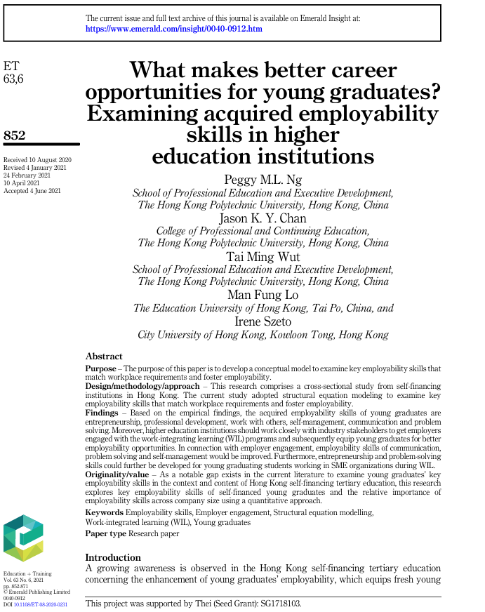

CRAAP Test
Currency | It was published on the 4th of June 2021 making it fairy recent Revised multiple times
Relevance | The relevance is the purpose of the paper is to examine key employability skills in the workplace exactly what we are looking for.
Authority | The source is is a peer reviewed article with 5 people researching all with prestigious university’s Peer review and academic affiliations
Accuracy | •  with 5 people researching this it is highly credible and accurate and it comes from a cross-sectional study from self financing in Hong Kong
udPurpose | The purpose of this is that it examines the employability skills that match workplace requirements and to help with employability

Task 3: Source Analysis
Your manager has provided you with a short extract from a source and has asked you to analyse the source by Identifying one strength, one weakness, and providing a brief explanation of the strength and weakness identified.
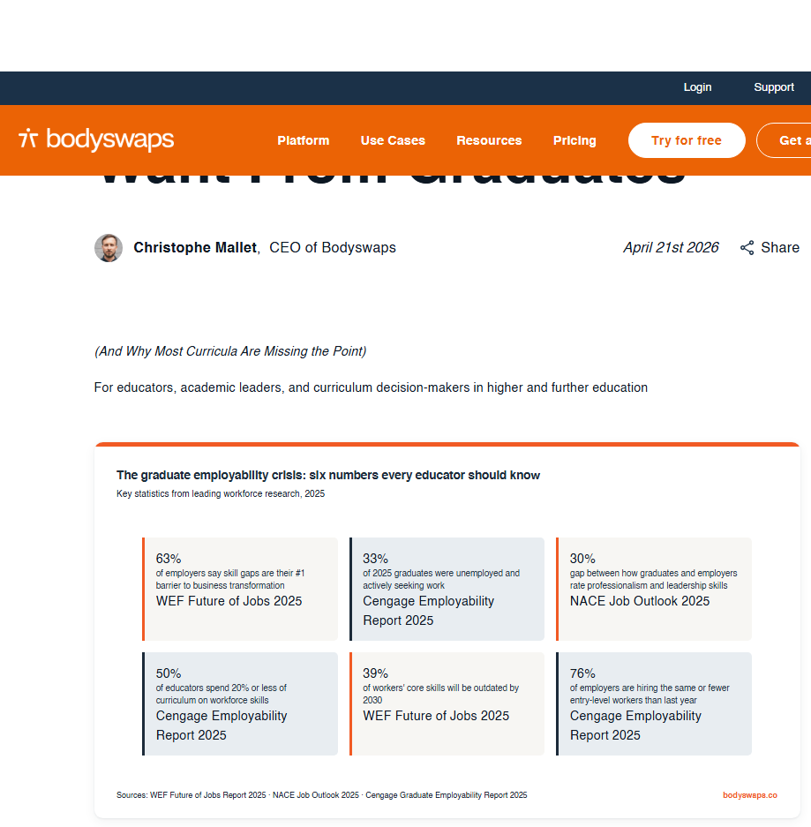
.

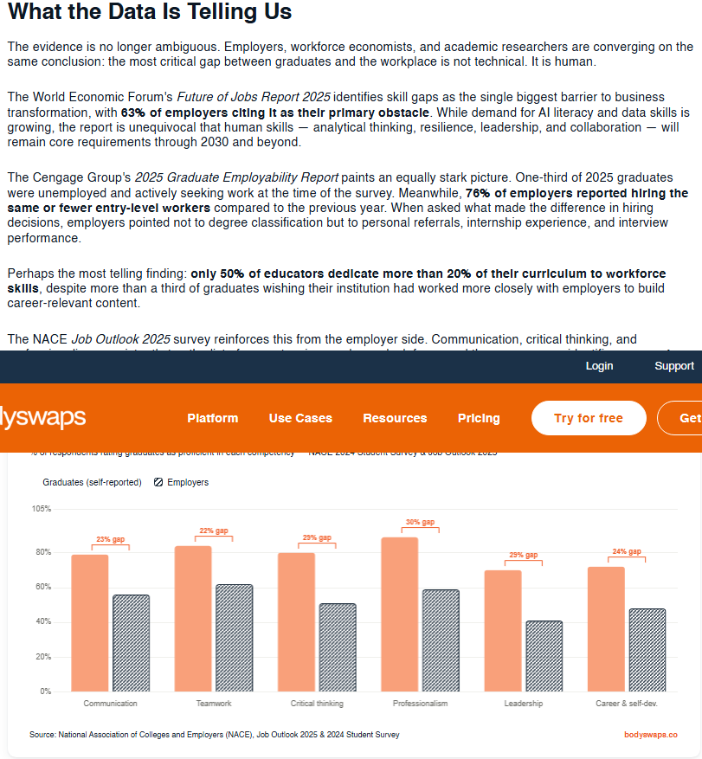

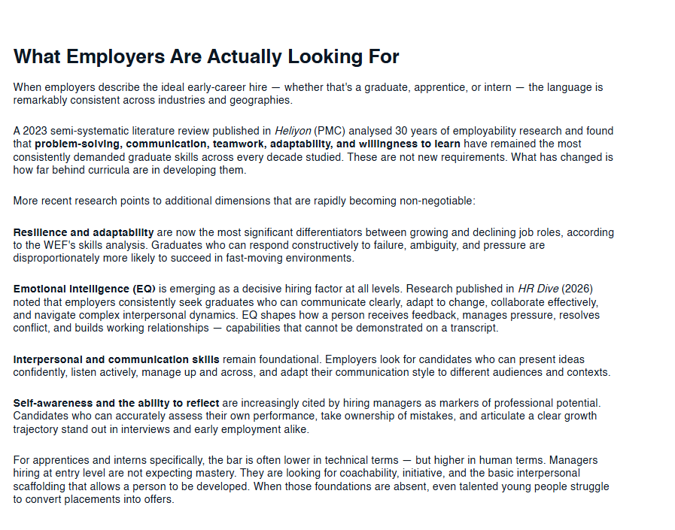

Please click the link, if you wish to read the article online.
What Employers Actually Want From Graduates

Strength of the Source:
One strength would be that this was published on the 21st of April 2026 making it recent and it is telling you exactly what employers would like to see with data to back it up and to tell you what the most desirable skills are with data. And with loads of references to.

Weakness of the Source:
It leaves you with a lot of questions such as. Why are graduates not job ready or how can university’s improve graduate employability?
The data was only recorded from 2023 – 2025 so it could of changed.

