

BMSW4008 – Digital Skills for Personal and Professional Growth – E-Portfolio
Title Page
Your name Nikolas punak
Student ID 2422304
Module code: BMSW4008
Lecturer: Muhammad Cassamo
Submission date12/12/25

AI Acknowledgement
I confirm that this assessment has been produced in line with the University’s academic integrity guidelines. AI tools were used only to support planning and understanding, and not to generate the final submitted work.

Contents Page
- Report including questionnaire and data collection
- Data analysis
- Website and marketing materials
- Report references
- Excel screenshots
- Importance of Excel in the digital era
- References

Market Research, Website and Marketing Analysis
SmokeyCats Café is a proposed student-focused café concept designed for the Cathays area of Cardiff. The business aims to provide a calm and affordable study café during the daytime, combined with a themed cat lounge atmosphere and an optional shisha area during the evenings. The idea was developed to meet the needs of students who regularly use cafés for studying, socialising, and relaxation. A questionnaire was carried out to collect primary market research data to support the development of the business idea. The purpose of the questionnaire was to better understand student preferences, price expectations, and attitudes towards themed cafés, sustainability, and loyalty schemes. This research helped ensure that decisions were based on evidence rather than assumptions.

Questionnaire Design and data collection
The questionnaire was created using google forms as it is free,assessible,and efficient digital tool for collecting data. Google Forms allows responses to be accurate.The questionnaire contained . ten questions and was distributed to students within the target market,primarily aged between 18 and 26.The questionnaire was shared with classmates and other students, resulting in a total of 16 responses. Online questionnaires are effective because they allow data to be collected quickly from a relevant audience while reducing cost and time compared to face-to-face research. They also allow participants to respond honestly and anonymously, which can improve the reliability of the results. The use of an online questionnaire reflects modern digital research methods commonly used in business planning and market research.The questionnaire was created using Google Forms, a digital tool that allows data to be collected efficiently and automatically displayed in graphical form (Google, 2024).

Results and Analysis of key findings

One key question in the questionnaire asked participants how often they visit cafes.The results showed 81% of respondents visit cafes weekly.This demonstrates that cafes play an important role in students daily routines and supports the idea that there is strong demand for a student-focused cafe in Cathays.This finding influenced the business concept by highlighting the need for affordable pricing and a comfortable environment that encourages repeat visits.
Another important question focused on the main reasons students visit cafés. The results showed that the most common reasons were purchasing drinks and socialising. This indicates that students value cafés not only as places to buy refreshments but also as social spaces. As a result, SmokeyCats Café was designed to include both quiet study areas and relaxed seating for social interaction. This balance helps the café appeal to a wider range of student needs throughout the day.
Price expectations were also explored in the questionnaire. Most respondents stated that they expected café prices to range between £2 and £4. This result was significant, as it confirmed that affordability is a key factor for students. This influenced the pricing strategy of SmokeyCats Café, ensuring that drinks are competitively priced to encourage regular visits rather than occasional use. Keeping prices within this range supports customer loyalty and aligns with limited budgets of students.

The questionnaire also revealed that 75% of respondents would value a loyalty scheme, and 87.5% considered sustainability to be important. These findings directly shaped both the marketing approach and operational decisions. A digital loyalty scheme was included as a SMART objective, and sustainable practices such as recyclable materials were incorporated into the business plan. Additionally, the results showed generally positive attitudes towards themed cafés and acceptance of shisha as long as it remained optional. This confirmed that the combined café and shisha concept would be suitable for the target market without alienating non-shisha customers.

Application to Website Desgin and SEO

The website design for SmokeyCatsCafe was directly informed by the questionnaire results. A clean and simple layout was chosen to reflect the calm study-focused environment that students value. Neutral and warm colours were selected to create a relaxing atmosphere, while cat-themed visuals were used to highlight the unique identity of the brand. The content focuses on affordability, comfort, and flexibility, clearly communicating that the café supports both studying and socialising.


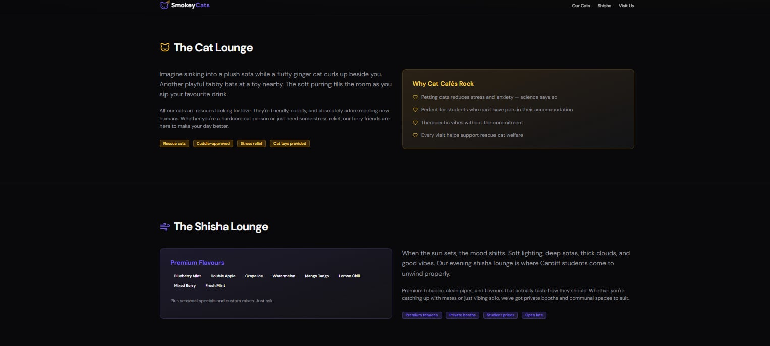

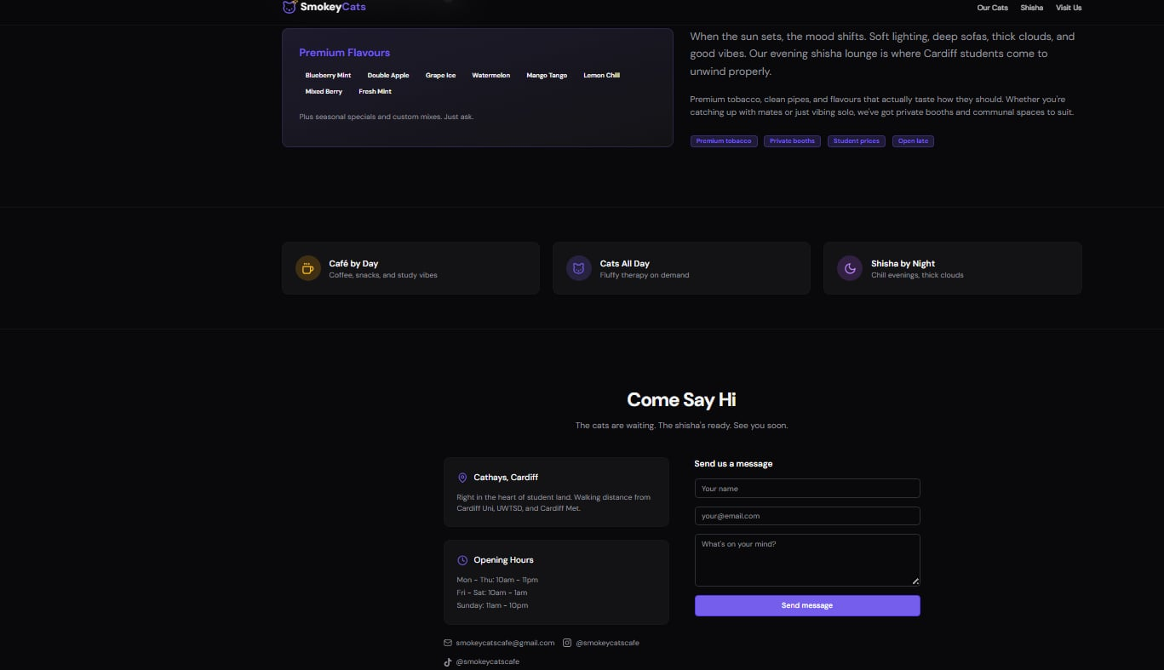

Search Engine Optimisation SEO was considered by including keywords such as “student café Cardiff,” “Cathays café,” and “study café near Cardiff University.” These keywords were placed within headings and page text to improve visibility on search engines. The website structure is clear and easy to navigate, which improves user experience and supports engagement. By aligning the website design and content with market research findings, the website effectively reflects customer preferences and strengthens the overall digital presence of the business.
Marketing Materials and Target Audience
Marketing materials were created using Canva, as it is a user-friendly digital design platform that allows professional-looking content to be produced quickly. The target audience is students aged 18–26 and young professionals living in Cardiff. The designs focus on social media platforms such as Instagram and TikTok, as these are widely used by students. Bright but simple visuals, short messages, and student-focused language were used to attract attention. The marketing materials promote key features such as free Wi-Fi, themed spaces, and loyalty rewards. These design choices align with the questionnaire findings and support engagement with the target market.Marketing materials were created using Canva, an online design platform that supports quick and professional digital content creation (Canva, 2024).

References

BBC News (2022) Why cat cafés are becoming a UK trend. Available at: https://www.bbc.co.uk/news (Accessed: 19 December 2025).
Canva (2024) Canva: Online graphic design platform. Available at: https://www.canva.com (Accessed: 19 December 2025).
Cardiff Council (2024) Cardiff population and student distribution report. Available at: https://www.cardiff.gov.uk (Accessed: 19 December 2025).
Google (2024) Google Forms. Available at: https://www.google.com/forms (Accessed: 19 December 2025).
IBISWorld (2023) Coffee and snack shops in the UK – industry report. Available at: https://www.ibisworld.com (Accessed: 19 December 2025).
Kotler, P. and Armstrong, G. (2018) Principles of marketing. 17th edn. Harlow: Pearson Education.
Mintel (2023) UK coffee shop market report. London: Mintel Group Ltd.
Office for National Statistics (ONS) (2023) Consumer behaviour of young adults in the UK. Available at: https://www.ons.gov.uk (Accessed: 19 December 2025).
Pinterest (2024) Pinterest: image sharing platform. Available at: https://www.pinterest.com (Accessed: 19 December 2025).
Statista (2024) Number of students enrolled at Cardiff University. Available at: https://www.statista.com (Accessed: 19 December 2025).
Conclusion

In conclusion, the market research process demonstrated the importance of using data to inform business decisions. The questionnaire provided valuable insights into student behaviour, preferences, and expectations, which directly influenced the business concept, website design, and marketing strategy. This task helped develop digital skills in data collection, analysis, and digital content creation. It also highlighted how evidence-based decision-making can reduce risk and improve business planning. Overall, the research confirmed that SmokeyCats Café has strong potential within the student market and showed how digital tools can support effective business development.

TASK 2 – EXCEL FINANCIAL PROJECTION
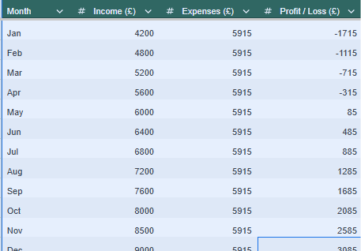
The Excel spreadsheet above presents a 12-month financial projection for SmokeyCats Café, showing monthly income, expenses, and profit or loss. Formulas were used to automatically calculate profit/loss, and a chart was included to visually demonstrate the transition from early losses to profitability over time.

Task 2: The Importance of Excel in the Digital Era
Microsoft Excel is one of the most important digital tools used in modern businesses. It allows organisations to collect,organise,analyse and interpret data efficiently. In the digital era,where data-driven decision-making is essential,Excel provides businesses with a simple but powerful way to manage financial information, monitor performance and a plan for the future.Its accessibility and flexibility make it a widely used tool across different industries,particularly for small businesses and start-ups.

One of the main reasons Excel is important is its ability to handle numerical data accurately Business regularly deal with income,expenses,profit and cash flow,and Excel allows this data to be calculated automatically using formulas. This reduces the risk of human error compared to manual calculations. For example, formulas such as SUM and subtraction functions allow users to quickly calculate total income, total expenses and profit or loss. This helps business owners understand their financial position and make informed decisions based on real figures rather than estimates.
Excel is also an essential tool for financial planning and forecasting. In this task, Excel was used to create a 12-month cash flow forecast for SmokeyCats Café. The forecast showed how income and expenses change over time and highlighted that the business would make losses in the early months before gradually reaching a positive cash balance. This is important because it demonstrates how Excel can help identify financial risks before they become serious problems. By visualising financial data month by month, businesses can plan ahead, manage costs and ensure they have enough funding to survive the early stages of operation.
Another key benefit of Excel is its ability to present data visually through charts and graphs. Visual data makes information easier to understand and communicate. For example, the bar chart comparing monthly income and expenses clearly shows how the business grows over time and when it reaches break-even. This is particularly useful when sharing financial information with stakeholders, such as potential investors or lenders, who may not want to analyse large tables of numbers. Visual tools improve clarity and support better communication in professional environments.
Excel also supports decision-making and problem-solving in the workplace. Businesses can use Excel to compare different scenarios, such as changes in pricing or expenses, and assess how these changes affect profitability. This allows managers to test ideas without taking real financial risks. In the case of SmokeyCats Café, Excel could be used to assess the impact of increasing marketing spending or adjusting prices to attract more students. This demonstrates how Excel supports strategic planning and improves workplace efficiency.
In addition, Excel is a valuable employability skill. Many employers expect workers to have basic Excel knowledge, particularly in roles involving administration, finance or management. Being able to use Excel shows digital competence and an understanding of how data is used in professional environments. Learning how to use formulas, formatting and charts helps students develop transferable skills that are relevant across a wide range of careers. This aligns with the module’s aim of improving personal and professional digital skills.
Excel also supports organisation and time management. Data can be structured clearly using rows, columns and labels, making it easier to track information over time. This is especially useful for small business owners who need to manage multiple tasks at once. By using Excel regularly, businesses can maintain accurate records, monitor performance and respond quickly to changes in the market.
In conclusion, Excel is an essential tool in the digital era due to its ability to manage financial data, support planning and improve decision-making. Its use in creating the cash flow forecast for SmokeyCats Café demonstrates how Excel can help businesses understand their finances and plan for future growth. Developing Excel skills not only supports business success but also improves employability by providing a practical and widely used digital skill.

References

Business Wales (2023) Financial planning for start-up businesses. Welsh Government. Available at: https://businesswales.gov.wales (Accessed: 19 December 2025).
IBISWorld (2023) Small business financial management in the UK. Available at: https://www.ibisworld.com (Accessed: 19 December 2025).
Investopedia (2024) Cash flow forecasting. Available at: https://www.investopedia.com (Accessed: 19 December 2025).
Kotler, P. and Armstrong, G. (2018) Principles of marketing. 17th edn. Harlow: Pearson Education.
(Supports decision-making and planning arguments)
Microsoft (2023) Excel for business and financial analysis. Available at: https://www.microsoft.com (Accessed: 19 December 2025).
Office for National Statistics (ONS) (2023) UK small business and employment statistics. Available at: https://www.ons.gov.uk (Accessed: 19 December 2025).
Start Up Loans UK (2023) Managing business finances. British Business Bank. Available at: https://www.startuploans.co.uk (Accessed: 19 December 2025).

