

Digital Transformation in the Health and Care Professions (BMHP6026)

Component 1: Written Report
Student name: Misjona Kovaci
Student number:2226356
Lecturer’s name: Muhammed Khan

Table of contents

1. Introduction…………………………………………………………………………………............3
2. Overview of the Technology………………………………………………………………………...3-5
3. Impact on Workforce……………………………………………………………………………………6
4.Impact on Patients and Service Users………………………………………………………………7
5. Impact on Service Delivery…………………………………………………………………………...8-9
6. Impact on the Community and Public Health…………………………………………………9-10
7. Critical Evaluation……………………………………………………………………………………….10
8. Conclusion………………………………………………………………………………………………...11
9. References…………………………………………………………………………12-13

Introduction
Over the past ten years, digital technology has changed the way health and social care services are delivered in the UK. Wearable devices, mobile apps and remote monitoring systems are now commonly used to support people with long-term conditions. One important example of this digital transformation is the FreeStyle Libre flash glucose monitoring system. The availability of FreeStyle Libre on the NHS marked an important shift towards digital self-management technologies in diabetes care (Crabtree, 2018). This device has changed how people with diabetes monitor their blood glucose levels. This report critically evaluates FreeStyle Libre as a digital innovation in UK health and social care. It will examine its impact on the workforce, service delivery, patients and the wider community, while also considering both positive and negative outcomes. Digital transformation involves organisational, professional and cultural change, not only the adoption of new technology.

Overview of the Technology
FreeStyle Libre is a flash glucose monitoring system developed by Abbott Diabetes Care and first introduced in Europe in 2014 as a digital alternative to traditional blood glucose testing (Crabtree, 2018). The FreeStyle Libre system is a wearable digital device used to monitor glucose levels in people with diabetes. A small sensor is placed on the back of the upper arm and measures glucose in the fluid under the skin for up to 14 days. Users scan the sensor with a reader or smartphone to view their current glucose level, previous readings and trend information (NICE, 2017). FreeStyle Libre technology has continued to develop, with newer versions such as FreeStyle Libre 2 providing optional alarms to warn users when glucose levels become too high or too low, improving safety compared with the original Libre system (Wilmot et al., 2021). The system combines a physical sensor with mobile technology, showing how healthcare is becoming more data-driven (NHS Leeds Teaching Hospitals NHS Trust, n.d.) (see Figure 1A–C). Compared with traditional finger-prick testing, FreeStyle Libre offers a less invasive way to monitor glucose. This may encourage more frequent monitoring and support better self-management. However, it does not completely replace finger-prick testing because accuracy can vary when glucose levels change quickly (NICE, 2017). This shows that digital tools often complement rather than fully replace existing clinical methods. The introduction of FreeStyle Libre onto the NHS Drug Tariff in 2017 represents an important step in digital transformation within diabetes care. By 2018, the FreeStyle Libre system was already being used by more than 300,000 people worldwide, demonstrating the rapid adoption of digital glucose monitoring technologies (Crabtree, 2018). It demonstrates how wearable technology can move monitoring from clinic-based testing to everyday life. At the same time, the technology requires user training, digital skills and ongoing funding, highlighting that successful implementation involves organisational change as well as new devices. Although the technology is simple to use, effective use depends on patient education and digital confidence.
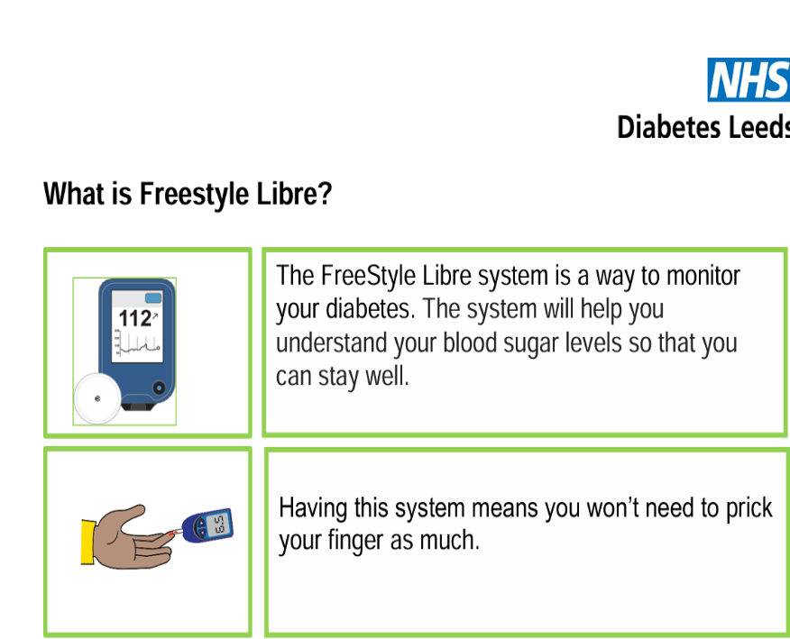

FIGURE 1A

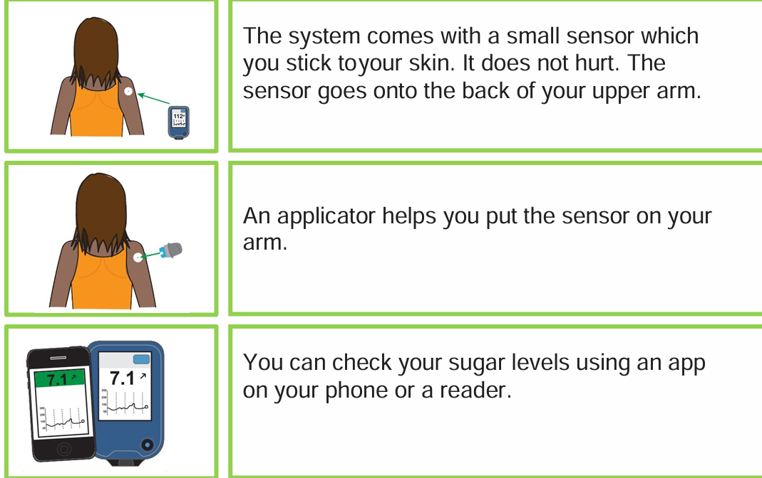 FIGURE 1B
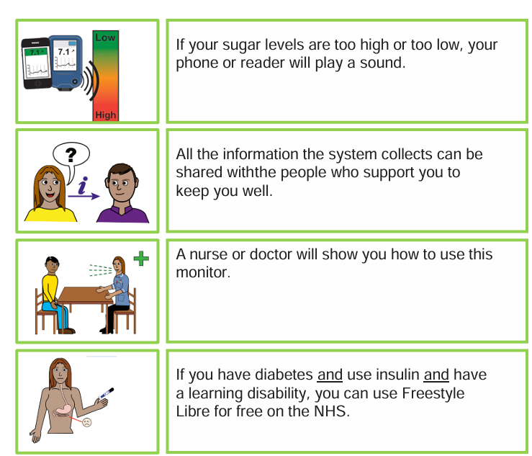FIGURE 1C
Figure 1: Overview of how the FreeStyle Libre system works (NHS Leeds Teaching Hospitals, n.d.).
Impact on Workforce
The introduction of FreeStyle Libre has changed how healthcare staff work in diabetes services. In the past, nurses and doctors mainly looked at finger-prick readings written in notebooks. These readings were usually taken a few times a day. Now, with FreeStyle Libre, professionals can see detailed glucose patterns over days and weeks. This means their role has shifted from checking single readings to analysing large amounts of digital data.
This change requires new skills. Staff need to understand how to read glucose trend graphs and ambulatory glucose profiles. They also need confidence using digital systems such as LibreView to review data remotely. This shows that digital technology does not just change patient care; it also changes professional expectations. Healthcare workers must now be more digitally competent than before.
There are clear advantages. Having access to continuous glucose data allows professionals to make better decisions about insulin adjustments. It can help identify problems earlier and may reduce emergency hospital admissions (Fokkert et al., 2017). This can improve patient safety and may reduce long-term complications. From a professional point of view, having clearer data can increase confidence in treatment decisions.
However, there are also challenges. More data can sometimes mean more work. Reviewing detailed glucose reports takes time, especially if patients scan very frequently. This may increase workload rather than reduce it. In busy NHS clinics where staff are already under pressure, this can be difficult to manage.
Another issue is digital confidence among staff. Not all healthcare professionals feel equally comfortable using digital tools. Some may need extra training and support. Without proper training, there is a risk of inconsistent practice between clinics or regions.
There is also a shift in responsibility. As patients can see their own glucose trends clearly, they may take more control over their diabetes management. This can be positive, as it encourages self-management. However, professionals must still ensure that patients understand the data correctly and do not misinterpret readings. This means communication skills remain just as important as technical skills.
Overall, FreeStyle Libre has changed workforce roles by increasing the need for digital skills, data interpretation and remote consultation. While it offers opportunities for improved care, it also creates new pressures and training needs. Digital transformation therefore requires investment not only in technology, but also in the people who use it.

Impact on Patients and Service Users
FreeStyle Libre has had a strong impact on patient experience. Many people with diabetes find finger-prick testing painful and inconvenient. The sensor reduces this burden and allows more flexible monitoring. Edge et al. (2017) reported high satisfaction among children and families. Increased scanning was linked to better glucose control. This suggests that digital tools can empower patients and support self-management by giving individuals more real-time information about their condition.
However, not all outcomes are positive. Ulriksdotter et al. (2019) identified cases of allergic contact dermatitis caused by chemicals in the sensor adhesive. Six out of seven patients tested reacted to these substances. This highlights that new technologies can introduce new health risks that require clinical monitoring and careful regulation. There are also psychological considerations. Constant access to glucose data may increase anxiety for some individuals, particularly if readings fluctuate frequently (Ulriksdotter et al., 2019). While some patients feel reassured by continuous data, others may feel stressed or overly focused on small changes in glucose levels.
Older adults or those without smartphone access may face challenges in using the technology effectively. Limited digital literacy or lack of access to compatible devices may reduce their ability to benefit fully from digital monitoring. This could widen existing health inequalities if additional support is not provided.
Overall, FreeStyle Libre improves patient independence and gives people more control over their condition. However, the benefits depend on correct use, education and access to technology. Some patients may feel overwhelmed by constant data, while others may not have the skills or resources to use the device effectively. This shows that digital innovation can improve patient experience, but ongoing professional guidance remains essential to ensure safe, confident and equitable use (NICE, 2017).

Impact on Service Delivery
FreeStyle Libre has significantly changed day-to-day diabetes management. Instead of testing only a few times per day using finger-prick methods, users can scan the sensor as often as they wish. This provides more detailed information about glucose trends and patterns, allowing people to better understand how food, exercise and insulin affect their blood sugar levels.
Rayman, Kröger and Bolinder (2018) examined whether Libre data could support safe driving decisions. They found that even when blood glucose was considered “safe” using traditional finger-prick testing, levels could drop within four hours. The trend arrows provided by Libre may help predict these drops. This shows how digital monitoring can improve safety and provide additional information beyond traditional methods.
In paediatric services, Edge et al. (2017) found that FreeStyle Libre was safe and acceptable for children and young people in UK diabetes centres. Children and families preferred the system because it reduced the pain of repeated finger-prick testing and improved understanding of glucose patterns. This suggests that digital innovation can enhance service delivery by making monitoring less invasive and more engaging.
From a wider NHS perspective, the introduction of FreeStyle Libre has also affected how local health services manage their budgets and resources. Blissett et al. (2022) carried out a UK budget impact analysis using real-world data from the Association of British Clinical Diabetologists (ABCD) nationwide audit. This highlights that digital innovation can improve efficiency, but its long-term value depends on sustained patient outcomes and effective implementation. Their study showed that although the FreeStyle Libre system has higher purchase costs compared to traditional finger-prick testing, some of these costs are balanced by reductions in hospital admissions and diabetes-related complications. In an average UK local health economy, increasing Libre use from 30% to 50% led to only a small increase in overall costs (around 3–4%). This suggests that while digital innovation may slightly increase short-term spending, it may support more efficient and preventive service delivery in the long term (NICE, 2017).
However, FreeStyle Libre does not provide automatic hypoglycaemia alarms in earlier versions (NICE, 2017). This means it is not a full continuous glucose monitor. In some situations, users must still rely on finger-prick tests to confirm readings. Therefore, although service delivery has improved through digital innovation, traditional monitoring methods have not completely disappeared.

Impact on the Community and Public Health
At a wider level, FreeStyle Libre may contribute to improved public health outcomes. Better glucose control reduces the risk of long-term complications such as kidney disease, blindness and cardiovascular problems. Research also shows that flash glucose monitoring improves overall glucose control and supports better long-term diabetes outcomes at population level (Wilmot et al.,2021).
A recent systematic review by de Pouvourville et al. (2025) found that FreeStyle Libre is generally cost-effective compared to traditional finger-prick testing. Improved HbA1c levels and reduced hypoglycaemia can lower long-term healthcare costs. However, many of the studies reviewed were industry-funded, which may influence results. This means findings should be interpreted carefully.
Access has also been a concern. As access increased, the number of people using flash glucose monitoring in the UK has continued to grow, demonstrating increasing acceptance of digital monitoring technologies within diabetes services. Prior to national funding arrangements, availability varied between regions. This created inequalities sometimes described as a “postcode lottery.” Even with NHS funding, some groups may struggle due to digital exclusion.
Families and carers also benefit from improved data sharing. Parents of children with diabetes may feel more reassured when they can monitor patterns and trends.
From a population perspective, Blissett et al. (2022) reported that increasing FreeStyle Libre use from 30% to 50% in a typical UK local health economy resulted in an overall cost increase of approximately 3–4% per year. This relatively small rise suggests that wider adoption of digital monitoring technologies may be financially sustainable within publicly funded NHS systems. However, long-term value depends on improved patient outcomes and reduced complications over time. Therefore, digital innovation has the potential to reduce long-term health inequalities, but only if access, digital literacy and funding are addressed.
Critical Evaluation
FreeStyle Libre demonstrates how digital technology can transform chronic disease management. It supports patient empowerment, improves access to health data and aligns with NHS digital transformation goals. Health Technology Wales (2020) highlighted that flash glucose monitoring can improve glycaemic control and reduce the burden of finger-prick testing, supporting its adoption within UK services. However, digital transformation is complex and requires more than introducing new technology. Workforce training, funding decisions and ongoing safety monitoring are essential for successful implementation. While clinical evidence shows improved monitoring and patient engagement, issues such as skin reactions, data governance and digital inequality highlight potential risks. The development of newer systems, such as Libre 3, reflects rapid technological progress, but also raises questions about cost, long-term sustainability and equal access in publicly funded healthcare. Digital innovation therefore involves organisational change, professional development and consideration of social factors. It may also increase reliance on technology, creating risks if systems fail or data is misunderstood. Overall, the success of digital innovation in health and social care depends on balancing technological advancement with workforce readiness, patient safety and equitable access

Conclusion
FreeStyle Libre has been an important example of digital innovation in UK health and social care over the last decade. It has changed how diabetes is monitored by moving from traditional finger-prick testing to continuous digital data collection. This has improved patient understanding of their condition and supported more personalised treatment decisions. It has also influenced service delivery by allowing remote data review and supporting virtual consultations.
However, digital transformation is not without challenges. While FreeStyle Libre offers clinical benefits such as improved glucose control and reduced hospital admissions, it has required healthcare professionals to develop new digital skills and adapt to new ways of working. Increased data can improve care, but it can also increase workload. In addition, although NHS funding has expanded access, inequalities and regional variation have affected who benefits from this technology.
From a wider community perspective, the system appears to be financially manageable for the NHS, but it still represents an increase in short-term costs. Long-term savings depend on sustained improvements in patient outcomes. Furthermore, safety concerns such as skin reactions and the need for confirmatory testing show that digital tools do not completely replace traditional methods.
Overall, FreeStyle Libre demonstrates that digital innovation can improve care quality and patient empowerment, but successful implementation depends on workforce training, equitable access and careful evaluation of long-term impact. Digital transformation in health and social care is therefore not simply about introducing new technology, but about ensuring that systems, professionals and communities are prepared to adapt to change.

References
Blissett, R., Blissett, D., Levrat-Guillen, F., Deshmukh, H. and Wilmot, E.G. et al. (2022) ‘FreeStyle Libre flash glucose monitoring system for people with type 1 diabetes in the UK: a budget impact analysis’, BMJ Open Diabetes Research & Care, 10(2), e002641. doi: 10.1136/bmjdrc-2021-002641. (Accessed: 19 February 2026).
Crabtree, T.S.J. (2018) ‘Freestyle Libre: available on the NHS?’, British Journal of Diabetes, 18(1), pp. 18–21. doi: 10.15277/bjd.2018.168. (Accessed: 17 February 2026).
de Pouvourville, G., Glintborg, B., Heaton, D., Hunt, B., Roze, S. and Schroeder, M. (2025) ‘Cost-effectiveness of the FreeStyle Libre flash glucose monitoring system: a systematic literature review’, Cardiovascular Diabetology, 24, Article 73. doi: 10.1186/s12962-025-00673-1. (Accessed: 17 February 2026).
Edge, J., Acerini, C., Campbell, F., Hamilton-Shield, J., Moudiotis, C., Rahman, S., Randell, T., Smith, A. and Trevelyan, N. (2017) ‘An alternative sensor-based method for glucose monitoring in children and young people with diabetes’, Archives of Disease in Childhood, 102(6), pp. 543–549. doi: 10.1136/archdischild-2016-311530. (Accessed: 17 February 2026).
Fokkert, M.J., van Dijk, P.R., Edens, M.A., Abbes, S., de Jong, D., Slingerland, R.J. and Bilo, H.J.G. (2017) ‘Performance of the FreeStyle Libre flash glucose monitoring system in patients with type 1 and 2 diabetes mellitus’, BMJ Open Diabetes Research & Care, 5(1), e000320. doi: 10.1136/bmjdrc-2016-000320. (Accessed: 17 February 2026).
National Institute for Health and Care Excellence (NICE) (2017) FreeStyle Libre for glucose monitoring. Medtech innovation briefing (MIB110). Available at: https://www.nice.org.uk/guidance/mib110 (Accessed: 17 February 2026).
NHS England (2018) FreeStyle Libre training pack for healthcare professionals and patients. Available at: https://www.england.nhs.uk/london/wp-content/uploads/sites/8/2019/07/dia-FreeStyle-Libre-training-pack-for-HCP-and-patients-052018.pdf (Accessed: 25 February 2026).
Health Technology Wales (2020) FreeStyle Libre flash glucose monitoring. Available at: https://healthtechnology.wales/reports-guidance/freestyle-libre-flash-glucose-monitoring/ (Accessed: 17 February 2026).

Rayman, G., Kröger, J. and Bolinder, J. (2018) ‘Could FreeStyle Libre™ sensor glucose data support decisions for safe driving?’, Diabetic Medicine, 35(4), pp. 491–494. doi: 10.1111/dme.13515. (Accessed: 17 February 2026).
Ulriksdotter, J., Svedman, C., Bruze, M., Glimsjö, J., Källberg, K., Sukakul, T. and Mowitz, M. (2019) ‘Contact dermatitis caused by glucose sensors’, Contact Dermatitis, 81(1), pp. 27–31. (Accessed: 17 February 2026).
Wilmot, E.G., Lumb, A., Hammond, P., et al. (2021) ‘Flash glucose monitoring with FreeStyle Libre 2 compared with self-monitoring of blood glucose in type 1 diabetes’, BMJ Open, 11(7), e050713. doi: 10.1136/bmjopen-2021-050713. (Accessed: 24 February 2026).

