Salma Aslam
2132607
Lecturer Name: Samuel Ofari

Module Code and Title: BMSW 4002 - Effective Team Working and Communication

Assignment Title: Component 1 – Report on Effective Teamworking for business success

Executive Summary
Amazon is a massive online retailer that sells a wide variety of goods to its billions of customers either directly or by serving as a link between themselves and other stores, including books, music, pictures, furniture, electronics, and toys. Amazon.com was started in 1994 by Jeff Bezos, a former private equity analyst for Wall Street. The name was selected in large part because of its association with the massive South American river and its proximity to the first letter of the alphabet. Amazon's massive online presence meant that it routed 1% of all U.S. online traffic in 2012. As a part of their continuous expansion, amazon wishes to create three large warehouses in three major cities in Europe, which are Paris, Berlin, and London. However, problems arose when this project was handled by Tom Jackson who had to form up a team to make the visions of Amazon successful.
This case study elaborately discusses the ideas necessary to achieve effective teamwork based on a team led by Tom Jackson. While highlighting some of the considerations for Tom’s team, Tuckman’s stages of development have been introduced. Another important topic for discussion here is the concept of roles for creating an effective team and the benefits of evolving into an effective team. This case study also considered the barriers to effective teamwork, especially the ones faced by Tom’s team and how they can overcome those facts. Overall, the writing is aimed to provide Tom and his team with a better overview and guidelines to deal with their current situation and attain Amazon’s overall goals.

Table of Contents
Executive Summary 2
Introduction 4
Developing Process of An Effective Team and Development Stage Model 4
Ways Of Developing an Effective Team 4
Tuckman’s Stages of Team Development 6
Team Roles for Creating an Effective Team 7
Benefits of teamwork in Tom’s Case 8
Barriers to effective teamwork and Ways to Overcome them 9
Conclusion 10
References 12

Introduction
This case study is about achieving effective teamwork based on a team of giant e-commerce company Amazon led by Tom Jackson which wanted to open a warehouse in three main countries of Europe. Amazon is a global technology firm with a focus on digital streaming, cloud computing, and artificial intelligence. Now they are attempting to establish a warehouse in Europe. So, they formed a team under Tom Jackson's direction. However, Tom Jackson has been facing several difficulties regarding teamwork and communication which is staggering their overall project. "Teamwork" is a term that refers to the process of working together with several people towards a common objective as per Davis, (2019). Teamwork is often an essential part of a company since employees must be able to collaborate effectively and provide their utmost in all circumstances. Employees that work together to accomplish a common objective, delegate tasks to one another, and share responsibilities demonstrate effective collaboration. Therefore, this case study will discuss the developing process of an effective team and development stage model. There will be a precise discussion about Tuckman’s stages of team development. Also, the team’s role in creating an effective team and the benefits of teamwork will be highlighted here. Finally, there will be an attempt to identify the barriers to effective teamwork according to Tom Jackson’s team and figure out ways to overcome them.

Developing Process of An Effective Team and Development Stage Model

Ways Of Developing an Effective Team
In many ways, working as a team is incredibly advantageous. Results produced by teams are more effective, efficient, and of higher quality. As the current scenario suggests, Tom Jackson created a team for Amazon and is struggling with his team. Here, he can apply ideas like commitment, communication, roles, engagement, diversity, and goal interdependence to create an efficient team.

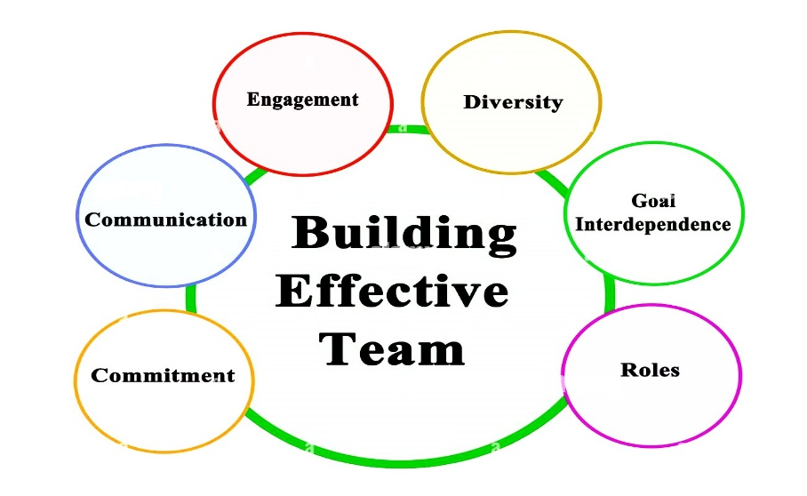
Figure: Process of building an effective team (Dubin et al., 2015)
Commitment: Every team effort starts with commitment which was lacking in Mihaela and Spencer’s case. Committed team members are more receptive to new ideas, abilities, and working methods according to Dubin et al, (2015). To begin with, Tom's team members need to be devoted to one another. Then, they need to understand their roles and their importance in the organisation as well as the projet. Afterwards, Tom needs to put appraisal systems in place to ensure they remain committed. In this way, it will be fantastic for Tom's team's growth. Teams who have this level of dedication can overcome any difficult conditions that may emerge swiftly.
Communication: A successful team also has an efficient and seemingly smooth communication system as per Colquit et al., (2015). Tom Jackson's team needs a strong and reliable communication channel so that Amazon can open and operate warehouses in various European nations. However, as there is a breakdown of communication between his staff, and the strength is not there. They lack an effective means of communication which should be established. Moreover, Tom can think of simplified yet direct communication channels where employees will directly and frequently communicate with him.
Roles: According to research conducted by various scholars and academics, assigning roles to team members is one of the tried-and-true team-building tips that focuses on fostering commitment by Cross et al, (2018). This is an important point for Tom's team because he is working to build an effective team. Developing such a team requires him to establish and verify each team member's contributions and abilities.
Engagement: If the group's leader does not know how to interact with the people under their charge, the group's work will quickly devolve into chaos as Eikenberry et al., (2019) illustrates. So, by properly and timely engaging with team members, Tom can make his team more effective.
Diversity: The term "diversity" refers to the wide variety of ways in which a group of people might differ from one another (Davis, 2019). An effective team will have members from a variety of backgrounds and perspectives. According to Gratton et al, (2017) age, gender, nationality, education, occupation, and length of service are just a few of the dimensions along which a company's demographics may be broken down which in this case Tom needs to ensure.
Interdependence of goal: Definition of Goal Interdependence Having a common understanding of the team's ultimate objective and adjusting individual objectives accordingly (Colquitt et al, 2015). Tom Jackson’s team must have the goal of interdependence to develop an effective team.

Tuckman’s Stages of Team Development
There are 5 stages of team development model which can help Tom Jackson’s to ensure an effective team management.

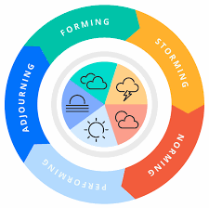
Figure: Tuckman’s 5 stages of team development (Tuckman and Jensen, 2018)

Forming: The first step in building a team is to establish its foundation. Members of the team experience uncertainty and conflicts are strictly avoided because of the need to fit in. So, Tom’s team needs to find out their core values to strengthen their foundation.
Storming: Individuals in Tom's team, including the leader, may face challenges from other teammates and from within if they have not already established themselves within the team (Carlson et al., 2022). While keeping this in mind, the members will try to find out ways to sustain their positions resulting in the proper formation of the group.
Norming: Tom’s group can reach a majority consensus thanks to the leader's capable facilitation. Major choices are settled upon by consensus. Here at this point, Tom’s team members are getting disappointed with the agreement. So, he must look over that.
Performing: This is the point in Tom’s group growth where the true reliance is on the norms. The team's adaptability stems from members' willingness to change to fulfil the requirements of others. So, while performing their regular obligations, Tom’s team members should keep these norms in mind when they reach such a state.
Adjourning: At this point, the team's composition and structure generally undergo a major change as individuals prepare to leave. So, Tom should establish a specific object and task for the amazon warehouse team prior hand so that they can approach this stage better prepared.

Team Roles for Creating an Effective Team
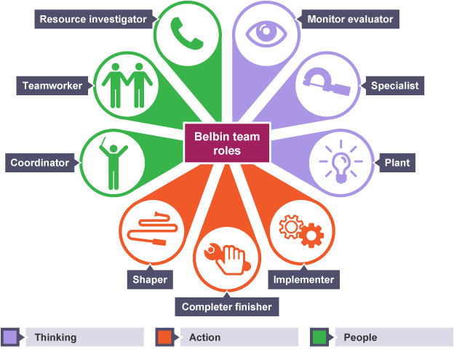
Figure: Team Roles for an Effective Team (Rosengarten, 2022)
As mentioned in the previous section, Tom should distinguish and allocate separate roles in his team for a better performance. The roles can be:
Leader: A leader's job is to set the team's direction, inspire them, and motivate them (Rosengarten, 2022). They also establish ground rules for how the team will interact with one another. Therefore, Tom must set the aim, define the target, and give directions first. Tom is also responsible for setting up and directing any meetings that may be held. Leaders like Tom are dependable for delegating tasks to their teams and ensuring that everyone is doing their part (Goyal and Gupta, 2022).
Creative Director Role: Any team's success depends on access to creative energy, according to Mc Kenzie et al, (2022). Therefore, Tom’s allocated creative director of the Amazon warehouse team should encourage his staff to retain the positive spirit that is essential for successful teamwork. This will keep Tom’s team continuously working toward improvement and prevent stunted development.
Facilitator: Tom's team's facilitator oversees assisting the group in comprehending its goals and providing guidance on how to get there. It is essential to have a facilitator present during brainstorming sessions and other group creative activities to ensure that all relevant information is captured in a clear and concise format (Martin et al., 2022). By doing so, a facilitator helps the group work toward its goals as a unit.
Coach: This is one of the vital roles for the team as they will direct how the team’s future performance (Nieuwoudt et al., 2021). Tom himself can be the coach or his allocated coaches can offer one-on-one assistance. They can play a vital role in communication with Tom’s other members. They can also solve communication problems through discussions.
Member: A productive team member's primary duty is to show up to meetings and do all assigned work. (Goyal and Gupta, 2022). Tom’s members should speak with him frequently and comprehend what the leader expects of them. Accordingly, Tom should have a proper monitoring and evaluation system in place to appraise their performance.

Benefits of teamwork in Tom’s Case
Given the size and significance of this project for Amazon, the collaboration will be beneficial to Tom Jackson's team. If Tom's team can demonstrate effective cooperation, it will make use of everyone's skills and areas of expertise while equally distributing workloads and responsibilities. Additionally, information will be shared among Tom Jackson's team members so that they may optimize learning opportunities for the whole company. The more capable team members successfully strengthen the less capable. With the help of one another, members of a high-functioning team may generate a wide range of options for addressing any given problem, from which they can then collectively decide upon the most promising course of action (Georgiou et al., 2021).
Individuals will therefore be likely to have fewer possible answers in Tom Jackson's team. Individuals may achieve common goals by working together on Tom Jackson's team. Tom Jackson's team frequently comes up with more precise, original, and useful answers to issues than a single person. Results are often better when teams work together. Teamwork fosters a greater sense of collective and individual involvement in the organization's goals (Oosthuizen et al., 2021). Which will aid the project team working on opening the Amazon warehouse in producing a better outcome.
When Tom’s team members feel the personal security that comes from being a member of a successful team, they will be more emotionally optimistic and greater at sharing information and responsibilities (Carlson et al., 2022). That will have an impact on Tom Jackson's Amazon teamwork. They can think more broadly and take greater chances because of the group's encouragement and support. In some cases, a group can solve complex, challenging, in-depth, and involved problems better than an individual. Teams can finish projects and solve issues more rapidly than individuals since they can come up with many solutions fast and via the efficient use of human resources. For an e-commerce giant like amazon, their target of opening a warehouse in Europe project can be very easy through teamwork.

Barriers to effective teamwork and Ways to Overcome them
Ineffective leadership
Tom Jackson's teams need him to lead them, provide advice, and continually promote cooperation if they are to work together well. Therefore, bad leadership can cause teams to feel disengaged and discouraged, which can negatively affect how well they can cooperate, which was happening in this case. Tom may take control of these circumstances by providing more chances for teamwork, assisting team members in developing their abilities, and identifying strategies to reward productive collaboration as suggested by McKenzie et al., (2022).
Communication gap
The team's failure to coordinate their efforts efficiently raises major red flags. Professionals need strong communication skills to build relationships with their coworkers, express their ideas, get feedback, and convey their expectations to their colleagues (Nieuwoudt et al., 2021). If there are problems with team communication, members may not know their duties as well as what is required of them. That's the case with Tom's group working on the Amazon-focused project. According to Andrei (2021), teams may try to better communicate to bridge these gaps and work together effectively. As a result, Amazon's project team's mode of communication is essential to its success.
Poor conflict resolution skills
Tom must know how to resolve conflicts so that everyone can move forward when teams are working together toward common goals. This issue was one that Tom Jackson's team encountered right away. This might be a difficult task if they lack dispute-resolution abilities (Paige et al., 2021). Tom Jackson's team may practice conflict resolution techniques genuinely using a preset method and in targeted learning and development workshops to get past this obstacle.
Inequitable decision-making
These issues are also affecting the Amazon project team. It's common for one team member to shoulder more decision-making weight and take the lead on projects than the others when working in a group (Westphaln et al., 2022). The team should thus overcome this, and team captain Tom Jackson can play a good role in doing so.

Conclusion
Effective teamwork is working well together are inspired to rely upon one another. Team members collaborate to accomplish a shared objective while assigning and sharing duties to help one another. In this case study, everything about effective teamwork development and process barriers is elaborately discussed. To overcome those barriers Tom Jackson’s leading team should work together and communicate effectively with each other. Tom also can play a vital role in giving proper leadership, where he has a silly lacking. He should create trust in every team member’s heart. Amazon is a giant commercial company. The stages of Tuckman’s development forming, storming, norming, performing, and adjourning can also help to develop Tom Jackson’s team. Now they want to open a warehouse in Europe. Also, the main focusing point is the communication gap which must be overcome by them for good formation. So, in this case, teamwork must be needed properly to conduct this amazing project. There are too many benefits of teamwork and if they overcome their barriers, they can make it easier.

References
Andrei, A.M., 2021. Teleworking, teamwork and transactive memory during the COVID-19 outbreak. Management dynamics in the knowledge economy.
Carlson, B., Graham, R., Stinson, B. and LaRocca, J., 2022. Teamwork that affects outcomes: A method to enhance team ownership. Patient Experience Journal, 9(2), pp.94-98.
Colquit, G., Alfonso, M.L., Walker, A., Gupta, A., Telfair, J. and 2015. “It all goes back to the services”: A rural/urban comparison of service providers’ perceptions of challenges and facilitators to disability services. Open Journal of Preventive Medicine, 5(10), p.434.
Cross, Khoshab, H., Nouhi, E., Tirgari, B. and Ahmadi, F., 2018. A survey on teamwork status in caring for patients with heart failure: A cross-sectional study. Journal of interprofessional care, 33(1), pp.8-14.
Davis, W.A., 2019. Identification of the critical nontechnical skills for surgeons needed for high performance in a variable-resource context (NOTSS-VRC). Annals of Surgery, 270(6), pp.1070-1078.
Dubin, R.D., Harvey, J.R., Heady, S.C. Bovey, R.L., Fainberg, M.A., Bashaw, V.D., Brooks, L.F., Celec, F.S., Cuda, D.L., and Wagner, R.L., 2015. Force Enhancement Packages for Countering Nuclear Threats in the 2022-2027 Time Frame.
Eikenberry, Crumpler, W. and Lewis, J.A., 2019. The cybersecurity workforce gap (p. 10). Washington, DC, USA: Center for Strategic and International Studies (CSIS).
Georgiou, M.K., Merkouris, A., Hadjibalassi, M., Sarafis, P. and Kyprianou, T., 2021. Correlation Between Teamwork and Patient Safety in a Tertiary Hospital in Cyprus. Cureus, 13(11).
Goyal, M. and Gupta, C., 2022. Intuitionistic fuzzy decision-making towards efficient team selection in global software development. In Research Anthology on Agile Software, Software Development, and Testing (pp. 1756-1775). IGI Global.
Gratton, Wattanapanit, N., 2017. An Investigation of the influences of Organization Communication Patterns upon Team Effectiveness among Private Universities in Thailand: A Multivariate Analysis. Journal of Institutional Research Southeast Asia, 17(1).
Martin, S.R., Emich, K.J., McClean, E.J. and Woodruff, C., 2022. Keeping teams together: How ethical leadership moderates the effects of performance on team efficacy and social integration. Journal of Business Ethics, 176(1), pp.127-139.
McKenzie, S., Hains-Wesson, R., Bangay, S. and Bowtell, G., 2022. A team-teaching approach for blended learning: an experiment. Studies in Higher Education, 47(4), pp.860-874.
Nieuwoudt, L., Hutchinson, A. and Nicholson, P., 2021. Pre-registration nursing and occupational therapy students’ experience of interprofessional simulation training designed to develop communication and team-work skills: A mixed methods study. Nurse Education in Practice, 53, p.103073.
Oosthuizen, H., De Lange, P., Wilmshurst, T. and Beatson, N., 2021. Teamwork in the accounting curriculum: stakeholder expectations, accounting students’ value proposition, and instructors’ guidance. Accounting Education, 30(2), pp.131-158.
Paige, J.T., Garbee, D.D., Bonanno, L.S. and Kerdolff, K.E., 2021. Qualitative analysis of effective teamwork in the operating room (OR). Journal of Surgical Education, 78(3), pp.967-979.
Rosengarten, L., 2022. Teamwork in nursing: essential elements for practice. Nursing Management, 29(3).
Tuckman, B.W. and Jensen, M.A.C., 2018. Stages of small-group development revisited. Group & organization studies, 2(4), pp.419-427.
Westphaln, K.K., Manges, K.A., Regoeczi, W.C., Johnson, J., Ronis, S.D. and Spilsbury, J.C., 2022. Facilitators and barriers to Children's Advocacy Center-based multidisciplinary teamwork. Child Abuse & Neglect, 131, p.105710.

