University of Wales Trinity Saint David
School of Computing
Network Operating Systems and Services
ACCA5023
Jericho Uzzell
1702201
19/04/2021


1. Introduction 3
2. Documentation; 3
2.1. Networking; 3
2.1.1. ARP mapping; 3
2.1.2. Deployment of core services - File Transfer Protocol Server; 5
2.1.2.1. Installing FTP; 5
2.1.2.2. Creating a user; 8
2.1.2.3. Connecting to FTP; 12
2.1.3. Routing and remote access service; 14
2.1.4. Packet filtering; 20
2.1.4.1. Filter server one and client one; 20
2.1.4.2. Restricting FTP to PrivateNet2; 22
2.1.4.3. Authorising access to FTP on PrivateNet1; 25
2.2. Clustering for high availability systems/services; 28
2.3. Observational task; 29
2.3.1. Enterprise network; 29
2.4. Troubleshooting; 29
3. References 29
4. Bibliography 29

1. Introduction
This report will discuss the routing and packet filtering within the network within core TCP/IP services. This report will also discuss failover and redundancy practices with practical examples.

2. Documentation;

2.1. Networking;

2.1.1. ARP mapping;
On server one, within the Windows search bar, search for run (or press Windows key and R), and within the run window type “cmd” (1). Once done, within the command prompt type “ARP -A” (2) and press enter.
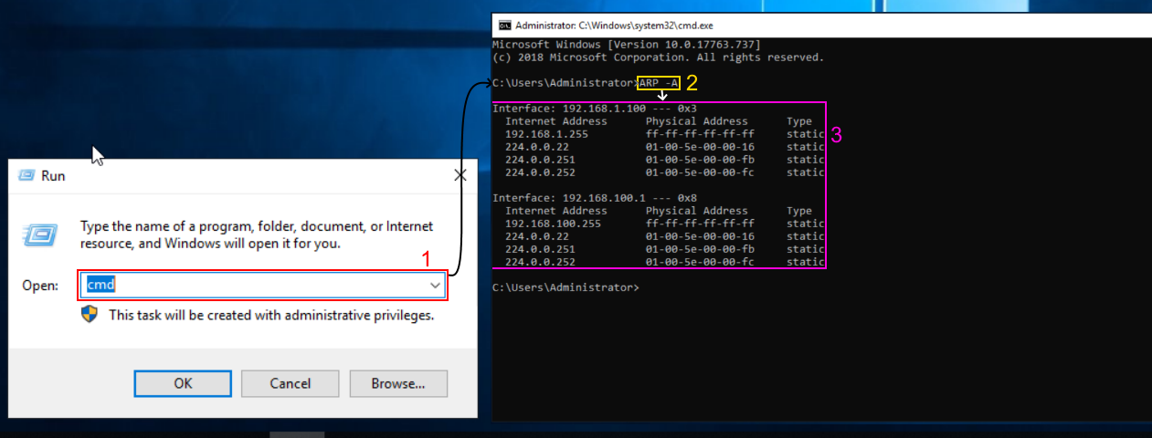

Now, ping something on your network (ensure client one machine is turned on), which is on “192.168.100.2” (as there is no DHCP server setup). A response will be stated, if successful type “ARP -A”. If the response was not successful, ensure the firewalls are off on both machines.
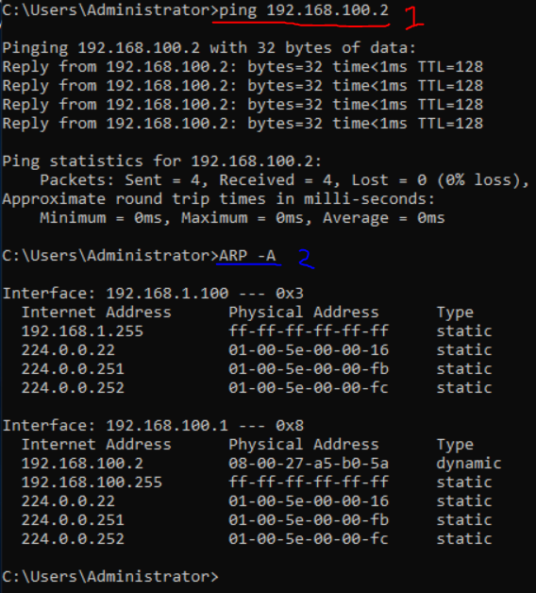
Within the command prompt, if you type “route print”, this will give you a rather in depth look into the network.
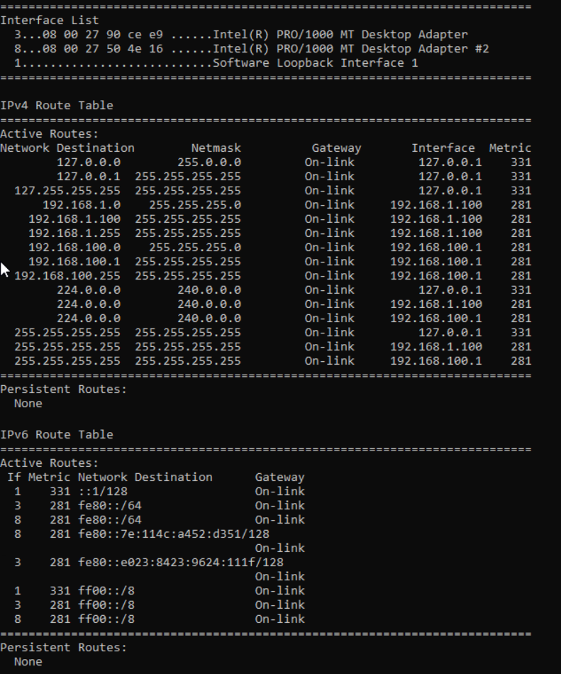

2.1.2. Deployment of core services - File Transfer Protocol Server;

2.1.2.1. Installing FTP;
On server two, launch server manager by going into the Windows search bar and typing it in. Click on “Add Roles and Features”.
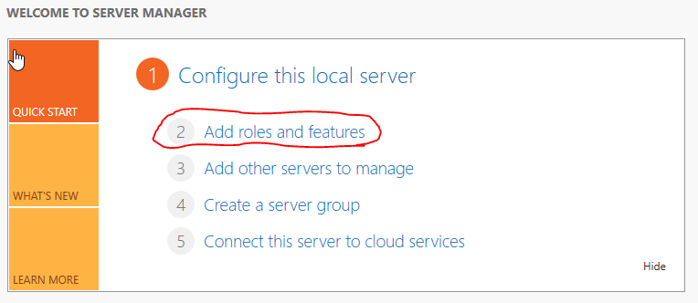

A new window will pop up, just click next (1), then ensure you have “Role-based or feature based installation”, on the select installation type then click next (2). Lastly, ensure you click “select a server from the server pool”, and the current server (server two) is selected, then click next (3).
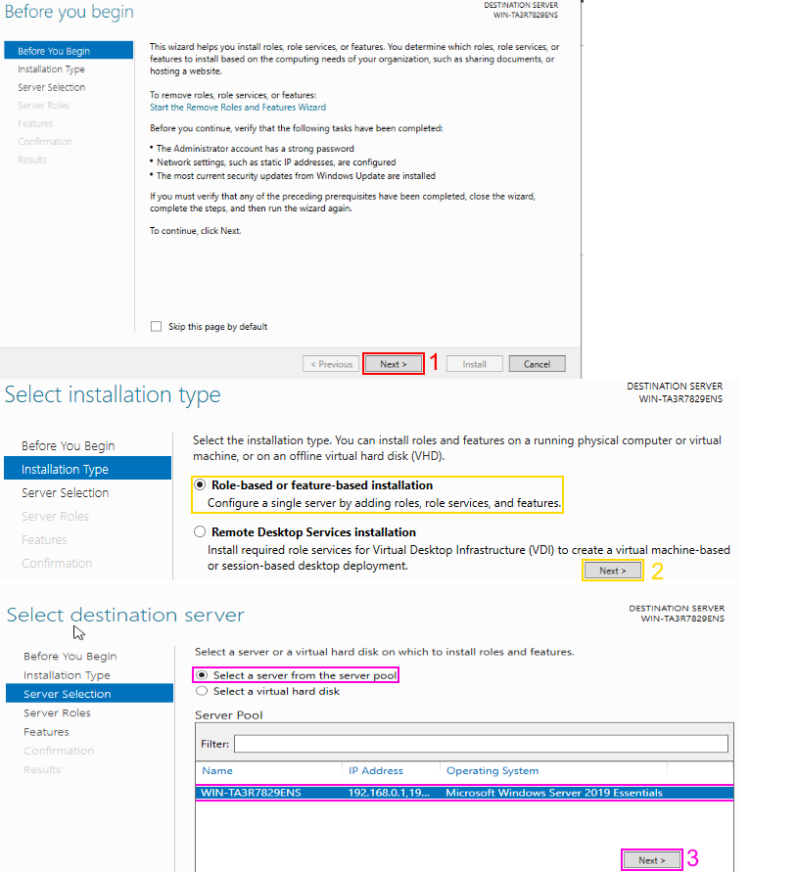
On the “select server roles”, select “Web Server (IIS)” (1), then select add feature (2), then click next. When you get to the features tab, simply click next, this goes for the web server role (IIS).
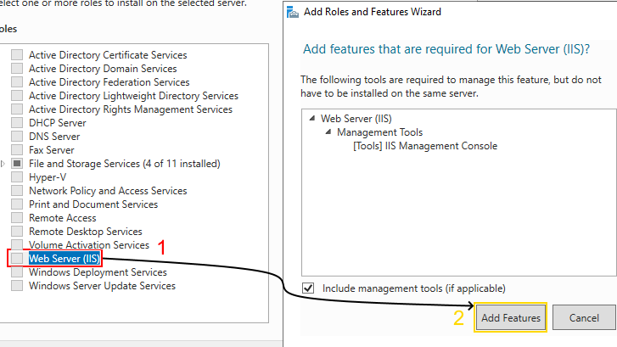

On the select role services to install for web server (IIS), scroll down until you find “FTP Server”, ensure you check this checkbox -- this extends to FTP Service under it. Then click next and then install.
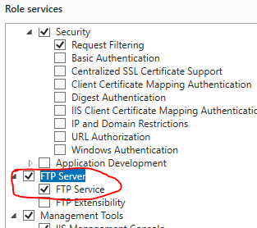

2.1.2.2. Creating a user;
On server two, within server manager, under the tools drop down (top right), go into computer management.
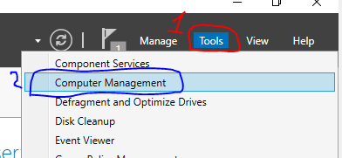

Within the new screen, under local users and groups (1), right click on users (2) and then click new user (3). In the new window, make the username “ftpuser” and the password “P@ssw0rd” (4), then click create.
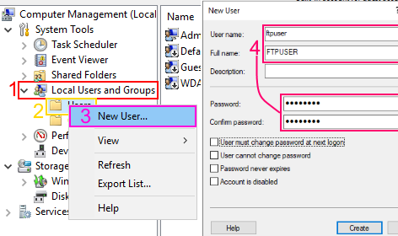

Now, under tools (1) on server manager, click on internet information services (iis) manager (2).
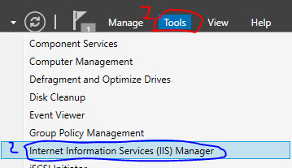
Expand the computer's name (1), then right click on sites (2), within the popup click add ftp site (3), within the new popup type the name “1STFTPSITE” (4), then click the dots to navigate to the path (5).
Within the path dialog, under local dist (5.1), intelpub (5.2) then within ftproot (5.3). Once located, click next (6) -- if you know the path, type it or paste it in the cyan area.
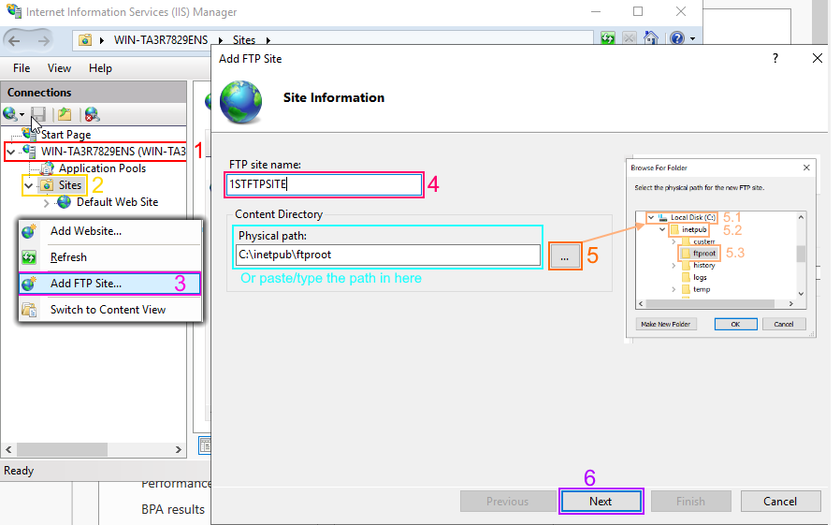

Ensure no SSL is checked, click next.
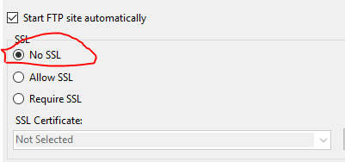

Under authentication, select basic (1), authorisation for specific user (put in the user you created), ensure they have read and write (2) and then click finish (3).
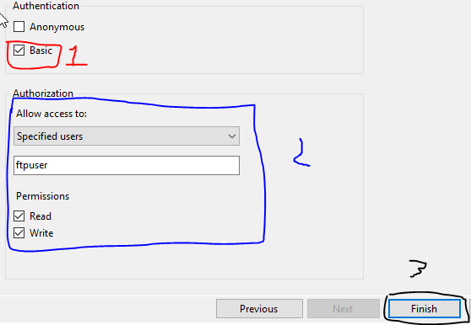
Within internet information services (ISS) manager, under the computer name (1), sites (2), the site you just created (3) double click on ftp messages (4).
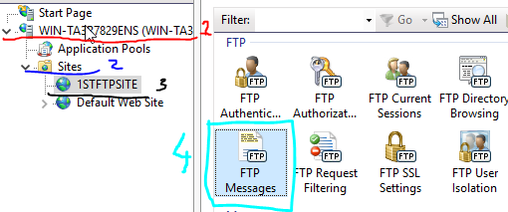

Within this, add a banner (1), the welcome message is displayed on login, exit is when you exit the connection and the last input is just how many times this account can be used, all optional (2).
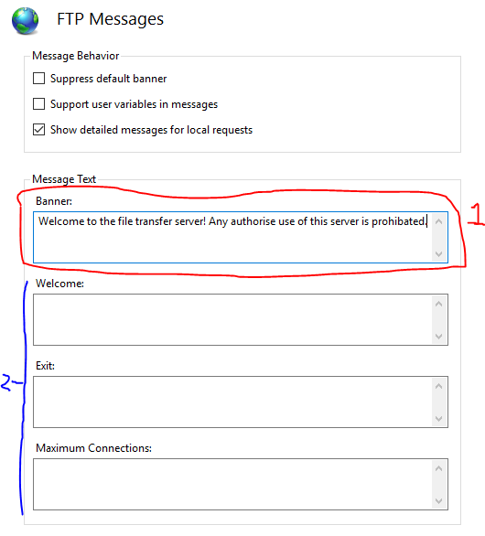
Now, you need to open file explorer and navigate to the ftproot folder. Under this PC (1), local disk (C:) (2), intelpub (3), ftproot (4) and then right click in the whitespace and click properties (5).
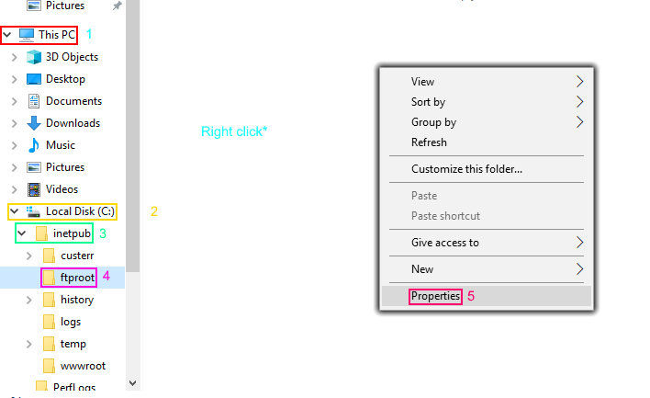

Click on the security tab (1), click edit (2), then click add (3), now type the name of the user you created “ftpuser” (4), click check names and then click okay (5). Now click okay (6) on the permissions for ftproot and then click okay (7) for the properties of ftproot.
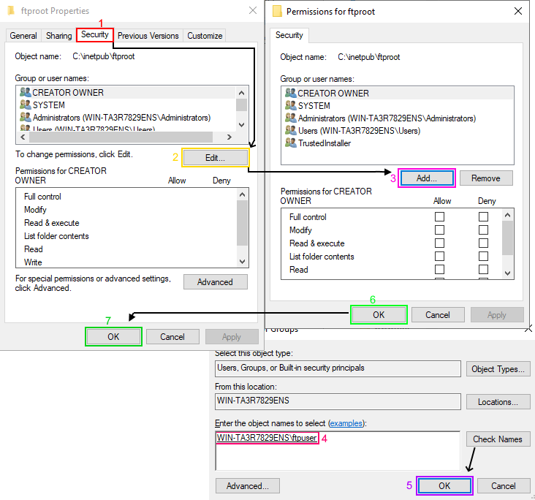
Now, within the ftproot folder, right click and under the new submenu (1), click folder (2), name it Ftpuploads. Please ensure that the Windows firewall is turned off for server two.
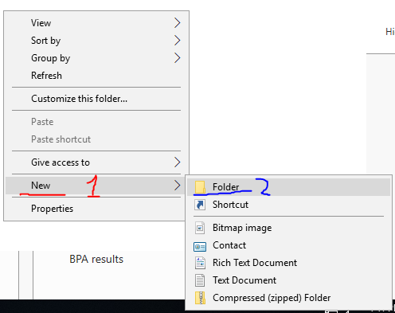

2.1.2.3. Connecting to FTP;
On client two, create a new folder within This PC (1), Local Disk (C:) (2) and name the new folder “FTPFiles” (3).


Within FTPFiles, create a new text file named “ftpfile2upload.txt”.

Now, open the command prompt by typing cmd into Windows search or by pressing Windows key and r, then typing “cmd”.
Within the command prompt, type “ftp 192.168.101.1” (1), or the IP address of the server.
Then, type the username of the ftp account (ftpuser) (2), and the password (P@ssw0rd) (3).
You can see the banner message we set is being displayed.
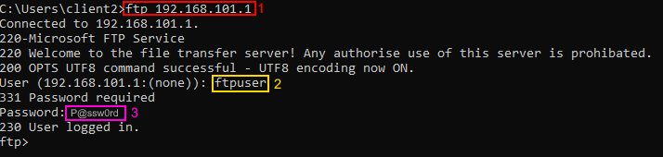

You need to type “lcd C:\FTPFiles” (or whatever client two ftp folder is called). Now type, “put ftpfile2upload.txt” (2) (or wherever the file you want to upload). You should observe a transfer complete message.
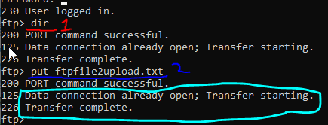
On the server, we can see the file has been uploaded.


2.1.3. Routing and remote access service;
On server one, open up server manager, click on Add roles and features.
On the window that pops up, click on role-based or feature-based installation, then click next.
On server selection, select “Select a server from the server pool” and then select your server.
Selecting server roles, check the remote access and then click next.
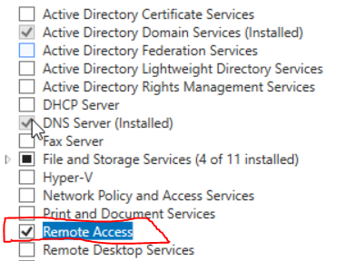

On the features tab,just click next.
On the select role service, check the “direct access and vpn (RAS)” and “routing” checkboxes, click next.
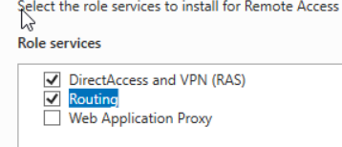
On the web server roles (IIS), click next, the click install.

Now set to the flag (1), and then click “open the getting started wizard (2).
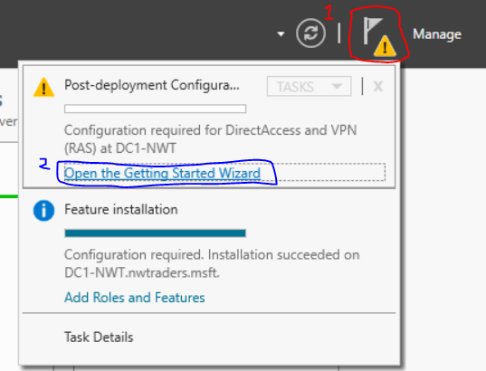

On the configure remote access, click “deploy VPN only”.
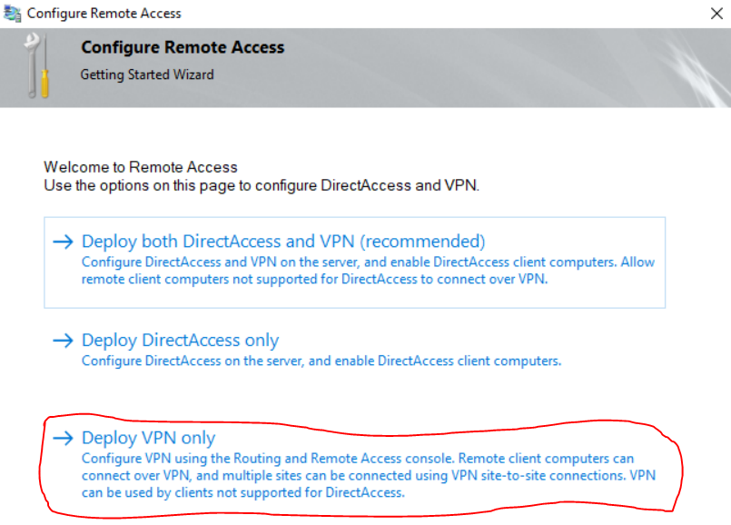

Now on the routing and remote access window, right click on your server (1), then click configure and enable routing and remote access (2).
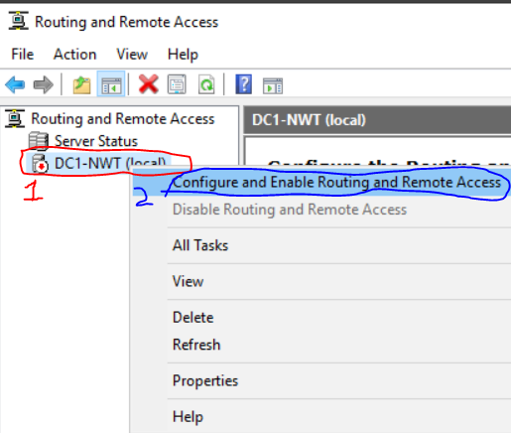

On the configuration window, select “custom configuration”, then click next.
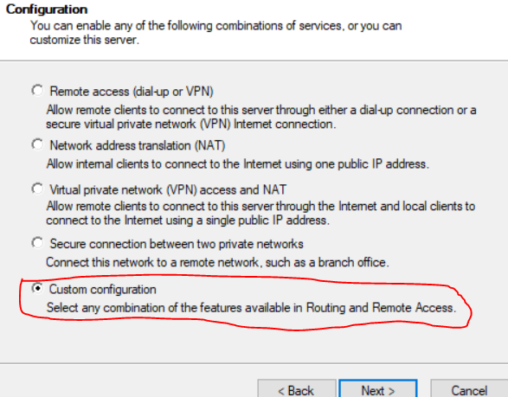
Now select LAN routing, then click next and then finish -- a popup will appear, click start service.
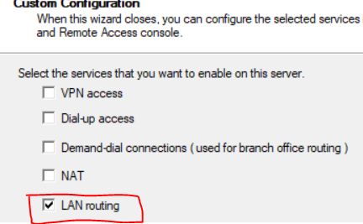

Now, in the routing and remote access, under the server, under IPv4 (1), right click on general (2) and the click “new routing protocol…” (3).
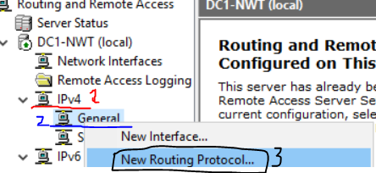
Then select “RIP version 2 for internet protocol”, then click okay.
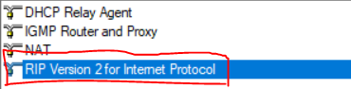
Under IPv4, you should see a new button called “RIP”, right click on that and click “new interface”.
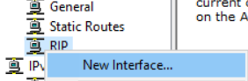

You need to select every interface here, select okay and then on the next window select okay. Ensure all of the interfaces have been added
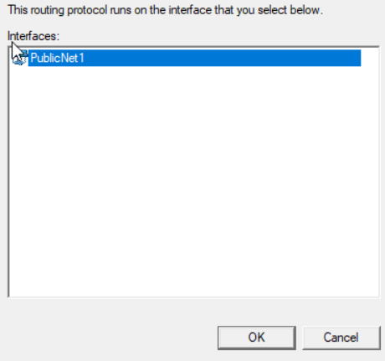

Now, redo this task (2.1.3) again for server two.
Ensure server two needs to be configured as a routing and remote access service (RRAS), RIP v2 will need to be used.
Open server one, server two, client one and client two. Within server one, type “ping 192.168.1.100” - you should get a response. On server two, type “ping 192.168.1.101” within the command prompt.

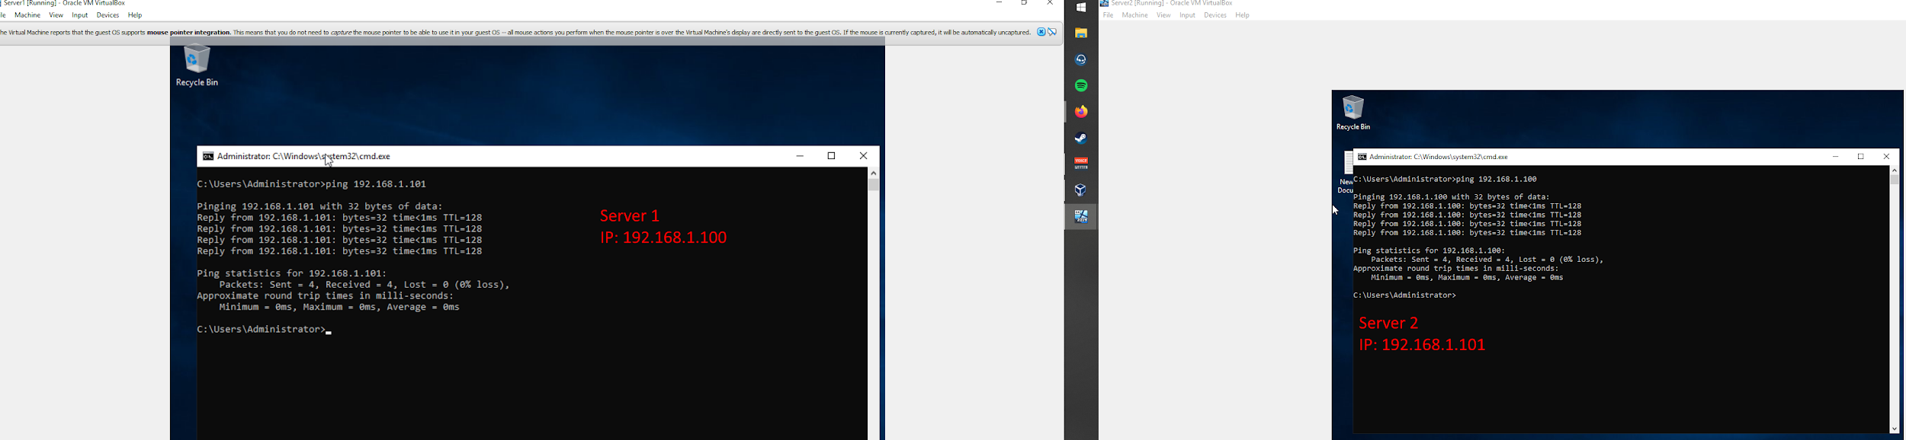
Now, on client one, type “ping 192.168.100.2”, on client two type “ping 192.168.100.2”.
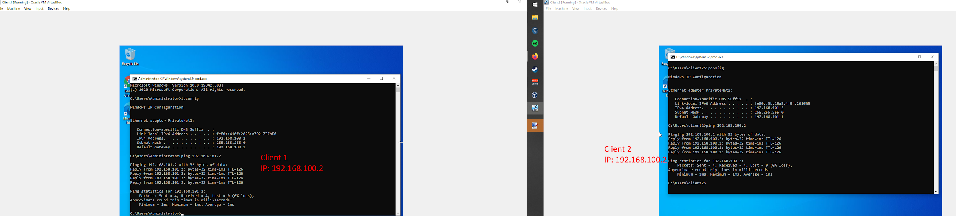

(!) Note: Observe point 2.4 Troubleshooting for network errors.

2.1.4. Packet filtering;

2.1.4.1. Filter server one and client one;
On server one, type “routing and remote access”, into the Windows search bar, or navigate to it by going into Server Manager, under tools (top right) and clicking “routing and remote access”.
Within routing, under your ServerName (1) and click IPv4 (2). Within general (3) right click on PrivateNet1 and click Properties (4).
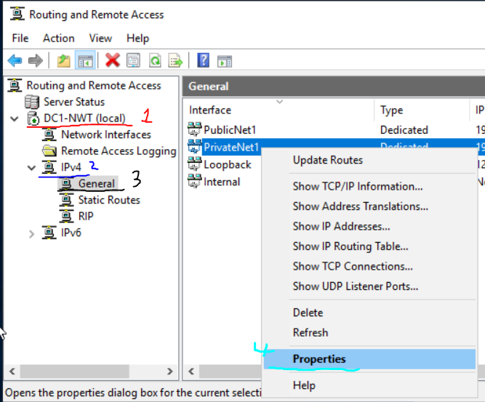

Within the properties window, click inbound filters (1) and then click new (2).
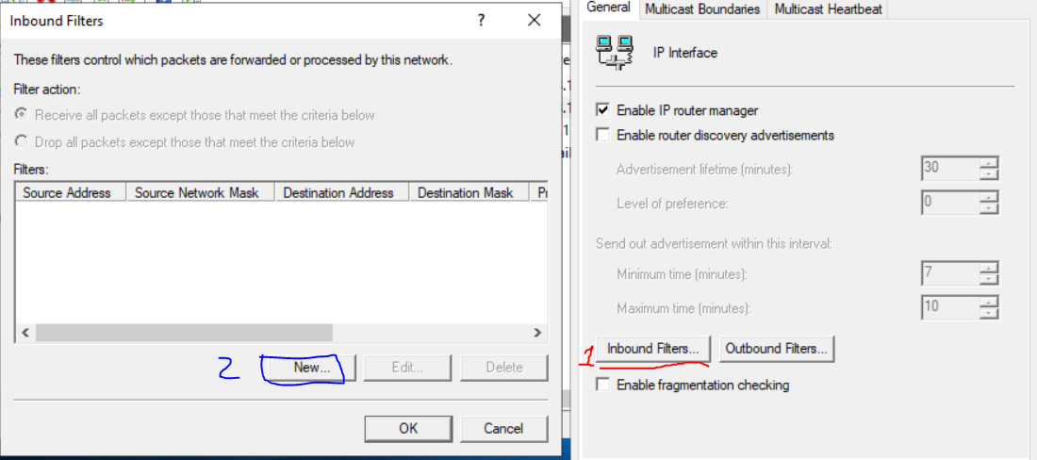
Ensure you select “destination network”, with an IP address of “192.168.100.1” (1), subnet mask of “255.255.255.255” (2) and protocol of “ICMP” (3).
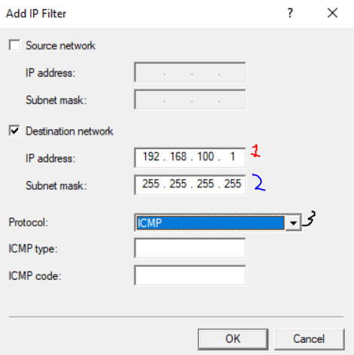

Within inbound filters, ensure you select “Receive all packets except those that meet the criteria below”.
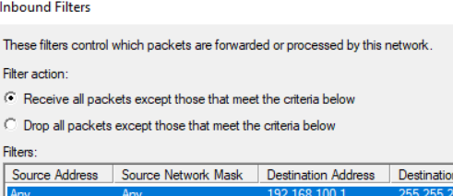

Ensure you close these windows by selecting okay. On client one, open the command prompt and type “ping 192.168.100.1”.
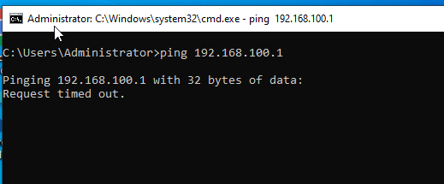
You should observe a timeout.

2.1.4.2. Restricting FTP to PrivateNet2;
On server one, type “routing and remote access”, into the Windows search bar, or navigate to it by going into Server Manager, under tools (top right) and clicking “routing and remote access”.
Within routing, under your ServerName (1) and click IPv4 (2). Go into General (3).
Right click on PublicNet1, go into properties (1), click onto outbound filters (2) and then a new window will pop up (3).
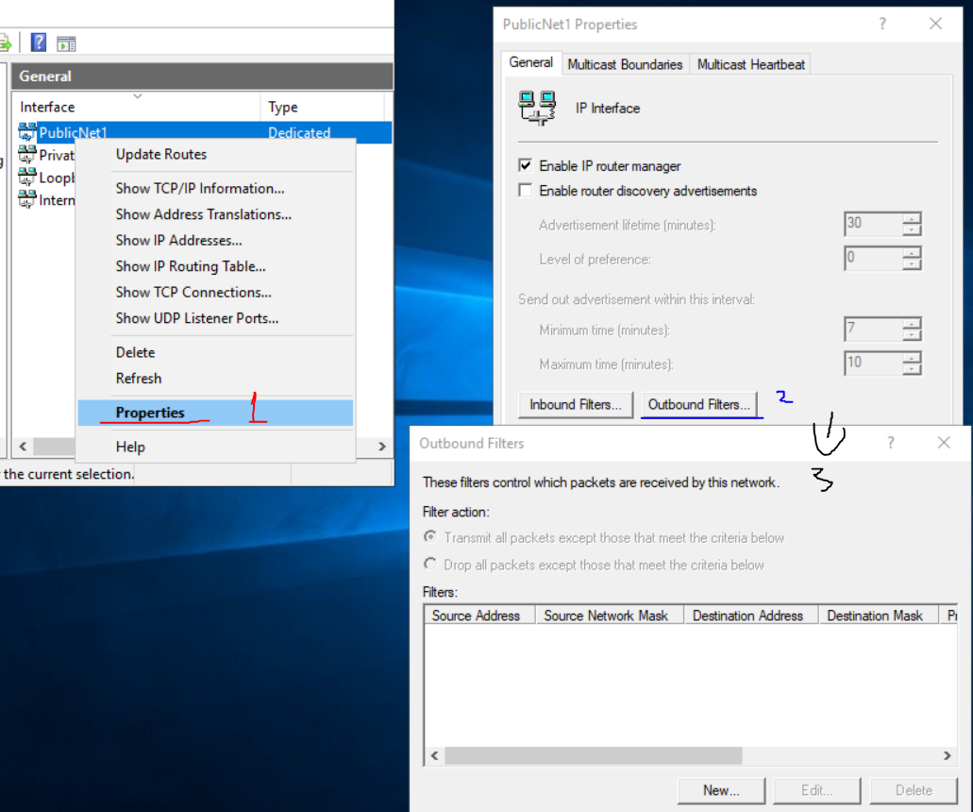

Click on new (1), then destination network, ip address “192.168.1.101” (2), subnet mask “255.255.255.255” (3) and then ensure protocol is TCP and port destination port is 21 (4).
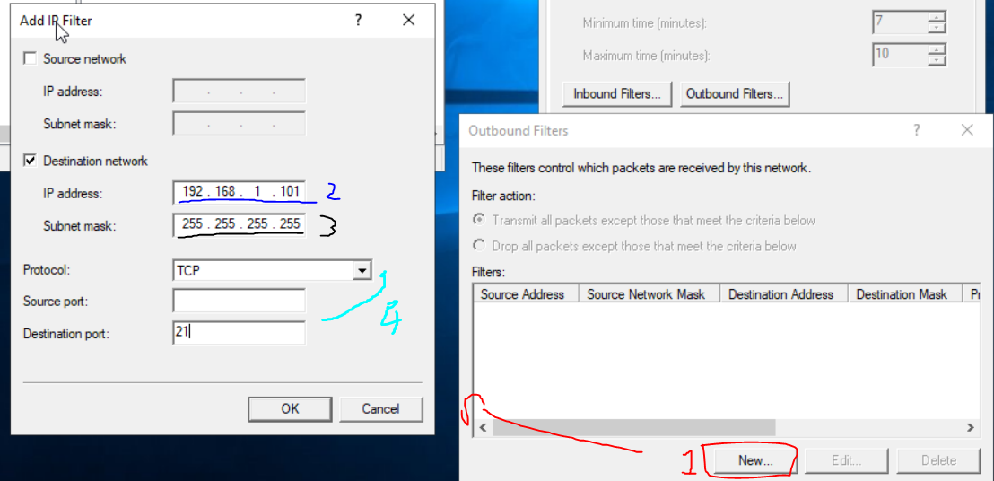
Ensure “Transmit all packets except those that meet the criteria below” (1) is checked.
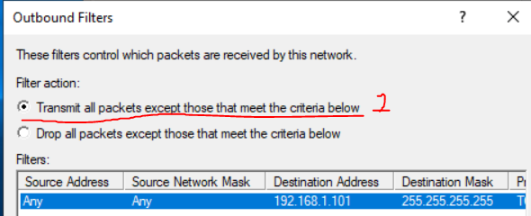

On click one, type in the command prompt “ping 192.168.101.1”. You will observe a connection timed out. On the other hand, client two will still work. If you can still connect to FTP using client one, please create an inbound rule within routing and remote access within server two for the IP address.
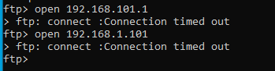
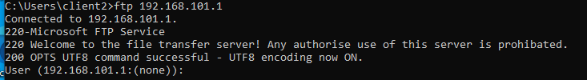

2.1.4.3. Authorising access to FTP on PrivateNet1;
To restrict it so only one IP address can access FTP service within server two can be done within the routing and remote access window.

On server one, in routing and remote access, right click onto PrivateNet1 (1), properties (2) and the click outbound filters (3).
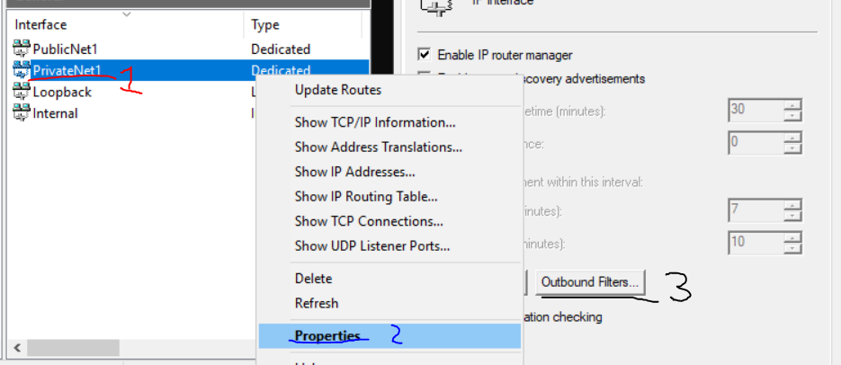

Click on new (1)

Ensure you enable source and destination networks. Make the IP address of the source “192.168.100.1”, with subnet mask “255.255.255.255”. On destination network, ensure the IP address is “192.168.101.1”, with a subnet mask of “255.255.255.255”, protocol of “TCP” and destination port of “21”.
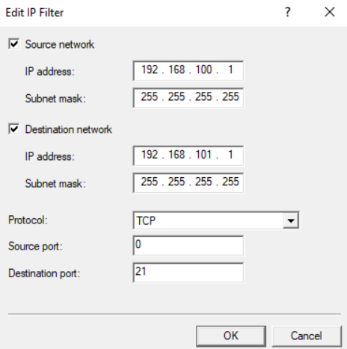

Click okay, then ensure the filter action is set to “Drop all packets except those that meet the criteria below”, click okay.
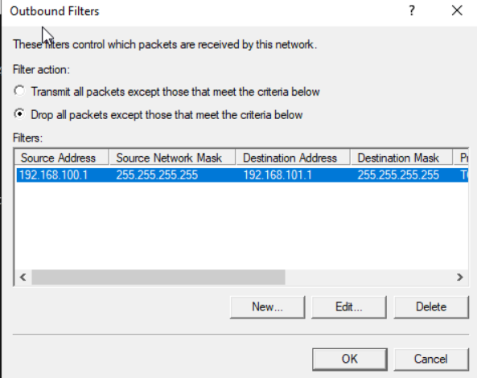
On server one, within the command prompt type “ftp 192.168.101.1”.
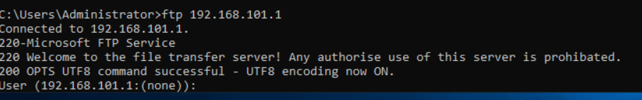

On client one, within the command prompt type “ftp 192.168.101.1”.
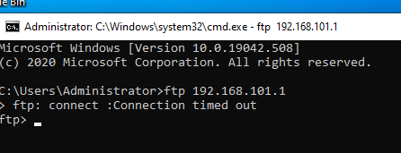

If everything is done correctly, only server one can connect.

2.2. Clustering for high availability systems/services;
According to [1], a failover cluster are groups of computers that work independently, that increase the availability and also the scalability of the machine. The purpose of a failover cluster is that, if one or more clusters fail the other clusters will take up the roles they were doing according to [1].

To do this on your server, you must have a CPU (central processing unit) that has capabilities of being virtualised. You would need to go into Server Manager, add a new role and ensure you click “Hyper X”. On the next page, ensure you click “Failover cluster”.

2.3. Observational task;

2.3.1. Enterprise network;
A network policy is a critical component to a business as it demonstrates the standard operating procedure for the business and will state when someone is in breach of the policy.
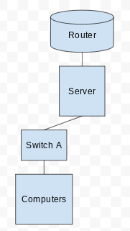

2.4. Troubleshooting;
Within server two, an error was seen after many attempts to diagnose why client one and client two could not ‘ping’ one another. This error was found to be within the network adapter for server two where a wrongly typed name was entered. This was entered wrongly within Oracle VM and within server two network options -- further to that, the IP address given within server two was incorrect.

The network adapter was renamed to the correct name and on server two, RIP was reconfigured by deleting the old adapter and then reading the adapter back. The IP addresses were also fixed where they were incorrect. This report believes in accountability and understands if you are following these reports, you may encounter the same issue.

3. References
[1] J.Gerend, K.Sharkey, G.Milener, D.Coulter, E.Ross, K.Downie, et. al, “Failover Clustering in Windows Server”, Microsoft, June 06 2019, [Online.], Available: https://docs.microsoft.com/en-us/windows-server/failover-clustering/failover-clustering-overview, [Accessed: 29 April 2021]

4. Bibliography

