University of Wales Trinity Saint David
BSc Health and Social Care
Module: Changemakers: Creativity and Value Creation
Module Code: BMHP5014
Component 2: Written Assignment (Poster and Pitch)
Student Name:Marie Andrews
Student ID Number: 2411716
Assignment Title:
CareLink UK – A Digital Community Support and Care Coordination Initiative
Submission Date: _____________________________
Word Count: Approximately 2,000 words

Poster
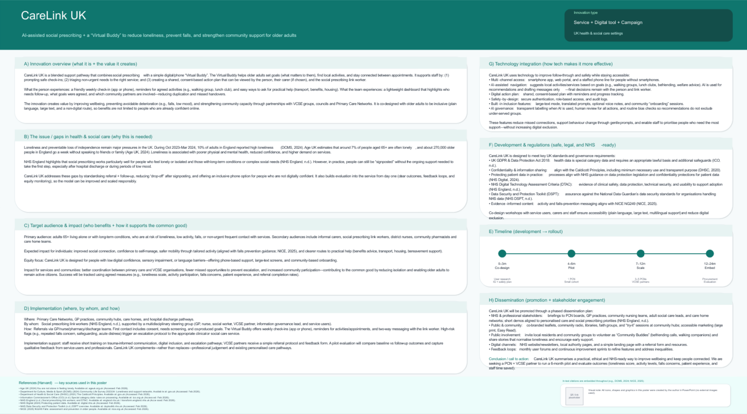

Pitch

CareLink UK - AI-assisted social prescribing with a 'Virtual Buddy' for older adults
The key sources of pressure in UK health and social care are loneliness and avoidable loss of independence, especially in older adults who live alone and with long-term conditions. In October 2023 to March 2024, 1 out of every 10 adults in England indicated high levels of indirect loneliness (DCMS, 2024). According to the reports of Age UK, 940,000 individuals aged 65 years and above feel lonely and 270,000 older adults in England spend a week without talking to a family member or friend (Age UK, 2024). Loneliness may lead to lack of motivation to leave the house, inactivity and predisposition to falls and preventable decline. This impacts people, carers and services, and this is why they should have a community-based intervention that is supportive and that the people can literally adhere to.
CareLink UK is a new, hybridized route which enhances social prescribing with regular follow-up, in the form of a simple digital and phone companion, the Virtual Buddy. Social prescribing is effective in individuals who are lonely or isolated, have complex social needs, and those with long-term conditions (NHS England, n.d.-a). Practically, however, there are individuals who receive information about support but cannot take the first step due to the feeling of anxiety, transport issues, lack of self-confidence, language requirements, the need to care or just forgetting about appointments. CareLink UK fills this drop-off gap by ensuring that follow-up becomes reliable, practical and personalised.
It is intentionally simple how it works. Referrals are made by GP practices and Primary Care Networks (PCNs), community nursing teams, community pharmacies, care homes and routes of hospital discharge. This is congruent with the national discharge guidance, which focuses on the use of coordinated community support to adults in their departure of hospital facilities and virtual wards (DHSC, 2024). A social prescribing link worker undertakes an induction dialogue centered around what matters, informed consent and a regimented plan of action (i.e. attend a local lunch club weekly, join a gentle movement group, seek benefits advice, or book a community transport). This is followed by weekly check-ins (app or phone), reminders, and a easy way out that the person can seek assistance should obstacles emerge (The Virtual Buddy). Staff also possess an easy dashboard that raises a flag of non-response or risk indicators to enable follow-up to be given priority.
CareLink UK has also been developed to meet the needs of adults (65+) who live alone or with long-term conditions and are vulnerable to loneliness, low activity or falls. It is purposefully accommodating: they can utilize a smartphone application, a web portal, or a staffed telephone choice, thus support is not restricted to the people who are not afraid on the Internet. The AI feature is only-decision-support-only-it implies local services and type short messages which are commented and refined by the link worker, leaving professional judgement in charge. The digital aspect will then be evaluated in relation to the NHS Digital Technology Assessment Criteria (DTAC) that provides the minimum standards of clinical safety, data protection, security, and interoperability in the acquisition of digital tools (NHS England, n.d.-b).
Adoption is all about trust and legality. CareLink UK will also adopt the UK GDPR and the Data Protection Act 2018 regarding special category health data such as identifying a lawful basis and an Article 9 condition with safeguards such as role-based access, secure authentication, audit trails, and clear rules on retention (ICO, n.d.). The sharing of information shall adhere to the Caldicott Principles, such as having a clear purpose, minimum use of data and disclosing to people how the information is used (DHSC, 2020). We would also adhere to the NHS instructions on patient data protection, and that is the reason why there are legal and confidentiality safeguards that cover patient information (NHS Digital, 2024).
CareLink UK contributes to the existing policy objectives in integration, prevention and community-based support. The integrated care systems introduce NHS organisations, local councils, the voluntary sector and other partners to enhance population health and reduce inequalities (NHS England, n.d.-c). Health and Care Act 2022 enhances the co-operation between the NHS and local government (legislation.gov.uk, 2022). This is operationalised at CareLink UK front line to enable the linkage of PCNs, adult social care, VCSE around a single plan with consent, instead of referring people to various disjointed services. It enhances wraparound support by making signposting a supported communication.
Assessment is in-built at the very beginning of the day thus any scale-up is evidence-based. The pilot will monitor uptake, engagement (check-ins made and activities attended), and outcomes by short measures including the ONS loneliness questions and wellbeing measures, and service outcomes including non-urgent GP contacts and recorded falls incidents. The content and signposting associated with falls will be in line with NICE indications on falls assessment and prevention (NICE, 2025). To enhance accessibility and ensure that the service works in the various communities, qualitative feedbacks of older adults, carers, and professionals will be sought. Equality of access (such as language needs, disability and deprivation) will also be monitored, and outreach adjusted in a way that the innovation decreases rather than increases inequalities. Notably, the model is projected to be financially realistic: it makes use of the available workforce and community infrastructure of social prescribing, and the layer of buddies minimizes missed contacts and duplicate administration.
Dissemination will be oriented towards the professional adoption and community buy-in CareLink UK will conduct short demos and referral briefings to PCN boards, GP practices, community nursing teams, adult social care leads, and care home networks and connect the model with the existing priorities of social prescribing (NHS England, n.d.-a). Promotion to the public will be done through available pathways (libraries, community hubs, faith groups and local radio) in the form of large-print and Easy Read. The model also welcomes society to contribute to the solution through volunteering to be a trained Community Buddies with local charities. The roadmap is planned: 0-3 months co-design and information governance implementation; 4-6 months pilot in one PCN; 7-12 months scale to 3-5 PCNs and 12-24 months entrench with procurement, evaluation and integration into personalised care pathways.
To conclude, CareLink UK is an implementable, scalable innovation that empowers social prescribing and addresses a well-known limitation people declining after signing post: people drop off. We are requesting local PCNs and integrated care partners to fund a 6-month pilot, identify a multidisciplinary steering group, and invest in shared evaluation to make evidence-based and lived-experience decisions to scale.

Reference List
Age UK (2024) ‘Building on success to beat loneliness’. Available at: https://www.ageuk.org.uk/discover/2024/december/building-on-success-to-beat-loneliness/ (Accessed: 11 February 2026).
Department for Digital, Culture, Media and Sport (DCMS) (2024) ‘Community Life Survey 2023/24: Loneliness and support networks’. Available at: https://www.gov.uk/government/statistics/community-life-survey-202324-annual-publication/community-life-survey-202324-loneliness-and-support-networks (Accessed: 11 February 2026).
Department of Health and Social Care (DHSC) (2020) ‘The Caldicott Principles’. Available at: https://www.gov.uk/government/publications/the-caldicott-principles (Accessed: 11 February 2026).
Department of Health and Social Care (DHSC) (2024) ‘Hospital discharge and community support guidance’. Available at: https://www.gov.uk/government/publications/hospital-discharge-service-policy-and-operating-model (Accessed: 11 February 2026).
Information Commissioner’s Office (ICO) (n.d.) ‘Special category data’. Available at: https://ico.org.uk/for-organisations/uk-gdpr-guidance-and-resources/lawful-basis/special-category-data/ (Accessed: 11 February 2026).
Legislation.gov.uk (2022) ‘Health and Care Act 2022’. Available at: https://www.legislation.gov.uk/ukpga/2022/31/contents/enacted (Accessed: 11 February 2026).
National Institute for Health and Care Excellence (NICE) (2025) ‘Falls: assessment and prevention in older people and people 65 and over (NG249)’. Available at: https://www.nice.org.uk/guidance/ng249 (Accessed: 11 February 2026).
NHS Digital (2024) ‘Protecting patient data’. Available at: https://digital.nhs.uk/services/protecting-patient-data (Accessed: 11 February 2026).
NHS England (n.d.-a) ‘Social prescribing’. Available at: https://www.england.nhs.uk/personalisedcare/social-prescribing/ (Accessed: 11 February 2026).
NHS England (n.d.-b) ‘Digital Technology Assessment Criteria (DTAC)’. Available at: https://transform.england.nhs.uk/key-tools-and-info/digital-technology-assessment-criteria-dtac/ (Accessed: 11 February 2026).
NHS England (n.d.-c) ‘What is integrated care?’. Available at: https://www.england.nhs.uk/integratedcare/what-is-integrated-care/ (Accessed: 11 February 2026).

