LCMB7012
Banking financial MANAGEMEN AND FINANCIA MARKETS
Fatima-Zahra Lebied (1602154)

Table of Contents
Introduction: 2
Bank regulation: 3
What is bank regulation? 3
Bank legalisation: 3
Key legalisation: 4
How regulation help banks? 4
Bank sustainability: 4
Example of how Barclays build a sustainable system: 5
The regulatory capital: 6
The liquidity level and its impact on lending: 9
The efficiency and its impact on lending: 10
Regulatory capital and its impact on profitability: 11
Bank’s risk and mitigation strategies: 12
Conclusion: 15
Appendix A: 16
References: 17
Presentation: 21

Introduction:

Due to the financial crisis, in 2007-2008, the UK has known an abrupt change in the economic policy. Preceding the crisis, The UK government lectured the light‐touch budgetary guideline and the monetary reasonability, the good news of price stability during the emergency crisis. Moreover, the government has countenanced the requirement for a reconsider of monetary management, a flood in public sector acquiring and the unusual money related arrangements in the wake of the crisis. However, in term of reordering the economic strategy, establishments and instruments, the UK has not yet encountered such as fundamental. The monetary thoughts supporting the United Kingdom financial strategy have, regardless, exhibited wonderful flexibility until now despite the third order changes that did not be precluded as the emergency unfurls (Hodson & Mabbet, 2009).

As a financial intermediary, the financial institution assumes a choosing part in the improvement of the financial crisis by adding to the effective exchange of assets from the plentiful operator towards the shortage of specialists. Banks can encourage the monetary emergencies through the exercises performed on the financial business sectors that can impact the loan costs, the vulnerability on the market and the cost of benefits, however also bank emergencies can create that change in budgetary crises (Marius, 2008).

This report will examine acritical discuss the bank regulation changes that the banking sector had since the financial crisis. The report will cover major ratios study of 3 banks that are listed in the London Stock Exchange which are Barclays, HSBC, and Royal Bank of Scotland.

Bank regulation:

What is bank regulation?

Banking guideline begins from microeconomic worries over the capacity of bank loan creditors (investors) to screen the dangers beginning on the loaning side and from macroeconomic worries over the strength of the financial framework in case of a bank emergency. Notwithstanding legal and authoritative administrative arrangements, the financial area has been dependent by regulation casual, wherein ,for example, the administration's utilization of its prudence, outside formalized enactment, to impact banking segment results such as to rescue bankrupt banks, keep up huge state possession or choose bank mergers or keep up huge State possession (Bonn, 2005).

The financial division is managed for prudential purposes by the Prudential Regulation Authority (PRA), which is essential for the Bank of England, the UK national bank. A council of the Bank of England, the Prudential Regulation Committee (PRC), is answerable for practising the elements of the Bank in its function as the PRA. The Financial Conduct Authority (FCA) is the lead controller for the financial division and arranges intimately with the PRA. The Financial Policy Committee (FPC), which works from inside the Bank of England, plays the role of the full-scale prudential controller for the UK financial framework (Kingsley, 2019).

Bank legalisation:

The essential wellspring of structure enactment overseeing the guideline of banking and monetary administrations in the UK is the Financial Services and Markets Act 2000 (FSMA).

While the current UK administrative system gets for the most part from the FSMA and related executing enactment and rules, it is additionally generously impacted by, and somewhat actualizes, different European laws which set least prerequisites for the guideline of banks and banking administrations in the European Economic Area (EEA).

The guideline of banks in the UK is embraced by three primary controllers, the Bank of England (BoE), Prudential Regulation Authority (PRA), a division of the BoE and the Financial Conduct Authority (FCA).

The PRA and the FCA are the lead bank controllers. The BoE is the goal authority, with essential duty regarding administrative mediation and exercise of goal powers comparable to banks that are coming up short or fail (Pen& Overy, 2019).

Key legalisation:

The authorization system for UK bank authorisations is set out in the Financial Services and Markets Act 2000 (FSMA). FSMA forbids any individual from continuing managed budgetary administrations business without having the important authorizations.

The Financial Services and Markets Act Order 2001, (RAO) is the key optional authorization which determines by far most of the monetary administrations business which is controlled in the UK. Regulated exercises incorporate in addition to other things, store taking, protections and derivates business, exercises identifying with speculation reserves, purchaser credit and private home loan exercises, and protection guaranteeing and dispersion.

Payment administrations are licensable under an independent authorization, the Payment Services Regulations 2017 PSRs, even authorized banks are consequently treated as being allowed to give controlled instalment administrations in the UK.

Banks are needed to follow a wide scope of enactment and guideline, including the PRA Rulebook and FCA Handbook, different European guidelines which are legitimately relevant, and different bits of UK homegrown legalisation, some of which actualize EU mandates (Holt, 2006).

How regulation help banks?

Regulation helps ensure that banks have great administration to not being too risky or making terrible speculation. Moreover, the regulation makes banks hold safeguards to help manage terrible ventures. These safeguards are alluded to as capital.

Regulation is utilized to make it more uncertain individuals will take out their cash startlingly. There is a store ensure plot that guarantees that regardless of whether a bank flops all stores under £85,000 will be secured. Banks additionally need to hold money or resources that can be sold rapidly to cover sudden withdrawals (Bank of England, 2018).

Bank sustainability:

There are two main elements of corporate sustainability and administration advancement execution that shape the business development in the financial area. With social and environmental aspect where corporate supportability expects to offset monetary obligations. Before the 2008 financial crisis, banks' troublesome position caused a generous enthusiasm for supportability as a way to re-establish a damaged reputation. Furthermore, developments permit the presentation of another item, administration or cycle to the market. Specifically, a help advancement is considered as a new assistance which bring both value and offer to clients. In the financial sector, innovation strategies have gotten basic to contend. For instance, half of the European financial clients played out their budgetary exchanges through computerized channels in 2015 (Aracil et al, 2019).



Example of how Barclays build a sustainable system:

The main principles for a responsible bank are to give a solitary system to the worldwide financial industry to insert manageability at vital, portfolio and conditional levels, and overall business territories. The principles help to adjust banks to society's objectives, as communicated in the PCA and the United Nations' Sustainable Development Goals – a lot of targets committed to handling environmental change, finishing destitution and guaranteeing worldwide harmony and success.

Barclays is focusing on financing arrangements that convey positive social and natural effect. A few models incorporate extending Barclays' green item portfolio to incorporate things, for example, a first-to-advertise green home loan item for the UK, or meaning to double over time the bank's green security speculation to £4billion.

By 2025, Barclays has likewise pledged to encourage £150billion of social and ecological financing, including subsidizing for divisions, for example, sustainable power source, clean innovation, training, reasonable lodging, and public and supranational improvement foundations (Barclays, 2019).

The regulatory capital:

Years | Banks | Tier 1 Capital | LCR | CIS | Lending ratio | ROE
2015 | HSBC | 11.9% | 142% | 55% | 166% | 3.24%
2016 | HSBC | 13.6% | 136% | 66% | 147% | 6.77%
2017 | HSBC | 14.5% | 142% | 54% | 129% | 5.09%
2018 | HSBC | 14.0% | 154% | 54% | 128% | 0.74%
2019 | HSBC | 14.7% | 150% | 59% | 117% | 6.67%
2015 | Barclays | 11.4% | 133% | 73% | 90% | 0.83%
2016 | Barclays | 12.4% | 121% | 67% | 88% | 3.66%
2017 | Barclays | 13.3% | 154% | 65% | 81% | 3.88%
2018 | Barclays | 13.2% | 169% | 64% | 82% | 2.97%
2019 | Barclays | 13.8% | 160% | 61% | 81% | 6.49%
2015 | RBS | 17.1% | 136% | 134% | 95% | 0.83%
2016 | RBS | 14.1% | 123% | 125% | 97% | 1.03%
2017 | RBS | 16.1% | 152% | 79% | 91% | 2.45%
2018 | RBS | 16.2% | 158% | 71% | 82% | 1.93%
2019 | RBS | 16.2% | 152% | 65% | 88% | 6.34%

Table1. HSBC, Barclays and Royal Bank of Scotland ratios, an explanation of how these ratios have been calculated will be found in Appendix A.

The regulatory capital prerequisites, throughout the most recent 20 years, have been refined and expanded to cover different kinds of danger, separate among resource classes of various danger, and consider a menu of ways to deal with the danger loads to be applied to every benefit classification. The rules have gotten progressively detailed during the process, reflecting the developing unpredictability of current banking, yet also the need to address continuous endeavours by managed elements to evade the necessities through budgetary advancement.

Without a doubt, the financial crisis in 2009 exhibited that current capital regulation, in its plan or usage, was insufficient to forestall a panic in the budgetary part, and governments around the globe needed to step in with crisis backing to forestall collapse. During the crisis, many of the banks that were protected gave off an impression of being in consistence with least capital prerequisites quickly previously and in any event, In the aim of making regulation stronger, capital keeps on assuming a significant job. Basel III agreement that has been produced around another arrangement of capital norms to make capital necessities more severe (Demirguc, 2010).

In order to comply with capital rules, banks felt obligated to sell contract protections during the financial crisis and thusly drove lower costs for protections, which compounded the balance sheet conditions of other money-related organizations. From financial perspectives, accordingly, hazard-based capital standards is seen as procyclical, which is undesirable regarding the financial crisis.

With holding various kinds of assets, risk-based capital principles drastically influence the pace of return banks to procure. Despite the goal of these guidelines, in the economy, they firmly impact capital distribution. Moreover, for market systems and singular bank discretion, these guidelines substitute rough administrative judgment. As Friedman and Kraus bring up, Furthermore, these standards force on bank supervisors the controllers' judgment about the hazard of various resource classes based on Friedman and Kraus. These decisions abrogate both the nearby information on the individual bank director and the developmental discovering that originates from progress and disappointment in the market (Kling, 2016).

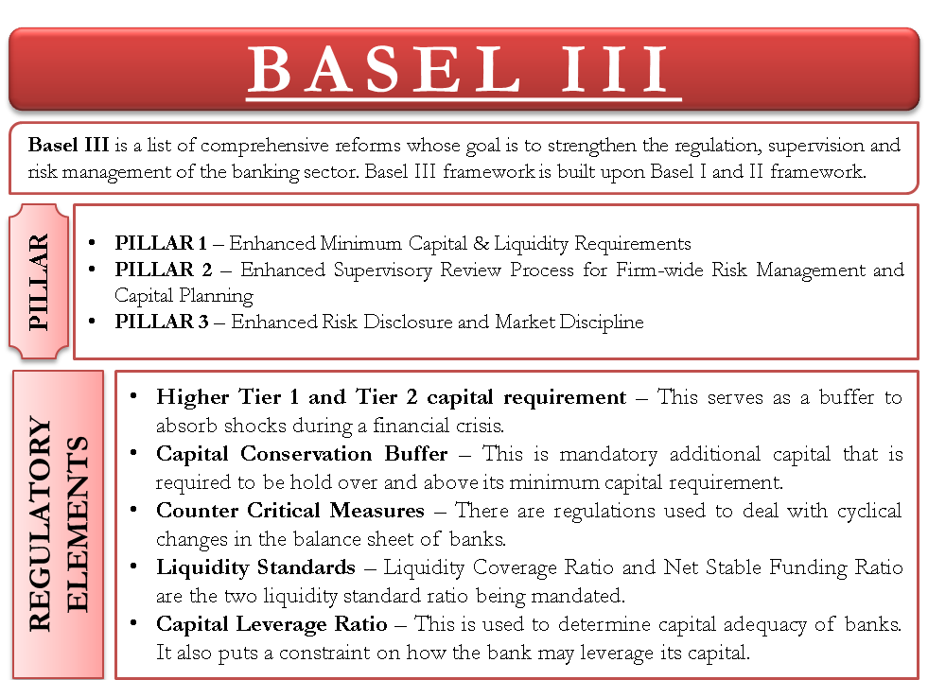

Without a doubt, the existing of the capital regulation during the recent financial crisis in its plan or its usage, exhibited the insufficient to forestall a panic in the financial part, and indeed governments around the globe needed to step in with crisis backing to forestall a breakdown. Many of the banks that were safeguarded gave off an impression of being in consistence with least capital prerequisites instantly previously and in any event, during the crisis. In the following discussion over how to reinforce guideline, capital keeps on assuming a significant job. Basel III, an agreement that has been manufactured around another arrangement of capital norms to make capital prerequisites more severe. A tier 1 capital ratio was introduced in July 2010, in the Basel committee, influence proportion of 3% on a preliminary premise, and later on, the Tier 1 capital necessity rise to 6% from 4%, while the absolute risk balanced capital prerequisite stays unaltered at the current 8% level. Banks will have the option to meet the contrast between the Tier 1 prerequisite with Tier 2 capital and the total capital necessity (Merrouche, 2010).

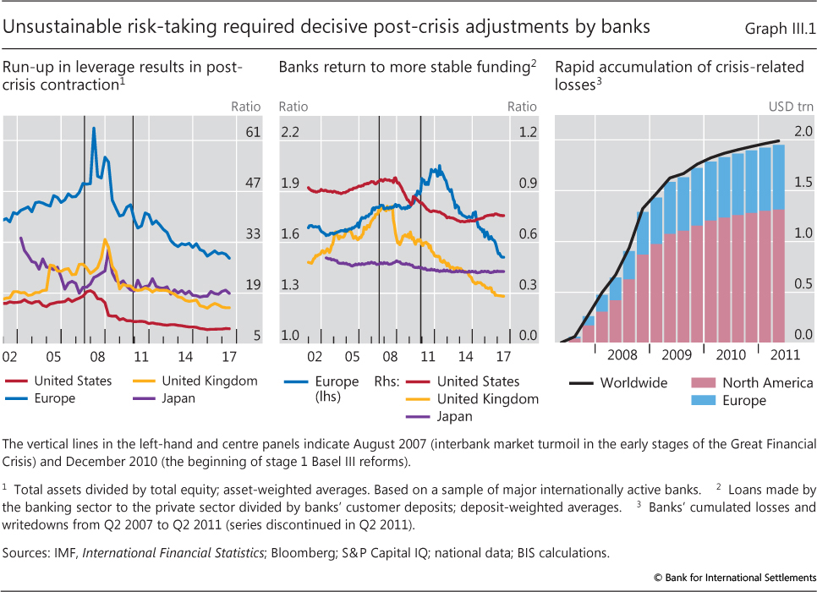

European banks have expanded their loaning more gradually than banks situated in different locales. In serious economies, a decrease in hazard weighted resources that are related to total assets has additionally assumed a job. More productive banks have extended resources and loaning quicker than others. There is some proof for the significance of beginning stages wherein banks that emerged from the crisis with moderately lower levels of capital have been bound to seek adjustment methodologies including moderate resource development (Benjamin & Scatigna, 2014).

The use of bank capital prerequisites as a strategy switches is probably going to affect bank capital proportions just as bank loaning. Because of expansion in capital prerequisites, banks slightly raise their capital proportions to re-establish the cushions over the administrative least that they initially held. Banks diminish loaning briefly as they revamp those supports. The biggest impacts emerge for business land loaning, trailed by loaning to different corporates and afterwards tied down loaning to family units (Gregory et al, 2014).

During the past five years, the three banks have seen an increase in term of their tier 1 capital ratio with some decrease exception in some years.
Based on Basel III, the tier 1 capital should be more than 6%, the higher tier 1 capital for banks the greater, as it illustrates the strength of failure absorption of the financial institution in case of losses.

The liquidity level and its impact on lending:

Numerous banks despite of sufficient capital levels still experienced challenges at the early liquidity stage of the crisis during the beginning of 2007 since they did not judiciously deal with their liquidity. The crisis shows the significance of liquidity in term of monetary business sectors and the financial part. The resource markets were light and financing was promptly accessible easily before the crisis. The fast inversion in economic situations delineated how rapidly liquidity can vanish, and that illiquidity can keep going for an all-encompassing timeframe. The financial framework went under serious pressure, which required national bank activity to help both the working of currency markets and singular organizations.

In order to advance the short run versatility of the liquidity hazard profile of banks, the committee has built up the liquidity coverage ratio by guaranteeing that they have an adequate high-quality liquid asset to endure a critical pressure situation enduring 30 schedule days (BIS, 2013).

Under the December 2009 proposition, banks are needed to meet two new liquidity prerequisites – a 30-day liquidity resource proportion called the LCR and a more extended term, basic liquidity proportion called the NSFR (net stable funding ratio)

The LC ratio measure the unhampered, top notch, fluid resources that can be utilized to counterbalance money surges. The point of the LCR is to guarantee that banks have sufficient subsidizing liquidity to endure one month of focused on financing conditions. The LCR cannot be assessed legitimately as it requires subtleties on a bank's normal cash outflows over a one month (King, 2010).

The bank's liquidity risk literature has reported the preparatory inspiration for banks to apportion credits. Banks react to the dread of a potential future liquidity stun that may prompt a mandatary to exchange illiquid resource by holding more fluid resources such as self-protection. Galeand Yorulmazer (2013) propose that banks perhaps careful about lending, at that point react by accumulating liquidity for preparatory reasons, for instance, future potential liquidity shocks or for key reasons such as to endeavour of potential resource liquidation (Dahir et al, 2019).

Some empirical studies propose that saves money with a high extent of stable financing, for example, stores are less inclined to loan. When examining over the dissemination of loaning with the quantile regression, the study reports a connection between bank lending and subsidizing liquidity which was not uniform in sign, however, diminishes essentially in greatness with the expansion of quantiles of loaning. The coefficients on financing liquidity are positive for banks with low loan growth. It gets negative with the expansion of quantile, recommending that a more depend on deposits as funding diminishes bank loaning. This likewise recommends high-credit development banks, utilized by higher dependence on deposits, are bound to diminish loaning (Cogent economic &finance, 2020).

Looking at each bank’s liquidity ratio, in 2019, RBS liquidity portfolio expanded by £1 billion reaching £199 billion, with essential liquidity decreasing by £3 billion to £125 billion. The decrease in essential liquidity is driven by diminished client surplus inside NatWest Holdings, profit instalments in the year and TFS (Term Funding Scheme) reimbursement, balanced by expanded net term issuance. The expansion in optional liquidity is driven basically by reimbursement of TFS, bringing about the arrival of recently burdened resources.

The decrease in essential liquidity brought about lower LCR from 158% to 152% in 2018 and 2019 respectively.

While in 2019 Barclays liquidity pool at £211billion mirrors the Group's reasonable way to deal with liquidity the executives. The LCR stayed well over the 100% administrative necessity at 160% (equivalent to £78biilion) and 168% (equivalent to £78billion in 2019 and 2018 respectively. In 2019, Barclays's liquidity coverage ratio, the liquidity pool, surplus have been overseen down through the course of the year, supporting expanded business financing necessities while keeping up a judicious liquidity position.

Similarly, to HSBC that manage to meet its regulatory requirement within a high-quality liquid asset reaching to $601billion in 2019.

The efficiency and its impact on lending:

The idea of effectiveness as an overall presentation marker for a wide range of organizations was first planned in the early works of Edgeworth (1881) and Pareto (1927).
Efficiency in financial matters is characterised as the most extreme expected proportion between the internal and external of the item advancement measure, which shows the ideal circulation of accessible assets that would permit accomplishing the greatest potential (Alber et al, 2019).

Based on Isrova (2010) in the banking sector the efficiency bolsters the productivity of executed macroeconomic strategies, which create a solid turn of events, financial development, and government assistance for society.

Getting firm level data is conducted as a significant test in dissecting the effect of bank effectiveness on the expense of credit on lending banks, as a result, both the bank level and firm level can be connected through the productivity and cost of credit respectively (Shamshur & Weill, 2019).

For banks stability, the efficiency of business banks become fundamental. Based on Europe banks studies, the outcomes demonstrated that high macroeconomic dependability bolsters the productivity of business banks. Additionally, banks which attempt higher dangers are more wasteful. Along these lines, the inefficient financial institution with higher credit risk have always lower dissolvability rate and are less liquid compared with other credit establishments. By dissecting the advancement of the cost index, it can be seen that the year 2009 brought upon it a reduction of the proficiency for the banks in Europe (Nitoi & Spulber, 2015).

Based on study done to 10 Europe nations, Brissimiset al. (2008) examined that there is a connection between bank efficiency and segment change. Their results uncovered that both financial segment change and rivalry positively affect effectiveness. Also, the capital and credit hazard negatively affect execution, while higher liquid resources reduce the effectiveness and profitability of banks.

Over the most recent decades, one of the most important assets for banks is bank efficiency since banks work in an amazingly serious condition, where endurance has gotten unsure. Another significant aspect is the bank lending channel, the presence and quality of which relies upon the impact a financial arrangement choice has on the economy through the adjustment in loan supply (Alevizopoulu & Apergis, 2019).

One of the important emerging measurement of a bank’s efficiency is the cost income ratio (Mathuva, 2009). Through table 1, it can be stated that CIR of three banks is increasing during the past five years, meaning that they have lower cost rate than income and that makes the banks more profitable and manageable in term of cost and overspending from revenues. The lower the cost income ratio the more efficiency the bank is.

HSBC would be slightly more efficient compared to Barclays and Royal Bank of Scotland.

Regulatory capital and its impact on profitability:

Based on interrelationships among liquidity creation, the administrative capital, and bank gainfulness of USA banks.

Based on Bhattacharya and Thakor (1993) and Repullo (2004), the risk retention theory which proposes that banks with more capital are in a superior situation to assimilate liquidity hazard coming from liquidity creation. Moreover, banks with more capital have a higher ability to make liquidity. The studies additionally propose that a more elevated level of administrative capital can be possibly expensive to an enough promoted bank, as the bank is probably going to move away from the ideal capital structure and subsequently experience lower profitability. Moreover, due to liquidity creation that is contrarily identified with bank benefit an expected bankruptcy cost speculation might occur. As the liquidity creation improves the bankruptcy, there will be more elevated level of illiquidity hazard, as a result, bringing down bank benefit (Tran et al, 2016).

The productivity of a bank is impacted by higher capital necessity and accordingly drifting worry on the connection between financial performance and least capital prerequisite of the bank (Christian et al., 2008).

In various examinations, empirical proof shows that higher capital prerequisite can be an explanation of higher profitability. For example, Insurance costs of very much promoted banks on different uninsured obligation become lower, projected bankruptcy cost of sound promoted firms becomes lower, therefore, their expense of subsidizing diminishes that eventually improves the degree of gainfulness and dissimilar degree of capitalization may uncover the distinctive degree of asset hazard.
A positive relationship has been concluded based on a various report on Basel accord between guideline on capital prerequisite and level of profitability. Furthermore, investigating Eastern European banks, it can be seen that the productivity of a bank is decidedly related to the capital adequacy proportion, the higher the ratio causes higher profitability. Similarly, different various examinations uncovered a positive connection between the productivity of banks and value to resource proportion. Contemporary banking hypotheses likewise declare positive connection between bank capital and its market share as banks with higher capital can undoubtedly draw in more contributors and dispense more advances with ideal conditions (Mahmud & Kumer, 2018).

Return of equity measure the annual income over shareholder’s equity and is counted one of the main ratios to measure bank profitability. Also, it is one of the unequalled top picks and the most generally utilized by a large proportion of corporate financial performance (Ahsan, 2012).

Bank’s risk and mitigation strategies:

Risk or danger can be characterized as the opportunity of misfortune or a troublesome result related to an activity. It could be either an internal or external factor. The more prominent of uncertainty, the more noteworthy the danger is (Cran et al, 2013).

Risk management is perceived in today’s business world as a basic piece of good administration practice. In its broadest sense, it involves the methodical utilization of the executive’s strategies, systems and practices to the tasks of distinguishing, dissecting, evaluating, treating and checking hazard.

Banks are presented to different dangers in the quest for their business targets, the nature and unpredictability of which has changed quickly over time. The failure to sufficiently deal with these dangers banks not just hampering the benefit as their profit is changing over in to bad debts, but also by expanding financing cost and causing an economic slowdown, eventually delivered them ineffective in accomplishing their key business goals (CFO tech, 2019).

Credit risk is characterized as the potential that a bank borrower or counterparty will neglect to meet its commitments regarding concurred terms. The objective of credit hazard management is to boost a bank's risk adjusted rate of return by keeping up credit hazard presentation inside worthy boundaries. Banks need to deal with the credit hazard characteristic in the whole portfolio just as the danger in singular credits or exchanges (BIS, 2000).

The liquidity risk undermines bank’s financial position or presence and alludes to how a bank's failure to meet its commitments. Through effective asset liability management, banks deal with their liquidity risk (SAS, 2020).

Most financial institutions use some strategies to avoid risk. One of the strategies used is GAP analysis which depend on balance sheet and it is defined as a management tool measuring the interest rate specifically the net interest income over a period of time. Also by using Danger Adjusted Rate of Return on Capital (RAROC) It gives a monetary premise to gauge all the applicable dangers reliably and gives managers apparatuses to settle on the proficient choices concerning the return or hazard trade off in various resources and Inner Rating System as an inward evaluating framework enables monetary organizations to oversee and control credit hazards they face through loaning and different tasks by gathering and dealing with the credit-value of borrowers and the nature of credit exchanges (Kumar, 2013).

Through the ERMF (Enterprise Risk Management Framework), at Barclays Bank UK Group, chances are recognized and regulated, which underpins the business in it expect to implant compelling risk management and a solid danger the board culture. The ERMF is affirmed by the Barclays PLC board on the proposal of the Barclays Group Risk official, it is then received by the Barclays Bank UK Group with minor adjustments where required.

The Group and the Barclays UK Risk Committees are the essential second line administration boards of trustees for oversight of direct danger profile and execution of the CRMF. The obligations of these danger boards of trustees corresponding to the exchanging substances incorporate the conversation and identification of any rising behaviour risked presentations which have been distinguished.

Risk Appetite is key for Barclays dynamic cycle, including continuous business arranging, new item endorsements and business change activities.

The Group accept that their structure and administration will help the bank in overseeing danger in the evolving financial, political and market situations which incorporates credit risk, market risk, treasury and capital risk, operational risk, reputation risk, model risk, conduct risk and legal risk (Barclays, 2018).

RBS has a solid spotlight on characterizing the control condition to guarantee the viable activity of approaches and cycles inserted in the client confronting organizations, subsequently encouraging the administration of the risks they take throughout their everyday exercises

The Royal Bank of Scotland operates an integrated risk management structure, based on the installing of a solid danger culture, which is intended to accomplish consistency with prudential and lead commitments. Every component of the danger management structure capacities both separately and as a major aspect of a bigger continuum. The structure guarantees the devices and ability are set up to encourage decision making and hazard management over the association.

The Royal Bank of Scotland's procedure is educated and formed by a comprehension of the danger landscape which includes, a scope of critical dangers and vulnerabilities for the outer financial, political and administrative condition. Recognizing these dangers and seeing how they influence RBS educates the risk management and risk a petite practice.

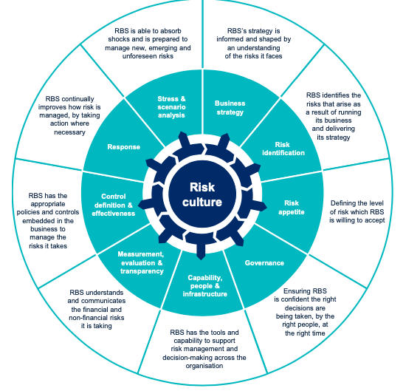

HSBC is similar to RBS and Barclays conducting nearly the same risk management by putting more resources in order to mitigate its risks.
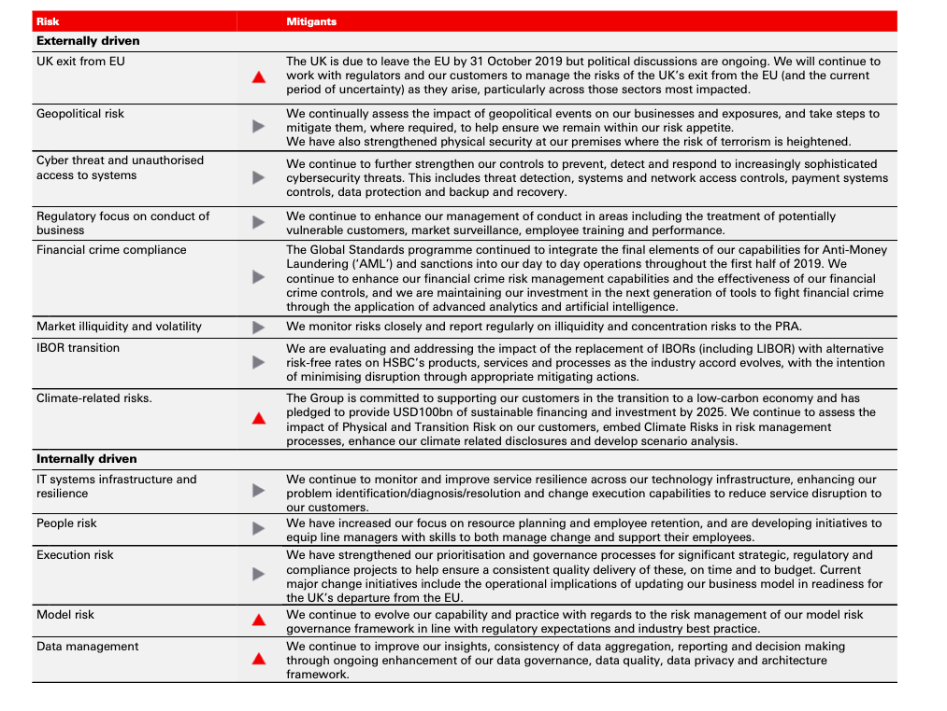

Conclusion:

The essential aim of bank regulation is to diminish the degree of danger to which bank lenders such as contributors who are uncovered and to moderate fundamental financial dangers. Even though that bank controllers may decide to utilize universally useful budgetary revealing data in meeting their targets, one ought to expect that bank controllers would not restrict themselves to data contained by and large reason money related reports.
As outcomes, the three banks used in this report shows that they mitigate the risk that has been occurred in the financial crisis in order to avoid it in future crisis (Landsman, 2010).

Appendix A:

Both tier 1 capital ratio and LCR written in Table 1 are found in each bank’s footnotes financial statement, others ratios are calculated as follow:

Cost income ratio:

Years | Cost income ratio
Years | HSBC | Barclays | Royal Bank of Scotland
2015 | = $\frac{39,768}{71,092}$ x 100  =55.94% | =$\frac{13,723}{22,040}$ x 100  = 73.3% | =$\frac{16,353}{12,123}$ x100  =134.90%
2016 | =$\frac{36568+3240}{59836}$ x 100  = 66.53% | =$\frac{14,565}{21,451}$ x 100  = 67.90% | =$\frac{16,194}{12,950}$ x 100  =125.05%
2017 | =$\frac{34,884}{63,776}$ x 100  = 54.70% | =$\frac{13,884}{21,076}$ x 100  =65.87% | =$\frac{10,401}{13,133}$ x 100  =79.20%
2018 | =$\frac{34,659}{63587}$ x100  = 54.51% | =$\frac{13,627}{21,136}$ x 100  =64.47% | =$\frac{9,645}{13,402}$ x 100  = 71.96%
2019 | =$\frac{35,000+7,349}{71,024}$ x100  = 59.63% | =$\frac{13,359}{21,632}$ x 100  =61.75% | =$\frac{9,325}{14,253}$ x 100  =65.42%

Lending ratio:

Years | Lending ratio
Years | HSBC | Barclays | Royal Bank of Scotland
2015 | =$\frac{90,401}{54,371} x 100$  = 166.27% | =$\frac{357,586}{390,307}$ x 100  = 90.07% | =$\frac{333,892+30,646}{38,296+343,186} x 100$  =95.56%
2016 | =$\frac{88,126}{59,939} x 100$  =147.03% | =$\frac{345,900}{390,744} x 100$  = 88.52% | =$\frac{351,950+30,138}{38,556+353,872} x 100$  =97.36
2017 | =$\frac{90,393}{69,922} x 100$  = 129.28% | =$\frac{324,048}{398,701} x 100$  =81.27% | =$\frac{30,251+349,919}{46,898+367,034} x 100$  =91.84%
2018 | =$\frac{72,167}{56,331} x 100$  = 128% | =$\frac{326,406}{394,838}$ x 100  =82.66% | =$\frac{305,089+12,947}{360,914+23,297} x100$  =82.77%
2019 | =$\frac{69,203}{59,022} x 100$  =117.25% | =$\frac{339,115}{415,787} x 100$  =81.56% | =$\frac{10,689+326,947}{369,247+20,493} x 100$  =88.68%

Return to equity ratio:

Years | Return on equity
Years | HSBC | Barclays | Royal Bank of Scotland
2015 | =$\frac{12,572}{188,460}$ x100  = 6.67 % | =$\frac{495}{59,810} x 100$  =0.83% | =$\frac{426}{51,177} x 100$  =0.83%
2016 | =$\frac{1,299}{175,386} x 100$  =0.74% | =$\frac{2,373}{64,873} x 100$  =3.66% | =$\frac{499}{48,609}x 100$  =1.03%
2017 | =$\frac{9,683}{190,250}x 100$  = 5.09% | =$\frac{2,477}{63,905} x 100$  =3.88% | =$\frac{1,064}{43,330} x 100$  = 2.45%
2018 | =$\frac{12,608}{186,253} x 100$  = 6.77% | =$\frac{1,861}{62,556} x 100$  =2.97% | =$\frac{882}{45,736} x 100$  =1.93%
2019 | $\frac{5,969}{183,955}$ x100  = 3.24% | =$\frac{4,181}{64,429} x 100$  =6.49% | =$\frac{2,763}{43,547} x 100$  = 6.34%

References:

Dermot Hodson & Deborah Mabbet (2009) ‘UK Economic policy and the global financial crisis: Paradigm lost?’ Journal of common market studies, 47(5), pp. 1041-1061 [Online]. Available at: https://onlinelibrary.wiley.com/doi/epdf/10.1111/j.1468-5965.2009.02034.x [Accessed 15th August 2020].

Alin Marius Andries (2008) What role have banks in financial crises? [Online]. Available at: https://core.ac.uk/download/pdf/6605413.pdf [Accessed 15th August 2020].

Bonn (2005) An increasing role for competition in the regulation of banks [Online]. Available at: https://centrocedec.files.wordpress.com/2015/07/an-increasing-role-for-competition-in-the-regulation-of-banks-2005.pdf [Accessed 15th August 2020].

Benn Kingsley (2019) Bank regulation in the United Kingdom [Online]. Available at: https://www.lexology.com/library/detail.aspx?g=4e55a6bc-5f01-4abd-b242-d6e0bdf3f405 [Accessed 16th August 2020].

Bob Pen, Allen & Overy (2019) Bank regulation in the UK: Overview [Online]. Available at: https://uk.practicallaw.thomsonreuters.com/w-008-0211?transitionType=Default&contextData=(sc.Default)&firstPage=true&bhcp=1 [Accessed 18th August 2020].

Alastair Holt (2006) Banking regulation | United Kingdom [Online]. Available at: https://www.globallegalinsights.com/practice-areas/banking-and-finance-laws-and-regulations/united-kingdom [Accessed 18th August 2020].

Bank of England (2018) Why do we regulate banks? [Online]. Available at: https://www.bankofengland.co.uk/knowledgebank/why-do-we-regulate-banks [Accessed 18th August].

Elisa Aracil & Fransisco Javier (2019) ‘The influence of innovation on corporate sustainability in the international banking industry’ Sustainability, 11(1), pp. 2-15 [Online]. Available at: https://repositorio.comillas.edu/xmlui/bitstream/handle/11531/40161/Aracil,%20Sustainability%202019.pdf?sequence=1 [Accessed 19th August 2020].

Barclays (2019) How Barclays is building a sustainable banking system [Online]. Available at: https://home.barclays/news/2019/3/how-barclays-is-building-a-sustainable-banking-system/ [Accessed 19th August 2020].

Demirguc-Kunt Asli (2010) Bank capital: lessons from the financial crisis [Online]. Available at https://www.imf.org/external/pubs/ft/wp/2010/wp10286.pdf [Accessed 20 August 2020].

Arnold Kling (2016) Risk-based capital rules [Online]. Available at: https://www.mercatus.org/system/files/peirce_reframing_ch1.pdf [Accessed 20 August 2020].
Detragiache E., Merrouche O. (2010) Bank Capital [Online]. Available at: https://openknowledge.worldbank.org/bitstream/handle/10986/3955/WPS5473.pdf?sequence=l [Accessed 20 August 2020].

Benjamin H. C., Scatgina M. (2014) Banks and capital requirements: channels of adjustment [Online]. Available at: https://www.bis.org/publ/work443.pdf [Accessed 21 August 2020].

Bridges, J., Gregory D., Nielsen M., Pezzini S., Radia A., Spaltro M., (2014) The impact of capital requirements on bank lending [Online]. Available at: https://www.mybib.com/tools/harvard-referencing-generator [Accessed 21 August 2020].

BIS (2013) Basel III: The liquidity coverage ratio and liquidity risk monitoring tools [Online]. Available at: https://www.bis.org/publ/bcbs238.pdf [Accessed 23 August 2020].

Michael R. King (2010) Mappin capital and liquidity requirements to bank lending spreads [Online]. Available at: https://www.bis.org/publ/work324.pdf?noframes=1 [Accessed 23 August 2020].

Dahir A. M., Mahat F., Razak N. H. A. (2019) ‘Capital, funding liquidity, and bank lending in emerging economies: An application of the LSDVC approach’ Science direct, 19(2), pp. 139-148 [Online]. Available at: https://www.sciencedirect.com/science/article/pii/S2214845018301844 [Accessed 24 August 2020].

Alber N., Elmofty M., Walied I. (2019) Banking efficiency: concepts, drivers, measures, literature and conceptual model [Online] Available at: https://papers.ssrn.com/sol3/papers.cfm?abstract_id=3310982 [Accessed 25 August 2020].

Shamshur A., Weill L. (2019) Does bank efficiency influence the cost of credit [Online] Available at: https://gdre-scpo-aix.sciencesconf.org/186741/document [Accessed 25 August 2020].

Nitoi M., Spulber C. (2015) ‘An examination of banks cost efficiency in central and eastern Europe’ Science direct, 22(1), pp. 544-551 [Online]. Available at: https://core.ac.uk/download/pdf/82733229.pdf [Accessed 26 August 2020].

Alevizopoulu E., Apergis N. (2019) Bank efficiency and bank lending channel: evidence from a panel of European Banks [Online]. Available at: http://citeseerx.ist.psu.edu/viewdoc/download;jsessionid=D8B6AE52A82727093C152C281F865524?doi=10.1.1.366.436&rep=rep1&type=pdf [Accessed 26 August 2020].

Tran T. U., Lin C., Nguyen H. (2016) ‘Liquidity creation, regulatory capital, and bank profitability’ International review of financial analysis, 48(1), pp. 98-109 [Online]. Available at: https://reader.elsevier.com/reader/sd/pii/S1057521916301454?token=3AB91292A41190ABD83E25F4187B049611CB84F3115351E77741D0957C8C44F162DDD2693B69CB283C85919B3E0ED6D6 [Accessed 27 August 2020].

Al Mahmud A., Kumer D. C. (2018) ‘Impact of capital adequacy on profitability under Based II accord: Evidence from commercial banks of Bangladesh’ European journal of business and management, 10(8), pp. 48-58 [Online]. Available at: https://www.researchgate.net/publication/336279543_Impact_of_Capital_Adequacy_on_Profitability_Under_Basel_II_Accord_Evidence_from_Commercial_Banks_of_Bangladesh [Accessed 28 August 2020].

Ahsan Mainul A. F. M. (2012) Can ROE be used to predict portfolio performance? [Online]. Available at: https://www.researchgate.net/publication/258341502_Can_Return_on_equity_be_used_to_predict_portfolio_performance [Accessed 28 August 2020].

Crane L., Gantz G., Isaaacs S., Jose D. Introduction to risk management. 2nd Ed. 2013 [e-book]. Available at: http://extensionrme.org/pubs/introductiontoriskmanagement.pdf [Accessed 29 August 2020].

CFO Tech (2019) How banks are executing strategies to mitigate risks [Online]. Available at: https://www.cfotechoutlook.com/news/how-banks-are-executing-strategies-to-mitigate-risks-nid-822.html [Accessed 30 August 2020].

Basel Committee on banking supervision (2000) Principles of the management of credit risk [Online]. Available at: https://www.bis.org/publ/bcbs75.pdf [Accessed 30 August 2020].

SAS (2020) Liquidity risk [Online]. Available at: https://www.sas.com/en_gb/insights/risk-management/liquidity-risk.html [Accessed 1st September 2020].

M. Manoj Kumar (2013) ‘Risk management in banking sector- an empirical study’ International journal of marketing, financial services & management research, 2(2), pp.145-153.

Wayne R. Landsman (2010) ‘How did financial reporting contribute to the financial crisis’ European Accounting review, 19(3), pp. 329-423 [Online] Available at: https://www.researchgate.net/profile/Wayne_Landsman/publication/227613809_How_Did_Financial_Reporting_Contribute_to_the_Financial_Crisis/links/0c96052b996d687e16000000.pdf [Accessed 3th September 2020].

Barclays (2018) Barclays Bank UK PLC annual report [Online]. Available at: https://home.barclays/content/dam/home-barclays/documents/investor-relations/reports-and-events/annual-reports/2018/2018-Barclays-Bank-UK-PLC-Annual-Report-28.02.2019.pdf [Accessed 4th September 2020].

D. M. Mathuva (2009) ‘Capital adequacy, cost income ratio and the performance of commercial banks: the Kenyan scenario’ The international journal of applied economics and finance, 3(2), pp. 35-47 [Online] Available at: https://www.researchgate.net/publication/40714127_Capital_Adequacy_Cost_Income_Ratio_and_the_Performance_of_Commercial_Banks_The_Kenyan_Scenario [Accessed 5th September 2020].

Presentation:







