Student Number: 2507361
Name: Sobia Hussain
Module: LCHS4003
Tutor: Mumtaz Goolam

Submission Date: 23/02/2
Community mental health services are locally based that assess, treat, support patients with mental health conditions but they can stay in their community. Unlike clinical hospital care, community services deliver care in a environment that promotes recovery and independence. Its person centred and a rights-based approach (WHO 2021).
The main aim is providing holistic care close to their home. It reduces hospital admissions and promotes early intervention. Also aims to reduce the discrimination of mental health. The NHS long term plan speaks on strengthening community mental health care improving outcomes and time of support (Department of health and social care, 2019).

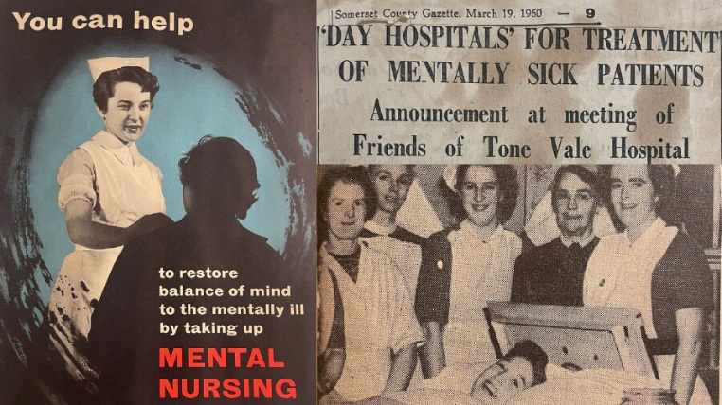
Community mental health services are Important it supports recovery, independence and social inclusion whilst reducing hospital admissions. The development of community mental health services has been shaped by the shift from the past of psychiatric institutions due to the limitations and harm with this and shifted to community based due to it changing societies attitude towards mental illness and supporting human rights. (WHO 2021)
The UK initiatives such as care programme approach coordinated community support (Department of Health, 1990). The modern community health services show the lessons from institutional care and committed care.
Community mental health services developed as a shift in mental health care during the 20th century. Before these individuals in mental health were being treated in psychiatric institutions. This was isolated and focused on therapeutic interventions. But this became overcrowded and not resourced so lead to poor living conditions (Thornicroft and Tansella, 2014).
In the UK policy reformed 1980s 1990s which transitioned to community care. This prompted closing psychiatric hospitals replacing it with local services. Also, the care programme approach, in 1990 strengthened community services by having coordinated care planning and risk management for individuals with mental health issues (Department of Health, 1990).

It’s delivered by multidisciplinary teams who work together to assess, develop, provide support. Services include at home treatment teams and rehabilitation services which aim to improve skills and support employment (NICE, 2022)
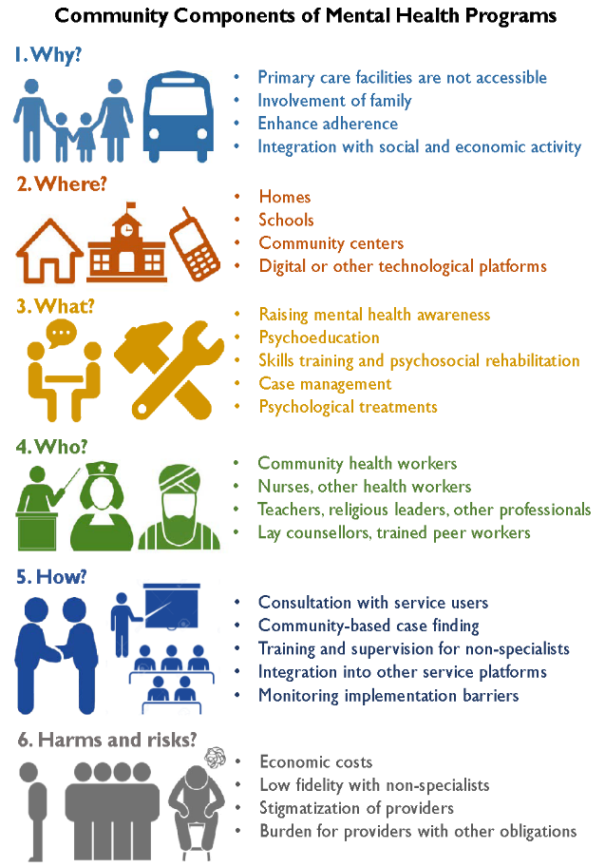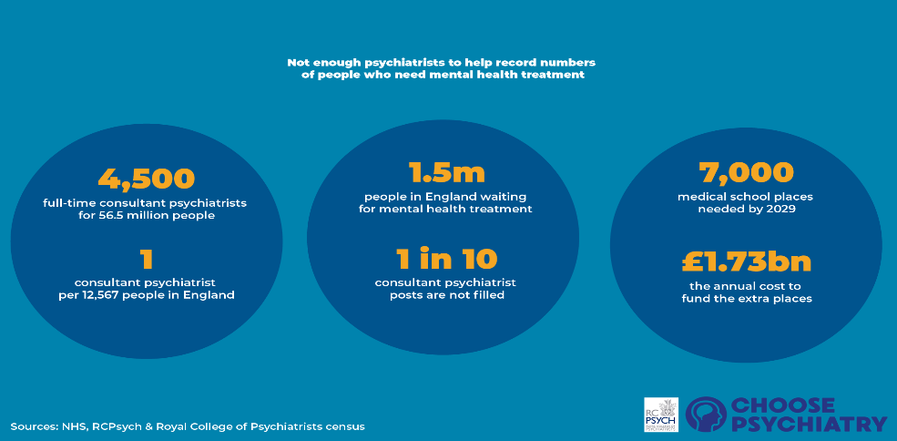
In the UK there are models which are in place to deliver person centred care outside a hospital to improve access for people with poor mental health (NHS England, 2019; NHS Confederation, 2025). Introduced in the NHS long term plan, the community mental health framework sets a vision where services are through a partnership approach involving different specialties and sectors. Emphasising on whole person care that includes psychological and physical support (NHS England, 2019; NHS England, 2025). It replaces the traditional care programme approach and is more personalised that tailors to an individual’s needs being more accessible as its closer to their home (NHS England, 2019; NHS Confederation, 2025). There are ongoing challenges and inconsistent implementation so there is a need for more investment and collaboration with teams to achieve the aims of the framework (Association of Mental Health Providers, 2025; NHS Confederation, 2025).
Community mental health services in the face a lot of pressures even though there have been policies in place which are aimed to strengthen community mental health. A massive challenge is staff shortages and capacity constraints which affect access, continuity and quality of care. There has been an increased demand for multidisciplinary care due to the NHS community mental health framework, but the recruitment difficulties across the multidisciplinary team have limited implementation (NHS England, 2019). Staff burnouts contribute to waiting times increased and reduced therapy engagement which undermines the frameworks ambition to deliver holistic care (Care Quality Commission, 2023). A challenge includes service fragmentation and inequitable access especially for those with complex needs. Although the care system wants to promote collaboration in local arrangements. (The King’s Fund, 2022). This can lead to repeated assessments, poor information sharing and care being discontinued increasing hospital admissions and the workforce pressure will be high.
Association of Mental Health Providers (2025) Our Response to the Health and Social Care Committee’s Report on Community Mental Health Services. Available at: https://amhp.org/our-response-to-the-health-and-social-care-committees-report-on-community-mental-health-services/
Care Quality Commission (2023) Community mental health survey 2022. London: CQC.
Department of Health (1990) The Care Programme Approach for people with a mental illness referred to specialist psychiatric services. London: HMSO.
Department of Health and Social Care (2019) The NHS Long Term Plan. London: DHSC.
https://www.bing.com/images/search?view=detailV2&ccid=DPtkkqf5&id=A6C8B2D84EA9484D0FA8FCC0E2F94BB538899FA7&thid=OIP.DPtkkqf56mzr0O2S58pW8wHaE8&mediaurl=https%3a%2f%2fopenminds.org.au%2fwp-content%2fuploads%2f2022%2f12%2fmental-health-support.jpeg&cdnurl=https%3a%2f%2fth.bing.com%2fth%2fid%2fR.0cfb6492a7f9ea6cebd0ed92e7ca56f3%3frik%3dp5%252bJOLVL%252beLA%252fA%26pid%3dImgRaw%26r%3d0&exph=800&expw=1200&q=community+mental+health+service&FORM=IRPRST&ck=50A702B054BCBFEF51C85AAEAC3DC501&selectedIndex=0&itb=0
https://www.bing.com/images/search?view=detailV2&ccid=hObNh%2ffJ&id=F638B0D724803867A74977D8E8FF7564977E5C90&thid=OIP.hObNh_fJ4yX25Bt1LBEvrgHaEH&mediaurl=https%3a%2f%2fwww.somersetft.nhs.uk%2fwp-content%2fuploads%2f2023%2f07%2fChanges-to-mental-health-ON-Thumb-900x500.jpg&cdnurl=https%3a%2f%2fth.bing.com%2fth%2fid%2fR.84e6cd87f7c9e325f6e41b752c112fae%3frik%3dkFx%252bl2R1%252f%252bjYdw%26pid%3dImgRaw%26r%3d0&exph=500&expw=900&q=History+community+mental+health+service&FORM=IRPRST&ck=B84D6C5A92F88EEF34AE7B4C59D013A4&selectedIndex=7&itb=0
National Institute for Health and Care Excellence (NICE) (2022) Community mental health services for adults with severe mental illness. London: NICE.
NHS Confederation (2025) Submission on community mental health services, NHS Confederation. Available at: https://www.nhsconfed.org/system/files/2025-03/nhs_confederation_submission_to_hscsc_inquiry_on_community_mental_health_services.pdf
NHS England (2019) Community Mental Health Framework for Adults and Older Adults. Available at: https://www.england.nhs.uk/wp-content/uploads/2019/09/community-mental-health-framework-for-adults-and-older-adults.pdf
NHS England (2019) The Community Mental Health Framework for Adults and Older Adults. London: NHS England.
NHS England (2025) Commissioner guidance for adult community mental health rehabilitation services, NHS England. Available at: https://www.england.nhs.uk/long-read/commissioner-guidance-adult-community-mental-health-rehabilitation-services
The King’s Fund (2022) Mental health policy and practice. London: The King’s Fund.
Thornicroft, G. and Tansella, M. (2014) ‘Community mental health care worldwide: current status and further developments’, World Psychiatry, 13(2), pp. 126–139.
World Health Organization (WHO) (2021) Guidance on community mental health services: Promoting person-centred and rights-based approaches. Geneva: WHO.

