Template Component 1 (Second option)

Part 1: Research Question Formulation
Identify your chosen topic and break it down using the Who/What/Where/Result framework.
- Topic Area: pharmacist
- Research Question: how effective is pharmacist- led request repeat prescription services for patients who lack mobility or transport access in the uk?

Part 2: Search Strategy (Keywords & Boolean Operators)
Use the table below to evidence how you combined your search terms to retrieve relevant, peer-reviewed articles
Search | Search Terms (Keywords) and  Boolean Operator (AND/OR/NOT) combinations | Database Used | Results Found
1 | “Uk” AND “Mobility” | Pubmed | 989
2 | “Patients” AND “Uk” OR “Transport Access” AND “Mobility” | Pubmed | 258
3 | “Patients” AND “Mobility” AND “Request Repeat Prescription” | Pubmed | 5
4
5

Part 3: Evidence of Peer-Reviewed Literature
David Elias-Campa et al. J Emerg Med. 2025 Nov.
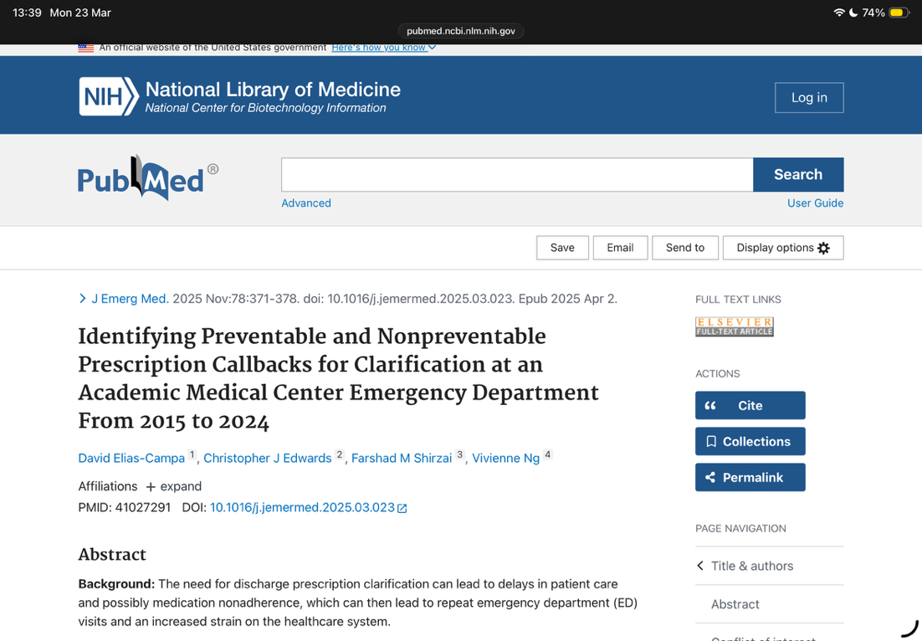

Part 4: Search Strategy Evaluation (Approx. 300 Words)

This topic of research is how affective is pharmacist-led request repeat prescriptions services for patients who lack mobility or transport access in the uk. It allows pharmacists to manage repeat prescriptions directly, reducing the need for patients to visit GP surgeries (NHS Business Services Authority,2024). This improves medication adherence and convenience, especially for those who are homebound or have difficulty travelling. Studies show increased patient satisfaction and better health outcomes with such services (Community Pharmacy England,2024). Using a focused search strategy with terms like “pharmacist-led,” “repeat prescription,” “mobility,” “UK” helps find relevant evidence on effectiveness, support ting the services role in enhancing access to medicines for vulnerable patients.
The structured PICO Framework work helps clearly define the search question.For example the population (patients in the UK with limited mobility or transport access), Intervention (pharmacist-led repeat prescription service), Comparison (usual care or other prescription methods), and outcome (effectiveness measured by medication adherence, patient satisfaction, or health outcomes (Chambers et al., 2024). This framework guides the search strategy by finding precise keywords and concepts, maiming it easier to find relevant studies and evidence about how well these services work this specific group in the UK.
Using PubMed, It allowed to find trustworthy sources and statements for the pharmacist- led request repeat prescription research (Farhana et al.,2025). Applied filters for UK studies and recent years to narrow the results. Also used a screenshot of the search results page to document the process and show the relevant articles found on the research.

Pharmacist-led request repeat prescription service has shown to be effective for patients who lack mobility or transport access by improving medication adherence and convenience (Smith-Ray et al.,2024). Searched for relevant keywords like “pharmacist-led repeat prescriptions” and “mobility.” The evidence suggests theses services enhance patient satisfaction and reduce healthcare barriers for this group.

References:
Chambers, D., Preston, L., Clowes, M., Cantrell, A.J. and Goyder,E.C. (2024) Pharmacist -led primary care interventions to promote medicines optimisation and reduce overprescribing: a systematic review of UK studies and initiatives.BMJ Open,14(8), e081934.
Community Pharmacy England (2024) repeat dispensary and eRD. Available at: https://cpe.org.uk (accessed:23 of March 2026)
Elias- Campa D, Edwards CJ, Shirzai,FM,Ng V. Identifying preventable and non preventable prescription callbacks for clarification at an academic medical centre emergency department from 2015-2024.J Emerg Med. 2025 Nov;78:378-378. doi: 10.1016/j.jemermed.2025.03.023. Epub 2025 Apr 2. PMID: 41027291.
Farhana,L., Rahayu, F.P., Sholihah, S., Sweileh, W., Abdulah, R. and Alfian, S.D. (2025) Effectiveness of pharmacist- led intervention on medication adherence in chronic disease: A systematic review of randomized controlled trails. Patient Preference and Adherence, 19,pp.2161-2178. Available at: https://pubmed.ncbi.nlm.nih.gov/40726768/
NHS Business Services Authority (2024) Electronic repeat dispensing (eRD). Available at: https://www.nhsbsa.nhs.uk (accessed: 23 of March 2026)
Smith-Ray, R., Feng, L., Singh, T., Rudkin, K., Emmons, S., Groves, E. and Kirkham, H. (2024) pharmacists as clinical care partners: how a pharmacist-led intervention is associated with improved medication adherence in older adults with common chronic conditions, Journal of managed care & Specialty Pharmacy, 30 (4) pp. 345-351

