

Come Shine with US !
STAR THEATRE
SCHOOL
BUSINESS PLAN

University Trinity Saint Davids – Gaynor Morgan 2014357

BMSW4006 Managing Enterprise in the 21st Century

Contents Page Page No.

Name of Business & Business Owner …………… 2

Mission Statement ……………… 2

Introduction ……………… 2

Aim & Objectives of Business ……………… 3

Product/Service ……………… 3/4

Marketing Activities ……………… 5/6

Physical Resources ……………… 7

Financial Resources 2022/23
  - Secured Funding/Capital ……………… 8
  - Incoming Funds ……………… 8
  - Projected incoming Funds ……………… 8
  - Predicated outgoings ……………… 9
  - Overall Gross Profit ……………… 9

9.0 Human Resource ……………… 10/11

10.0 SWOT Analysis ……………… 12

11.0 Conclusion ……………… 13

12.0 Appendices ………………. 14

12.1 Poster ………………. 14
12.2 Job Description ………………. 15
12.3 Questionnaire ………………. 16
12.4 Cash Flow ………………. 17
13.0 References ………………. 18/19

STAR THEATRE SCHOOL

1.0 NAME OF BUSINESS –
BUSINESS OWNED BY – Mrs Gaynor Morgan/Sole Trader

2.0 MISSION STATEMENT

The STAR Theatre School will inspire creativity, confidence and independence by encouraging integration, participation and acceptance, and enable their individual talents and personalities to shine through.

- INTRODUCTION

Performing arts has always been a passion of mine. In addition to this, I also enjoy working alongside young children. In the past, I have gained experience in chaperoning and helping in my daughter’s local drama group. It has also been an ambition of mine to open a part time and inclusive business that can fit around my family commitments. After conducting detailed research in my local area, it was evident that there was a lack of affordable youth activities, and, more concerningly, a number of barriers of entry to participation in the field of performing arts. Subsequently, the proposed business plan will aim to identify how the business will be formed, with myself being named as a sole trader.

One of the key advantages of being a sole trader is that it allows the individual more control in the way they choose to run their business, and therefore, you can run your enterprise in the way you want, and without any outside interference from anyone else. This benefit covers the whole business and organisational spectrum, from the most mundane of daily tasks, to the more complex strategic decision making. Additionally, the sole trader does not have accountability to directors or shareholders either, which allows you a clear pathway to realise your vision and organisational potential. Given this scope and autonomy, it is you who will make the decisions, implement them with due diligence and haste, and then anticipate meeting or even exceeding your clients’ needs and expectations both efficiently and effectively, often without incurring any delays or the often-unnecessary burden of bureaucracy (Gorilla Accountants. 2019).
- AIM AND OBJECTIVES

- To improve the shortfall and accessibility of affordable youth activities in the South Wales area.
- To run regular classes and theatre performances for children aged between 4 – 16 and overcome any barriers to entry or participation.
- To promote individual self confidence, wellbeing, and social and academic development.
- To nurture pathways of creativity.
- To make a projected overall financial profit of 15% each year.

- PRODUCT SERVICES

Theatre in Education “TIE” was established by Gordon Vallins, in 1965. Its sole aim was to educate young children into the joys of theatre. (BBC Bitesize, 2020). Since then, Theatre in Education has proven itself to be an essential way of educating young children. For example, a low budget play can give a strong message throughout the production, and often serves to leave a lasting and inspirational impact on a child.
STAR Theatre School will not only provide the children with excellent performing arts training in a safe and secure environment, but will also aim to build their confidence and assist them in the development of their social and academic skills. We aim to provide a wholly inclusive first class service to the community, giving all local children an opportunity to participate in singing, dancing and drama classes at a price that is affordable to everyone.

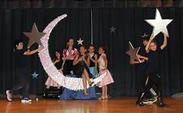


5.0 PRODUCT SERVICES (continued)
The Saturday morning classes will commence at 9.30 am. These sessions will be run for 90 minutes. This class will be split into two groups, namely for children aged 4-6, and 7-9. Two classes will run simultaneously alongside each other, one group consisting of children aged 4–6-year-olds, and the other 7–9-year-olds. Following on from this, at 11.30 am, two new classes of 4-6s and 7-9s will start and run until 1.00 pm. There will be one teacher in each class, and one assistant, who will alternate between classes. The classes will consist of a range of many performing arts activities, along with fun and games. Each of the classes will run for 90 minutes, and will consist of a range of many performing arts activities, along with fun and games. The staff will then have an hour’s break.
The Saturday afternoon session will be for children aged from 10-13. This class will be for 3 hours, running from 1pm – 4pm. Students will work on performance skills, confidence building, teamwork and collaboration, as well as dance and singing activities. This class will focus on the development of the older students, aged from 10 – 16. Students will learn different singing techniques, and also participate in improvisation and performance.
Each class will have trained and experienced teachers, each of whom have experience in performing arts training and hold a range of accredited professional qualifications. In addition to this, each teacher will hold an advanced DBS check, and be fully conversant and compliant with all the relevant safeguarding procedures and legislation required for this environment (DBS Check Online, 2021).

6.0 MARKETING SERVICES
While conducting the relevant Market Research, I looked into the three most important lines of activities, i.e. product positioning and target marketing, and then segmenting each area to identify which group would benefit from my business (Rogers, 2014). Another important factor, which undoubtedly will be the main marketing strategy of my company’s success, would be the marketing phrase, “The Four P’s”, otherwise known as a product, price, promotion, and place, (Borden, 1984).
Drawing upon my local knowledge of the area, and analysing the findings gleaned from an online primary research questionnaire, which was completed by the local public via Facebook, it was evident that my intended target market was families with young children, Questionnaire attached (Appendix C).
In my opinion, my research results conclusively led me to identify that there was no performing arts school or community centres available for an inclusive and affordable facility for those aged 16 and under. In addition to this, it is my belief that the chosen location is well positioned to allow access for not only public transport, but also for those travelling on foot or travelling by car.



6.0 MARKETING SERVICES – (Continued)

Marketing of the School will consist of a well constructed website, providing extensive information, which will be monitored and updated regularly, allowing any enquiries to be answered quickly. I would need to be creative and investigate different ways to connect with potential students and parents, for example, by including an online live chat feature. In addition to this, it is my intention to distribute leaflets, posters and flyers, which will be placed in local schools and youth organisations.
Regular promotions will he held on social media, encouraging members to share the schools advertising slogan, and offering them the chance to win one of the many scholarships that will be available throughout the year. Local radio stations will be contacted, and advertising slots will be negotiated. Regular leaflet drops will be scheduled throughout the year, calling on local schools, youth clubs, and community centres to increase awareness and availability of the business. The sale of school t shirts and hoodies can be purchased from the School Website.



STAR THEATRE SCHOOL
HODDIES ON SALE £15.00
T SHIRTS - £10.00

In addition to this, there will be regular meetings with staff to conduct mutually beneficial sharing exercises. I also intend to create a network of similar schemes, and aim to contact others in similar industries, and share suggestions to help all of our business’s thrive in this uncertain economy (Hurrell and profile, 2021).
In accordance with this, our school will offer the legislative reassurance, to all stakeholders, that all personal data collected about staff, students, parents, visitors and other individuals or organisations is collected, stored, and processed to act in compliance with the General Data Protection Regulation (GDPR) and the expected provisions of the Data Protection Act 2018 (DPA 2018) as set out in the Data Protection Bill.
7.0 PHYSICAL RESOURCES

The location of the theatre will be based in a local primary school, which is well situated for public transport, and has the added advantage of numerous parking slots. As my market research indicated, there are no other performing arts school in the area. The primary school has the benefits of a large hall with a stage and a piano, and provides us with the use of an additional classroom should the need arise. The headteacher has given unreserved permission for the theatre school to have exclusive use of the piano, stage, and classroom.


The view of the school premises from the road.

As you can see from this photo, there is ample car parking spaces for parents.

The business with comply with all current health & safety legislation, and complete a thorough and comprehensive risk assessment on the premises, facilities, and activities (Hse.gov.uk.2021).

8.0 FINANCIAL RESOURCES
ens

Due to the recent Covid 19 pandemic, and the associated downturn in employment opportunities, from March 2020, my employer had to cease trading and I received a redundancy pay out of £20,000 from my secretarial position. Consequentially, I intend to invest the full amount into this business venture. Additionally, I received the sum of £100,00 from the sale of my grandparent’s property, from which I am the sole beneficiary. This amount will also be invested. I have successfully secured a “support the community” funding grant from the National Lottery of £10,000 (The National Lottery 2020). For further details on cashflow, please see (Appendix D).
8.1 Secured Funding /Capital 2022/23

Inheritance amount £100,000
Redundancy payment £ 20,000 “National Lottery Community Fund” Grant £ 10,000
Total: - £ 130,000

8.2 Incoming Funds - School Fees 40 weeks per year School fees from term (to run in connection with the LEA term times) 2022/23

Saturday morning classes

  - Group 4 – 6 (approx. 18 pupils 1.5 hours) x 2 £ 14,400.00
  - Group 7 - 9 (approx. 18 pupils 1.5 hours) x 2 £ 14,400.00
(£10.00 per session)
Saturday afternoon class
- Group 10 – 16 (approx. 30 pupils 3 hours) £ 24,000.00
(£20 per session)

8.3 Projected Funding 2022/23

  - Sale of Theatre School t shirts
and hoodies - £10 and £15 each
(50% profit on each) £ 1,275.00
  - Revenue for tickets sold from concert
productions £ 1,050.00

Total £55,125.00
8.4 Predicated Outgoings 2022/23 (per annum)

      - Manager’s salary £14,000.00
      - Rent on Premises £ 4,800.00
      - Teachers x 2 (self employed)
£25 p/session (£100 per Saturday) £ 8,000.00
      - Teachers’ assistants x 1 (self employed)
£15 p/session (£60 per Saturday) £ 2,400.00
      - Public Liability Insurance £ 220.00
      - Rental of school hall for concert 3 evenings £ 135.00
      - Production/props
(Costumes funded by parents) £ 150.00
      - Overtime pay for 3 nights for
Teachers & Teaching Assistants (Show) £ 90.00
(£10 per hour)

Total £ 29,795.00
8.5 Overall Gross Profit 2022/23
After analysing the above incomings and outgoing,
the overall projected profit for the year will be:- £ 25.330.00

9.0 HUMAN RESOURCES

STAR Theatre school seeks only to employ the very best. Each teacher would have received professional training, and hold accredited qualifications or professional performance experience in all three disciplines. (Job Description Appendix B).

Our teachers will endeavour to pass on to each student the tools and transferable skills they require to overcome shyness, gain confidence, learn how to work together, and, most importantly, ensure the children have fun in a safe and secure environment. All staff will be self employed, and therefore, will be responsible for their own tax and national insurance (Gov UK, 2021). All staff will be based in the South Wales, hold a current DBS Check, and be available to work most weekends.
During the summer term, staff, and pupils will prepare for the annual summer concert, with the dates and times being determined later. Alongside two qualified teachers, the business will be looking to appoint one teaching assistant and one school manager.
I intend to recruit staff by advertising in local drama colleges/universities for graduates, or for those with equivalent experience in the performing arts industry. I also intend to utilise the advantages of social media, and use the contacts that I have established throughout my time working within this sector. In keeping with the ethos of my business, it is my intention, wherever practically possible, to recruit teachers from the local area, as it is my belief that they will have the support, empathy and understanding of the community in which they teach.

- HUMAN RESOURCES (Continued)

The role of School Manager will be undertaken primarily by myself. With over twenty years clerical and secretarial experience, this role would be a perfect fit for my skill set. In addition to this, I am an experienced bookkeeper, thereby minimising the school’s accountancy fees. I will also adhere to: -

- Notify the HMRC of my new business and register as Self Employed.
- Keep records of sales and expenses.
- Complete a Self Assessment tax return each year.
- Pay class 2 or 4 National Insurance Contributions
- Self employed
- will be responsible for their own tax and NI Contributions (Gov UK, 2021)
- Take out all relevant insurance policies.

10.0 SWOT ANALYSIS
After conducting a detailed SWOT analysis, I aimed to identify any potential threats and weakness, alongside any potential opportunities and potential strengths. By identifying the opportunities, I am confident that I can adapt the business model and school to maximise its potential alongside the ever changing “new normal” of post COVID-19. To enable the business to thrive, I would need to be both aware and productive to prepare for any changes in the market.

I believe that I have raised enough capital to invest into the business. However, my capital is somewhat limited, and it is my intention to seek to secure further investments and funding, which will provide the sufficient capital to enable further scope and growth of the business.

STAR THEATRE SCHOOL – SWOT ANALYSIS

STRENGTHS | WEAKNESSES
- The location of the business is well positioned, with excellent facilities.  - The staff are well qualified, hold a current DBS check and all live locally.  - Experienced Administrator for Office Manager.  - Strong sense of family community in the area.  - No other Performing Arts School in the area.  - Significant amount of secured monies.  - Low admission fees. | - Young children audience does not produce high income from concert sales.  - Limited Financial Resources.  - Low admission fees.  - Governed by the School we rent from.  - Limited size classes.  - Employ staff on self employed  basis and only part time.
OPPORTUNITIES | THREAT
- Opportunity to expand by accruing more classrooms.  - Develop personal skills and nurture talent.  - Annual school productions.  - To offer on line singing lessons.  - To market the school uniform and produce a good revenue. | - Covid 19 virus – Economy and Society distribution.  - Other Schools opening up in the area.  - Staff could be head hunted  - Health & Safety legal requirements.  - Threat of litigation.  - Being the sole proprietor - risk of significant financial loss to myself.

- CONCLUSION

It is evident, in the financial breakdown in section 6, that the company is on target to achieve its forecasted projected profit of 15% in year 1. In consideration of this, I plan to invest a substantial amount of this profit into improving the company’s digital technology systems to enable a greater overall audience, enhanced efficiency, and means of communication (Stanton, 2020). I am also keen to strengthen the Theatre Schools online presence, as I feel a growing business will require a more advanced system to meet with the forever changing times, especially with regard to the foreseen and unforeseen impact of Covid 19 on the economy and in the wider society.
Creating and managing my own drama school is the fulfilment of a lifelong dream for me. I am motivated and driven, and I have no doubt that this school will encourage effective learning for the local children, and that we can all take inspiration from the words of Greg Anderson (2013), who quite eloquently stated that we should “Focus on the journey not the destination. Joy is found not in finishing an activity but in doing it.”

12.0 APPENDICES
12.1 Appendix A- Poster



12.2 Appendix B- Job Description
STAR THEATRE GROUP
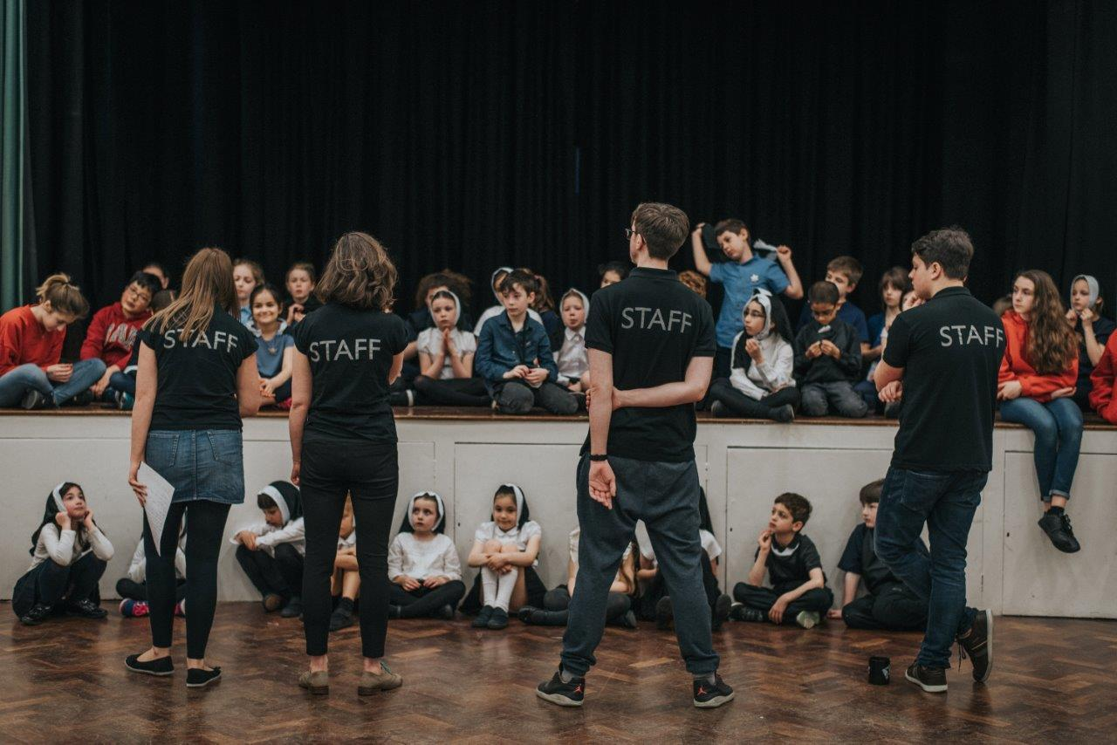

PART TIME - Performing Arts Teacher X 2
Star Theatre School based in Swansea, South Wales, has a long-term goal of helping every individual to become successful and motivated through high standards of teaching staff, ensuring that all students are ready to overcome any challenge in which they may face within the future. The school is a strong believer that with the right teaching and learning strategies in place every pupil can succeed. We are a small Theatre school who teach children from 5 – 16.

Our classes are run throughout the day on Saturday, the morning consisting of two classes for students in the age group from 4–6 and 7-9 (9:30 to 11), and a further two classes (11:30 to 1) for the same age ranges. Then Saturday afternoon will consist of a 3-hour class for students aged 10-16 (2 to 5).
Our students will be grouped into smaller class sizes enabling the teachers to know every pupil.
We are looking for energetic an enthusiastic teacher for our weekends school. Each teacher will be teaching drama, singing and dance to children of various ages and must be available on Saturday and Sunday. All teachers should have a current clear DBS check, hold a relevant qualification in performing arts/or working towards a qualification or have professional performance experience. Ideally candidates should live in the Swansea area and hold a full, clean driving licence with access to a vehicle.
- From £25 per session (depending on experience)
- Application needs to contain a C.V and covering letter.
- Closing date 19 June 2021
Please forward applications to startheathre@sky.com
Please telephone 07770409664 or further details
12.3 Appendix C 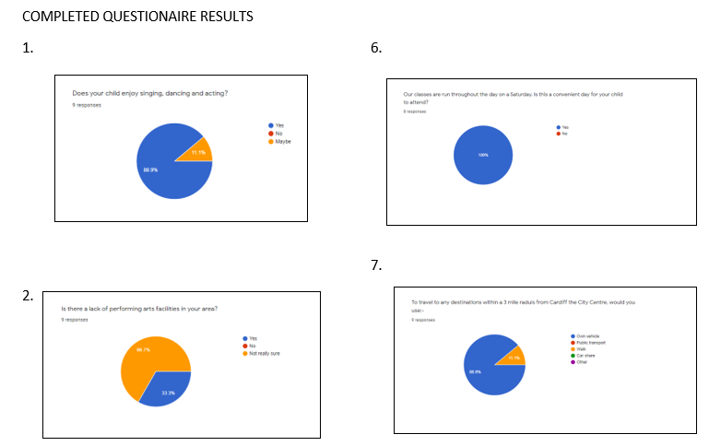
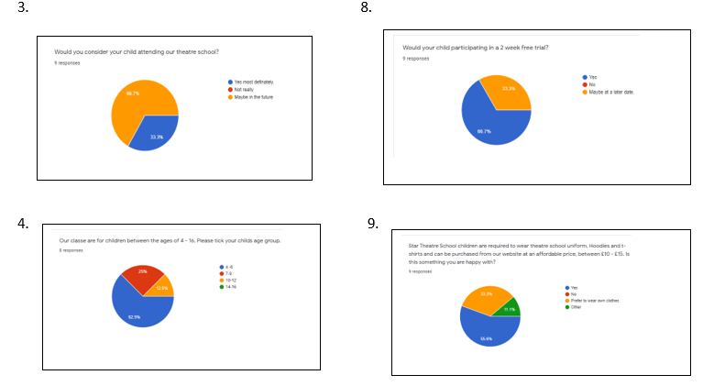
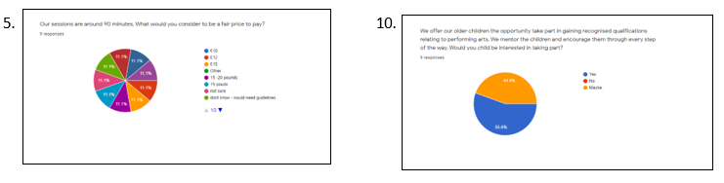

13.4 Appendix D – Cash Flow
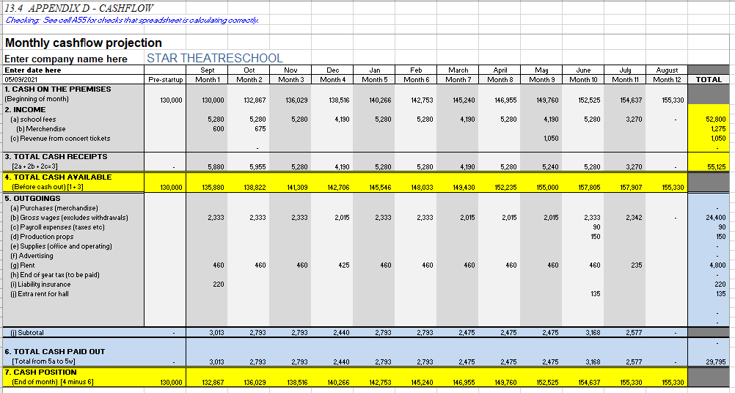
17.
13.0 REFERENCES
Anderson, G., n.d. (2013) A quote by Greg Anderson. [online] Goodreads.com. Available at: <https://www.goodreads.com/quotes/61250-focus-on-the-journey-not-the-destination-joy-is-found> [Accessed 16 May 2021].
BBC Bitesize. 2021. Preparing a performance for assessment - Theatre in education - GCSE Drama Revision - BBC Bitesize. [online] Available at: <https://www.bbc.co.uk/bitesize/guides/zsbjn39/revision/5> [Accessed 18 May 2021].

(UK Data Protection Act 2018 (DPA ACT) | 2021 Update, 2021)
Borden, N., 1984. The Concept of the Marketing Mix. Harvard Business School Journal, 2, pp.7-12.

Bshapiro Financial. 2021. Business Building Part Two: Do You Have a 20 Percent Profit Margin? [online] Available at: <https://www.bshapirofinancial.com/blog/business-building-part-two-do-you-have-a-20-percent-profit-margin> [Accessed 28 May 2021].

CIPD. 2021. Data Protection and GDPR in the Workplace | Factsheets | CIPD. [online] Available at: <https://www.cipd.co.uk/knowledge/fundamentals/emp-law/data-protection/factsheet#75630> [Accessed 22 May 2021].

CRB Direct. 2021. DBS Check, CRB Check, Basic Disclosure Check online - CRB Direct. [online] Available at: <https://crbdirect.org.uk/> [Accessed 20 May 2021].

Csek Creative - New Site. 2021. Using the 3 P's in service-based businesses' marketing mix. [online] Available at: <https://www.csekcreative.com/the-3-p-s-of-service-marketing> [Accessed 21 May 2021].

Goldsmith, R.E. (1999), "The personalised marketplace: beyond the 4Ps ", Marketing Intelligence & Planning, Vol. 17 No. 4, pp. 178-185. https://doi.org/10.1108/02634509910275917
Gorilla Accountants. 2019. What Are the Pros and Cons of Being a Sole Trader?. [online] Available at: <https://gorillaaccounting.com/blog/what-are-the-pros-and-cons-of-being-a-sole- trader/#:~:text=%20What%20are%20the%20Benefits%20of%20Being%20a,since%20there%20isn%E2%80%99t%20much%20paperwork%20to...%20More> [Accessed 15 June 2021].
18.
GOV.UK. 2021. Data protection. [online] Available at: <https://www.gov.uk/data-protection> [Accessed 20 May 2021].

GOV.UK. 2021. Employment status. [online] Available at: <https://www.gov.uk/employment-status/selfemployed-contractor> [Accessed 18 May 2021].

GOV.UK. 2021. Set up as a sole trader. [online] Available at: <https://www.gov.uk/set-up-sole-trader> [Accessed 21 May 2021].

Hse.gov.uk. 2021. Health and safety legislation - laws in the workplace. [online] Available at: <https://www.hse.gov.uk/legislation/> [Accessed 22 May 2021].

Hurrell, P. and profile, 2021. Adapt your business and thrive in the future | The UK Domain. [online] The UK Domain. Available at: <https://www.theukdomain.uk/adapt-and-thrive/> [Accessed 18 May 2021]

Ico.org.uk. 2021. Your data matters. [online] Available at: <https://ico.org.uk/your-data-matters/> [Accessed 20 May 2021].

Jigsaw Performing Arts Schools. 2021. Jigsaw Performing Arts Schools | Dance Drama & Singing For Children. [online] Available at: <https://www.jigsaw-arts.co.uk/> [Accessed 20 May 2021].

Nyt.org.uk. 2021. [online] Available at:
<https://www.nayt.org.uk/writeable/editor_uploads//files/Downloads/Starting%20a%20Youth%20Theatre%20basic%20advice.pdf> [Accessed 8 May 2021].

Rogers, K., 2014. [online] Samples.jbpub.com. Available at: <http://samples.jbpub.com/9781449622213/Chapter14.pdf> [Accessed 16 May 2021].

Saxena, D., 2019. 4Ps of Marketing (Marketing Mix with Examples) - Super Heuristics. [online] Super Heuristics. Available at: <https://www.superheuristics.com/marketing-mix-4ps-with-examples/> [Accessed 21 May 2021].
Stanton, C., 2020. The impact of COVID-19 on small business outcomes and expectations. Proceedings of the National Academy of Sciences, 117(30), pp.17656-17666.
Tnlcommunityfund.org.uk. 2020. How to get a grant for up to £10,000 | The National Lottery Community Fund. [online] Available at: <https://www.tnlcommunityfund.org.uk/funding/under10k> [Accessed 9 May 2021].

