3/24/2025
University of Wales Trinity Saint David
London campus
E-Portfolio Link: Click here
Module Name: Learning In the Digital Era
Module Code: ACCA 4025

Student Name: Srikanth Venkaiah Thotakuri
Student ID:2518293
Group: 1

Lecturer’s Name: Koushik Modak

LDE Assignment 1
E-Portfolio
Table of Contents
Introduction 2
Main Body 2
Task 1: Essential Academic and Employment Skills for the future career Path 2
Task 1 (a): Report on Essential Academic and Employment Skills 2
Task 1 (b): Evaluation of Task 1 (a) based on Similarity report 2
Task 2: Collaborative Mind Map and Individual Poster 2
Mind Map (Collaborative) 2
Poster (Individual) 2
Task 3: Virtual Collaboration and RefWorks 2
Report on Virtual Collaboration 2
Step-by-step process of using RefWorks with visuals 2
Task 4: E-Portfolio Creation and Evaluation 2
Task 4 (a): E-Portfolio Creation 2
Task 4 (b): Illustrative Review of E-Portfolio tool Selection 2
Conclusion 2
References 2
Task 1 References: 2
Task 3 References: 2

Introduction
In the modern-day hyper busy world being a student no longer means simply attending lectures but a combination of both technological skills and power skills that connect the life in school with the job world. This report unearths the desirable academic and employability skills such as effective communication, time management and critical thinking which are long-lasting and permanent in career success. Through doing this assignment, I realise how I have improved as an academic writer, how I managed to multitask through virtual teamwork, and how I relied on digital systems such as RefWorks to manage my research. These digital and people skills combined in an E-Portfolio are helping me create a strong framework of my professional development in the digital era.

Main Body

Task 1: Essential Academic and Employment Skills for the future career Path

Task 1 (a): Report on Essential Academic and Employment Skills

Keeping up with university life implies learning a multitude of tricks on the very first day. I simply have to know how to write intelligible English to achieve good grades and performance in exams. In addition, I have a giant pile of reading and papers, so I have to learn to be better at my note-taking,reading techniques as well. A large portion of it is time management on my side. By remaining motivated and putting a schedule to it I manage to keep myself organized and accomplish those deadlines without losing my head. It is also important to conduct research and work on my own learning projects since that is the essence of every university project. Communicating with individuals has ceased being a hobby but a handy skill. The comfort to chat helps in boosting my confidence and networking with the classmates and professors. My other entire skill set to master is living on my own, which is cooking, cleaning, anything to make the dorm or apartment run smoothly. Mastering these fundamentals does not only help me become a better student, but also prepares me to whatever I can get to do after my school work. They are simply the whatever-the-field tools, which you can bring to school, workplace or any other place and consequently this is termed as transferable skills [1].
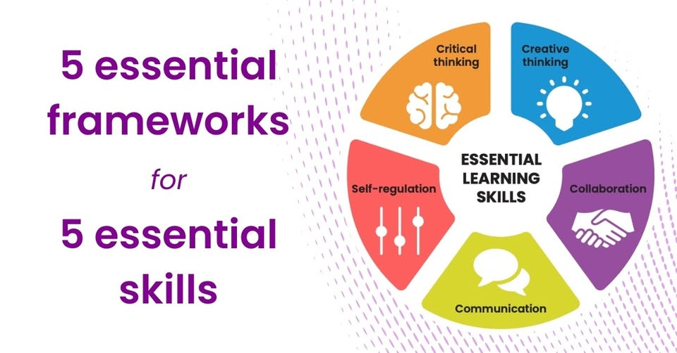Figure:2 Essential academic skills
These so-called power skills or employability competencies are absolutely prerequisite when it comes to our future professional activities. The large ones are time management, problem solving, and communication. Employers desire individuals who are able to recover after failures and those who are self-motivated. Applying such tools as AI or Trello is extremely convenient when it comes to keeping on schedule and being productive. These skills are movable and this means that you can apply them in any job and firm. Studies indicate that individuals having necessary competencies in a high degree will succeed in life and earn more income. With help of polishing these abilities at school and at work, you can become an employee of the first rank and contribute to the prosperity of the company. Also, these abilities are the foundation in which you can translate all your technical knowledge in any work place [2], [3].
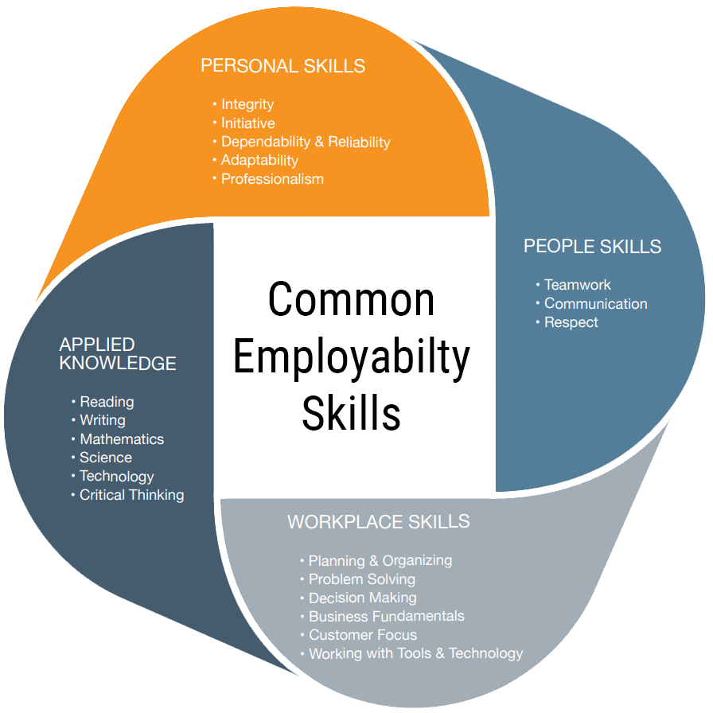
Figure:2 employability skills [4]

Task 1 (b): Evaluation of Task 1 (a) based on Similarity report
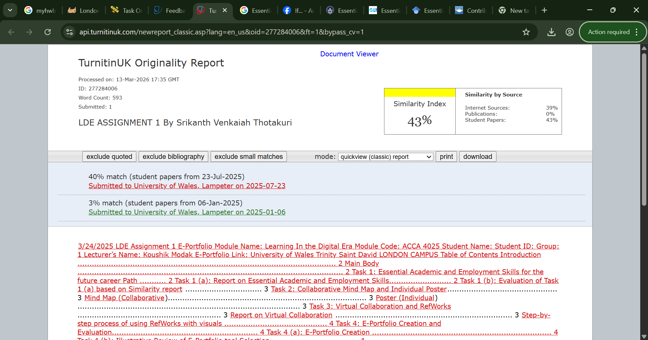Figure:3 Report
Writing skill rating and improvement
I understand that effective communications of my technical concepts in my computing classes means that I need to work on my writing abilities. I am able to sum up major ideas and retain it in a formal manner, although I occasionally face the problem of word repetition and small grammar problems. I intend to use editing tools and to develop the habit of using different sentence structure that will ensure that my writing is as precise as systems I am creating. By thickening those pieces, I will become more successful in making a case to professors and future employers. I would have graded this draught at about 69%.

Task 2: Collaborative Mind Map and Individual Poster

Mind Map (Collaborative)
Mind map link: https://mm.tt/map/3952803597?t=pruh6bcFFH
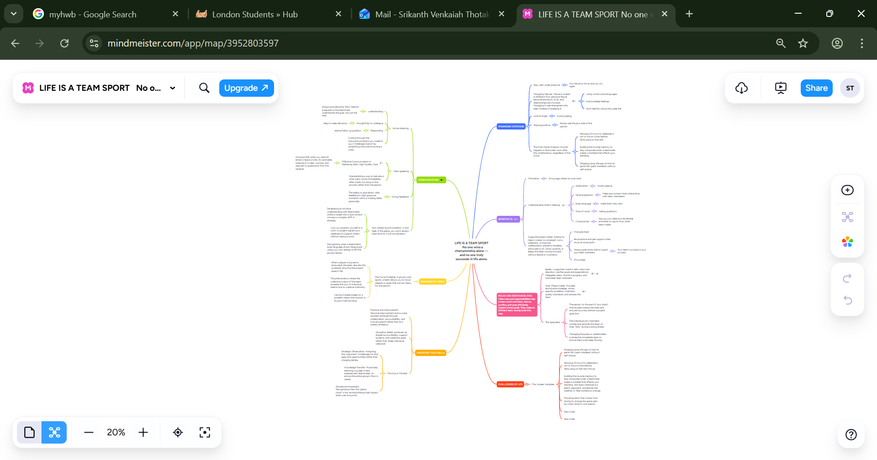Figure:4 Mind map

Poster (Individual)
Poster link: https://www.canva.com/design/DAHD8HgJh0k/qQvfL5e-007p_F8xt4nPUQ/edit?utm_content=DAHD8HgJh0k&utm_campaign=designshare&utm_medium=link2&utm_source=sharebutton
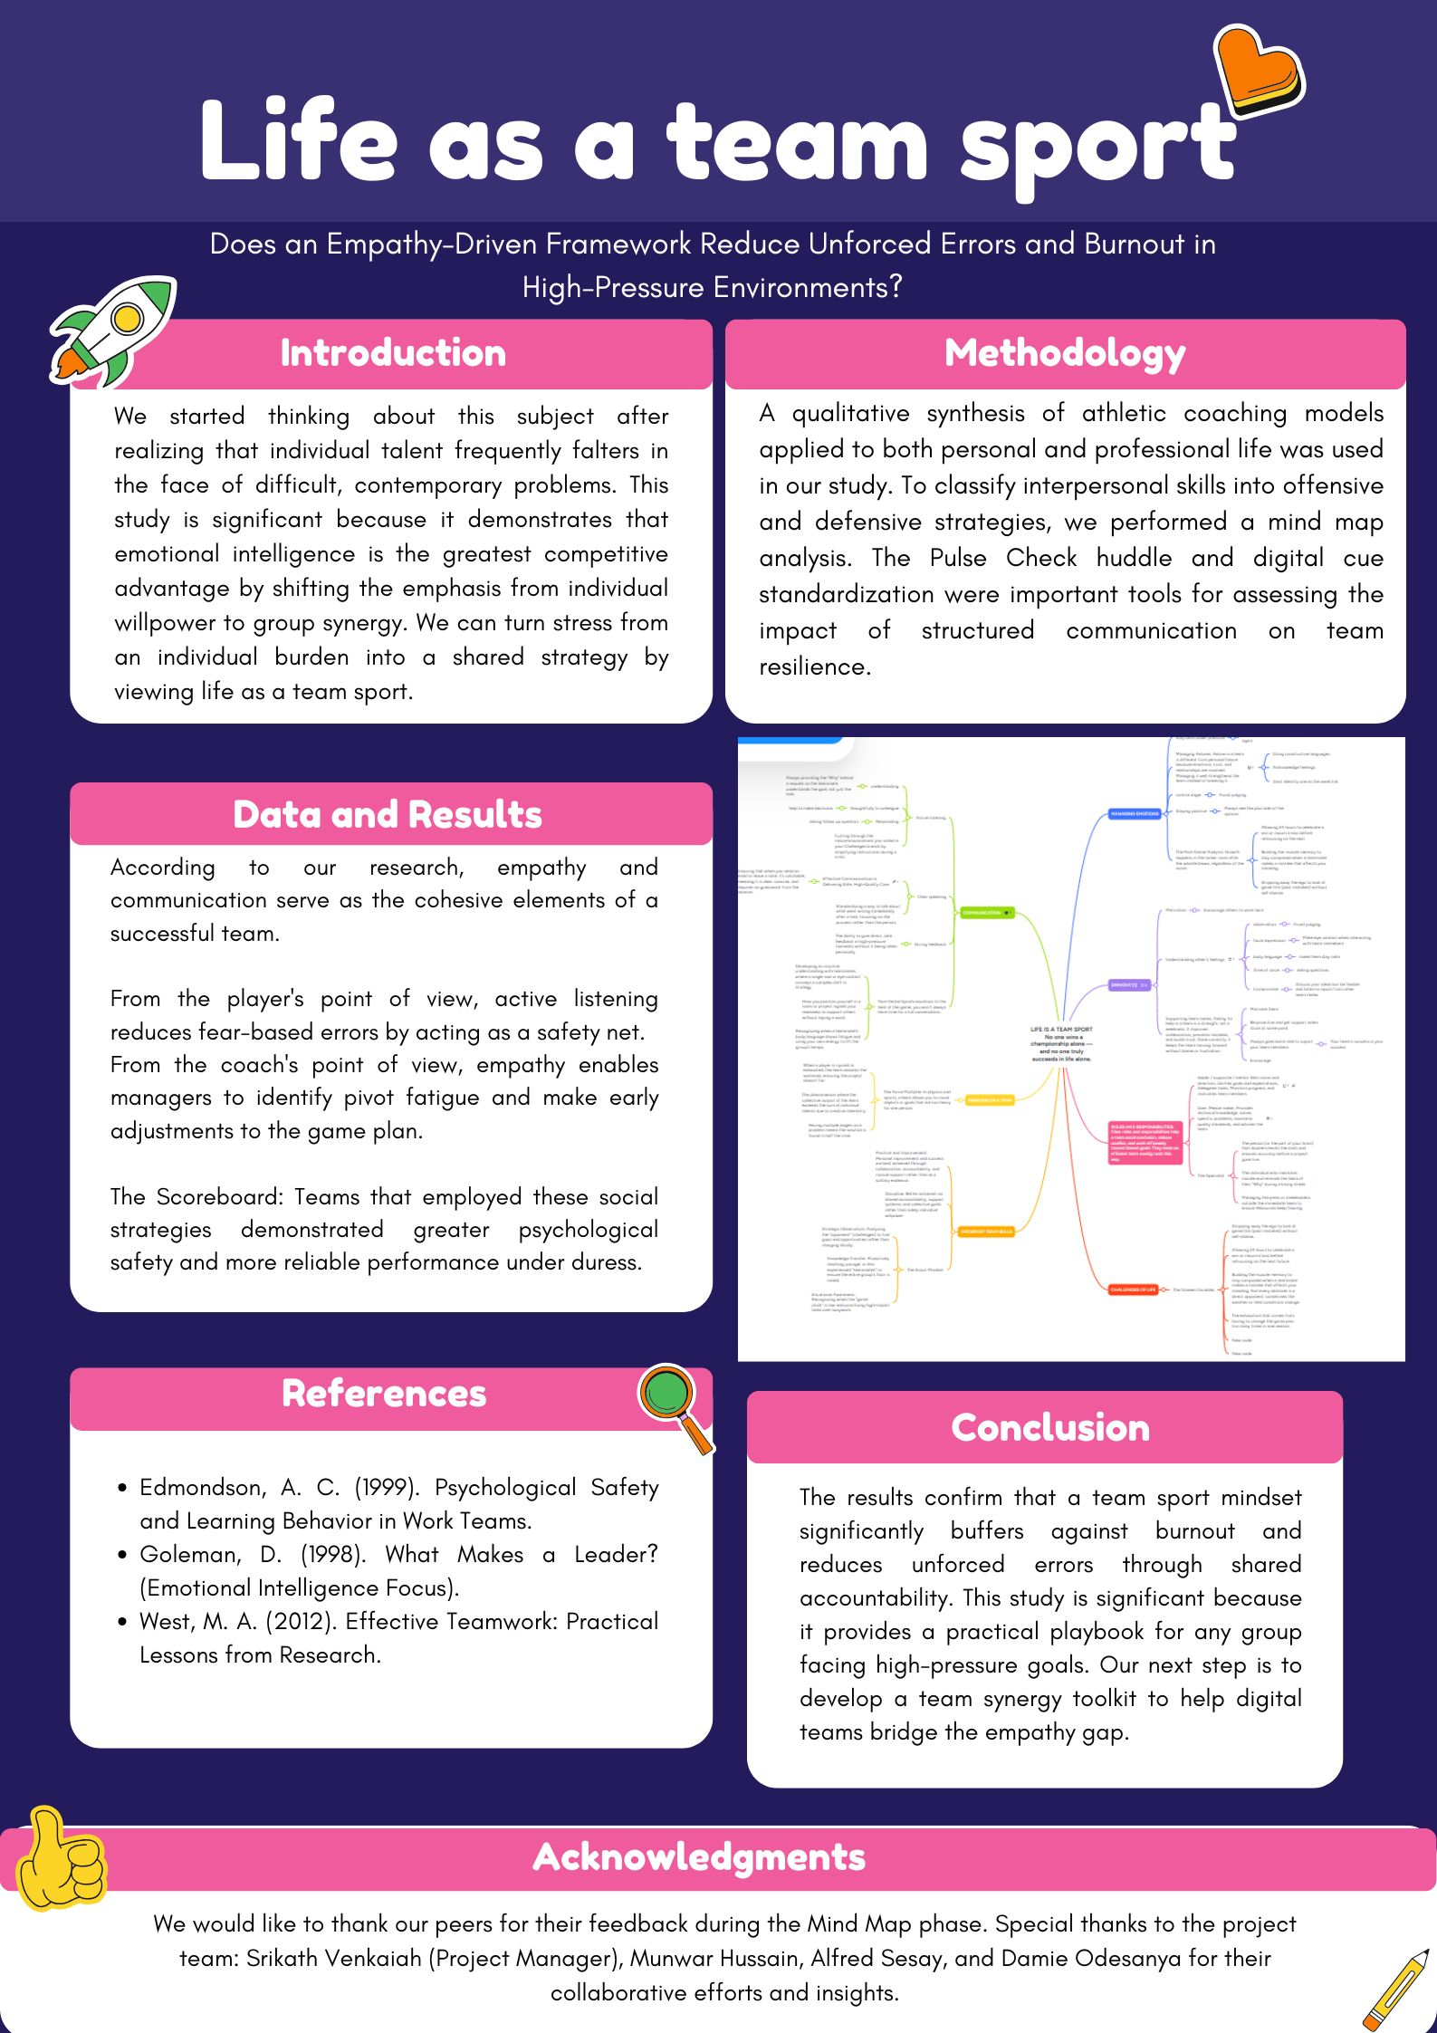Figure:5 poster

Task 3: Virtual Collaboration and RefWorks

Report on Virtual Collaboration
The New Norming
Srikath, Munwar, Alfred, Damie, and I have finally overcome the storming phase of the group into the norming phase. It is in that Group Dynamics lecture that Professor Lee mentioned that this is the critical point in which we begin to actually respect the authority of the boss, squash our beef and begin to see the strengths in each other (Tuckman and Jensen, 1977). It is simply when we cease to play a game as detailed soloists and set down a common playbook to our collective sport endeavour[1].
The only thing that is keeping this stage intact is compassion and communication. We have been applying the Kim Scotts module of Radical Candour framework in our business communication subject to be able to send out truthful remarks without necessarily being polite. Radical Candour entails the ability to confront each other at all costs yet remain personally caring (Scott, 2017). It provided us with a good language on the feedback loops that we traced on our mind map. That way when I who am the project owner or anyone of us unleash constructive criticism, it does not sound like an attack but rather a helpful kick to us to make up any ways we may be making errors[2].
Added to that, there is the factor of psychological safety, courtesy of the research by Amy Edmondson that we witnessed during the course in organisational behaviour and that is necessary to achieve healthy norming. We have made space where all can confess about slip or slight alteration of pitch without fear of getting turned away by simply listening and getting those nonverbal expressions on point (Edmondson, 1999). Since trust has stiffened to the extent that it comforts on abrupt strategic changes, this is an alignment that reduces what we formerly whined about, pivot fatigue[3].
Step-by-step process of using RefWorks with visuals
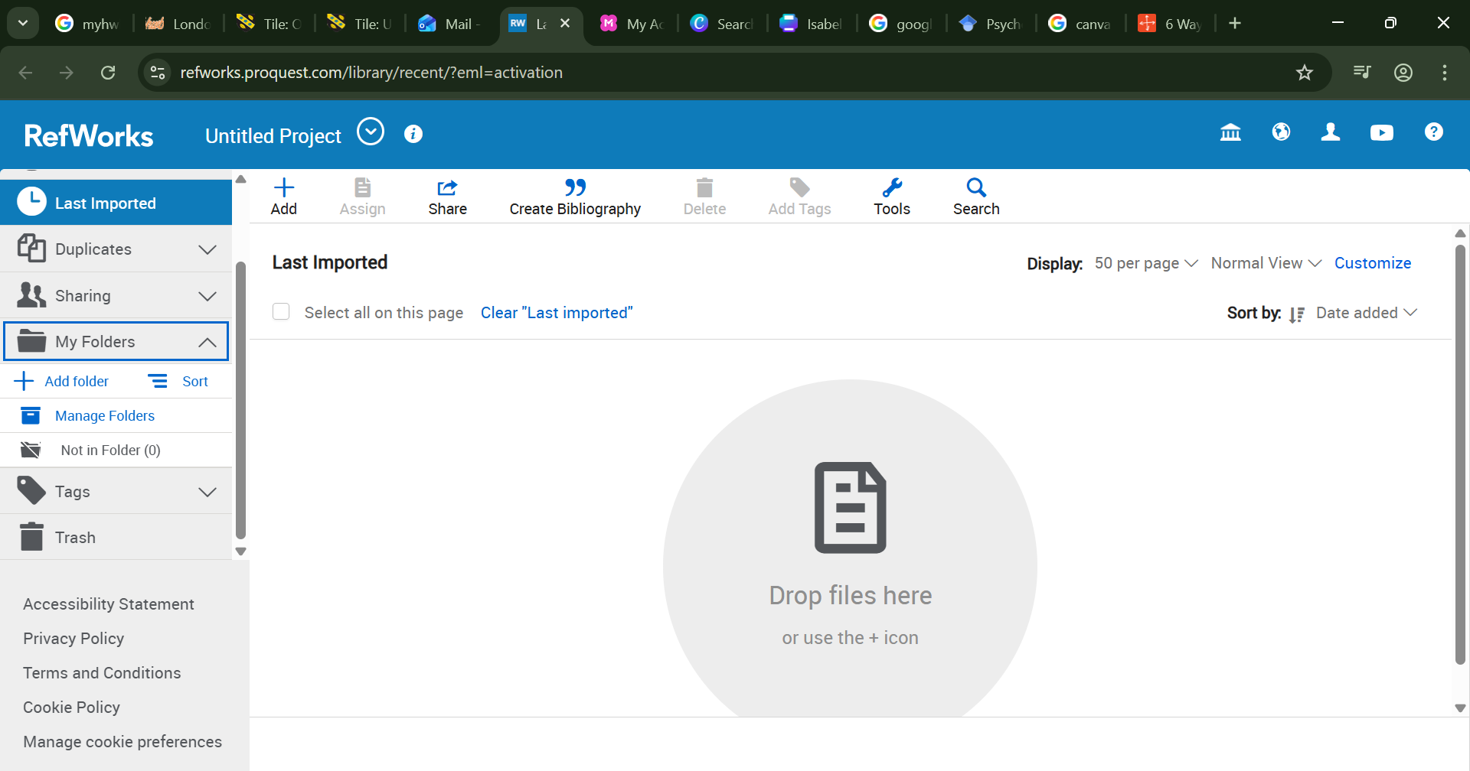Automatic reference tool (refworks) home page.

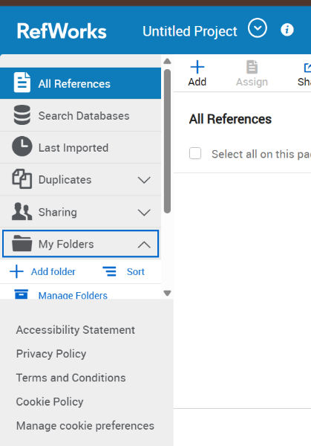
to create a folder click on my folder and then add folder.
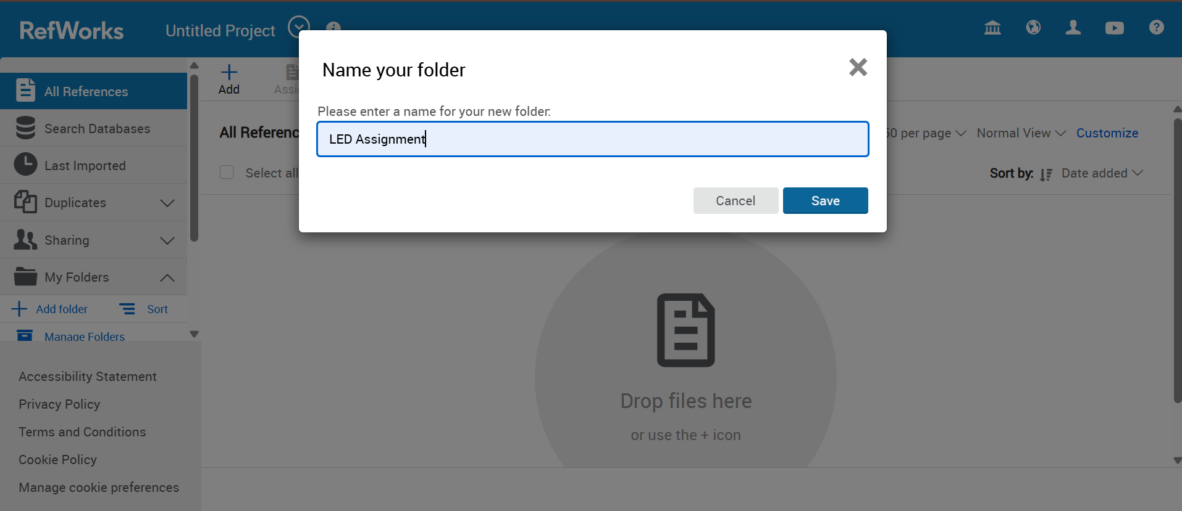write a name of the folder and save it.

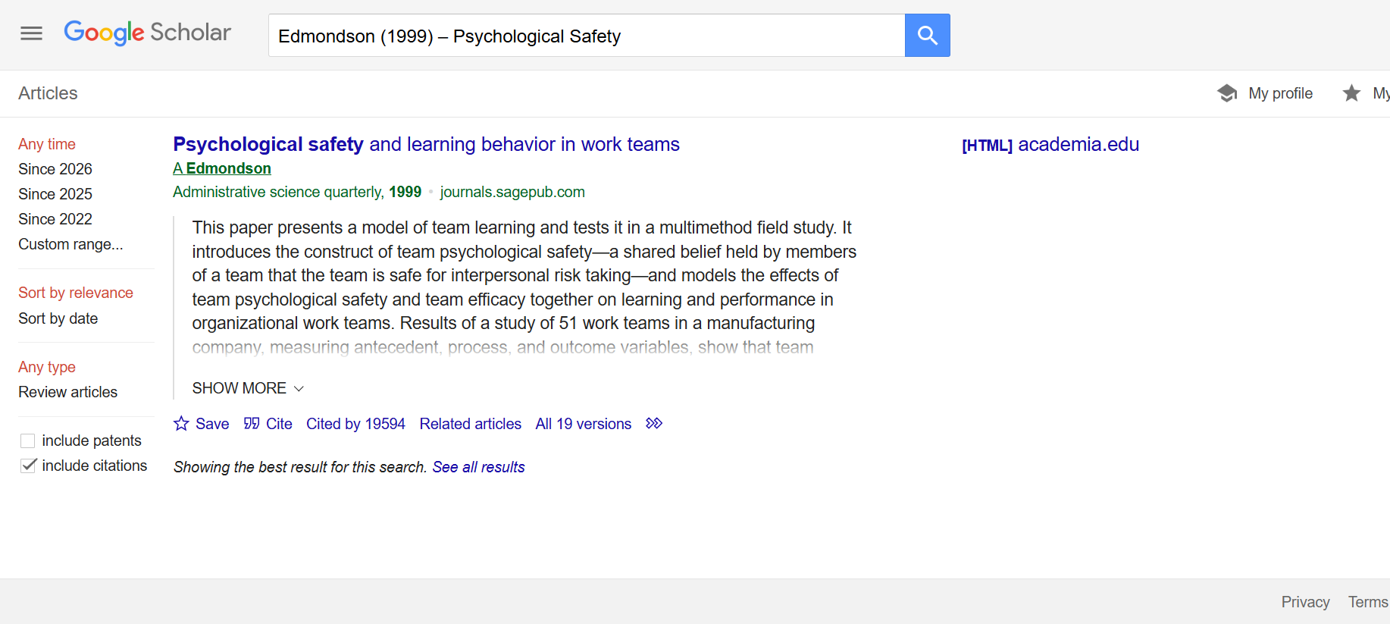search on google scholar on the bottom of the search result there is option call “cite” click on it.

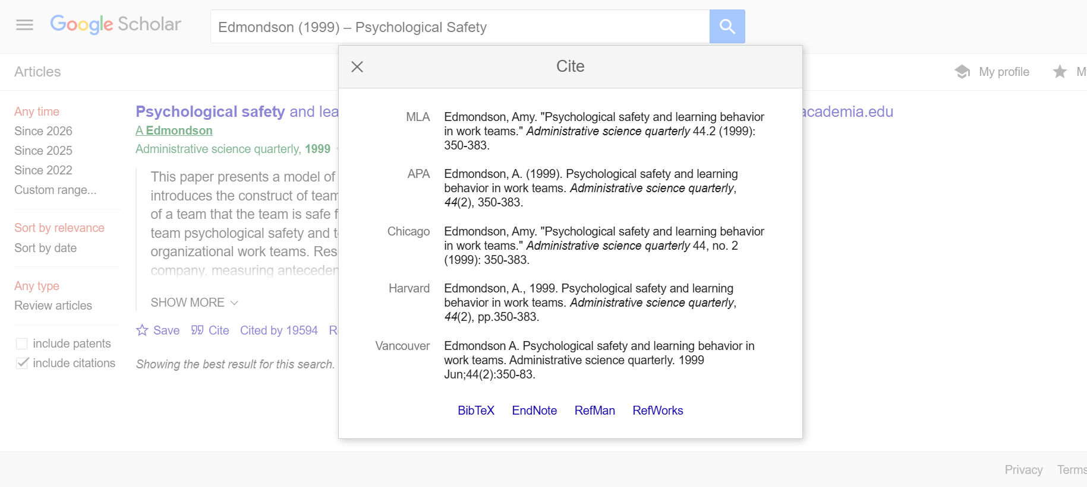after click on the cite information come up. Now click on refworks.
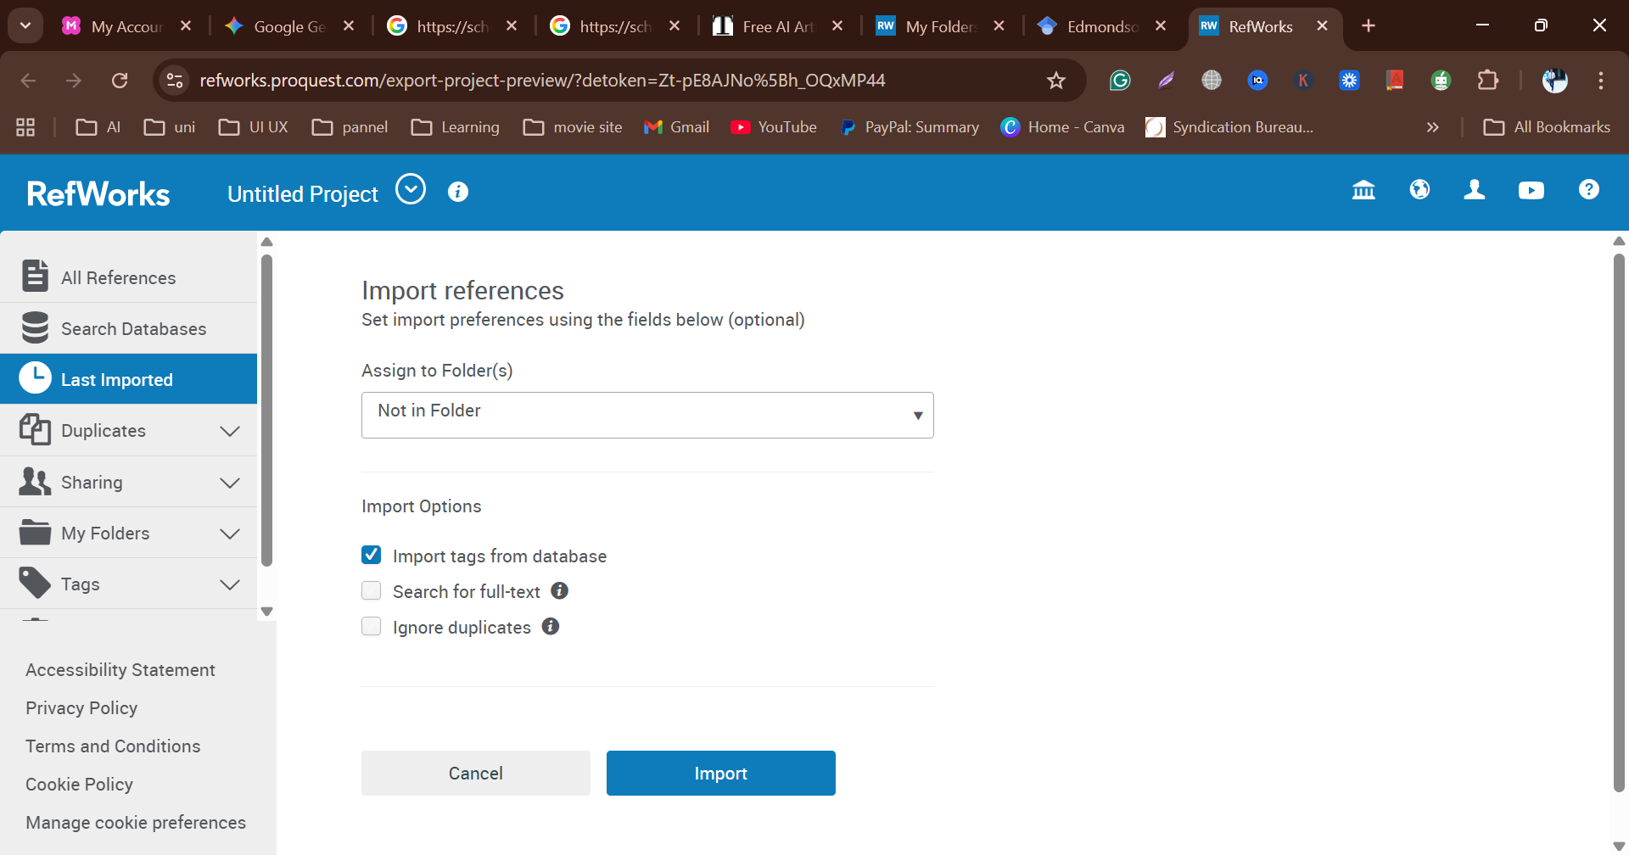to import references select the folder what I created earlier.

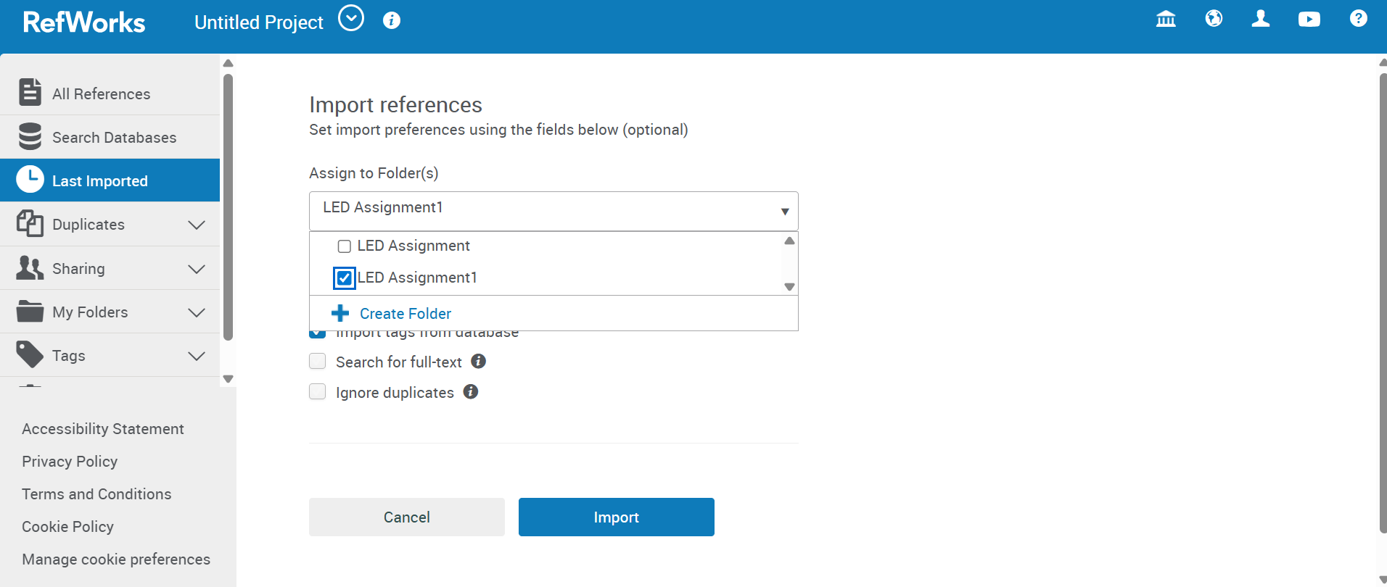select the folder by click tick and click import.

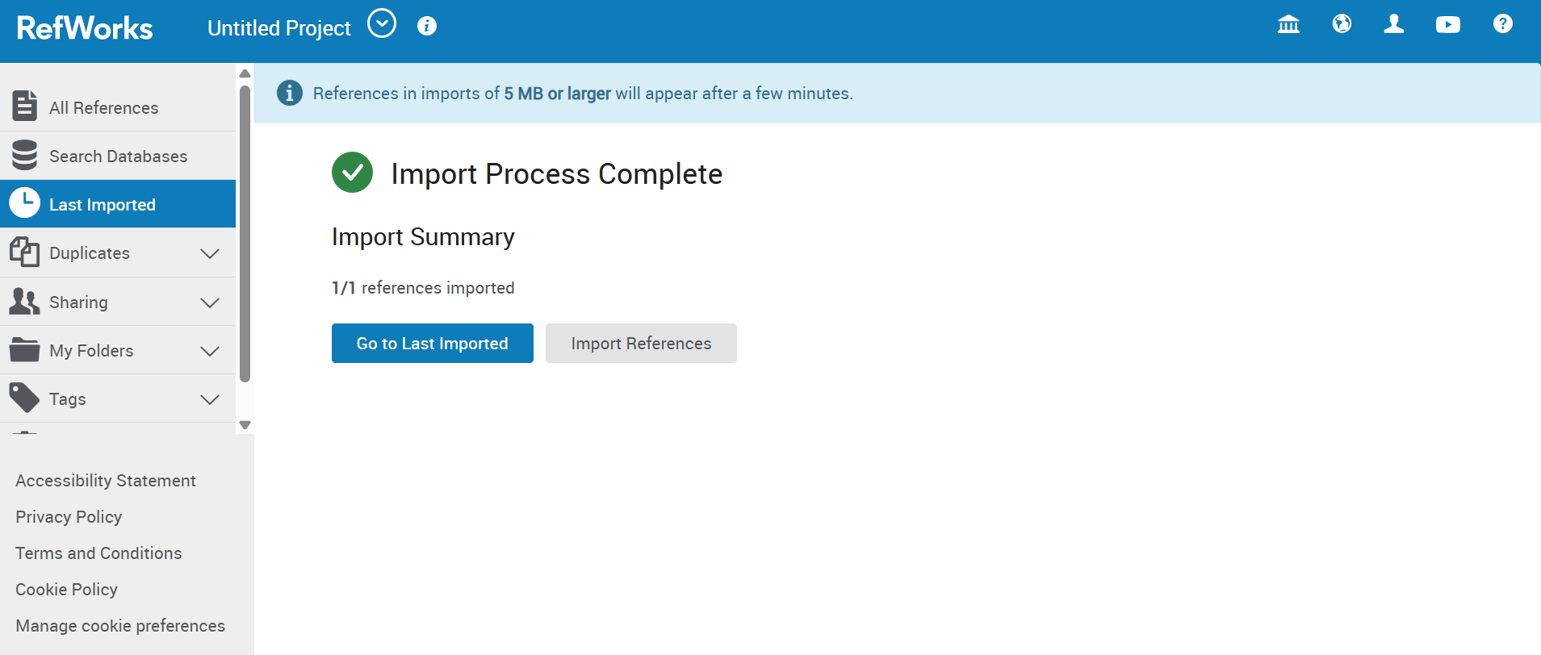when import complete click go to last imported.

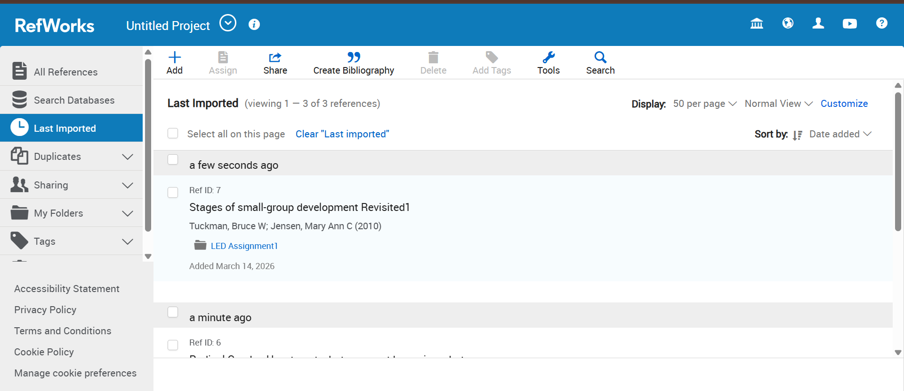here are the all imported sources.

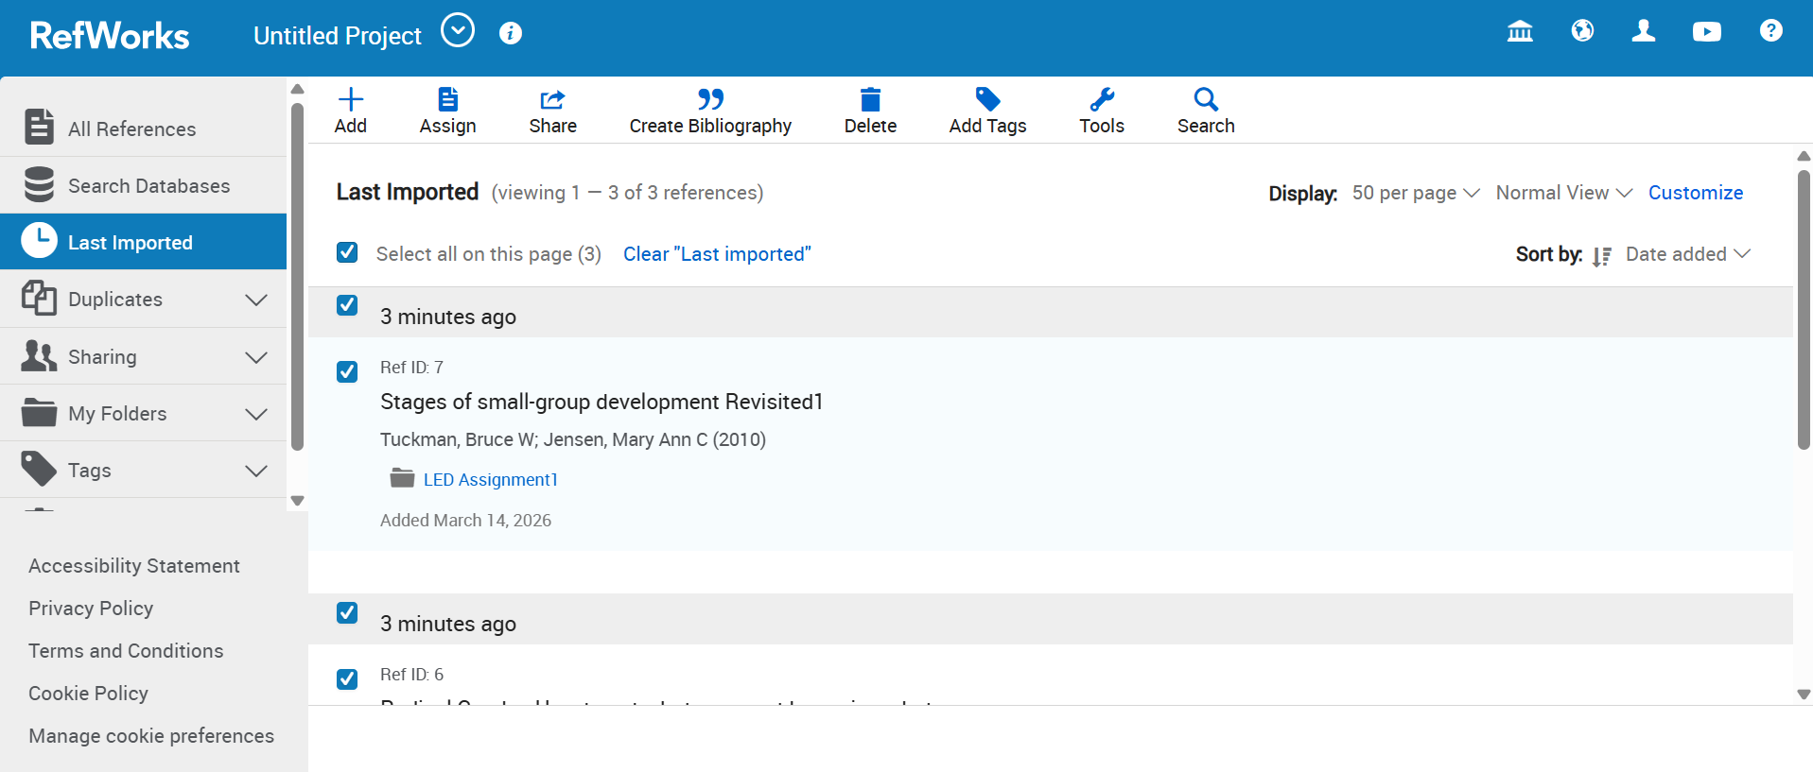to create bibliography select all the sources and click on create bibliography.

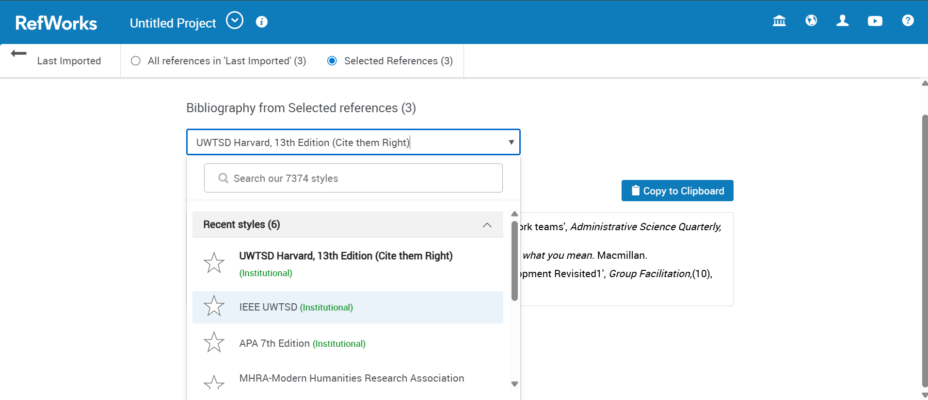I need to create bibliography and select IEEE UWTSD.

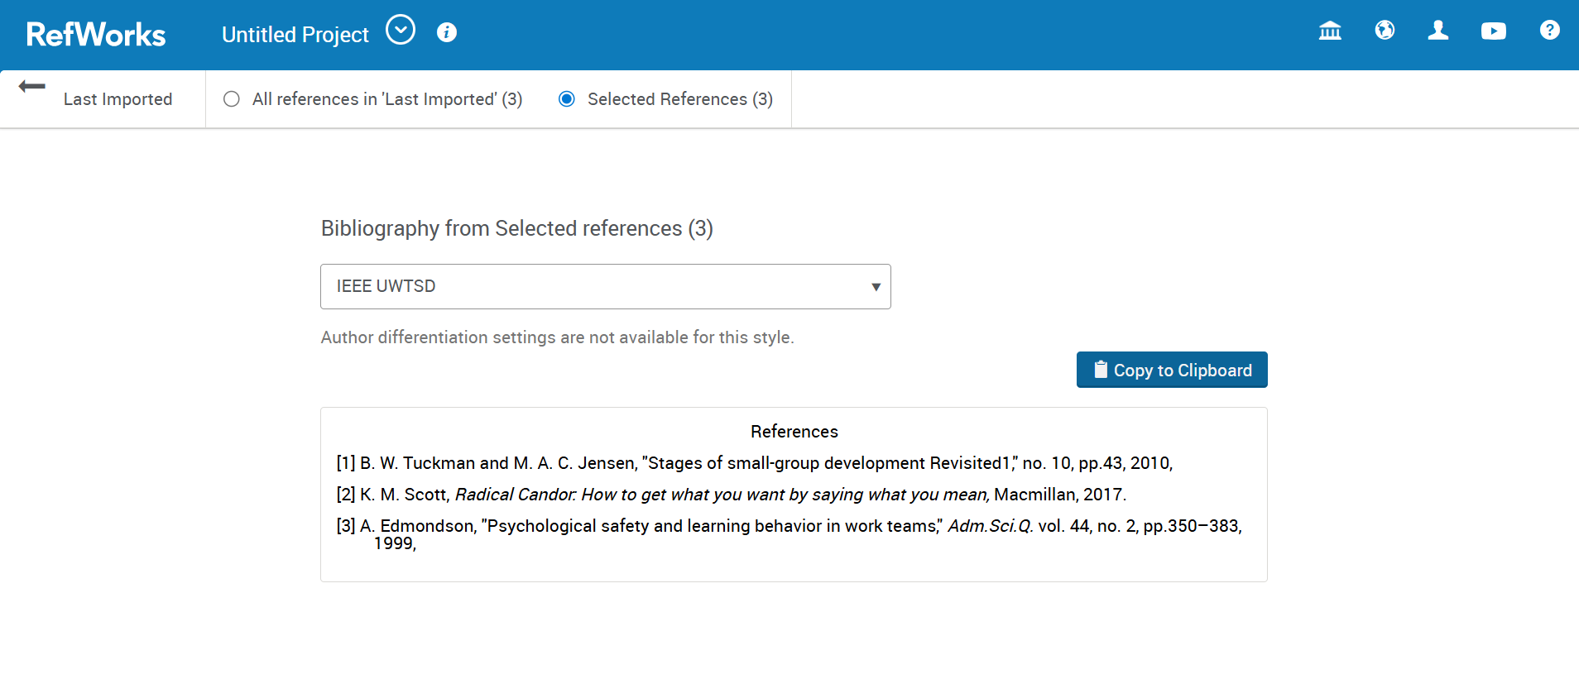than copy on clipboard.
now I have to connect refworks and MS Word. To do this create add-ins.
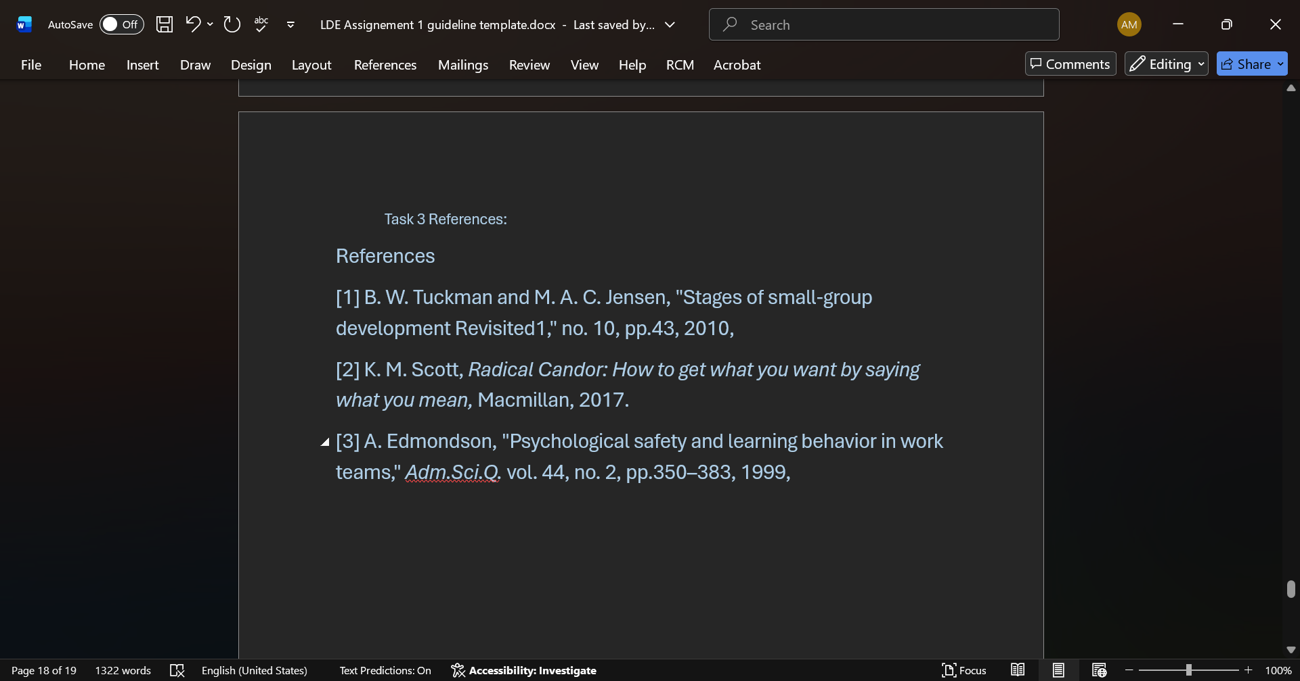past on the task 3 reference.

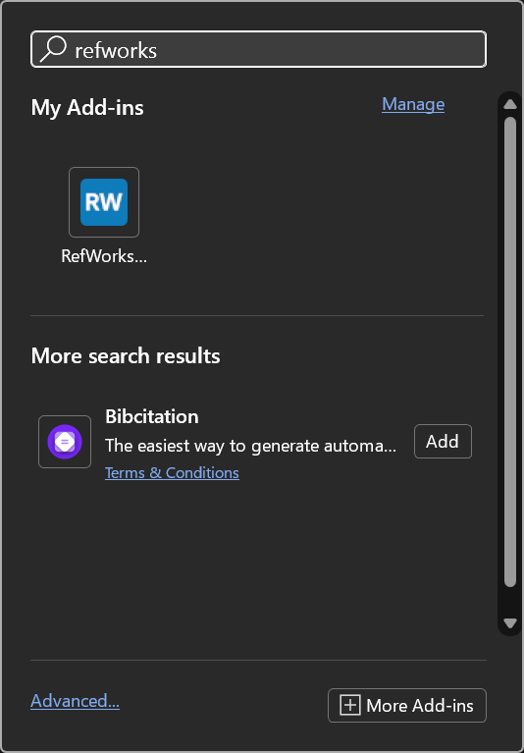 search on task bar for refworks and click on it.
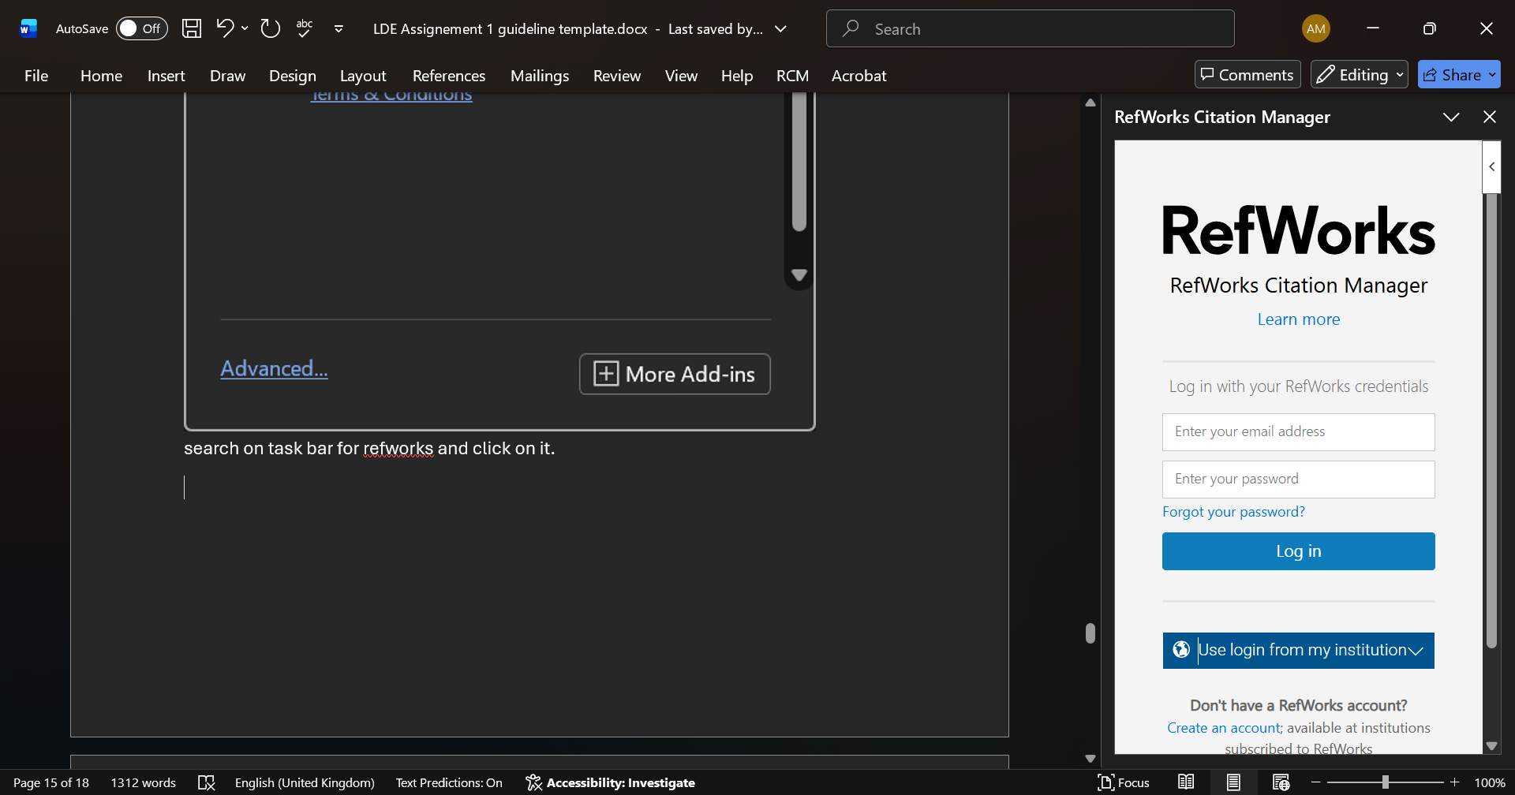now I need to log in.
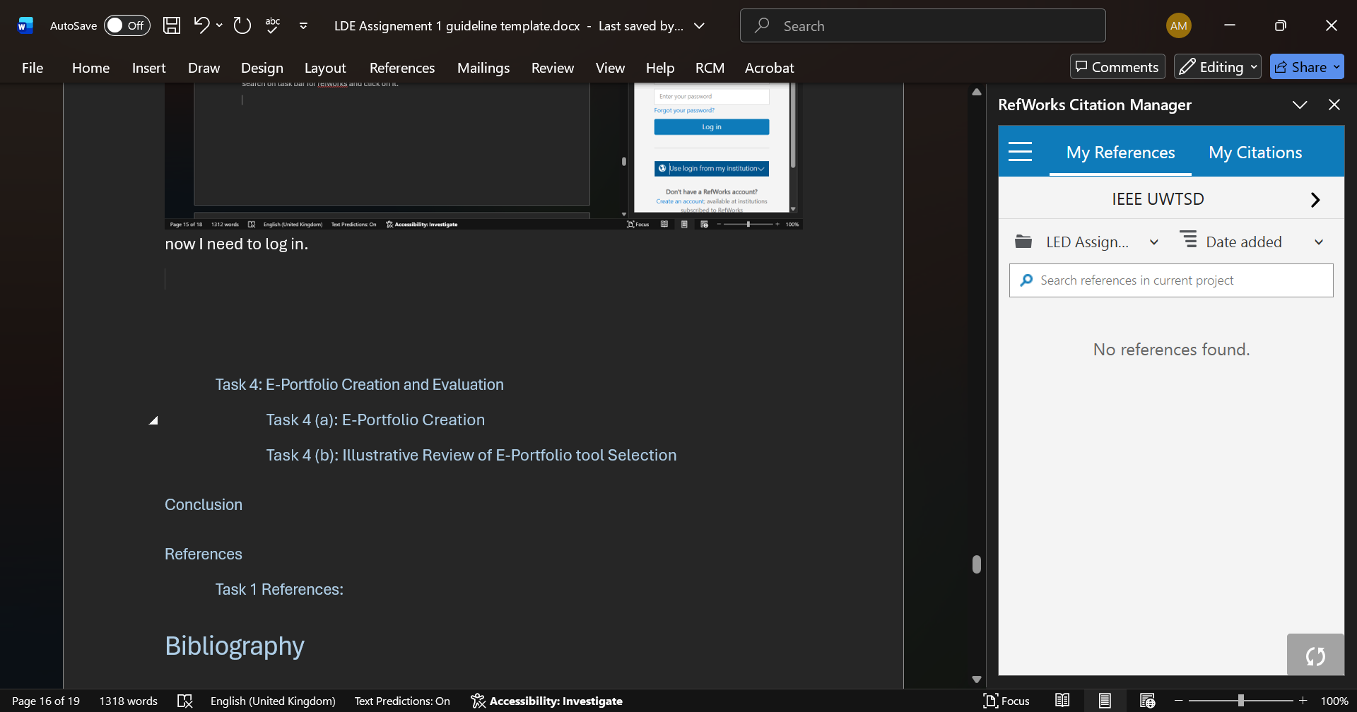click on my citation.
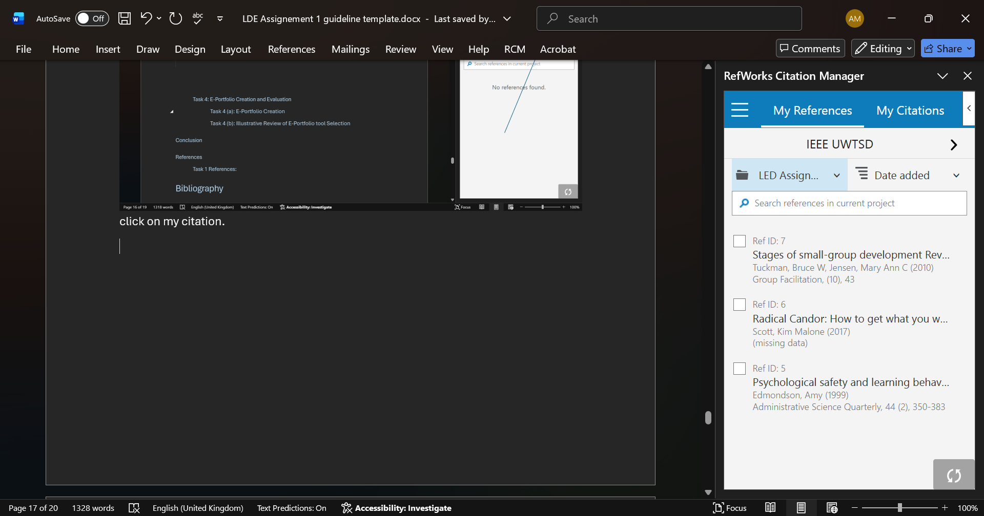here are the all sources. Now select one by one to reference paragraphs.
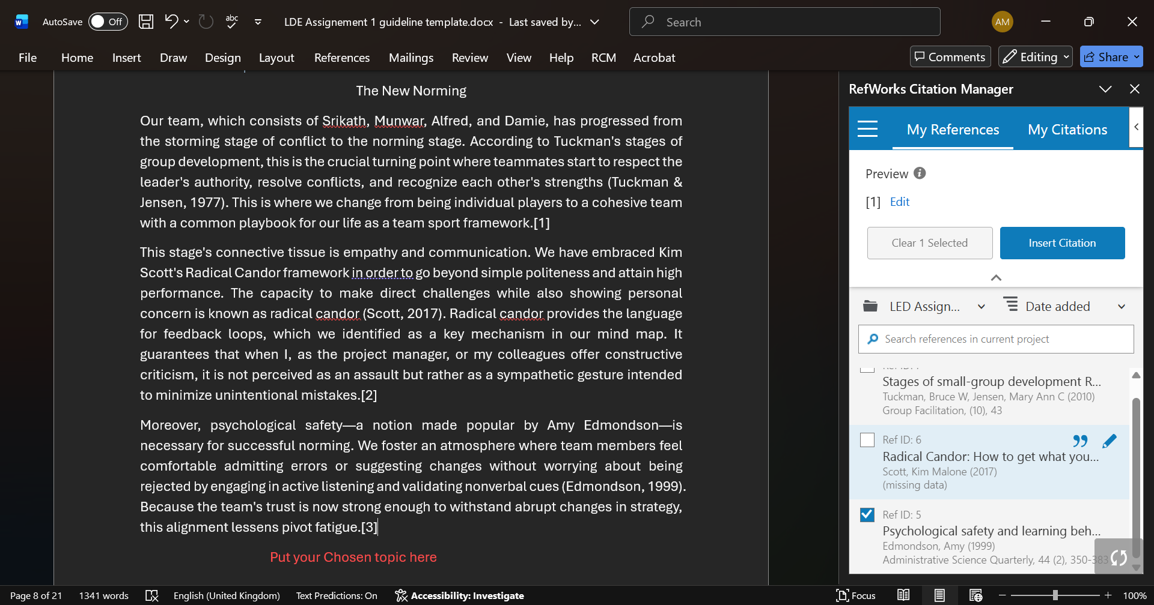after selecting the source click on insert citation, then number comes up end of paragraph.
2n Click on it
Select first

As a result we can see here numbers.

Task 4: E-Portfolio Creation and Evaluation

Task 4 (a): E-Portfolio Creation
Click here

Task 4 (b): Illustrative Review of E-Portfolio tool Selection

Conclusion
Looking back on the work that I have achieved, there is no doubt that this module has not been a mere checking off as I proceed through the assignments; it has been my actual encounter into developing my professional identity. I have learned that being flexible, establishing psychological safety, and being brutally honest really are the keys to success, both in my personal writing and in group dynamics, through the process of critiquing personal writing style and phasing through the norming stage of the group dynamics. The familiarity with the digital systems such as RefWorks has helped my workflow in research to feel much more balanced, and the group mind mapping and poster activity helped to stress the enormous advantage of collaborative work in comparison to the isolated study. In the future, my prospective career will use this E-Portfolio as my game changer as I will be in a better position to be resilient and to be productive as I move forward.

References

Task 1 References:

Bibliography

[1] | Essential Skills for Undergraduate Life: the 13 Things You Should Know How to Do Before You Go to University, 2026.
[2] | C. Dutton, “ Cumbria Careers Hub.,” Enterprising Cumbria, 27 02 2026. [Online]. Available: https://www.careershubcumbria.co.uk/employers-volunteers/essential-skills-for-employment/. [Accessed 10 03 2026].
[3] | N. n. college, “Skills for employment are crucial for the future of the workplace and your place in it, for your future.,” Skills For Employment, vol. 118, no. 11, p. 07, 2026.
[4] | Common Employability Skills Framework, National Network, 2026.

Task 3 References:

References

[1] A. Edmondson, "Psychological safety and learning behavior in work teams," Adm.Sci.Q. vol. 44, no. 2, pp.350–383, 1999,

[2] K. M. Scott, Radical Candor: How to get what you want by saying what you mean, Macmillan, 2017.

[3] B. W. Tuckman and M. A. C. Jensen, "Stages of small-group development revisited," vol. 2, no. 4, pp.419–427, 1977,

