DIGITAL SKILLS AND RESEARCH METHODS
CLASS: BMSW4003_LON

ASSIGNMENT TITLE: А РESEARCH REPORT ON THE IMPACT OF VIRTUAL LEARNING ENVIRONMENT (VLE) - MOODLE ON STUDENTS’ LEARNING EXPERIENCE AT THE UNIVERSITY OF WALES TRINITY SAINT DAVID LONDON CAMPUS

Student: Kristiyan Stanimirov
Student id: 1816841

Lecturer: Amitave Banik

2021, UWTSD

Contents

Introduction 2
1. Impact of Virtual Learning Environment – MOODLE on students’ learning experience 3
1.1. Description of Virtual Learning Environment 3
1.2. Analysis of Virtual Learning Environment 4
1.3. Summary of Virtual Learning Environment 6
2. Research on VLE – MOODLE on students’ learning experience at UWTSD 7
2.1. Description research method 7
2.2. Analysis of Questionnaire’s answers 8
2.3. Summarising of the research 12
Conclusion 13
Reference list 14
Appendix: Students’ Questionnaires 15

Introduction

A virtual learning experience (VLE) or CMS (Course Management System) has now been implemented by nearly every educational institution for use either as an alternative to its standard courses (often called a "blended" or "hybrid" course system) or as a platform for its distance education program.
Martin Dougiamas, who developed the software while studying on his Ph.D. at Curtin University of Technology, Perth, Australia, is the brainchild of Moodle (Naamani, 2012) . He created it as an instrument for his research on a socio-constructivist approach to learning. Initially, Moodle excelled in features that supported this approach to education, particularly through its very user-friendly layout of the discussion forum that includes participants' mug shots as an aid to community building. In PHP, Dougiamas programmed Moodle, a programming language (or more strictly, 'scripting') that can create web pages based on user feedback and details based on results.

Impact of Virtual Learning Environment – MOODLE on students’ learning experience

Description of Virtual Learning Environment

As an online (web-based) platform, Moodle is an open, collaborative, and object-oriented learning system in English: Moodle, acronym for the modular object-oriented structured learning environment. This is a free interactive teaching/computer learning program. An open-source course management system (LMS) or a machine learning environment is used by MOODLE (Rice, 2011).
As the platform is transparent and cleanly designed for use in adult and university education, Moodle is particularly suitable. They are a highly convenient open-source portal for uploading to your own website, which makes it possible to store almost unlimited data in terms of learning materials, be it text, video, audio and more. Figure. Figure. For lectures with multiple add-ons, Mood Leaves uses a video conferencing network. Data obtained and assessed are used for the purposes of another review, but they are useful for analysis and the achievement of the objectives of this paper. This paper complements studies carried out at Trinity Saint David University of Wales by students. The thesis has been developed for other purposes.
In March-June 2020, the main purpose of this study was to investigate the impact of distance learning on the efficacy of school education in Bulgaria, either in an electronic environment or in other lacking forms. The survey was carried out in July 2020 by 135 schools across the world. 4448 students from 5th to 12th grade were present (Kamenoposlka, 2018). A new framework tool was developed in order to assess the impact of distance learning in an automated world or in other areas that are not present. In order to define and adjust effective qualitative and quantitative thematic tools, a comprehensive analysis and evaluation of current theoretical models and observational studies has resulted.

Analysis of Virtual Learning Environment

As an online (web-based) platform, Moodle is an open, collaborative, and object-oriented learning system (in English: Moodle, acronym for the modular object-oriented structured learning environment). This is a free interactive teaching/computer learning program. An open-source course management system (LMS) or a machine learning environment is used by MOODLE (Rice, 2011). The computer does not permit the user to install additional applications under the exception of a browser to create and view the learning content. It needs the opportunity to illustrate educational tools, tests, forums for communicating with other students and instructors, etc.
As the platform is transparent and cleanly designed for use in adult and university education, Moodle is particularly suitable. They are a highly convenient open-source portal for uploading to your own website, which makes it possible to store almost unlimited data in terms of learning materials, be it text, video, audio and more. Figure. Figure. For lectures with multiple add-ons, Mood Leaves uses a video conferencing network. Data obtained and assessed are used for the purposes of another review, but they are useful for analysis and the achievement of the objectives of this paper. This paper complements studies carried out at Trinity Saint David University of Wales by students. The thesis has been developed for other purposes.

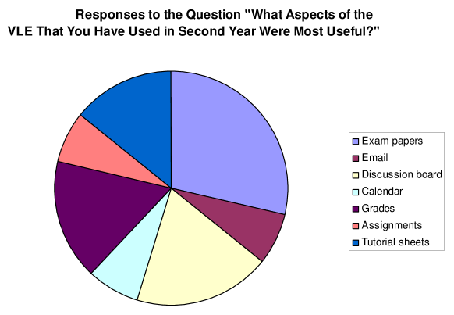
Jackson, S. and Fearon, C. (2013). Exploring the role and influence of expectations in achieving VLE benefit success. British Journal of Educational Technology, 45(2), pp.245–259.

‌

In March-June 2020, the main purpose of this study was to investigate the impact of distance learning on the efficacy of school education in Bulgaria, either in an electronic environment or in other lacking forms. The survey was carried out in July 2020 by 135 schools across the world. 4448 students from 5th to 12th grade were present. A new framework tool was developed in order to assess the impact of distance learning in an automated world or in other areas that are not present. In order to define and adjust effective qualitative and quantitative thematic tools, a comprehensive analysis and evaluation of current theoretical models and observational studies has resulted.

Summary of Virtual Learning Environment

These results make it easier for students to transition to distance learning in electronic environments to be more supportive during their learning experience for teachers in the use of ICT, and the greater passion, motivation and commitment to the learning process has easily seen and mastered the learning material. Improved student success and improved performance are associated with the more positive behaviour of one's teachers in regards to the use of ICT in the learning process. The hypothesis that teachers have an influence on the technology used during distance learning is reinforced by this (Hiscock, 2020).
The willingness of teachers to use technology to facilitate student learning technological self-efficiency of teachers, is significant with regard to the impact of distance learning in e-learning on the effectiveness of classrooms. We believe that teachers have an important role to play, particularly in the excellent working environments of distance learning in the electronic world, based on our literature review on these subjects, in their faith in their ability to work with technology and to achieve high-quality teaching (Pelet and Lecat, 2012).

Research on VLE – MOODLE on students’ learning experience at UWTSD

Description research method

In order to determine the effect of distance learning in an electronic world, or otherwise not up to date, a new paradigm approach has been developed. A detailed analysis of the existing theoretical models and observational experiments has culminated in the selection and adaptation of suitable quantitative and qualitative thematic tools:
Questions contained in the questionnaire from the student.
• The method for the assessment of internal cohesion, durability and validation of the scale shall be applied on the basis of a sampled survey.
Optimization of sizes and effect assessment.
A method analysis of observational literature and current psychometric testing tools is organized by three participation scales designed for distance learning impact tests to conceptualize three modes of engagement (cognitive, mental, and emotional). Both kinds of company. Like an endeavour, whatever.
Students may use the questionnaire to answer three questions from the population, one for yes/no, two questions that provide alternate alternatives to select from, two for graduates and three questions for free text.
The survey questionnaire for the research module, which was created and accepted by the instructor, is also included.

Analysis of Questionnaire’s answers

This search was created and conducted for the purposes of the DSR module. It was developed by the student Kristian Stanimirov, based on the instructions given by the lecturer at the University.The questionnaire begins with standard demographic questions such as gender and age. Then the fact whether the respondent uses VLE is investigated and from there the impact of VLE on students is researched.

Graph 1.
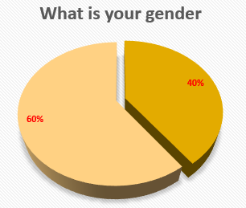
The object of the study were randomly selected students who showed willingness and consent to assist in the search. In this case, 40% of the respondents were men and 60% of the respondents were women. Usually, most students are women and a little less are men. So it can be said that this sample is relatively representative and it can be said that it is relevant and comparable to the general population.

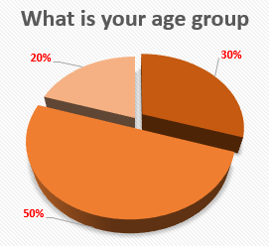
Graph 2.

30% of the surveyed students indicated that they are between 20-29 years old. The largest part, namely 50% of them, indicated that they are between 30-39 years old, but we also have 20% representatives of the group aged between 40-49 years. Here, too, we came across an average normal distribution in the sample. The answers to these two questions suggest that the survey is realistic about the answers received and their results.

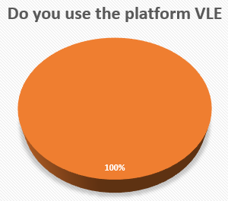
Graph 3.

If someone has answered No to this question, their survey should not be considered valid and should not be included in the answers to the overall analysis when processing the results. Here, however, we have 100% answers Yes, which means that all students use VLE.

Graph 4.
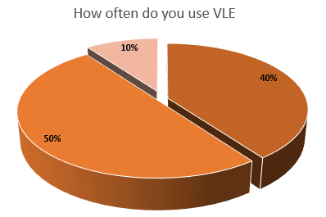
If a student has not used VLE-Moodle or has used it only 2-3 times in his / her studies so far, it means that he / she still has no real idea what the system is, how it is arranged, how it works, for what happened and how it is used. The more often it is used, the more realistic the student's idea of the platform.
40% answered that they use it once a week, 50% stated that they use it 2-3 times a week, which is logical because the lectures are 3 days a week. This means that more or less every time a student enters lectures, he also uses VLE. 10% indicated that they use the platform more often, which could be a sign of higher interest or need / desire to re-read what has been taught, review what is to come, in order to prepare for the next lecture, etc.
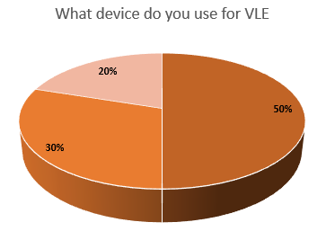
Graph 5.

50% of respondents use VLE on a tablet or mobile phone, and 30% said they use a laptop or personal computer, which means that the software is designed appropriately for different types of devices. There are also some 20% who use VLE on different types of devices. This means that in addition to flexible software, we have flexible students who know how to use different devices, in their desire to develop themselves through education, even in a pandemic, they do not give up learning, even in lockdown and distance, they spend enough of their time to absorb Moodle-based material.

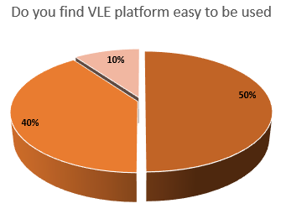
Graph 6.

It is important for the learning platform to recreate the real classroom in a way that makes it easier for your students, not to complicate everyday life or the learning process. In this regard, 50% of students state that they strongly agree with the statement that VLE is easy to use, 40% agree with it and only 10% remain neutral on this issue.

Graph 7.
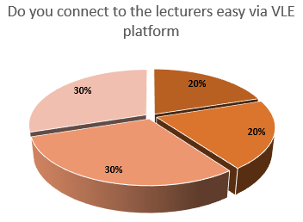
It is very important for each student to have feedback from his / her teacher when necessary, without violating the private perimeter of any of the parties, but at the same time to be effective enough, as in face-to-face training. 20% of the respondents answered that they strongly agree with the statement and another 20% that they agree on the effectiveness of communication with their lecturers. 30% have remained neutral, but there are some 30% who disagree with this statement. This indicates certain difficulties in the need for feedback from the teacher and perhaps this would be the direction in which to develop VLE.

Graph 8.

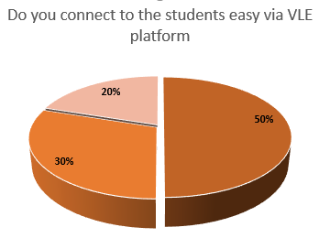
The other communication that students need is with their fellow students to work on common projects or for other learning and non-learning purposes. 50% of respondents strongly agree and 30% agree with the statement of good communication and only 20% indicated that they are neutral on this topic.

Questions that require a free answer are best in the survey because they give the respondent the freedom to indicate his or her own answer. Thus, it can be concluded that a large number of students consider the advantages of VLE that the system saves time and money for travel, the convenience to study in the comfort of your home, to reread lectures or to watch a record of such, VLE is user friendly and many other benefits. The shortcomings were technical problems that sometimes occur, the lack of effective communication with the lecturers and the lack of live contact in general.

Summarising of the research

For students, a VLE encourages them to benefit from self-paced schooling and the ability to learn new skills when taking classes without needing to drive or plan childcare. They will also get a true feeling of pride; there is still a certificate to download and print at the conclusion of Virtual College courses as a record of this accomplishment.
The rewards of a Simulated Learning Environment are also huge for students. No matter how far away they are located, they will set lessons or training classes for their students to complete all at once, enabling the instructor to work remotely if necessary, too.
A blended approach to learning will also allow them to keep their students more involved with a lesson, to spend some time focusing on specific projects and to understand the philosophy behind what they do with a VLE.
The core results of this research indicate that there is a place for VLEs in student teaching. There is a need for the incorporation into health care education of digital technologies as augmented reality, such as Virtual World in Radiotherapy, has demonstrated increase in the happiness, participation, and recall of students. It is still undetermined whether VLEs qualify students better than traditional didactic instruction, but these first observations are promising.

Conclusion

As an online (web-based) platform, Moodle is an open, collaborative, and object-oriented learning system. An open-source course management system (LMS) or a machine learning environment is used by MOODLE (Rice, 2011) This paper complements studies carried out at Trinity Saint David University of Wales by students. The main purpose of this study was to investigate the impact of distance learning on the efficacy of school education in Bulgaria. This study was to investigate the impact of distance learning on the efficacy of school education in Bulgaria. The survey was carried out in July 2020 by 135 schools across the world. A new framework tool was developed in order to assess the impact on students. Improved student success is associated with the more positive behaviour of teachers. Study was conducted by Kristian Stanimirov, based on the instructions given by the lecturer at the University. The sample is relatively representative and is comparable to the general population. If someone has answered No to this question, their survey should not be considered valid. The more often it is used, the more realistic the student's idea of the platform. 40% answered that they use it once a week, 50% stated that they used it 2-3 times a week and 10% more often. It is important for the learning platform to recreate the real classroom in a way that makes it easier for your students, not to complicate everyday life or the learning process. 50% of respondents strongly agree and 30% agree with the statement of good communication with their lecturers. The benefits of a VLE include the convenience to study in the comfort of your home, to reread lectures or to watch a record of such. The rewards of a Simulated Learning Environment are also huge for students. There is a need for the incorporation of digital technologies into health care education.

Reference list

- Hiscock, C. (2020). International Student Voices and the VLE. International Journal of Computer-Assisted Language Learning and Teaching, 10(3), pp.16–27.

- Jackson, S. and Fearon, C. (2013). Exploring the role and influence of expectations in achieving VLE benefit success. British Journal of Educational Technology, 45(2), pp.245–259.

- Kamenoposlka, T. (2018). Organization and Management of U.S. Education- School Level. Педагогически форум, 6(3).

- Naamani, C. (2012). It is not just about the Technology: A Large Scale Implementation of Moodle as a VLE across Schools in. International Journal for Digital Society, 3(4), pp.714–719.

- Pelet, J.-E. and Lecat, B. (2012). Virtual Worlds as the Next Asset of Virtual Learning Environments for Students in Business? International Journal of Virtual and Personal Learning Environments, 3(2), pp.59–76.

- Rice, W.H. (2011). Moodle 2.0 e-learning course development : a complete guide to successful learning using moodle. Birmingham, U.K.: Packt Publishing Limited.

Appendix: Students’ Questionnaires

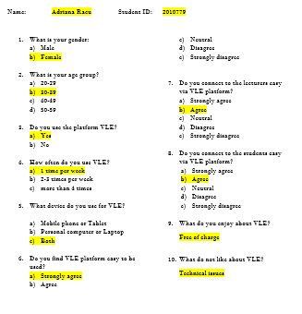
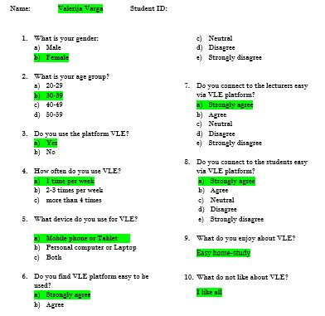
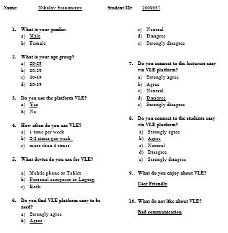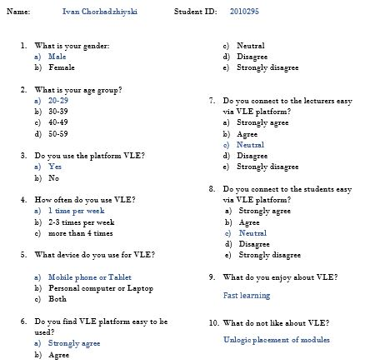

 | 1 | 2 | 3 | 4 | 5 | 6 | 7 | 8
Nikolay Stanimirov | a | a | a | b | b | b | d | b
Ivaylo Tabandzhov | a | a | a | a | c | a | c | a
Nurhayat Sadak | b | b | a | b | a | b | d | c
Elizabet Georgieva | b | b | a | b | b | b | d | b
Dimitar Sokerov | a | c | a | b | b | c | c | a
Valerija Varga | b | b | a | a | a | a | a | a
Ivan Chorbadzhiyski | a | a | a | a | a | a | c | c
Adriana Racu | b | b | a | a | c | a | b | b
Ivelina Draganova | b | b | a | c | a | a | b | a
Mariya Delieva | b | c | a | b | a | b | a | a

 | 9 | 10
Nikolay Stanimirov | User Friendly | Bad communication
Ivaylo Tabandzhov | easy to learn | slow disscusion with lecturers
Nurhayat Sadak | develop my IT skills | missing live contact
Elizabet Georgieva | Save travel expences | nothing
Dimitar Sokerov | Easy to organize studies | I like everything
Valerija Varga | Comfortable from home | Errors
Ivan Chorbadzhiyski | Fast learnin | Unlogic placement of modules
Adriana Racu | Free of charge | Technical issues
Ivelina Draganova | Saves time | All good
Mariya Delieva | Home learning | I like it

