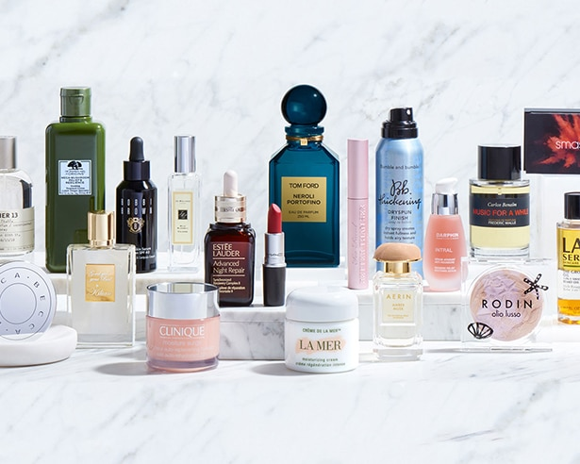


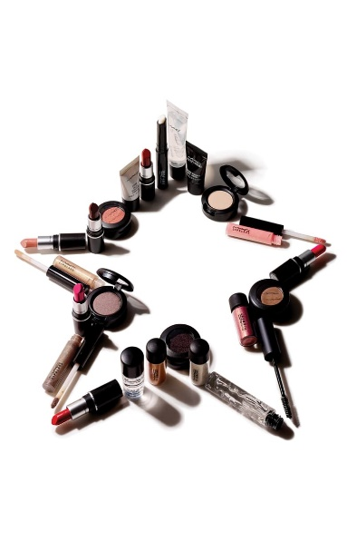




REPORT

Marketing fundamental A2
The Estee Lauder Company in
Global Marketing of Luxury Beauty



Prepared to: Dr. Tushara Balendran
Prepared by student: Reneta Ivanova
Stud. Number: 1906323



TABLE OF CONTENT

- The role of marketing in creating value for customers…………3
- Marketing concept…………………………………………………3
- Advantages of marketing to consumers……………………………5
- Advantages of branding and state how this creates value for customers…………………………………………………………..6
- The Ansoff matrix strategies could also create value such as product development, or diversification……………………………………7
- Relationship marketing at company……………………………….8
- Stakeholder engagement and their impact on the marketing activities of an organization……………………………………10
  - Stakeholders at Estee Lauder company……………………….10
- Internal Stockholders……………………………………………..11
- Employees and managers……………………………………...11
- Connected Stockholders………………………………………….12
- Distributors……………………………………………………13
- Retailers……………………………………………………….13
- Customers……………………………………………………..13
- External Stockholders…………………………………………….13
- Government……………………………………………………13
- Press media……………………………………….……………14
- Conclusion……………………………………………………….15
- Recommendation………………………………………………..16
- Reference………………………………………………………...17

- The role of marketing in creating value for customers.
- Marketing concept
‘’Marketing concept: the achieve of corporate goals through meeting and exciting customers needs and expectation better than the competition. To apply this concept, three conditions should be meet: customer orientation, integrated effort and goal achievement.’’ said David Jobber and Eliss-Chawick, Principle and practice of marketing, seventh edition, 2013.
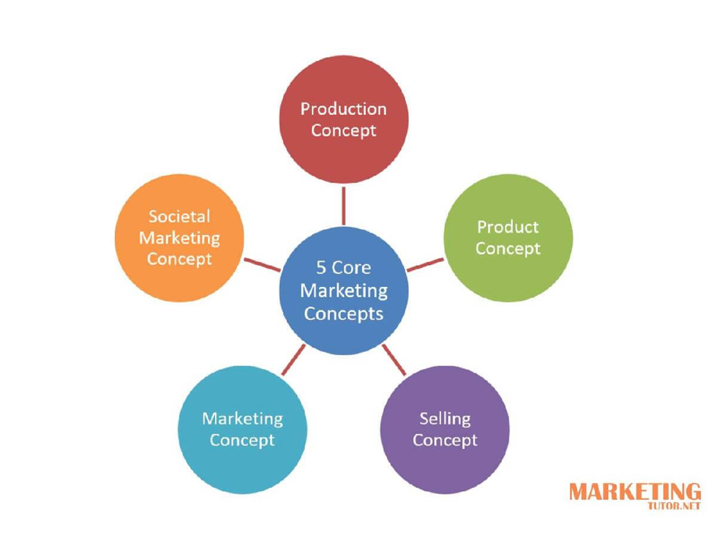
Fig 1.
- How does company use marketing strategies and add value to new customer?
Estée Lauder is a highly valued company by its customers, and the company achieves this goal by focusing on good marketing strategies to promote its high-quality luxury products, as a result, in 2014 it reached 2.8 billion dollars, which is 25.4% of net sales.
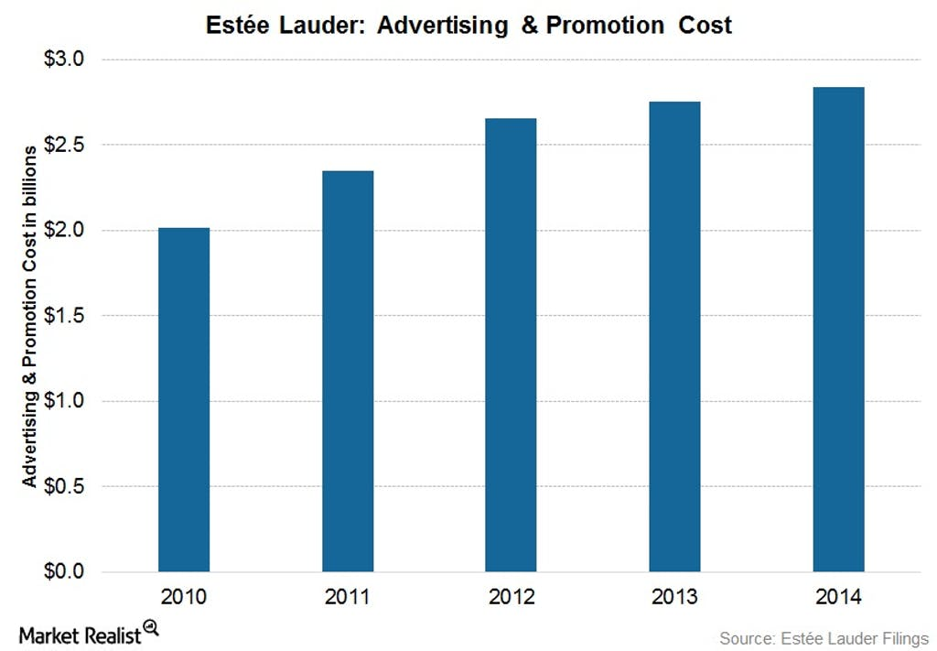
Fig 2.
https://marketrealist.com/2015/08/estee-lauders-marketing-strategies-reach-new-consumers/
Estée Lauder and his competitors L'Oréal et al. use various media, including social media, such as Facebook, Twitter; digital channels, such as television; the press, such as magazines and newspapers. The company advertises and promotes through direct mail, billboards, displaying photos in public places, and regulating media channels with editors, which is successful especially for newer brands.
One of Estée Lauder's successful marketing strategies is when the customer receives a gift. This technique affects loyal customers emotionally, they feel rewarded, but the strategy also attracts new customers. In 2015, the company provided the opportunity for each purchase of New Dimension Skincare for the customer to receive free five-day delivery of Advanced Night Repair.
The purpose of the promotions is to attract new potential customers, as each new customer receives a 15% discount on the first orders. Their clients have a huge interest in their brands, such as Clinique Consultants, Origins Guides and MAC and Bobbi Brown Makeup Artists.
Estee Lauder has an interest in partnering with key retailers to make optimal use of to satisfy consumers' preferences for online shopping. E-commerce through the way videos, testimonials and ratings give customers more interest in mobile and tablet

applications, which will help boost the company's sales and build consumer engagement.
Estee Lauder invests millions of dollars in research, and the most important thing is the opinion of customers. Their appreciation and value to the company through this prism of worldviews from different cultures, communities is paramount as the company focuses on constant innovation that makes it competitive.
- Advantages of marketing to consumers
The building of the brand and the company is due to innovation and passion, which is the basic concept of the founder Estée Lauder that everyone can be beautiful. The company provides its customers not only with a product for their care, it gives them something more, such as confidence with the highest quality.

Their most important motive and the engine is customer satisfaction, so they innovatively anticipate the desires of consumers by using the latest technology. They invest in maintaining the stability of brands and their progressive development, as each process is under strict control and monitoring from product development, packaging, design and sampling, to sales, marketing and merchandising. Their aim is to look through the prism of customers and what they would like and what they would not, and the analyzes provide them with useful information about innovative approaches that the customer will evaluate through their brands.
The main focus of the company is the use of revolutionary products, and the results after use by consumers are visible and remarkable, with sensory aspects of the skin, and the main goal is for the customer to feel the benefits and effects.
The company invests a huge investment in modern technologies for researching new products, providing the best quality with high standards for customer safety.

Estée Lauder's focus is on fostering innovation, and this has an impact on the user experience and emotions, both online and offline.
They take innovative approaches, one of which is by creating the Estée Lauder Consumer Excellence Center, where consumers learn about their products, which centralizes consumer education and insight into what is best for them, and the company receives data from a diverse range. users and apply what you teach. the company, which makes it competitive.
- Advantages of branding and state how this creates value for customers
‘’Branding is the process by which companies distinguish their product offering from the competitions. By developing a distinctive name, packaging and design, a brand is created. The marketing task is ensure positive association between the chosen positioning objectives, the product and the brand.’’ said David Jobber.
Development skills are essential to developing products of their brands, in accordance with the use of the most appropriate formula or concept to satisfy even the most demanding consumer, regardless of age, culture, or ethnicity.
The development of branded products is independent and this is not a marketing function. Rather, it occupies an identifying role in the company, making it a rare application in the beauty industry. The development of the brand's products cooperates with research and development, corporate innovation, packaging, as well as with the teams of the global brand to develop a number of luxury products for consumers, without which they can not live and are part of their daily lives.
The world-famous brand Estee Lauder provides significant value to its customers with the success that today the company is an established name in the cosmetics industry and the reputation for providing the market for reliable high-quality products.
The company's products have a wide range of distribution and accessibility, through global sales channels, serving customers in Asia, America, Europe, Africa, the Pacific, and the Middle East.
The company invests significant amounts of money in research and development to develop innovative products that satisfy the desires of its customers.

The last decade has seen an increase in demand for cosmetic products for protection and aging in cosmetic markets. The company applies new and innovative
technologies and a huge number of qualified staff to provide the most personalized care with the best effect on the beauty of its customers. Consumers associate the company with the unique value of the brand, in which customers feel the benefits of high-quality Estee Lauder products.
- The Ansoff matrix strategies could also create value such as product development, or diversification
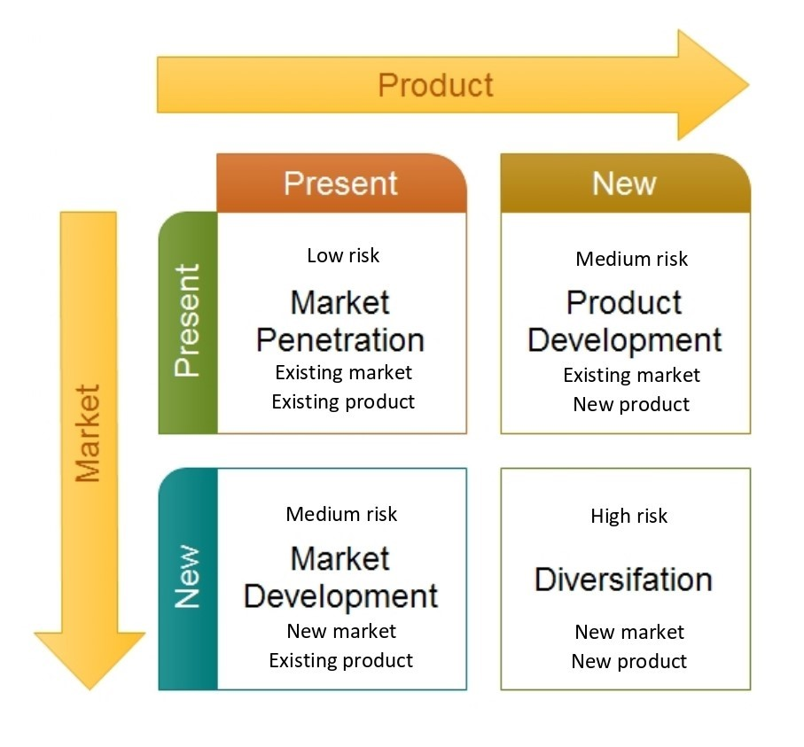
The goal of any business is to grow, for example, for a start-up or an already established market leader that has the desire to increase profitability. To the question "How does a business decide the best growth strategy?" A solution is offered with Ansoff Matrix, which is an important management tool and can predict the level of risk-taking into account according to our choice and the expected result for growth through existing or new products in existing or new markets risk-taking into account according to our choice and the expected result for growth through existing or new products in existing or new markets.
To show the stability and legitimacy of Ansoff's Matrix, it is attached to Estee Lauder, one of the world's most famous luxury cosmetics brands and a company operating today in more than 130 countries; and a brand that has implemented countless development and growth strategies in its history.
Fig 3.

- Market Diversification:
The market diversification strategy includes as creating new market line or ranges for sale in new markets. Types of diversification: vertical and horizontal diversification.
The existing portfolio is supplemented by a new category of goods produced to penetrate a new market. For example, Lauder focuses on markets in China where there are no substitutes.
Ansoff's matrix growth is applied with a strategic goal of the company that is responsible for each product in the portfolio, depending on whether the product has the necessary growth potential. The division of make-up is Market Penetration with low risk, the division of skin care is Market development with medium risk, the division of fragrance is Product development with medium risk, the division of hair car is Diversification with high risk.
Diversification is part of the four strategies of the Ansoff method and compared to the other three strategies, which usually have the same financial, technical, and commercial resources used for the original and secure product line, the company requires more skills, knowledge, techniques and equipment. significant investment when it decides to diversify.
The company invests in a global market, such as China, based on innovation, retail and digital, and it is successful because the younger generation has a preference for online sales.
- Relationship marketing at company
‘’From the more theoretical position, ideas about customers relationship lifecycles, loyalty and retention program are introduced. This is followed by a consideration, of various relationship-oriented concept, such as trust, commitment, and customer satisfaction.’’ says Paul Baines, Marketing, 2nd edition, 2011.
For understand relation marketing, it is important to understand principles of perceived value for both customers and company.
Estee Lauder provides accessibility to its products to consumers through online sales channels where customers can make purchases without interacting with members of

Estee Lauder's sales team, as well as through the company's branded store network, where customers have the opportunity to receive feedback and advice on their products for their personal care. <https://www.esteelauder.co.uk/customer-service/contact-us>
The company creates an emotional connection between their products and consumers. The relationship is extremely important, following the well-founded belief of the company's founder in creating a "friendship". Estee Lauder values ​​innovation and understands that it connects with its employees, consumers, suppliers, and retailers.

- Stakeholder engagement and their impact on the marketing activities of an organization

- Stakeholders at Estee Lauder company
‘’Marketing is a management process that seek to maximize returns to shareholders by developing and implementing strategies to build relationships of trust with high-value customers and to create a sustainable differential advantage.’’ says Jim Blythe, Principles and practice of marketing, third edition, 2014.
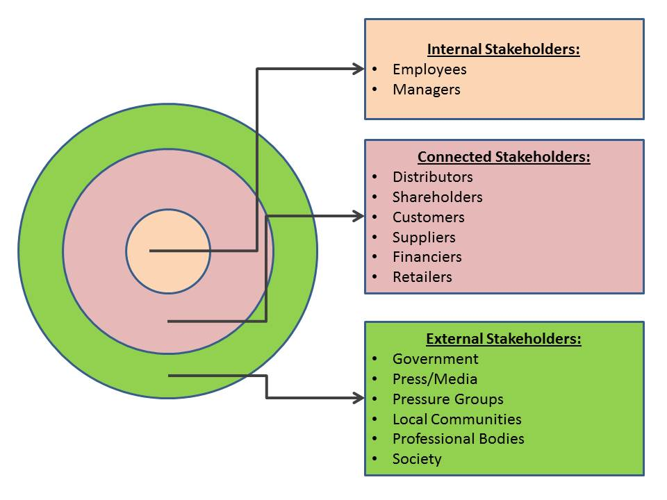
Fig 4.
Stakeholder engagement is the process by which companies communicate and get to know their stakeholders. In addition, they can improve strategies and operations by having long-term benefits, such as brand reputation.
Stakeholders have the same goal, for which they identify, research, understand, analyze issues, and problems related to the sustainability of the organization.

- Internal Stockholders

- Employees and managers
Estée Lauder employees are part of a global family that is caring and committed to its success. They strive to create a comfortable environment that supports their employees, provides them with opportunities for personal and professional development, and an inclusive and diverse culture that is also to provide them with security and safety in the workplace.
They value the different views of their employees, welcoming the talents of each person, regardless of a different culture, gender identity, gender, race, etc.
With the growth of consumers in over 130 countries, it is of great importance to continue to need a workforce that can understand the local significance and changing beauty needs of all our global consumers.
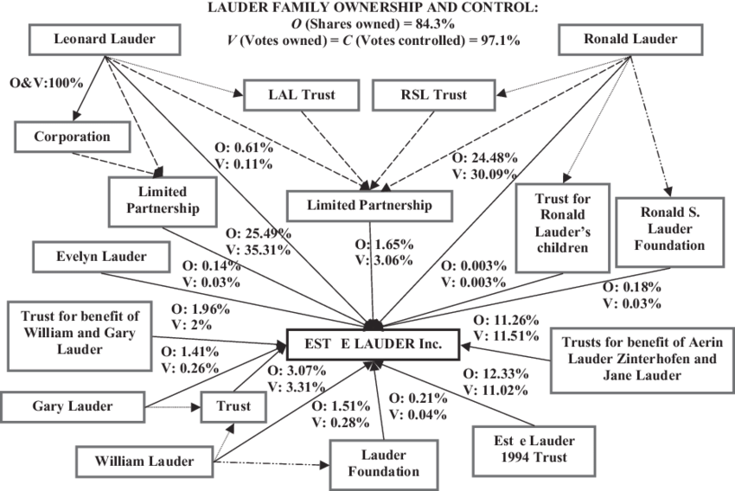
The approach to work in the company is through the pursuit of continuous training and development from their newest employees to the most experienced managers. This method of work is based on the values ​​and culture of the brand, which is committed to education, to foster creativity and innovation and to create professional leaders.
Fig 5.
<https://www.researchgate.net/figure/Estee-Lauder-Companies-Incs-ownership-structure-in-1996-O-denotes-ownership-stakes_fig6_237729990>
"Ours is a family culture," says Cedric Prouvé, Group President, International.
The company encourages its employees by investing in developing and rewarding the talented as a result of their efforts.
The company provides development opportunities and rewards for talented employees, which leads to increased productivity. Every year business meetings are held between their managers and employees and the result of the set goals is discussed. This allows employees to identify and implement their capabilities through innovation and on-the-job training.
- Connected stockholders
Estee Lauder manufactures and markets beauty and cosmetics products to a number of customers in various sizes. These customers mainly include: Distributors, retailers and general users.
- Distributors
Distributors, including wholesalers and independent distributors, who sell the company's products to retailers and consumers.
The company uses diversified distribution channels, including department stores for 2017 company from net sales 42% , retail 18% , speciality stores 11%, online distribution channels 7% and salon and spa 3%.
A strategy to diversify the supply channels of their products, how and where individual brands are sold provides an advantage of positioning for the company, and customer satisfaction.
In 2017, Estee Lauder earned 42% of its revenue from net sales from department stores or, more specifically, the direct channel.
Suppliers are global and multiple production facilities allow the country of origin to be on the same continent as the customer.

For example anti-angin products met quality specification. Lauder develop effective distribution system in India, China and Brazil.
- Retailers
Retailers based on local retail outlets such as specialty beauty stores, department stores, and pharmacies, as well as online retailers and markets.
US department store chain Macy's, which became the company's largest customer, accounting for approximately 9% of Estee Lauder's 2016 net sales.
Estee Lauder has the highest revenues in the global market in America, in particular the United States, followed by Europe, the Middle East, and Africa, and the Asia-Pacific region.
- Customers
The company invests a large percentage in the share of marketing because it understands how important it is for their business, which is the main generating value that creates a connection between consumers and the company.
Before starting to create a new product, they first develop an in-depth analysis, identifying the desires and needs of their potential customers or target group.
The company works with a strategy for vision, mission and goal to satisfy consumers through its products that meet these needs and desires at the moment. Their customers are happy with the value of their products and services for what they pay for. Accordingly, the consumer is satisfied with the product for which he has paid.
Marketing is a process that requires perseverance to retain customers and find approaches to new potentials.
- External stockholders

- Government
Estée Lauder companies maintain high standards of professional conduct and are therefore committed to being accountable to citizens in every community they serve. In order to achieve the desired results by law, they have a constant relationship with governments and abide by their rules and regulations.

The company's business has different development of their activities in different countries around the world, and one of the factors that influence is legislation and regulations. Constant communication with governments gives them the opportunity to give their views on the proposed regulation and work. Sometimes they participate and take a position on public policy issues and may affect their business, employees, or consumers. Top management monitors their political policies by periodically sending reported, most often on political contributions, expenditures, and fees.
The company has been pursuing various policy policies since 2018, making political contributions to state and local political candidates and parties in the United States.
On public policy issues, Estée Lauder works with trade organizations such as industry associations and this has a beneficial effect on their key markets.
- Press and Media
‘’Social media marketing has to be focused on using these media to help achieve your marketing objectives – both protecting and expending your brand: ‘Monitoring and facilitating customer – customer interaction, participation and sharing through digital media to encourage positive engagement with a company and its brands leading to commercial value.’’ says Dave Chaffey and Smith, Digital Marketing excellence, 5th edition, 2017.
Nowadays, we can say that companies are increasing their sales thanks to their online presence. Estee Lauder improves its sales every year through its online business not only from its own sites, but also from the sales of the sites of their authorized retailers.
A reliable channel that provides users with convenience is mobile commerce, as it is constantly available to answer customer questions.
They are strategically focused on making it easier and more convenient for the consumer to buy what they want, when they want, through their sales channels in the store and online directly.

- Conclusion
Marketing includes a number of activities such as delivery and exchange of offers and communication that have value for others. At Estee Lauder, the goal is to implement strategic marketing strategies that bring value to customers who are trying to identify satisfying and retaining their customers, both loyal and new.
Stakeholders engage in supporting a tactical and strategic decision to meet the needs of customers and the company, as they help to update the finding of information and trends that may arise in their actions. Their role in the organization is important, as each of them helps to achieve the greatest success of Estee Lauder, they support innovation and change, development, and growth of people.
Estee Lauder offers over 25 luxury brands, and their products are popular on the world market, having an identity, ethos, and point of view and purpose. Product development works very closely with the president of the global brand, Creative and Marketing, to identify the strategy of the brand that supports the business. They use their strong personal connections to the essence of the brand - which helps to ensure the integrity, exclusivity and authenticity of each brand.

- Recommendation
Estee Lauder has a good strategic approach to provide perfect customer service, without quality and synchronicity in management and staff, which makes it a different competitor in the global market.
In order to be competitive in the future, the company can analyze the external environment, further applying the value chain, also the growth model of Boston Consulting Group and analyzing the strategic plan.
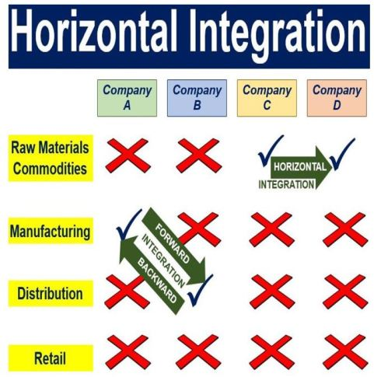
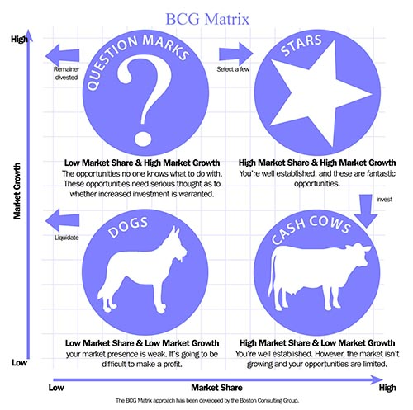
Fig 7.
Fig 6.

The recommends strategies for Estee Lauder are horizontal integration, product and market development, market-entry, and greater diversification.

- Reference

- David Jobber and Eliss-Chawick, Principle and practice of marketing, seventh edition, 2013.
- Jim Blythe, Principles and practice of marketing, third edition, 2014.
- Paul Baines, Marketing, 2nd edition, 2011.
- Dave Chaffey and Smith, Digital Marketing excellence, 5th edition, 2017.
- Announces Key Strategic Appointments to Further Expand Capabilities in Digital and Consumer Engagement, April 21, 2016,
https://www.elcompanies.com/en/news-and-media/newsroom/press-releases/2016/4-21-2016, (Accessed: July 13, 2020).
- https://www.elcompanies.com/en/who-we-are/retail-channels/in-store-experiences, (Accessed: July 13, 2020).
- Creativity & Innovation, https://www.elcompanies.com/en/who-we-are/creativity-and-innovation, (Accessed: July 14, 2020).
- https://marketrealist.com/2015/08/estee-lauders-marketing-strategies-reach-new-consumers/, (Accessed: July 15, 2020).
- Ansoff Matrix Estee Lauder, https://ansoffs.com/ansoff-matrix-estee-lauder/
- Careers at Estée Lauder Companies,
https://www.cleverism.com/company/estee-lauder-companies/, (Accessed: July 19, 2020).
- Student managed fund 2019 analyst report, https://smf.business.uconn.edu/wp-content/uploads/sites/818/2019/05/Estee-Lauder-Long-Report-Stamford.pdf, (Accessed: July 19, 2020).
- Estée Lauder’s latest campaign is a beauty digital first, https://uk.fashionnetwork.com/news/estee-lauder-s-latest-campaign-is-a-beauty-digital-first,826529.html, (Accessed: July 20, 2020).
- https://wwd.com/business-news/financial/lauders-diversification-drives-growth-11040564/, https://wwd.com/business-news/financial/lauders-diversification-drives-growth-11040564/, (Accessed: July 20, 2020).
- How Estée Lauder is rethinking consumer engagement to drive innovation, By Molly Fleming 2 Aug 2018, https://www.marketingweek.com/estee-lauder-customer-engagement/, (Accessed: July 21, 2020).

- Beauty Content Marketing, https://insights.newscred.com/beauty-content-marketing-estee-lauder-companies/, (Accessed: July 22, 2020).
- Estee Lauder, December 6, 2016,
<https://www.slideshare.net/MarissaTorrejon/estee-lauder-69861141>, (Accessed: July 19, 2020).
- Estee Lauder analysis, July 9, 2015,
<https://www.slideshare.net/KaitlynCockcroft/estee-lauder-analysis>, (Accessed: July 20, 2020).
- https://www.statista.com/statistics/267939/net-sales-share-of-estee-lauder-worldwide-by-distribution-channel/, (Accessed: July 21, 2020).

