

Online education system of spring boot and Vue

By
HaoDong He
Supervisor: Michael Dacey

Project submitted as part of the requirements for the award of
MSc Software Engineering

November 2021

DECLARATION
HaoDong He declares that I am the only author of the work and have completed the project independently. All references are cited in the article, and there is no academic plagiarism。

Signed : HaoDong He

Date : 2021/11/10

FORM OF CONSENT
HaoDong He FULL NAME HaoDong He hereby consent that my Project, submitted in candidature for the M.Sc. Applied Computing degree, if successful, may be made available for inter-library loan or photocopying (subject to the law of copyright), and that the title and abstract may be made available。

Signed : HaoDong He

Date : 2021/11/10

Absrtact
Using springboot^{[1]} + Vue^{[2]} framework, using springmvc mode to realize an online education system, designing a front-end and back-end separation system, using B2C^{[3]} business model, that is, the so-called business to customer model. The front end of the project designs a login interface and registration interface. The main interface includes some course materials that customers can browse, video learning materials related to famous teachers, etc. Customers first log in the website to the portal interface, and can click Register to register users. After registration, they can log in to the information, and log in to the main interface to start corresponding learning. The completion of the whole project is still too difficult for me. There are many functions, but I chose to complete this project mainly because it conforms to the current epidemic situation. In the process of completion, it allows me to complete the functions in detail and understand the application of Java functions more deeply. The project includes some popular technical points, such as mybatis plus, Nacos Nginx, paging query function, etc. these technical points are worth learning. In my opinion, the online education system is a very meaningful java project.
Under the current situation of COVID-19, the project is in line with the student learning environment under the current epidemic situation, and is committed to creating a distributed front end separation project.

Table of content
Absrtact 3
1. Introduction 5
2. Literature review 5
3. Development method 6
3.1 structure generation 6
3.2 page display 7
3.3 login and registration 8
4. Design and related technologies 8
4.1 Related technology 8
4.1.1 framework 8
4.1.2. Front end 12
4.1.3 other technologies 15
4.2 Project realization 21
4.2.1 Overall implementation 21
4.2.2 preliminary preparations 22
5 Results and discussion 33
6 Conclusions and recommendations 37
7 consideration 37
References 38
Appendices 41

1. Introduction
The major epidemic situation caused by New Coronavirus infection has been spreading rapidly all over the world, which poses a great challenge to the traditional classroom teaching mode in Colleges and universities. Instructional design has entered the era of changing from classroom center to resource center. The teaching content does not only rely on Teachers' classroom teaching. Network teaching is a virtual classroom different from the traditional classroom. The network provides more abundant teaching resources and technology application space.
Compared with traditional offline education, online education has unique advantages. Online education is not limited by time and geography. Users can learn anytime and anywhere, meeting the fragmented learning needs of customers. In addition, personalized customized learning services have stimulated the vitality of the market. The rapid development of Internet technology helps to realize a variety of online education courses, such as one-to-one live broadcast, one to many live broadcast, the combination of live recording and broadcasting and other courses, which meet the needs of personal customized learning. Online education has a price advantage. Compared with traditional offline education, online education saves a lot of labor and rent costs. Courses are not limited by the number of students. The company can sell the best products to different users in batches, thus providing a huge profit space. And in the current global context of promoting globalization, the online education system can faster promote the communication between students and students, students and teachers, give students the opportunity to access the knowledge of different countries and enhance students' autonomous learning ability.

2. Literature review
In the current COVID-19 and learning environment^{[4]}, autonomous learning has become a trend. Students need to acquire knowledge of different disciplines through various channels. Under the promotion of Internet, online learning has become the first choice for many students. Java based online shopping mall has an efficient and clear learning environment. Students only need to log in to the learning platform to learn about their own subjects and their own shortcomings. At present, there are many online learning platforms. Here I replace some new frameworks and add them to the project, such as mybatis plus and Nacos registration, and use the distributed micro service mode to develop framework applications in line with the current mainstream.

3. Development method

3.1 structure generation
The persistence layer data is generated by using the mabatis plus^{[5]} persistence layer framework, but before that, you need to establish an appropriate database table to correspond to the following entity class data. The whole project module uses the MVC^{[6]} mode, that is, the controller layer, the view display layer and the model layer. The controller layer is used to accept the access request from the front end and process it through the service. In this process, the use of some public modules is added, such as music lock, unified exception handling and unified data type return, The optimistic lock function can access data at the same time. When an administrator modifies the data, another management institute cannot modify it. The unified return result is to make the result type returned when we input data the same. For example, when we use data, some people are used to returning true or false, The other person may be 1 or 0, which makes my code look clearer. When creating entity classes, you should also pay attention to writing corresponding dependencies in advance, such as Lombok annotation dependencies, spring web related dependencies, and mabatis plus related dependencies. When writing dependencies, you can write the version of the corresponding coordinates in pom.xml file in advance. Then, when writing related dependencies, you only need to write them instead of writing the version, In this way, it is more concise. Pagination query and some conditional query functions are added to the function module to facilitate the front end to look more neat and organized when viewing data. After the establishment of database tables and the introduction of related dependencies, I need to write some entity classes and interfaces I need. The fields of entity classes need to correspond to the data in the database one by one. In this process, I don't need to write corresponding getter and setter methods, but just add corresponding annotations on the classes, Idea can help me automatically generate corresponding methods and simplify development again, which is also the advantage of spring framework. After completing this part, I will write corresponding functions, classes and interfaces. For example, the online education system I am doing now must have instructor modules. Each module occupies a separate package. When writing code, The common package contains the general functions that need to be used. When using, you only need to call them. Under each module, you need to complete the corresponding Dao layer, controller layer, config configuration layer, entity layer, mapper layer, as well as service business layer. You need to write different business modules for different module functions, When in use, the controller layer will call the business implementation of the service layer, the service layer will call the Dao layer, call the relevant entities, and finally output the returned results to the front-end display. When completing the service layer business, first write the corresponding service layer class, and then write the corresponding interface. The purpose of this writing is to modify the corresponding interface function instead of modifying the corresponding class later.

3.2 page display
When dealing with the front-end page display part, Vue + ES6^{[7]} is used, that is, the framework of JS is used to realize the front-end display. The displayed interfaces include login, registration interface and online education and learning interface after successful login. ES6 is a set of specifications, and JS implements this set of specifications. When writing front-end code, I use vscode, and configure some plug-ins in vscode, live server and other initiators. After editing, I can directly visualize the editing interface, generate HTML code using JS^{[8]}, add HTML tags in vscode, make corresponding modules, and then use interpolation expressions to obtain corresponding values. AJAX is applied in the use of the front end. I use it to interact with the back end of the project. After receiving the request, the back end will return the corresponding results to the front end. For example, in this project, I click a famous teacher's data in the lecturer module, and then send a request to the back end through Ajax, and then access the database to return the corresponding values. In the process of using the code, I also need to install the JS running environment. I use nodejs, which is the JavaScript running environment. Through it, I can directly run JS code without going through the browser, and use NPM to manage some dependencies of JS. After editing my project, it will help me generate the corresponding package.json file. When writing JS code, As in the later section, the front end also needs the main calling relationship, that is, modularization. Finally, the API defining the calling method, the location of static resource storage, the corresponding components, icons, routes and the final page display are written in the SRC source file. Through the above functions, when writing the front-end of the instructor module, first add a route, then display the interface corresponding to the route, define the access interface address in the corresponding API file, define the corresponding method function of the interface, and use element to display the data accessed by the request interface. Similarly, when completing the corresponding front-end page, It is necessary to realize the paging function and the condition query function.

3.3 login and registration
When processing the login and registration functions, define the interface, define the page after login, that is, the main interface, copy it, and define the hyperlink address of login and registration in advance. In the video viewing part, I integrate Alibaba cloud's video player. After customers click to view relevant videos, they will jump to the corresponding interface. The implementation of the payment function is to pay customers after selecting the commodity information they need. In the payment module, I consider using the QR code payment mode^{[9]}. After the payment is completed, the customer's order will be generated in the customer's personal order to facilitate customers to view. In general, the whole project is divided into three parts for development, that is, front-end development, back-end development and login registration. In addition, it is expected to add some other small function implementations. The completion environment of the project depends on idea environment, springboot environment and ES6 and Vue of front-end development.

4. Design and related technologies

4.1 Related technology

4.1.1 framework
Mybatis plus:
Mybatis plus is a persistence layer framework, which mainly involves the interaction between database fields and entity classes in idea. The framework is an upgraded version of mybatis framework. While the original functions remain unchanged, new functions such as automatic filling and optimistic locking are added^{[10]}. Most importantly, it has reason to encapsulate the operation of the database. There is no need to write SQL language. Just add comments to realize the addition, deletion, modification and query interface of the database, which is very convenient and fast. Use MP framework to develop the project, introduce relevant dependencies, and make it easy to develop by adding annotations.
function
No invasion: it is only enhanced without change, and its introduction will not affect the existing project, which is as smooth as silk
Low loss: the basic curd will be injected automatically upon startup, with basically no loss of performance and direct object-oriented operation
Powerful crud operation: built in general mapper and general service, most CRUD operations of a single table can be realized only through a small number of configurations, and there is a powerful condition constructor to meet various use requirements
Support lambda formal call: it is convenient to write various query conditions through lambda expression, and there is no need to worry about wrong fields
Support automatic generation of primary key: support up to 4 primary key strategies (including distributed unique ID generator - sequence), which can be configured freely to perfectly solve the primary key problem
Support activerecord mode: support activerecord formal calls. Entity classes only need to inherit model classes to perform powerful CRUD operations

Support custom global general operations: support global general method injection (write once, use anywhere)
Built in code generator: code or Maven plug-in can be used to quickly generate mapper, model, service and controller layer code, support template engine, and more custom configurations for you to use
Built in paging plug-in: Based on mybatis physical paging, developers do not need to care about specific operations. After configuring the plug-in, writing paging is equivalent to ordinary list query^{[11]}
The paging plug-in supports multiple databases: MySQL, MariaDB, Oracle, DB2, H2, hsql, SQLite, postgre, sqlserver and other databases
Built in performance analysis plug-in: it can output SQL statements and their execution time. It is recommended to enable this function during development and testing to quickly find out slow queries
Built in global interception plug-in: it provides intelligent analysis and blocking of full table delete and update operations, and can also customize interception rules to prevent misoperation

Spring framework^{[12]}:
spring is a lightweight java development framework rising in 2003, derived from some concepts and prototypes described by rod Johnson in his book expert one on one J2EE development and design. It is created to solve the complexity of enterprise application development. One of the main advantages of the framework is its layered architecture, which allows users to choose which component to use, and provides an integrated framework for J2EE application development. Spring uses basic JavaBeans to do things that previously could only be done by EJBs. However, the use of spring is not limited to server-side development. From the perspective of simplicity, testability and loose coupling, any Java application can benefit from spring. The core of spring is inversion of control (IOC) and aspect oriented (AOP). Simply put, spring is a layered Java Se / EE full stack (one-stop) lightweight open source framework. Spring framework is produced due to the complexity of software development. Spring uses basic Java beans to do things that previously could only be done by EJBs. However, the use of spring is not limited to server-side development. Most Java applications can benefit from spring in terms of simplicity, testability, and loose coupling. Spring framework is generally developed based on annotations, including dependency injection, control inversion, aspect oriented programming and other technologies, which solves the problem of too complex program development.
Facilitate decoupling and simplify development: through the IOC container provided by spring, we can control the dependencies between objects by spring to avoid excessive program coupling caused by hard coding. With spring, users do not have to write code for the very low-level requirements such as single instance mode classes and property file parsing, and can focus more on the upper-level applications.
AOP programming support^{[13]}: through the AOP function provided by spring, it is convenient for aspect oriented programming. Many functions that are not easy to realize with traditional OOP can be easily handled through AOP.
Declarative support: in spring, we can get rid of the tedious transaction management code, flexibly manage transactions through declarative methods, and improve development efficiency and quality.
Convenient program testing: almost all testing work can be carried out in a container independent programming way. In spring, testing is no longer an expensive operation, but an easy thing to do. For example, spring supports junit4. You can easily test spring programs through annotations.
It is convenient to integrate various excellent frameworks: spring does not exclude various excellent open source frameworks. On the contrary, spring can reduce the difficulty of using various frameworks. Spring provides direct support for various excellent frameworks (such as struts, hibernate, Hessian and quartz).
Reduce the difficulty of using Java EE APIs: spring provides a thin encapsulation layer for many difficult Java EE APIs (such as JDBC, JavaMail, remote calls, etc.). Through the simple encapsulation of spring, the difficulty of using these Java EE APIs is greatly reduced.

MVC：
View: view represents user interaction interface. For web applications, it can be summarized as HTML interface, but it may be XHTML, XML and applet. With the complexity and scale of applications, the processing of interfaces has become challenging. An application may have many different views. The processing of views in MVC design pattern is limited to the collection and processing of data on the view and user requests, but not the processing of business processes on the view. The business process is handled by the model. For example, the view of an order only accepts the data from the model and displays it to the user, and passes the input data and requests of the user interface to the control and model.
Model: it refers to the processing of business processes / states and the formulation of business rules. The processing process of business process is a black box operation for other layers. The model accepts the data requested by the view and returns the final processing result. The design of business model is the most important core of MVC. The current popular EJB model^{[14]} is a typical application example. It further divides the model from the perspective of application technology implementation in order to make full use of existing components, but it can not be used as the framework of application design model. It only tells you that some technical components can be used according to this model, which reduces the technical difficulties. For a developer, you can focus on the design of business model. MVC design pattern tells us that the application model is extracted according to certain rules, and the extraction level is very important, which is also the design basis to judge whether developers are excellent or not. Abstract and concrete cannot be too far apart or too close. MVC does not provide a model design method, but only tells you that you should organize and manage these models to facilitate model reconstruction and improve reusability. We can use object programming as an analogy. MVC defines a top-level class and tells its subclasses that you can only do this, but there is no limit to what you can do. This is very important for programming developers. Another important model of business model is data model. Data model mainly refers to the data preservation (persistence) of entity objects. For example, save an order to the database and get the order from the database. We can list this model separately, and all operations related to the database are limited to this model.
Control: the controller can be understood as receiving the request from the user, matching the model with the view, and jointly completing the user's request. The role of dividing the control layer is also obvious. It clearly tells you that it is a distributor, which model, view and user requests can be completed. The control layer does not do any data processing. For example, when the user clicks a connection, the control layer does not process the business information after accepting the request. It only transmits the user's information to the model, tells the model what to do, and selects the qualified view to return to the user. Therefore, a model may correspond to multiple views, and a view may correspond to multiple models.
The separation of model, view and controller makes a model have multiple display views. If the user changes the data of the model through the controller of a view, all other views that depend on these data should reflect these changes. Therefore, whenever any data change occurs, the controller will notify all views of the change, resulting in the update of the display. This is actually a change propagation mechanism of the model. The relationship among model, view and controller and their main functions
1) The top layer is the "view layer" directly facing the end user. It is the operation interface provided to the user and the shell of the program.
2) The bottom layer is the core "data layer" (model), that is, the data or information that the program needs to operate.
3) The middle layer is the "controller", which is responsible for selecting the data in the "data layer" according to the instructions entered by the user from the "view layer", and then operating it accordingly to produce the final result.
These three layers are closely linked, but they are independent of each other. The changes in each layer do not affect other layers. Each layer provides an interface for the upper layer to call. In this way, the software can be modularized, and there is no need to modify other layers to modify the appearance or change the data, which greatly facilitates the maintenance and upgrading.

4.1.2. Front end
Vue
Vue is a progressive framework for building user interfaces. Unlike other large frameworks, Vue is designed to be applied layer by layer from bottom to top. Vue's core library only focuses on view layers, which is not only easy to start, but also easy to integrate with third-party libraries or existing projects. On the other hand, when combined with modern tool chains and various supporting class libraries, Vue can also provide drivers for complex single page applications.
(1) Responsive data binding
When the data changes, the view is automatically updated, that is, two-way data synchronization. The principle uses the setter / getter proxy data in object.definedproperty in ES6 to monitor the operation of the data.
(2) Combined view components
That is, the page is finally mapped into a component tree, which is designed with tree data structure to facilitate maintenance and reuse.
Declarative rendering:
At the heart of vue.js is a system that allows you to declaratively render data into the DOM^{[15]} using concise template syntax.
Rendering is divided into command rendering and declarative rendering
Imperative rendering: what we command our program to do, the program will follow your command step by step
Declarative rendering: just tell the program what effect you want, and leave the rest to the program.
advantage:
Lightweight framework: vue.js can automatically track dependent template expressions and calculation attributes, provide MVVM data binding and a composable component system, and has a simple and flexible API, which makes it easier for readers to understand and get started faster.
Two way data binding: declarative rendering is the main embodiment of two-way data binding, and it is also the core of vue.js. It allows the integration of data declarative rendering into DOM using concise template syntax.
Instructions: vue.js interacts with the page mainly through built-in instructions. The role of the instructions is to apply some behaviors to the DOM when the value of its expression changes.
Componentization: component is one of the most powerful functions of vue.js. Components can extend HTML elements and encapsulate reusable code.
In Vue, parent-child components communicate through props, one-way from parent to child. The child component communicates with the parent component and notifies the parent component of changing data by triggering events. In this way, a basic parent-child communication mode is formed. When components are closely related to HTML and JavaScript in development, you can customize components according to actual needs, which makes development more convenient and greatly reduces the amount of code writing. The component also supports hot reload. When we make changes, we will not refresh the page, but reload the component itself immediately, which will not affect the current state of the whole application. CSS also supports hot overloading.
Client Routing: Vue router is the official routing plug-in of vue.js. It is deeply integrated with vue.js and is used to build single page applications. Vue single page application is based on Routing and components. Routing is used to set access paths and map paths and components. Traditional pages switch and jump through hyperlinks.
State management: state management is actually a one-way data flow. The state drives the rendering of the view, and the user operates the view to generate action to change the state, so as to re render the view and form a separate component.

Axios^{[16]}
Axios is a promise based HTTP library that can be used in browsers and node.js.
Create xmlhttprequests from the browser
characteristic:
Create HTTP request from node.js^{[17]}

Promise API supported
Intercept requests and responses
Convert request data and response data
Cancel request
Automatically convert JSON data
Client support defense xsrf
Parameters are used when passing parameters using the get method, and are described in the official document as: parameters are the URL parameters to be sent with the request. Must be a plain object or a urlsearchparams object. Params sends the request as a parameter in the URL link, and it must be a plain object or urlsearchparams object. Plain object refers to a common object defined in JSON or a simple object created by new object(); Urlsearchparams object refers to an object that can handle the query string of URL by some practical methods defined by urlsearchparams interface, that is, params parameter is passed in the form of / user? Id = 1 & name = Mike & sex = male. When using post, the corresponding transmission parameter uses data, which is sent as the request body. Similarly, put, patch and other request methods also use this form. It should be noted that the default request body type of post in Axios is content type: application / JSON (JSON specification is popular), which is also the most common request body type, that is, the serialized JSON format string is used to pass parameters, such as: {"name": "Mike", "sex": "male"}; At the same time, the background must receive parameters in the form of @ requestbody, otherwise the parameters transmitted by the foreground will be correct and the background will not receive them.

Element-ui^{[18]}
The components that element UI basically needs to use in Vue can be found in it, such as time control, rotation chart, folding menu options, etc. the corresponding components can be found in it, which saves me a lot of time in front-end development.

4.1.3 other technologies
Navicat + MySQL^{[19]}: Navicat is a multi connected database management tool. It can connect to MySQL, Oracle, PostgreSQL, SQLite, SQL server and / or MariaDB databases, making database management more convenient. The function of Navicat can meet all the needs of professional developers, and it is not difficult for novices of database server to learn. With an extremely complete graphical user interface (GUI), Navicat can easily and safely create, organize, access and share information.
Navicat offers three operating platforms: Microsoft Windows, Mac OS X, and Linux. It allows users to connect to local or remote servers, and provides some practical database tools, such as data model, data transmission, data synchronization, structure synchronization, import, export, backup, restore, report creation tools and plans, to help manage data. In the project, Navicat is used to visualize the established entity data.

Navicat benefits
1. Intelligent object design
Navicat provides an intuitive and well-designed user interface for creating, modifying and managing all objects of the database, such as tables, views, functions or procedures, indexes, triggers and sequences. Our table designer helps users create and modify tables in the database, allowing you to set advanced options such as relationships, restrictions, triggers, and more.
2. Simplify data editing
Use Navicat to browse and modify data, insert, edit, delete data, or copy and paste records into the data editor in the form of data table. Navicat will run corresponding commands (such as insert or update) to avoid writing complex SQL. Extensive data editing tools make editing easier, such as foreign key search, set / enum selector and record filtering.
3. Simple SQL editing
It can create, edit, run queries and view results. The automatic code completion function can not only help users complete input queries, but also ensure fast and error free code input. The query creation tool enables users to create and edit queries without SQL knowledge. SQL beautification function aims to improve work efficiency, create neatly formatted queries and improve the readability of queries.
4. Seamless data migration
Navicat has a wide range of functions and is equipped with a simple and easy-to-use user interface to manage and process data. Data synchronization: analyze and migrate data between databases or schemas to ensure that each database holds the same information.
5. Advanced report creation tool
The report creation tool can convert data from the user's data source into a beautiful and elegant report. With its interactive design interface and efficient workflow, you can create professional and high-quality reports in minutes. Rich charts and visual options can improve users' report level. A comprehensive set of report components, such as region, sub report and cross tabulation, gives users a quick start to create reports.
6. Intelligent model design
Using our sophisticated database design and modeling tools, you can graphically express your database. Use entity relationship diagrams to show the database structure and relationships, so that you can more easily shape, build and understand complex databases.
7. Powerful user management
The user management function improves and manages the management authority of each user. Without entering any commands, you can create and edit user roles in a few minutes. With this precise control level, you can create rules and let users access the database without affecting the security of the database.

JWT^{[20]}
JWT, fully known as JSON web token, is an open standard that defines a compact and independent way to securely transmit messages between parties as JSON objects. This information can be verified and trusted by digital signature. JWT can sign with a secret (using HMAC algorithm) or with RSA or ECDSA's public / private key pair.
Although JWT can be encrypted to provide confidentiality between parties, it will only focus on signing tokens. The signed token can verify the integrity of the claims contained therein, while the encrypted token hides the claims of other parties. When signing a token using a public / private key pair, the signature also proves that only the party holding the private key is the party signing the private key.
Generally speaking, JWT is an encrypted string containing a signature and carrying user related information. When the page requests to verify the login interface, the request header carries the JWT string to the back-end service, and the back-end matches and verifies the signature encrypted string to ensure that the information is not tampered with. If the verification is passed, it is considered a reliable request and the data will be returned normally.
Usage scenario of JWT:
Authorization: This is the most common use scenario to solve the single sign on problem. JWT is widely used because it is light to use and has low overhead. The server does not need to record user status information (stateless);
Information exchange: JWT is a good way to safely transmit information between services. Because JWT can sign, for example, using a public / private key pair - it can be determined that the requester is legitimate. In addition, since the signature is calculated using the header and payload, it is also possible to verify that the content has not been tampered with.
JWT structure: JWT consists of three parts: request header information, payload and signature (generally separated by.).
JWT working mechanism: generally, in authentication, when the user successfully logs in with his credentials, JSON web token (i.e. JWT) will be returned. Since tokens are credentials, great care must be taken to prevent security problems. In general, tokens should not be retained longer than required. In theory, the shorter the timeout, the better. Whenever a user wants to access a protected route or resource, the user agent should send a JWT using the bearer mode, usually in the authorization header. In the project, JWT single sign on can be used to automatically log in after logging in one service without logging in to other services. When the client accesses, it will access with token code information.

Redis
Redis is a key value database. It supports storing many data types, such as common strings, linked lists, sets, ordered sets, hashes, etc. It is written in C language and supports Internet interaction. Redis supports two data persistence methods: RDB and AOF. RDB, in short, generates snapshots of redis stored data at different time points and stores them on disks and other media. Aof implements persistence from a different perspective, that is, record all the write instructions executed by redis. When redis restarts next time, just repeat these write instructions from front to back to realize data recovery.
In this project, redis^{[21]} cache is used to store the home page of the website. Due to the large amount of data access on the home page of the general website, in order to deal with the problem of concurrency, it is stored in redis.
At present, redis has become the main NoSQL tool for the following reasons.
1) Fast response
Redis responds very fast. It can perform about 110000 write operations or 81000 read operations per second, which is much faster than the database. If some common data are stored, the performance of the system can be effectively improved.
2) Six data types are supported
They are strings, hash structures, lists, collections, sortable collections, and cardinalities. For example, strings can be stored in some java basic data types, hashes can store objects, lists can store list objects, etc. This makes it easy to choose the type of data stored according to your own needs in the application, which is convenient for development.
For redis, although there are only six data types, it has two advantages: on the one hand, it can meet the needs of storing various data structures; On the other hand, with fewer data types, there are fewer rules and less judgment and logic, so the reading / writing speed is faster.
3) Operations are atomic
All redis operations are atomic, so that when two customers access the redis server at the same time, they get the updated value (the latest value). When high concurrency is required, redis transactions can be considered to handle some businesses that need locks.
4) Multiutility tools
Redis can be used in caching and message delivery queues (redis supports the "publish + subscribe" message mode), and in any short-term data such as web application sessions and website page hits.
It is precisely because redis has these advantages that it has become the mainstream NoSQL technology and has been widely used in the Java Internet
On the one hand, using NoSQL to read data from the database for caching, you can read data from memory instead of disk like the database. The reality is that there are far more read operations than write operations, so caching a lot of commonly used data and improving its hit rate will help to improve the overall performance and reduce the pressure on the database, which is very beneficial to the Internet system architecture.
On the other hand, it can also meet the occasions where the Internet needs high-speed data processing, such as red envelope grabbing, commodity spike and other scenes. These occasions need high-speed processing and ensure the security and consistency of concurrent data.

Nginx is a reverse proxy server
The main functions include request forwarding, load balancing, dynamic and static separation, etc. the request forwarding function is mainly used in the project. When the browser and client send a request, nginx will have an exposed port number. When it is necessary to access the service, it will first pass through the nginx port, and then send it to different services through nginx, Nginx sends different requests to different ports through path matching.
Nginx advantage
1. As a webserver, nginx handles static files and index files, and its own active indexing is very efficient
2. As a proxy server, nginx can accelerate the reverse proxy without cache and improve the execution speed of the site
3. As a load balancing server, nginx can directly support rails and PHP internally. It can also support the HTTP proxy server for external services. At the same time, it also supports simple fault tolerance and load balancing using algorithms
4. In terms of performance, nginx is specifically developed for performance optimization. Pay great attention to efficiency in implementation.
It uses the kernel poll model. It can support many other concurrent connections. It can support the response to 50000 concurrent connections at most, and only occupies very low memory resources
5. In terms of stability, nginx^{[22]} adopts phased resource allocation technology, which makes the occupation rate of CPU and memory very low. Nginx official said. Nginx maintains 10000 inactive connections, which only occupy 2.5Mb of memory. Therefore, attacks like DOS basically have no effect on nginx
6. In terms of high availability, nginx supports hot deployment and starts very quickly. Therefore, it can provide continuous service. The software version number or configuration can be upgraded without another startup even if it is executed for several months. It can almost be executed continuously for 7x24 hours
Nginx has very high stability; Support hot deployment. The code quality is very high. The code is very standard and mature. Module extension is also very easy; Some latest features provided by OS are adopted, such as sendfile (Linux 2.2 +), accept filter (freebsd4.1 +), TCP_ DEFER_ With the support of accept (Linux 2.4 +), the performance is greatly improved.

Nacos:
as a registry, Nacos is mainly used to configure and manage micro services. It provides a set of easy-to-use features that can help us realize dynamic services, service configuration management, traffic management and other functions. When Nacos is used as a registry, the default startup port number is 8848. You can modify the Nacos configuration, port number For address and other information, an interface will appear when accessing the corresponding address website. This interface is used to manage the use of micro services. In the specific use process, first of all, you need to create a new springboot project, which is developed based on the springboot project, introduce Nacos^{[23]} dependencies into the project, add the properties property file in the resource directory and configure relevant information, so that the configuration file information will be read in the configuration center when the project is started, And a single micro service is registered in the Nacos registry. Every time a micro service needs to be called, it can be called from the registry.

Oauth2^{[24]}：
OAuth (open authorization) is an open standard that allows users to authorize third-party mobile applications to access the information they store on other service providers without providing user names and passwords to third-party mobile applications or sharing all the contents of their data. OAuth 2.0 is a continuation of OAuth protocol, but it is not backward compatible with OAuth 1.0, that is, OAuth 1.0 is completely abolished.
Applicable scenarios:
When the app or web page accesses some third-party applications, the duration will require the user to log in to another cooperation platform, such as QQ, microblog and wechat.
Native app authorization: app login requests the background interface. For security authentication, all requests carry token information. If login authentication and request background data.
Front and back end separated single page application (SPA): front and back end separated framework. The front end requests background data and needs oauth2 security
Full authentication, such as apps developed using Vue and react H5.
Running process：
After the user opens the client, the client requires the user to give authorization. The user agrees to grant authorization to the client. The client uses the authorization obtained in the previous step to apply for a token from the authentication server. After authenticating the client, the authentication server confirms that there is no error and agrees to issue the token. The client uses a token to apply to the resource server to obtain resources. The resource server confirms that the token is correct and agrees to open the resource to the client.

4.2 Project realization

4.2.1 Overall implementation
Firstly, the project adopts B2C mode, that is, the form of business to customer, which is divided into administrator and ordinary user. The administrator mainly performs some adding, modifying and deleting operations, and the customer mainly performs some querying and order placing operations. In the whole system module, the administrator includes lecturer management module, course classification management module, order management Authority management and so on, while on the client, ordinary users have the functions of displaying lecturer course related data, login and registration, wechat scanning login and so on.
The whole project adopts front-end and back-end separate development. The technologies involved in the back-end include springboot and springcloud, mybatis plus, redis, Nacos, JWT and so on. The technologies involved in the front end include Vue, node JS and Axios. Other technologies include docker, GIT, Jenkins, continuous integration, etc.
In the front-end and back-end separation development, the front-end does data display, and the back-end adopts a three-tier structure, that is, controller, service and mapper. The corresponding front-end calls the interface part of the back-end through Ajax, and the interface part returns JSON data to the front-end page for display. First, create the database, create the database table of relevant lecturers, create the springboot project, the corresponding Maven project of POM type, create the properties configuration file, and use mybatis plus to generate the corresponding three-tier structure. The controller layer is marked as a controller layer with restcontroller annotation and requestmapping annotation, Requestmapping is an annotation used to add a path. The structure is as follows:
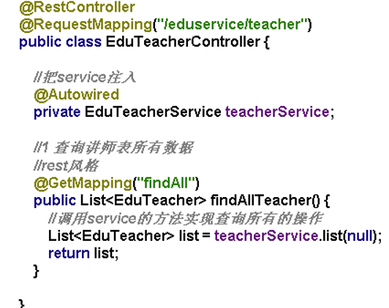

4.2.2 preliminary preparations
After completing the preparation of the controller, you also need to write the corresponding configuration class, start the class, and finally start it on port 8001. Similarly, the logical deletion of data is a similar operation. Use the deletemapping annotation. After this annotation, you need to add an ID, that is, pass the ID value through the path. In the basic methods of adding, deleting, modifying and checking, I use swagger to test the interface. I prefer to create a public swagger^{[25]} module so that all sub modules can use this module. Add the enableswagger2 annotation to this common module. When it is necessary to use swagger test interface, I only need to introduce the dependency of this common, That is, add the corresponding coordinates to the POM. Similarly, in this process, I also perform a unified result return operation, which is also created under the common package. The purpose is to return the same data results, such as 20001 for failures and 20000 for successes. In this way, I define the returned class as an R class. In the following method definitions, the returned data types are all r types, This avoids data
4.2.3 Function writing
When defining the instructor's paging query method, you need to pass in two parameters, that is, the current page and the number of records per page. At the same time, you need to create a new page object to encapsulate the paging data, encapsulate the data into the new object, and finally return it through the getrecords method.
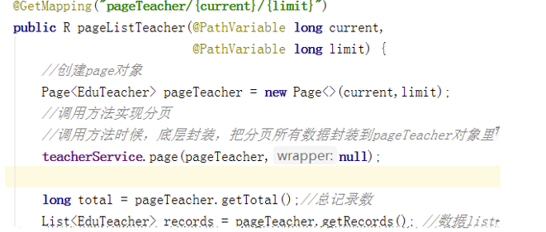
To modify the instructor's method, you first need to query according to the instructor's ID. after querying the corresponding data, you need to pass the ID value to modify the test JSON data in swagger.

front end:
First, you need to install the vscode compilation environment, which uses the JavaScript standard of ES6. This specification can better adapt to this project. After the addition, deletion, modification and query interface of the back-end is written, the front-end also needs to write corresponding functions to call the back-end interface. In this process, first change the background management login address of the project to the local address, that is, my own interface address 8001, which is defined as localhost: 8001 in Vue's base API, and return the token data value through login, In this process, we should pay attention to the cross domain problem. We need to add crossrigin annotation in the back-end controller to avoid error reporting. In the process of using the Vue framework, first define the route, create a JS file under the router, then locate the page data class content corresponding to the route, such as path, name, etc., then define the Vue page in the views view layer, define the address and parameters of the interface in the API file, and finally introduce the corresponding JS file in the Vue page to call the implementation of methods and functions, using data Created and methods structures. The paging of lecturer list plus the conditional query function set the current page, record limit and total total records in vscode. The method definition also defines the path in the API. The conditional query is implemented by element UI and the v-mode method in Vue is used for data binding. There is a delete button in each front-end lecturer record to delete unnecessary lecturer information. Click annotation is added to the button. The lecturer can be deleted through the lecturer's ID, and the corresponding deletion interface address is defined in the API. At the same time, after the deletion is successful, the deleted page will be refreshed, and the data will disappear. The same instructor modifies the function. A modification button will be displayed after each record. Then, the data will be displayed by clicking and modifying. That is, according to the ID query data value of the instructor, then the api-router- page will be displayed.

Implementation of course classification front end:
First, you need to add the route of course classification and create the page at the end of. Vue of course classification. In this part, you need to create a tree structure at the front end, that is, there are corresponding primary structure and secondary structure, and different courses are corresponding under each layer structure.
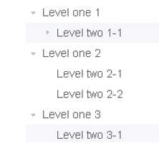

In the course management process, it needs to be connected to the database mysql, so it needs to create a new entity class in the back end. A primary classification has multiple secondary classifications, so it needs to be encapsulated to encapsulate the relevant data into the classification relationship,
In the whole process, first create a VO entity class, submit the form and add it to the database, and then display the lecturer and classification in a list to make a secondary linkage effect. There is a code generator in mybatis plus that can automatically generate one
MVC type structure includes control layer, logic layer and persistence layer, as well as some configuration layer and entity class layer. Modify the primary key generation policy and set it manually. In the front end, use the El form tag with the life Vue cycle to call the method.
Online learning needs to improve some course information, such as some course syllabus, some introduction information of lecturers, etc. in this process, integrate the text editor, confirmation of course information, etc. first introduce the configuration file of the text editor, then introduce the text file, and then use the text editor component, When used in the page, the tag language can be used to generate the corresponding interpretation documents. When modifying course information, you need to design data echo and a "previous" button. Click this button to return to the relevant information filled in in the previous step. In this process, you need to do a data echo operation. You need to develop the back-end interface part to query the information of relevant courses according to the ID and modify the interface of course information so that it can be called. In the process of developing the front end, first define two methods of the interface in course.js in the API, then modify the chapter page and jump path, connect the path of the interface and the incoming data ID after the path, and finally echo the page on the info page. When you click the previous step, you can realize the data echo.
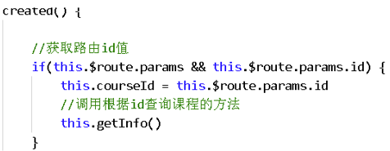
At the same time, add and modify the course button to perform corresponding operations when the administrator needs to modify or delete a course. Click the modify or delete button to delete the corresponding data. After submission, it will be modified to the database accordingly.

multi-table query^{[26]}：
Multi table query generally needs to query multiple tables. It can be obtained by writing SQL statements in idea, creating mapper interface in the project, writing XML and writing SQL statements. Before publishing the course, using mapper to write SQL statements will cause errors. This is because there is a problem with Maven's default loading mechanism. Only SRC main java files will be loaded, and other types of files will not be loaded. The solution is to copy the XML file to the target directory, configure it through the configuration file, and let Maven load the XML file by default, so that we can load the file we need to load. Only then can the course be released correctly.

Nuxt.js
Most of the projects are built based on webpack. The compiled HTML files and resource files are packaged into JS. The page code in Figure 404 below is taken as an example. It can be seen from the code that such a page is not conducive to search engine optimization (SEO), and the time to content (or the first screen rendering time) also has a lot of optimization space. In order to solve the above problems, nuxt.js framework is introduced^{[27]}.
Based on the general application framework of vue.js, it presets various configurations required for developing server side render (SSR) applications using vue.js, and can also generate static sites with one click.
As a framework, nuxt.js provides many useful features for the typical application architecture mode of client / server, such as asynchronous data loading, middleware support, layout support, etc. Different from other Vue SSR frameworks, nuxt.js has the following obvious features.
Automatic code layering
Powerful routing function, support asynchronous data (no additional configuration for routing)
HTML header tag management (dependent on Vue meta Implementation)
Built in webpack configuration without additional configuration

Alibaba cloud video on demand：
In this project, you need to use Alibaba cloud's video on demand function for video on demand, so that users can watch videos. You can register in Alibaba cloud's video service. The operation process first obtains the video playback address according to the video ID, stores the video ID information in the database, uploads the video to Alibaba cloud video on demand service, creates a sub module in the service layer, introduces POM dependency, initializes the player object, and obtains the video playback address according to the video ID, Finally, the playback voucher is obtained according to the video ID. Then add the upload of course video in the course section. First, introduce dependency, create application configuration file, create corresponding startup class, and create controller and service. In this process, pay attention to the video size set in the configuration file^{[28]}, otherwise an error will be reported that the video is too large. After the back-end integration is completed, the front-end integration needs to be carried out. 8003 port rules are configured in load balancing nginx. There are restrictions on the size of videos uploaded in nginx. This can be added to the nginx configuration to store the video name in the database.
In Alibaba cloud video storage, you can delete the video, set the corresponding interface at the page caller, and call the delete method to delete the interface.

Spring cloud fuse
In the microservice architecture, multi-layer services will call each other. If one layer of services fails, it may lead to the failure of one layer of services or multi-layer services, resulting in the failure of the whole system. This phenomenon is called service avalanche effect.
This problem can be solved by the hystrix component in spring cloud. Hystrix^{[29]} is responsible for monitoring the calls between services and protecting against repeated failures. The protection method is to use fallback. When the called service fails, the return value of the fallback method can be used; The hystrix interval will check the failed service again. If the failed service recovers, it will continue to use the service.

SpringSecurity
Spring security is a highly customized security framework. Using the functions of spring IOC, Di and AOP, it provides the system with declarative security access control function, and reduces the work of writing a large amount of repeated code for system security. There are many reasons for using spring security^{[30]}, but most of them are found that the security functions in the servlet specification or EJB specification of Java EE lack typical enterprise application scenarios, and they are recognized that they cannot be transplanted at the war or ear level. Therefore, if you change the server environment, there is still a lot of work to rewrite the configuration application. Spring security solves these problems and provides you with many other useful and customizable security functions. The two main areas of an application are authentication and authorization (access control). These two points are also important core functions of spring security. Authentication is the process of establishing a declared subject. A subject generally refers to the user, device or some other system that can perform actions in your application. In short, the system thinks whether the user can log in. Authorization refers to the process of determining whether an entity is allowed to perform an action in your application. In short, the system determines whether the user has permission to perform certain operations.

Microservices and spring cloud:
Microservice mainly refers to an architectural style. It focuses on splitting a project into multiple independent services. Each service runs independently and each service occupies an independent process. Spring cloud does not refer to a technology, but a general term for a variety of technologies. It is a collection of many frameworks. Spring cloud relies on springboot technology. The basic components of spring cloud include Eureka. In the project, I use Nacos, which plays the role of a registration service, feign, hystris and so on. In the video deletion function, the Nacos registry is used to delete a service, call different services, register the service into Nacos, and then use Nacos to delete a service function. In the use of Nacos, you first need to install the corresponding files. After decompression, run the startup.cmd file to start Nacos. Then create a new service in the idea, introduce the POM file of the corresponding service, and configure the Nacos address in the application in the service configuration file to be registered. Then add an annotation on the startup class, where the Nacos registration corresponds to the @ enablediscoveryclient annotation. Finally, log in to the Nacos address and you can see that the service is registered in Nacos. When you need to call other services, you only need to introduce corresponding modules into the dependency, create a new interface at the calling end, specify the name of the calling service with annotations, and define the method path of the call. In the whole deletion process, each chapter corresponds to many sections, and each section may contain videos, so it may be necessary to delete multiple videos at the same time during the deletion process. It is necessary to create a new interface to delete multiple videos at the same time according to multiple video IDs.

Banner^{[31]} data display and redis cache:
On the display of home page data, use banner display (slide or rotation diagram), create corresponding database tables and configuration files, and crud the banner management interface in the background. In the front-end page preparation, use the command NPM install Axios to download the relevant dependencies of Axios and encapsulate the corresponding Axios, The banner data display on the home page and the page call interface display the data.
Redis is a key value database. It is stored based on key value and supports a variety of data structures: string, list, hash, ordered collection, etc. It supports persistent operations. Those stored in memory can also be stored in the hard disk. It supports expiration time and transactions. However, generally speaking, it stores the frequently queried, infrequently modified and not particularly important data in redis, such as the home page data in this project. In the process of using, first create the redis configuration class, write it to the common public service, introduce springboot, integrate the redis related dependencies, create the redis cache configuration class, and configure the plug-in. Add the annotation cacheable on the method of querying all banners. In the process of page calling, first query the database, return the data queried by the database, and add the returned data to the cache, and then query the cache. If there is data in the cache, you can return it directly. Redis service runs in virtual machines. First, install redis service in Linux system. You can start redis cache service by using the command. You need to configure the running port number of redis in the service configuration file.

Log in and register with alicloud SMS service：
In the login service, I use the JWT single sign on method suitable for distributed cluster deployment. There are three commonly used single sign on methods: session broadcast mechanism, cookie + redis mechanism and token login method. Cookie + redis will randomly generate the only value on the key side, and the value side will generate the corresponding user data and store it in redis, The key value generated in redis can be put into the cookie. Will the cookie access with the key value every time you visit other modules? You can query the value user data in redis through the key value, so you can log in. Another token method is to log in to a module of the project. After logging in, a string is generated according to the rules. The logged in user is included in the string and the string is returned. The string can be returned in the form of cookie or in the address bar. When accessing other module projects at this time, each access takes the string generated by the address bar, and obtains the user information according to the string information to log in. In the JWT part, the token is a string generated according to certain rules. This string contains user information. JWT has built-in rules and is directly generated when used. The generated string information includes three parts: the first part is JWT header information, the second part is payload, and the third part is signature hash. When using in idea, first import dependencies in common and use JWT tool classes.
When users register, they will use the mobile phone to log in. After entering the mobile phone number, they will send a SMS verification code to the mobile phone. In this service, you need to create a new module under the service module, create the package structure, the corresponding controller and service layer, configure the startup class and configuration file. At the same time, you need to open SMS service on Alibaba cloud website to apply. After the application is completed, you can use it. The code side needs to write code to realize the sending of SMS, introduce dependency in the new module, write the method of sending SMS, and then set the sending related parameters
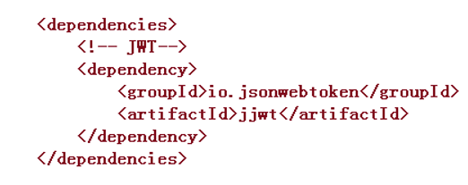
Front end integration of login and design of wechat scanning login function：
First, log in to the front-end function integration. You need to create a login.js file in the API and define the corresponding interface address. Then, you can make a method call in the login interface and download the cookie plug-in using the NPM install instruction. Call the interface to log in and return the token string, put the returned string information into the cookie and create a front-end interceptor, that is, judge whether there is a token string in the cookie, if so, put the token string into the header (request header), then obtain the user information from the cookie and display the user information on the home page. Oauth2 is a solution to specific problems. It mainly solves the authorization problems between open systems and distributed access problems. First of all, the permission problem between open systems is that users can operate Baidu online disk to store photos, and users can also authorize the print shop to print photos, but the print shop cannot directly operate our Baidu online disk to operate photos. Distributed access uses token mechanism in oauth2 solution, and generates string information according to certain rules, which contains user information. In the early stage of wechat scanning and login, you need to first prepare to register the developer qualification, and then apply for the website application name and domain name address. Then you can configure the file, wechat ID, key and domain name address in the back-end service module of the project, create a class, read the content of the configuration file, and finally generate the QR code scanned by wechat. After wechat scanning, you need to execute the local callback method, get two values in the callback, pass them in the jump, request wechat to provide a fixed address from the obtained code value, get two values, an access credential and a wechat unique credential, and then take the two obtained values to request a wechat fixed address, You can access personal information, such as avatar, nickname, etc.

Course comment function and course payment function：
The course comment function requires users to edit comments and reply at the bottom of the course details page, and has the function of pagination. First, create a course comment table in the database, then create an interface and create two methods. The first method is to query course comments in pages. You need to add the input data to the interface, course ID and instructor ID. The second method is to add a comment method, which requires the user's ID, avatar and nickname, that is, before commenting, you must log in, obtain the token string from the header, and obtain the user's ID according to the token string. The course payment function needs to be divided into two situations. The first is that the course is free. You can directly play the video by clicking watch now. The second one requires charging. There is an immediate purchase option. Click to generate an order. Click to pay to generate the corresponding payment QR code for payment. After payment, you will return to the course details page. At this time, click play now to play normally. At the same time, you need to create a new order table and payment record table. After each transaction is completed, you need to add data in the table. In the back-end interface part, you need to write an interface for order generation, an interface for querying order information according to order ID, an interface for generating QR code for wechat payment, and an interface for querying order payment status. The interface for generating purchase order needs to call Nacos remotely, and needs course information and user information, that is, call other interfaces to query the order information according to the order number and use wrapper.
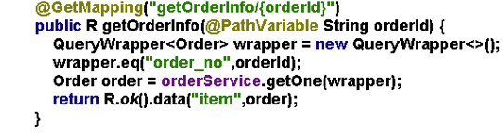
On the front page of the order, you need to define the JS file in the API, click buy now to generate the order, bind the event, write the interface method, call the interface, call it in the page, click buy now on the course details page, and then create an order display page to display the generated order information. Use the route jump function to realize the route jump, and add CSS style to the layouts page. To generate the QR code of wechat payment, you need to prepare the payment ID, merchant number and merchant key, introduce relevant dependencies and write the interface. After the payment is completed, you need to return to the details page. After that, you need to query the order status every three seconds. When querying the payment status, if the payment is not completed, wait. If the payment is completed, clear the timer in the page. In addition, if the course is free, you can watch it directly and the course has been paid, you can also watch it by clicking watch now.

Canal data synchronization function^{[32]}
Canal is an open source project of Alibaba. It is implemented based on Java and has been widely used in many large-scale Internet project production environments, including Alibaba and meituan. It is a very mature database synchronization scheme. The basic use only needs simple configuration.
Canal listens to the MySQL binlog log to obtain data by simulating the way of becoming a MySQL slave. After binlog is set to row mode, it can not only obtain each addition, deletion and modification script executed, but also obtain the data before and after modification. Based on this characteristic, canal can obtain the changes of MySQL data with high performance.
Nowadays, large IT systems will use distributed methods, and there will be many middleware, such as redis, message queue, big data storage, etc. However, the actual core data storage is still stored in the database. As the most widely used database, how to synchronize MySQL data with middleware data can ensure data consistency and timeliness, Can you also make the code non intrusive? If there is such a requirement, the data in MySQL needs to be updated to elastic search in time after data modification.
code implementation
When adding, deleting or modifying a database in the code, the elasticsearch operation is performed at the same time.
Mybatis implementation
It is implemented through the mybatis plugin, intercepts SQL statements for analysis, and processes insert, update and delete statements. Obviously, these operations are easy to handle if they are single data operations. However, in actual development, there will always be some batch updates or deletions. At this time, it is difficult to deal with them.
AOP implementation
No matter which AOP method is adopted, the section processing is carried out according to the formulated rules, such as specification, method name, annotation, etc., but the problem of batch operation data still cannot be processed.
logstash
The file and data synchronization function provided by similar synchronization components of logstash can synchronize data. MySQL data can be synchronized to elasticsearch with simple configuration. However, the principle of logstash is to perform incremental data query every second and synchronize the results to elasticsearch. The real-time requirements are particularly high and may not meet the requirements. And the performance of this scheme is not very good, resulting in a waste of resources.

Statistical analysis function
Count the number of people registered in the mall in a day, and then display it in the form of charts. You need to create a data statistics table to use statistics. You need to store the data in the user registry in the data statistics table, and then make the data in the data statistics table into a table for display. The first step is to configure nginx path rules, then configure the routing address for statistical analysis in the router, create a JS file in api.js, define the method of the interface, and call the method on the generate statistics page. During this period, add scheduled tasks for statistical analysis and conduct scheduled data analysis and processing at regular intervals. You need to add annotation @ enablescheduling in the startup class and use cron expression to set execution rules. Create a scheduled task class and use expressions in this class to set when to perform operations. The front end of the project needs to integrate ecarts. First, you need to download the dependencies of ecarts, use the NPM install command to download the dependencies, and then operate the integration page to display them.

5 Results and discussion
Using swagger to test the back-end interface, you can get the test data as follows:
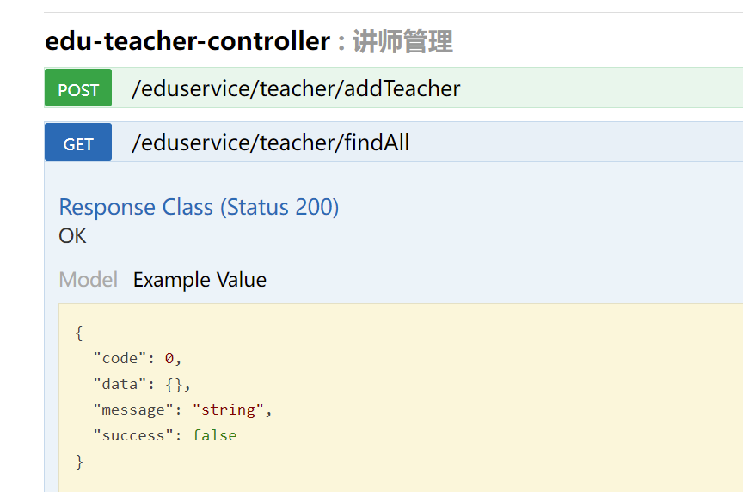
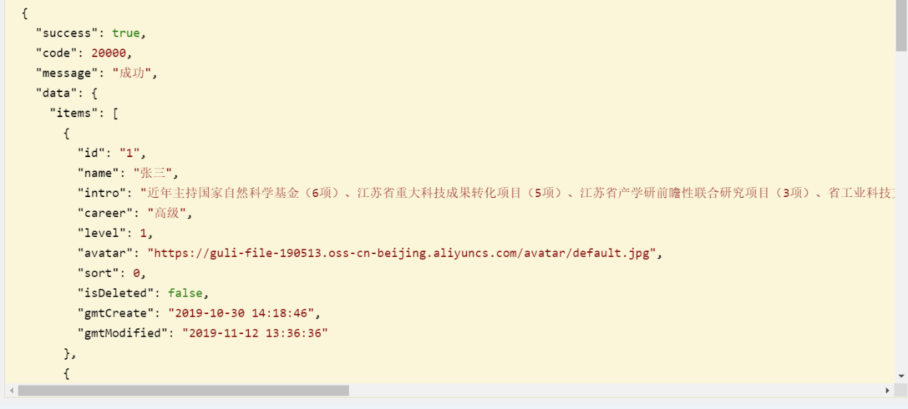
You can see that all the data is displayed using the swagger test query. And it integrates the implementation of some basic addition, deletion, modification and query methods, paging query and so on. Can be tested by transmitting data.

Run the front-end page through the NPM run dev instruction, and you can see that our page is opened on port 9529.
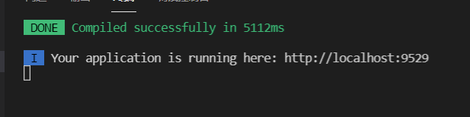
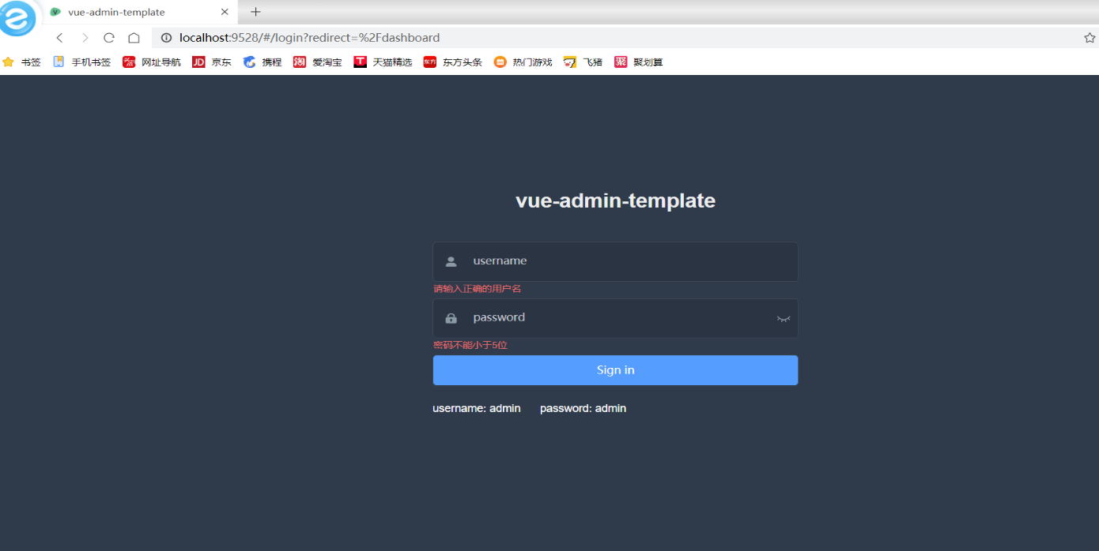
In the front-end module, the Vue framework is used and the NPM run dev instruction is used to successfully run the background front-end interface in the web page. The following is the administrator operation page and some lecturer query pages. On this page, you can add, delete, modify and query lecturers, and publish some new courses.
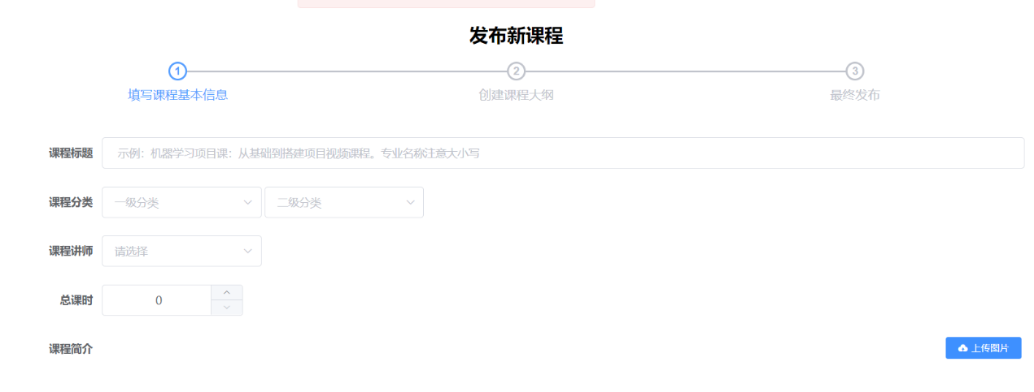

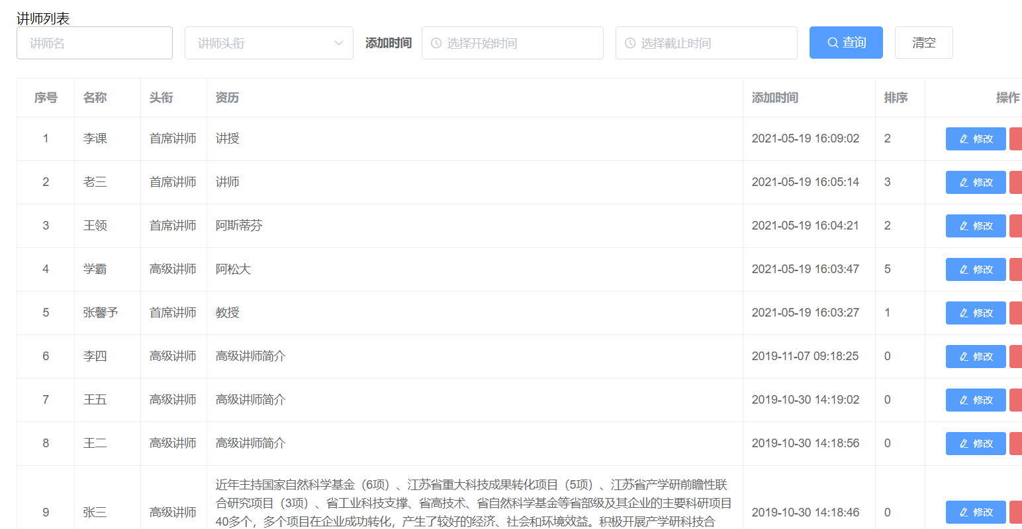
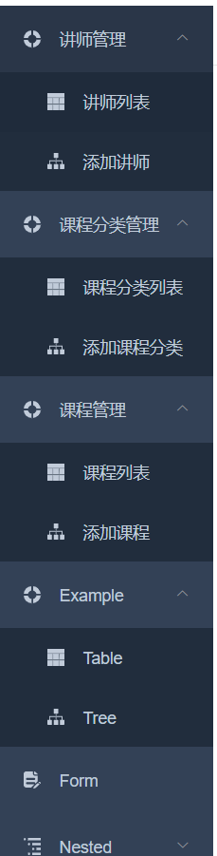

The following figure is the front page display page of the front desk. You can choose to watch the video and watch it immediately. The price of the corresponding course will also be displayed. If the price of the course in the database is 0, you can click to watch it directly without paying.
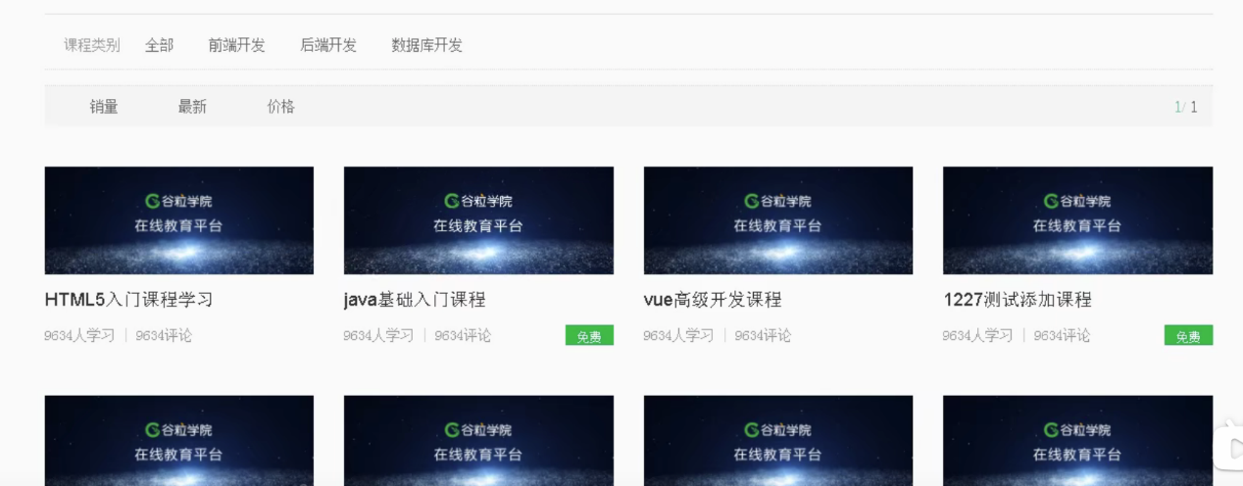

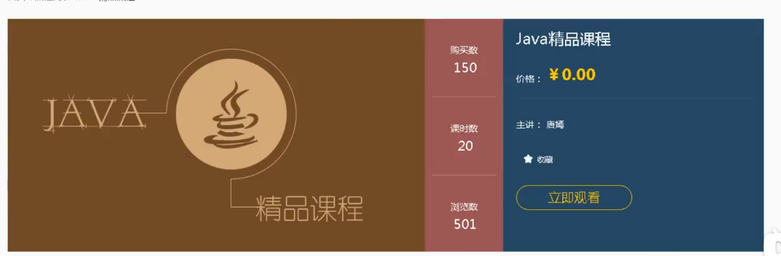

6 Conclusions and recommendations
The online mall project developed separately from the front end and the back end has high usability and intuitiveness. Although the mainstream websites in the market have occupied most of the market, the use of some new technologies can only improve the performance of the website to a higher level. Firstly, the development of mybatis plus is added to the project, and the code generator is introduced to improve the hierarchy of the code, And the convenience of developing the website. Secondly, the encapsulated swagger test documents can more intuitively test the feasibility of the interface. When using springboot to develop the website, annotation based development and encapsulated web container Tomcat are the convenience of mainstream frameworks to developers. How to use these frameworks flexibly, So as to achieve the quick construction project is the focus that programmers should pay attention to. Secondly, developers should focus more on customer needs and user experience.

7 consideration
In this development, I have encountered many problems and difficulties, such as the cross domain problem encountered in the middle. It is necessary to add crossrigin annotation on the control layer to achieve a cross domain purpose. In addition, when introducing dependencies, you can't download dependencies from the remote library. You can only download jar packages on the official website and download dependencies through CMD instructions. The front-end and back-end modules of the whole project are a large plate. In the process of writing back-end functions, I found that the most used functions are adding, deleting, modifying and querying, and more operations on data. Then, the remaining interfaces are the writing of some public classes and plug-ins, or some interfaces related to avatars and video functions, such as the writing of some public classes, In fact, in this project, I learned that although it is important to write code, we must also focus on the optimization of some functions, which will reduce many unnecessary troubles for the developers behind us. For example, if the class that returns the unified result does not return the unified result, when a front-end developer calls the interface, The success of the return value definition is 2000, and another person is 20000, which will make the development messy. Therefore, our back-end developers not only need to be able to write certain ports, but also need to standardize some things, just like interfaces. Everyone uses the same specification.
Secondly, in the learning process of the front end, the use of Vue and some element UI components brings a lot of convenience to the development. From API route Vue page, the page display part of the front end still has a certain basis. The process of calling the interface API to route and then to the page is more intuitive in the use of the front end, and the logic is not particularly strong, More importantly, it emphasizes the beauty of the page and some specific positions and layout.
Generally speaking, this project involves a lot of knowledge points. In this learning process, I have made great progress from a person who can use idea and some simple frameworks to the clarity of the whole architecture. I hope I can continue to refuel.

References
[1] Yu Jia, Wu Danxin. Web rapid development framework based on springboot [J]. Computer programming skills and maintenance, 2021 (09): 31-33
[2] Wang Wei, Chang Qingli, Wu Chaoxia. Research and implementation of precision assistance system based on springboot + Vue [J]. Henan science and technology, 2021,40 (27): 12-14
[3] Gan Ning. Application and test of B2C e-mall shopping website in the Internet era [J]. Information and computer (theoretical Edition), 2021,33 (14): 98-100
[4] sun Shiqi, Wu Shanlu. COVID-19's evaluation of online learning effectiveness of college students [J]. network security technology and applications, 2021 (08): 101-103.
[5] Ye Gang, Wang Lihe, Wang Yingming, Gu Guodong. Design and implementation of dynamically generated code based on mybatis plus [J]. Computer programming skills and maintenance, 2019 (07): 7-8
[6] Zhao Yang, Jiang Xiuhui, Liu Xiaoyu. Model design of government procurement management system for scientific research institutions based on MVC [J]. China management informatization, 2021,24 (15): 80-84
[7] Li Shuangyuan, Ding Wenhao, Zheng Kai. Design and implementation of calculator program based on ES6 standard [J]. Journal of Jilin Institute of chemical technology, 2018,35 (09): 66-69
[8] Wu Yuanjie, he Yiping, Zhu Xiaoqing, Chen Geng. Design and development of mobile web front end based on HTML5 technology [J]. Information recording materials, 2021,22 (08): 139-141
[9] Jia Rui Xin. Museum of hyperlinks in the context of "Internet plus": Taking the "AR first show" activity of the Museum of intelligence as an example, [J]. Wenzhou heritage, 2018 (01): 85-89.
[10] Hao pingting, Hu Liang, Jiang Jingyan, Che Xilong. Optimistic locking protocol based on multiple management nodes [J]. Journal of Jilin University (Engineering Edition), 2017,47 (01): 227-234
[11] Wang Dan, sun Xiaoyu, Yang Lubin, Gao Shengyan. Design and implementation of software statistical analysis system based on springboot [J]. Software engineering, 2019,22 (03): 40-42
[12] Cao Huashan. Design and implementation of SSM framework in web application development [J]. Wireless interconnection technology, 2021,18 (11): 108-109
[13] Huang Wenhao. Research on the application of aspect oriented programming (AOP) in Web programs [D]. Wuhan University of engineering, 2016
[14] Hu Yanmei. Research on the application of EJB Technology Based on Java development [J]. China's new technologies and products, 2015 (11): 16-17
[15] Pan Wenwen. Research and implementation of some optimization technologies of web front end under cloud platform [D]. University of Electronic Science and technology, 2020
[16] Wang Zhiren. Design and implementation of development platform based on vue.js [D]. Guangdong University of technology, 2018
[17] Yan Juan. Oral English test platform based on node.js [J]. Microcomputer application, 2021,37 (08): 173-175
[18] Zhang Yueting. Application of Vue element admin in online training system for radio and television employees [J]. Television technology, 2020,44 (12): 1-3
[19] Wang Yuxin, Liu Feng. Application practice of data visualization in University Library Based on Navicat + tableau [J]. Electronic world, 2020 (21): 94-95 + 99
[20] Chen Jia. A power system microservice authentication and authorization scheme based on JWT token authentication [J]. Electrotechnical, 2021 (16): 151-154
[21] Wei Jiangdong, Tu Jihui, Lai Shaodong, Gao mengran. Design and implementation of moving target trajectory tracking system based on websocket and redis [J]. Computer age, 2021 (08): 76-79 + 83
[22] Promise. Optimization design of educational administration system based on nginx load balancing under big data [J]. Information technology and informatization, 2021 (06): 191-193
[23] Li man. Design and implementation of SaaS application integration framework based on micro Service Architecture [D]. Xi'an University of Electronic Science and technology, 2020
[24] Liu Xiaohui, Qin Zishi. Design and practice of rest API based on oauth2 certification [J]. Computer knowledge and technology, 2021,17 (15): 56-57
[25] Liu Xiangli. Definition method and notification mechanism design of network management interface based on restful / HTTP [D]. Beijing University of Posts and telecommunications, 2019
[26] Song Yongpeng. Database query performance optimization based on MySQL [J]. Electronic design engineering, 2021,29 (12): 43-47
[27] Wang Yingying, Zhao Zhimin. Research on the construction of Web front-end development curriculum system based on professional ability [J]. Computer and information technology, 2021,29 (05): 57-60
[28] Land, savings, Tao Jinglian, Liang Haibin. Transformation of traditional file center based on Alibaba cloud OSS [J]. Cable TV technology, 2019 (06): 99-101
[29] Xiong Kai. Design and implementation of training business system based on spring cloud [D]. Beijing University of Posts and telecommunications, 2019
[30] Song xinlai, Zhang Haitao. Design and implementation of user login function based on front end separation and spring security [J]. Scientific and technological innovation and application, 2021,11 (18): 19-21 + 24
[31] Pei Chunyan. Design and implementation of front-end advertising component library based on react [D]. Shandong University, 2018
[32] Xu Zhichao. Design and implementation of cache synchronization system based on configuration [D]. Xi'an University of Electronic Science and technology, 2020

Appendices
package com.atguigu.eduservice.controller;
import com.atguigu.commonutils.R;
import com.atguigu.eduservice.entity.EduTeacher;
import com.atguigu.eduservice.entity.vo.TeacherQuery;
import com.atguigu.eduservice.service.EduTeacherService;
import com.atguigu.servicebase.exceptionhandler.GuliException;
import com.baomidou.mybatisplus.core.conditions.query.QueryWrapper;
import com.baomidou.mybatisplus.extension.plugins.pagination.Page;
import io.swagger.annotations.Api;
import io.swagger.annotations.ApiOperation;
import io.swagger.annotations.ApiParam;
import org.springframework.beans.factory.annotation.Autowired;
import org.springframework.util.StringUtils;
import org.springframework.web.bind.annotation.*;
import java.util.List;
/**
* <p>
* 讲师 前端控制器
* </p>
*
* @author testjava
* @since 2020-02-24
*/
@Api(description="讲师管理")
@RestController
@RequestMapping("/eduservice/teacher")
@CrossOrigin
public class EduTeacherController {
//访问地址： http://localhost:8001/eduservice/teacher/findAll
//把service注入
@Autowired
private EduTeacherService teacherService;
//1 查询讲师表所有数据
//rest风格
@ApiOperation(value = "所有讲师列表")
@GetMapping("findAll")
public R findAllTeacher() {
//调用service的方法实现查询所有的操作
List<EduTeacher> list = teacherService.list(null);
return R.ok().data("items",list);
}
//2 逻辑删除讲师的方法
@ApiOperation(value = "逻辑删除讲师")
@DeleteMapping("{id}")
public R removeTeacher(@ApiParam(name = "id", value = "讲师ID", required = true)
@PathVariable String id) {
boolean flag = teacherService.removeById(id);
if(flag) {
return R.ok();
} else {
return R.error();
}
}
//3 分页查询讲师的方法
//current 当前页
//limit 每页记录数
@GetMapping("pageTeacher/{current}/{limit}")
public R pageListTeacher(@PathVariable long current,
@PathVariable long limit) {
//创建page对象
Page<EduTeacher> pageTeacher = new Page<>(current,limit);
try {
int i = 10/0;
}catch(Exception e) {
//执行自定义异常
throw new GuliException(20001,"执行了自定义异常处理....");
}
//调用方法实现分页
//调用方法时候，底层封装，把分页所有数据封装到pageTeacher对象里面
teacherService.page(pageTeacher,null);
long total = pageTeacher.getTotal();//总记录数
List<EduTeacher> records = pageTeacher.getRecords(); //数据list集合
// Map map = new HashMap();
// map.put("total",total);
// map.put("rows",records);
// return R.ok().data(map);
return R.ok().data("total",total).data("rows",records);
}
// @RequestBody主要用来接收前端传递给后端的json字符串中的数据的(请求体中的数据的)；GET方式无请求体，所以使用@RequestBody接收数据时，前端不能使用GET方式提交数据，而是用POST方式进行提交。在后端的同一个接收方法里
//4 条件查询带分页的方法
@PostMapping("pageTeacherCondition/{current}/{limit}")
public R pageTeacherCondition(@PathVariable long current,@PathVariable long limit,
@RequestBody(required = false) TeacherQuery teacherQuery) {
//创建page对象
Page<EduTeacher> pageTeacher = new Page<>(current,limit);
//构建条件
QueryWrapper<EduTeacher> wrapper = new QueryWrapper<>();
// 多条件组合查询
// mybatis学过 动态sql
String name = teacherQuery.getName();
Integer level = teacherQuery.getLevel();
String begin = teacherQuery.getBegin();
String end = teacherQuery.getEnd();
//判断条件值是否为空，如果不为空拼接条件
if(!StringUtils.isEmpty(name)) {
//构建条件
wrapper.like("name",name);
}
if(!StringUtils.isEmpty(level)) {
wrapper.eq("level",level);
}
if(!StringUtils.isEmpty(begin)) {
wrapper.ge("gmt_create",begin);
}
if(!StringUtils.isEmpty(end)) {
wrapper.le("gmt_create",end);
}
//排序
wrapper.orderByDesc("gmt_create");
//调用方法实现条件查询分页
teacherService.page(pageTeacher,wrapper);
long total = pageTeacher.getTotal();//总记录数
List<EduTeacher> records = pageTeacher.getRecords(); //数据list集合
return R.ok().data("total",total).data("rows",records);
}
//添加讲师接口的方法
@PostMapping("addTeacher")
public R addTeacher(@RequestBody EduTeacher eduTeacher) {
boolean save = teacherService.save(eduTeacher);
if(save) {
return R.ok();
} else {
return R.error();
}
}
//根据讲师id进行查询
@GetMapping("getTeacher/{id}")
public R getTeacher(@PathVariable String id) {
EduTeacher eduTeacher = teacherService.getById(id);
return R.ok().data("teacher",eduTeacher);
}
//讲师修改功能
@PostMapping("updateTeacher")
public R updateTeacher(@RequestBody EduTeacher eduTeacher) {
boolean flag = teacherService.updateById(eduTeacher);
if(flag) {
return R.ok();
} else {
return R.error();
}
}
}

