Qualification: CIPD Diploma in Applied Human Resources
Module Name: Understanding the Management of Employment Relations – 5KCER – On the Job Training

Word Count: 1,007

Student Name: Catherine Thomas
Student Number: 2012743
CIPD Membership Number: 57612349

By signing below, I confirm that the work/evidence presented is my own, unaided work. I understand the regulations pertaining to candidate malpractice and the action that may be taken as a result.

Signed: C Thomas
Date: 9 December 2021
Understanding the Management of Employment Relations – 5KCER
On the Job Training

Within my workplace Hywel Dda University Health Board there have been changes since the pandemic and there has been a lot of activity on our intranet page. This to communicate information across the Workforce and ensuring parity between Health Boards across Wales. As shown below there is the Covid-19 Workforce Risk Assessment tool – FAQ’s, along with guidance for managers in filling out the tool for staff.

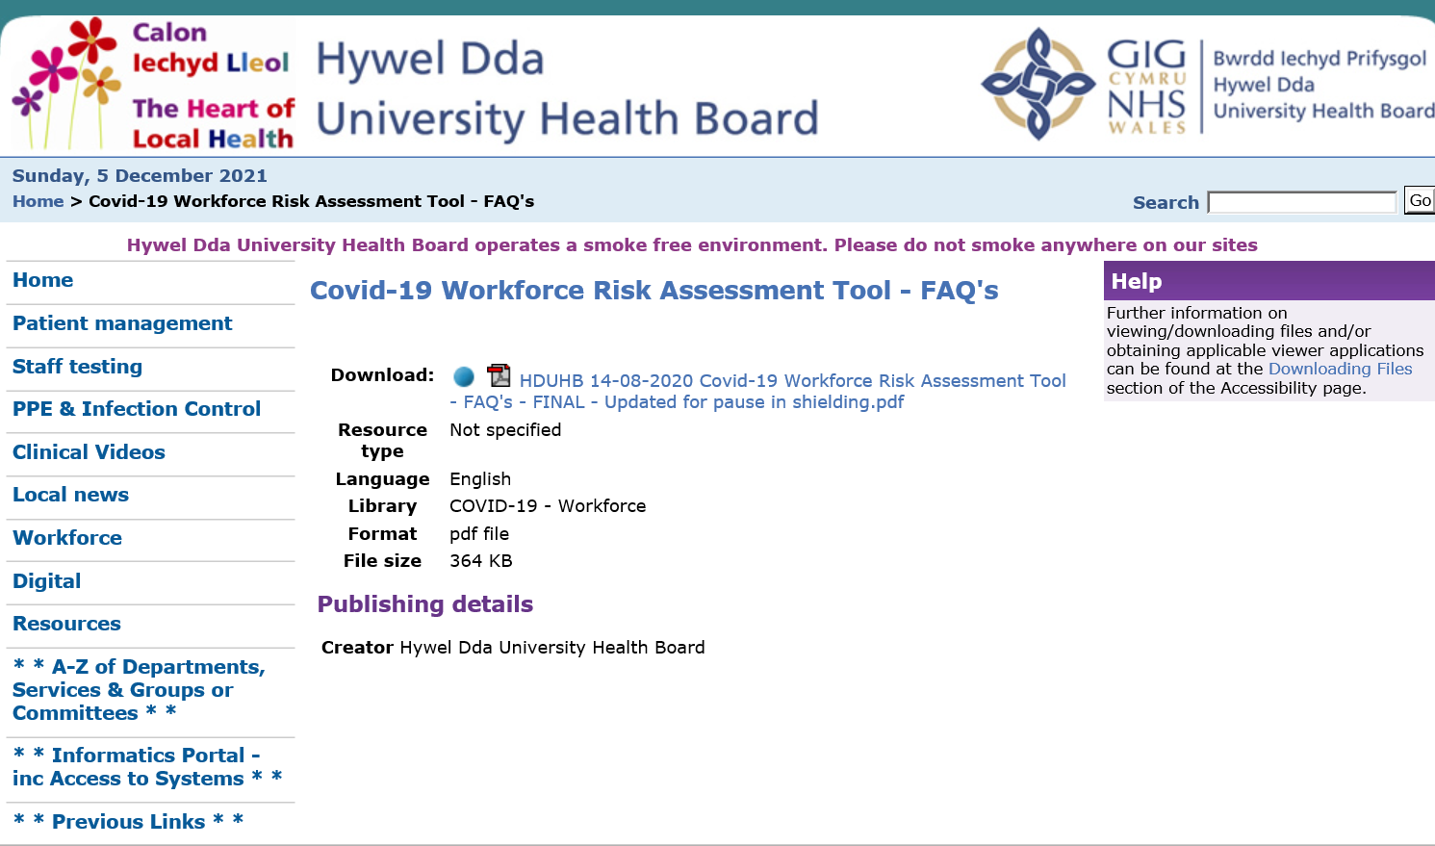
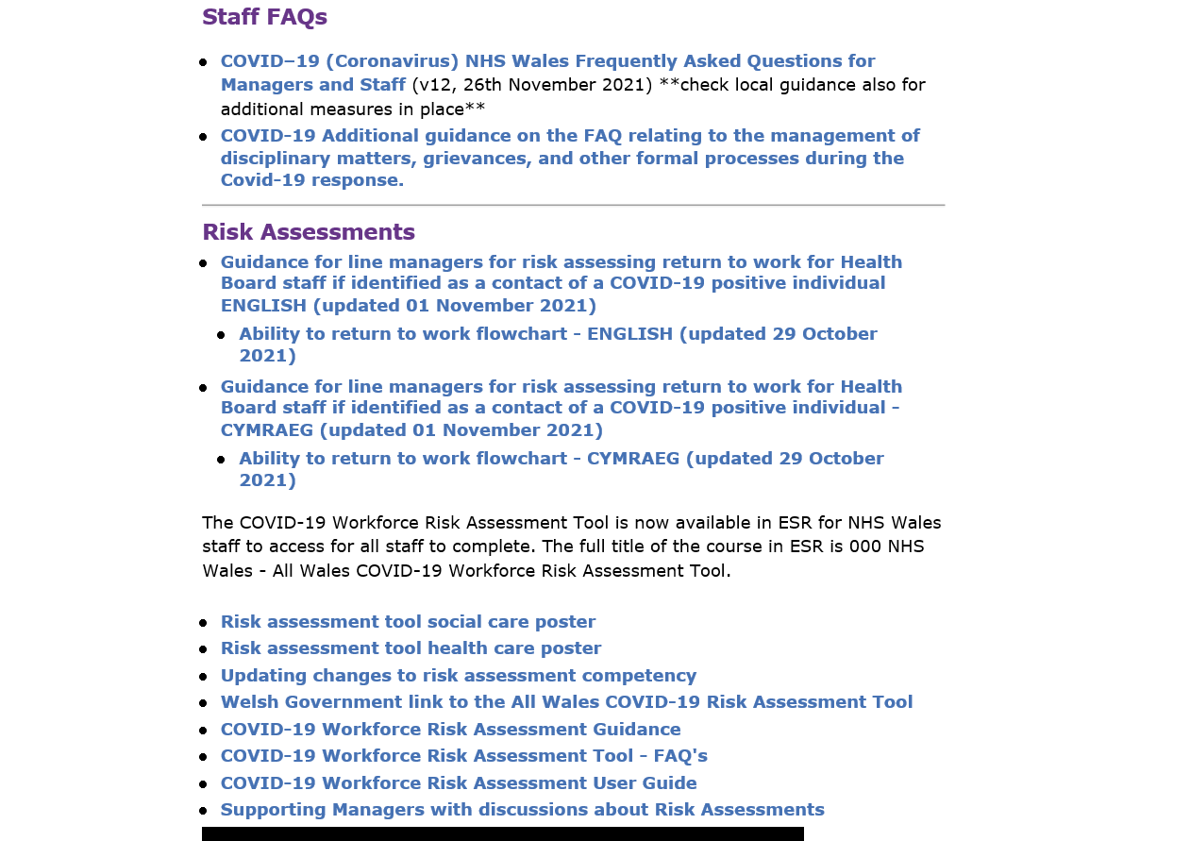
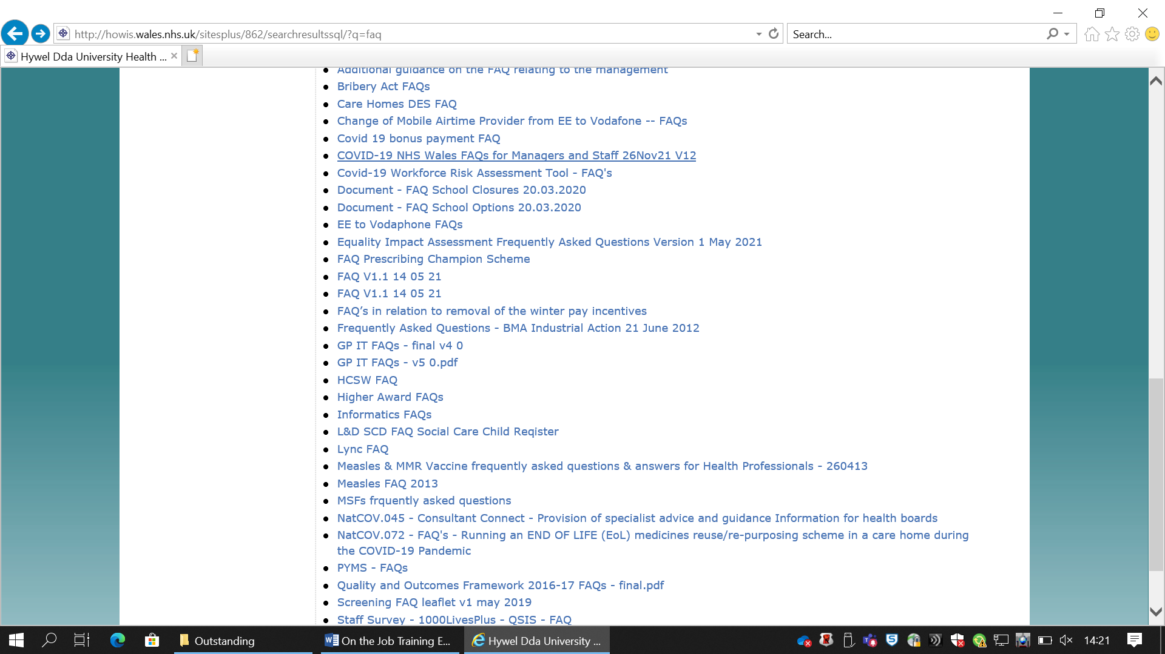
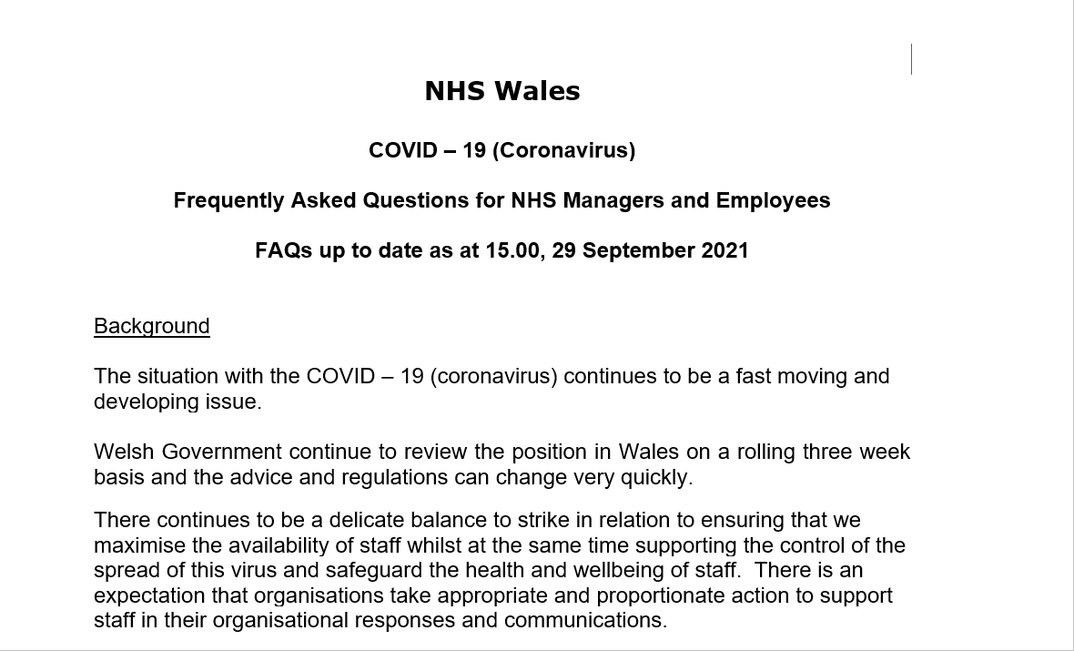
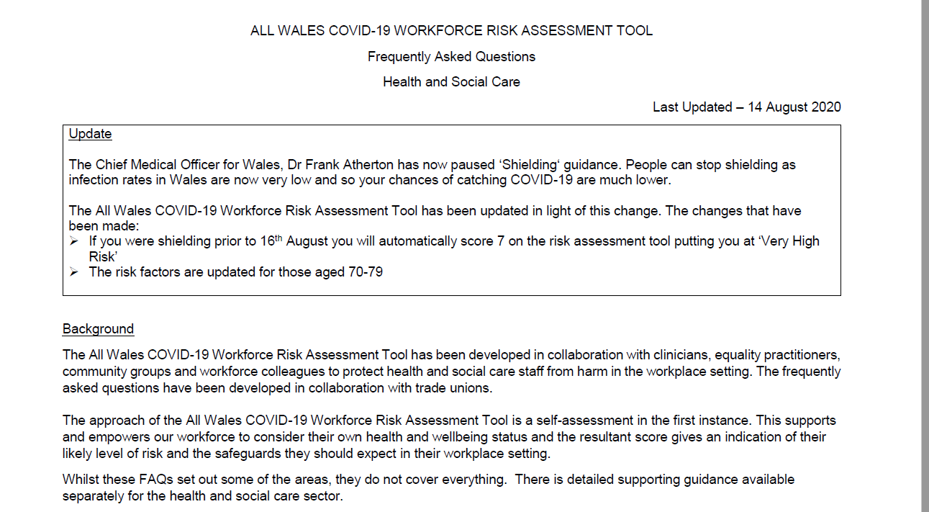
Q8 I have not completed a risk assessment before do I need to
complete this now?

A8 Yes, the All Wales COVID-19 Workforce Risk Assessment is for everyone working or volunteering in health and social care in Wales, including those who were shielding prior to 16th August.

Q9 If I have already discussed with my line manager what my risks are or/and had a formal risk assessment, can I have another one using the new risk assessment?

A9 Yes, the All Wales COVID-19 Workforce Risk Assessment should be discussed with your line manager and repeated depending upon your personal circumstances. If you have any changes to your health or working environment, a new risk assessment should be completed. If you are a PA, you should discuss with your employer.

Additional Guidance and Support

A25 Further guidance is available from
NHS Employers:
• https://www.nhsconfed.org/-/media/Confederation/Files/Wales-Confed/Wales-Employers/COVID--19-FAQs-for-Managers-and-Staff-Jun-2020-v50.pdf?la=en&hash=72A6720CA5A526B090C397DBC04EFE1D453843CA

• https://www.nhsconfed.org/regions-and-eu/welsh-nhs-confederation/nhs-wales-employers/covid19

Welsh Government:

• https://gov.wales/workplace-guidance-employers-and-employees-covid19

Social Care:
• https://socialcare.wales/service-improvement/information-and-resources-to-guide-you-through-covid-19

You can also seek support from your line manager, Workforce / HR team and Occupational Health Service / doctor that advises your employer/GP. If you are a member of a Trade Union or professional organisation, they will also be able to provide support.

From the screenshot below you can see that there is a tile for Workforce Covid-19 with staff FAQ’s, flowchart and risk assessments.
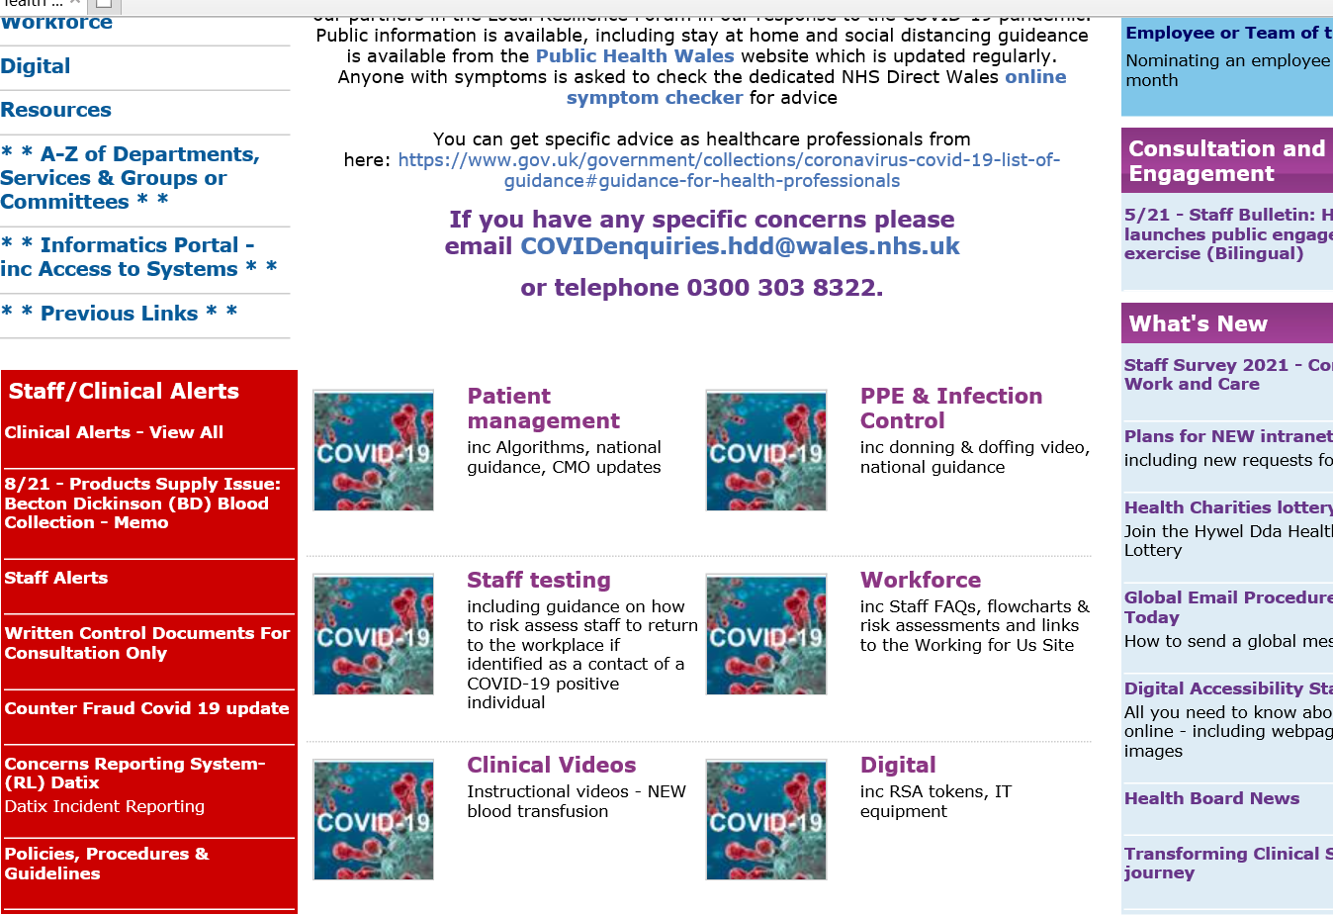

Below also shows that there is a Covid-19 related updates to existing Health Board Policies. Although upon a conversation with HR they confirmed that I wouldn’t find updates/changes to any policies during Covid-19 that they remained the same and instead any changes that would replace what’s stated in them (i.e. changes to Sickness, Annual Leave, Special Leave and what to do about Disciplinary, Grievance and Dignity at Work procedures) are all noted in that FAQ document. It’s covered everything during the pandemic. HR also confirmed that they used to update it regularly at the start but now it’s every couple of months and are new version is being produced shortly.

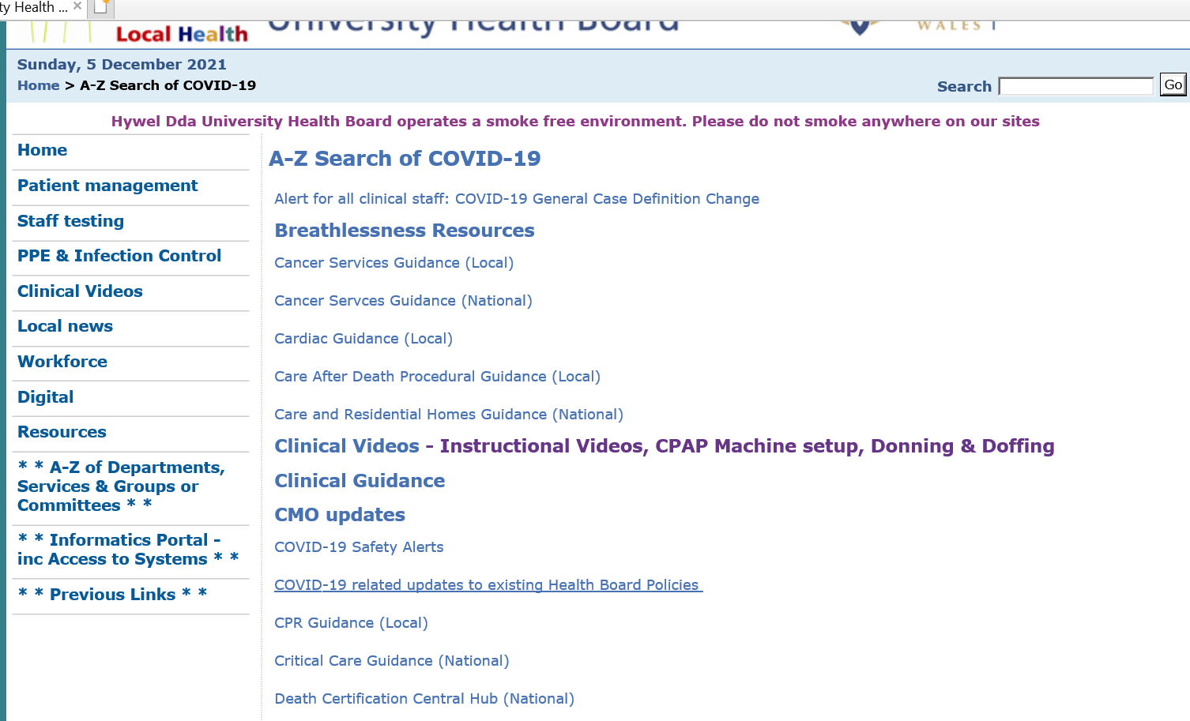

On the intranet relating to employee relations is also additional guidance on the FAQ relating to the management of disciplinary matters, grievances, and other formal processes during the Covid-19 response. This to provide information on how to handle disciplinary proceedings to ensure staff still have a fair investigation/ hearing whilst adhering to Government guidelines. A screenshot below shows some details.

R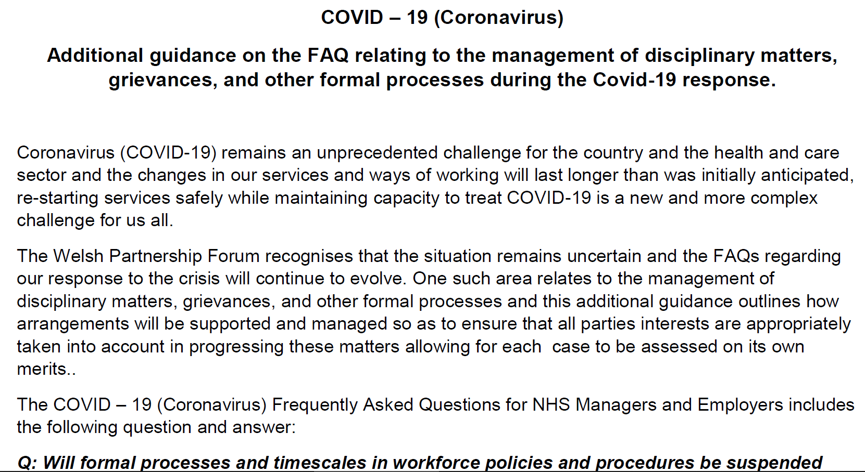

Sickness has also been recorded with an emphasis on how to record shielding, Covid symptoms, having Covid-19 and it had to be uniform across All Wales. As there are two systems e.g. e-rostering for clinical and ESR for admin. At first there was a lot of confusion on whether to record in one or both systems, what had to be recorded. Whether a sickness certificate was required for those with Covid-19. As time has gone on it recording and understanding has been more accurate. As you will see from below there is clear clarification of how to record via each system.
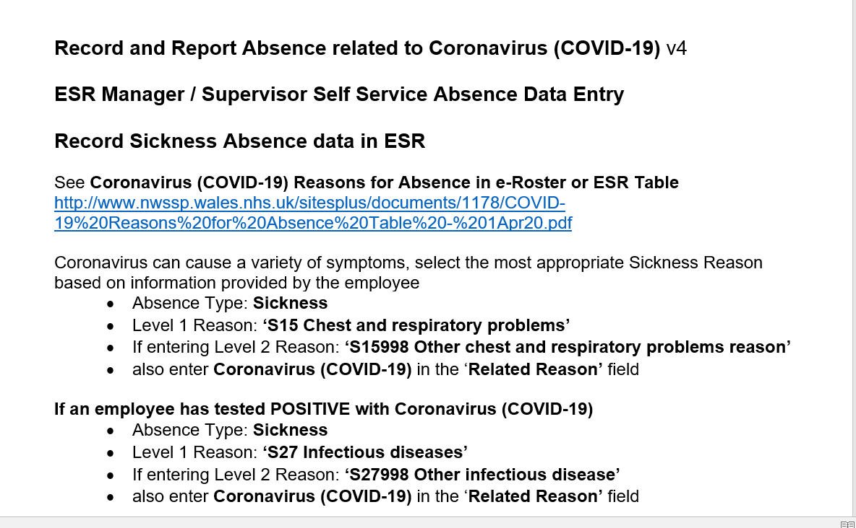
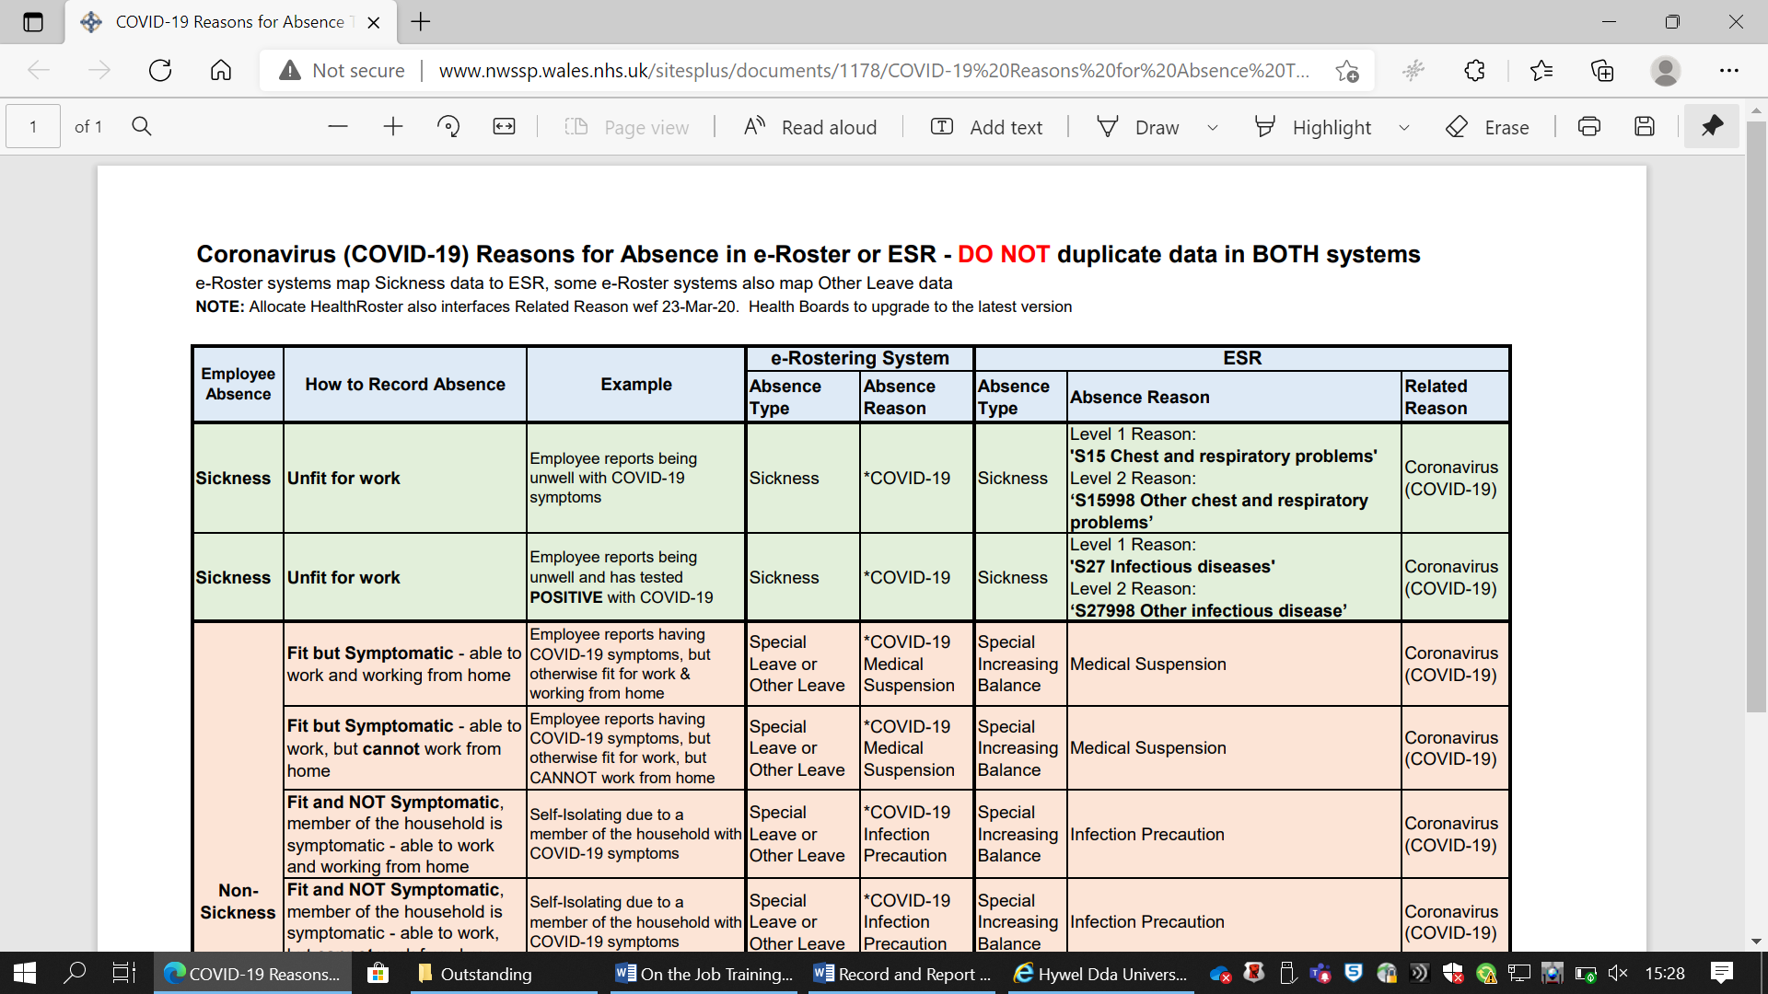
The graph below shows the increases and decreases in sickness since November 2019 to October 2021. It shows the sickness rate just before the beginning of the pandemic to where we are now. Sickness has drastically increased since the pandemic. The FAQ’s noted if Covid-19 related staff’s pay wasn’t affected and they weren’t escalated under the sickness policy.

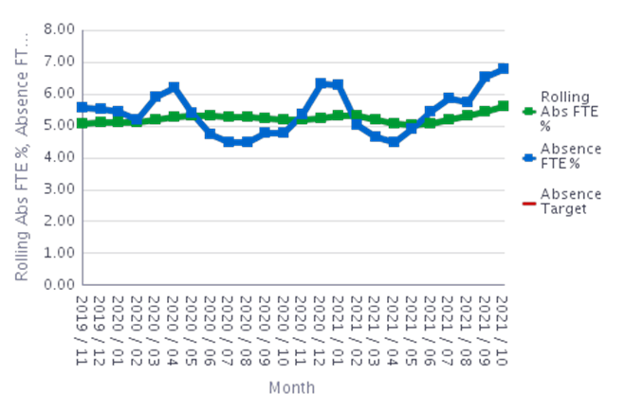
Very early on a letter was provided to staff in case they were stopped by the Police and this indicated the Health Boards name, employee payroll number, department worked and details to confirm we were required to travel as part of the Police’s enforcement for Covid-19 lockdown. Also all staff had to have updated identification badges as shown below.

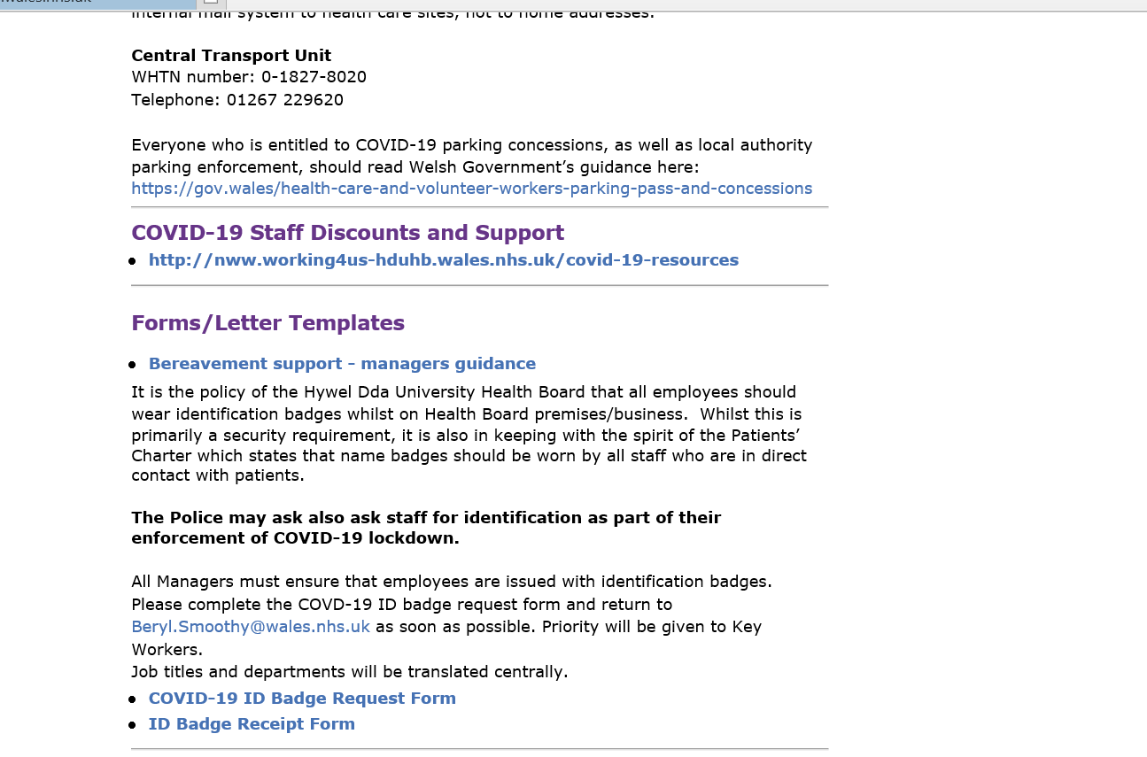
There was also guidance regarding Covid-19 Transport information and parking permits for key workers.
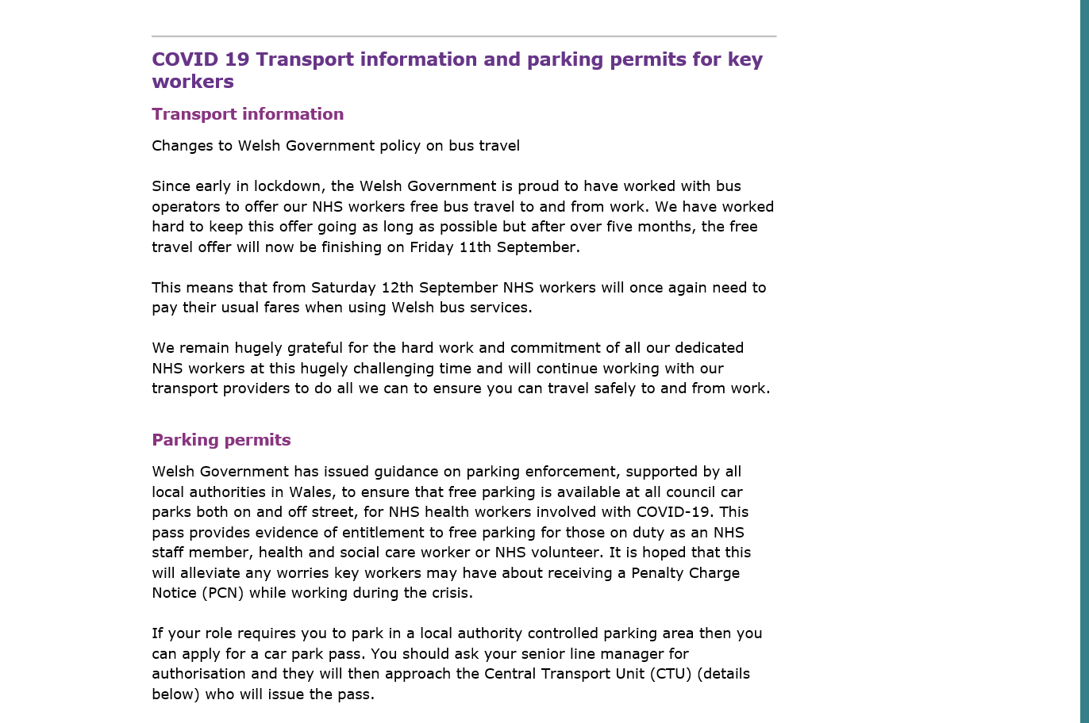

Well-being was a huge factor when Covid-19 rose its head. There were constant globals’ advising staff where to go to speak to people if they had any concerns. Reminding staff of the wide range of resources available. There was also free Psychological First Aid Training for staff to help staff develop skills and confidence in providing Psychological support to people affected by Covid-19. Including issues on job worries, bereavement or isolation.

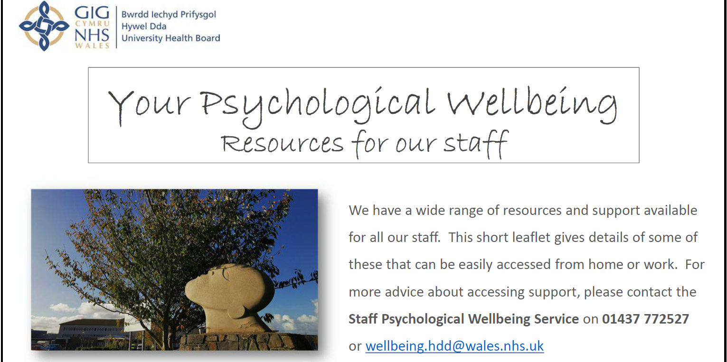

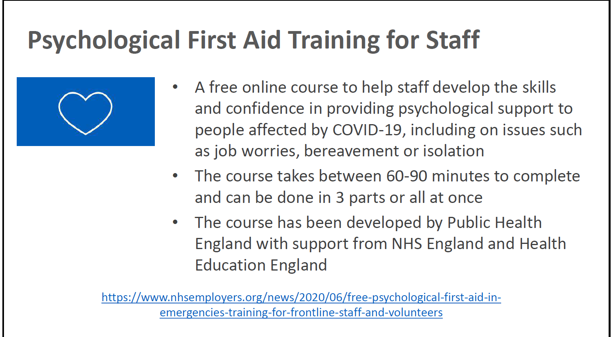

At a certain point there was an antibody test as guidance below shows the difference. This was not only relevant to clinical staff but all employees of Hywel Dda University Health Board and Workforce managers were advised that the test had to be taken by staff as soon as they were able. Managers were also advised as to staff testing, including guidance on how to risk assess staff to return to the workplace if identified as a contact of Covid-19 positive individual. This was bilingual.

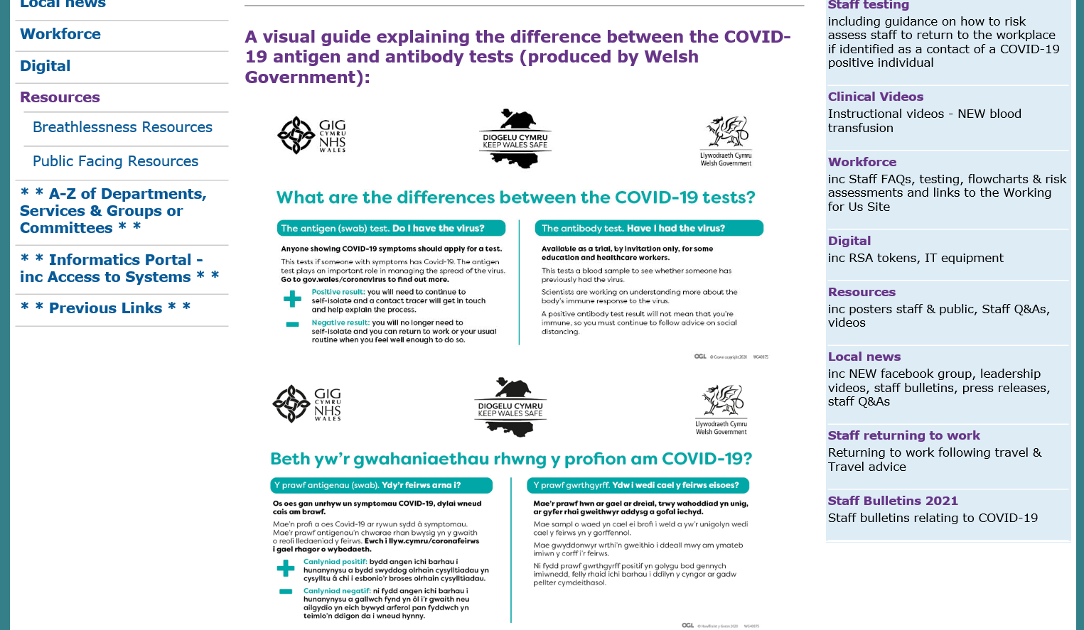

Some departments were required to have temporary redeployment/alternative duties principles. This due to the pandemic placing unprecedented challenges on the NHS Wales. With services reconfigured to respond to the increase in the demand and services provided had to change to adapt to fit in with this response. Roles were taken up on a temporary basis. Below is the context relating to this which was on the Health Board’s intranet site.

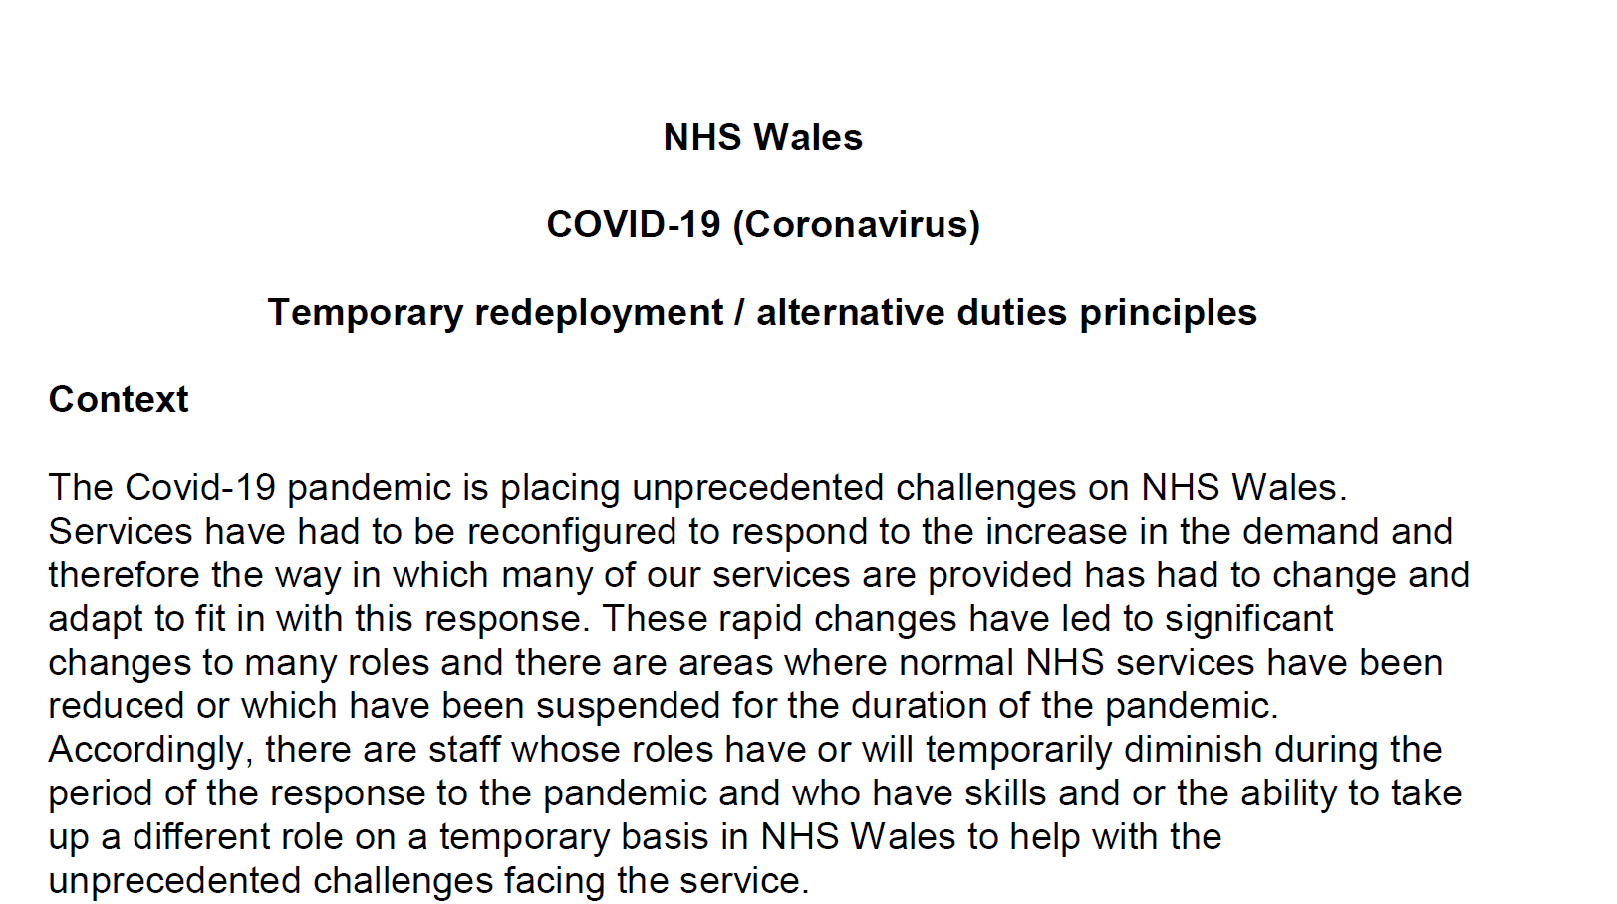

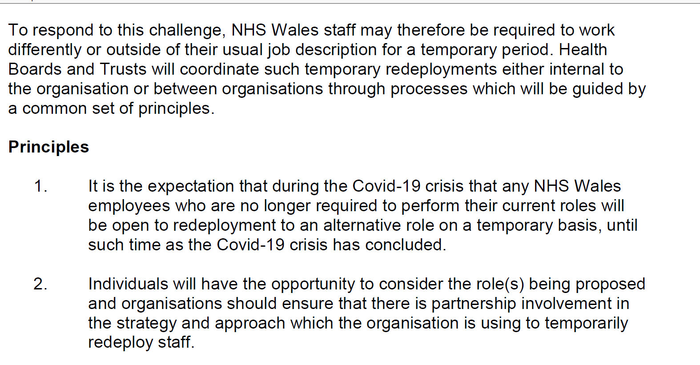
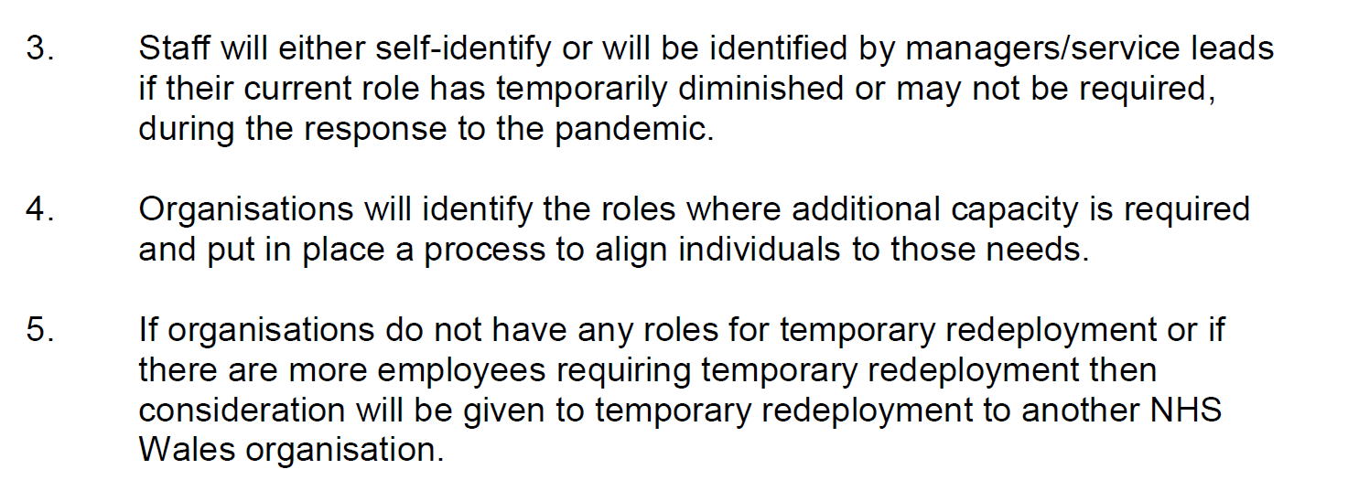
Workforce were also responsible providing Covid-19 Home Working Advice and Guidance for Managers and Staff, this in supporting the government’s strategy to delay the spread of the virus. To ensure that home working was effective approaches for the employer and employees needed to following thus ensuring individuals were supported when undertaking their roles. A snapshot of this is below. Along with links from ACAS, CIPD and HEIW.

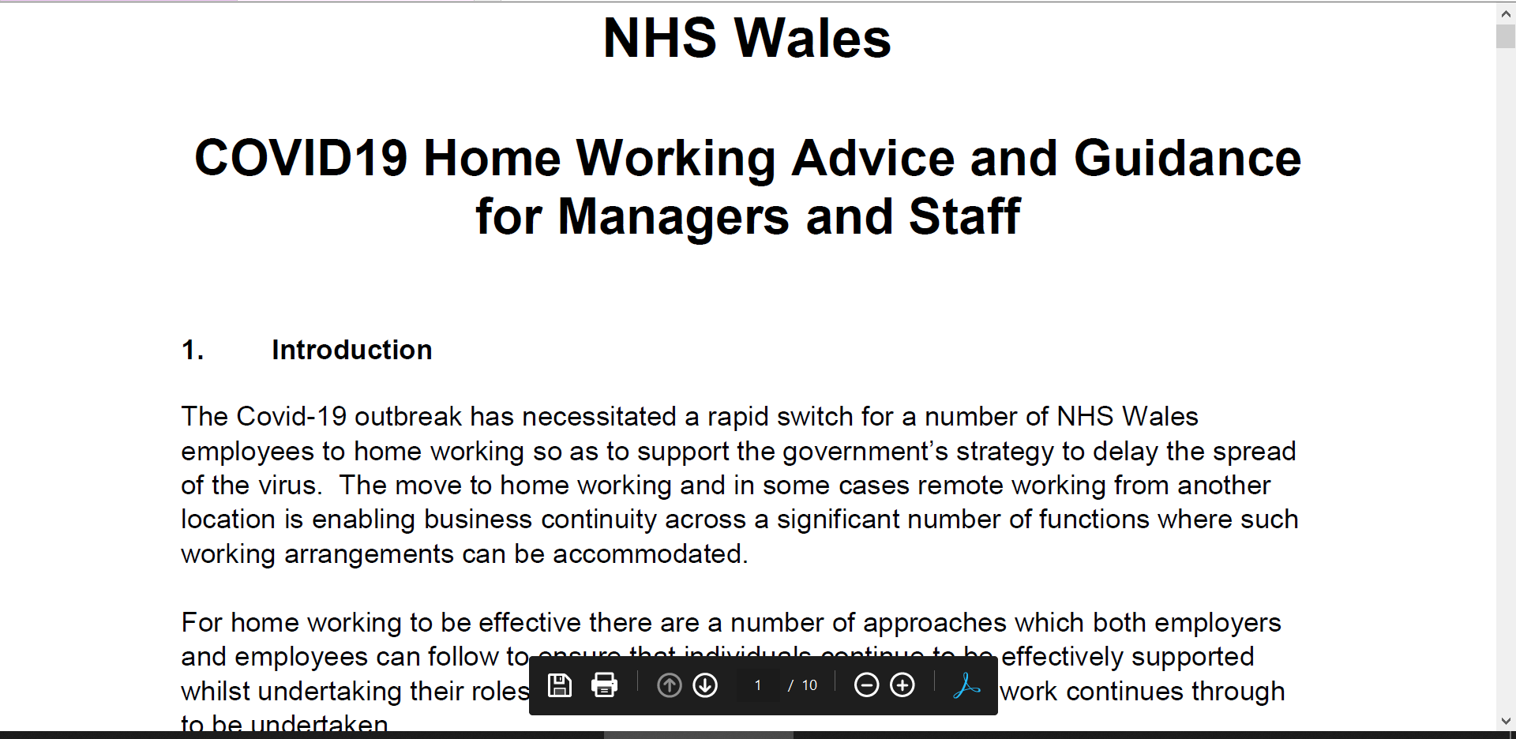
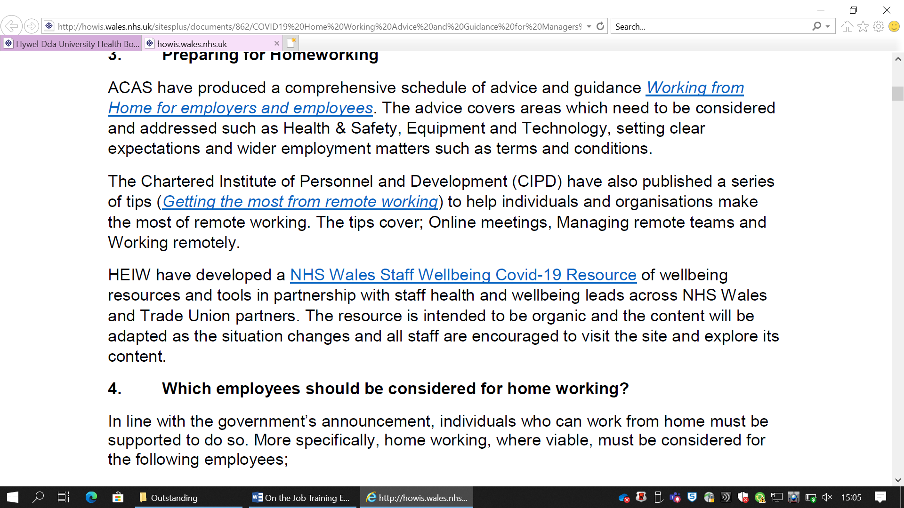
On 22nd October 2021 via the Collaborative teams there was a presentation from HR regarding Hybrid Working. There then was a Hybrid Working Questionnaire that was requested to be completed from Director of Workforce & OD.
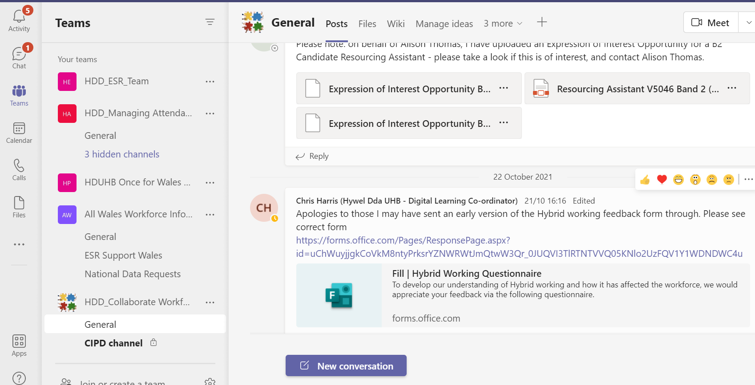
As mentioned earlier there is a Collaborative Workforce Teams and you will note from snapshots below the Head of Recruitment and Workforce Equality, Diversity and Inclusion launching HCSW (Bridging/Homecare) jobs. There has been and continues to be a real focus on recruitment in the Pandemic.

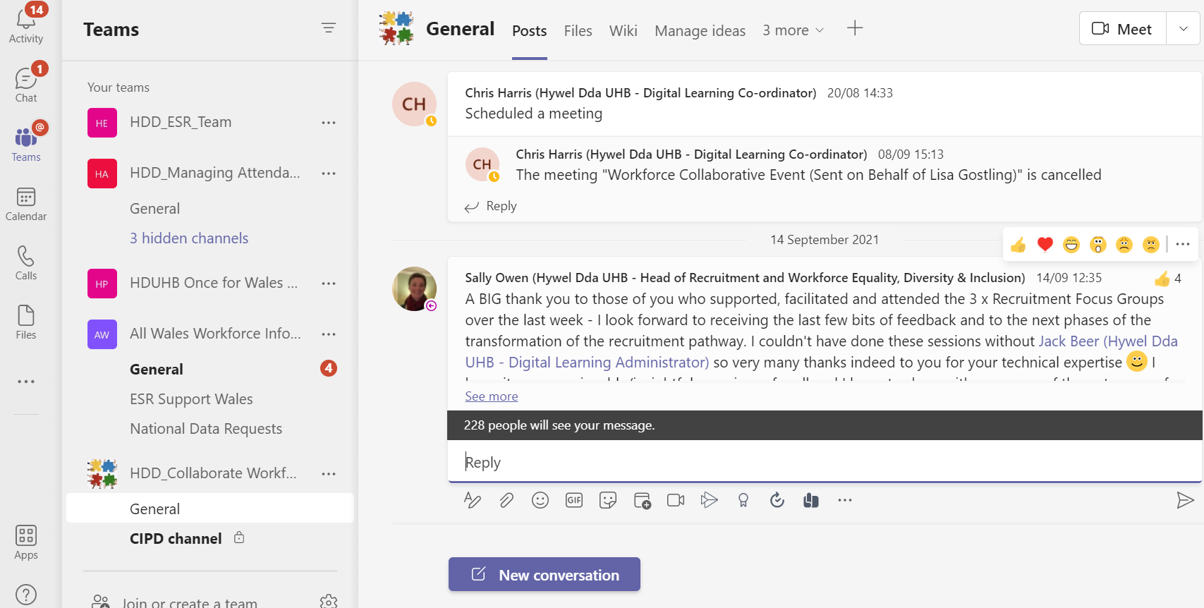

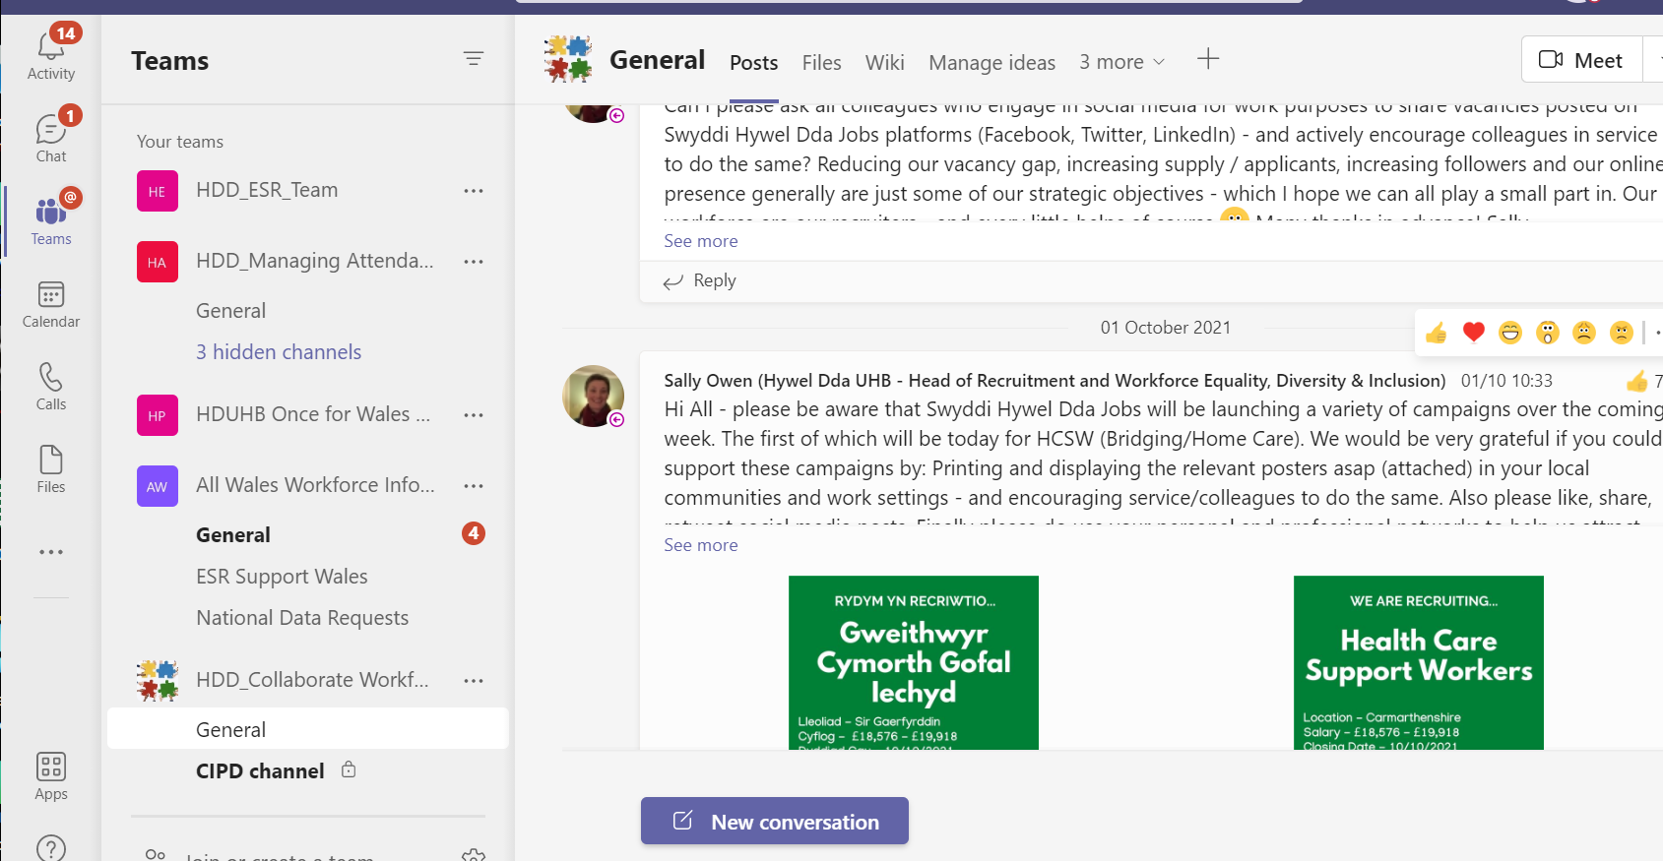
The report below shows the data on the COVID recruitment from Applicants to offers/withdrawals and the total appointed that Hywel Dda has done.

 | Applicants | Offers | Withdrawn / rejected | Total appointed
COVID | 1904 | 1292 | 335 | 957
COVID 2 | 1002 | 504 | 123 | 381
COVID 3 | 930 | 479 | 111 | 368
COVID 4 | 724 | 373 | 78 | 295
COVID 5 | 163 | 153 | 28 | 125
COVID 6 | 278 | 182 | 34 | 148
COVID 7 | 360 | 163 | 31 | 132
COVID 8 | 63 | 49 | 15 | 34
TOTAL | 5424 | 3195 | 755 | 2440

Reflection regarding the pandemic was the subject in one of the collaborative team meeting and below are some comments about the past year being challenging due to home working, home schooling, loved ones passing away, or very ill with Covid-19. Also how teams pulled together and adapted.

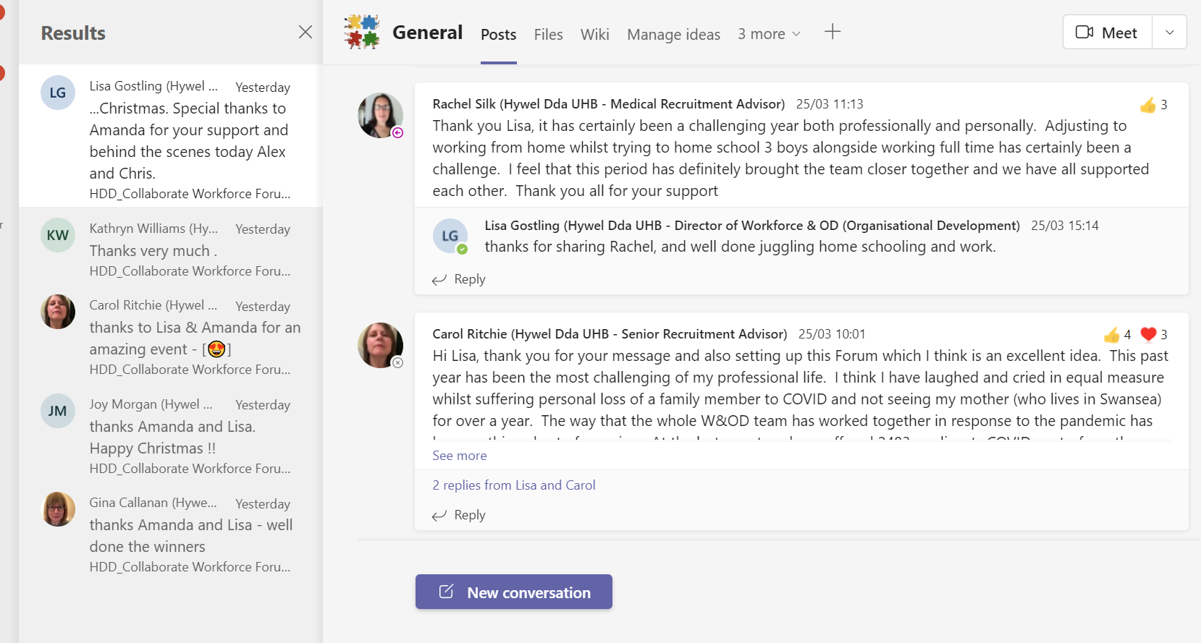
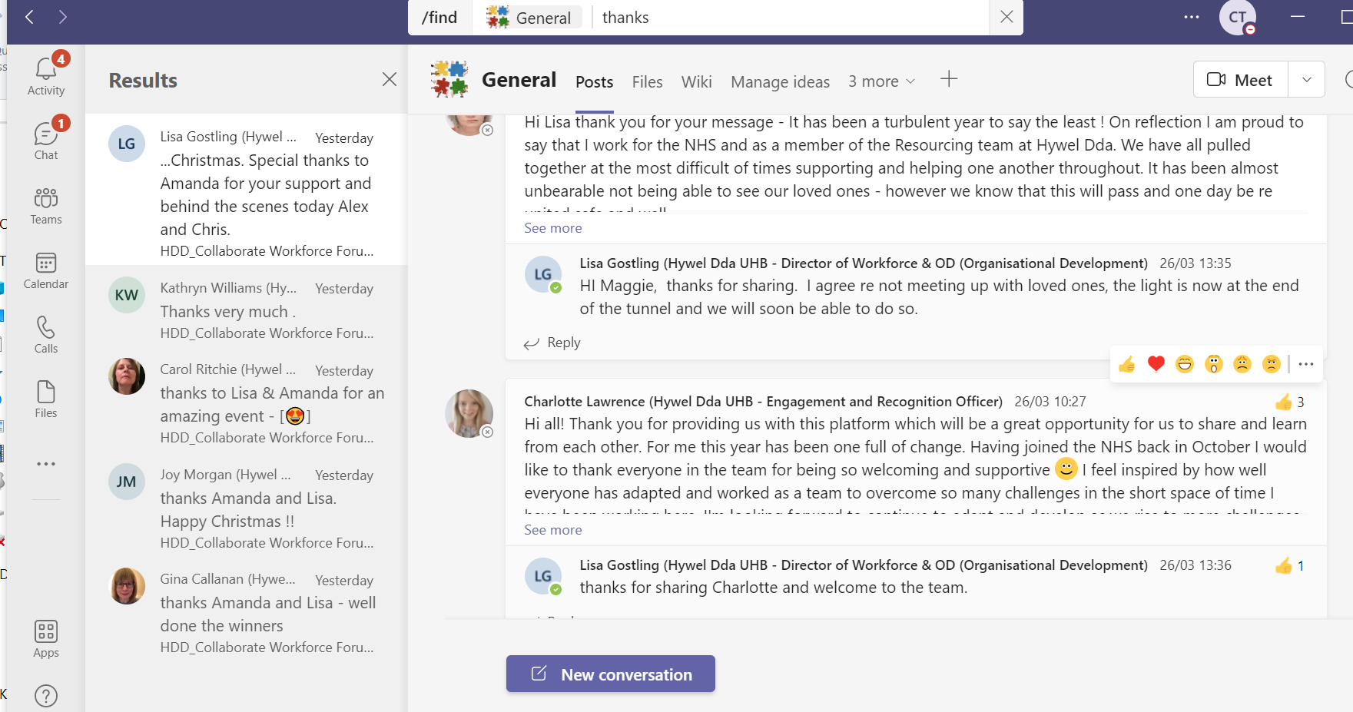

In December 2020 the Director of Workforce & OD saying a “Thank You” to all staff. Providing information on the struggle the Health Board has been up against. The recruitment department had recruited 1,500 people in 8 months. Undertook Occupational Health checks and training regarding new recruits. ESR Electronic Staff Record setup new positions for recruitment to advertise posts, setup rosters for Field Hospitals, expanded bank and Registered Nurses, extended 500 contracts for those recruited via the pandemic, responded to further demands for FOI requests and deployed staff across teams for priority areas of work.
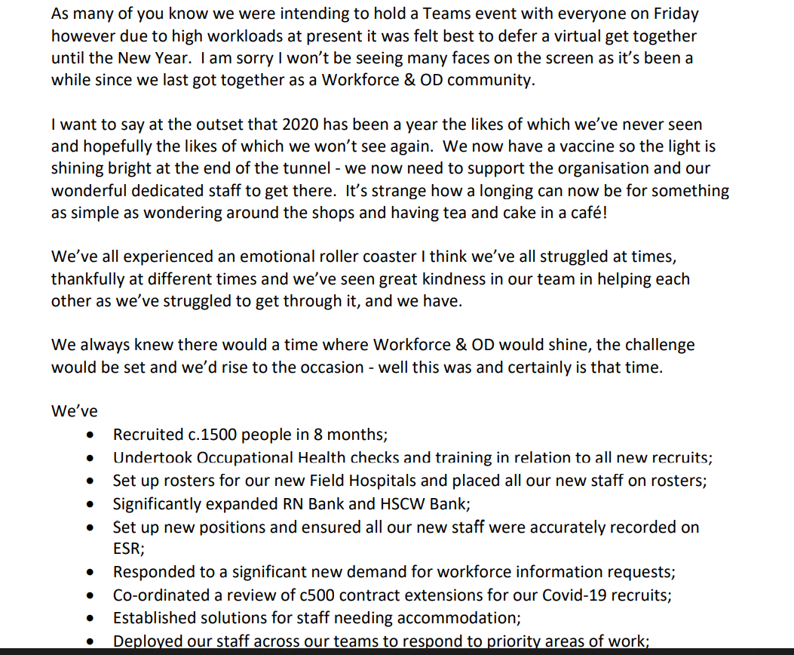

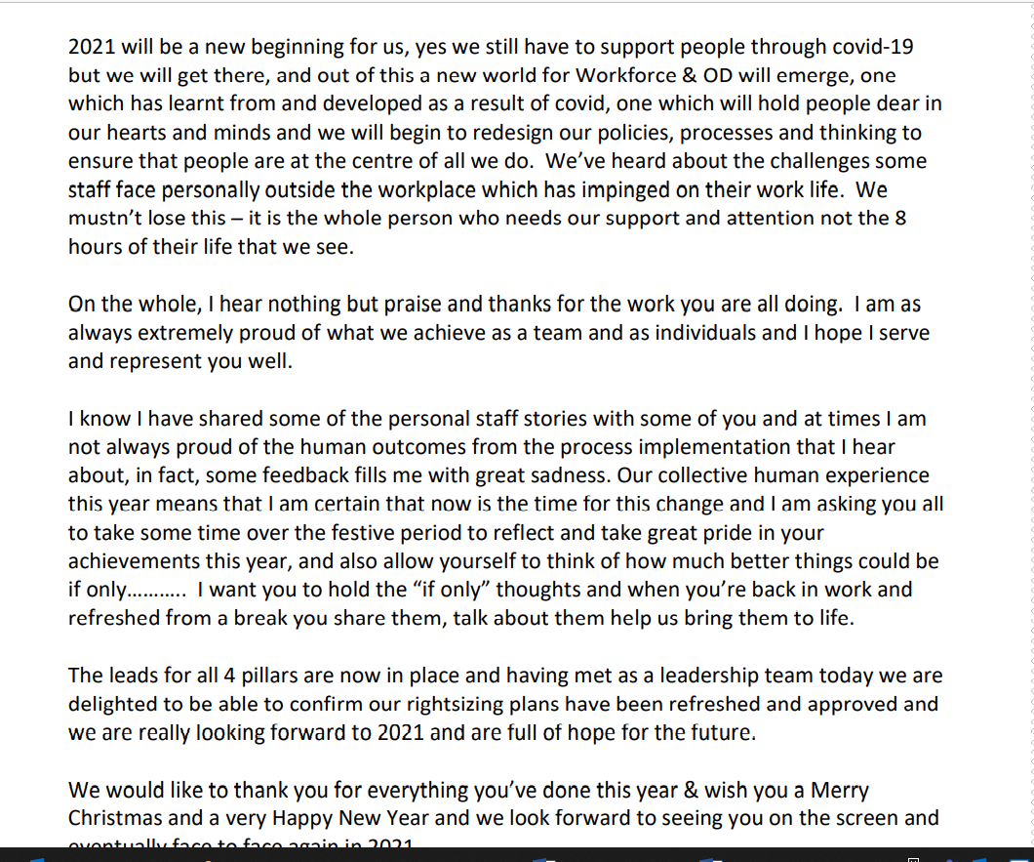
References

Hywel Dda University Health Board (2021). Intranet Page. Available at: http://howis.wales.nhs.uk/sitesplus/862/home (Accessed: 15 November 2021).

Hywel Dda University Health Board (2021). Workforce. Available at: http://howis.wales.nhs.uk/sitesplus/862/page/78068 (Accessed: 30 November 2021).

Welsh Government (2021) COVID-19 workforce risk assessment tool. Available at https://gov.wales/covid-19-workforce-risk-assessment-tool (Accessed: 7 December 2021).

