

The rise of Netease Cloud Music

Course：Digital Entrepreneurship

Name: Zhiyu Liu

Student ID: 1803782

Introduction

Netease Cloud Music was established on April 23, 2013. It is a music platform launched by China NetEase based on Netease Cloud Service. It mainly provides music playback, download and analysis services (Sisi, 2016). In April 2017, users exceeded 300 million. After only seven months, users exceeded 400 million and became one of the most popular applications in China.

Different from the traditional music sharing platform, NetEase Cloud is committed to the acquisition of music digital rights and has invested in another battlefield: the public (Hu, 2014). Netease Cloud Music changed the role of traditional music as a medium of communication, positioning its services to a music critic and publisher: the public can portray their favourite music as a story, or perhaps their own story, written as a beautiful song. Similar to the sharing economy, the ultimate result of P2P.

At the beginning of Netease Cloud Music, the entire project team was only a few dozen people, and only a few people were responsible for the market (including public relations, channels, and social networking) (Hu, 2014). The disadvantage of the number of people made the early Netease cloud music difficult. In the Chinese music market at the time, QQ music and various music sharing platforms from Tencent had already divided the entire online music market. Netease cloud music is challenging to break through. This article will start with the Porter Value Chain and analyse how Netease Cloud Music creates value gains in each link and gradually establish its competitive advantage.

Main body

In 1985, Porter divided the company's value-adding activities into two main parts. One was the necessary activities, including inbound logistics, operations, marketing, and services. The second was supportive activities, including procurement, technology development, human resource management and enterprise infrastructure construction. Among them, not every link creates value, and those that create value in the real sense are strategic links in the value chain. To maintain a competitive advantage, companies are creating an advantage over competitors in these value-creating activities (Harvey and Porter, 1988).

Based on the Porter’s Physical Value Chain (PVC)，Jefferey F. Rayport and John J. Sviokla, came up with Virtual Value Chain theory (VVC), Different from the Physical Value Chain, the Virtual Value Chain is based on the Internet, and the data flow formed by the network digital information is used to generate and transmit value (Van, 2011). Netease Cloud Music Company is its typical representative. Generally speaking, VVC is divided into three major modules: Content, Infrastructure and Context(Lin and Wu, 2010).
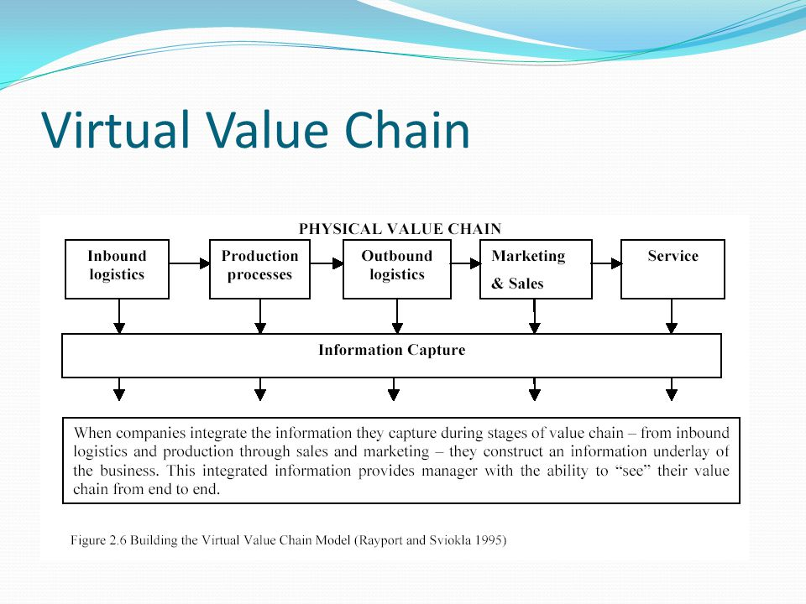

Throughout the VVC of Netease Cloud Music Company, and combined Porter’s Physical value chain, it can be roughly divided into the following joints.

Collection of music
Application design
Marketing activities
After-sales service
Primary activities
Support activities
Technical development
Human Resource Management system
Support activities

NetEase Cloud Music's virtual value chain
Start with the collection of music. The time when Netease Cloud Music was founded is precisely the highest point of the rise of digital recording. Consumers are not limited to hearing the idol voice by purchasing CD albums, and more choices in personal mobile terminals (such as mobile phones) to obtain music information. Netease Cloud Music Company has created a stable music source by purchasing a large number of digital albums, in order to attract a large number of fans to become their loyal customers (Yu and Shunko, 2017). Also, Netease Cloud launched a personal radio station to popularise the music creation process and source form. On this music exchange platform, everyone is the protagonist, and they can use their music to express their emotions and even seek friends with similar interests. The role of Netease Cloud in it, except for the necessary content review, is just a common communication platform and will not interfere with any market choices (Yu, 2017).

Second, it is the technical development process. NetEase has a group of excellent technical R&D personnel. Its “Scene Cloud Service” and Big Data Computing can effectively and quickly help Netease Cloud Music to locate service objects. In August 2017, NetEase technicians once again launched “Scenario Cloud Service + Exclusive Cloud”, and its business covered 700 million end users, and provided a large amount of data support for 350,000 enterprise customers (Zhen, 2017). Benefiting from the strong technical capabilities of the parent company, NetEase Cloud Music has taken the lead in robbing customers of competition.

Third, it is the superior terminal application construction of Netease Cloud Music. The ability of enterprise infrastructure construction is an essential foundation for a company to move toward strength (Hu, 2014). Netease cloud music as an online music platform, the quality of the application directly determines its popularity in the market. By analysing the primary audience, Netease Cloud Music recruited a large number of young designers to design an application look that is unique to young people's aesthetics. At the same time, precious and optimised interface settings, users can design their appearance through their preferences, in the real sense of personalised service.

The fourth is the great marketing activities of Netease Cloud Music. NetEase knows that its primary audience is a large number of young people, so it has organised a large number of offline activities, invited famous singers and network reds to go deep into the university for product promotion. At the same time, NetEase is a game company. 85% of its operating revenue comes from the game industry (Wang, 2014). Netease cloud music is bound to music played in the game and has a large number of loyal customers. Besides, with the current hot big data analysis and digital marketing, NetEase Cloud pushes specific service content to specific target customers through "peer-to-peer" services and differentiates services to the extreme.

The fifth is the meticulous after-sales service of Netease Cloud Music. After choosing to use Netease Cloud Music, customers are incorporating themselves into the entire Netease cloud service system. From email to games, music to video, customers can choose their favourite products. Also, after purchasing the digital album in Netease Cloud, NetEase Cloud will give a large number of offline coupons, customers can choose and replace according to their needs (Wang, 2014). At the same time, if the customer encounters a variety of problems, 24-hour online customer service will help solve.

The last point is the different human resource management system of Netease Cloud Music and other music companies. Since NetEase Cloud Music Company is more engaged by the whole people, the music publishers on the platform are not limited to limited famous singers, but more ordinary people. On this basis, everyone can be an employee of Netease Cloud. Netease Cloud Music does do the same. Excellent "customers" will be invited by Netease Cloud to participate in a series of offline and online activities, and use the opportunity to participate in product design and decision making directly. On the whole, Netease Cloud Music is no longer a leader in the traditional sense, and more is a music platform production participant, the future of the product is handed over to the people who use the product.

Although the above points belong to all stages of the value chain, they all lay a solid foundation for Netease Cloud Music to establish its market position. From the initial collection of music to the final after-sales service, every step is crucial, and each step gradually forms a competitive advantage for other competitors. Unique music collection methods and productive marketing methods make NetEase cloud music popular among the masses. At the same time, excellent R&D technology gives its "peer-to-peer service" technical support, The complete infrastructure construction and meticulous after-sales service make itself stand out, and finally, the unique human resource management system makes the products to the next level.

Conclusion

Netease Cloud Music is not just a music platform, and its purpose is to become "understand your music platform." From collecting music to making music, everyone participates in every step. The success of Netease Cloud Music is not accidental. From the previous Airbnb to the later Uber, we can see that the more profound the customer participates in the value system, the higher the benefits the company can get. For this series of digital companies, the ability to deal with the critical issue of customer relationship has, to a certain extent, determined the level of future success.

Reference

Harvey, M. and Porter, M. (1988). Competition in Global Industries. Journal of Marketing, 52(1), p.150.

Hu, Z. (2014). Netease cloud music "host radio" online everyone can be "host". [online] Guangdong: Guangdong News Network. Available at: http://ww.gd.chinanews.com/2014/2014-10-29/2/333948.shtml [Accessed 17 Apr. 2019].

Lin, L. and Wu, J. (2010). Virtual Value Chain and Competitive Advantages in the Context of E-commerce. 10th ed. Jiangsu: Jiangsu University, pp.1467-1472.

Rayport, J. F. & Sviokla, J. J. (1995). Exploiting the virtual value chain. Harvard Business Review, 73(6), 75

Sisi, L. (2016). Netease cloud music: 3 years of user growth of 200 million, the word of mouth is the best marketing tool. [online] Mediaclub.cc. Available at: http://www.mediaclub.cc/News/infos/id/6695 [Accessed 17 Apr. 2019].

Van Vliet, V. (2010). Virtual Value Chain model. Retrieved [insert date] from ToolsHero: https://www.toolshero.com/problem-solving/virtual-value-chain/
Wang, Y. (2014). Netease Announces Unaudited Financial Results for the Fourth Quarter of 2013 and the Financial Year 2013. [online] Corp.163.com. Available at: http://corp.163.com/14/0213/06/9KUOVLM900832V3T.html [Accessed 17 Apr. 2019].

Wang, X. (2014). Netease cloud music teamed up with Uber to fight Mercedes-Benz, not afraid of expensive. Guangdong: Netease Technology.

Yu, J. (2011). What Role Does Political Environment Play in Economic Development? - A Case Study of China. SSRN Electronic Journal.

Yu, Q. and Shunko, M. (2017). A Quality Value Chain Network: Linking Supply Chain Quality to Customer Lifetime Value. SSRN Electronic Journal.

Zhen, W. (2017). Netease cloud "scene cloud service + exclusive cloud" attracted attention. Beijing: Xinhua website.

Bibliography

DONG Cheng-hui. Sharing Economy: Theory and Reality[J]. Journal of the Guangdong University of Finance Economics, 2016,31(5): 4-12.

M.sohu.com. (2017). Netease cloud music users exceeded 400 million. [online] Available at: https://m.sohu.com/a/204880748_161623/?pvid=000115_3w_a [Accessed 17 Apr. 2019].

Statistical bulletin on national science and technology funding in 2013. (2014). 4th ed. Beijing: National Bureau of Statistics, p.1.

Sainathan, A. (2017). Customer Differentiation with Shipping as an Ancillary Service? Free Service, Prioritization, and Strategic Delay. Decision Sciences, 49(4), pp.690-727.

Strategy and the Internet. (2019). [video] Directed by M. Porter. Slideplayer.

Trench, M. (2017). ARTIFICIAL INTELLIGENCE THE NEXT DIGITAL FRONTIER?. 7th ed. London: McKinsey Global Institute.

