Understanding the Role of Statistics in Machine Learning and Data Science
Modern machine learning and data science rely strongly on statistical methods to analyse data, build predictive models, and support decision-making. The main idea explored in this report is how statistics provides the theoretical and practical foundation for machine learning and artificial intelligence (AI). Statistical techniques are essential in model development, feature selection, inference, and model validation.

Research literature shows that statistics and machine learning are closely related disciplines. Bzdok, Altman, and Krzeminski [1] explain that statistics mainly focuses on inference and understanding relationships within data, while machine learning focuses on prediction and pattern recognition. Statistical inference allows researchers to test hypotheses and measure uncertainty through tools such as probability distributions, confidence intervals, and hypothesis testing. Machine learning algorithms use these statistical principles to identify patterns and make predictions from large datasets.

Kroese et al. [2] further discuss how data science combines statistics, mathematics, and computer science to process structured and unstructured data. Their work highlights the importance of statistical models such as regression analysis, Bayesian methods, clustering, and principal component analysis (PCA). These techniques are widely used for feature selection, reducing data complexity, and improving prediction accuracy. The authors also emphasize that validation techniques such as cross-validation and error analysis are necessary to evaluate model performance and avoid overfitting.

Similarly, Jalajakshi and Myna [3] describe statistics as one of the most important disciplines in data science. Their study explains that methods such as linear regression, logistic regression, support vector machines (SVM), random forests, and Bayesian analysis help improve data interpretation, classification, and optimization. The paper also explains the importance of descriptive and inferential statistics in summarizing data and making reliable conclusions from big data applications.
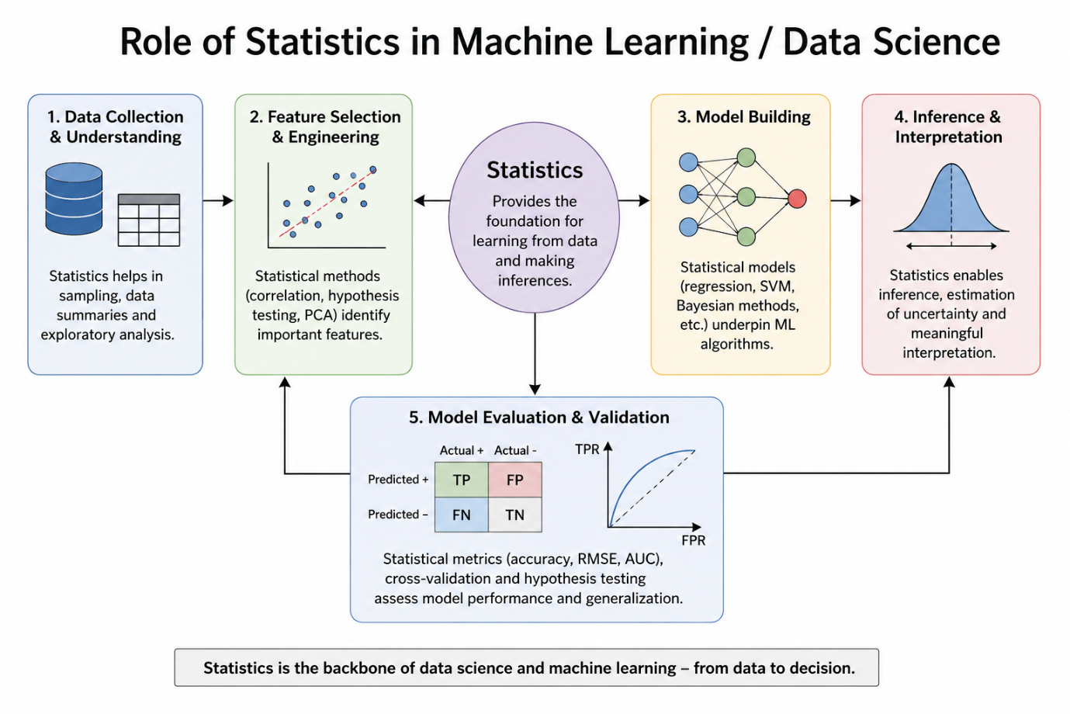
Figure 1: Statistical Methods Supporting Machine Learning Workflows

Overall, the literature demonstrates that classical statistical methods strongly influence modern data science workflows. Statistics helps researchers collect, analyse, interpret, and validate data efficiently. Without statistical reasoning, machine learning models would lack reliability, interpretability, and accuracy. Therefore, statistics remains a fundamental component in the development of modern AI and machine learning systems.

References
[1] D. Bzdok, N. Altman, and M. Krzywinski, “Statistics versus machine learning,” Nature Methods, vol. 15, no. 4, pp. 233–234, 2018.
[2] D. P. Kroese, Z. I. Botev, T. Taimre, and R. Vaisman, Data Science and Machine Learning: Mathematical and Statistical Methods. Boca Raton, FL, USA: CRC Press, 2019.
[3] J. V. and M. A. N., “Importance of statistics to data science,” Global Transitions Proceedings, vol. 3, no. 1,

