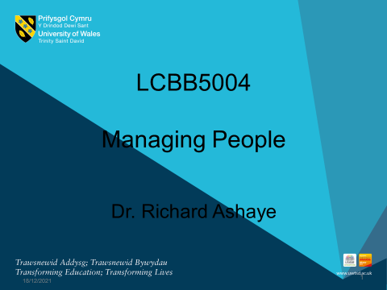

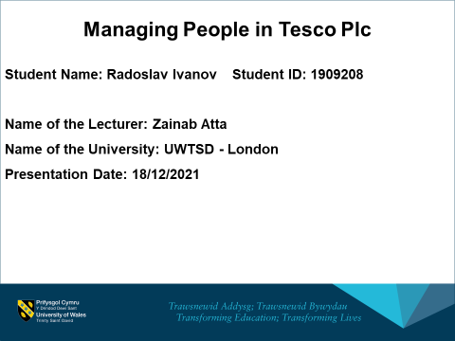
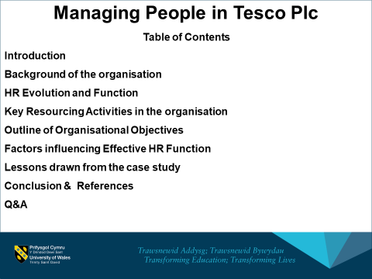

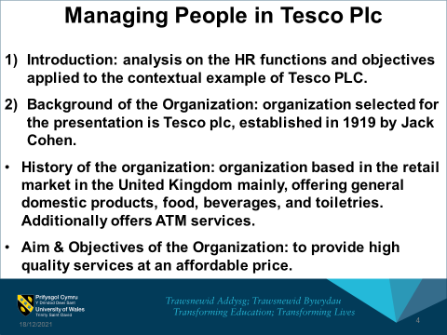

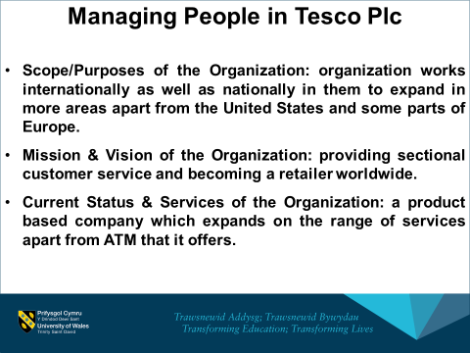

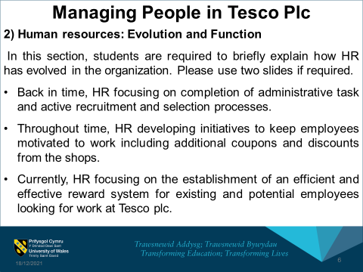
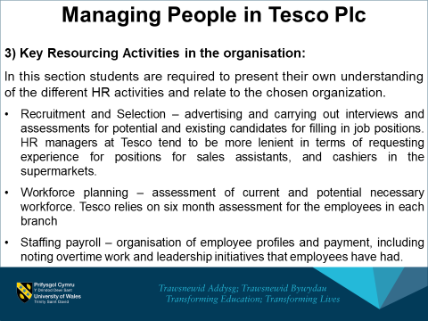

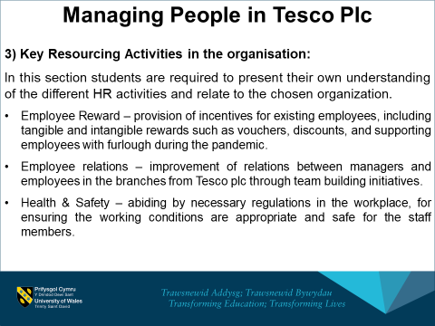
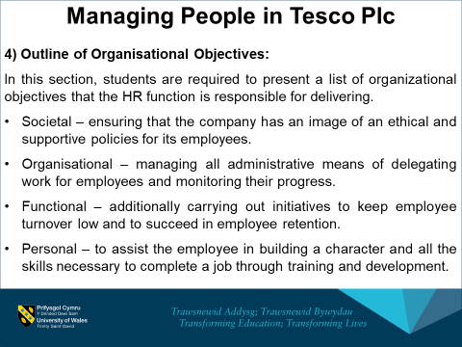

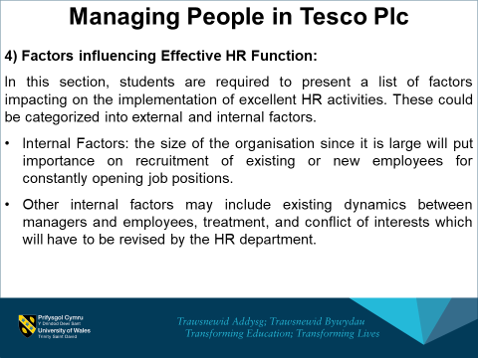
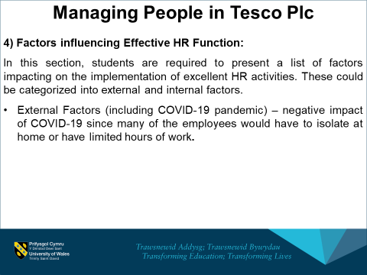

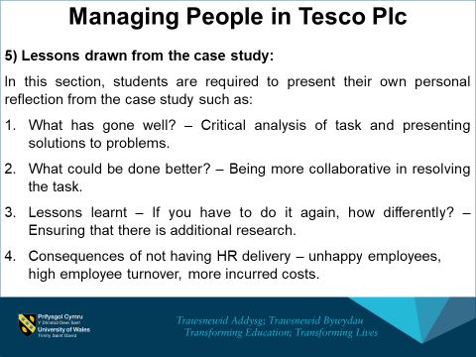
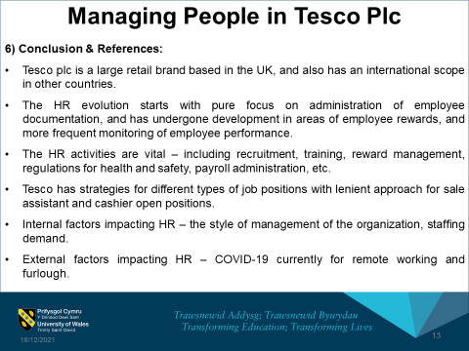

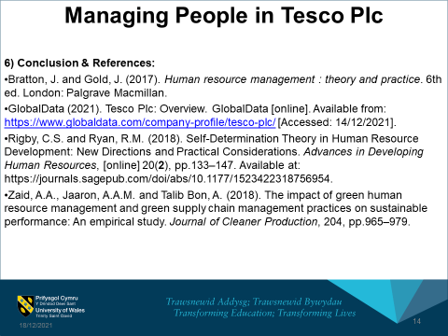
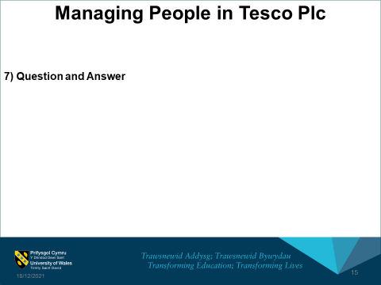

6) Conclusion & References:
Bratton, J. and Gold, J. (2017). Human resource management : theory and practice. 6th ed. London: Palgrave Macmillan.
GlobalData (2021). Tesco Plc: Overview. GlobalData [online]. Available from: https://www.globaldata.com/company-profile/tesco-plc/ [Accessed: 14/12/2021].
Rigby, C.S. and Ryan, R.M. (2018). Self-Determination Theory in Human Resource Development: New Directions and Practical Considerations. Advances in Developing Human Resources, [online] 20(2), pp.133–147. Available at: https://journals.sagepub.com/doi/abs/10.1177/1523422318756954.
Zaid, A.A., Jaaron, A.A.M. and Talib Bon, A. (2018). The impact of green human resource management and green supply chain management practices on sustainable performance: An empirical study. Journal of Cleaner Production, 204, pp.965–979.

