

University of Wales Trinity Saint David
Master of Business Administration (MBA)

The Influence of National and International Labour Markets on HRM and IHRM Strategies
Module Name: Human Capital Management
Module Code: LCMB7023
Lecturer’s Name: Ejike Udeogu
Student Name: HEMANG AMRUTBHAI DESAI
Student ID: 2438589
Word Count: 2528
Submission Date: 17/10/2025

Table of Contents

Q1. Technological Advancements and Their Implications for HRM and IHRM Strategies 3
Q2. Demographic and Geopolitical Factors Influencing Employment Markets and Challenges for HR Professionals 5
Q3. Addressing Skills Gaps and Talent Shortages in Critical Sectors through Strategic HRM 8
Q4. Reflective Report on Capabilities for Working in an International and Technological Context 10
References 14
Appendix A – Critical Evaluation and Evidence Matrix 16

Q1. Technological Advancements and Their Implications for HRM and IHRM Strategies
The modern labour market is being transformed by rapid technological evolution that is reshaping both employment structures and human resource management practices. Artificial intelligence (AI), automation, and digital platforms are redefining the nature of work, demanding new skill sets and altering how organisations attract, develop, and retain talent (World Economic Forum, 2023). In Australia and globally, HRM and IHRM professionals are shifting from traditional administrative functions toward data-driven, strategic roles that integrate technology into every stage of the employee lifecycle. The convergence of AI, big data analytics, and human capital information systems (HCIS) has created an environment where decisions about workforce planning, performance management, and global collaboration are increasingly grounded in digital intelligence (OECD, 2024). This transition is transforming HR from a support function into a strategic business partner capable of leveraging technology to achieve agility, inclusivity, and competitiveness in dynamic labour markets.
  - Technological Advancements
The fourth industrial revolution has accelerated technological change through AI, robotics, and advanced data analytics, enabling automation across multiple HR functions. Repetitive tasks such as payroll processing, interview scheduling, and employee data management are now automated, freeing HR professionals to focus on strategic initiatives (ILO, 2023). Modern HR ecosystems integrate predictive analytics to anticipate turnover, identify emerging skill gaps, and model workforce demand scenarios (Deloitte, 2024).
In Australia, the government’s Future Skills and Workforce Strategy 2024 supports organisations in reskilling employees through micro-credentialing and digital learning platforms (Australian Government Department of Employment and Workplace Relations, 2024). These systems enable personalised learning pathways that align employee development with future job demands. Technological transformation within HR can be seen through:
- AI-based recruitment using machine learning algorithms to screen and rank candidates objectively.
- Digital collaboration tools such as Microsoft Teams and HRIS systems, enhancing productivity and cross-border communication.
- Cloud-based HR data systems that provide real-time analytics, supporting talent mobility and compliance monitoring across global subsidiaries (CIPD, 2023).
(1.2) Implications for HRM and IHRM Strategies
The impact of technology on HRM and IHRM extends beyond efficiency it is redefining strategic capability. At the national level, HR managers are adopting data analytics-driven decision-making to optimise workforce planning, enhance engagement, and measure productivity outcomes. HRM now relies on integrated systems such as Workday and SAP SuccessFactors to link performance, compensation, and learning under a unified data framework (Deloitte, 2024).
Internationally, IHRM is being transformed through digital global workforce coordination. Remote work, virtual expatriation, and cloud-enabled collaboration have created new models of cross-border employment (Tarique and Schuler, 2023). Advanced Human Capital Information Systems (HCIS) allow multinational firms to:
- Monitor global compliance with data protection and labour laws.
- Manage talent mobility and knowledge transfer among regions.
- Evaluate workforce trends using centralised dashboards for real-time insights (Schuler, Jackson and Tarique, 2011).
However, these advances introduce challenges including data privacy concerns, algorithmic bias, and the ethical use of AI in HR processes. Addressing these requires robust digital governance frameworks, employee digital literacy programs, and ethical auditing systems to safeguard fairness (CIPD, 2023). As a result, technology has repositioned HRM and IHRM as digitally empowered disciplines that balance automation with human insight, ensuring adaptability and resilience within globally integrated labour markets.

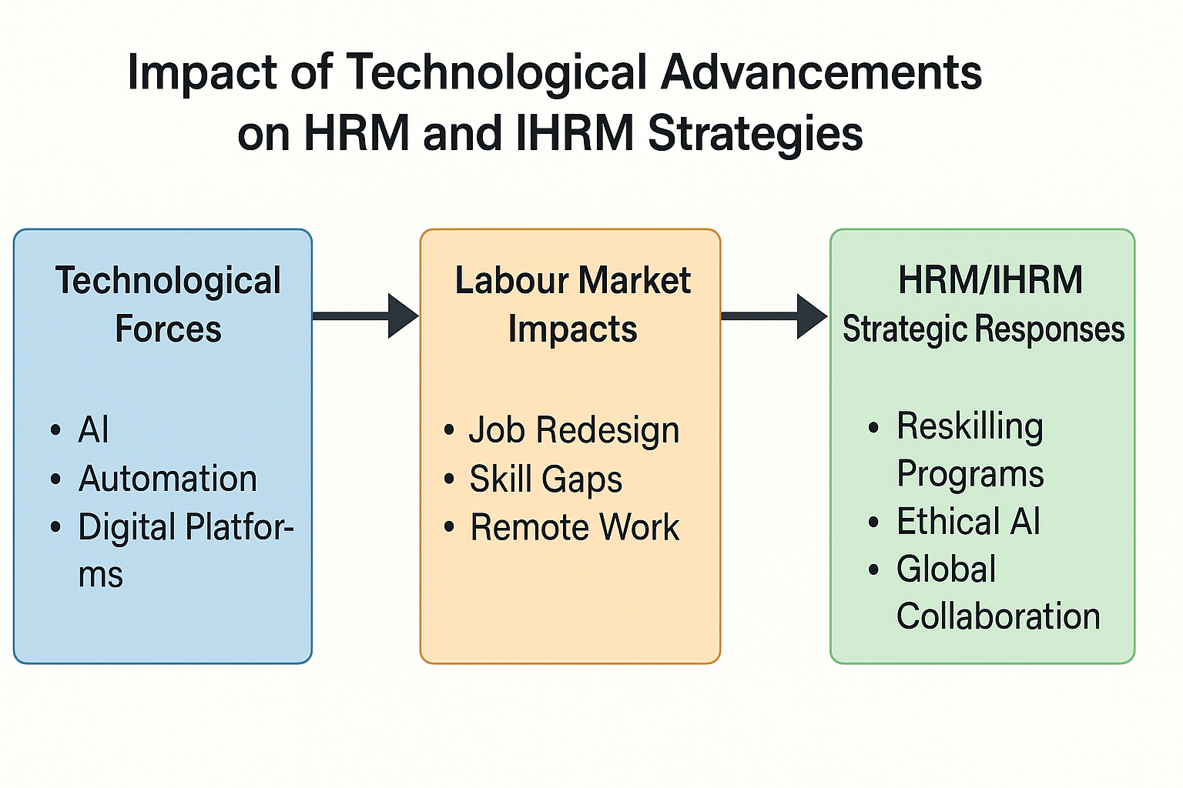
Figure 1. Impact of Technological Advancements on HRM and IHRM Strategies

Q2. Demographic and Geopolitical Factors Influencing Employment Markets and Challenges for HR Professionals
Demographic change and geopolitical dynamics are exerting transformative pressure on employment markets globally and within Australia. Evolving population structures, migration patterns, and geopolitical instability are collectively reshaping workforce composition, skill availability, and talent mobility (OECD, 2024). These shifts are forcing organisations to re-evaluate workforce strategies and compelling HR professionals to develop adaptive, technology-enabled responses that address both local and international workforce challenges (ILO, 2023).
(2.1) Demographic and Geopolitical Factors Influencing Employment Markets
The demographic profile of the workforce is changing rapidly. Australia’s ageing population is expanding, with workers aged over 55 representing a growing share of the labour force, increasing the urgency for succession planning and flexible retirement policies (Australian Government Department of Employment and Workplace Relations, 2024). Simultaneously, younger employees are entering the labour market with expectations centred on flexibility, hybrid work, and purpose-driven employment (CIPD, 2023). These contrasting generational needs have redefined employee engagement models and talent retention strategies.
Technological literacy is a definitive employability factor whose digital divides are unevenly distributed among the older generations. To cope with this, HR departments are investing in predictive workforce analytics and micro-credentialing solutions to predict the possible shortages and to support reskilling (Deloitte, 2024). Gender and cultural diversity are also equally important demographic factors; the workplaces that are inclusive are also associated with increased innovation and retention. In line with these most Australian organisations have developed diversity dashboards and AI-based hiring audits to facilitate equitable recruitment and representation (OECD, 2024).
Regional conflicts, trade realignments and restrictive migration policies have led to the destabilisation of global labour markets on the geopolitical front. The skilled migration intake has been varying in Australia due to the changing visa programs and international competition of the key workers (World Economic Forum, 2023). The multinational organisations are subjected to the tightening of the complexity in the management of compliance, data security and movement of talent across borders. Due to this, Global Talent Management (GTM) systems are being used to bring together workforce data, remote employment models and legal consistency across regions (Tarique and Schuler, 2023).
(2.2) Challenges for HR Professionals
Geopolitically, global labour markets have been destabilised due to regional wars, trade re-aligning and reductions in migration. The professional migration intake has been fluctuating in Australia with the evolving visa schemes and the global ambiguity of rivalry of the key workers (World Economic Forum, 2023). The cross-border complexity of managing compliance, data flow and transfer of talent is tightened in the multinational organisations. As a result, Global Talent Management (GTM) systems are being employed to integrate data of workforce, remote employment models and legal uniformity which effortlessly cuts across regions (Tarique and Schuler, 2023).
HR professionals need to therefore adopt data inspired agility by incorporating workforce projection models and scenario planning in HR strategy. This involves:
- Simulating workflow changes with AI workforce simulators.
- Implementing cross-cultural leadership programs to manage distributed teams.
- Strengthening cyber and data governance frameworks to ensure ethical compliance.
From an IHRM perspective, the ability to coordinate global workforce strategies while maintaining local responsiveness has become a key differentiator of organisational success (Tarique and Schuler, 2023). The future of HR leadership lies in balancing technological efficiency with human-centred inclusivity enabling organisations to sustain resilience in the face of demographic imbalance and geopolitical uncertainty.
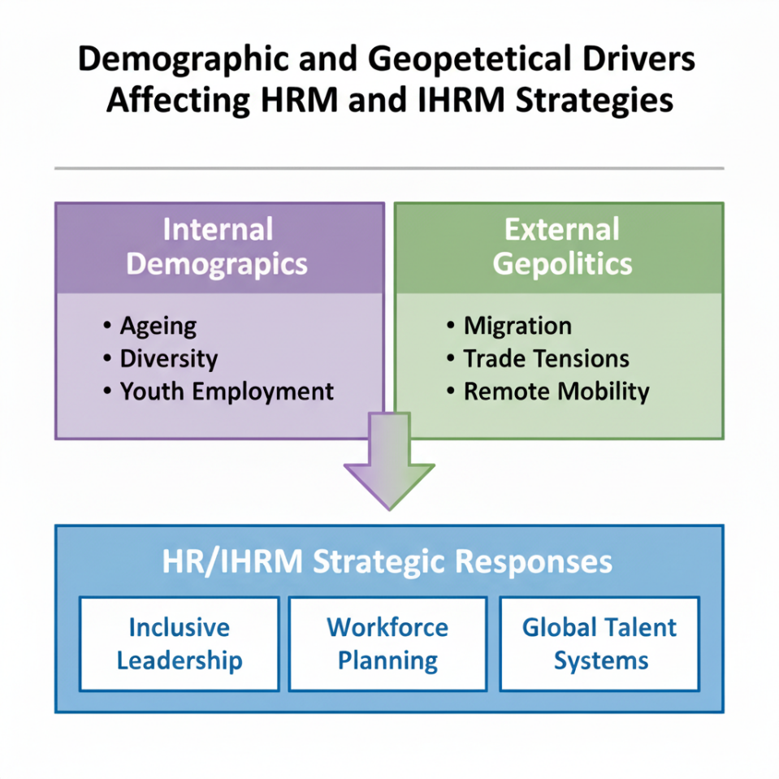
Figure 2: Demographic and Geopolitical Drivers Affecting HRM and IHRM Strategies

Q3. Addressing Skills Gaps and Talent Shortages in Critical Sectors through Strategic HRM
Skills gaps and talent shortages have become a persistent structural challenge across both national and international labour markets. In Australia, these shortages are particularly acute in technology, healthcare, and education, while globally they extend to logistics and advanced manufacturing (OECD, 2024). The primary causes include technological disruption, demographic ageing, and an education-to-employment mismatch that limits the availability of job-ready talent (World Economic Forum, 2023). Strategic Human Resource Management (SHRM) is therefore critical to predicting, mitigating, and bridging these deficits through workforce analytics, capability development, and international talent mobility.
(3.1) Skills Gaps and Talent Shortages in Critical Sectors
Australia’s Future Skills and Workforce Strategy 2024 identifies advanced digital, cybersecurity, and engineering skills as priority areas for development (Australian Government Department of Employment and Workplace Relations, 2024). Similarly, the OECD (2024) reports that over 60% of global employers face hiring difficulties, especially in STEM-related roles. Skill shortages arise primarily from:
- Technological acceleration, which outpaces traditional workforce training (Deloitte, 2024).
- Demographic ageing, which reduces labour participation; and
- Educational misalignment, where qualifications do not match evolving job requirements.
To address this, organisations increasingly use predictive workforce analytics to forecast demand, track attrition, and map future capability needs. AI-based HR dashboards analyse performance and labour trends, allowing precise interventions in recruitment and reskilling (CIPD, 2023). For instance, Australian healthcare networks are integrating AI-enabled training modules for telehealth roles, while technology firms deploy digital learning pathways for coding and automation skills.
Global labour shortages have also accelerated the use of remote employment ecosystems, allowing organisations to source talent internationally. However, this introduces IHRM complexities related to legal compliance, taxation, and cross-cultural management (Tarique and Schuler, 2023). As a result, HR professionals are required to balance global integration with local responsiveness, supported by digital talent platforms that ensure workforce visibility and flexibility.
(3.2) Addressing Skills Gaps through Strategic HRM
Strategic HRM integrates analytics, technology, and policy alignment to build future-ready workforces. It focuses on long-term capability development rather than short-term recruitment fixes (Schuler, Jackson and Tarique, 2011). Effective SHRM responses include:
- Workforce Planning: Using AI-driven models to forecast skill needs and succession risks.
- Learning and Development: Delivering targeted, modular training and continuous digital upskilling.
- Employer Branding: Enhancing the Employee Value Proposition (EVP) through flexibility, inclusion, and innovation (CIPD, 2023).
- Global Talent Mobility: Expanding digital expatriation programs and cross-border collaborations (Tarique and Schuler, 2023).
At the macro level, collaboration between government, academia, and industry is essential to maintain labour sustainability. The Australian Government’s vocational frameworks emphasise lifelong learning and industry partnerships, while HR leaders operationalise these through data-informed, inclusive workforce strategies.
Through proactive planning and evidence-based decision-making, SHRM transforms skill shortages into opportunities for innovation and competitiveness. By embedding analytics, learning agility, and global coordination, HR professionals ensure workforce resilience in a rapidly evolving economic landscape.

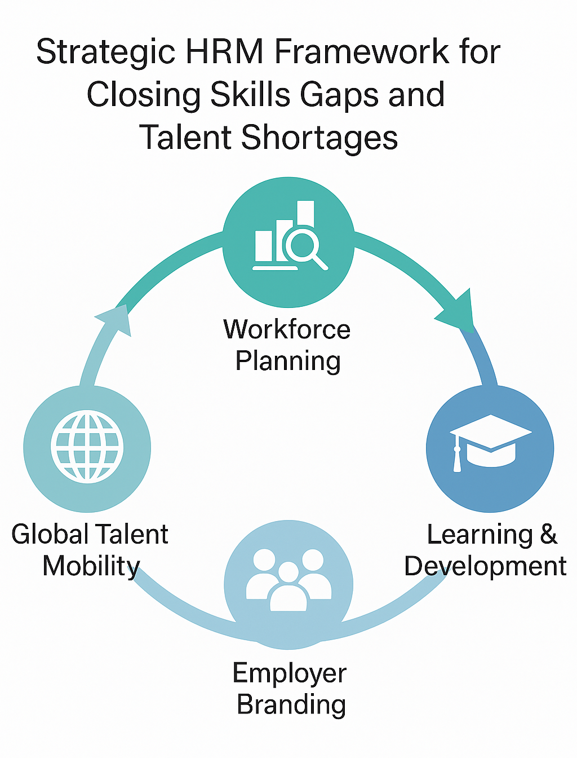

Figure 3: Strategic HRM Framework for Closing Skills Gaps and Talent Shortages

Q4. Reflective Report on Capabilities for Working in an International and Technological Context
In today’s globalised workplace, professionals are required to operate across diverse cultural boundaries while continuously adapting to technological advancement. This reflection evaluates my current capabilities in five areas technology, communication, teamwork, leadership, and self-directed learning based on my learning and experiences throughout this term. Using Schön’s (2016) reflective practice model and Kolb’s experiential learning cycle, I explore my strengths, areas for improvement, and actionable plans for professional growth (Kolb and Kolb, 2013).
(4.1) Technology
Throughout this term, I have recognised my capacity to adapt to new digital tools and systems as one of my core professional strengths. The experience with using Microsoft Teams, Trello, and HR simulation tools helped me to feel more confident in the virtual collaboration and digital project management process. I am also comfortable navigating cloud-based HR systems, which aligns with global trends in digital workforce transformation (Deloitte, 2024). These experiences demonstrate my ability to integrate technology into professional practice, an essential capability in both HRM and IHRM.
However, I have also identified a gap in my technical proficiency, particularly in using advanced HR analytics and data automation tools. As noted by the CIPD (2023), modern HR professionals must be capable of translating data insights into strategic decisions. My limited exposure to predictive analytics restricts my ability to interpret workforce data effectively. To address this, I plan to enrol in a short HR analytics certification and participate in peer-based projects where data interpretation is a key component.
(4.2) Communication
Strong communication skills have consistently supported my performance in academic and professional settings. I demonstrate clarity, empathy, and structure in both verbal and written interactions. During group projects, I was often responsible for synthesising and presenting key points, which improved my ability to communicate concisely and persuasively. According to Goleman (2017), emotional intelligence underpins effective communication by enhancing self-awareness and empathy skills I actively apply when engaging with diverse peers.
Despite this strength, I occasionally find it challenging to adapt my tone and communication style across cultural or hierarchical contexts. As global collaboration increases, this flexibility becomes crucial for inclusivity and relationship management (ILO, 2023). To improve, I plan to attend intercultural communication workshops and apply Hofstede’s (2001) cultural dimensions theory to real interactions. I will also seek feedback from international peers to refine my adaptability and cross-cultural awareness. Developing this skill will enhance my professional presence in international and multicultural environments.
(4.3) Teamwork
Collaborative work has been a central part of my development during this module. I consider myself a reliable and supportive team member, often taking initiative to coordinate schedules and ensure clarity of objectives. These qualities align with effective teamwork principles such as accountability and open communication (CIPD, 2023). Working with peers from different cultural and professional backgrounds has expanded my awareness of inclusive collaboration, which is critical in IHRM contexts.
However, I have recognised that I tend to avoid confrontation when disagreements arise, which can delay decision-making. Research indicates that constructive conflict can lead to better innovation and group cohesion when managed effectively (Deloitte, 2024). To strengthen this area, I intend to develop conflict management competence through simulations and role-play based on the Thomas-Kilmann Conflict Mode Instrument. Applying Schön’s (2016) reflection-in-action approach will allow me to analyse and adjust my behaviour in real time during team interactions.
(4.4) Leadership
My leadership capability is grounded in empathy, responsibility, and a focus on shared outcomes. My participative style of leadership is natural, allowing others to contribute and promoting psychological safety. This style is in line with the notion of resonant leadership proposed by Goleman (2017), who connects the emotional intelligence and the engagement with a positive team. In team work at school, I
tended to initiate meetings and share responsibilities fairly, which enhanced the level of productivity and trust.
Even though these attributes are strong, I also realize that I should be a better strategic foresight and decision-maker, particularly in situations associated with uncertainty. According to the World Economic Forum (2023), digital age leaders need to integrate emotional intelligence with technological literacy to be effective. To practice this competency, I will participate in leadership case studies and online simulations where critical judgment, and strategic thinking is required. A reflective journal by Schön (2016) recommending to journal after every leadership task would assist in tracking progress and improving my leadership style.
(4.5) Self-Directed Learning
Lifelong learning is one of my professional strengths. I also seek feedback actively, self-evaluate the performance, and accept responsibility towards personal development. My eagerness to actively participate in the discussions and projects of the term has empowered my critical thinking and computer skills.
At times, this contradiction restricts my ability to reflect and self-judge. To prevent it, I will specify my goals by SMART and apply online scheduling like Trello to monitor the progress and maintain responsibility. Also, membership in professional associations like AHRI and CIPD will give it exposure to the existing HR trends and provision of structured learning opportunities. By making this field stronger, my capacity to be nimble and independent in the ever-evolving professional environment will be strengthened.
(4.6) Overall Reflection
The reflection process has strengthened my understanding of the interrelated nature of the professional competencies such as technology, communication, teamwork, leadership, and self-learning as the keys to success in the global HR. I am flexible, empathetic, and reliable which makes my competencies a strong source of developing. The specified areas of development such as analytics proficiency, strategic leadership, and time management are opportunities that allow continuous learning. Finally, I wish to become a globally competent, technologically confident
HR professional who can lead and work together in diverse digitally enabled workplaces.

References
Akter, S. et al. (2023) 'Mastering digital transformation in workforce management,' Production Planning & Control, 35(13), pp. 1525–1532. https://doi.org/10.1080/09537287.2023.2270465.
Asif, A. et al. (2025) 'The Impact of Digital Transformation on HR Practices: A Systematic Literature Review,' SSRN [Preprint]. https://doi.org/10.2139/ssrn.5376835.
CIPD (2023). People Profession 2023 International survey report. [online] Available at: https://www.cipd.org/globalassets/media/knowledge/knowledge-hub/reports/2023-pdfs/2023-people-profession-report-international.pdf.
Australian Government Department of Employment and Workplace Relations (2024) Department of Employment and Workplace Relations. [Online] Available at: https://www.dewr.gov.au/ (Accessed: 13 October 2025).
Deloitte (2024). Deloitte | Audit, Consulting, Financial, Risk Management, Tax Services. [online] Deloitte. Available at: https://www.deloitte.com/in/en.html.
Goleman, D. (2017) Emotional Intelligence: Why It Can Matter More than IQ. 1st ed. London: Bloomsbury Publishing.
ILO (2023). International labour organization. [online] Ilo.org. Available at: https://www.ilo.org/.
Kolb, A. and Kolb, D. (2013). THE KOLB LEARNING STYLE INVENTORY 4.0 A Comprehensive Guide to the Theory, Psychometrics, Research on Validity and Educational Applications. [online] Available at: https://learningfromexperience.com/downloads/research-library/the-kolb-learning-style-inventory-4-0.pdf.
OECD (2024). OECD Employment Outlook 2024. [online] OECD. Available at: https://www.oecd.org/en/publications/oecd-employment-outlook-2024_ac8b3538-en.html.
PWC (2024). Global Workforce Hopes and Fears Survey. [online] PwC. Available at: https://www.pwc.com/gx/en/issues/workforce/hopes-and-fears.html.
Schön, D.A. (2016) The Reflective Practitioner: How Professionals Think in Action. New York: Basic Books.
Schuler, R.S., Jackson, S.E. and Tarique, I. (2011) 'Global talent management and global talent challenges: Strategic opportunities for IHRM,' Journal of World Business, 46(4), pp. 506–516. https://doi.org/10.1016/j.jwb.2010.10.011.
Tarique, I. and Schuler, R.S. (2023) ‘Global talent management: Literature review, integrative framework, and suggestions for further research,’ Journal of World Business, 45(2), pp. 122–133. Available at: https://doi.org/10.1016/j.jwb.2009.09.019.
World Economic Forum (2023) Reports. [Online] Available at: https://www.weforum.org/publications/series/future-of-jobs/.
Appendix A – Critical Evaluation and Evidence Matrix

Criterion | How Demonstrated & Supported | Key Theories / Sources
Critical evaluation of current research | Compared global research (ILO, OECD, Deloitte) on automation and AI; assessed both efficiency gains and ethical risks. | SHRM framework (Schuler, Jackson and Tarique, 2011); CIPD (2023); ILO (2023); Deloitte (2024).
Synthesis of complex issues | Integrated Australian and global HRM perspectives across technology, demographics, and workforce policy. | Ulrich’s HR Model; Global Talent Management (Tarique and Schuler, 2023); OECD (2024); WEF (2024).
Contradictions and judgements | Analysed tensions such as ageing workforce vs. migration limits; balanced benefits and risks of remote work. | Workforce analytics; IHRM risk models; OECD (2024); WEF (2024).
Evidence-based argumentation | Supported analysis using data from ILO, OECD, and corporate reports; applied national workforce policies. | Deloitte (2024); CIPD (2023); Australian Government DEWR (2024).
Self-reflection grounded in experience | Evaluated personal strengths and development areas in leadership, teamwork, and digital adaptability. | Schön (2016); (Kolb and Kolb, 2013); Goleman (2017).

