
Hospitality & Tourism Management
BA International Hotel Management

Britannia’s Essence: Culinary Fusion at Hotel Trinity's Bounty

Student Name:
Nicoleta Cornelia Mocanu
Student ID:
2220990
Tutor's Name:
Antoinette Milne

Assignment 2 Menu Engineering (Practical Task) - BMIH4002 - LEVEL 4
PART 1: Restaurant Concept for Hotel Trinity
Concept Name: "Britannia’s Bounty"
Hotel Trinity stands tall as a landmark in the city's vibrant heart, offering unparalleled luxury and service. Introducing "Britannia’s Bounty", our newest dining endeavor, crafted meticulously to mirror Trinity's ethos. This venture marries Britain's rich culinary heritage with contemporary global flavors, promising an unforgettable gastronomic journey.
Concept Overview:
Hotel Trinity, a prominent entity in the Trinity Hotel chain, is strategically positioned in the heart of the United Kingdom's bustling city centre. Its reputation as a 4-star establishment makes it a beacon for discerning diners. Drawing inspiration from this, "Britannia’s Bounty" is conceptualized as an upscale dining experience that bridges the best of local British produce with global culinary techniques (Cousins, 2020). The name signifies a tribute to the abundant riches of British agriculture and fisheries, presented in a manner befitting the modern global diner.
Target Audience:
Given Hotel Trinity's strategic location and clientele, "Britannia’s Bounty" is designed to cater to a broad demographic. This includes international tourists eager for a sophisticated dining experience, local professionals seeking a gastronomic retreat after a long day, families aiming to celebrate special occasions, and couples desiring a romantic rendezvous. The age bracket of 25-65 is our primary target, aligning with the hotel's typical guest profile (Davis et al., 2018).
Reasoning Behind Menu Choices:
1. Emphasis on Local: Celebrating British ingredients is more than a culinary choice; it's a commitment to sustainability and freshness. By sourcing locally, "Britannia’s Bounty" ensures reduced carbon footprints, supports local producers, and guarantees the freshest ingredients on the plate (Motarjemi & Lelieveld, 2014).
2. Global Techniques: The United Kingdom, particularly its urban centres, is a melting pot of cultures. Reflecting this cosmopolitan nature, our dishes, while rooted in British ingredients, will be infused with French, Italian, and even Asian techniques. This blend ensures a unique dining experience, catering to both local and international palates (Wood, 2013).
3. Diverse Dietary Options: Acknowledging the diverse dietary needs and preferences of the modern diner, our menu will incorporate vegetarian, vegan, and gluten-free options. This inclusivity ensures that every guest, irrespective of their dietary choices or restrictions, finds something delightful at "Britannia’s Bounty" (Zutshi, 2019).
In essence, "Britannia’s Bounty" isn't just a restaurant; it's a narrative of the rich tapestry of British ingredients, woven with threads of global culinary techniques. It's a testament to Hotel Trinity's commitment to offering an unparalleled dining experience, resonating with both local charm and global sophistication.

PART 2: Menu Design



Britannia’s Bounty

at Hotel Trinity

A Britannic Soiree
An evening of refined British culinary delights

Appetizers
Cotswold Cress Soup - Velvety watercress essence, garnished with crème fraiche, whisper of truffle. £12
Dover Delight - Fresh Dover sole ceviche, zesty lime and ginger notes, served on crisp microgreens. £14

Main Courses
Highland's Hearty Steak - Premium Angus tenderloin, char-grilled, Bordelaise hint of thyme and rosemary. £28
Thames Twist - Pan-seared salmon, citrusy glaze, partnered with dill-infused beurre blank. £24

Side Dishes
Yorkshire Pudding - Classic puff, golden-brown, rich gravy companion. £5
Cornish Cauliflower Gratin - Baked cauliflower delight, creamy cheddar embrace, golden breadcrumb crown. £6

Desserts
Lancashire Lemon Tart - Tangy lemon essence, buttery crust, fresh berry garnish. £10
Windsor Walnut Brownie - Deep cocoa, crunchy walnut jewels, vanilla bean ice cream side. £9
Beverages: Ask our server for our curated selection of British wines, craft beers, signature cocktails, and refreshing non-alcoholic choices.
Note: Our commitment to sustainability ensures locally sourced, seasonal ingredients. Kindly consult our staff for any dietary preferences or restrictions.

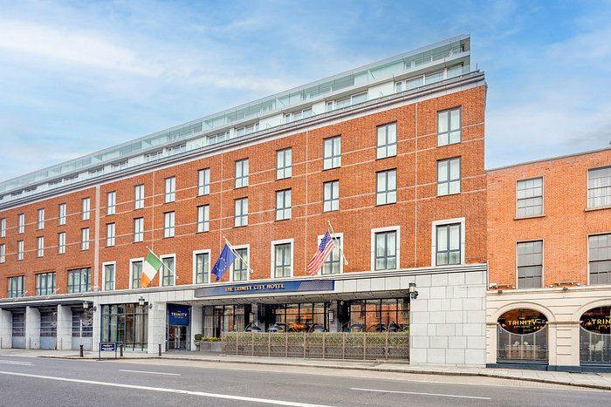
References:
- Cousins, J. (2020) *Food and beverage service*. 9th ed. London: Hodder Education Group.
- Davis, B et al. (2018) *Food and Beverage Management*. 6 edn. London: Routledge.
- Motarjemi, Y. and Lelieveld, H. (2014) *Food safety management: a practical guide for the food industry*. Illustrated edition. Amsterdam: Academic Press.
- Wood, R. (2013) *Key Concepts in Hospitality Management*. London: Sage.
- Zutshi, A. (2019) 'Embracing Dietary Diversity in Modern Dining', *Perspectives in Public Health*, 140(4), pp. 200–202.
- Foskett, D. et al. (2021) The Theory of Hospitality and Catering. 14th Edition. London: Hodder Education Group.
- Walker, J (2017) Introduction to Hospitality. Harlow: Pearson Education Limited.
- Wood, R. (2013) Key Concepts in Hospitality Management. London: Sage.
- Boussard, S (2021) Food and Beverage Management in the Luxury Hotel Industry. New York: Business Expert Press.
- Hotel Trinity. (2023). Welcome to Hotel Trinity - The Jewel of City Centre. Retrieved from https://www.trinitycityhotel.com/en/

