JIM JONES: THE PEOPLES’ MACHIAVELLI
Catherine Jewson 1801935
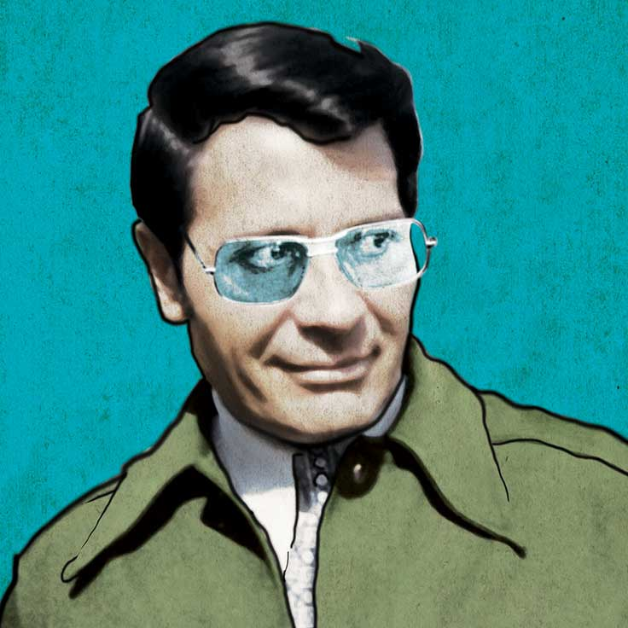

Image: Indiana Historical Society.
What makes a person charismatic? We might all begin to answer this question in our own heads; confidence, an ability to connect with people, inspiring respect or being admired may all come to mind. But what makes a person so charismatic that they can convince 900 people to drink poison? This question may be more baffling. Many of us would see charisma as a desirable trait, but the thought that someone would want that level of control over others is unfathomable, let alone the idea of actually acting on it. In this article, we will explore the life and personality of Jim Jones, infamous leader of the Peoples’ Temple cult, and ask how charisma allowed one man to hold the reins of terror over nearly a thousand adults and children and make them end their lives.
Born in 1931, Jones grew up in rural Indiana; he was the only child of working-class parents. He was described as a “weird kid” and found it difficult to make friends amongst his peers; Jones allegedly displayed a number of worrying behaviours, including abuse of animals, an obsession with death and an interest in racist and nationalist organisations. During his late teens Jones worked at a hospital in Richmond, Indiana, where he was generally well-liked by colleagues, and met his future wife, Marceline.
While these snapshots of his childhood and early life do not conjure the image of someone who is naturally warm or charming, Jones was an adaptable communicator and a skilled manipulator. By all accounts, Jim Jones was a progressive thinker in adulthood; he was a member of the communist party and an avid advocate for racial integration in an era where significant civil unrest was rising in relation to both issues. However, Jones’ number one priority was himself, and he was willing to go to any lengths in order to be successful in his social and personal pursuits.
In 1952, Jones joined the Methodist church, later leaving and becoming a student pastor of the Baptist Church; this decision was not based on faith, however. Jones believed that the resources and funding unlocked by joining the Church would be beneficial to his own quests. The power and responsibility handed to Jones in his success in the Church undoubtedly fuelled his desire to be revered by, and in control of, others.
In 1957, the Peoples’ Temple was formed; an integrated church with Jones at its helm. In his new position of leadership, he sought to cement his glowing reputation and power. What he and the Peoples’ Temple offered to his followers was belonging.
But what was it, exactly, about Jones’ persona that made him so charismatic? Psychologist Robert J. House once described charismatic people as “capable of having profound and extraordinary effects on followers”, and certainly Jim Jones did this. Jones painted himself as a saviour of the oppressed; by promising to advocate a better, more communal and integrated future, he immediately appealed to many people who lived in fear of social persecution, and feared for the United States’ social and political future. In this, he also created a shared enemy for his followers, from which he would be their protector. Jones cultivated this fear and used it as a means of control; Peoples’ Temple followers were told that the world was an evil place filled with evil people that were trying to hurt them, and that Jones would protect them from this evil.
Jones has been described time and again, by many different people, as a gifted speaker. It is this gift which was the root of Jones’ charismatic personality, and enabled him to manipulate, and essentially brainwash, his followers into compliance. Jones’s persona was an astonishing example of Machiavellianism at work. In 2007 documentary Jonestown: Paradise Lost, Jones’ son describes his father as “A guy [who] found out what you wanted to hear and see, and showed it to you”. Jones reportedly had an uncanny ability to identify what people sought most, and whatever it was, offered it to them neatly packaged in a Peoples’ Temple membership; the only payment required was their unwavering loyalty. Healing miracles were a regular part of Jones’ repertoire at Temple services. The healings were staged, of course, but the confidence with which Jones expounded that church goers would be healed of their ailments if they only worship him and “feel his power” convinced hundreds of people of his abilities.
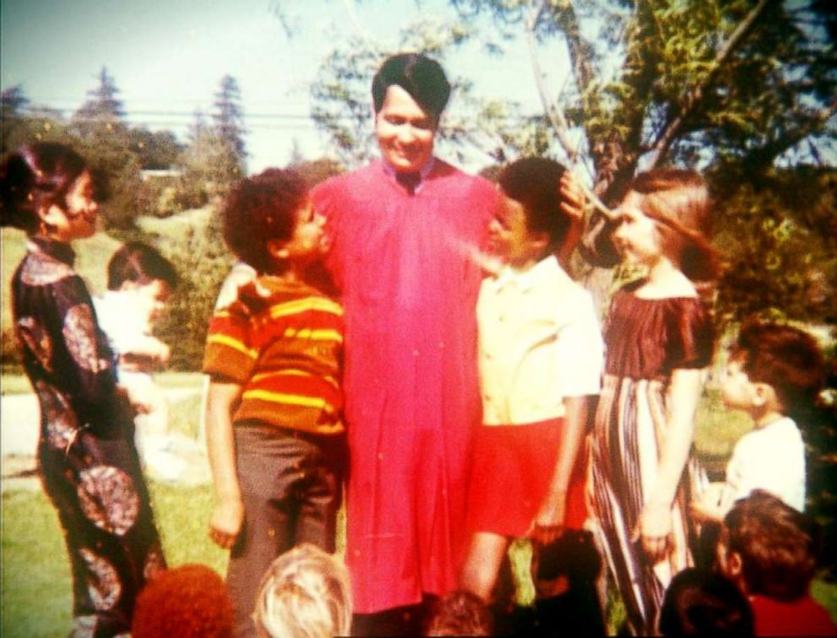
Jones’ reach was not completely inescapable, however; Jonestown, the remote Peoples’ Temple settlement in Guyana which would become the setting in which Jones convinced his followers to commit to their horrific end, was founded in the aftermath of several former members leaving the church and alerting the authorities and press of alleged torture, sexual assault and forced drugging occurring within the organisation. Jones feared that these allegations and the negative media attention attached would begin to unravel his plans. In an effort to separate his followers from outside influence which could unravel his plan, Jones moved several hundred Peoples’ Temple members deep into the Guyanese rainforest to start an environmentally sustainable commune; Jones sold an image of Paradise with no fear of persecution to his followers, but in reality, he was always ready to persecute and punish his own members when they stepped out of line.
Despite Jones’ efforts to portray the Jonestown as a welcoming, sacred place that was free from evil, the reality could not have been more different. He ruled over the new settlement through a mixture of manipulating those he could, and threatening those who began to question the Peoples’ Temple and Jones. Members were not permitted to leave and were regularly tortured or shot for disobeying orders. Jones used his power over people to sexually assault women, and others were forced to take narcotics. With Jonestown watched over by a large band of armed henchmen, there was very little chance of any escape for members. While Jones’ charismatic personality drew people in and utterly captivated lots of members until the very end, it was fear of persecution, ironically, which forced many to stay.
All the while Jones pushed the rhetoric that the outside world meant to harm the Temple; members were expected (or forced) to attend “White Night” drills, in which Jones prepared them to make the ultimate sacrifice should they be infiltrated by the “evil” of the outside world. During White Nights Jones exhorted members to be prepared to end their own lives before letting Jonestown be destroyed by outsiders, and claimed that their deaths would be an unmistakable protest against the evils of the modern world. Members were desensitised time and again to these ideas, with Jones painting himself as their protective shepherd, guiding them to goodness.
Jim Jones was becoming increasingly physically unwell and mentally unhinged due to a longstanding drug addiction; despite this, he ruled over his mini empire for a year before, in November 1978, a group of anxious family members of Jonestown residents, joined by US Congressman Leo Ryan, his staff and a handful of press reporters made the journey to Guyana, in order to make contact with their loved ones and for Congressmen Ryan to conduct and investigation into the allegations made against the Peoples’ Temple by ex-members. The few days that followed quickly turned into a nightmare; Ryan’s visit sparked a string of defectors from the church who saw their opportunity to escape. Fearing that his plans were falling apart, Jones acted on the power he had been cultivating all those years.
Photo: Rolling Stone Magazine.
On 18th November 1978, Jones’ body was found among 908 others that littered the ground of Jonestown, including nearly 300 children and infants. They had died from drinking Flavor Aid laced with a potent mixture of potassium cyanide and sedatives; Jones himself had died from a gunshot wound to the head. Those who would not drink willingly were force-fed, or forcibly injected with cyanide. 5 further people from Congressman Ryan’s departing party, including Ryan himself, had been shot and killed when Jones’ henchmen opened fire on the group at the air strip during their attempted departure.
While it is apparent that Jones’ leadership methods evolved over the years to become reliant on force and fear, it is undeniable that his charisma drew in loyal followers who were willing to obey his every command, even when that command caused such unspeakable suffering. Jim Jones capitalised on the civil tension which was rising at the time and enchanted members with promises of a better life; once he had convinced a few people to show him unending loyalty and carry out his bidding, there was no stopping him. Though Jones did not convince everyone he met of his power, he convinced enough that he could exercise control over the rest through them. His ability to communicate and stir people’s deepest desires and emotions ultimately enabled the atrocious string of events which ended nearly a thousand lives in that remote Guyanese settlement; testament to the sheer power of charisma, and the terrible devastation it can cause in the wrong hands.

