

STUDENT NAME: PADAM BAHADUR SHAHI
STUDENT NUMBER: 1711132
PROGRAMME: BA LEADERSHIP AND MANAGEMENT
MODULE: BMSW6103 – LEADING AND IMPLEMENTING WORKPLACE CHANGE
GROUP: 2
LECTURER: SYED JAFFERY

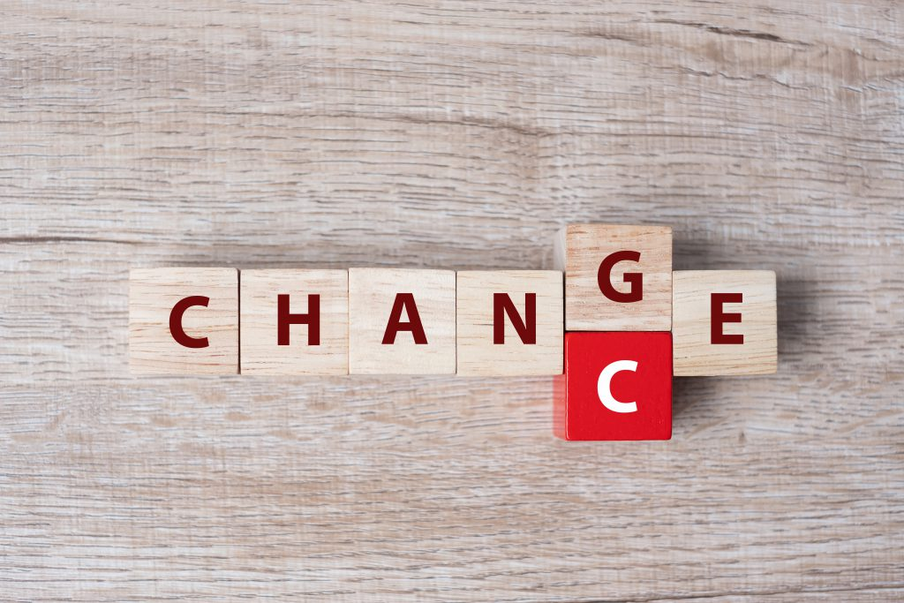

Table of Contents
Abstract 3
Introduction 3
Motivations to understand changes 4
Change the administration interaction 5
Coca Cola: 6
Change Management in Coca Cola 9
Employee Management 9
Importance of Change to Coca cola 10
Guaranteeing that change is successful 11
Marketing procedure of Coca Cola 12
Financial Impact on Coca-Cola during Covid-19 15
Recommendations 15
Challenges 16
Opportunities 17
Conclusion 18
References: 19

Abstract
Associations need to change and embrace dynamic endurance techniques to make due in questionable political, social and monetary conditions (Hyatt and Creesey, 2018). All ecological variables in nature change consistently. Human instinct opposes change, so an all-around arranged technique of progress is expected to oversee opposition.
This report depicts the objectives and goals of the association, the significance of progress the executives for change the board measures, how to effectively set up change the executives, and how to include all investors in carrying out fruitful change. Organizations that can embrace a procedure. The current business circumstance during the COVID Business 19 pestilence has put a high need on students in HR administrators and associations because of representative commitment lockdowns. This paper is planned to decide the commitment of representatives of different associations during the Covid-19 pandemic. Nowadays organizations are continually creating inventive and viable approaches to connect with representatives during these troublesome occasions. In this report we will discuss organizational’/ change in coca cola during pandemic.

Introduction
Hierarchical change the executives include any deliberate way to deal with effectively raising your association's objectives, cycles, and methodologies from bothersome current status to better execution later on. Simultaneously, it powers people inside the association to acknowledge, acknowledge and permit this change.
Change the executives helps individuals in your association to roll out compelling improvements by zeroing in on the human factor of hierarchical change and adjusting to their new surroundings - with no opposition and profitability outcomes. It's just plain obvious, four of the three organizations are going through four huge changes over a five-year time frame. In the event that this seems like your organization, you should think of a temporary change plan consistently.
Authoritative change the board is required when at least one significant cycle should be changed to improve the viability of an association. Probably the most well-known circumstances are:
- Execution of new techniques to enhance the item
- Overhauling cycles or strategies to improve and enhance measures
- Making another item or administration office
- Change of initiative and the executives
- Work culture and program execution
- Consolidation or obtaining of the organization
- Unforeseen emergency because of financial/socio-political issues
To put it plainly, when your organization needs to change the manner in which it works - and individuals need to tackle their work in an unexpected way - there is sufficient opportunity to execute change the board.
Change the board is the better way to move an association, its kin and cycles from the present status to the ideal future state. This cycle enables them to understand changes in the current business climate. The progressions can be of different kinds, for instance, changes in innovation, activities or procedure, etc. The organization should carry out close to home systems to manage each sort of progress.

Motivations to understand changes
Following reasons to understand changes
- To react to quickly changing climate
- To improve the general presentation of the association
- Quick reaction to client needs
- To improve representative execution
- Making the prescribed procedures in the association and setting guidelines for the business
- To improve productivity and profit from all out venture
Hierarchical endurance requires change the board. So the organization needs to receive changing administration practices to keep up its worth in the business.

The significance of progress the board
In one investigation, 327 task directors asked, "In the event that you had the chance to do it once more, how might you respond?" Many of them reacted that we would carry out a compelling change the executives plan as arranged before the undertaking started. This investigation features the significance of progress the executives in authoritative point of view. Change controls the dangers that lead to the board disappointment (Jeff and Creesey, 2013).

Change the administration interaction
Change the board has been concentrated by logicians, analysts and business experts for a long time. Therapists and the board experts build up various change the executives hypotheses, approaches, and methods of reasoning to carry out effective change in an association (Patton and McCallman, 2018). There are three phases of progress the executives, to be specific, setting up change, overseeing change. Getting ready for a change stage includes evaluating change capacities and abilities and building up a system suitable to those capacities. The subsequent stage, "the executives of progress" stage, includes cycles, for example, the arranging and execution of the procedures made in the principal stage. Support of the last stage change includes cycles, for example, reaction information assortment and examination, understand the issue and adapting to showed levels of opposition within organisation and outside organisation remedial activities that effectively complete replacement of executives interaction. Doing (Learning Change Management) Center, 2016–2018). As per the "Lewins 3 Step Model", the change is "rambling" and can be effectively arranged in three phases:
Change Support Coca-Cola supervisors can lead the labor force to a "non-freezing" state by efficiently clarifying changes as far as the organization's advantages. Preparing staff can make them more capable in tolerating the progress stage.
In the "evolving stage" the association can make useful strides comparable to the essential arrangement of progress.

A new improvement in its system with the goal that the labor force doesn't get back to the operational techniques recently utilized (Robbins and Kupter, 2019).
Sending a drink portfolio to catch development in a quickly evolving market, the Coca-Cola Company has reported key measures to drive refreshments into the Coca-Cola framework for drinks for its life.
The organization is building an arranged worldwide organization that joins the force of scale with the top to bottom information expected to win locally. The organization makes new operational units zeroed in on provincial and neighbourhood execution, working with five showcasing grade authority groups to quickly spread thoughts all throughout the planet.
The construction is upheld by the organization's recently made Platform Services organization, which offers worldwide types of assistance and progressed skill in various key capacities.

Coca Cola:
This company coca cola is a retailer and producer of non-cocktails and is known worldwide for its Coca-Cola drinks. Notwithstanding the Coca-Cola brand, The Coca-Cola Company offers more than 500 refreshment and non-drink marks in almost 200 countries. Company was established in 1892 by Asa Candler. It is settled in Atlanta, Georgia, United States. The company had all out total compensation of roughly US $ 11.8 billion out of 2017, with 139,600 representatives around the world. Company brand is number one on the rundown of the most well known brands on the planet (The Coca-Cola Company, 2016-2019).
Coca-Cola is a kind of business enterprise that requirements to make changes in its gadgets and enterprise methodologies to healthy client assumptions and the outer weather. On this examination we will refer to numerous fashions from the historic backdrop of Coca-Cola enterprise and examine what systems the enterprise has created and carried out to drive the trade interplay ahead.

The requirement for trade in an affiliation is regularly made by outer and inside factors, in which untouchables contain government laws, paintings markets, financial conditions, monetary scene, and so on, and inner elements that observe the labor pressure, belongings, employees' mentalities, and technique. Pass. Agency(robbins and kupletor, 2008). The Coca-Cola business enterprise is perhaps the most mounted business enterprise on this planet. It went via numerous inner and outside adjustments from presence. The organization applied the innovation of development to bear the effect of these events.
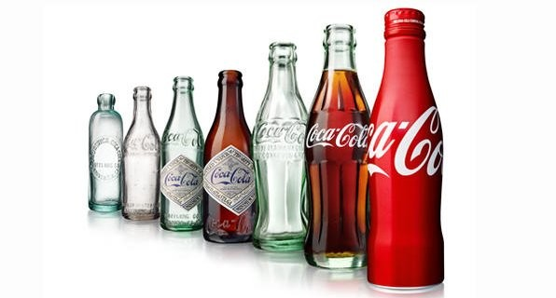

The employer went via numerous outer changes, as an example all through global war ii, when it changed into found that the organization had the option to preserve up its gift reputation around then and entered numerous new enterprise sectors and new specialties (the Coca-Cola employer, 2006–2011). The corporation likewise gave unfastened beverages to warriors as a aspect of a methodology to turn into an photo of enthusiasm for people of the country. But it supported deals, so the organization finished the two goals through cautiously looking to react to that out of doors natural trade. The plants created by the business enterprise during the battle helped its improvement after the war.

Barton et al. (2012) report that the Coca-Cola organization acquired a procurement methodology all through seasons of the Asian monetary emergency. The employer has procured packaging, espresso and bistro corporations in Korea and Malaysia. There is a type of refreshment industry that changes on a non-stop premise as in step with consumer tastes and dispositions. The Coca-Cola Corporation has correctly reacted to such consumer converting practices by means of growing new objects like food plan coke and Coca-Cola 0. The enterprise displayed its advertising blender when an opponent business enterprise dispatched a dark beverage with a reasonably sweet and easy taste. The item turned into named new coke. Anyways, offers steadily declined and the employer confronted true purchaser analysis and fights. The company treated the situation very well by using patching up the antique recipe and converting over the field into weight loss plan coke (kotler and Armstrong, 2010). Coca-Cola is likewise creating juices and unique caffeinated beverages, as people are wellbeing cognizant and inclined to position sources into wellbeing primarily based gadgets. It mirrors the agency's method of reacting to numerous clients 'tastes and assumptions and adjusting as it should be.

The Coca-Cola framework is having its effect in supporting the monetary cycle, coming near to help the much less fortunate areas and line well-being workers across Pakistan. Our health labourers are on the bleeding fringe of this struggle against kovid-19 and need to give greater PDH (person defensive hardware), so Coca-Cola Pakistan is bringing in who fashionable PDH for health workers the kingdom over, including fits, covers and goggles.
In our networks, we endeavour to help our everyday lives and the maximum influenced positions locally with the aid of giving meals proportions to 105,000 people throughout Pakistan via vast associations with the close by authorities and the Pakistan military. These packs contain meals things for a multi week own family for about fourteen days. As consistent with the MSM (middle for sickness manipulate), it's far vital to stay hydrated to war the infection, so Coca-Cola is giving clean drinking water to health employees and sufferers in specific attention wards.
Coca-Cola has additionally constructed up a customer nearby place software that facilities across the recuperation of inspired shops (low/medicines tire). Pakistan will in the end win the warfare on Covid, albeit the economic system could be critically harmed. Perceiving the requirement for a solid recuperation level, we can make contributions belongings for the sluggish healing of the little retail segment. It assists with giving safe positions and new paintings openings. Like different fmcgs, Coca-Cola is confronting a terrible enterprise course - however we are difficult in the midst of extra special emergency.

We likewise understand the demanding situations regarded with the aid of independent corporations, independently hired people and merchants of our merchandise. To assure their commercial enterprise soundness and jeopardized occupations, our battler coca-cola (cci) has expanded credit score backing of Rs. 1 billion customers. Moreover, notwithstanding the financial plunge and misfortunes, we are targeted on securing all positions and giving a work to our accomplices with the aid of pleasing financial obligations. We thank you on your initiative throughout this time. The power of your association is that it lets in the framework to ease and at closing get well from the real effects of this emergency.
However our alleviation bundle, Coca-Cola is ready to work with the NCOC (National command and manipulate middle) in Pakistan. We paintings in correspondence, selling, publicizing.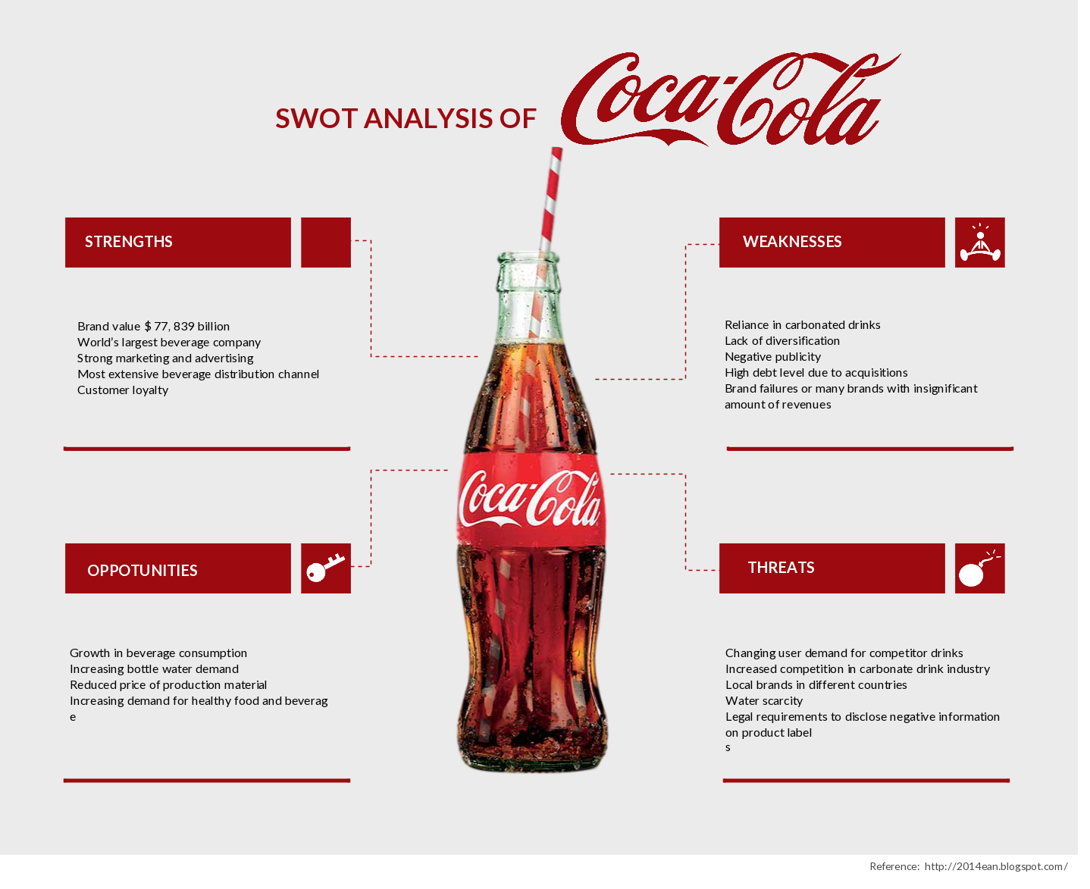

Change Management in Coca Cola
Authoritative change is the change achieved by development innovation or individuals of an association. Changes in structure incorporate overseeing control periods, relegating diverse occupation jobs, overhauling position situations, etc. Changes in innovation Introducing new creative strategies to improve the item quality started by the organization. Change in individuals implies change in the manner in which individuals think and act. It implies altering their conduct to benefit the association (Robbins and Kuptar, 2018, p. 34).

In this company (Coca-Cola), we do our part to forestall the spread of the infection, while simultaneously supporting the requirements of our clients, clients, representatives and networks. We put the wellbeing, wellbeing and security of individuals first. Our vision depends on our organization objective, which guarantees that we continually make progress toward our networks and people in our work territories. We comprehend the job that partnerships need to play in uniting aggregate information and assets to help the battle against Covid-19.

Employee Management
The brand new change the executives at coca cola are coordinated toward the inherent features and inspirations of the personnel and may be alluded to as 'consultant dedication'. The alternate the government’s interaction, together with inner marking programs is relied upon to obtain quality practices in representatives, that may alter the sports of coca cola spherical the world, and gain skills during coca cola for the duration of the whole lot of its commercial corporation fragments. Coca cola desires to achieve an altogether included affiliation of correspondences, and highlight on making emblem establishments with their representatives. This may improve the obligations of coca cola, as an incorporated technique could endorse all representatives’ trust in connecting simply with within the functions. Coca-Cola is effectively seeking to fuse the alternate into its organisation for "building potential in determination, preserving up dedication stress and making sure that dedication is integrated into ccr's circle of relatives rehearses" (Samdahl, 2019). Because of this, employee willpower research are directed double every three hundred and sixty five days for all the coca cola partners, which serve to function the territories wherein hobby is needed, and in addition sports activities and executions can therefore be finished. Coca-Cola accepts that their business company outcomes depend upon the willpower in their personnel to operational greatness. The agency without a doubt perceives the significance of humans to the economic company, and realizes that to maintain on reaching large effects it is acquiring, representatives at some point of the arena should believe with in the features naturally, and therefore the worker willpower is being focused spherical every one of the international locations the company serves to alter, altogether coordinate and adjust the company so operational skills may be carried out. At the element at the same time as covid-19 elevated right into a international pandemic, Coca-Cola EU companions did no longer have the opportunity to more to deliver their representatives with the quality assets and statistics to discover the emergency. By means of utilizing the provider now health alert employee revel in % as motivation, the enterprise had the selection to acquire a covid-19 asset entryway in days. Presently, their employees have backing and management has the information they want.

Importance of Change to Coca cola
Representative commitment is amazingly significant associate to any or all fragments of tasks at Coca-Cola and has converted into execution in territories any place specialist commitment is higher. For Coca-Cola, a drew in power implies:
- An extra dedicated labor force
- Representative execution lined up with structure destinations
- Representatives have a straightforward arrangement of what's anticipated from them and what are the expectations
Client ability centers an inborn a piece of staff' values, who endeavors to create a more strong encounter to the clients. customer center was known as a focal inhabitant of the multi-year commitment methodology to be implemented in 2019(Gee,2019). At the point when workers are lined up with organization objectives, they, at the end of the day, receive a proactive methodology towards issues suggestive of waste disposal Representatives mindfulness gives them a voice that assists with affecting enactments at local levels.
A coordinated arrangement of correspondence is extraordinarily helpful inside the unpredictable and dynamic business sectors of today, any place conditions adjustment off and on again and hence the organization should be responsive in any regard times. In this way, for all the business period of Coca-Cola where they're set across the world, the change towards specialist commitment is regardless of whether they need to harvest the natural products acquired by a decent arrangement of reconciliation.
The Covid-19 pandemic has set off precarious movements in looking through conduct, troublesome The Coca-Cola Company and creating new open doors in everything from entire dispatches and offering efforts to courses to attachment and income development the board systems. Coca-Cola bunches round the world are teaming up with basic food item clients to direct offer chains and focus on conveyance and advancement of center brands and SKUs like multipacks as people fits stay-at-home ways of life and make less, quicker stock-up trips. "We're doing what we'd prefer to attempt to do to remain the eye of the customer," potato said. With customers going after set up, reliable brands all through uncertain occasions, Coca-Cola is finding a way ways to keep top-selling contributions accessible and downsizing or suspending arranged entire dispatches.

Guaranteeing that change is successful
A few issues that may fit with the exchange the board approach include:
- Profitable related full-size exchanges and talks with professional delegates
- At the internet and paper research from each one of the neutrals involved inside the 'alternate' in the course of the world, and with partners to understand a expertise on their insights
- Powerful correspondence at this stage for teaching the companions the clarifications for change and subsequently the edges it'd convey
- Beating the 'idleness' by taking all companions in actuality. The studies will work a pre vital to acquire an know-how on the partner point of view
- Subtleties of the pastime concocting measure imparted to all or any folks that may start the trade.
Marketing Strategies:
Segmentation, focusing on, situating of Coca Cola
Division assists the brand with characterizing the proper items for explicit client bunch; Coca Cola doesn't focus on a particular fragment yet adjusts its advertising system by growing new items.
Also it utilizes blend of undifferentiated and mass promoting procedures just as specialty showcasing for specific items to drive deals in the serious market. Its Cola is famous overall and is enjoyed by individuals of all age bunch while the eating regimen coke targets specialty portion for individuals who are more wellbeing cognizant.
Coca Cola has serious edge over its rivals regarding Operations, Cost control, Brand portfolio, Channel promoting, Collaborative client relationship.

- Tasks : Coca cola has re-appropriated the packaging hobby to the franchisee, femsa that is the largest bottling franchisee of the Coca-Cola brand call refreshments on this planet. It allows the organisation in catching sizable development openings in immature non-carbonated refreshment fragment and in crucial acquisitions by way of going into arrangements to together get groups with the coca cola business enterprise.
- Cost control: Its extended item portfolio, outsourcing tasks and economies of scale allows it in decreasing its operational fee and increment its productivity.
- Solid Brand Portfolio: Corporation gives an incredible and wide arrangement of refreshments to its customers, and often investigates promising drink classifications to trap development in its diverse commercial enterprise sectors. Its refreshment portfolio comprise of carbonated soda pops, filtered water, juices, orangeades, iso-tonics, teas, caffeinated liquids, milk, espresso and even lager in certain business sectors like brazil.

Marketing procedure of Coca Cola
Coca cola's emblem call brand involves an exchange scenario in bcg network depending on the hobby and critical function. Bangs up, sprite, Fanta and maaza are stars as these brands have excessive piece of the general enterprise but high competition in their precise portion.
Kinley is query mark purpose being low offers. Company can't specifically situate kinley because of the presence of hundreds of community predominant elements inside the tremendously commoditized marketplace bringing approximately low offers.
The primary logo coca cola is considered as a gold mine since it has a solitary rival in pepsi and has an high-quality presence across the world. Coke-weight loss program, tea and espresso brands are canines on account that it is not geared up to pull in customers for this section and these are presumably greater lengthy haul gadgets and below basis.
Dispersion process inside the advertising method of coca cola.It utilizes a few deals and appropriation fashions depending upon marketplace, geographic conditions and the purchaser's profile:

1.The pre-deal framework, what isolates the deals and conveyance capacities, allowing vehicles to be stacked with the blend of gadgets that outlets have lately asked, in this manner increasing the 2 deals and dispersion skill ability.

2.The normal truck direction framework, in which the character answerable for the conveyance makes short deals from inventory available on the truck.

3.1/2 breed dissemination framework, where a comparable truck conveys object handy for certain fireplace deal and item these days asked thru the pre-deal framework.

4.The selling framework, which will be joined with pre-deals visits and
offers through outsider wholesalers of the gadgets.

Resistance of extrude is a now not unusual place human behavior. Specifically, withinside the regulatory recognition individuals resist the extrude in authoritative culture, shape and techniques. But, at the off threat which you want to proficiently and strongly positioned into impact the extrude manage software, it's far crucial for coca cola organization that it want to widen techniques to decrease labourer insubordination to extrude. Kotter and schlesinger (1979) characterized six techniques, which is probably treasured for coca cola business enterprise in professional insubordination control.

First strategy is to include the specialist in extrude process and reason them to participate as a ways as they could.

Second strategy is to talk the extrude manage bundles to the human beings efficiently to reveal them roughly the endowments the bundles could carry. This can cause them to at ease in embracing the extrude.

1/3 technique is arrangement and agreement. The affiliation want to make an agreement on essential extrude troubles and with the agreement of every unmarried vital accomplice; it need to supply the extrude manage program. The obstruction stage may be 0 on extrude bundles, which can be being introduced with the common agreement of every single pertinent partner.

Fourth method is that to control the group of workers who're a end result of more than one insufficiency or passionate or intellectual difficulty or a couple of various peril no longer ready to alter to the extrude. Inside the occasion that the association grows proper channel for such human beings, they could alter robotically to the extrude control application.

In the occasion of sadness of above expressed 4 processes, affiliation can cope with the workforce with the manual of utilizing calling affiliation boss separated from pertinent ones as 5th technique.

Sixth approach is to pressure the workforce with eloquent or non-articulate strategies anyway this isn't always generally a dazzling methodology.

Brand value in the Marketing procedure of Coca Cola
Coca cola is the only emblem that is perceived via virtually every body all throughout the planet. At the factor at the same time as we talk approximately logo price then it is its well worth and it is approximately stories, recollections, affiliations, and human associations (no matter the reality that manifestly, those establishments might were cautiously and purposely designed through way of skilled advertisers over several years and infinite government gatherings).
That is something that Coca-Cola has been the professional of for extra than 100 years. This fee is gotten from humans' eagerness to pay a top rate for the logo and reluctance to well known substitutes. Coca-Cola’s showcasing device has constantly been to narrate satisfaction, energy and clean street with their objects, and this is the way through which they can make high toma (top of psyche mindfulness).

Serious investigation in the Marketing system of Coca Cola
Big giants within the non-cocktails fragment have similar system and goals which imply improvement and creative showcasing efforts can assist the businesses with isolating from each different. Rivalry from the nearby game enthusiasts is the other large problem that enterprise is confronting now days. Pepsi is the unmarried largest vital contender of Coca-Cola having devices throughout the fragments.

Market investigation in the Marketing procedure of Coca Cola
Non-cocktails market is steadily developing industry and with the approaching of developing Asian commercial enterprise sectors and non-industrial countries the usage can be higher additionally due to the evolving way of life, financial situations and converting buying propensities. On this enterprise client have thousands of options going from water to tea/coffee to soda pops, so odds of consumer changing to some other logo is high. The first-class way to separate gadgets and maintain customers is the strong emblem fabricating, and making pull on the lookout.

Client investigation in the Marketing system of Coca Cola during Covid-19
Coca cola focuses on a mass marketplace. What is greater, the consumer assumption is low value, fantastic flavor, lodging and availability and one-of-a-kind choices to browse.
Coca cola utilizes extreme situating methodology to be course in front of its competitors in the non-cocktails marketplace. Coca-Cola has multiplied down on its machine to chop down its portfolio and exchange assignment to its centre manufacturers, at the same time as likewise wanting to take showcasing speculation degrees back to pre-pandemic activities to help improvement.
Coca-Cola net earning declined eleven% to $33bn (£23bn) in 2020, this was pushed by means of a decline in concentrate deals. Whilst income inside the final area was someplace around five% to $8.6bn (£6.2bn).
They'll correctly explore to a completely unique marketplace climate in 2021 to bring with out trying to get up with more shoppers higher provide, more grounded framework financial matters, and extra noteworthy accomplice sway.

"As antibody conveyances continue with will permit greater deceivability to how the global recovery will come to fruition. Also, given our trust in the switches we want to cope with the enterprise; we're giving a perspective to 2021. Considerably, we are last regular with our obligation to purchaser centricity and our drinks for life method. We have won first rate headway in making ready the corporation to win for quite a long time to come back as we will fulfil our motivation invigorate the world and have an impact," finished up Quincey.

Financial Impact on Coca-Cola during Covid-19
Local marketplace strategies and activities to reduce the transmission of covid-19 have significantly extended. These activities incorporate the heading to end from looking after at eateries, the wiping out of foremost brandishing and enjoyment activities, material lower in movement, the advancement of social setting apart and as a consequence the reception of work-from-domestic arrangements. Those activities, at the side of the ultra-modern tendencies in go back costs, will contrarily have an effect on our entire year cash related and operational outcomes and, on this way, they may in standard don't count on understanding our aforesaid gave entire year path. Due to the rate at that the covid-19 situation is advancing, there is vulnerability around its ultimate impact. The detrimental outcome on their cash associated and operational outcomes cannot be really measurable right now; besides the impact probable will be material. They have a tendency to pray to supply companion degree replace during their q1 2020 profit release and call.

Recommendations
Inside the unstable elements with that agencies work these days, trade is inescapable. Consequently, the number one goal should not get on staying away from trade, as an alternative transportation multiple wash progress towards the brand new alternate with the aid of human hobby concerning the trade, and ensuring all gatherings of the change that it is for the fine of every one of those blanketed. To with progress execute structure trade of any nature, specific respects to hierarchical production, plan, culture, the board and administration is anticipated to imagine whether or not the change might collect a pleasant paintings with the authoritative objectives and desires.
- Venturing into the food item – Coca-Cola needs to offer new product in bites and food sections.
- Zeroing in on well-being associated difficulty – it should carry some response to address the growing wellbeing issues from social activists.
- Improving its water the board framework and coping with the reactions from herbal places of work.
- Venturing into agricultural international locations with moist temperatures – there are a few results of Coca-Cola like igniter tea, Dasani and hi-c that are not appropriated in many non-commercial countries. Coca-Cola wishes to construct the appropriation of such gadgets.
- Expanding the dispersion of bundled ingesting water like kinley.
- The company ought to find out the center troubles exist inside the agency for the alteration the executives. The company may additionally build up a change the executives program for reacting to monetarily unsure climate of the world. It additionally can create exchange the executives programs for better sports and coordination’s. The corporate can present new techniques and mechanical frameworks to keep out obligations. Initiatives will be provided in structures dynamic organization's major aim and pals lifestyle improvements. For all that, the primary fundamental problem is to mentor better administration to supply them with explicit abilities critical to correctly inspecting the converting interaction. Following is that the transitory articulation of plans that the organisation can obtain.

Challenges
Water the executives associated troubles
Water is one of the premiere vigorously applied crude materials inside the offer chain of dope anyway conjointly a limited asset. Coca cola has visage several valid troubles and quite a few analyses over its water the board rehearses previously. Though coca cola ensures that it recharges the water it utilizes, the corporate has confronted a ton of dissent over incurring water insufficiency in some additives of the globe simply as India.

Lower item broadening
Contrasted with its driving adversary, cola, the diploma of item enhancement of coca cola is low. Though Pepsi heterogeneous its object portfolio to fuse snacks, oats, chips, nutritious glue and a ton of dairy-based totally gadgets, the product arrangement of dope has stayed confined normally to beverages. Coca cola is furthermore confronting accelerated rivalry from cola whose offers and earnings have big faster while contrasted with coca cola.

Forceful competition with Pepsi
Pepsi is that the greatest opponent of Coca-Cola. Had it no longer been Pepsi, Coca-Cola would are the reasonable market pioneer in the refreshment.

Object enhancement
Coca-Cola has low item broadening. Wherein Pepsi has dispatched a few snacks things like lays and kurkure, Coca-Cola is safety throughout this section. It gives Pepsi impact over Coca-Cola.

Health contemplations
Carbonated beverages are one in everything about key wellsprings of sugar intake. It prompts 2 grave clinical problems – fat and diabetes. Coca-Cola is that the best maker of bubbly liquids. It is a questionable problem for the employer. Anyhow, Coca-Cola hasn't conceived any wellness specific or solution for this drawback yet.

Opportunities
- For faster development and extension, cola should enlarge its object portfolio to make it more diverse. Regardless of coca cola's extensive item portfolio, its degree of broadening is low. The company should upload more health agreeable product to its portfolio moreover as make it greater special through adding bites, chips, and elective eatable product.
- Clients have big increasingly more step by step greater and a ton of well being cognizant within the new decade. They're at gift looking for extra health agreeable gadgets like low-calorie gadgets and caffeinated beverages. Dope can expand its offers faster with the aid of growing its object association of health agreeable items. This may work with the corporate spigot into a bigger than common length of wellness cognizant clients and along these lines produce greater profits.
- Agencies with extraordinary brands likewise can help the business enterprise with promoting and offers. By means of cooperating with unique manufacturers just as refreshments and titbit marks, the business enterprise is prepared to broaden its offers. Coca cola can make use of its accomplices' property to increase its reach and infiltrate new or existing enterprise sectors more profound. As an instance, starbucks and nestle entered an corporation to develop the deals in their product and develop their piece of the pie. Dope likewise can enter new associations to reduce severe pressing factor.

Conclusion
To finish up, it can be expressed that discussion might be a critical detail to a triumph extrudes control. Convey the changes to the staff; advise them why extrude became inescapable and the manner in which they'll appreciate extrude. The control need to itself embrace a colossal mentality toward extrude all together that work force can follow their lead and welcome extrude. Coca-Cola as an association has a past filled with embracing extrude instead of withstand it and it need to convert into their predetermination attempts toward extrude control to verify that the organization is magnificent ready to commercial center underneath all styles of natural conditions. During pandemic Coca-Cola has suffer a lot initially but they overcome this situation rapidly by implementing management change. They follow new showcasing methodologies with time, and simultaneously, and they follow their old straightforward standards which they set in the beginning. Another purpose for the achievement is that they do appropriate exploration and investigations about the new innovation and afterward apply that.

References:

- Patro, C. S. (2019). The effect of representative commitment on association's profitability second worldwide meeting on Manageing HR at the work environment, December 13–14. ISBN: 978‐81‐922146‐5‐8. Available At: https://www.warc.com/newsandopinion/news/coca-cola-looks-to-post-covid-moment-marketing/43685

- Robertson, I. (2018, May 3). The significance of representative commitment in troublesome occasions. The Guardian Retrieved Available At: https://www.theguardian.com/public‐leaders‐network/2012/may/03/importance‐employee‐engagement‐difficult‐times.

- Robison, J. (2019, February 19). Building commitment in this monetary emergency. Gallup Business Journal Retrieved Available At: https://news.gallup.com/businessjournal/115213/building-commitment monetary crisis.aspx

- Hasan, A. (2020, April 13). How organizations are helping workers in light of COVID‐19. Individuals Matters Retrieved Available At: https://www.peoplemattersglobal.com/article/c-suite/how-organizations are-helping-workers in light of Coronavirus 25301

- Jalal, H. (2016). Testing the impacts of worker commitment, workplace, and hierarchical learning on authoritative responsibility. fifth worldwide meeting on authority, innovation, development and business the executives. Available At: https://www.coca-colacompany.com/press-releases/announcement-to-reorganize-for-future-growth

- Tensay, A. T. , and Singh, M. (2020). The nexus between HRM, worker commitment and hierarchical execution of government public assistance associations in Ethiopia. Heliyon,
Available At: https://www.tinypulse.com/blog/sk-case-studies-successful-change-management

- Tiwari, B. , and Lenka, U. (2019). Representative commitment: An investigation of survivors in Indian IT/ITES area. IIMB Management Review. Available At: https://www.warc.com/newsandopinion/news/coca-cola-looks-to-post-covid-moment-marketing/43685

- Torraco, R. J. (2015). Composing integrative writing audits: Guidelines and models. Human Resource Development Review, Available At: https://www.researchgate.net/publication/341523199_Challenges_and_Solutions_A_Case_Study_of_Coca-Cola_Company
- Atlanta Georgia Attractions - Attractions in Atlanta Georgia | World of Coca-Cola
Page title: Coca-Cola History | World of Coca-Cola Website: World of Coca-Cola
URL: http://www.worldofcoca-cola.com/coca-colahistory.htm

- Tracy V. Wilson, Page title: How Coca-Cola works How Stuff Works
URL: http://money.howstuffworks.com/coca-cola1.htm

- Bernal, J. and Redondo, I. (2016). Item position versus ordinary publicizing: The effect on brand decision of incorporating special upgrades into films. Diary of Promotion Management, https://www.coca-colacompany.com/news/how-coca-cola-is-pivoting-its-innovation-and-commercial-strategies-in-the-covid-19-era

- Elmore, B. J. (2013). Resident coke: A natural and political history of the Coca-Cola organization. Venture and Society, https://www.marketing91.com/marketing-strategy-of-coca-cola/
- Nagata, J. M., Barg, F. K., Valeggia, C. R. and Bream, K. D. W. (2011). Coca-colonization and hybridization of diets among the Tz'utujil Maya. Nature of Food and Nutrition, https://www.coca-colacompany.com/news/3-ways-coca-cola-is-embracing-the-pandemic-fueled-ecommerce-revolution

