​​‘The Internet, like the steam engine, is a technological breakthrough that changed the world.”

Peter Singer, Australian Philosopher

Thomas Newcomen invented the first steam engine in 1712. (National museums Scotland).It was later improved upon in 1765 by James Watt who saw the energy inefficiency of the original design and reimagined the engine to release less heat. He “greatly improved the Newcomen engine by adding a separate condenser to avoid heating and cooling the cylinder with each stroke.” (Howard.R.Gold, 2018) The steam engine revolutionized travel and was a huge component in the industrial revolution allowing for better trade networks. Transport systems for people and stock and provided many job opportunities either at the station, or by broadening the area in which people could travel to work. “Steam locomotives and railways dramatically redefined cities by separating business and manufacturing districts from residential areas, argue University of Bristol’s Stephan Heblich, Princeton’s Stephen J. Redding, and London School of Economics’ Daniel M. Sturm.” (Howard.R.Gold, 2018). Before the steam engine locomotive became popularized, workers would be limited in work opportunities, often sticking to a close radius to where they lived. This is evident with old towns and villages being built around production sites such as steelworks and mines. Workers needed to be able to get to and from work and the way to keep workers was to provide homes and communities near the workplace.

We can look at the impact of technology and innovation on societal and economic changes by studying The Kondratieff wave. This concept was introduced during the Russian Communist era by a sociologist economist, Nikolai D. Kondratieff. “He noticed that agricultural products and copper prices underwent long-term economic cycles that he believed to be a result of technological innovation and periods of evolution.”(Corporate finance institute. 2021)

The Kondratieff wave below illustrates the transition from steam engine to where we are currently around “information technology, communications technology” ; it suggests we may be headed towards more environmental technology and biotechnology. We are already seeing examples of this with solar power and green energy solutions, and biotechnology such as gene therapy to treat genetic conditions. (NHS 2022) “Kondratieff first introduced the concept of long wave theory in his 1925 book, “The Major Economic Cycles.”” (Corporate finance institute. 2021)

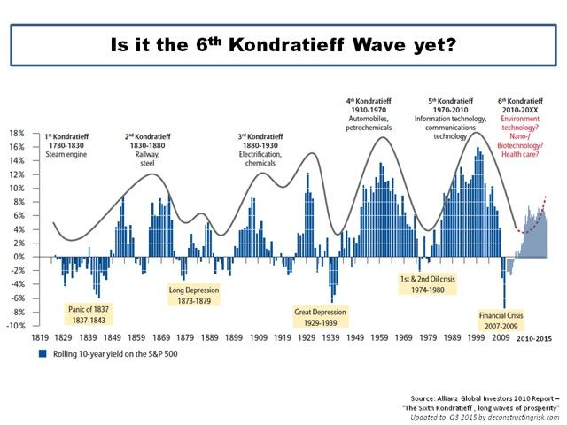
(Corporate finance institute. 2021)

The internet was introduced in 1983, with January 1st considered the official birthday of the Internet (Andrews. E, 2019) Prior to this, the various computer networks did not have a standard way to communicate with each other. The concept of the internet Initially faced criticism as it was believed it would be a passing trend and wouldn’t catch on. It has since become a global asset we depend upon for many aspects of modern life from medical intervention and managing patient information to daily interactions online and in business. 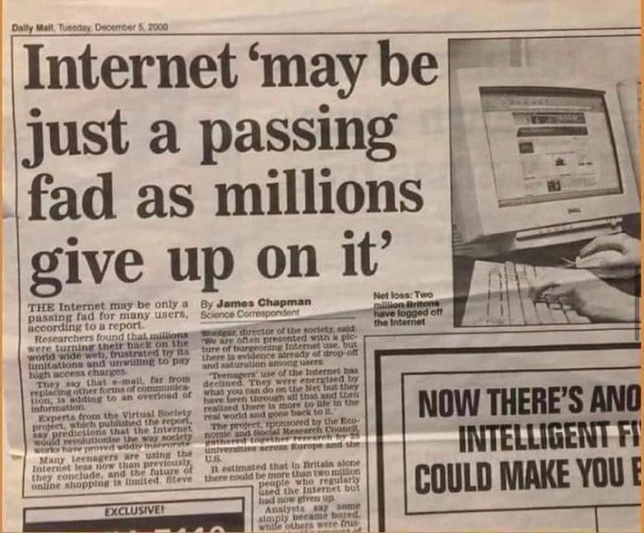
Image from Twitter. Daily Mail, December 5, 2000

Nobody could have predicted the firm grasp it has on society today and how much we have learned to depend on its seemingly ever expanding potential. Much like the steam engine, the internet led to huge economic change and a shift in how we as a society operate and experience the world trade networks. We are now only a quick google search away from learning the recipe conversion of cups to grams (136g - allrecipes editorial team. 2020) or who won the latest Grammy award for best new artist? (“19-year-old Olivia Rodrigo took home the Grammys for best new artist and best pop vocal album for her debut Sour”. The Scotsman -Davies.R, 2022) This leads us to be less incentivised to learn and remember because ‘I can just search it’. This is true for the most part, however much of what is online is unreliable. Anyone can post their opinions to the masses, and there isn’t much to filter out the unreliable results.
Google scholar is recommended by university’s and educational institutions as a reliable source of cited and peer reviewed articles from reputable sources. Although these are peer reviewed and considered more trustworthy, they can still be outdated, nolonger applicable or irrelevant to the search made and so it is important to check publication dates and use multiple sources to compare and contrast.

As well as incredibly broad access to information from all over the world, the internet has influenced our technology and innovation and how we apply them. With the internet we can hold global meetings online rather than arranging several country representatives to travel to one location. This is a huge step towards better environmental sustainability with communication. Flying long haul flights to global conferences is no longer as necessary as the option for video conferences has increased in popularity and all members can log on from their current location to join the meeting. Popular platforms include skype, zoom and google meet. Biochemist Kathleen Prosser presented her research at a conference this spring. by going virtual as a result of Coovid 19, she gained an international audience. “The day after her talk she heard from a chemist in Australia, asking for more details and hinting at a future collaboration. "The time zone difference would not have allowed them to see it live, but they watched it [afterward]," (Price.M, 2020)

Another growing use for the internet is e-commerce. Selling online is easier now than it has ever been. Platforms such as Shopify (Shopify.com) and Depop (depop.com) are emerging to sell new items or second hand. Gone are the days when you needed brick and mortar shops or market stalls to shift stock or produce. We have opened a new global market place with worldwide shipping companies and global transportation methods such as planes, ships and lorries. Transporting worldwide and having such a massive variety of products puts pressure on producers to compete with a much bigger competition. The internet has boosted efficiency, and in a capitalist world, time is money and efficiency is the key to success. As a resultan many businesses who sell online attempt to offer 24/7 service so customers don’t just go elsewhere for immediate response. We as a society have become increasingly impatient and impulsive. If one shop is closed another will be open. If one price is too high another will be lower. There is constant pressure to consume and make it more convenient to consume.
“In this setting, it is the consumer who gains the upper hand, and the conventional rules and methods of distribution and marketing break down.” (Dentzel,Z. 2014) As consumers gain access to more information and variety, “their reviews of their experience with various products and services take center stage.”(Dentzel,Z. 2014) With so much available consumers can turn to reviews to help narrow down the selection and read about product performance from other buyers and compare prices and rankings.

Online market and digital transactions is a very popular way to exchange goods and services. Anyone can sell virtually anything online. Even digital files are growing in popularity. This means the seller doesn’t own any physical items, they only sell the rights to a file which can be re-sold infinite amounts of times. The buyer purchases the file to print out or read, such as Journal page templates to print out, kindle books or audio books. Amazon is a great platform for users to buy and sell such products.

NFT’s and bitcoins(or equivalent) have also become increasingly mainstream. NFT means “non fungible tokens” (Ravikiran.A.S, 2022)These are generally created using the same type of precise encrypted programming used for cryptocurrencies (bitcoin and others). In simple terms “these cryptographic assets are based on blockchain technology. They cannot be exchanged or traded equivalently like other cryptographic assets.” (Ravikiran.A.S, 2022)They are unique and non-replicable and can sell for hundreds if not thousands of dollars online. The digital characters can be used in games and may be usable in a new project by Facebook called The Metaverse. The Metavers doesn’t refer to one specific technology or design but rather a new way to interact with technology and a shift into new social connections online (Ravencraft E. 2022).The metaverse would allow us to have more of a true online presence where our NFT avatar gives us real time interactions and even careers online in place of our physical presence in “the real world” with the use of Virtual reality. We could be living in a real life sims game in the near future. This could lead to incredible social isolation or those who don’t engage with the new technology shift if it really takes off. On the flip side, having the world through a virtual reality (VR) headset could make the world significantly more accessible to those who are stuck at home or ill. Anyone bedbound but still able to maintain some mobility may be able to operate a VR headset and join the metaverse online virtual world in real time. Other “characters” would be played by real people in real time and so this distinguishes them from games like sims where they’re often computer generated characters and game fillers.

McLuhan's tetrad concept can be used to analyze what the internet so far has enhanced, retrieved, obsoleted and reversed.

“Enhance- The technology must enhance some capability of the person. The medium is an extension of the person.
Retrieve- The result is a retrieval of some earlier service or capability that was lost and is now brought back into play in a new form.
Obsolesced- What is pushed aside and made obsolescent.
Reverse- If the new media is taken to extreme what will result that reverses the original characteristics of the media when it was first introduced.”
(Kraft,T. 2010)

Using this model, the internet has;
- Enhanced - communication, access to information, global network connection, online market and business opportunities.
- Retrieved - lost information- with worldwide information we can learn about new ancient discoveries, scientific breakthroughs in historical exploration, old lost memories and ability to share these findings.
- Obsolesced - with instant search results we have become impatient and unwilling to learn new information that can be easily searched online, such as names of capital cities we are unlikely to ever visit or think about. We have also become attached to social media and we are increasingly dependent on having access to our social media and messages. Some will feel very isolated, even when with people, if their phone dies or they lose connection.
- Reversed - as mentioned previously the internet is a huge mass of information and some would think that as a result we would all be very educated and interested and intellectually advanced as a species. However due to its near constant availability to dip into, we treat it like a filing cabinet to retrieve information and no longer rely on personal memory for trivial information, or even more important information, as it seems unnecessary. The brain is muscle, and without the need to store masses of diverse information we are losing our ability to function effectively without reliance on modern technology. If we lost the internet tomorrow whole economies would collapse, society would crumble, and we would all be faced with the harsh reality of how far we’ve come away from our roots and ancient pre technology methods and traditions.

In conclusion, the social and economic impact of the internet is not unlike the social and economic shift that came about from the industrial revolution when the steam engine was introduced to society. The job creation, the expansion of world trade, the travel opportunities and social development, are all key factors in both the industrial revolution and the era of technology and online interconnection we are in today. We can expect future inventions and creations, such as the metaverse to reinvent the ways in which interact as societies and cultures. We will become increasingly blended communities as country borders and travel restrictions need not apply in the Metaverse.

References

A Brief History of the Internet. (n.d.-b). https://www.usg.edu/galileo/skills/unit07/internet07_02.phtml

Andrews, E. (2019, October 28). Who Invented the Internet? HISTORY. https://www.history.com/news/who-invented-the-internet

Cup to Gram Conversions. (2020, November 19). Allrecipes. https://www.allrecipes.com/article/cup-to-gram-conversions/

Davies.R (2022, April 4) The Scottsman. Grammys 2022: Grammy Award winners of 2022, and who performed at the Grammys?. URL: https://www.scotsman.com/whats-on/arts-and-entertainment/grammys-2022-grammy-award-winners-of-2022-and-who-performed-at-the-grammys-3639743

Depop.(Accessed Dec 2022).URL:
https://www.depop.com/

England, NHS. (2022, February 4). NHS England » NHS to roll out life-saving gene therapy for rare disease affecting babies. https://www.england.nhs.uk/2022/02/nhs-to-roll-out-life-saving-gene-therapy-for-rare-disease-affecting-babies/

Forgeard, V. (2022, July 6). What Was Life Like Before the Internet. Brilliantio. https://brilliantio.com/what-was-life-like-before-the-internet/

Gold.R.H. (2018).How the Steam Engine Spurred Modern Cities.The University of Chicago Booth School of Business.
https://www.chicagobooth.edu/review/how-steam-engine-spurred-modern-cities

Kraft. T. (2010). McLuhan’s Tetrad Applied to Internet. Mind Before You Mine. https://mindbeforeyoumine.com/2010/07/12/mcluhans-tetrad-applied-to-internet/

Marinho, R. (2022, January 4). Internet May Be Just a Passing Fad, The Newspaper Said 21 Years Ago. Medium. https://regia-marinho.medium.com/internet-may-be-just-a-passing-fad-the-newspaper-said-21-years-ago-153aae2e0c2f

Price.M, (2022. April 28). As COVID-19 forces conferences online, scientists discover upsides of virtual format
https://www.science.org/content/article/covid-19-forces-conferences-online-scientists-discover-upsides-virtual-format

Ravikiran.A.S (2022).What is NFT and How Does NFT Work? The Ultimate Guide. URL:
https://www.simplilearn.com/tutorials/blockchain-tutorial/what-is-nft

Ravencraft E. (2022). What Is the Metaverse, Exactly?. Wired. URL:https://www.wired.com/story/what-is-the-metaverse/

Schwab. K. (2016, Jan 14). The Fourth Industrial Revolution: what it means and how to respond. (2020, September 22). World Economic Forum. https://www.weforum.org/agenda/2016/01/the-fourth-industrial-revolution-what-it-means-and-how-to-respond/

Shopify.(accessed Dec 2022). URL: https://www.shopify.com/uk/free-trial

The Lost Villages | An Oral History of Miners’ Rows and Deindustrialisation in East Ayrshire, Scotland. (n.d.). https://www.thelostvillages.co.uk/

