Fallingwater
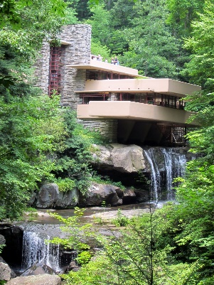
Introduction
wmcclure333, (2008),
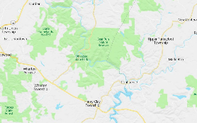
The Fallingwater house is in Pennsylvania, built upon the waterfall Bear Run. Frank Lloyd Wright was the architect that designed the Kaufmann’s home, becoming one of Mr. Wrights most famous buildings in his career for organic architecture. Wright’s inspiration came from the way Japanese architecture insures the property is in harmony with the nature that surrounds the house. The house was designed to replace the Kaufmann’s summer home and to become the family’s main weekend residence. The house was designed in 1993 and took three years to complete. The main house took two years to be built between the years 1936 and 1938. The guess home took an additional year after the completion of the main house between the years 1938 and 1939. The Kaufmann’s sent $155,000 to build the house resulting in the property being worth millions of dollars in today’s money.

maps 2020

Location
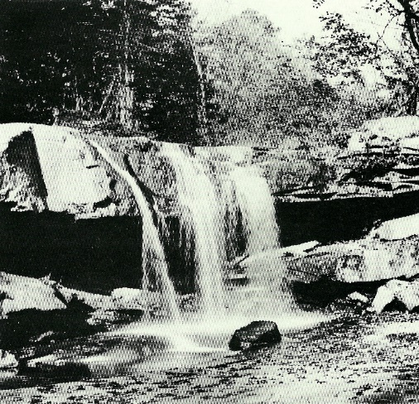
Frank Lloyd Wright understood that the client had a strong connection and appreciation to the waterfall due to the sound and movement of the water. Wright saw a perfect opportunity for architecture not to just work with nature, but to adapt to become a part of nature. Mr Wright placed the building directly upon the waterfall, this created the relationship between the building, nature and the waterfall. The idea was inspired by the interest Mr. Wright had to the way the water fell over these incredibly big rocks from the ledge, adding a natural feature to the property.
Richard Garcia, (1923)

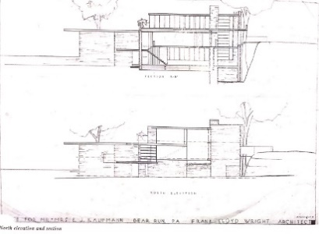
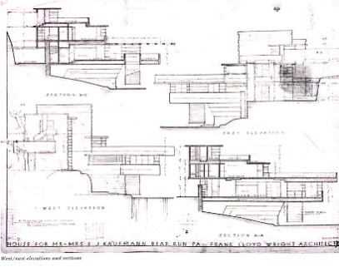
Plans

The main home takes a total of 5,330 square feet, while the guess home use 1,700 square feet. The property is surrounded by 5,000 acres of the Bear run nature reserve.
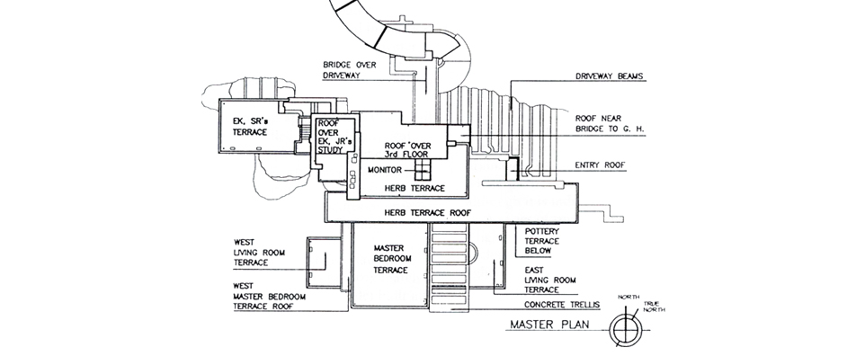
At the north side of the property there is a small room with stairs that lead up into the main room of the property, this is the living room located on the second floor. Also located on the second floor is two bedrooms, an office and a staircase that leads to the top floor of the property, both rooms and the staircase provide a view of the nature reserve, connecting the inside to the nature provided outside. There is a concrete terrace on the second floor that lead directly above the waterfall. In the main room there is a fireplace made with the same stone on the exterior, this creates a focus point within the room. Across the property there is a total of six bedrooms, that are spread between second and the third floor of the property.
fallingwater, (2020),
Paul Rudolph and Yukio Futagawa, (2009),
Paul Rudolph and Yukio Futagawa, (2009)
The house also had personalised furniture that was designed by Mr. Wright, the furniture kept the theme running throughout the whole house. Sofa’s that cantilevered off the walls, low seating and tables that extended similar to the balconies. He carried the same colour scheme throughout, the grey stone floor and the red steel interpreted into cushions.
Engineers
The plans where shown around, and some engineers gave the advice that the property is not engineered in a sensible manner and they believed that the property wouldn’t be able to be held up from the weight and become unstable. They weren’t convinced that the waterfall rocks were stable enough as they had parts that started to break off. Serious studies were conducted; figure reports were drew up. From the report it showed the building cannot work, they believed that the building would collapse from the weight and the rock it was built upon.
Living room
Frank Lloyd Wright stood by his design and did not listen to the engineers. Wright investigated the top of the waterfall, when he discovered a great many boulders. Wright picked a boulder that he then went and built the property around. This boulder is located in the living room that extends down to the basement level though this was not the original plan. Originally that boulder was to be grinded down to be level with rest of the floor. The idea came from the client to make another feature. Also located in the living room Wright designed the property to have stairs that lead directly into the waterfall to make an immediate connection to the main feature of the house.
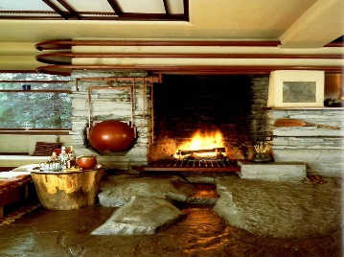
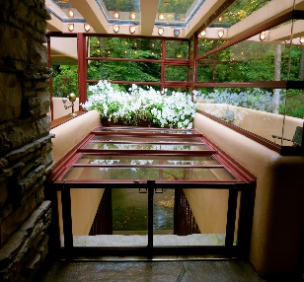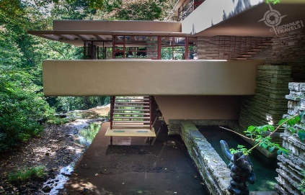
gateway mavens, (2018), chris, (2010)
Alexis, (2012),
Sense of space
Mr Wright wanted to create a sense of space inside and outside to create the feeling that the property was open to the outdoors. To do this Mr. Wright had to make a focus point on one spot to be a natural way to enter and exit the property.
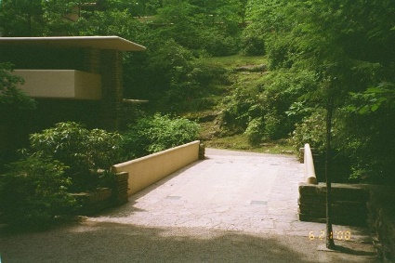
Bridge
Rick McNees, (2014),
Mr. Wright designed a bridge that went from the main house at the main bedroom level to the guest house. Though originally the bridge was to be built from the top floor of the main house, they soon discovered that this was unnecessary causing problems limiting access to main property and the guest house.

Windows In the waterfall property it contains glass windows that created corners due to this Mr. Wright created these corners in a way that showed no visible vertical element. Creating a twist on a traditional window, the corner is known for the point of support and a point of obstruction between your eyes and the outside. In this building the corners became the most open area of the property. The property contained sequences of horizontal and vertical windows, that also included a design feature for where the glass and frame meet the stone wall, it slots with in the stone eliminating the need of a metal upright keeping the illusion that the inside and outside are connected. 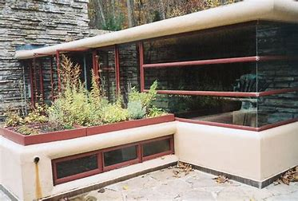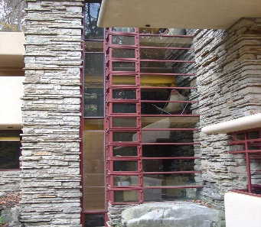
Dr. Galen R. Frysinger, (2009), Dr. Galen R. Frysinger, (2009),
Roofs
The property contains low ceilings, this was a design feature to make the eyes in the room go directly to edge of the room, this tied into where the window placings were located. Mr Wright designed the edge of the room to be big glass windows, drawing the people inside to be connected to the nature outside.
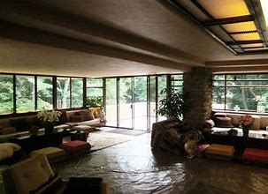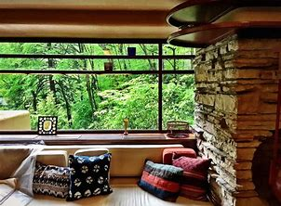
Hess landscape architects, (2012), Squarespace, (2016),
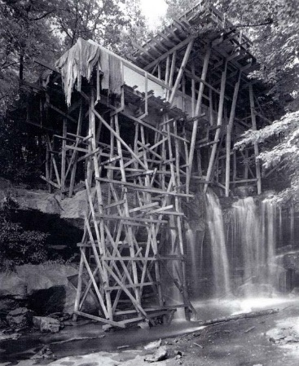
Materials
Wright used a lot of different materials throughout the building that he took careful decisions in making, to ensure the building was structurally safe and to make the property to be in harmony with nature reserve. The external walls are made from locally quarried Pottsville sandstone and reinforced concrete. The exterior consisted of cantilevered concrete ledges. The concrete used was made up from cement, sand and river gravel. The interior had floor made of stone, fireplaces made from sandstone, and glass windows and metal frames painted Cherokee red.
Robyn Smith, (1923),
Awards
The Fallingwater is still being described as a masterpiece of Wright interpretation of organic architecture. The design Mr. Wright made for Fallingwater was architecturally generations ahead of its time. The property went on to be recognised and win awards. The property was listed as a national historic landmark that is Preserved in 1966, the home achieved 29th on the list of Americas favourite architecture.
Fallingwater today
Fallingwater was the Kaufmann family’s property from 1937 to 1963. Edgar Kaufmann Jr. inherited the home and donated the home with surrounding acres to non-profit trust called Western Pennsylvania Conservancy. The home was opened to the public in 1964, with over 5 million people traveling from all over the world to view the property.
Conclusion
Mr Wright succeed in placing the building above the waterfall without any issues accruing till a later date. Despite the engineers believing the house would be a disaster, the house still stands above the waterfall and is still a functioning home. The house was designed by Mr. Wright and it became one of his most famous buildings, he did not go on to design anything even remotely similar. The architecture interpreted in the house, is still looked up on today for inspiration, with millions of people knowing the building. The property was able to keep to Mr. Wrights ideas, of making the home spacious, at a part of the surrounding nature. The home was able to display some of the principles of Japanese architecture, where Mr. Wright inspiration came from. The home helped Mr Wrights career as the house became famous and went on to win awards. Though the house was a success, the home had reports of structural issues. This led to the discovery that there was not enough rebar used in the foundation, which was fixed immediately.

My own sketches
Different angles of the building
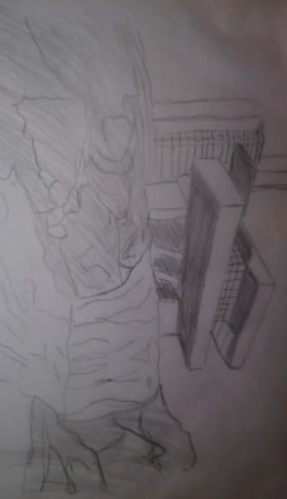
Olivia Rowland (2020)
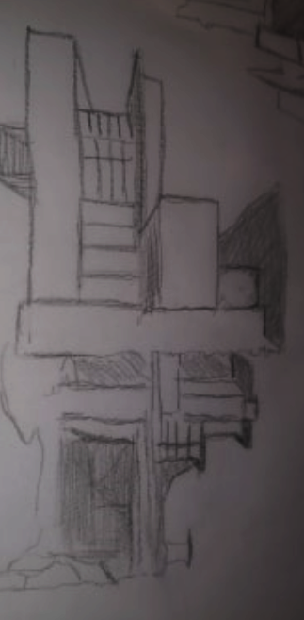
Olivia Rowland (2020)
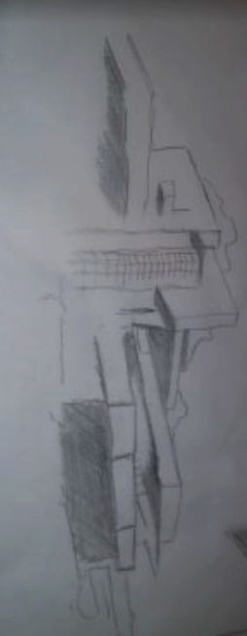
Olivia Rowland (2020)
Sections
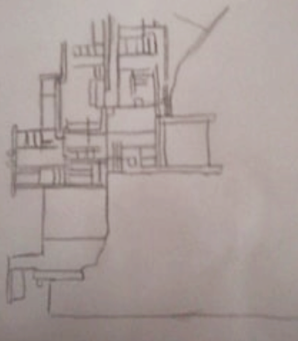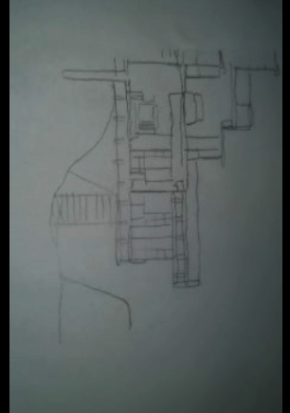
Olivia Rowland (2020) Olivia Rowland (2020)

References
Websites:
Fallingwater. (n.d.). Fallingwater. [online] Available at: https://fallingwaterproject.weebly.com/ [Accessed 19 April 2020].
Fallingwater & Frank Lloyd Wright. (2019). YouTube. Available at: https://www.youtube.com/watch?v=UDmlzRtyVNM [Accessed 11 April 2020].
Fallingwater. (2019). What is Fallingwater? - Learn more about Frank Lloyd Wright’s Masterpiece. [online] Available at: https://fallingwater.org/what-is-fallingwater/. [Accessed 19 April 2020].
www.bing.com. (n.d.). Maps. [online] Available at: https://www.bing.com/maps?q=pennsylvania+bear+run+waterfall+&FORM=HDRSC4 [Accessed 19 April 2020].
Fallingwater. (2019). The Kaufmann Family - Fallingwater. [online] Available at: https://fallingwater.org/history/about-fallingwater/the-kaufmann-family/. [Accessed 19 April 2020].
My Modern Met. (2018). How Frank Lloyd Wright’s ‘Fallingwater’ Home Changed Architecture Forever. [online] Available at: https://mymodernmet.com/frank-lloyd-wright-fallingwater-house/
www.bing.com. (n.d.). pennsylvania fallingwater bridge - Bing images. [online] Available at: https://www.bing.com/images/search?q=pennsylvania+fallingwater+bridge+&form=QBIR&first=1&cw=1117&ch=711 [Accessed 2 April 2020].
Wordpress.com. (2017). [online] Available at: https://visuallexicon.files.wordpress.com/2017/10/5north-elevation-and-section-e9bb84e79aaee4b9a626.jpg?w=723 [Accessed 2 April 2020].
www.bing.com. (n.d.). youtube fallingwater - Bing video. [online] Available at: https://www.bing.com/videos/search?q=youtube+fallingwater&docid=607991086127383643&mid=D5E0A20AC8697BDC9B40D5E0A20AC8697BDC9B40&view=detail&FORM=VIRE [Accessed 19 Apr. 2020].
A Look At Fallingwater. (2008). YouTube. Available at: https://www.youtube.com/watch?v=pSbjVgpXDoA [Accessed 5 April 2020].
Fallingwater House by Frank Lloyd Wright. (2016). YouTube. Available at: https://www.youtube.com/watch?v=TPYNcYNU0Ig [Accessed 5 April 2020].
Fallingwater. (2019). History of Fallingwater - Kaufmann family - Frank Lloyd Wright. [online] Available at: https://fallingwater.org/history/.
Mentalfloss.com. (2017). 12 Facts About Frank Lloyd Wright’s Fallingwater. [online] Available at: https://www.mentalfloss.com/article/90823/12-facts-about-frank-lloyd-wrights-fallingwater.
Wright-house.com. (2020). Fallingwater - house over waterfall, Frank Lloyd Wright. [online] Available at: http://www.wright-house.com/frank-lloyd-wright/fallingwater.html.
Alicja Zelazko (2018). Fallingwater | History, Description, & Facts. In: Encyclopædia Britannica. [online] Available at: https://www.britannica.com/place/Fallingwater.

Pictures
- wmcclure333, (2008), fallingwater-1 [ONLINE]. Available at: https://www.flickr.com/photos/7229307@N07/2195456834/ [Accessed 19 march 2020].
- www.bing.com. (n.d.). Maps. [online] Available at: https://www.bing.com/maps?q=pennsylvania+bear+run+waterfall+&FORM=HDRSC4 [Accessed 19 Apr. 2020].
- Richard Garcia, (1923), the future site of fallingwater [ONLINE]. Available at: https://www.pinterest.com.mx/pin/289778557270665289/ [Accessed 27 March 2020].
- Paul Rudolph and Yukio Futagawa,, (2009), north elevations and sections [ONLINE]. Available at: https://visuallexicon.wordpress.com/2017/10/04/fallingwater-house-frank-lloyd-wright/ [Accessed 19 March 2020].
- Paul Rudolph and Yukio Futagawa,, (2009), West/east elevations and sections [ONLINE]. Available at: https://visuallexicon.wordpress.com/2017/10/04/fallingwater-house-frank-lloyd-wright/ [Accessed 19 March 2020].
- fallingwater, (2020), designing falling water [ONLINE]. Available at: https://fallingwater.org/history/about-fallingwater/designing-fallingwater/ [Accessed 27 March 2020].
- gateway mavens, (2018), Fallingwater hatch to river beneath house [ONLINE]. Available at: https://www.getawaymavens.com/laurel-highlands-pa/ [Accessed 31 March 2020].
- alexis, (2012), interior design [ONLINE]. Available at: https://alexiscannariato.wordpress.com/2012/10/19/fallingwater/ [Accessed 31 March 2020].
- chris, (2010), stairs to the waterfall [ONLINE]. Available at: https://chrisglass.com/album/2010/07/30/fallingwater/ [Accessed 31 March 2020].
- Rick McNees, (2014), Fallingwater, Mill Run, PA - Frank Lloyd Wright - 1938 [ONLINE]. Available at: http://www.mcnees.org/architecture/flw_architecture_fallingwater.htm [Accessed 12 April 2020].
- Dr. Galen R. Frysinger, (2009), the Conner window [ONLINE]. Available at: http://www.galenfrysinger.com/fallingwater_penna.htm [Accessed 12 April 2020].
- Dr. Galen R. Frysinger, (2009), outside the kitchen window [ONLINE]. Available at: http://www.galenfrysinger.com/fallingwater_penna.htm [Accessed 12 April 2020].
- Hess landscape architects, (2012), low ceilings throughout the residence [ONLINE]. Available at: http://www.hessla.com/interests/frank-lloyd-wright-part-1-falling-water/ [Accessed 6 April 2020].
- Squarespace, (2016), living room [ONLINE]. Available at: http://www.buildingsarecool.com/new-blog/bucketlist-fallingwater [Accessed 6 April 2020]
- Robyn Smith, (1923), saved to Fallingwater (Edgar J. Kaufmann Sr. Residence) 1938 PA in FLW 1923 - 1940 Fallingwater/Edgar Kaufman House / 1413 Mill Run Road, Mill Run, Pennsylvania / Frank Lloyd Wright [ONLINE]. Available at: https://www.pinterest.co.uk/pin/399061216957395947/ [Accessed 19 March 2020].

