

Programme: | MSc Public Health and Social Care in Practice
Module: | Practice-Based Research
Module code: | LCHS7008
Lecturer: | Oluwadamilola Tayo and Diola Bijlhout
Assignment Title: | Component 2 Written Research Proposal
Student Name: | Vignesh Kalsariya
Student ID. | 2525353
Word Count: | 2732
Date of Submission:

Table of Contents
Introduction and background 3
Research problem, rationale and evidence gap 4
Literature review 5
Theoretical framework 6
Research gap 6
Research Question/Aims/question 7
Aim 7
Objectives 7
Question 7
Research methodology section 7
Research Design and methodological approach 7
Research Question Framework 8
Search Strategy and Information Sources 8
Inclusion and Exclusion Criteria 9
Study Screening and Selection 10
Quality Appraisal / Risk of Bias 11
Data Extraction 11
Data Synthesis and Analysis 11
Ethical considerations 12
Limitations 12
Timeline and expected contribution 12
Expected contribution 13
References 14

Title of the proposed research
An evaluation of socioeconomic dental health inequalities driven by water fluoridation in the UK, especially in the areas without water fluoridation systems.

Introduction and background
This research will examine the prevalence of water fluoridation, significantly affecting dental health and driving disparities among the population, leaving areas without a fluoridation system, which is an increasing concern throughout public health. Dental health is a significant public health concern, which is evidenced by 31,165 total hospital admissions of children in 2022 for dental extractions (UK Parliament, 2024).
In this context, socio-economic inequalities are significant catalysts of dental health, as children and adults from deprived communities are highly susceptible to tooth decay, pain and tooth losses (Fluoridation Information, 2026). According to the fluoridation health monitoring report 2022 for England, dental health issues have been observed at 20% in deprived areas, 25% of which are under no fluoridation scheme yet (UK Parliament, 2024). As per NHS data, a total of 35 million courses of treatment (COT) have been delivered to the UK population, evidencing a 4% growth from 2023/24 (NHS BSA, 2026), partially evidence non-fluoridation is affecting dental health.
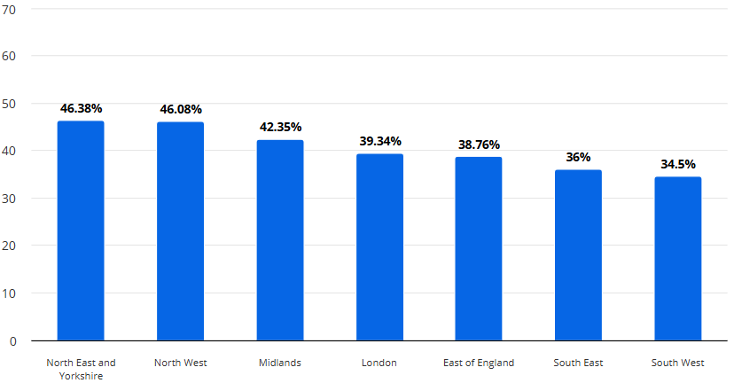
Figure 1: Share of adults who were seen by a dentist in 2024
(Source: Statista, 2025)
Surveys have shown that almost 19% of Brits aged 18-34 years accepted their unawareness about the connection between dental health with physical and mental health, aligning with the research topic (British Dental Journal, 2024). Between 2014/15 and 2019/20, funding for NHS dental care services has been reduced by 15%, resulting in an 8% increase in patient charges which has significantly affected people in deprived areas (UK Parliament, 2024). On the other hand, dental problems significantly impact the quality of life, evidenced by the statements of 12-15-year-old children, especially those belonging to lower income families.
As per governmental reports, currently Northern Ireland, Scotland, and Wales are not included in the community water fluoridation schemes in the UK (Fluoridation Information, 2026a), which has hindered dental care inequalities in deprived areas. Therefore, the research will evaluate how insufficient fluoridation creates concerning dental health issues and highlight inequalities between UK people living in the area with and without any fluoridation scheme.

Research problem, rationale and evidence gap
Research problem: The community water fluoridation schemes are effective in minimising dental decays by creating a shield over the dental enamel. Dental health service accessibility and cost-intensity are the key factors in increasing inequalities among the UK population in terms of socio-economic background.
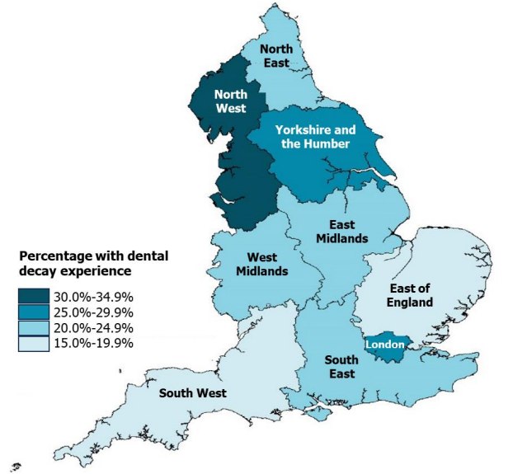
Figure 2: Regional differences in the prevalence of dental decay in 5-year-old children
(Source: UK Parliament, 2024)
Despite this, the effectiveness of community water fluoridation schemes in the minimisation of inequalities in socio-economic contexts still remains ambiguous.
Rationale: CWF is effective to reduce dental health inequalities by addressing the dental service shortages at NHS and remineralising water to safeguard their enamel, avoiding dental issues. A lack of fluoride in the water supplies can significantly lead to dental decays and other dental issues, whereas over exposure to fluoride can result in cancers, bone fractures, and dental fluorosis (UK Parliament, 2024). Therefore, innumerable studies have emphasised the effectiveness of CWF, but overlooks the reasons of inequalities in dental care, which has inspired to conduct this research in the socio-economic context.
Evidence gap: Governmental data shows almost 70% of the population in England lives in the area with <0.2mg/litre CWF (gov.uk, 2022), but it did not evaluate how CWF is managing inequalities. Dental care inequalities among the UK population have been a persisting issue (Oral Health Foundation, 2025), although CWF impact has not been included here. This research will address the limited evidence on its effectiveness in minimising inequalities and offer a comprehensive synthesis of practical evidence from the fluoridation policy, practices and a path for future research.

Literature review
Evaluating the relationship between CWF and dental care inequalities
CWF is considered a significant population health programme to prevent dental caries in individual socio-economic groups in an equitable way (Zokaie and Pollick, 2022). CWF maintains a standard level of fluoride in the water to ensure mineralisation and safeguard dental health to minimise dental issues. Arguably, Do et al. (2026) have commented that CWF is not a sufficient measure in controlling dental health risks in larger populations. Hence, in largely populated places with a high rate of dental crisis and poor access to dental care, CWF cannot solely resolve the issues and ensure equitable opportunities.
Identifying the importance of CWF scheme in addressing dental health inequalities in different socio-economic layers
Cumbrian Assessment of Teeth a Fluoride Intervention Study for Health (CATFISH) researchers have found that dental conditions in the children and adults in the places under CWF schemes, are better and require less dental care intervention (Hearnshaw et al. 2023). Standardised level of fluoride significantly improved dental health and minimised unequal accessibility to dental care services. On the other hand, Patel, Patrick and Dyer (2025) have opined that CWF scheme ensures that the fluoride concentration does not exceed the standard mentioned in WHO guidelines. Therefore, implementation of the CWF schemes endeavours to maintain an ideal amount of fluoride in community water supplies to avoid dental and other health hazards.
Investigating the impacts of improper fluoridation in increasing dental health problem
Fluoride is often mixed with communal water to ensure dental health to minimise dental caries and aims to minimise the inequalities among different socio-economic backgrounds (Zokaie and Pollick, 2022). Precisely, community water fluoridation primarily addresses various social and environmental health determinants to offer safe drinking water for multiple health benefits. Arguably, Raghav et al. (2023) have stated that fluoride levels exceeding the range of 1.2 to 1.5 ppm, can lead to significant health concerns, including dental fluorosis, skeletal fluorosis and neurological issues. Therefore, it signifies that the presence of fluoride in a generous amount can lead to health hazards rather than offering health benefits among children and adults.
Identifying the factors influencing dental health inequalities in socio-economic context
Studies have evidenced that dental caries are largely found among the socio-economically deprived groups due to limited knowledge for dental care and hygiene, and low accessibility to dental care services (Dunleavy et al. 2024). Precisely, a lack of awareness, prompt treatments and no CWF system have become catalysing factors in accelerating dental disease among the children and adults belonging to lower socio-economic backgrounds. Contrastingly, Zokaie and Pollick (2022) have commented that children and adults belonging to low socio-economic groups under communal fluoridation, have comparably lower risk of tooth decay than non-fluoridated communities. Hence, the CWF system can become a wiser choice to enhance dental health and safety even in the low socio-economic context.

Theoretical framework
By considering the research topic, the Fundamental Cause Theory can be implemented to address how socioeconomic factors have catalysed dental health inequality in the UK by minimising accessibility to dental care services (Subica and Link, 2022). It has exhibited that a lack of awareness regarding dental care and hygiene, and poor access to healthcare, are driving dental caries among the deprived groups. Hence, in this context, CWF has been considered a cost-effective and convenient method to enhance dental health and address inequalities among the low socioeconomic groups.

Research gap
Dunleavy et al. (2024) have emphasised a lack of awareness, and poor access to dental care services as significant catalysts of dental care inequalities, whereas Patel, Patrick and Dyer (2025) have emphasised the importance of CWF scheme in ensuring a standard concentration of fluoride. These studies have not elaborated the effectiveness of fluoridation in reducing inequalities. Whereas, Do et al. (2026) has mentioned the limited effectiveness of CWF in larger populations, but overlook the significance or real-life evidence of minimised dental health inequalities. Hence, this study will address the identified and will try to present actual consequences of CWF in combating inequalities.

Research Question/Aims/question

Aim
This research proposal aims to investigate the role of community water fluoridation (CWF) in addressing dental health care inequalities among adults and children in socio-economic context in the UK, through a secondary systematic review.

Objectives
- To analyse the influence of CWF on socioeconomic inequalities in dental health outcomes among children and adults in the UK.
- To compare dental health outcomes between fluoridated and non-fluoridated UK communities across different socioeconomic levels.
- To identify socioeconomic and public health factors that influence the effectiveness of community water fluoridation in reducing dental health inequalities.
- To synthesise supporting evidence on the impact of community water fluoridation on improving public health outcomes and reducing dental health inequalities in the UK.

Question
How does community water fluoridation influence socioeconomic dental health inequalities and public health outcomes in the UK?

Research methodology section

Research Design and methodological approach
This research will select a secondary systematic review design to synthesise existing secondary evidence regarding the impacts of CWF in managing dental health care inequalities among different socio-economic groups in the UK (Gericke et al. 2022). Such a systematic review will be appropriate for the researcher for the identification, appraisal and synthesis of the collected evidence from diverse studies, relating to the pre-identified research question. A systematic research approach will be effective in minimising the selection bias by integrating predefined and transparent methods considering study identification and selection (Myung et al. 2023). In this context, the PRISMA 2020 guidance will be followed to ensure transparent reporting of the review rationale, identifying studies, followed by the selection, approval and synthesis of the secondary information (Mishra and Mishra, 2023). This research design will be effective in this research as the evidence shows that fluoridation and dental health inequalities vary in terms of population characteristics, exposure to dental decay and outcome definitions. Therefore, the systematic synthesis may help in facilitating an in-depth and insight-driven criteria assessment of the consistency and ambiguity in the evidence.

Research Question Framework
In this systemic review, the research question will be structured by applying the PICO framework to analyse the selected public health concern.
Population (P)- This will comprise the population, involving children and adults belonging to different socio-economic backgrounds in fluoridated and non-fluoridated areas.
Intervention (I)- CWF will be considered the exposure/intervention to impact the inequalities.
Comparator (C)- Based on existing studies, the comparator will involve the population without CWF or minimal fluoride concentration.
Outcomes (O)- Outcomes will focus on oral health indicators and examples of socioeconomic inequalities.
Hence, a well-structured question is required to influence study eligibility, searching, secondary data collection and synthesis decisions (Nishikawa-Pacher, 2022).

Search Strategy and Information Sources
In this systematic research, an information search strategy will be followed across relevant and authentic health, medical, dental and multidisciplinary databases, such as Google Scholar, Embase, CINAHL, Scopus and Web of Science and MEDLINE/PubMed. Data collection from these sources will be optimistic to offer a broader insight on epidemiological, public-health, dental and health-services research (Fitria, 2022). Alongside the searching method involving relevant references and citation networks will be also included in the study to identify potentially eligible data sources. The search strategy in this research will focus on four key conceptual principles, such as fluoridation, dental/oral health socioeconomic inequality and the UK. In this context, Boolean Operators will be applied to represent synonymous and relevant terms (Carcassi and Sbardolini, 2023), for instance, fluoridation OR fluoride concentration, dental health OR oral health, OR dental health OR dental caries, and inequalities OR socioeconomic difference OR deprivation. Database-specific headings, including MeSH terms, will be applied to enhance quality along with free-text keywords. Current Cochrane guidance recommends mandatory documentation of the search process including dates, databases, strings, terms and retrieval records to support reproducibility (Korfitsen et al. 2022).

Inclusion and Exclusion Criteria
For this research, the studies in research publications, published within 2022-2026 in English, involve the investigation of CWF in a UK population and reports on the consequences relating to dental health and socioeconomic diversities (Whittaker et al. 2024). Inclusion of quantitative observational or other comparative designs will effectively examine the interconnection between the fluoridation process and dental health outcomes among the UK population. Precisely, the studies which involve the selected population, fluoridation exposure, comparator and consequence on dental health conditions will be included. The studies that consist of non-communal sources of fluoride, pollution outside the UK, experimental research, irrelevant to the population-led and dental health outcomes will be excluded. Additionally, non-research publications and different editorials will also be excluded for not offering primary empirical evidence. Hence, eligibility criteria in this research will be conducted to reduce relevant secondary study selection before the screening process and accelerate consistency (Ajayi, 2023).

Study Screening and Selection
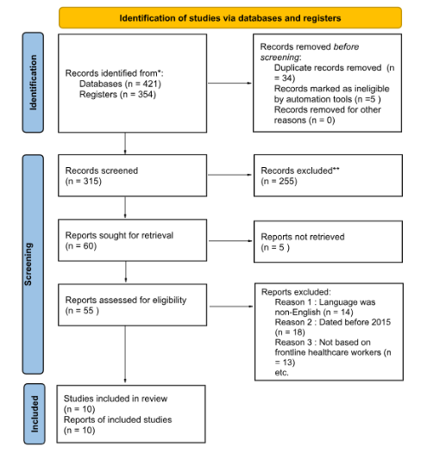
Figure 3: PRISMA Table
(source: self-created)
Collected secondary information will be imported into a reference-management software to remove the similar copies, while the titles and abstract will be scrutinised based on the predefined eligibility criteria. In this phase, the exclusion process at the full-text stage will be recorded, whereas the PRISMA 2020 flow diagram will document the identified screens, eligibility assessment and final inclusion of studies (Rethlefsen and Page, 2022). PRISMA 2020 will enhance guidance and the following diagram will improve transparency throughout the systematic review selection method. Hence, the potential ambiguities will be resolved by the references to the predefined criteria despite subjective emphasis.

Quality Appraisal / Risk of Bias
The quality and authenticity of the methodology along with the potential bias in the selected studies will be critically evaluated by the appraisal tools for appropriate study designs. In this context, Joanna Briggs Institute (JBI), can become a wiser choice for the researcher to enhance trustworthiness, relevance and outcomes of published research, due to its suitability in observational or quasi-experimental studies (Glaría et al. 2024). Such appraisal will help in assessing the selection bias, methodological transparency and measuring the suitability of the analytical procedure. Quality assessment will help in recognising methodological limitations (Cheong et al. 2023) to understand evidential consistency, which is essential as the connection between fluoridation and dental outcomes may differ in diverse socioeconomic and other relevant contexts.

Data Extraction
A data-extraction method will be applied to ensure data collection from studies, highlighting author and publication year, geographical setting, design of the study, samples, fluoridation, comparator, socioeconomic standards, dental outcomes and limitations as well (Schmidt et al. 2025). Information involving methodological quality and ambiguities will also be included, as standardisation will help to enhance transparency and richness of the study.

Data Synthesis and Analysis
Finally, the extracted information will be passed through a descriptive synthesis to identify patterns in the interconnection between CWF, dental health conditions and socioeconomic diversities (Taghavi et al. 2022). Thereby, the findings will be compared through population characteristics, study design, socioeconomic differences and outcome definitions. Here, agreement, contradiction and methodological heterogeneity will be emphasised more than the assumptions over the equivalence of the evidence. Relatively, a narrative synthesis will be ideal if meaningful statistical pooling is prevented by the substantial heterogeneity (Jacob et al. 2025). The effectiveness of meta-analysis will be considered if sufficient quantifiable data is present, despite compatibility and interpretation can be affected by the identified differences in study design. Therefore, the narrative synthesis will effectively differentiate evidence of CWF impacts and CWF in reducing socioeconomic dental health inequalities.

Ethical considerations
This secondary qualitative research may face ethical risks for improper acknowledgments to publications or data sources by inaccurate referencing, even by placing transparency in representing findings. To avoid moral degradations, the researcher will strictly emphasise university-led referencing style, minimising plagiarism and transparent reporting of the findings in original data sources (Lal and Sharma, 2023). The researcher will require university confirmation and approval for conducting the secondary qualitative research to avoid further ethical violations. Hence, the researcher will ensure ethical integrity by adhering to legal and institutional terms of the secondary sources to ensure reliance and validation.

Limitations
This secondary qualitative research will face a few inherent limitations by restricting data collection solely to full-text peer-reviewed, and English articles, resulting in language and publication bias (Taherdoost, 2022). Whereas, secondary thematic analysis may introduce researcher’s subjective bias in data interpretation which can be addressed and managed by transparent data collection criteria and quality assessment methods. Therefore, rigorous reflective practices will be highly effective in minimising such biases and contextualising findings rather than overall generalisation.

Timeline and expected contribution

Figure 4: Timeline
(source: self-created)

Expected contribution
This research will inspire UK policymakers to reconsider the importance of CWF schemes in enhancing dental health and minimising inequalities by informing the scheme in non-fluoridated areas. Whereas, the research may contribute in health promotion to enhance health literacy and influence people to minimise consumption of foods or drinks that cause tooth decay, significantly broadening the path for future researchers to explore the unfolded aspects of fluoridation in terms of dental health.

References
Ajayi, V.O., (2023) A review on primary sources of data and secondary sources of data. Available at SSRN 5378785.
British Dental Journal (2024) Younger adults know more about mental health than dental health. Available at: https://www.nature.com/articles/s41415-024-8085-1 (Accessed: 2 August 2026).
Cheong, H.I., Lyons, A., Houghton, R. and Majumdar, A. (2023) Secondary qualitative research methodology using online data within the context of social sciences. International Journal of Qualitative Methods, 22, p.16094069231180160.
Do, L.G., Ha, D.H., Spencer, A.J. and Rugg-Gunn, A. (2026) Controversies and public health implications of community water fluoridation. Journal of Dental Research, 105(5), pp.561-569.
Dunleavy, G., Verma, N., Raghupathy, R., Jain, S., Hofmeister, J., Cook, R., Vujicic, M., Kebschull, M., Chapple, I., West, N. and Pitts, N. (2024) Inequalities in oral health: estimating the longitudinal economic burden of dental caries by deprivation status in six countries. BMC Public Health, 24(1), p.3239.
Fitria, T.N. (2022) Using authentic material and created material (teacher-made) for English Language Teaching (ELT): Benefits and limitations. JADEs Journal of Academia in English Education, 3(2), pp.117-140.
Fluoridation Information (2026) The UK Fluoridation Evidence Base and Information Centre. Available at: https://fluoridation.co.uk/ (Accessed: 2 August 2026).
Fluoridation Information (2026a) Extent. Available at: https://fluoridation.co.uk/extent-of-community-water-fluoridation/ (Accessed: 2 August 2026).
Gericke, N., Högström, P. and Wallin, J. (2023) A systematic review of research on laboratory work in secondary school. Studies in science education, 59(2), pp.245-285.
Glaría, M.G., Fernández, M.M., Salgado, C. and Hernández‐Leal, M.J. (2024) A Joanna Briggs Institute Framework Approach to Shared Decision Making in End‐of‐Life. Health Expectations, 27(5), p.e70041.
gov.uk (2022) Health monitoring report for England 2022. Available at: https://assets.publishing.service.gov.uk/media/622ee4518fa8f56c1d3113dd/water-fluoridation-health-monitoring-report-2022.pdf (Accessed: 2 August 2026).
Hearnshaw, S., Cockcroft, B., Rugg-Gunn, A., Morris, A.J., Lowry, R.J., Beal, J., Johnson, J. and Jacob, M. (2023) Comments on recent community water fluoridation studies: Comments on recent community water fluoridation studies. British Dental Journal, 235(8), pp.639-641.
Jacob, C., Brasier, N., Laurenzi, E., Heuss, S., Mougiakakou, S.G., Cöltekin, A. and Peter, M.K., (2025) AI for IMPACTS framework for evaluating the long-term real-world impacts of AI-powered clinician tools: systematic review and narrative synthesis. Journal of medical Internet research, 27, p.e67485.
Korfitsen, C.B., Mikkelsen, M.L.K., Ussing, A., Walker, K.C., Rohde, J.F., Andersen, H.K., Tarp, S. and Händel, M.N. (2022) Usefulness of Cochrane reviews in clinical guideline development—a survey of 585 recommendations. International journal of environmental research and public health, 19(2), p.685.
Lal, K.K. and Sharma, B. (2023) Research integrity & ethics: Scientific misconduct. In National seminar on academic integrity and research ethics. National Seminar on Academic Integrity and Research Ethics.
Mishra, V. and Mishra, M.P. (2023) PRISMA for review of management literature–method, merits, and limitations–an academic review.
Myung, S.K (2023) How to review and assess a systematic review and meta-analysis article: a methodological study (secondary publication). Journal of educational evaluation for health professions, 20, p.24.
NHS BSA (2026) Dental statistics - England 2024/25. Available at: https://www.nhsbsa.nhs.uk/statistical-collections/dental-england/dental-statistics-england-202425 (Accessed: 2 August 2026).
Nishikawa-Pacher, A. (2022) Research questions with PICO: a universal mnemonic. Publications, 10(3), p.21.
Oral Health Foundation (2025) Impact of health inequalities report highlights a growing concern. Available at: https://www.dentalhealth.org/news/impact-of-health-inequalities-report-highlights-a-growing-concern (Accessed: 2 August 2026).
Patel, B., Patrick, A. and Dyer, T.A. (2025) The ethics of community water fluoridation: Part 1-an overview of public health ethics: The ethics of community water fluoridation: Part 1-an overview of public health ethics. British Dental Journal, 238(5), pp.311-315.
Rethlefsen, M.L. and Page, M.J. (2022) PRISMA 2020 and PRISMA-S: common questions on tracking records and the flow diagram. Journal of the Medical Library Association: JMLA, 110(2), p.253.
Schmidt, L., Mutlu, A.N.F., Elmore, R., Olorisade, B.K., Thomas, J. and Higgins, J.P. (2025) Data extraction methods for systematic review (semi) automation: Update of a living systematic review. F1000Research, 10, p.401.
Statista (2025) Share of adults who were seen by a dentist in England as of June 30, 2024, by region. Available at: https://www.statista.com/statistics/1045434/patients-seen-by-dentists-england-by-region/?srsltid=AfmBOopFy3IlQt-50CenftKlayvF37l6i4xoIt9rwlFXylL15t8ni4eO (Accessed: 2 August 2026).
Subica, A.M. and Link, B.G. (2022) Cultural trauma as a fundamental cause of health disparities. Social Science & Medicine, 292, p.114574.
Taghavi, M.H., Akhavan, P., Ahmadi, R. and Bonyadi Naeini, A. (2022) Identifying key components in implementation of internet of energy (IoE) in Iran with a combined approach of meta-synthesis and structural analysis: A systematic review. Sustainability, 14(20), p.13180.
Taherdoost, H., (2022) What are different research approaches? Comprehensive review of qualitative, quantitative, and mixed method research, their applications, types, and limitations. Journal of management science & engineering research, 5(1), pp.53-63.
UK Parliament (2024) Water fluoridation and dental health: 2024 update. Available at: https://researchbriefings.files.parliament.uk/documents/POST-PB-0063/POST-PB-0063.pdf (Accessed: 2 August 2026).
Whittaker, W., Goodwin, M., Bashir, S., Sutton, M., Emsley, R., Kelly, M.P., Tickle, M., Walsh, T. and Pretty, I.A., (2024) Economic evaluation of a water fluoridation scheme in Cumbria, UK. Community Dentistry and Oral Epidemiology, 52(4), pp.601-612.
Zokaie, T. and Pollick, H. (2022) Community water fluoridation and the integrity of equitable public health infrastructure. Journal of public health dentistry, 82(3), pp.358-361.

