
APPENDIX GA36c

LEVEL 6 ASSESSMENT SPECIFICATION

Student name: | JAMES LLOYD BRACE | Student ID number: | 1703193
Programme: | SECONDARY HISTORY PGCE
Module: | Principles of Teaching, Learning and Pedagogy in the Secondary Sector
Module code: | ECSP6001 | Contribution to Overall Module Assessment (%): | 50%
Lecturer: | Alison S Evans | Internal Verifier:
Assignment Title: | Part B, (i) and (ii) | Word count (or equivalent): | - = 1,500  - = 2,000
Submission deadline: | 26 November 2018 | Return date of provisional marks & written feedback: | 17 December 2018
Submission method: | All written assessments, where practical and possible, must be submitted via Turnitin unless otherwise instructed by the Lecturer. (Please DO NOT put this assessment specification into Turnitin or it will match many similarities with other students’ submissions.)  Alternative submission method (if applicable):  Late submission of the assessment will result in a late penalty mark. Penalties for late submission: Up to one week late, maximum mark of 40%. Over one week late, 0%. Only the Extenuating Circumstances Panel may approve a change to submission dates.
Academic honesty / referencing: | Academic honesty is required. In the main body of your submission you must give credit to authors on whose research and ideas your work is based. Append to your submission a reference list that indicates the books, articles, etc. that you have used, cited or quoted in order to complete this assessment.

Micro-teach: Critical Reflection and Evaluation

REVIEW OF LITERATURE
The scheme of work, on changes during the Protectorate and Restoration, was designed primarily around cognitivist learning principles. Cognitivist theory is one of three major theories of learning (along with behaviourist and humanistic) which have come into the field of teaching from Human Psychology (Hartley, 1998; Gross, 2001; Petty, 2014). Theorists within this cognitivist school of thought posit that learning is a ‘physical process’ as neurones connect and encode information, thus ‘learners must construct their own meaning’ and practitioners should therefore ‘teach for understanding’ (Petty, 2014, 11-12). It is the last point in particular which drove the planning and way the scheme of work and lessons within it, was structured. In particular Benjamin Bloom’s ordering of cognitive skills into a hierarchy inspired the choice and order of tasks in lessons (Bloom, 1956). Each of the first four lessons, would begin with an starter and exposition of knowledge, followed by source analysis main tasks, enabling learners by the end of each lesson to be able to synthesise what they have learned in a written plenary paragraph. By these means learners would not just gain knowledge, but develop a rich understanding and an individual interpretation through applying knowledge, evaluating sources of information and contrasting different aspects.
Deeper learning, as learning with understanding is called, also represents a more fundamental practical belief recognised in the teaching profession long before the advent of cognitivist theories of learning. This is shown in the Assistant Master of Clifton College’s 1898 assertion of the risk that, that without specialists teaching history, lessons may
degenerate into mechanical attempts to exact from the boys the names and facts which they do not understand or assimilate - - a worse than useless proceeding (Spence, 1898, 164).
This is the realisation that teaching for understanding is more effective than teaching for remembrance alone. If the effectiveness of teaching for understanding has long existed within the profession, then its importance has certainly been consolidated by cognitivist learning theory in the last few decades.
This consolidation under the cognitivist learning banner, is also part of a broader societal shift. A shift reflecting the ever-increasing knowledge and understanding and the changing needs of our societies. Thus, where shallow learning (without understanding, also known as rote learning) was once adequate in the twentieth century, the increasing complexity, ‘post-truth’ lack of consensus, and changed labour market demands of the twenty-first century now urge the need for deeper learning in schools (West-Burnham, 2005, 35-6; Donaldson, 2015, 6-8; Tough, 2016, 104; Open University, 2018, 6-8). In practical terms this has meant that some schools’ educational provision is no longer meeting their society’s changing needs, leading to a disconnect (Tough, 2016, 104). This takes on added significance when John West-Burnham’s (2005, 36) observation, that a teacher teaching the right answer (shallow learning) is still the basis of most education systems, is considered. Herein lies also a troubling socio-economic correlation: that low income and/ or lower ability learners are more likely to be taught in a repetitive way which is less engaging, restrictive, less creativite, and (by over-practicing) potentially reinforces a sense of failure and promoting disengagement (Tough 2016, 100-1; Kitson, Husbands & Steward, 2011, 125). Paul Tough goes so far as to say that, in the United States, traditional pedagogy is operating in direct opposition to what psychological research suggests is necessary for learners to succeed (Tough, 2016, 104). In this way the older educational pedagogies which epitomised teacher-led learning and discipline (both key principles of behaviourist learning theory) in the ninetieth and twentieth century, have in many places outlived the industries they grew up preparing children for.
However, where this has been recognised significant progress has already started to be made in reconciling educational provision with the needs of today’s society. Recognising these pressures and other external influences on the curriculum in his review of education in Wales, Graham Donaldson (2015, 6-8) suggested that maintaining the irrelevant whilst adding new expectations put teachers under pressure and diverted crucial attention from learners’ needs and quality teaching. The four curriculum purposes Donaldson proposed (capable learners, creative contributors, ethical citizens and healthy individuals) are indicative of the way in which education has shifted from training industrial workers to developing the young people as individuals (Donaldson, 2015, 29-30). Hereto Donaldson’s (2015) recommendation of three cross-curriculum responsibilities (literacy, numeracy and digital competency) and emphasis on greater inter-subject links especially within the six Areas of Learning and Experience (AOLE) were key factors in the scheme of works design. Engaging with the Literacy and Numeracy Framework, every lesson (except lesson 5 which is specifically an oral class debate) was created to ensure a mix of reading, written and oral literacy, and (to varying degrees) the integration of numeracy where appropriate. The four first lessons, which each focused on a different type of change during the period, were produced with specific cross-curricular links in mind: lesson one focussed on political changes (Politics); lesson two religious changes (Religious Education); lesson three social changes (Education for Sustainable Development and Global Citizenship [ESDGC]); and lesson four global changes (Geography). The intention being to broaden learners’ historical perspectives through introducing and applying other disciplinary perspectives.
The value of theories vary but a key take-away is that learning theories are not concrete realities. Whilst cognitivist theory informed the design of the scheme of work, it was not the sole influence. Geoff Petty (2014, 11) suggested that cognitivist, behaviourist, and humanistic theories ‘supplement rather than contradict each other and frequently overlap in practice’, but this masks that they remain merely theoretical perspectives which can only help inform, rather than specifically prescribe, teaching approaches. It is sometimes easy to oversubscribe to these and miss the core empirical reality of teaching. Has John West-Burnham (2005, 38) articulated it there is ‘probably not a science of learning at present’, this means theory and practise have developed what James Hartley (1998, 16) called a ‘symbiotic relationship’. Social science studies frequently provide case studies to support points, but the reality for teaching and learning is there are too many subjective variables to quantify (West-Burnham, 2005, 33; Hattie, 2012). Chris Husband’s (2011, 93) framework of a teacher’s knowledge base well illustrates the number of variables informing the teacher, let alone the learners and the environment.
Here one may draw together several strands which remain an underlying trend. The humanistic theory of learning (focusing on learners’ emotional and developmental needs), Donaldson’s (2015) emphasis on developing the individual, the limits of cognitivist theory and influence of external factors on learning and development combine to show that teaching a curriculum is only half the battle (Petty, 2014, 22-24; Tough, 2016; Hartley, 1998). For learning to occur the learner must engage with the learning process, this is often taken for granted but is fundamental. As Alison Kitson, Chris Husbands and Susan Steward (2011, 120) noted, success relies on more than talent, it also needs: resilience; reflectiveness; resourcefulness; disposition; motivation and determination to learn.
In a seemingly radical opinion John Holt’s (1982) humanistic critique is that schools are in fact capable of promoting the opposite: ‘bad strategies, rais[ing] children’s fears, produce learning which is usually fragmentary, distorted and short-lived, and generally fail to meet the real needs of children.’ His view, which like Sociology studies looks at the experience of school as an institution from the learner’s perspective (Berger & Berger, 1976), sees schools performing the reverse of their function: destroying rather than developing young people. If Holt’s language appears exaggerated, the sentiment behind it is not. Schools possess a substantive capacity to change young people’s lives, but to ensure they are changed for the better, how individual differences affect learning must be considered (Hartley, 1998, 19; West-Burnham, 2005, 40-1; Donovan, Henderson, James & Martin-Denham, 2015). For Tough (2016), having recognised the role of adversity and other circumstances as barriers to learning and how some school environments make learning harder not easier, the answer lies in the development of noncognitive skills in the classroom. Seeing the psychological research of Edward Deci, Richard Ryan and Camille Farrington as a whole, Tough (2016) suggested promoting a sense of belonging through relationships and setting achievable but challenging work through pedagogy. Rather than school disabling learners therefore, the emphasis is put back on enabling them to succeed.
Promoting non-cognitive growth is harder to plan for, but an attempt was made to include this as an organic element of the scheme of work. This was done by setting a series of challenging source analysis main tasks in lessons one to four, but in a structured and scaffolded way to build learners’ confidence and capability prior to the class debate in lesson 5. Applying Jerome Bruner’s conception of scaffolding (Phillips, 2005, 26), the plan was specifically based on the inspiration provided by Trevor MacKenzie and Rebecca Bathurst-Hunt’s (2018) structured approach to inquiry: moving from a teacher-led source analysis task in lesson one, to an independent learner-led source analysis task in lesson four. It being hoped, that the sense of confidence and level of understanding built up would encourage learners to contribute to the class debate in lesson five.
To conclude, learning needs the ‘positive interaction [...of] complex variables’ (West-Burnham, 2005, 33), it relies on multiple aspects being identified and engaged with. Knowing then considering how individual learners think, respond and feel are all important to effective teaching and learning. For educating young people is now about more than imparting academic knowledge, it is also about helping them develop themselves as capable, creative, ethical healthy individuals.

CRITICAL EVALUATION
[Studies] perfect nature, and are perfected by experience (Bacon, 2005, 85).
On 11 October 2018, a microteach lesson on political changes during the Protectorate and Restoration was delivered to a group of peers in Ysgol Bro Dur. It was the first lesson designed as part of a six lesson scheme of work focused on the range of changes which took place during the period. Given a thirty minute window to present each, the decision made taken to present the sixty minute lesson in a condensed form. Both these planning decisions had significant implications for the microteach, as its author will now evaluate.
In essence, selecting the first lesson and a concertinaed teaching approach meant that there were already structural issues acting to the detriment of the microteach lesson. As the complex primary aim of the lesson (to be able to explain, analyse and summarise why and how political systems change) indicates, there was already too many different processes intended for the lesson. Together with the inclusion of an overview chronology as a starter, as the mentor’s lesson comments observed: ‘it felt like there were three lessons competing here - one on chronology, one on causation and one of change’. The result of this planning decision in practice was that the lesson was immediately setting learners at a disadvantage. As professional teaching experience in the weeks following has clearly shown, a lesson must be clearly aimed with all activities within that lesson contributing toward it. This provides learners a clear vision of what they are going to learn, and knowledge that everything they do in that lesson will help them meet that learning objective by the end of the lesson. Where the microteach structurally failed was that its original purpose, to analyse political changes, was overloaded by additional concepts of chronology and causation. This led to a microteach lesson which departed on one heading (chronology), changed direction (causation), then tacked back and forth for the duration (causation/ change). Whilst the learners (postgraduate peers) held on and performed well under these circumstances, hindsight and teaching experience since suggests that this would easily have overwhelmed the Year 8 class it was originally designed for. Catalysing the structural issues was the decision to teach a concertina version of an already complex lesson, this created time pressures and left little space to clarify understandings and take time to explain/ explore key concepts. A related structural issue, which did not become apparent until the microteach was delivered was the level of prior knowledge. Having researched the topic and intended it as a scheme of work to succeed one on the British Civil Wars, some crucial prior conceptual understandings (for instance that Cromwell was a Parliamentarian, that King Charles I was executed) were taken for granted. Here some learners encountered problems initially accessing the lesson, which led to improvised verbal scaffolding being given to individual groups to try and make up the shortfall. This also had time implications.
TARGET 1: Plan lessons with a clear learning aim and activities appropriate to meeting it. This is not only a condition of Qualified Teacher Status (QTS), Standard 3.1.2 Planning lessons which includes ‘use [of] teaching and learning objectives to plan lessons’ (Welsh Government, 2009, 56), but more fundamentally by provide clearly focussed lessons affords learners better access to learning.
The starter activity, a timeline of the period completed by the learners, worked very well. It served well as an outline activity, allowing explanation and important context to be provided verbally as the timeline was completed as a class. Here the PowerPoint served well in enabling events to be easily added to a visual timeline identical the learners’ paper copies. Timing meant that it was not run fully as a numeracy activity, the differentiated timeline handouts (with dates already entered) being distributed on the day to save time. The numeracy component, working out the timeline’s scale, was included in the activity as a natural means of promoting learners’ numeracy and sense of chronology (as one of the three cross-curriculum responsibilities and part of the Literacy and Numeracy Framework [LNF]). In a full lesson the calculations would have been made by learners then reviewed as a class together with the order of events, but in the concertina version this was not practical. The activity also went on longer than was needed, this was owing to a deficit of prior knowledge that had not been anticipated and in the spur of the moment led to each group being verbally scaffolded to help them. As the mentor noted, and as lesson comments since have also highlighted, at such moments - when the majority of the class is unsure of something - go through it as a class together. It was the decision not to do this which cost the time. This being said the activity was completed to a good standard by the entire class.
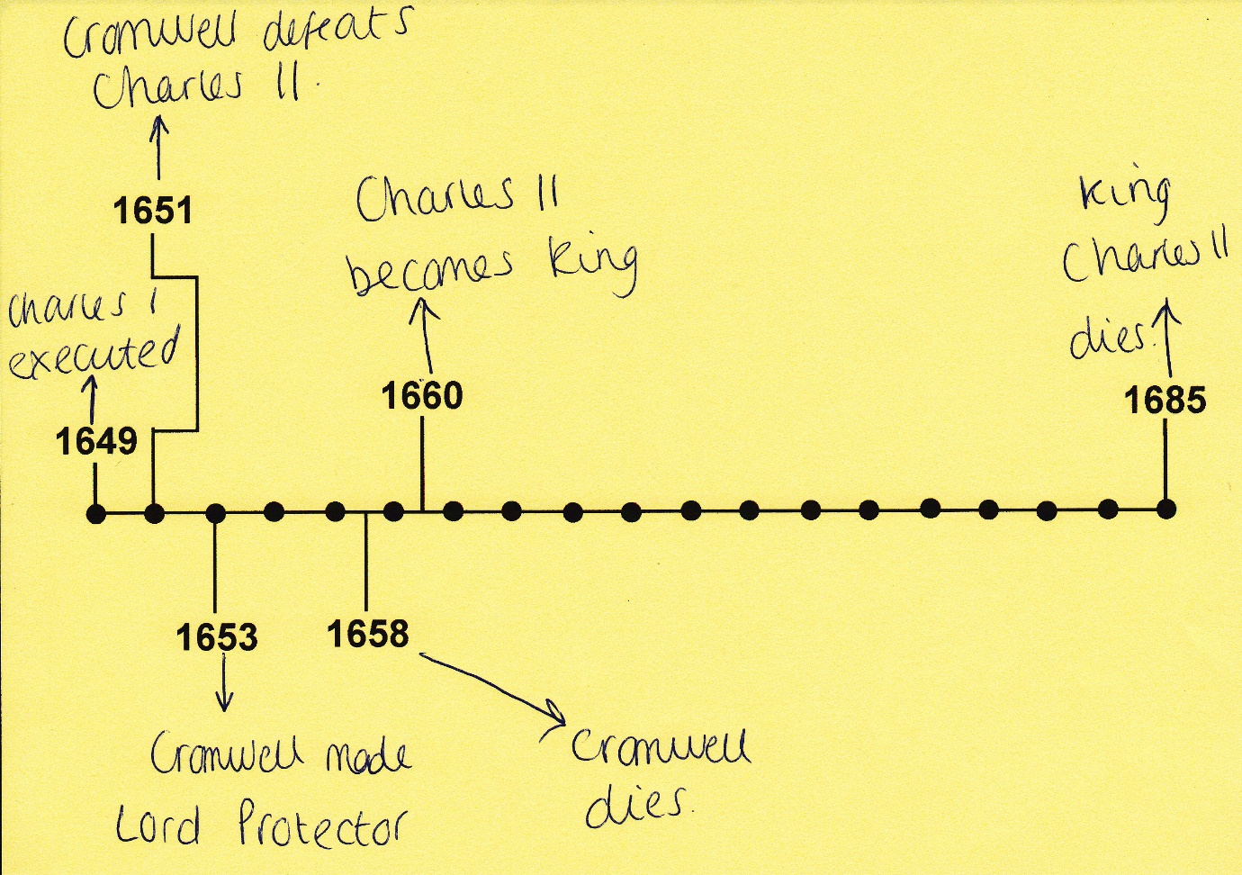
[Timeline Handout (scaffolded) as completed by one of the learners]
TARGET 2: When gap in understanding encountered, go through it as a class. This will save time and is a more organised approach which will enable the teacher to spend more time supervising the whole class, rather than rushing around and focusing on one group at a time.
The structural overloading in the plan had the biggest implications for the main tasks, these were: visual puzzle on causes of Protectorate; source analysis on political changes under Protectorate; visual puzzle on causes of Restoration; source analysis on political changes under Restoration. Intended as two tasks, they were broken into two parts and re-arranged to consolidate learner understanding. However, the inverse proved to be the case, as the conceptual impact of this decision for learners was overlooked. The puzzles were well received by learners, one learner commenting: ‘Really good use of images for explanation of Cromwell as Lord protector’. In particular the fact that these were learner-led activities in which the learners worked out the causes for change themselves using visual clues, the teacher providing context and guiding (as needed). This enabled learners to build an understanding of why the change occurred through making their own connections. In practice this activity relied on a level of prior knowledge and necessitated more verbal scaffolding than was initially intended. Prior knowledge and accessibility were
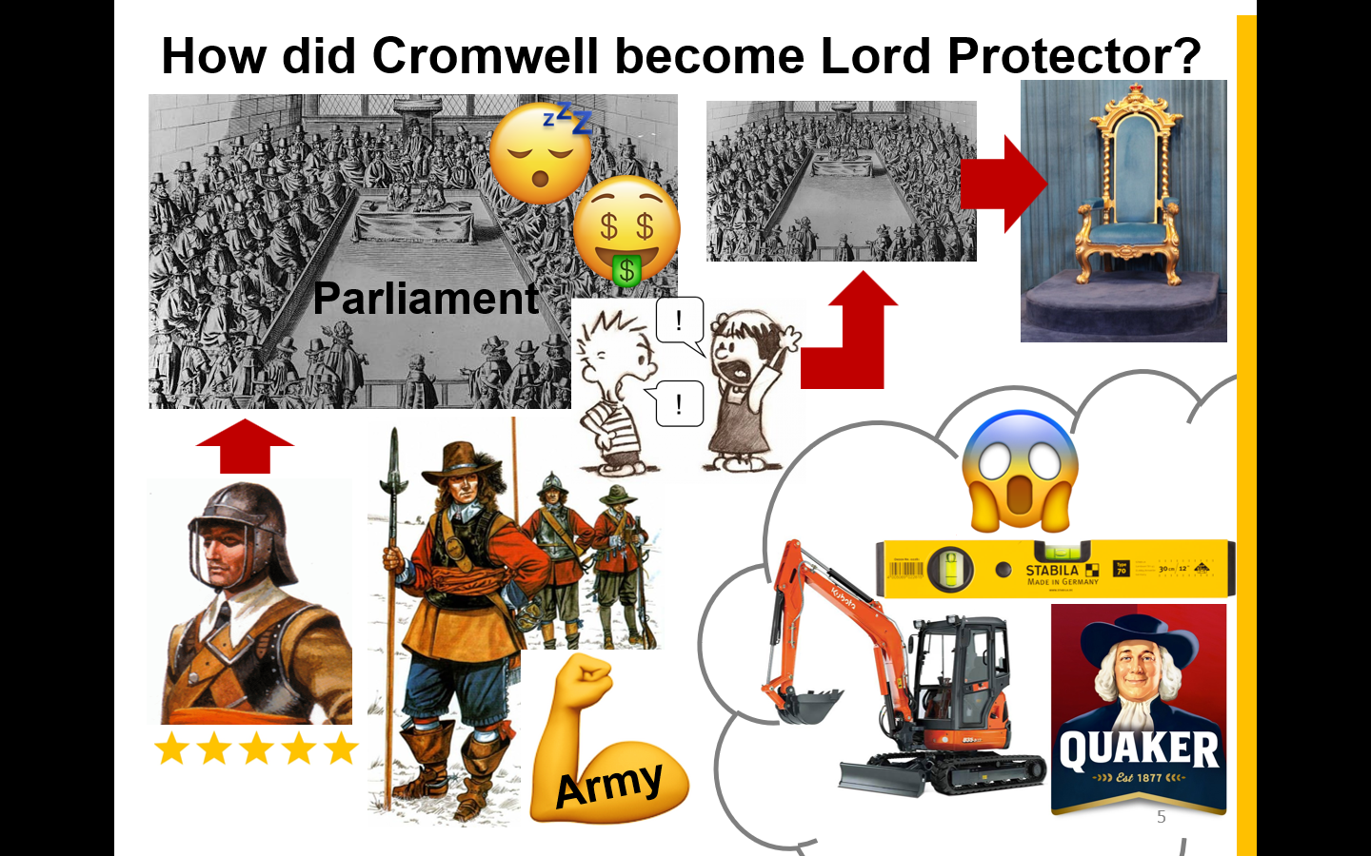
[Protectorate & Restoration L1 (PowerPoint), slide 5]
raised in mentor feedback, along with the suggestion that gradual introduction of images via animations might make narrative easier to work out and follow.
When it came to the analysing sources for political changes, learners felt this was introduced well: ‘Good explanation on using sources (COP).’ A major oversight however, was forgetting to use the whiteboard pen. Without annotating the source on the whiteboard as learners contributed their ideas verbally, there was no record for the key changes learners to copy down for their own understanding. This made the plenary task harder later but was also keenly felt by the learners themselves who noted: ‘Not enough written down, lots of verbal discussion’. Beyond this there were two conceptual issues raised in mentor feedback which are also significant here: that questioning needed more scaffolding and that trust was presented in very binary terms, which may lead learners to wrongly assume no source can ever be reliable.
TARGET 3: Ensure sufficient scaffolding for learners to access each task.
TARGET 4: Lesson task checklist. Perhaps just a Post-It note but can be consulted easily during lesson to ensure all tasks completed and nothing forgotten.
The lesson’s plenary proved difficult for learners, since no notes or annotations had been made during the main tasks. This, plus the overloading and fast pace of the tasks meant that creating a synthesis paragraph was not straightforward for learners new to the topic. The instruction for this task (‘write a summary of the political changes during the period AND explain which political change you think was the most important?’) was also too broad, the latter alone would have been better. It provokes the learner into making a choice based on their (synthesised) understanding of everything they have learnt in the lesson, and that is more important than writing a general summary. The other core reason for the plenary paragraph is that it would serve as a reminder of political changes when it comes to deciding which change was most significant in lesson five’s debate. An added advantage of this as an assessment of learning was that learners have the flexibility to demonstrate their level of understanding, from a concise answer to an extended paragraph, as these examples from learners (who recorded themselves as having little prior knowledge at the start of the lesson) show.
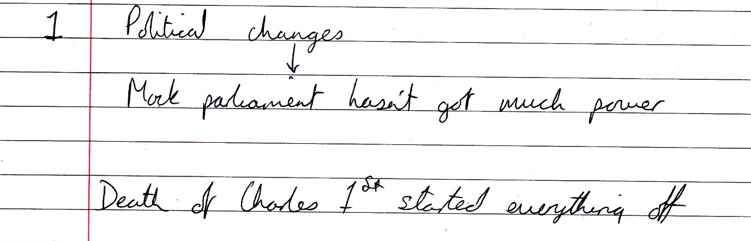
[Written plenary by a learner who recorded their prior knowledge as 1/5]
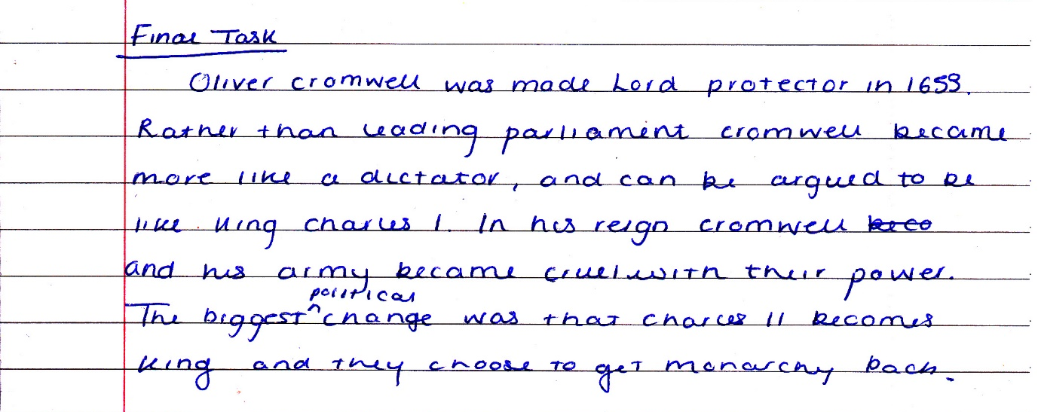
[Written plenary by another learner who also recorded their prior knowledge as 1/5]
The PowerPoint performed its function well as a visual support for the lesson, and I think the teaching style was well received and engaging. One learner commenting on ‘fantastic style and Ppt resources and teaching method.’ This was an especially pleasing comment to receive, but also meant that the lesson was delivered fairly well given the structural defiencies of its planning. As another learner’s comment related: ‘Natural use of humour helped to make a serious topic light hearted.’ Explanation, provision of context and chairing feedback and discussion went well. This enabled learners to take ownership of their learning and share ideas as a class during the source analysis task. By contrast, instructions needed to be much clearer and more concise. This will give learners a much better grasp of what is required of them. Another aspect of the exposition which needed correction, as was identified by the mentor’s comments, ‘Don’t talk at them while they write.’ This derived from the percieved need to fill the silence with further context and guidance, but of course this also distracted learners from the task they had been set and were working on.
TARGET 5: Ensure clear talk/ work routines, for teacher and learner. This contributes to QTS S1.2 Consideration for learners and mutual respect, tasks are clearly explained but learners are then given the opportunity to concentrate and learn.
The teacher’s relationship with the class was priased by one learner as ‘really good/ natural’, whilst the mentor commented on ‘Effective support given to small groups’. These are both highly pleasing pieces of feedback as positive class interaction was one of the key focuses going into the micrtoeach. Throughout the PGCE so far and school experiences beforehand, positive teacher/learner relationships has always stood out as a key foundation stone for effective teaching and learning. This is also an aspect which cannot be planned for in the same way as tasks can, therefore for positive teacher/learner to have been identified from the thirty minute microteach lesson is a great source of confidence going forward. Interactions were encouraging, but by no means perfect. Prior to the lesson it was apparent that whilst History PGCE students were able to use their colleagues’ names during the lesson, the Religious Education PGCE students names were less familiar and little used. Whilst not everyone’s name was known, in the microteach it was intended to use these students’ names to show that they were a part of the class and engage them in the lesson. However, much like the intention to use the whiteboard marker to annotated the sources, this idea was an significant loss in the momentum of the microteach delivery. As related to an earlier point was the balance between explaining something to the whole class, rather than to each group. Whilst contributed to the teacher/learner relationship and positive interaction, it also took valuable time and left the majority of the class unsupervised and unsupported in the meantime.
The scheme of work was designed to challenge learners, and given the full hour the sources (used and unused) could have been unpacked in more detail and notes made on them. A level of differenciation was planned into the microteach but this was made difficult by not knowing the exact composition of learners, and that learners were actually postgrauate peers. Handouts were printed on pale yellow paper in clear font to make the large texts easier to read. An oversight was the lack of extension activities, since during the second puzzle task one group finished very early. These more able learners therefore were not challenged sufficiently by that aspect of the lesson, and would have benefited from an extension task to deepen their learning further.

APPENDIX: ACTION PLAN - OBJECTIVES AND PROGRAMME FOR TERM 1
Name: James Lloyd Brace |  | Subject: PGCE Secondary History |  | Date: 26-11-18
OBJECTIVES | ACTIONS TO BE TAKEN |  | SUCCESS CRITERIA |  | TARGET DATE
Target 1: Plan lessons with a clear aim and activities appropriate to meeting it.  (QTS S3.1.2 Planning lessons) | - Decide and distil a clear learning objective for every lesson.  - Plan lessons with this objective in mind.  - After lessons have been prepared consider whether the tasks help learners to meet objective. |  | - Ensure lesson has clear aim, based on its place in scheme of work.  - Select appropriate tasks to meet aim.  - Review lesson to check relevance and coherence. |  | All targets set are to be met before the end of the first Professional Teaching Experience  (PTE 1)
Target 2: When gap in understanding encountered, go through it as a class. | - Check class understanding before setting learners off on task.  - If similar question raised twice, explain to class. |  | - If misunderstanding explain to class.  - Overall a decrease in times learners are confused after instructions.
Target 3: Ensure sufficient scaffolding for learners to access each task.  (QTS S3.3.4 Differentiating teaching) | - Have guided questions prepared to direct learners’ focus on larger tasks.  - Consider level of prior knowledge and how fill gaps (verbally, handout).  - Extension task challenge learners who finish early. |  | - Learners engage with task with fewer instruction related questions.  - Higher class engagement in discussions/ feedback.  - All learners are challenged.
Target 4: Lesson task checklist. | - Create list of tasks to be completed in lesson. |  | - All lesson tasks being completed.
Target 5: Ensure clear talk/ work routines, for teacher and learner.  (QTS S1.2 Consideration for learners and mutual respect) | - Establish clear talk/ work time in lessons (e.g. ‘Any issues?’ ‘Okay, so now I expect you to write...’)  - Learner not to disrupt when teacher explains, likewise teacher not to disrupt learner working.  - Ensure clarity of instructions. |  | - Learners begin to feel comfortable sharing their misapprehensions before task starts.  - Classes are capable of working in silence or with acceptable chatter.  - Fewer queries about instructions.

BIBLIOGRAPHY
Bacon, Francis (2005) Of Empire. London: Penguin.
Berger, Peter L. & Berger, Brigitte (1976) Sociology: A Biological Approach. Harmondsworth: Penguin Books.
Bloom, Benjamin S. (ed.) (1956) Taxonomy of Educational Objectives: Handbook 1 Cognitive Domain. New York: Longman.
Donaldson, Graham (2015) Successful Futures: Independent Review of Curriculum and Assessment Arrangements in Wales. Cardiff: Welsh Government.
Donovan, Judith, Henderson, Dawn, James, Pauline & Martin-Denham, Sarah (2015) “Teaching and Learning” in Teaching Children & Young People with Special Educational Needs & Disabilities. London: SAGE, pp. 23-37.
Gross, Richard (2001) Psychology: The Science of Mind and Behaviour, 4th edn. London: Hodder and Stoughton.
Hartley, James (1998) Learning and Studying: A Research Perspective. London: Routledge.
Hattie, John (2012) Visible Learning for Teachers: Maximizing the impact on learning. Abingdon: Routledge.
Holt, John (1982) How Children Fail. New York: Merloyd Lawrence.
Husbands, Chris (2011) “What do history teachers (need to) know? A framework for understanding and developing practice” in Davies, Ian (ed.) Debates in History Teaching (Abingdon: Routledge).
Kitson, A., Husbands, C. & Steward, S. (2011) Teaching and Learning History 11-18: Understanding the Past. Maidenhead: Open University Press.
MacKenzie, Trevor & Bathurst-Hunt, Rebecca (1 March 2018) ‘How To Ease Students Into Independent Inquiry Projects’, Mindshift [www] https://www.kqed.org/mindshift/50620/how-to-ease-students-into-independant-inquiry-projects (date accessed: 12 September 2018).
Open University (2018) Trends in Learning Report. Open University.
Petty, Geoff (2014) Teaching Today: A Practical Guide, 5th edn. Oxford: Oxford University Press.
Phillips, Rob (2005) Reflective Teaching of History, 11-18. London: Continuum.
Spence, C. H. (1898) “The Teaching of Modern History” in Cookson, Christopher (ed.) Essays on Secondary Education. Oxford: Clarendon Press.
Tough, Paul (2016) Helping Children Succeed: What Works and Why. London: Random House.
Welsh Government (2009) Becoming a Qualified Teacher: Handbook of Guidance (2009). Cardiff: Welsh Government.
West-Burnham, John (2005) “Understanding Learning” in West-Burnham, John & Coates, Max (eds.) Personalizing Learning: Transforming education for every child. Stafford: Network Educational Press.

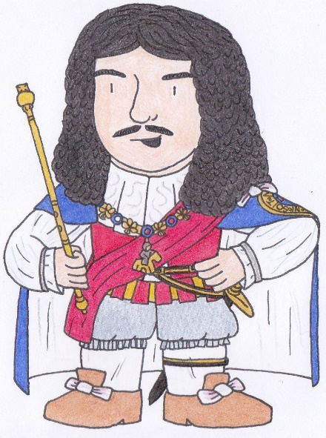
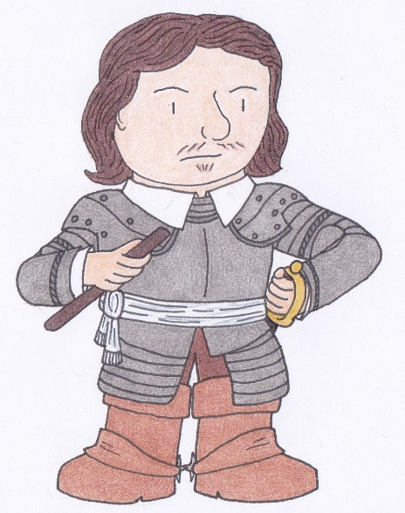
Charles II
(King, 1660-85)
Oliver Cromwell
(Lord Protector, 1653-58)

