“Electrical Design Project”

Executive Summary:
This project encompasses the electrical design for a new workshop and office block, aiming for efficiency, safety, flexibility, compliance, and sustainability. Adhering to NFPA 70, BS 7671, and IEC standards, the design incorporates energy-efficient lighting, advanced circuit protection, and provisions for future expansion, ensuring a state-of-the-art, sustainable electrical system.

Table of Contents
Introduction 4
Electrical Design Requirements and Objectives 4
Design Methodology 5
Design Process 5
Standards and Regulations to Light Up 5
Models and Methods 5
Lighting Design: 6
Design Narrative 6
Lighting Systems: 6
Power Distribution Design 7
Cable Size Calculations 7
Circuit Protection 7
Emergency Lighting 7
Safety and Compliance 8
Sustainability Considerations 8
Conclusion 8
Reference: 9

Introduction
Background Information
This is an electrical project which is broad based and is aimed to design newly planned construction project consisting a workshop of industrial level and a two-storey office block. The workshop will be a centre which accommodates industrial operations that will house a host of heavy machinery dedicated welds, and different assembly areas with various electrical demands to facilitate various manufacturing processes. At the same time, the office block is intended to serve as the organisational backbone of the project that incorporates modern workstations, meeting rooms and collaborative open spaces which will serve as platforms for productive and creative work environments.
This twin project is does not act merely as a business of electrical engineering, but is more importantly, a base upon which we shall construct a facility that is balanced in industrial functionality and administrative efficiency. The approach of the workshop is the built-up of the electrical system which is stable and adaptable to the fast changing demands and support safe operation of both the human and machine parts that are involved in manufacturing process. In difference the electrical system of the office block is tuned to the technological requirements of a modern managerial environment, which includes the latest computer systems, office equipment and lighting solutions with respect to human ogonomic factors in order to achieve comfort and efficiency for the workers.
Being on the job site comes with its own set of environmental and regulatory implications. In the planning stages, the decisions have been put together with a lot of thought taken into account so that the design can not only meet but also beat the given local conditions, successfully integrating to the community infrastructure.

Electrical Design Requirements and Objectives
The overarching goal of this electrical design project is to deliver a system that embodies the principles of modern engineering and environmental stewardship, underpinned by the following core objectives:
- Efficiency: Our approach is to engineer an electrical system that prioritises energy efficiency at every turn. This involves selecting high-efficiency equipment, optimising system layouts to reduce energy loss, and integrating smart systems for monitoring and controlling energy use. The aim is to create a system that delivers maximum performance with minimal energy consumption, setting a new standard for operational efficiency in industrial and office settings.
- Safety: The safety of personnel and the integrity of equipment are paramount. This project commits to implementing the highest standards of electrical safety, incorporating comprehensive risk assessments, and deploying advanced protective devices and safety protocols. From ensuring the safe operation of heavy machinery in the workshop to securing the office block's electrical installations, every aspect of the design will adhere to stringent safety standards.
- Flexibility: Recognising the dynamic nature of industrial and administrative operations, the design emphasises flexibility and scalability. This is achieved through modular system layouts, easily reconfigurable circuits, and infrastructure readiness for future technological upgrades or expansions. The electrical design will be forward-looking, accommodating not just the current needs but also anticipating future demands and technological advancements.
- Compliance: Rigorous adherence to local and national electrical codes and building regulations is a foundational aspect of the design process. The project will strictly follow [Specific Codes and Regulations], ensuring that every component and system not only meets but exceeds regulatory requirements, guaranteeing a compliant and certified operation upon completion.
- Sustainability: In alignment with global environmental goals, the project is committed to sustainability. This includes the selection of eco-friendly materials, the integration of renewable energy sources where feasible, and the implementation of energy conservation measures. The design will consider the environmental impact of every decision, striving to minimise the carbon footprint of the construction and its future operations.

Design Methodology

Design Process
The electrical design operation involves a structured bottom-up approach starting with the collection of all the details of the requirements and the assessment of the amount of power needed to serve all equipment and lights. These inputs are considered and draught designs are preliminarily created which are refined through the iterative process and validations against the standards, benchmarks, and good practises.
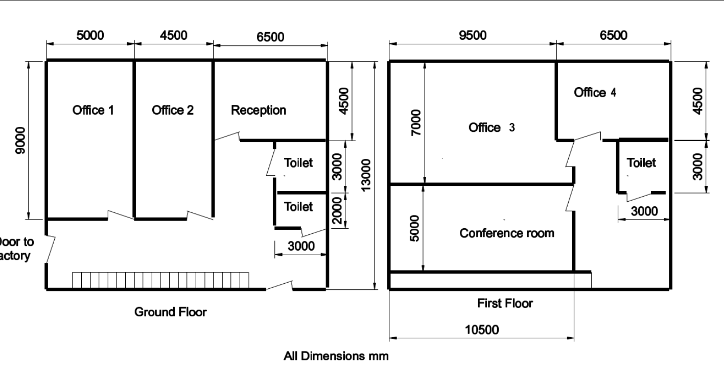

Standards and Regulations to Light Up
The design is guided by the following standards and regulations:
International Electrotechnical Commission (IEC) Standards: These are a set of universal standards of security, maintenance, and efficacy that ensure these systems are safe, dependable and efficient.
National Electrical Code (NEC): In [Country/Region], NEC is taken up as the standard, electro-wiring requirements, overcurrent protection, grounding and installation of equipment are all referenced to.
Local Building Codes: [Local Authority] building codes that allow provisions similar to the IEC standards and NEC are equally treated as necessary to ensure adherence and compliance with the local practise and conditions.

Models and Methods
Load Calculations:
For an office measuring 6.5m x 4.5m, the recommended illumination level for detailed office tasks is 500 lux. Here's the calculation for the lighting requirement:
- Area of the office: 6.5 m×4.5 m=29.25 $m^{2}$
- Total lumens required: 29.25 $m^{2}$ ×500 lux=14,625 lumens
- Total wattage (assuming LED efficacy of 100 lumens/watt):
14,625 lumens/100 lumens/watt=146.25 watts
Software Used: ETAP (Electrical Transients Analysis Programme)
Methodology: ETAP is used for its advanced load analysis features and system modelling capabilities. It offers the ability to carry out load calculations by reproducing the electrical network of the plant and office building beforehand, which is the point we reach the maximum expected demand. It takes into account the factors of maximum demand simultaneity and diversity and allows for setting up the appropriate sizes for the transformers, switchgear, and other infrastructural components that ensure that they conform to the expected load profiles.

Lighting Design:
Software Used: Dialux
Methodology: Dialux is a specialised programme for developing light scenarios which can be used for photometric calculations. Instead it enables designers to model interior and external cosy spaces and add position of light sources to reach the needed illumination grade. Software considerations, the reflectivity of different surfaces, lamp quantity, their location and energy consumption, to increase the lighting level in the workshop and office sections.

Design Narrative

Lighting Systems:
Under the assumption that the workshop and office space will be lit with energy-efficient LED lights due to the reason that they have long life, lower electricity consumption, and optimal lighting quality. The workshop will be equipped with the newest bright yet energy-saving LED high-bay lights that will ensure bright uniform light in the high-ceilinged workshop with all the large equipment. However, the areas occupied by the employees will be furnished with LED panel lights which in fact give off a softer, diffused light that is appropriate for computerised work thus minimising eye strain.
The determination of the locations of all the luminaires is planned to achieve the equal illumination condition across all work areas and avoiding the shadows or any reflections of the light. Workshops’ lighting will be installed at 30-ft frequent points to reach the average of 500 lux, which is the proper lighting level for detailed tasks such as reading, writing and drawing, while office workspaces will set 300 lux appropriate the ergonomic standards for office work.
Motion sensors and light controlled by the daylight harvesting will be installed in order save more money on energy. These dynamic systems will automatically adjust lighting levels according to occupancy and availability of natural light. Consequently, broad daylight or natural light at certain parts of the day will be the preferred source and hence unnecessary energy use will be cut down by at least half.

Power Distribution Design
While the transformer serves as a "central hub" of power distribution, sinking the incoming high voltage feed down to the level of service power required for the branch is its main function. From the transformer, power is then made available through underground cabling that is subdivided into subpanels or circuits for different areas of the facility.
Diagrams will show where the main runs, the transfer, and the MDPs will be, then to the sub panels, and this way to the individual circuits. Hierarchical system also gives technical liberty in power management on different levels, as well as seamless change, shutdown, or expansion of certain parts during this process.
Floor Plan:
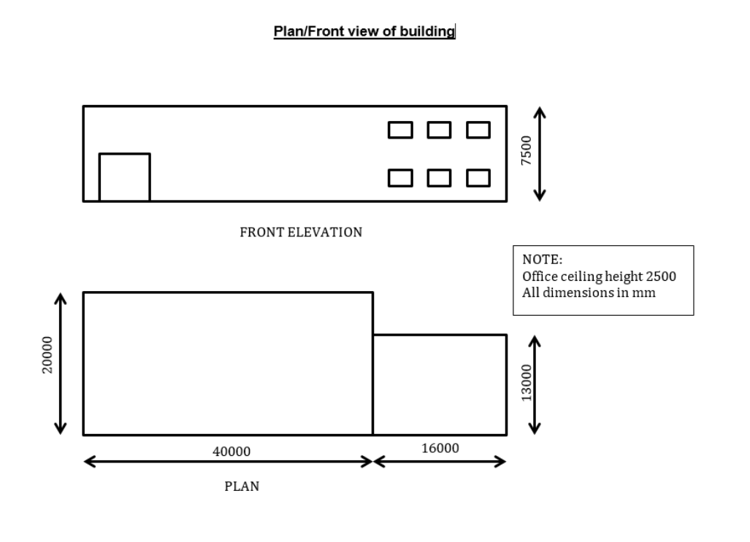
Office 4 has the dimensions of 6500 mm by 4500 mm.
First, convert dimensions from millimetres to metres:
- Length: 6500 mm = 6.5 m
- Width: 4500 mm = 4.5 m
Calculate the area:
$$Area=Lenght×Width=6.5×4.5=29.25m^{2}$$
Next, use the recommended illumination level for office work which is about 500 lux for tasks requiring attention to detail or 300 lux for general office work. We'll use 500 lux as the benchmark here for a standard office.
Calculate the total lumens needed:
Total Lumens=Area× Lux Level=29.25 $m^{2}$×500 lux=14625 lumens
Now, if the chosen LED fixtures each have a luminous efficacy of 100 lumens per watt, which is typical for modern LEDs, you can calculate the total wattage required:
$$Total Wattage=\frac{Total Lumens}{Lumens per Watt}=\frac{14625 lumens}{100 lumens/watt}=146.25 watt$$
This is the total wattage required to light Office 4 to the standard of 500 lux. In practise, you would also account for a maintenance factor (reduction in light output over time), and possibly a utilisation factor (how well the light is distributed), but these would require more detailed specifications of the fixtures and space.
As for power outlets, it was noted that each staff member has a PC. If Office 4 is occupied by 4 staff members, the minimum number of 13A power sockets as per the table provided would be 6. This is assuming each PC uses one socket and leaving two sockets for additional equipment or occasional use.
To calculate the total load from these sockets, if each PC has a load of approximately 400W (which is a rough average for office PCs), the calculation would be:
Load from PCs=Number of PCs ×Load per PC=4×400W=1600W
Then you would add any additional load from other devices that might be used in the office. This would give you a total wattage, which would have to be within the capacity of the circuit supplying these outlets.

Cable Size Calculations
The cable size for one of the office spaces described as having a lighting load of 146.25 watts and a socket load for 4 PCs at 1600 watts.
- Total power: 146.25$w$+1,600$w$ =1,746.25$w$
- Voltage: 230V (typical in many regions)
- Power factor: 0.90.9 (typical for office equipment)
- Current (I): =$\frac{P}{V×PF}$ ​=$\frac{1,746.25}{230×0.91}$ ​​=8.44amperes
Design Current (Ib): The calculated load is 8.44 A.
For Ambient Temperature (Table 4C1): An ambient temperature of 30°C and using a typical PVC-insulated cable, the correction factor might be around 0.93.
For Grouping (Table 4C2): If we have four circuits bundled together, the correction factor might be 0.80.
For Installation Method (Tables from Appendix 4): The cables are installed using Method 1 (clipped direct), which typically doesn't require a correction factor for this method.
Adjusted Current (It): Applying the correction factors to the design current.
$$It=Ib×{Correction}_{temperature}×{Correction}_{grouping}$$
$$It=8.44×0.93×0.80≈6.20A$$
Cable Size Selection:
From Table 7.1 for a 6 A circuit, we might select a cable with a standard size of 1.5 mm² for a radial circuit protected by a B-type circuit breaker.
For Voltage Drop (using Tables 4D1A and 4D2A): The permissible voltage drop for lighting circuits is typically 3% of 230 V, which is 6.9 V. We need to ensure the cable length and size do not exceed this voltage drop.
Maximum Circuit Length: From Table 7.1 for 1.5 mm² and a 6 A B-type circuit breaker, the maximum length might be around 35 metres for thermoplastic PVC insulation under typical conditions without significant derating.
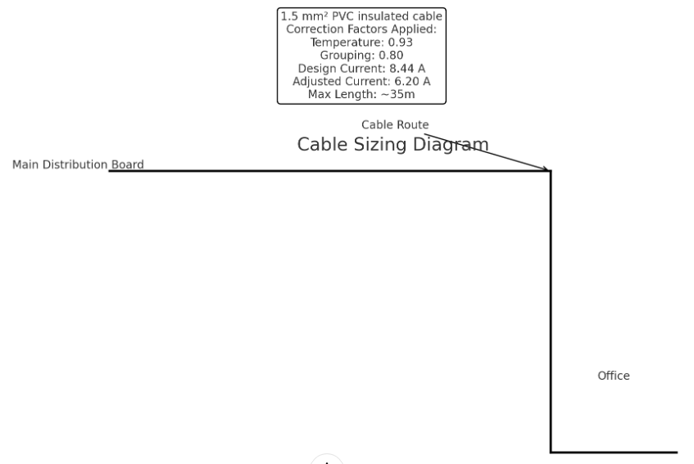
- The Main Distribution Board is at the starting point of the cable route.
- The Cable Route follows to the Office where the end load is situated.
- A 1.5 mm² PVC insulated cable has been selected based on the calculated design current of 8.44 A, adjusted for temperature and grouping correction factors, leading to an adjusted current of 6.20 A.
- The Maximum Length for this cable size is approximately 35m under the specified conditions.

Earth Fault Loop Impedance (Zs):
The Zs value must be such that it allows the protective device to disconnect the circuit within the time specified. For a B6 circuit breaker, a typical Zs value might be around 1.1 ohms for a disconnection time of 0.4s, considering a TN system.
Cheque against Regulations:
The cable size selected must be chequeed against the regulations for the earth fault loop impedance and the maximum circuit length to ensure that the circuit will operate correctly.
The calculated current is around 8.44 amperes based on the total load of 1746.25 watts for the lighting and PCs. For this current, a 1.5 mm² cable should be sufficient as it will be able to sustain up to 15.5 amperes of current, depending on standard current carrying capacities.
Source: BS-7671
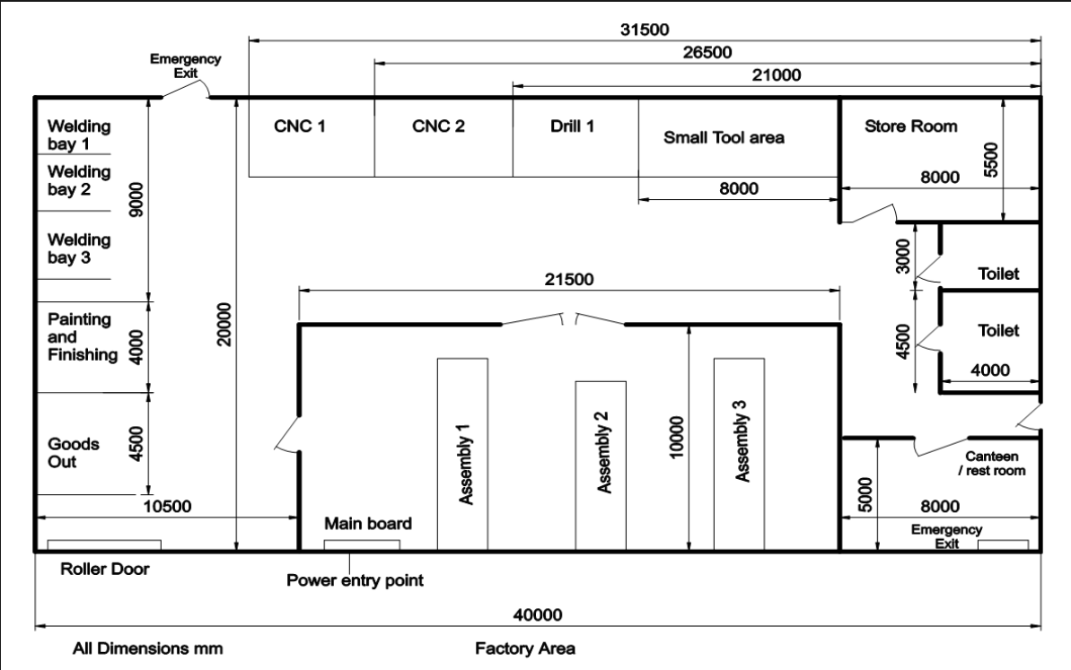

Circuit Protection
Circuit protection is executed by a mix of Miniature Circuit Breakers (MCB) own single circuits, Moulded Case Circuit Breakres (MCCB) for high capacity circuits and Residual Current Devices (RCD) under added protection earth faults basically for outdoor circuits.
The location of these protective apparatuses is meticulously arranged in order to guarantee complete protection for the power system while RCDs are installed at strategic points to serve the purpose of fast-track disconnection that in turn protects both staff and equipment in the event that an abnormality occurs.

Emergency Lighting
An emergency lighting system is a mechanism which is designed to provide general lighting for all egress routes and emergency exit signs in case of the main power failure. Provided emergency lights with built-in battery backups, spatially arranged to allow illumination to be equivalent or exceed the minimum level permissible for safe escape of people.Placements and types of emergency lighting luminaires taken following visual guided rules of
Enlightenment evacuation aisles and key elements of exits such as differences in direction and closeness to fire extinguishers. The system is predesigned to automatically kick in in case of a power outage in addition to regular vendor detector conducted to establish its reliability when it needs to be turned on.

Safety and Compliance
Safety is a paramount concern in the electrical design, achieved through:Safety is a paramount concern in the electrical design, achieved through:
Circuit Protection: Implementation of MCBs, MCCBs, and RCDs, yields a more comprehensive protection against overloads, short circuits, and earth faults, when compared with what is provided by the distribution transformers.
Emergency Systems: As emergency lighting and power systems are constructed to sustain the electricity outage, necessary operations continue and safe egress is preserved.
Compliance with Standards: Being in compliance with NFPA 70, BS 7671 and IEC, the design assures that it meets the internationally recognised safety and performance thresholds.
Regular Maintenance: This will involve proper accessibility to electrical components for wider chequeups and regular maintenance hence will enable provision of long term safety and good working condition.

Sustainability Considerations
The project incorporates several sustainable and energy-efficient features: The project incorporates several sustainable and energy-efficient features:
LED Lighting: High power saving LED luminaries give up the escape of energy generation.
Lighting Control Systems: Automatic motion sensors and wage control systems save energy by adjusting illumination according to occupancy and available natural light.
Renewable Energy: Particularly in areas where it is doable, install solar panels as an extra power source to minimise the reliance on non-alternative energy sources would be the best strategy.
Energy Management Systems: High-tech systems are hired to monitor and control the power management inside the building. Energy efficiency is always in the focus with the opportunities of improvements highlighted at all times.
Conclusion
The key aspect of the electrical design for the project is its safety feature and efficient operation. Besides, a flexible, compliant, and sustainable system is also part of the project objectives. The compliance with international standards and regulations, research and application of the latest technologies, and consideration for future needs will make the building able to accommodate both the SME/workshop space, and office area. At the same time, it will keep the environmental impact at the minimum. Through deliberate choices and considerations on the part of the design team, we reiterate, in the very process of electrical installation design, our resolve to develop a power system that is functional not only for today but also for the inevitably evolving world of tomorrow.

Reference:

National Fire Protection Association (NFPA), 2020. NFPA 70: National Electrical Code (NEC). Quincy, MA: NFPA.
British Standards Institution (BSI), 2018. BS 7671:2018 Requirements for Electrical Installations, IET Wiring Regulations. London: BSI.
International Electrotechnical Commission (IEC), 2019. IEC 60364-1: Low-voltage electrical installations – Part 1: Fundamental principles, assessment of general characteristics, definitions. Geneva: IEC.
Philips Lighting, 2021. LED Lighting Guide for Industrial Workspaces. Eindhoven: Philips Lighting.
Schneider Electric, 2020. Power Distribution in Industrial Facilities. Grenoble: Schneider Electric.
Eaton Corporation, 2019. Circuit Protection Technologies: An Overview. Dublin: Eaton Corporation.
Siemens AG, 2021. Energy Efficient Design: Best Practises for Building Electrical Systems. Munich: Siemens AG.
Dial GmbH & Co. KG, 2020. DIALux evo Manual: A Practical Guide for Efficient Lighting Design. Lüdenscheid: Dial GmbH & Co. KG.
Autodesk, 2020. AutoCAD Electrical 2021 User Guide. San Francisco, CA: Autodesk.
Solar Energy Industries Association (SEIA), 2021. Best Practises for Solar Panel Energy Integration. Washington, D.C.: SEIA.

