Garbology in Action

Garbology, the study of human waste and discarded materials, originated as an anthropological approach to understanding contemporary society. The term was popularised in the 1970s by archaeologist William Rathje, who founded the “Garbology Project” at the University of Arizona. Rathje’s goal was to apply archaeological methods traditionally used for ancient civilisations to modern waste, uncovering insight into consumption habits, social behaviours, and environmental impacts. Initially, garbology faced scepticism, as it was unconventional to study present-day society through their refuse. However, Rathje’s work highlighted its value by systematically excavating and analysing waste from landfills, he revealed discrepancies between self-reported behaviour and actual disposal habits, for instance, his research showed that people often underestimate the amount of food waste they generate and misjudge the proportion of certain materials, such as paper in their trash. Rathje’s findings provided data on consumer behaviour, which had applications in environmental policy, public health, and economic planning.
Over time, garbology has expanded beyond Rathje’s foundational studies. Today, it encompasses diverse areas, from waste management and recycling behaviours to environmental sustainability and pollution control. Garbologists examine how various demographics discard waste and what this reveal about economic class, culture and lifestyle. The field also delves into the environmental impact of waste, focusing on issues such as plastic pollution, food waste, and landfill methane emissions.
In recent years, garbology has gained importance as the world grapples with climate change and resource scarcity. The insights gained from studying waste help inform sustainable practices and influence policies aimed at reducing waste production and promoting recycling. By understanding waste patterns, garbology continues to provide a unique lens on modern human society and its importance on the planet.
The practical garbology sessions introduced us to the sociological side of archaeology, showing how traditional archaeology methods can reveal personal and societal insight. As we first examined the bag of rubbish, it felt surprisingly personal, as if we were stepping into someone else’s life. This experience made us realise how revealing discarded items can be. Trash is more than just waste – it is telling a story, offering clues about a person’s lifestyle, education, income, age, spending habits, hobbies, and even personal events.
For example, certain types of packaging hinted at spending patterns or dietary habits, while other items like receipts or medications gave insight into upcoming or recent events in the individuals life, such as travel, health issues, or celebrations. This exercise was eye-opening, demonstrating how much of our lives is reflected in the items we discard, consciously or unconsciously.
By analysing contemporary waste, we experienced archaeology not only as a study of the distant past but also as a lens on modern life, it showed us how archaeology can connect with the present, broadening out understanding of the discipline as one deeply connected to human behaviour and everyday life across all eras.
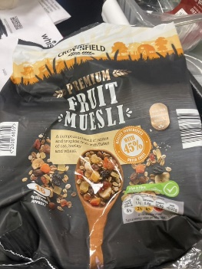
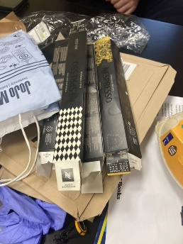
Dissecting the bag of rubbish allowed us to construct an image of the family this waste might have belonged to, creating a profile based on small but telling clues. One of the first things that stood out was the presence of Chinese Nespresso coffee pods. This detail suggested an interest in travel or access to international products, with the prods directly sourced from China, hinting at a well-connected or cosmopolitan household. Additionally, the choice of Nespresso coffee conveys an impression of high income, as the brand is associated with a luxurious, aspirational image – often reinforced by its advertisement with George Clooney. The sleek, upscale package design, with gold accents on a matte black and the Nespresso logo in raised glossy lettering, reinforces this high-end appeal. The presence of these pods also suggested that the household likely stays up to date with kitchen appliances, which aligns with the perception of a higher income. Beyond that, it hints at a fast-paced lifestyle; the convenience of single-serve pods implies a need for high-quality coffee on the go, suggesting to a household that values efficiency but still appreciates a touch of luxury in their daily routine.
Figure 1 - Kip Williams - 29/10/2024
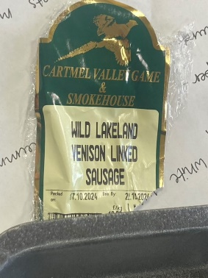
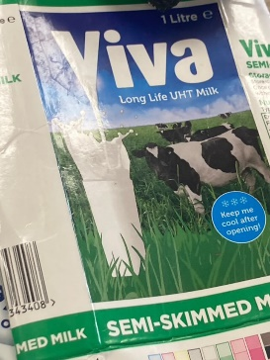
Another observation we identified as a group was that all packaging appeared ripped, except for the fruit muesli, which had been cut open carefully with scissors. This detail supports the idea that the family leads a fast-paced lifestyle, as they don't seem to have the time to meticulously open every plastic wrapper or Amazon parcel. They’re likely in a rush, tearing open items quickly to save time. However, the muesli was handled with extra care, which could signify that cereal is an essential, everyday item for them. Muesli, in particular, has a long shelf life, suggesting that they may travel frequently and thus prefer foods that don’t spoil easily. This preference for non-perishable foods might indicate that they don’t want to waste food or money on items that will expire while they're away. Another hint pointing to their preference for long-life items is a carton of Viva long-life milk, which can be kept in the cupboard for extended periods and used when they return from traveling. The long-life milk carton had an expiration date of August 28th but was only recently discarded, possibly indicating that the family had just returned from a trip and needed milk; instead of buying fresh milk right away, they used the long-life milk from the cupboard, which, though technically expired, was still usable. The choice of packaging also provides insight, as seen in both the fruit muesli and the Nespresso coffee pods, which share a similar matte black background with gold embellishments. The “premium” label in gold writing on the fruit muesli packaging, a product from Lidl, suggests it’s among their best-quality offerings. This careful selection of “premium” yet cost-effective items might further indicate that they prioritize both quality and practicality in their purchasing habits.
Figure 3 - Kip Williams - 29/10/2024
Figure 2 - Soli-Anne Green - 29/10/2024
A common feature observed among the products so far is the use of gold accents, which suggests a desire for items that convey a sense of luxury. This detail implies that the family may enjoy presenting an image of affluence or prefer products that appear “premium and high-end.
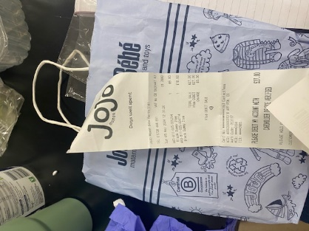
The types of meats purchased by this household are quite unusual, including items like Wild Lakeland Venison Linked Sausage and Oxtail. These selections are not typical for most households and suggest a family with distinctive taste preferences, which could indicate that they enjoy exploring unique foods. This, combined with their apparent interest in specialty items, hints at the possibility that they travel often or have roots in a different country, shaping their unique palates. Further clues about their heritage come from items directly connected to Germany, such as a German-branded paper shopping bag featuring a German website and a letter sent from Germany. These items strongly suggest that they might be German or have close family ties to Germany, where they receive mail from relatives. The likelihood of a German background provides insight into their shopping preferences and brand loyalties. Lidl, a popular German supermarket chain, appears to be a go-to choice for this family. It’s reasonable to assume that they may choose Lidl not only because of the store’s wide selection of European delicacies but also due to its affordability compared to other stores. This connection to Germany is further emphasized by the German shopping bags, showing that they travel regularly and that this frequent travel might be an integral part of their lives. Collectively, these observations suggest a lifestyle deeply connected to travel, unique tastes, and cultural ties to Germany.
Figure 4 - Kip Williams - 29/10/2024
One standout item in the bag of rubbish was a shopping bag from JoJo Maman Bébé, a store primarily known for children’s products. This item is unique, as the other contents of the bag show no indication of a child being present in the household. This can be inferred from the dominant colours seen in the rubbish, including black, beige, gold, green, and navy—tones that are not typically associated with children’s products or food packaging. Inside the JoJo Maman Bébé bag, there were multiple discarded items, including a receipt for jewellery, a plastic protective layer for wrapping paper, and a receipt for two baby dummies from JoJo Maman Bébé. The presence of wrapping paper and baby dummies suggests that the household may have been purchasing a gift for someone expecting a child. Additionally, other items in the bag, like a letter advertising private healthcare for individuals aged 50 and over, hint that the household members may be older adults, possibly grandparents. This further supports the idea that the dummies and other baby items were likely intended for younger family members, such as grandchildren.
Figure 5 - Soli-Anne Green - 29/10/2024
The jewellery receipt was for pearl earrings, a purchase that hints at a certain level of wealth and an interest in maintaining a presentable, perhaps even polished, appearance. This could imply that at least one family member has a professional role requiring them to look well-dressed or put-together. However, the fact that the dummies were purchased on sale suggests that they may be conservative with their spending on non-essentials, particularly for gift items. This frugality is also reflected in their choice to shop at Lidl, a store known for its affordable pricing. Together, these details suggest that while the household may be relatively affluent, they still value saving money and are selective in how they allocate their resources, particularly for items intended as gifts or non-essential purchases.

References
Rathje, W. and Cullen Murphy (1992) Rubbish! the archaeology of garbage. New York, Ny Harpercollins.
Márquez-Grant, N. (2017) ‘Archaeological and Environmental Forensic Science’, Archaeological and Environmental Forensic Science, 1(1), pp. 1–2. Available at: https://doi.org/10.1558/aefs.34203.

