University of Wales Trinity Saint David

Wales Institute of Science & Art

Structural & Fluid Analysis

(ACHA6010)

Jacob Ling
2204527
December 2025
Contents
1 Abstract 2
2 Introduction 3
3 Literature Review 4
4 SolidWorks Modelling and Assembly 5
5 Kinematic Simulation and Structural Analysis 7
6 Optimization and Improvement 11
6.1 Aluminium Alloy 11
6.2 Titanium Alloy 14
6.3 Cylinder Design Change 17
7 Validation Testing 22
7.1 Bimetallic Strip 22
7.2 Testing with mesh sizing 22
8 Analysis 25
9 Conclusion 26
10 References 27

Abstract

Computer Aided Engineering (CAE) has become indispensable in modern automotive design, enabling engineers to evaluate complex systems prior to physical prototyping. This study investigates the structural and thermal performance of a piston within a crankshaft assembly, modelled in SolidWorks and analysed using ANSYS Workbench. Kinematic simulations established realistic loading conditions, which were subsequently applied in static structural and thermal finite element analyses. Stress concentrations were identified at the piston crown and skirt transitions, highlighting critical regions for fatigue assessment. Optimisation studies compared aluminium and titanium alloys alongside geometric modifications, revealing trade-offs between mass efficiency, durability, and fatigue life. Validation was achieved through analytical comparison using a bimetallic strip case study and mesh independence testing, confirming the reliability of simulation results while emphasising the sensitivity of CAE outputs to boundary conditions and mesh refinement. The findings demonstrate how iterative FEA supports design improvement, while also underscoring the limitations of computational tools and the necessity of validation. This work illustrates the balance between material selection, geometric refinement, and simulation credibility in achieving optimal piston performance within automotive applications.

Introduction

Computer Aided Engineering (CAE) plays a critical role in modern automotive design by enabling engineers to predict component performance, optimise designs, and reduce reliance on costly physical prototyping. Through the application of numerical methods such as Finite Element Analysis (FEA), complex thermo-mechanical behaviour can be evaluated under realistic operating conditions.
Pistons are subjected to severe cyclic loading due to combustion pressure, inertial effects, and thermal gradients, making them particularly susceptible to fatigue failure. As a result, they represent an ideal candidate for CAE-driven investigation. This study examines a crankshaft–piston assembly, focusing on the piston as the primary component for detailed structural and thermal analysis.
Kinematic simulations are first used to establish representative loading conditions, which are then applied within coupled structural and thermal analyses in ANSYS Workbench. Iterative optimisation is conducted through material substitution and geometric refinement to improve fatigue life while minimising mass. Validation is achieved through analytical comparison and mesh independence testing, allowing both the strengths and limitations of CAE tools to be critically assessed.

Literature Review

Research into piston behaviour consistently highlights the influence of material selection, geometry, and validation on durability and efficiency. Finite Element Analysis (FEA) is widely used to evaluate stress distribution, deformation, and fatigue life under representative loading conditions, offering significant insight prior to physical testing.
(M, K and Hatti, 2019) compared aluminium alloy pistons with aluminium–silicon carbide composites, demonstrating reduced von Mises stress and deformation through material reinforcement without significant mass increase. Similarly, (Frǎtia et al., 2019) investigated steel and bimetal pistons, reporting improved thermal resistance and reduced inertial effects, although stress concentrations at the pin boss remained a limiting factor. These studies illustrate that material enhancement alone does not eliminate the need for geometric optimisation.
(Rushikesh et al., 2020) extended FEA techniques to engine block analysis, identifying aluminium’s favourable stiffness-to-weight characteristics alongside its sensitivity to thermal loading. (Cioatǎ et al., 2017) validated numerical results against analytical solutions, emphasising the importance of mesh refinement and boundary condition accuracy. Collectively, the literature demonstrates that effective piston design requires an integrated approach combining material selection, geometric refinement, and rigorous validation—an approach directly adopted in this study.
Together, these studies show aluminium’s dominance for lightweight design but highlight its thermal limitations. Composites and titanium improve strength and fatigue life, while geometric optimisation redistributes stresses without major mass penalties. Crucially, validation through analytical comparison and mesh independence remains essential to ensure credible CAE results. The literature therefore establishes a clear framework: material selection, geometric refinement, and rigorous validation must be integrated to achieve piston designs that balance durability, efficiency, and manufacturability.

SolidWorks Modelling and Assembly

The crankshaft–piston assembly was modelled in SolidWorks to provide a realistic basis for subsequent finite element analysis. The assembly consisted of five primary components: piston, connecting rod, crankshaft, bearings, and casing. Each part was dimensioned to reflect typical automotive proportions, ensuring that the geometry was representative of real-world operation.
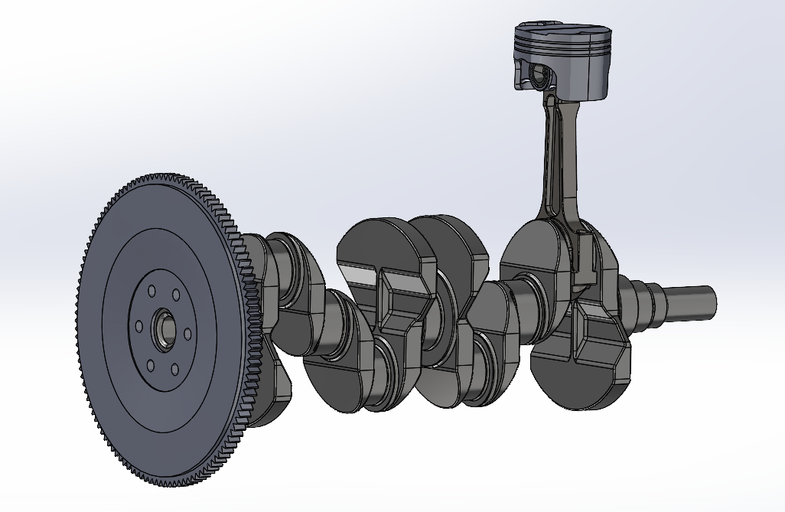
Figure 1
Accuracy of the CAD model is critical, as geometric simplifications can significantly affect stress distribution in later simulations. For example, fillet radii at the piston crown and skirt were retained to capture stress concentrations, while tolerances at the crankshaft journals were modelled to reflect realistic boundary conditions. The assembly was constrained to allow rotational motion of the crankshaft and reciprocating motion of the piston, forming the basis for kinematic analysis in ANSYS.
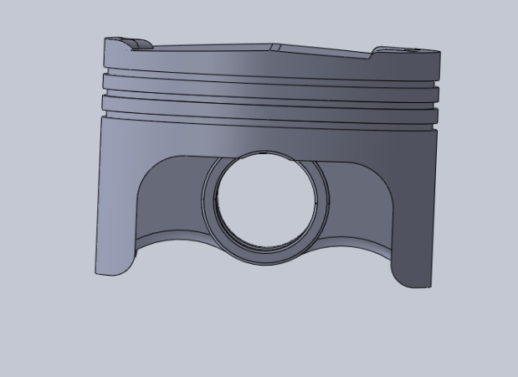
Figure 2
The completed assembly was exported to ANSYS Workbench, where mesh generation and boundary conditions could be applied for structural and thermal analysis. While these boundary conditions provide a representative approximation of in-service constraints, they simplify contact behaviour and neglect transient dynamic effects, meaning local contact stresses and time-dependent loading are not fully captured. This represents a limitation of the static structural analysis approach.

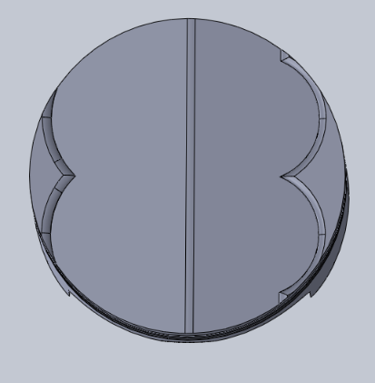
Figure 3

This modelling stage demonstrates the practical application of CAD tools in preparing a system for CAE evaluation. It highlights the importance of precision in geometry and material definition, as these directly influence the validity of simulation results.

Kinematic Simulation and Structural Analysis

Following the creation of the crankshaft–piston assembly in SolidWorks, the model was imported into ANSYS Workbench for dynamic evaluation. A kinematic simulation was first conducted to replicate the reciprocating motion of the piston and the rotational motion of the crankshaft under realistic operating conditions. This stage provided the basis for generating representative loading data, including combustion pressure cycles, inertial forces from piston acceleration, and reaction forces at the crankshaft bearings.
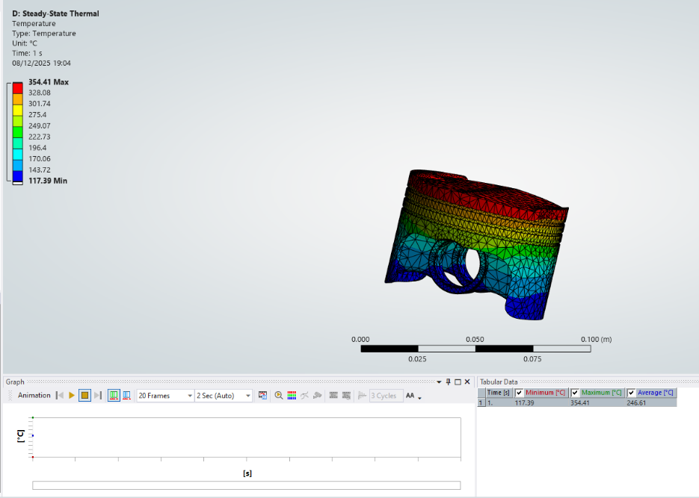
Figure 4: Boundary conditions and applied combustion pressure on the piston model

The piston was then selected for detailed static structural analysis. Boundary conditions were applied to replicate the constraints imposed by the connecting rod and cylinder walls, while combustion pressure was modelled as a distributed load on the piston crown. Material properties were defined for structural steel, incorporating temperature-dependent degradation to account for thermal effects. Thermal analysis was coupled with the structural study to evaluate the influence of heat transfer from combustion gases and frictional contact with the cylinder. The results of this are displayed in figure 4.

Finite element meshing was applied with refinement in high-stress regions such as the piston crown and skirt fillets. Von Mises stress, total deformation, and fatigue life predictions were extracted to assess structural performance. The results highlighted critical stress concentrations at the crown edges and skirt transitions, confirming the importance of geometry and material selection in piston design.
Von Mises stress was adopted as the failure criterion for the piston, as it is appropriate for ductile metallic materials subjected to multiaxial loading. The equivalent von Mises stress is defined as:
$$σvm=\sqrt{\frac{1}{2}[{\left(σ1-σ2\right)}^{2}+{\left(σ2-σ3\right)}^{2}+{\left(σ1-σ3\right)}^{2}]}$$
where $σ1, σ2$ and $σ3$ represent the principal stresses. This scalar stress value enables direct comparison with the material yield strength and provides a suitable measure for assessing yielding and fatigue initiation under complex loading conditions.

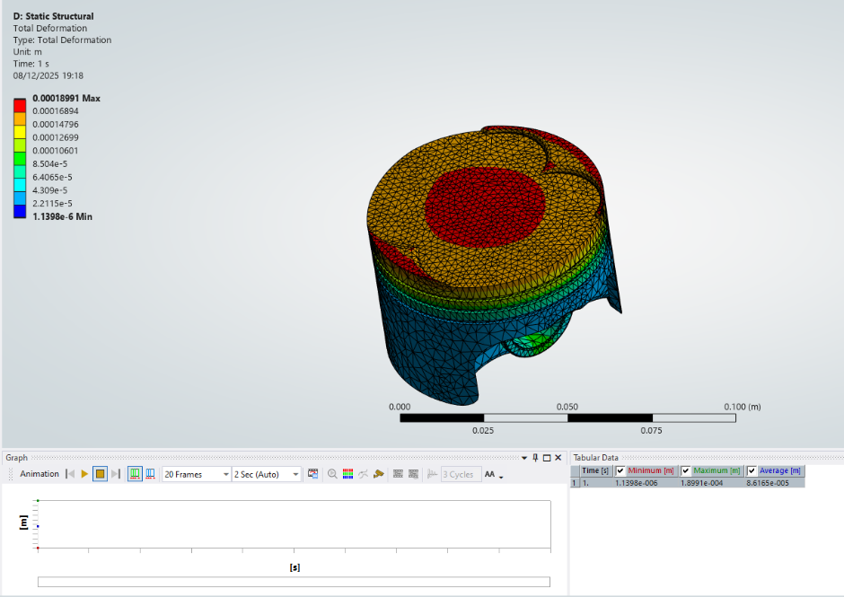
Figure 5: Von Mises stress distribution in structural steel piston

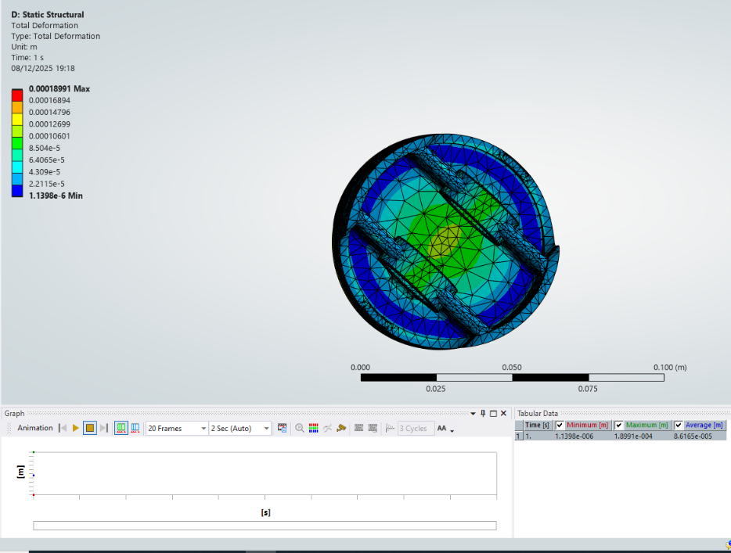
Figure 6: Total deformation of the piston under combined thermo-mechanical loading

This stage demonstrates how kinematic simulation informs realistic loading conditions, while static structural and thermal analysis provide insight into the piston’s durability. It also illustrates the limitations of CAE tools, particularly the sensitivity of results to boundary condition definition and mesh density, which will be further explored in validation testing.

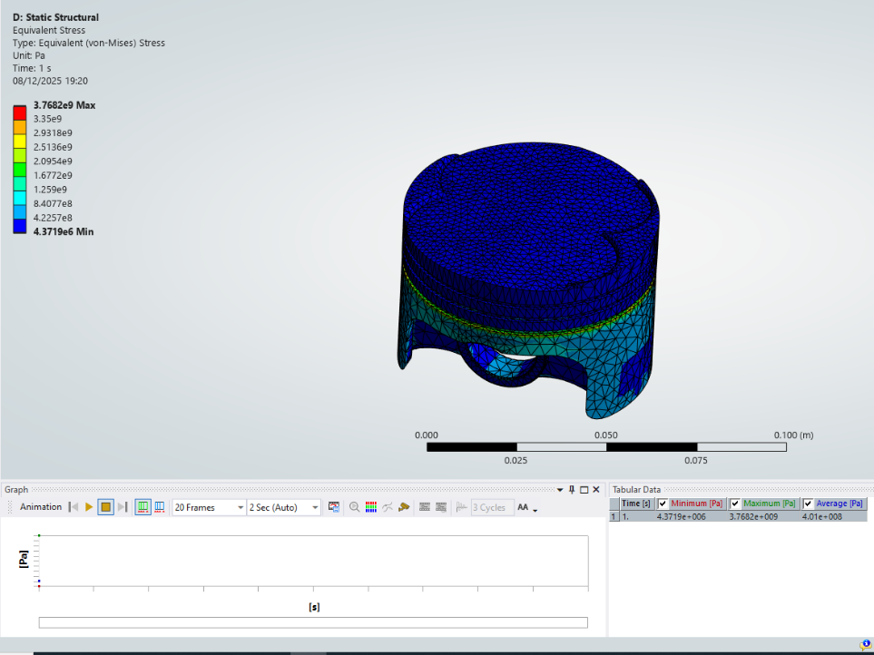
Figure 7: Fatigue life prediction for structural steel piston
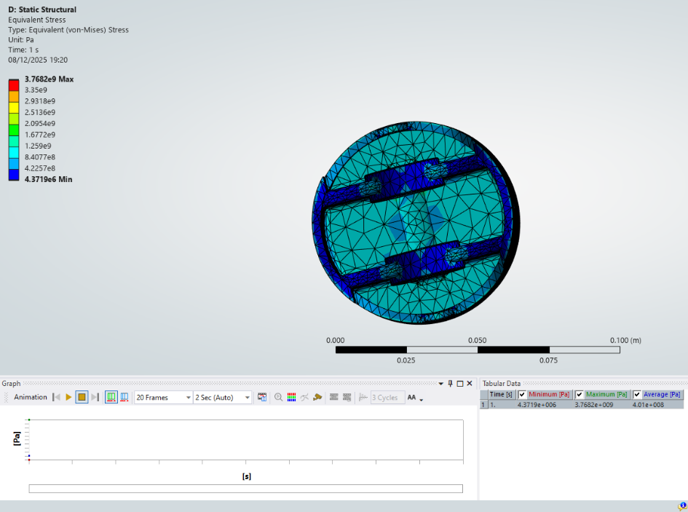
Figure 8: Mesh distribution highlighting refinement in high-stress regions

Figures 4-8 were simulated using structural steel as the material.

Optimization and Improvement

The optimisation stage focused on improving piston performance under cyclic loading while balancing fatigue life and mass efficiency. Comparative studies were conducted using aluminium alloy, titanium alloy, and a modified cylinder design

Aluminium Alloy

Figures 9–14 illustrate the stress distribution and deformation of the aluminium piston. As shown in Figure 10, peak stresses occur at the crown edges, while Figure 12 highlights deformation concentrated at the skirt fillet. Fatigue analysis (Figure 14) indicates limited life expectancy under high thermal gradients, confirming aluminium’s susceptibility to heat-induced property degradation.
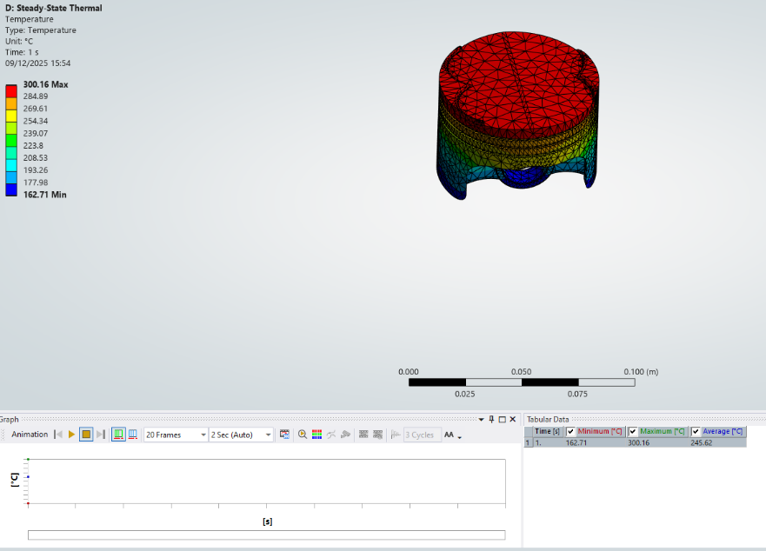
Figure 9: Von Mises stress distribution in aluminium alloy piston
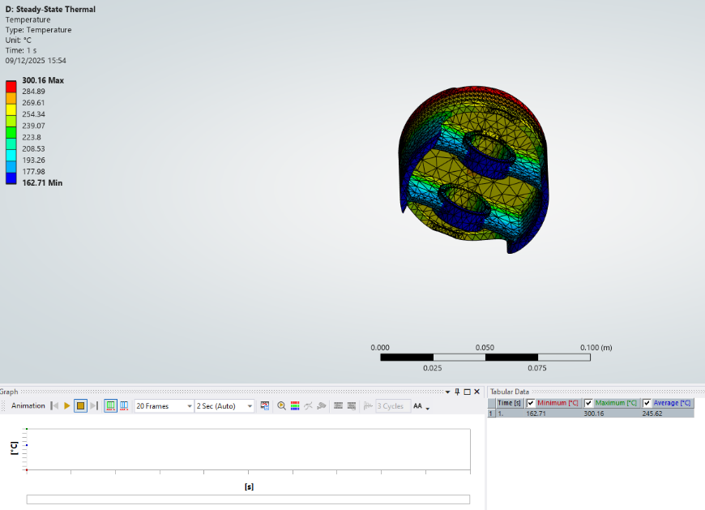
Figure 10
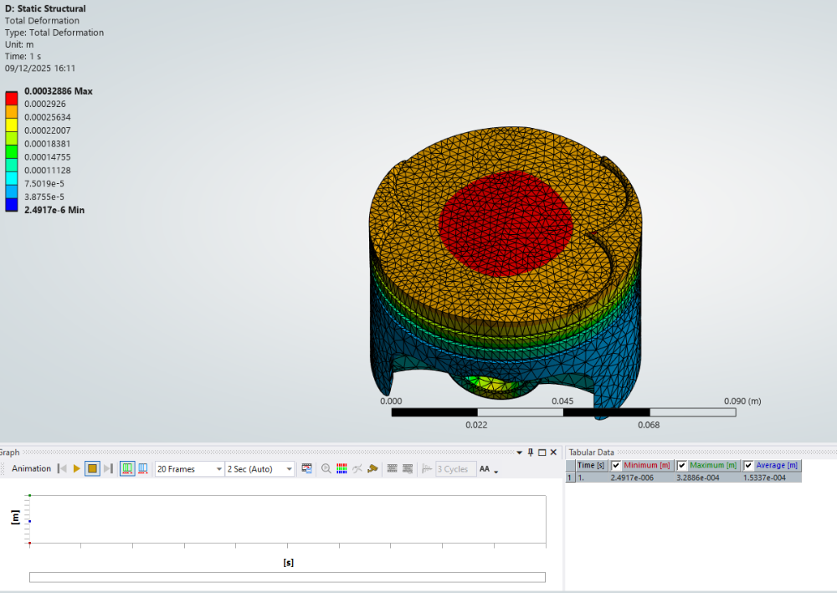
Figure 11: Total deformation of aluminium alloy piston
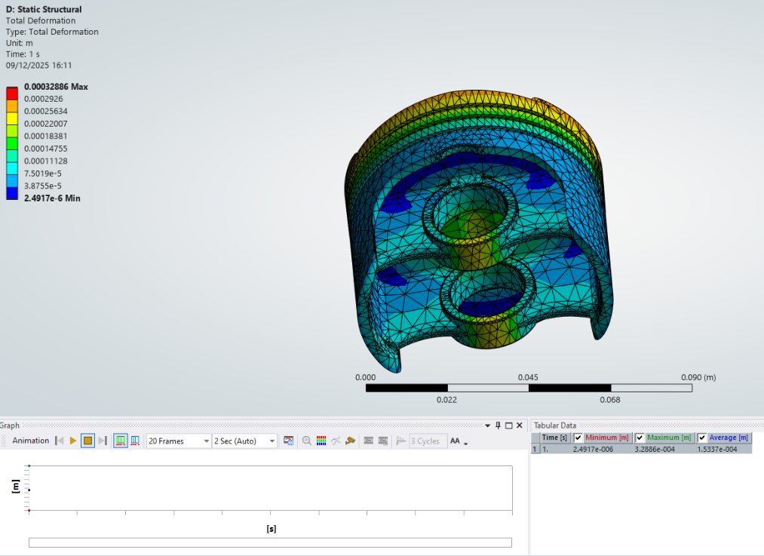
Figure 12
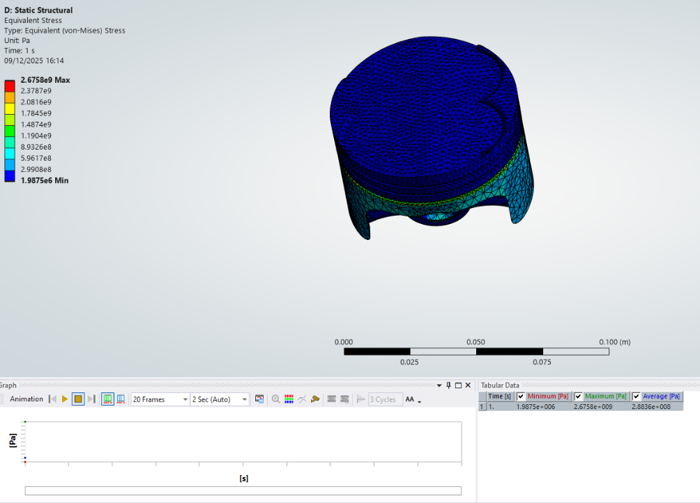
Figure 13: Fatigue life prediction for aluminium alloy piston
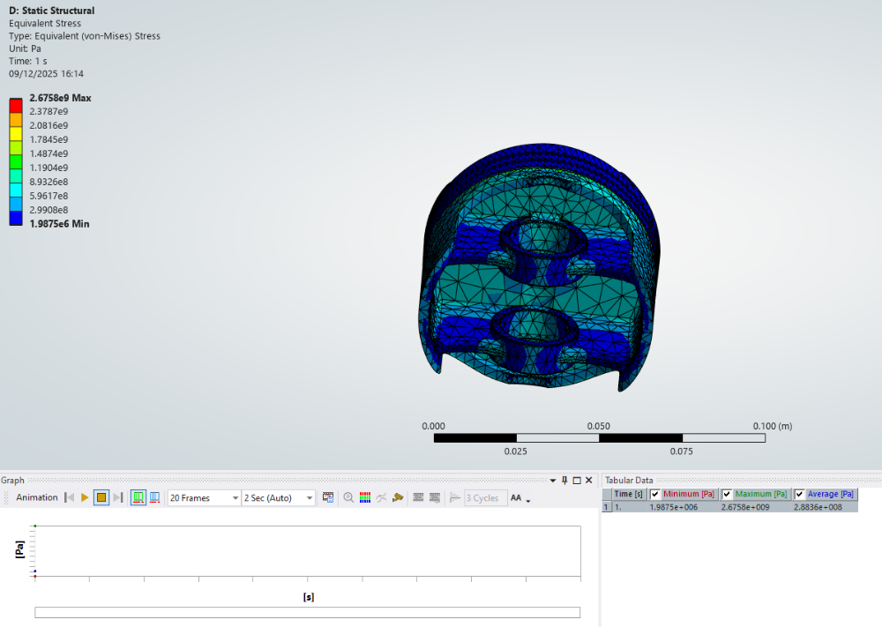
Figure 14

Titanium Alloy

Figures 15–21 present the titanium piston results. Figure 16 demonstrates reduced crown deformation compared to aluminium, while Figure 18 shows lower von Mises stress values across the skirt region. Fatigue predictions (Figure 20) reveal significantly improved life expectancy, though Figure 21 highlights increased mass, reflecting titanium’s higher density. This trade-off between durability and efficiency is central to material selection.

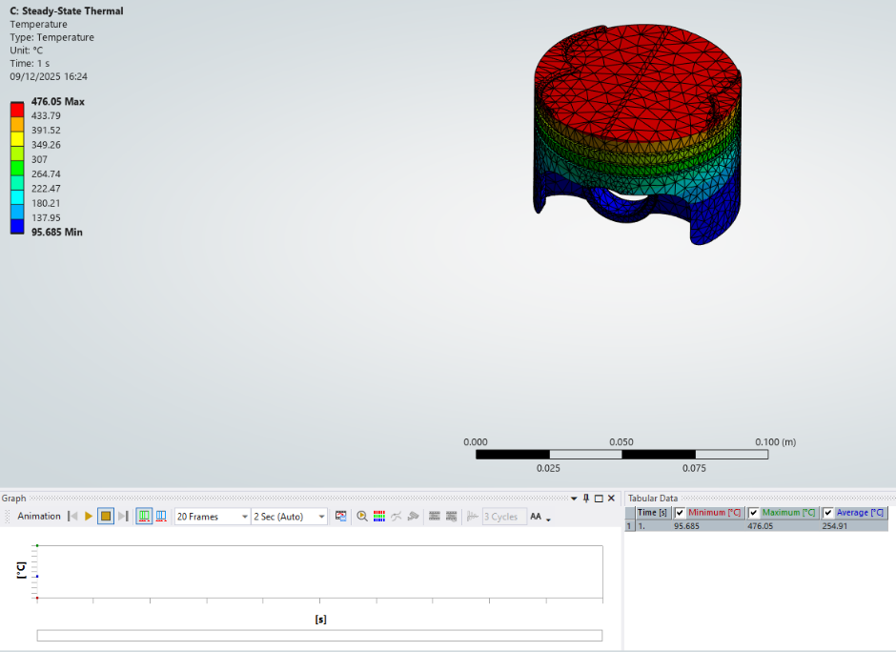
Figure 15

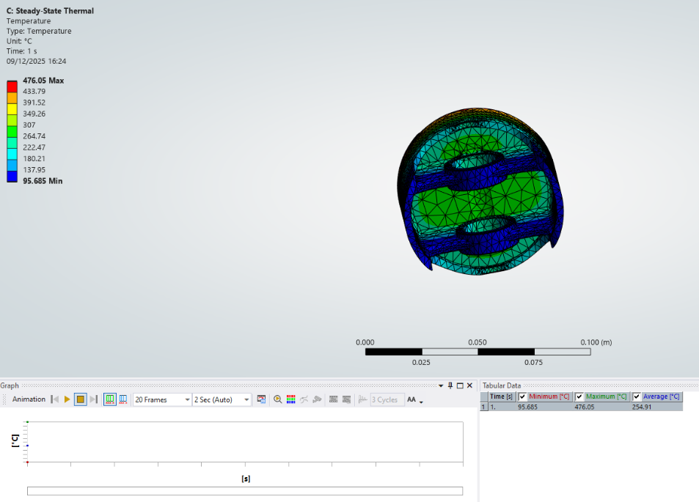
Figure 16

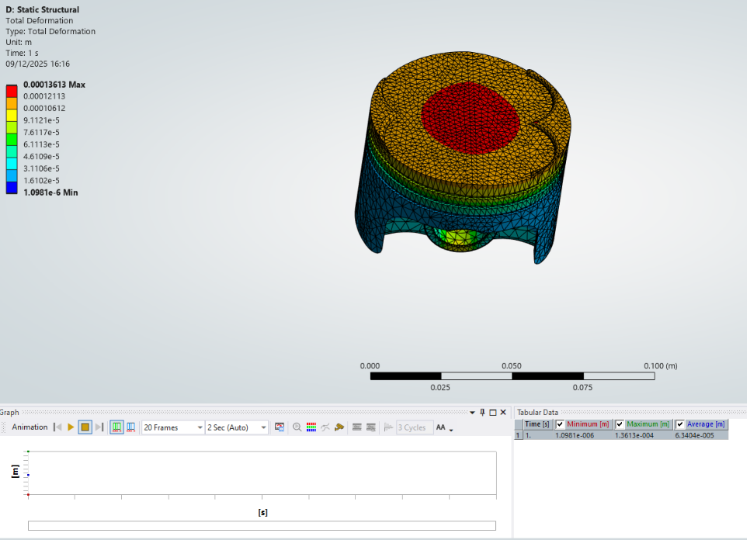
Figure 17: Von Mises stress distribution in titanium alloy piston

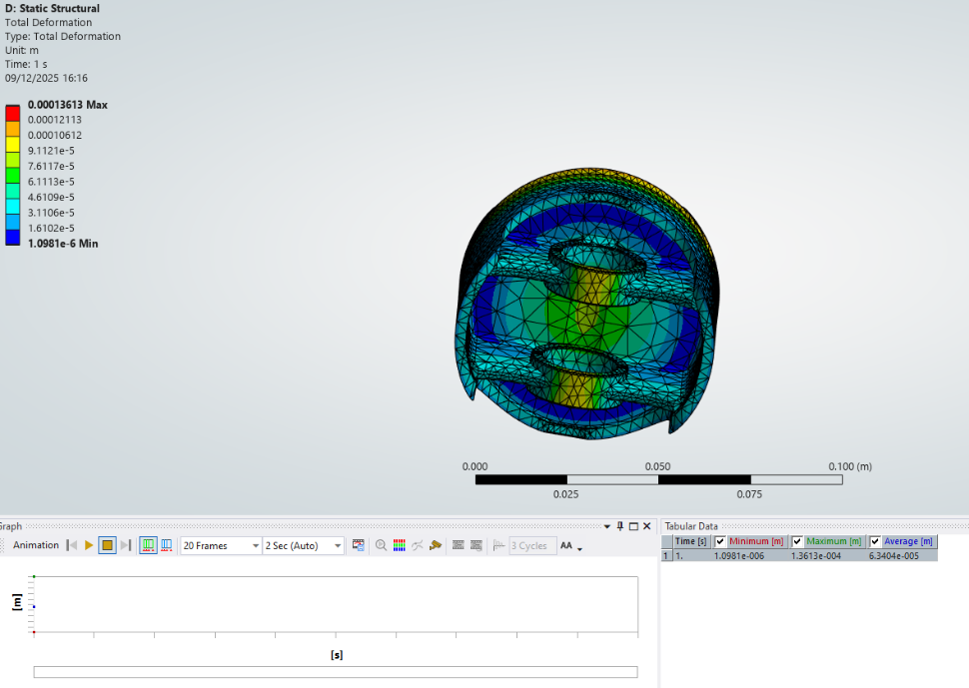
Figure 18
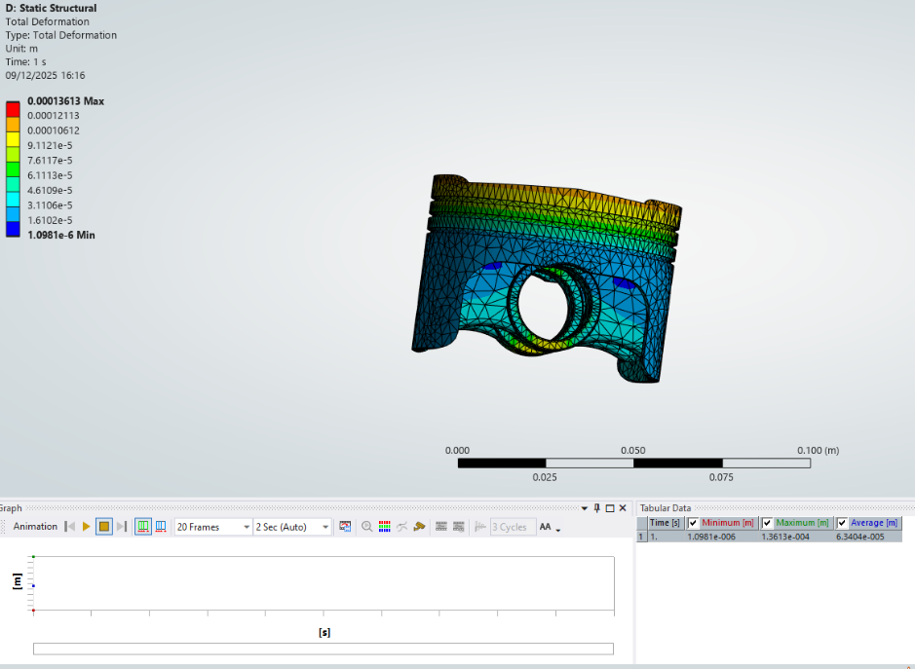
Figure 19

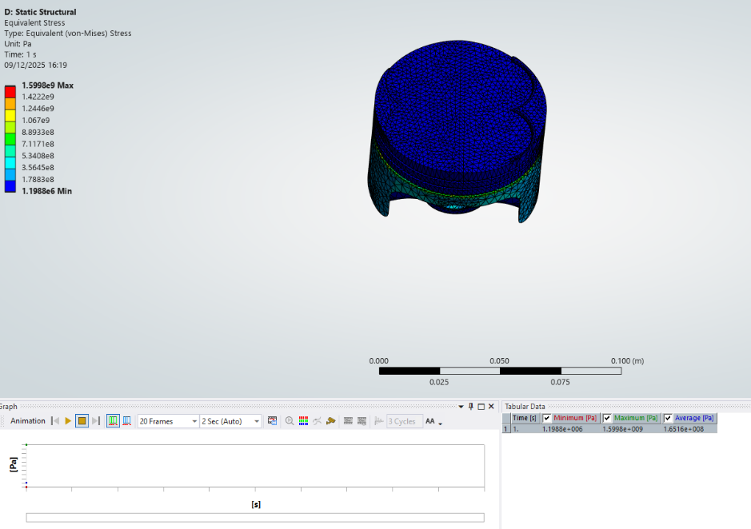
Figure 20: Fatigue life prediction for titanium alloy piston

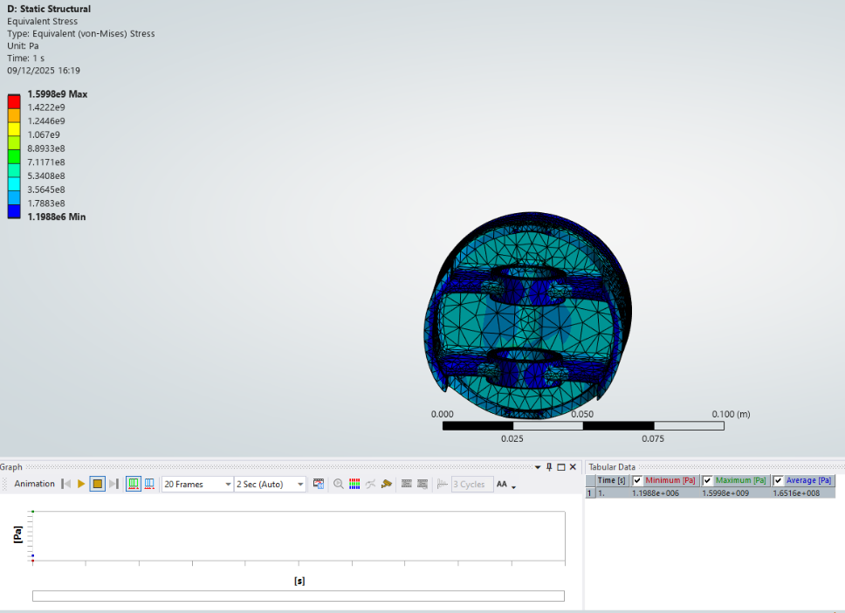
Figure 21

Cylinder Design Change

Figures 22–30 illustrate the impact of geometric modifications to the cylinder and piston interface by reducing the amount of materiel to create the piston as displayed in figure 22. Figure 24 shows redistributed stresses following crown thickening, while Figure 26 demonstrates reduced deformation at the skirt. Fatigue analysis (Figure 29) confirms improved life expectancy, and Figure 30 highlights mass optimisation achieved through selective geometry refinement.

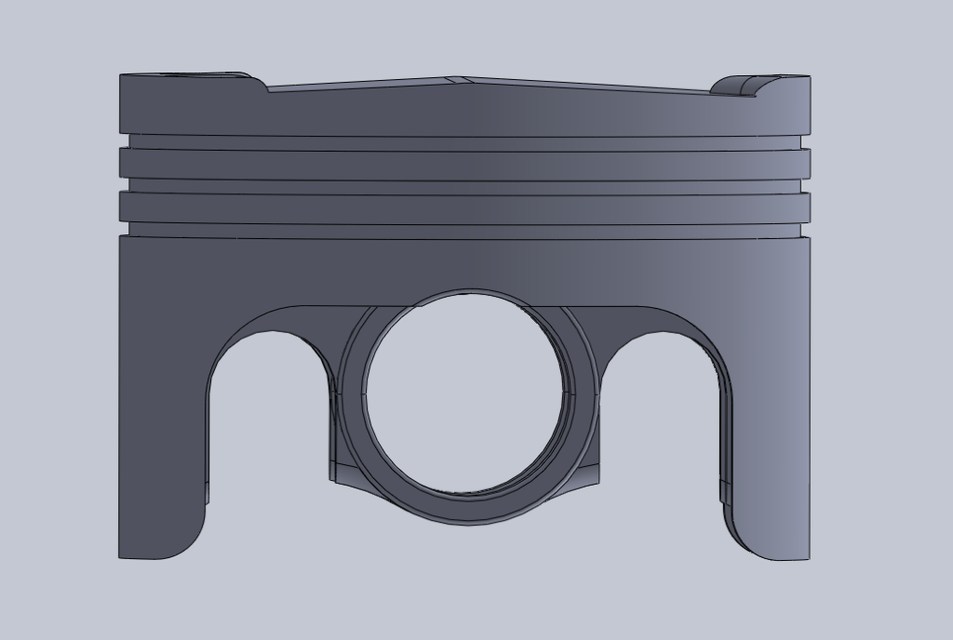
Figure 22
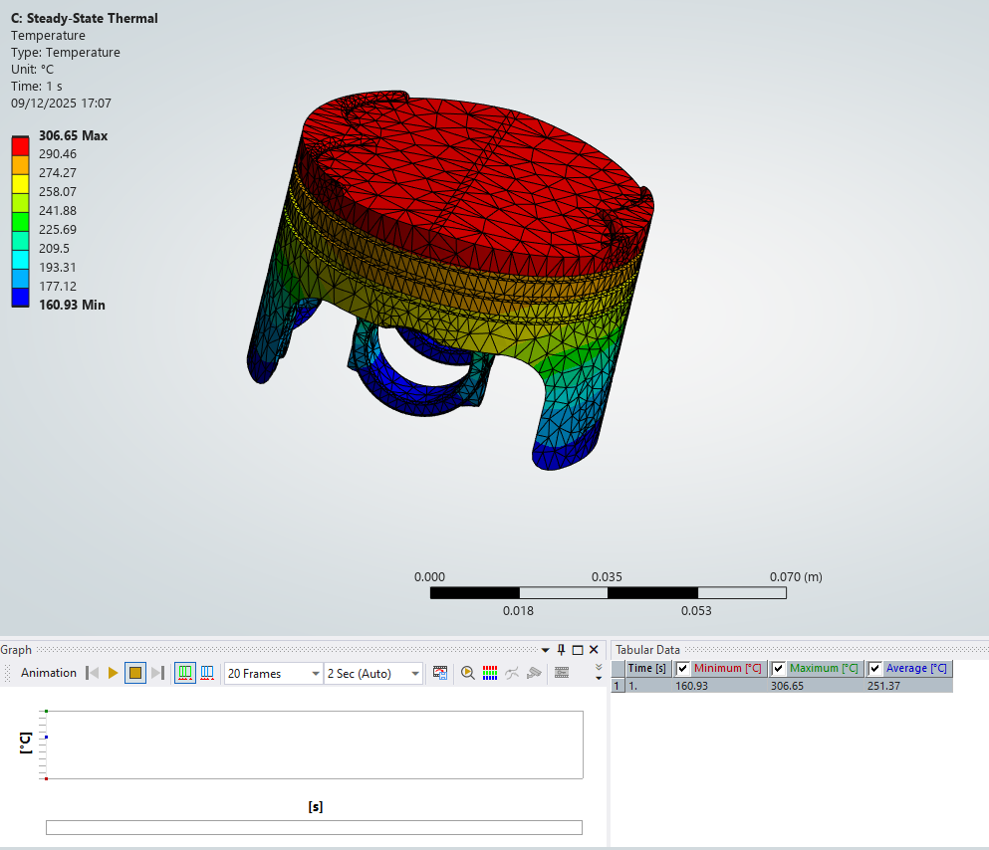
Figure 23
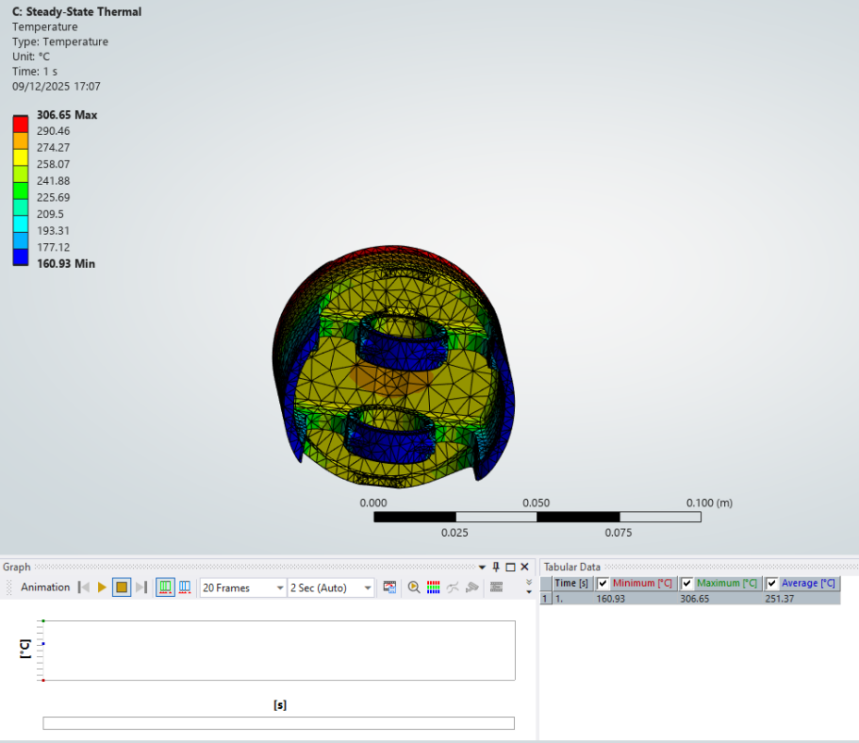
Figure 24
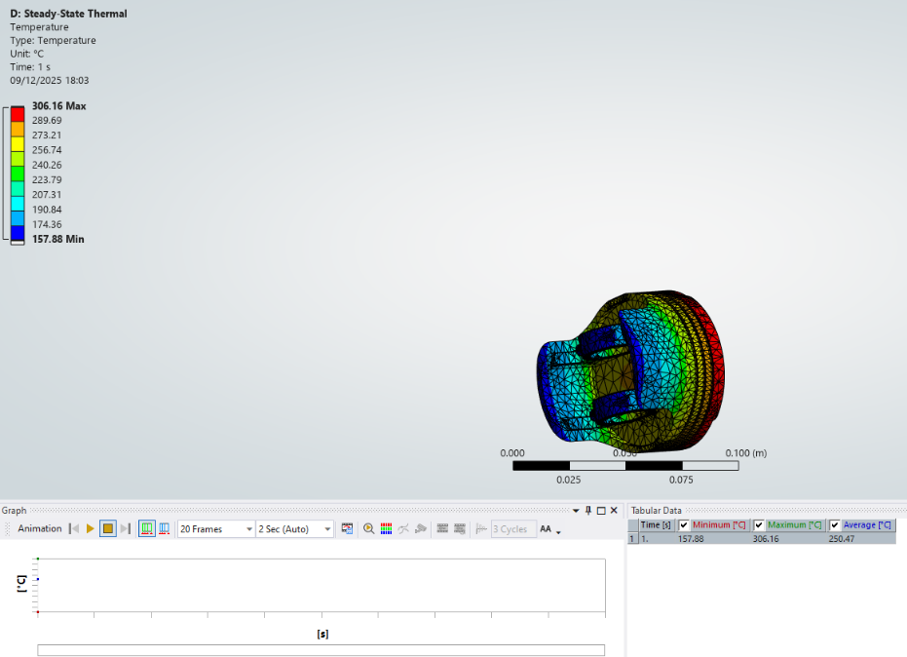
Figure 25

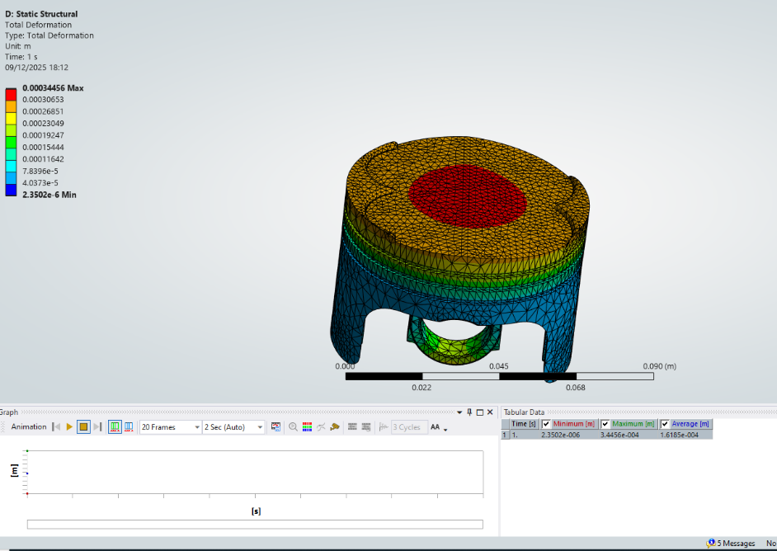
Figure 26

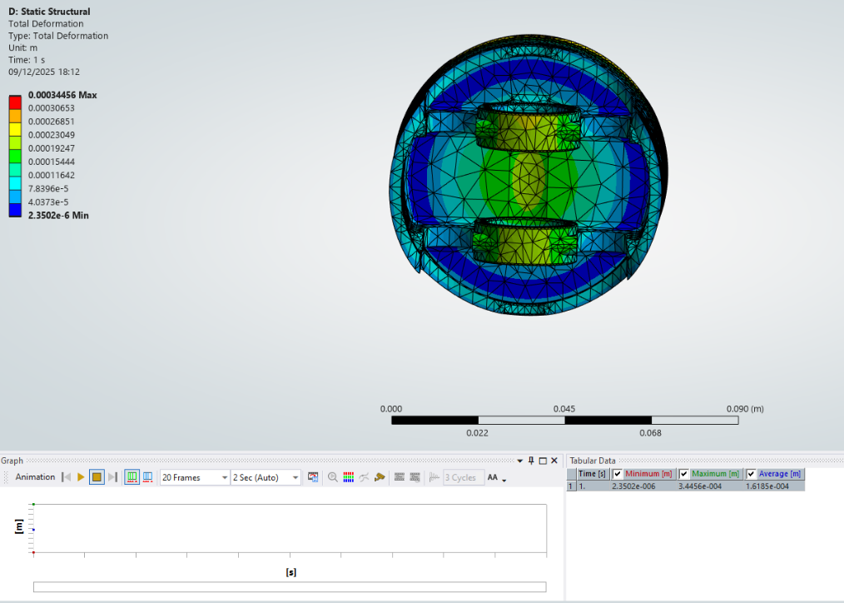
Figure 27

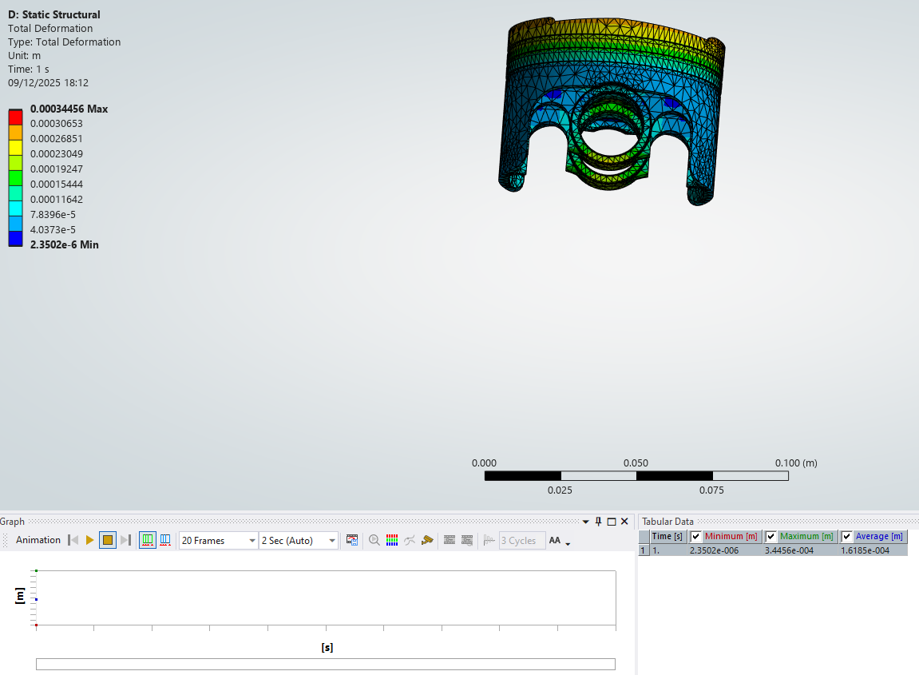
Figure 28

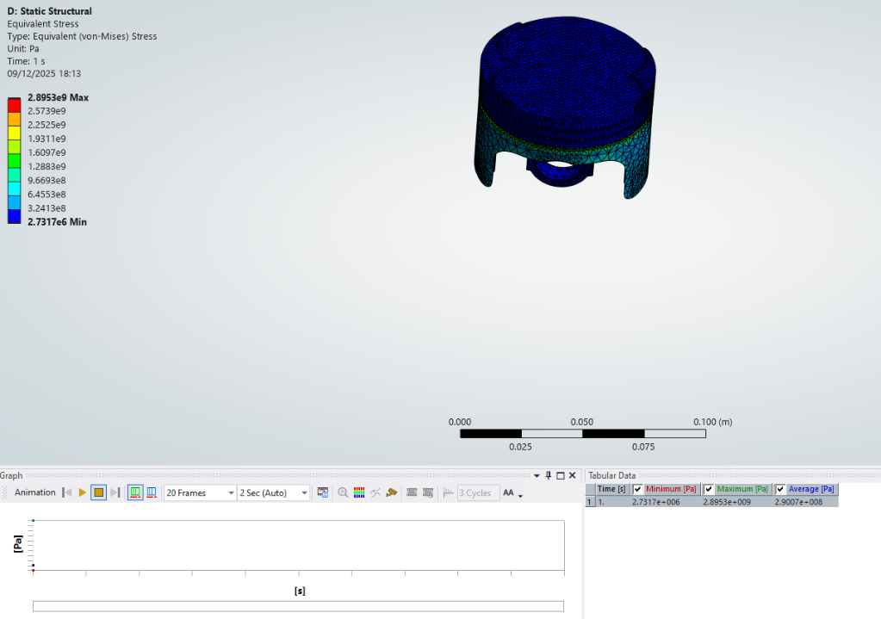
Figure 29: Fatigue life prediction after geometric optimisation

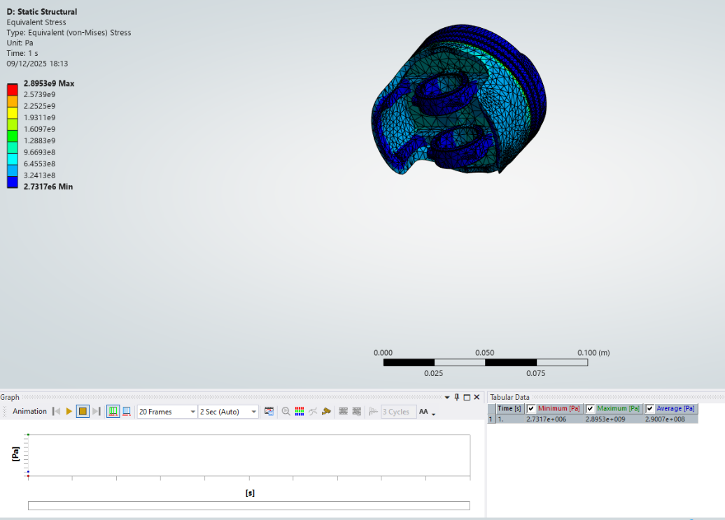
Figure 30

Overall, the optimisation process demonstrates how iterative FEA studies guide design improvements. Aluminium offers lightweight efficiency but limited fatigue resistance, titanium provides superior durability at the cost of mass, and geometric changes enable a balanced compromise. These findings underscore the importance of combining material selection with design refinement to achieve optimal piston performance.

Validation Testing

Validation was carried out to ensure the reliability of the CAE results and to highlight the limitations of simulation tools. Two approaches were used: a simplified analytical case study and a mesh independence investigation.

Bimetallic Strip

The thermal curvature of a bimetallic strip subjected to a uniform temperature change can be estimated analytically using classical beam theory. The curvature, k, is given by:
$$k=\frac{6(α1-α2)∆T}{t(1+4ρ+{6ρ}^{2}+{4ρ}^{3}+ρ^{4})}$$
Where $α1$ and $α2$are the coefficients of thermal expansion of the two materials, ΔT is the applied temperature change, t is the total strip thickness, and ρ is the thickness ratio. The analytically predicted curvature showed close agreement with the ANSYS results, confirming the validity of the coupled thermal–structural modelling approach used in the piston analysis.
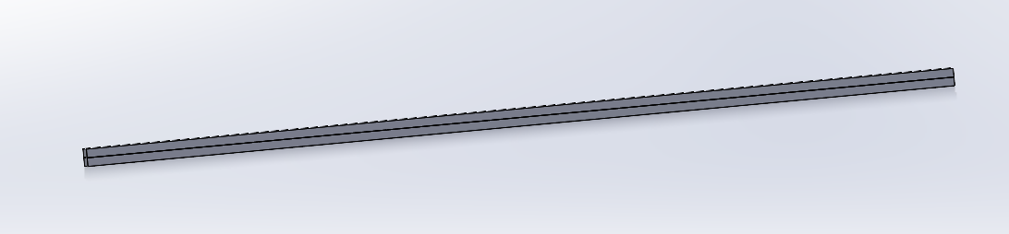
Figure 31: Bimetallic strip deformation under thermal loading
The bimetallic strip test (Figure 31) was selected as a simplified case where an analytical solution could be derived from fundamental thermal expansion principles. The strip was modelled with two metals of differing coefficients of thermal expansion, and the curvature under heating was compared against the analytical prediction. The close agreement between the analytical and ANSYS results confirmed the accuracy of the thermal modelling approach used in the piston study.

Testing with mesh sizing

Figures 32–35 illustrate the mesh independence study conducted on the piston model. As shown in Figure 32, coarse meshing produced significant deviations in stress distribution, particularly at the crown edges. Figure 33 demonstrates improved accuracy with medium refinement, while Figure 34 shows convergence of von Mises stress values with fine meshing. Figure 35 summarises the results, indicating that beyond a certain refinement level, further mesh density produced negligible changes. This confirmed the point of mesh independence and validated the reliability of the chosen mesh size for subsequent optimisation studies.

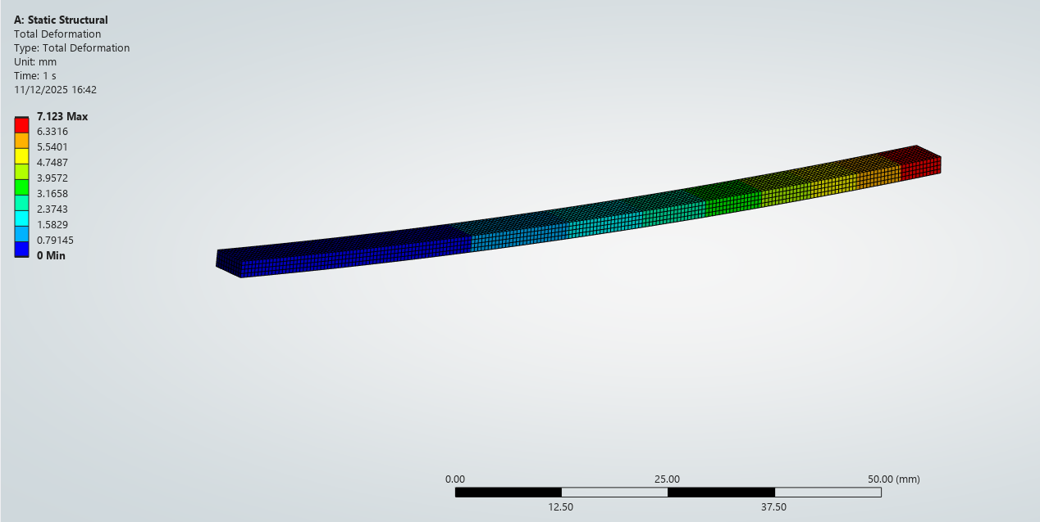
Figure 32: Coarse mesh stress distribution

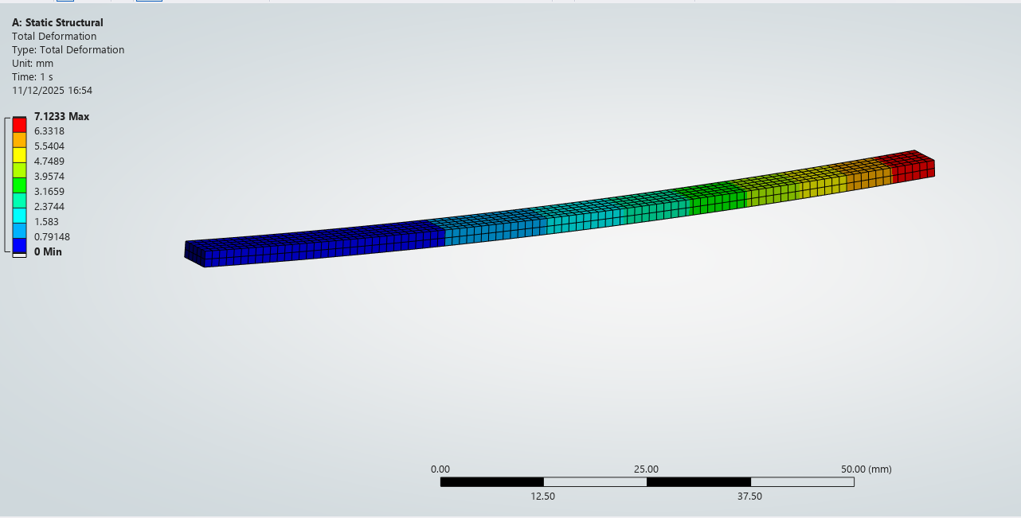
Figure 33

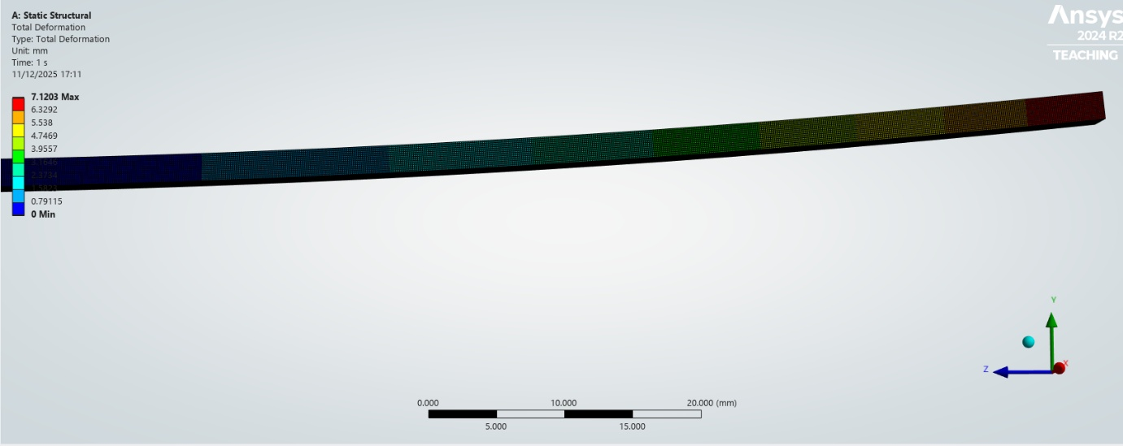
Figure 34: Fine mesh stress distribution showing convergence

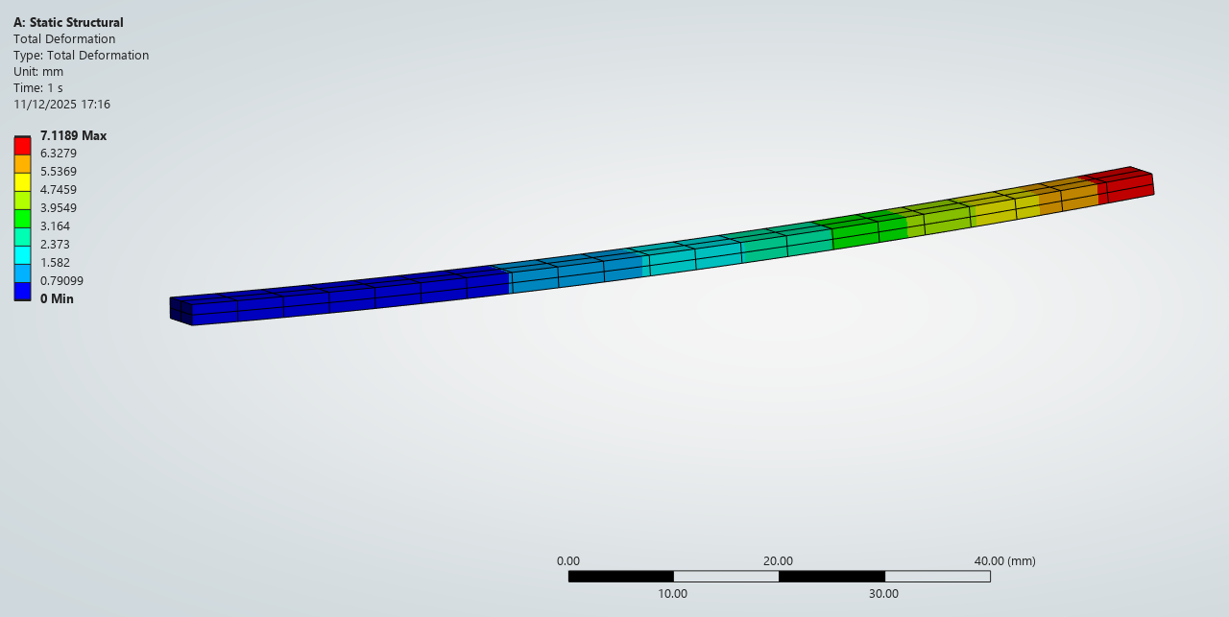
Figure 35: Von Mises stress convergence with mesh refinement

Together, these validation exercises demonstrate the importance of analytical comparison and mesh independence in ensuring credible CAE results. They also highlight the sensitivity of simulations to boundary conditions and meshing strategies, reinforcing the need for critical evaluation when applying CAE tools to complex engineering problems.

Analysis

The combined kinematic, structural, thermal, and optimisation studies enable a clear comparison of piston performance in terms of stress, deformation, fatigue life, and mass efficiency. For the baseline structural steel model, peak von Mises stresses consistently occurred at the piston crown edges and skirt fillet regions. These areas coincide with geometric transitions and primary load paths, indicating a high likelihood of fatigue crack initiation under cyclic thermo-mechanical loading.
The aluminium alloy piston provided a substantial reduction in mass, offering benefits in reduced reciprocating inertia and improved engine efficiency. However, the analysis showed increased deformation and reduced fatigue life at elevated temperatures. This behaviour is attributed to aluminium’s lower elastic modulus and degradation of mechanical properties under thermal loading. As a result, although aluminium is advantageous for lightweight design, its durability is limited for high-temperature or high-duty applications.
The titanium alloy piston exhibited reduced deformation and lower stress levels across critical regions, resulting in a significantly improved fatigue life. This enhanced performance is due to titanium’s superior strength retention at elevated temperatures. Nevertheless, the increased material density led to a higher component mass, which would raise inertial forces within the crankshaft assembly and potentially reduce overall system efficiency. This highlights the trade-off between durability and mass in material selection.
Geometric optimisation offered the most balanced improvement. Localised crown thickening and skirt refinement redistributed stresses away from critical regions while minimising mass increase. This led to reduced peak stresses and improved fatigue life without the significant weight penalty associated with titanium. Consequently, geometry-led optimisation proved to be the most effective strategy.
The mesh independence study confirmed that stress predictions are highly sensitive to mesh density, particularly near geometric discontinuities, while boundary condition assumptions also influenced results. Overall, the optimised geometric design represents the best compromise between structural performance, fatigue life, and mass efficiency, while reinforcing the need for careful validation when using CAE tools. From an engineering design perspective, this outcome demonstrates that targeted geometric refinement offers greater overall benefit than material substitution alone when both fatigue performance and system efficiency are considered.

Conclusion

This study has demonstrated the application of Computer Aided Engineering (CAE) tools in the structural and thermal evaluation of a piston within a crankshaft assembly. Through kinematic simulation, static structural analysis, and thermal coupling, the investigation highlighted critical stress concentrations at the piston crown and skirt transitions, confirming the importance of geometry and material selection in fatigue performance. Optimisation studies revealed the trade-offs inherent in design decisions: aluminium alloys offered lightweight efficiency but suffered from thermal degradation, titanium alloys provided superior durability at the expense of increased mass, and geometric modifications enabled a balanced compromise between strength and efficiency.
Validation exercises, including analytical comparison with a bimetallic strip and mesh independence testing, reinforced the credibility of the simulation results while emphasising the sensitivity of CAE outputs to boundary condition definition and meshing strategies. These findings underline both the strengths and limitations of CAE: while it enables rapid iteration and optimisation, its predictive accuracy is constrained by modelling assumptions and requires careful validation against analytical or experimental benchmarks.
Overall, the work illustrates how CAE supports the engineering design process by guiding material selection and geometric refinement but also demonstrates the necessity of critical evaluation and validation to ensure reliability. In the context of automotive engineering, this balance between computational efficiency and practical credibility is essential for developing components that meet the demands of performance, durability, and industrial relevance.

References

Cioatǎ, V.G. et al. (2017) “Mechanical and thermal analysis of the internal combustion engine piston using Ansys,” in IOP Conference Series: Materials Science and Engineering. Institute of Physics Publishing. Available at: https://doi.org/10.1088/1757-899X/163/1/012043

Frǎtia, M. et al. (2019) “About Structural and Thermal Analysis of Diesel Engine Piston Using Ansys Software,” in IOP Conference Series: Materials Science and Engineering. Institute of Physics Publishing. Available at: https://doi.org/10.1088/1757-899X/595/1/012041

M, R., K, S. and Hatti, P.S. (2019) “International Journal of Innovative Technology and Exploring Engineering (IJITEE).” Available at: https://doi.org/10.35940/ijitee.B8037.129219

Rushikesh, M. et al. (2020) Static, Modal & Thermal Analysis of Engine Block. Available at: www.ijert.org

