Managing enterprise in the 21st century
Business Plan – Laura Morgan – 1811899

Phoenix Play
Business Plan
2020



Proposal
Our business proposal is to open a soft play area in Townhill. We feel there is a need for this because the closest play area is in Cwmdu. It would bring the community together, a place for single parents or newcomers to the area to socialise. Townhill is a highly deprived area therefore we must make it affordable for the community, but we must be making a profit as well. We will rent a unit within the Phoenix Centre based in the heart of Townhill, this building is well known in the community and this will help establish our business as we advertise through the Phoenix. There is an on-site café, on-site toilet facilities with ample parking. Nicola and I currently work in the Phoenix Centre, Nicola works in the café and I work in the office covering the finance and payroll. Lisa is a past employee but still has connections to the Phoenix and lives in the community. This will be a partnership business, between myself, Nicola Brain and Lisa Dower.
Before deciding on our business, we carried out a Pestle Analysis to consider all factors that would affect the business.
Pestle Analysis
PESTLE analysis, which is sometimes referred to as PEST analysis, is a concept in marketing principles. This concept is used as a tool by companies to track the environment they’re operating in or are planning to launch a new project/product/service etc.
Pestle analysis (2019)
Political
Reduced services in parks and outdoor facilities due to government cuts.

Economic
The area our play centre will be based is a high deprivation community and we would need to set prices accordingly.

Sociological
Increased usage and need for different culture awareness due to immigration. The need for parents to gain confidence when bringing children.

Technological
The use of new and interactive toys to stimulate the child and create fun ways of learning

Legal
Ensuring all rules and regulations are adhered to. Health and safety is paramount and all risk assessments carried out. All staff have required qualifications and DBS check.

Environmental
Ensuring comfort and safety. Environmental factors play a major role in determining the health and well-being of children. The implementation of energy saving measures.

All the aspects of this technique are crucial for any industry a business might be in. More than just understanding the market, this framework represents one of the vertebras of the backbone of strategic management that not only defines what a company should do, but also accounts for an organization’s goals and the strategies stringed to them.

Pestle analysis (2019)

Our aim is making a profit for ourselves and the Phoenix. The Phoenix is a not for profit organisation with charitable aims, which rents out units. This will be a bricks business as it will be a face to face service except for advertising online.
Based on our individual skills and qualifications I will be responsible for all the finance, accounts and payroll as this is already my current job role and I am working towards my accountancy qualification. I am responsible for completing the pestle analysis, equipment and location for the business, all the financial duties, smart action plan and the cash flow forecast.
Equipment
I have measured the size of the unit we will rent; it is 86.6m2. this is ample space for what we want, and I have priced up some equipment that would fit. We also have room for some chairs and small tables for parents to sit and relax while their children play. The chairs and tables would be provided by the Phoenix Centre as part of the unit.
Below are some examples of soft play areas we could use.
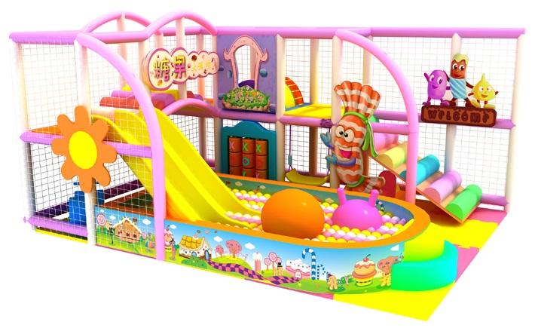
An Angel playground equipment (2019) accessed on 29/10/2019

The price of this is £2390.00 and the size is 600cmx500x280.

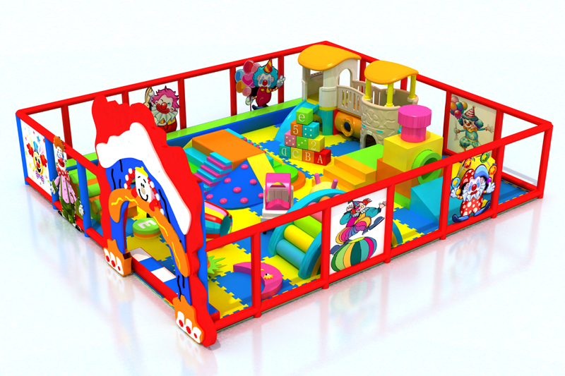
Another one I priced up is £3888.50 and measured 750cmx600cm.

Angel playground equipment (2019) accessed on 29/10/2019

I have checked that these are suitable for our age range up to 7 years old, excellent quality and promotes moto-skills. They look colourful and exciting with plenty of areas for young children to play with.
Health and safety are paramount, our equipment would be updated and checked on a regular basis to ensure it is safe and secure and at an excellent standard of quality. It will be cleaned and checked daily.

Birthday Parties
On weekends we will specialise in birthday parties, we will arrange everything, from the food, the play and we can hire a mascot. Fairy-tale moments have a huge range of princesses to choose from, we will arrange all of this, all the customer would need to do is turn up on the day as we will take away all the stress of organising a party. However, having a princess of superhero would come at an extra cost. Parties would need to be booked in advance we recommend two weeks to ensure you get the day and time requested.
Financial Resources
We have between us £50,000 capital of our own money that we have saved. We do not feel there is a need for any grand funding yet.
To rent a unit in the Phoenix Centre will cost £350.00 per month, gas and electric is estimated at around £90.00 per month based on other unit usage. The rates are £118.00 per month. We won’t need to hire an accountant as I am working towards my accountancy qualification. We will need to hire two part time staff and a cleaner who will all be paid minimum wage.
Due to Townhill being a highly deprived area we must keep costs to a minimal but also be making a profit. It will cost £3.00 per child to play and £5.00 for two children. For an extra £2.00 per child they can have a meal from the Phoenix Café, the café would potentially profit £1.40 and we will profit 60p. We will only hold parties at the weekends at a charge of £9.00 per head, this includes play and food, the customer can choose from set meals or a buffet. It will cost extra to hire a princess or superhero.
We hope to make a profit not only for ourselves but for the Phoenix Centre also. Being a not for profit organisation it could go under where we would lose our current jobs and our business, therefore we hope this will benefit both businesses’.
Smart Goals

Smart is an effective tool that provides the clarity, focus and motivation you need to achieve your goals.
It can also improve your ability to reach them by encouraging you to define your objectives and set completion dates.
Mind tools (2019)
This is our smart action plan.
Specific
The goal is to open a soft play area in the Phoenix Centre, Townhill. Partnership business between three of us. We aim to bring the community together at an affordable price due to the area being highly deprived, we will also be specialising in birthday parties on the weekends where we will take all the stress away and the customer simply must just turn up.
Measurable
We will know when we have accomplished our goal by keeping a record of the number of children and parties that take the opportunity to use our facilities. We will also keep a record of the profit and expenditure.
Achievable
Due to competitive prices for play and parties we believe this goal is attainable, we take away all the stress of arranging a party, including hiring a mascot and having food, all you need to do is turn up!
Realistic
Our goal is relevant to us as we currently work at Phoenix Centre and this will gain custom for both our business and the Phoenix, as we are based on site most days, we are able to keep an eye on the business regular.
Time
Our time frame is set out in our Gantt chart. We each have set tasks to complete each week, in week two I was responsible for looking into financial resources and researching the location and equipment needed. Week three was again looking at financial resources, talking to the café manager on agreeing prices for children’s meal plans. During week six and seven I looked at a cash flow forecast.
Cash Flow Forecast
A cash flow forecast is a plan that shows how much money a business expects to receive in, and pay out, over a given period of time. Usually over a year.
The business will usually start by planning how much it expects to earn in sales, then how much it expects to spend in day-to-day running costs, and finally how much it expects to receive from other sources (such as a bank loan) and pay for other costs such as buying new equipment and overheads expenses.
Free agent (2018)

This is our cash flow forecast.

Down the left side of the cash flow forecast is a list of our income and expenditure. Across the top is the profit or expenses for each month. Some months vary due to having busier months, for example April and May could be busier as the children are off school for Easter, but during summer months we could see a decrease in our gas and electric bill as they would not be used as much as the winter months. We started the business with £50,000 capital and after all the expenditure including wages, we have estimated that we will make a profit of £4912.00 for our first year.

If a business expects to receive more than it spends, it is said to be cash positive, or to have positive cash flow. If it expects to spend more than it earns, it is said to be cash negative, or to have a negative cash flow.
Free agent (2018)
To summarise, cash flow forecasts are the main tool used by companies for forward liquidity planning. Their format and duration vary depending on the exact nature of each business’s requirements. Finance teams structure their cash forecasts depending on what makes sense for them and what is important for the CEO. A robust and accurate cash flow forecasting process, where accountability is built in, is an indicator of strong fiscal discipline in a company.
Cash Analytics (2019)

Conclusion
The primary goal of this business proposal is to bring something to the area that we feel is needed and will be well used. There isn’t a soft play area in or around Townhill. We believe the community will massively benefit from using our soft play, children will have somewhere to play, and parents will have a place to bring their children and meet other people in the area.
Our prices will be affordable due to the area being classed as a deprived area.
As well as making a profit for ourselves we believe this will help the Phoenix Centre which is a not for profit organisation to stay open. Therefore, everyone benefits.
This is our proposal for Phoenix Play.

Angel playground equipment (2019) www.angelplayground.com accessed on 20/11/2019
Cash Analytics (2019) https://www.cashanalytics.com/cash-flow-forecast/ accessed on 20/11/2019
Free agent (2018) https://www.freeagent.com/glossary/cash-flow-forecast/ accessed on 27/11/2019
Mind tools (2019) www.mindtools.com accessed on 22/11/2019
Pestle analysis (2019) https://pestleanalysis.com/what-is-pestle-analysis/ accessed on 28/11/2019

