
(Robinson & Garton, 2007)

Problem Solving and Decision Making

BMSW4004_LON

MODULE LECTURER´S NAME: Dr Nandish Patel
STUDENT NAME: IRENA LONCAR
STUDENT IDENTITY NUMBER: 1917107

Contents
INTRODUCTION 2
MAIN BODY 3
CONCLUSION 10
REFERENCES 11

INTRODUCTION
I am presenting the self-reflection essay where I am working in a retail shop on the profile of sales executive. I am facing problems due to the high workload. I am working on a 12 hour basis and still I am not getting any appreciation for my work, I am staying on the shop over time but still I am not getting the salary for my extra efforts.

MAIN BODY
I am working in a retail shop as a sales executive and I am not happy with my manager because he is giving a lot of work on daily basis. I am working daily for 12 hours and even after that I am staying in the store working overtime but I am not getting any appreciation for this. I am not even getting the expected salary. This issue is impacting my performance, loss of motivation, lack of interest, poor work productivity, frustration, absenteeism and many more issues are there. All such issues are due to the manager pressure, he is not hiring the new employee for the extra work just because he has to pay them the salary which he don’t want to pay and due to this, he makes me overburdened. Looking on to my problem there are some other reasons also where I am not happy with my manager and the store both: (DeClercq et al., 2019):
- Not being appreciated enough: most of the times, I am dissatisfied when I am rewarded as per my work efforts. I can feel that no matter how hard the efforts were, my work will not recognised at all or is never being appreciated. This is one of the main causes that lead to job dissatisfaction. I am definitely blaming my manager for the reason of dissatisfaction and also the less motivation and appreciation from his side.
- Change of mind: it is not that uncommon for a manager to find out the issues and problems within the team he is handling. It is known to be quite hard when someone is quite irregular and unfocussed towards their job, but I am completely loyal towards my work. I never change my behaviour towards my work, all the frustration and stress is due to my manager who don’t support me or appreciate me for my work and I feel demotivated (Jannat et al., 2020).
- The gossips or the people who talk at the employee back: there are some people who talk at my back that why I am working so hard or why I am staying late in the store, such types of gossips are the worst possible thing that someone can expect in the organisation. The gossiping pitchers are all around me and I cannot hope to avoid them at some points of time. In any organisation, the gossips are started on the very minor and imaginative level. And the time when it reaches to the particular employee it has been changing with a lot of talks and angles and also it becomes quite dramatic them previous. The best way to deal with such types of gossips is that the employee has to be wise enough and don't trust too easily on anyone.
- Not enough benefits: as my main reason for dissatisfaction is that I am not getting the benefits that I deserve, this is also the reason I want the higher authority should notice that I am wishing that I will be getting enough rewards for my work (Olanrewaju and Pradhan, 2019).
- When it is not according to something excepted: it occurs when the employees are in confusion when they don't meet their expectation and I am never getting the response as per my efforts and the work I do. If the job is not that exciting as it looks them this leads to dissatisfaction and gives somewhere a similar effect. The only way to ignore such disappointments is to spend most of the time in thinking and making the work more effective.
As everyone is talking about the performance and experience that I have gained from my work, I just want to say that I am not having the good experience because I am not getting any support from my manager. I am overburdened; I am not getting any work appreciation from my manager. I just want motivation to work more effectively, but due to such problems I am unable to focus on my work and I feel very demotivated and unhappy (Meltem and Caliskan, 2020).
THERE CAN BE SEVERAL STEPS WHICH MY MANAGER CAN TAKE TO SOLVE MY PROBLEM SO THAT I CAN EFFECTIVELY WORK WITH THEM:
With the help of the below stages mentioned, the problem about the lack of appreciation and salary can be resolved effectively:
Communication: The manager can come to me or call me to discuss about my problems. He can ask me why I am not working effectively. Why I am unhappy? I will share all my negative experience with him so that I can get the appreciation I deserve.
Employee relations: from my past work experience also; I have observed that there should be good relation between a employee and an manager. Here the manager should take a step to improve the relation between him and me so that we both can work together to improve the performance of the store (Pryce, 2016).
. Rewards: the rewards are something which I am looking for my efforts. The manager can motivate me; appreciate me for my work so that I can also feel happy. As I am working 12 hours along with it I am staying late in the store. So I need a reward from my manager.
There are several methods for developing an alternative solution to the problem; the steps included in it. As per my past experience, I can find that the solution can be given for my problem, it includes:
- Define the problem: the first step in finding the alternative for the problem is to define the problem so that the manager can focus on it. Some problem-solving techniques include is the flow-charts to identify the steps and the cause and effect diagrams to define and analyse the main reason for the problem.
- Find out the alternative solutions: carry over the selection of the one solution till the other problem-solving alternatives are being prepared. Taking up the multiple alternative solutions, the managers can significantly enhance the values of the ideal solution. Most of the time, the managers prefer the brainstorming sessions with their subordinates to find out the maximum alternative solutions to the problem.
- Evaluate and select an alternative: all the skilled problem solvers utilise the series of considerations while selecting the best and suitable alternative. They prefer the extent to which:
- A specified alternative will solve the problem or not.
- All the employees involved in it will accept the alternative solution or not.
- The plan for implementation of the problem is suitable or not.
- The best alternative fits the organisational constraints or not.
- Implementation and follow up on the solution finalised: the managers are called up to direct the final solution and its implementation, it means “sell” the solution or smooth up the implementation with the assistance of others. Involving others in the implementation is also an effective way to gain support and reduce oppose the subsequent changes (Zavushchak et al., 2018).
FISHBONE TECHNIQUE TO ANALYSE THE PROBLEM IN AN ORGANISATION:
For the purpose of solving the problem in my case, my manager can use the fishbone technique to analyse and solve the problem effectively. As the major problem is about the workload and a lack of appreciation and also I am getting the desired salary for my over time also.
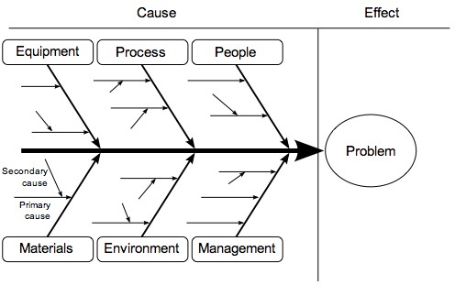
Fig: 1 (fishbone technique for problem-solving)
Source: Matto, 2019
Fishbone technique is also known as the “Cause and Effect” method that is one of the great tools for dealing with several problems in the organisation that are required to be determined. It gives a specific procedure that clearly defines the effect and then puts the thinking about all the possible reasons on different characteristics of any common problems. The fishbone technique steps are as following (Matto, 2019):
DEFINING YOUR “EFFECT”
The first stage in utilising the fishbone diagram as an effective problem-solving tool is clearly stated efforts or the outcome that is liked or disliked. This may be due to the quality issues, or not meeting up the metrics or the troubleshooting introduction of the procedure or the product line. Ultimately this becomes the "Head" of the fishbone technique diagram. Defining or stating any effect takes a specific practice. It helps to get a concise solution. Here in the first stage, the problem i.e. the overburden issue and a lack of appreciation, along with it I am not getting the desired salary according to my work.
BRAINSTORMING THE “CAUSES”
With the help of the team, brainstorming makes the possible to influence the factors that could be located in a specific category or branch. It is generally accepted as the 6 main branches or roots that require proper investigation. These are generally described as the "6M's" to utilise it in terms of the best alternative. It includes the following (Ipsen et al., 2017):
- People/manpower: everyone who is involved with the process in the value stream, includes all the supporting functions.
- Processes/methods: this states that how the process is achieved and all the needs are relating to it. It includes the quality procedures, work orders, work instructions and many more.
- Machines/equipment: all the machines and equipment should be tested and confirm that they are accomplishing the job including all the tools.
- Materials: all the raw materials, purchased parts and assembled parts that feed to the end product.
- Measurements: it states the determination about the right and wrong outcomes.
- Environment: it depends on the condition that influences the procedure including time, temperature, humidity and cleanliness.
The above presented the fishbone technique for analysing the problem in an organisation is very effective and assists the manager a lot in identifying the problems that why the employees are not satisfied with the job (Marye, 2020).
DECISION-MAKING TECHNIQUE
The decision making technique is something that solves most of the problem, it is suggested that the higher authorities of my store can apply to take a final decision for the same. Most of the organisation prefers the decision-making tree to take quick decisions about the problem that is occurred in the organisation.
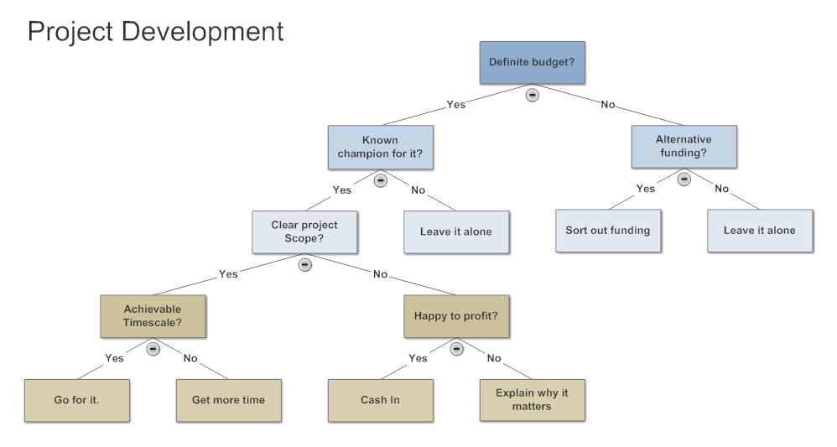
Fig: 2 (decision-making tree)
Source: Xu et al., 2019
A basic decision tree is a flowchart similar to the diagram which shows the different outcomes from a chain of decisions. the organisations use it as the decision-making tool for research analysis or any planning strategy. The primary advantage of utilising the decision tree is that it is quite easy to follow and understand.
There are four main steps to follow the decision tree process to take instant decisions. it implies the following (Xu et al., 2019):
Decision nodes: it represents the decision that further shows the choice that is made for taking the quick decision.
Chance nodes: this shows the significance of uncertain outcomes. This branch is used when the desired future result is uncertain and not guaranteed.
End nodes: as it is clear from the name, it shows the result and illustrations relating to the outcomes of the decisions finalised.
Branches: This is something that connects all the nodes in a very aligned manner. each branch shows a potential choice and it should be categorised.
Different elements are involved to monitor, review and evaluate the implementation to a solution. The elements are:
Report to others: it means that there should be a clear purpose and demand for agreeing towards monitoring, reviewing and evaluating the activities. It means that everything should be targeted towards the specific employees and arrangements to improve transparency and accountability (Sarkar et al., 2018).
Involve stakeholders: all the stakeholders must be involved in this process to be successful. Clear and effective communication benefits in providing the necessary support for creating more opportunities.
Monitor progress: it helps in delivering the timely and accurate information that helps in tracking the progress towards the desired outcomes and necessary adjustments could be done as per requirements.
Review on a daily base: it includes the daily evaluation and responses to specific issues that help in focussing on the solutions and project management structures.
Evaluation of outcomes: the success of the implementation is determined with the extent to which the planned and unplanned strategies are achieved. The effective evaluation is the result of the planning process that helps in taking different initiatives (Reddy and Reddy, 2019).
The decision tree technique is suggested for taking the correct decision about the problem specified.

CONCLUSION
The above reflective report is presented in favour of my problem with my manager. My manager was increasing work load, I was working regularly on a 12 hour basis and apart from this I was staying late in the shop just to share the work. My manager never appreciated me for my work. The reflective report showed the different reasons due to which the problem may arise, the solution for the problem has been suggested. The fishbone technique has been suggested to resolve the problem and the decision tree technique is suggested to give a unbiased decision towards my problem.

REFERENCES
- De Clercq, D., Haq, I.U., Azeem, M.U. and Ahmad, H.N. (2019). The relationship between workplace incivility and helping behaviour: roles of job dissatisfaction and political skill. The Journal of Psychology, 153(5), pp.507-527.
- Ipsen, C., Sørensen, O.H., Poulsen, S. and Gish, L. (2017). The fishbone workshop: How to transform. In 12th International Conference on Occupational Stress and Health: Contemporary Challenges and Opportunities.
- Jannat, T., Omar, N.A. and Nazri, M.A. (2020). Analysing the Mediating Effects of Job Satisfaction and Dissatisfaction on Employee Voluntary Turnover Intention. Jurnal Pengurusan (UKM Journal of Management), 59.
- MARYE, M. (2020). CAUSES OF EMPLOYEE TURNOVER AND ITS EFFECT ON THE PRODUCTIVITY OF BAHIR DAR TEXTILE SHARE COMPANY (Doctoral dissertation).
- Mättö, T. (2019). Innovation through =implementation of a quality improvement method. The TQM Journal.
- Meltem, A.K.C.A. and ÇALIŞKAN, B.Ö.Ö. (2020). Stigma, dissatisfaction, disengagement and intention to quit: A model proposal. Yaşam Becerileri Psikoloji Dergisi, 4(7), pp.101-114.
- Olanrewaju, O.A. and Pradhan, A. (2019). Dissatisfaction in the workplace and its correlation to high staff turnover.
- Pryce, A.C. (2016). Strategies to reduce employee turnover in small retail businesses.
- Reddy, S.N. and Reddy, T.N. (2019). Decision Tree Analysis on Employee Job Satisfaction and HRD Climate: The Role of Demographics.
- Sarker, A., Shamim, S.M., Zama, M.S. and Rahman, M.M. (2018). Employee’s Performance Analysis and Prediction using K-Means Clustering & Decision Tree Algorithm. Global Journal of Computer Science and Technology.
- Xu, Z., He, Y. and Wang, X. (2019). An overview of probabilistic-based expressions for qualitative decision-making: techniques, comparisons and developments. International Journal of Machine Learning and Cybernetics, 10(6), pp.1513-1528.
- Zavushchak, I., Burov, Y. and Pasichnyk, V. (2018). Context modelling in process of developing employment solutions. ECONTECHMOD: An International Quarterly Journal on Economics of Technology and Modelling Processes, 7.

