Academic Scrapbook

With reference to the classroom observation and practice one will demonstrate an understanding of the effective application of three Educational Theories.
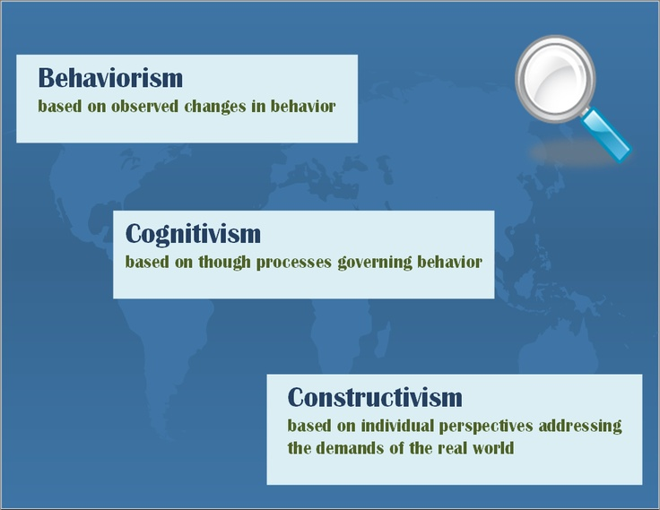
There are three main Educational Theories in learning and development, they are Constructivism, Behaviourist and Cognitism. A theory is a set of statements or principles which explain a group of facts or a fact which has been tested and then accepted, which then can be used to make predictions.

Constructivism
Learning Constructivism is a part of the Cognitive Development theory, and a learning as process of construction. This is when children are actively being involved in their own learning experiences. They learn through observation as well as imitating others. These activities have a meaningful context, and related to the real world. Constructivism is an observation and a scientific study about how people learn. Through experience children build on their own understanding of the world and give them the knowledge to reflect on experiences. The children then find a way to transfer this knowledge to learning new experiences.
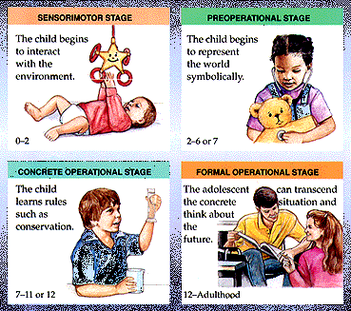
The thoerists Jean Piaget 1952 believes that childrens thinking was an effective process rather than a passive absorption of information. He believed that children were born with a basic mental structure which learning and knowleged were based. (simplyschology assessed 17/011/17).Piagets theory produced the knowledge of cognitive development in fixed ages in children. This theory is also used in prediction of childrens capabilits and understanding, on their stage of development. He believed that all children go through the stages of development and no stages can be missed out but agreed that children do have individual variations in the rate a child develops, and some may never be able to retain information. Teachers use this knowledge from Piaget to influence the curriculums and to have effective activities and lessons. Some children progress through each stage faster than their peers. Their development stage is believed to be based on a child’s interaction with their, peers and family. There are many benefits from this theory that encourage the following, team work, diversity, engages the children in their problem-solving skills, and can offer differentiated instructions to the learners.

Cognitivism
This theory can be divided into two theories, social cognitive theory and the cognitive behavioral theory. Cognitivism psychology was initiated in the late 1950s. The cognitive processes are categorising forming and observing information. The learner is an information-processor who absorbs information, and undertakes cognitive operations on it, and store it in their memory, by being encouraged by creativity, imagination, sensory experiences. (learning.gov. wales. Assessed 2017) From one’s own experience and while working in education one gives the children experiences and encouragement to enjoy messy play, crafts, painting, singing songs, playing in the role play, sticking and cutting out, dancing, jumping, skipping and many more fun activities. These activities can teach the children many skills, include children with additional needs. This can be done both in and outside of the classroom environment, and reinforces the development of the child that give them the experience, knowledge and skills they require throughout play and promotes individual development.
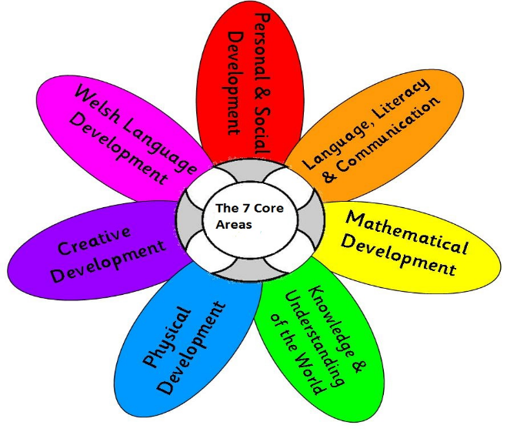
There are many reason why play is important it encourages communication this includes children that English is a second language and a mixed ability needs and age. This also can be done on their own or in a group, it enhances concentration, logical reasoning, cognitive learning and perception. Play Improves not only their Cognitive
Development but motivates children in their problem solving, and social skills.

Friedrich Wilhelm Froebel was a German educator who was the founder of the Kindergarten. Kindergarten means children’s garden. Friedrich devised many activates that encouraged learning through play. Friedrich discovered that the brain development is most dramatic between birth and the age of 3. He was also known for recognising the importance of children starting in an educational environment earlier than what was practise. He even funded his own school and called it kindergarten for children of the ages 3-4 in 1837. (Kamen 2013.p118). In his kinder garden he used many activities that we used today in out nursery and throughout the foundation phase in school. Stories were used, free play crafts to stimulate imagination while developing physical and motor skill.
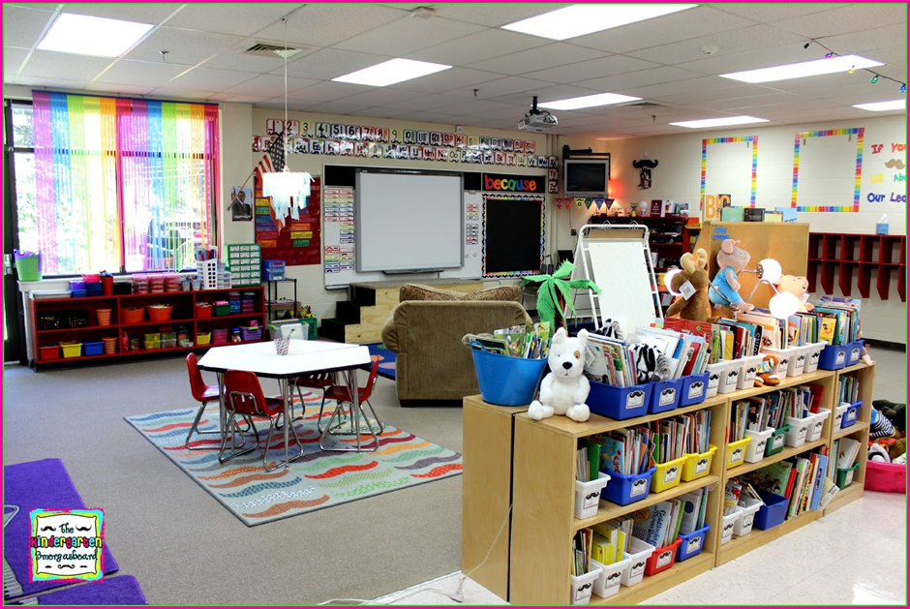

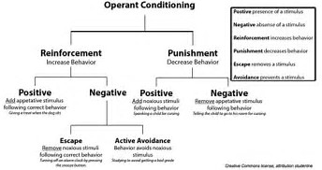
Behaviorism suggests that to receive active engagement of the learner and reinforcing learning with rewards instantly is essential. When the reward is satisfying, it strengthens the behaviour while learning, and punishments, weaken behaviour (Skinner1976). If a child has a rewarded for their good behaviour they are more likely to repeat the positive behaviour. Skinner believed that the focus is on reinforcements and on success rather than on punishing failure. Reward systems are important and from one’s own experiences, even in the simplest form of a sticker being given mainly to the for younger children, for good behaviour or, washing their hands before lunch, sitting quietly listening to a story, or answering a question or even just for taking part in an activity, can have a lasting effect in learning and their behaviour.
From personal experience in the classroom, a small minority of children, in some cases, don’t manage well when they have positive attention, or are praised by their teachers for good behaviour and work. They can behave badly and become in some cases embarrassed as they may not be used to positive attention in their day to day life.
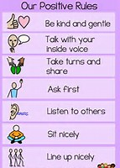
Due to the high number of children with additional needs and schools believing highly in inclusion. The children quite often have their lessons disturbed, due to the children shouting, throwing things, running out of the classrooms, verbally and physically insulting others, and screaming and crying. This can be deemed as negative attention and It is very difficult to get a balance in behaviour as some children enjoy it and think it’s amusing when a child gets upset and distressed. And then try to upset them furthermore. Behaviour sometimes escalates quickly even if sanctions are put in place and it is very hard to keep a positive mind and attitude when this happens on a regular basis. When these feeling arise, it is necessary the staff work together and support the children and each other to continue to provide the best, safe positive environment possible for them to learn. Strategies are put in place in school classrooms, to help and support the children with difficulties and issues that need specific attentions. These are Derbyshire positive play therapy which is a unique early intervention programme designed to raise the self-esteem and emotional, shy, timid, raise confidence, challenging children in a relaxed un threating in environment. This is done by talking, or playing games suitable to their needs and issues. A teacher models putting toys good behaviour and the pupils practice. Students are taught to review behaviour.

Rewards, positive attention and sanctions are used throughout the school and a time out system is used as a last resort, which gives the child time with a teacher to think, diffuse and talk about what they did and how they can turn it around and to avoid it happening again. Also used is a restorative circle which gives children a voice to explaining what issues they have and a chance to tell each other how they make each other feel.
By encouraging all children and praising them on their achievements will result in higher their self-esteem and confidence. Teachers need to develop various strategies to enhance their pupils to learn in a positive teaching environment which will maximize their individual learning. Children can then participate in more in a fun, and enjoyable environment if they are given the opportunity and have the infrastructure in place to do so. Teachers must also take into consideration the complex diversity of their pupils in their classrooms respecting and remembering that every child is an individual and will therefore have different abilities, needs and expectations during their development, compared to their classmates.
Teachers need to be a good role models addressing each of their pupil’s individual needs. The theories described can help us give the children the potential to real

Reference
https://www.education.com/reference/article/child-development-changing-theories/
http://thepeakperformancecenter.com/educational-learning/learning/theories
http://childpsych.umwblogs.org/developmental-theories/jean-piaget/stages-of-cognitive-development/
www.learning-theories.com
www.incurriculum.org.uk/main/resources/inclusive-approaches-to-teaching-and-learning
www.derbyshire.gov.uk
www.gov.wales
www.assembly.wales
www.learning.gov.wales-framework
www.playtherapy.uk
www.hollyhouse.derbyshire.sch.uk
www.nurturegroup.org/policy/wales

Bibliography
Cottrell, S. M. (2013) Palgrave Study Skills Hand Book: The Study Skills Handbook 4th edn. Basingstoke: Palgrave Macmillan.
Kamen, K. (2011) Teaching Assistant’s Handbook Level 3.

