Daniel Michael Galloway (2009763)

Live Music Event – Event Planning Report

Cian Ducrot
Friday 17th March 2023

Event description & Concept

This is a live music touring event tied in with St Patricks Day. The event is a one-off live music show and is part of a national tour. Cian Ducrot has become one of the fastest growing pop artists not only in the UK, but the world. This event will showcase a large-scale touring act to Swansea. The word event has been defined as specific rituals, presentations, performances and celebrations that have been intentionally created and planned (Bowden et al 2006). With a stern commitment to planning and focussing on attention to detail, this event will certainly be remembered in the community of Swansea.

Event Title: Cian Ducrot (UK & Ireland Tour 2023)
Event Date: Friday 17th March 2023
Location: Patti Pavilion, Swansea
Event Times: 18:30 – 22:30
Event Programme:
- Doors Open: 18:30 (to ease customers in as it’s sold out to 900 capacity)
- Opening Act: Sadie Jean (19:45 – 20:30)
- Headline Act: Cian Ducrot (21:00 – 22:30)

Aim and Objectives

One of the leading event platforms (Eventbrite) in the UK outline “Goals refer to a particular aim that clarifies your event purpose. Objectives are specific targets you set to help you achieve those goals” (Eventbrite 2023). This live event will provide a unique and intimate experience for customers to witness, engage and appreciate an artist before growing to an Arena level. As well as this, Swansea has been established as a secondary market (also known as B Market) to host live music in Wales. This event ensures growth within Swansea, with an aim of becoming noticed and offered to host similar events of this quality. By appealing to a wider audience of pop music, rather than a niche genre, this also helps build a reputation and trust with not only customers but established artist booking agents too. A clear objective for this event is to sell the event out to capacity and generate maximum profit with these sales.

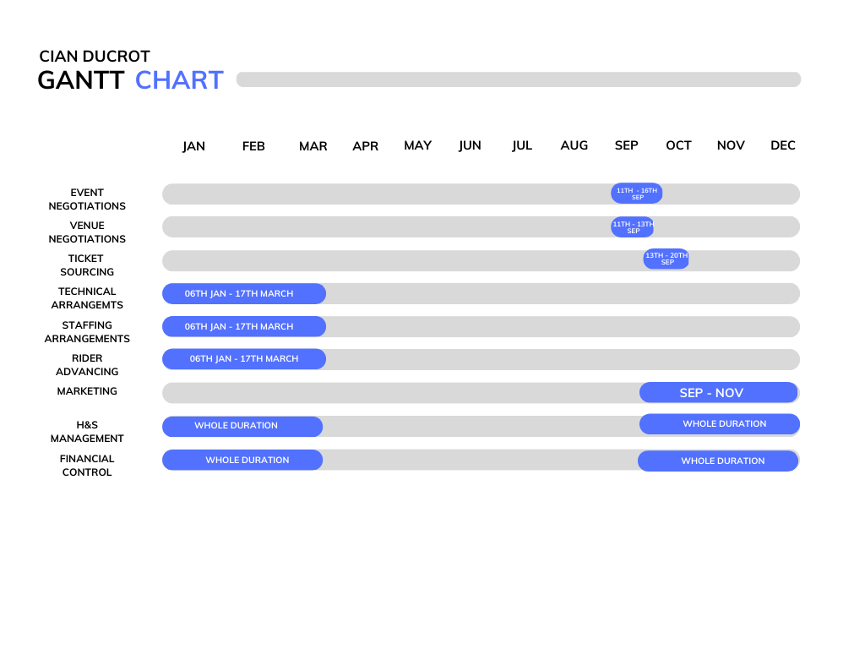
Project Planning
END OF 2022
2023
Strategic planning for any event will generate a positive legacy for the customers and community, creating a tangible return. Throughout the planning procedure, a continuous critical evaluation will help ensure the event not only becomes successful but also creates customer retention for future events (Uttarakhand Open University 2023). By using a GANTT chart, this easily and clearly identifies the tasks and a time frame for completion. Although, GANTT charts do not provide a great deal of information and could become counterproductive when working in larger groups (Donato H 2022). As this event was a sole project and not a group, a GANTT chart was visually the easiest to use to pre-plan this event.

Market Research

First identifying the talent Cian Ducrot possessed in late 2021, he is an artist that certainly grabbed attention, with promising potential. Cian at this time was still relatively unknown and foreseeing his ability and talent so early in his career was extremely beneficial. This insight created the ability to capitalise on a growing star. By following social media platforms such as Instagram and TikTok, this drastically helped record his growth and progress. Since the digitisation of music, development of social media platforms and the popularity of these platforms, social media has become the most effective marketing tool in the world (Salo J et al 2013). Due to this, social media plays a huge role in gaining information on any artist.

Market segmentation allows an organisation to identify a target market who will respond and purchase a product. Evan Tarver of Investopedia defines this as “aggregating prospective buyers into groups or segments with common needs and who respond similarly to a marketing action (Tarver, E 2023). There is a clear outcome of the target market, which was easily identified by using social media. This was primarily female between the age of 16-30, helping outline a key demographic easily. With Cian Ducrot’s natural growth across the UK, defining a geographical market became simple. Rather than reaching out to a wide audience, narrowing this down a 50-mile radius. Covering the largest counties in South Wales.

It is seriously important to keep this event affordable for customers. With trending artists, it can be difficult to gage the demand for a future event. As trends can and do die rather quickly. A YouGov poll recently discovered that during the cost of living crisis, 53% of Britons have recently been priced out of live music events, due to the sharp rise in ticket sales (YouGov 2022). By keeping the face value ticket price as low as possible, this would help generate sales and hopefully achieve the goal of selling out this event, ultimately profiting.

Marketing Plan

As this event is part of a UK wide tour, there are some very beneficial elements when booking a package live music event. A package event is of course naturally advertised on all artist social media platforms, which are instantly seen by direct consumers. As well as this, various music and media outlets also cover the tour package. Which also advertisers to consumers interested in live music.

Although Cian Ducrot is establishing himself as a top selling artist, there still needs to be a local and inbound marketing campaigns to confirm sales are locally made, ensuring local consumers are aware of the event. Inbound marketing campaigns allow an organisation to be in control of marketing, rather than outsourcing and spending additional funds, builds close relationships and helps provide a solution a customer’s needs. With proven statistics of delivering 54% more leads than outbound marketing (Toner L and Walker M 2022). By being in full control, swift decisions can also be made if a campaign isn’t working. This means a change can be implemented a lot quicker than outsourcing advertising, as well as saving on costs.

Due to the demographic findings, social media will be the main source of advertising. With paid social media campaigns to target this market. There will also be a press release composed to be published by Wales Online. As well as this, having identified Cian Ducrot’s growing popularity in the mainstream pop music scene, a local radio ticket competition will be organised to further reach the demographic who may not use social media platforms. By covering all angles this will help generate maximum exposure for the event.

A rarity in live music events but there is a sponsorship opportunity with Guinness available. Sponsorships are difficult and aren’t easily accessible form of advertising in live music events. With Cian Ducrot rising, being Irish and the event taking place on St Patricks Day, an agreement has been made to sponsor the event. Sponsorship is an extremely beneficial and strategic resource for all live events, becoming a valuable tool within marketing, especially as the brand is instantly recognised and trusted (Meenaghan T 1998).
Finances

For any event to be successful, there needs to be a strict and controlled budget in place. A budget will create the foundations for an event, allowing an organisation to assess the viability. This will outline a clear guide on whether the event will profit, break even or even make a loss (Imperial College London 2023). By using a step by step template available from Franklin & Marshall College, there were are 2 clear elements outlined, which were; to list all costings openly and to never over spend (Franklin and Marshall College 2022).

There is a fixed and structured agreed costing and fee offer in place for this event. Negotiations took place with Cian Ducrot’s representatives based on the costs of implementing the show (detailed below in an attached spreadsheet). Cian was placed on a guarantee of £1800 with a vs 80%.
This means once sales generate enough to cover the cost of the fee and costings of the show, Cian will receive 80% of sales after show costings. Leaving a 20% profit margin.
For live music events, this is an industry standard agreement between booking agents and promoters for touring shows. Depending on the artist or agent, the percentage margin can vary, often being 75%, 80% or even 85%. The costings attached show a clear breakdown of all costings based on a 500 capacity show. With an increase to full capacity, this will incure higher costs.

*Please note these costings are contractually confidential and must only be viewed by the relevant people for this report. No copies or photographs are to be taken*

Risk Assessment/Management

All events entail a risk, by processing, analysing and anticipating potential risks, this will help eliminate the risks culminating. Ultimately leading to a safe and successful event which will achieve the events mission and objectives ( Hopkin P 2010). Not all risks will be manageable or within control, as accidents always have a possibility of happening. A risk assessment for this event will help not only outline all potential risks but define a solution to these risks.
The HSE UK Gov outline 5 key points to factor in to a risk assessment, these are;
- Scale, type and location of the event
- Type and size of audience
- Location
- Duration
- Time of day/year of the event (HSE Gov UK 2023)

A clear and strict risk assessment has been placed together, with an annual review for the venue placed on this assessment (please see below on next page)

Contingency Plan

Contingency management is extremely important, it helps identify potential issues and put preventative plans to overcome any unforeseen issues (Wondoh J et al 2017). Contingency planning can often be difficult in live music events. With being such a fast-paced industry there needs to be patience, resilience and clear communication to enforce these swift changes.

Communication
There is constant and strong communication with the tour manager for the event. The communication helps allow an understanding of the venue set up, the technical aspects as well as the plan for the event day. If any changes are needed, this needs to be communicated with the tour manager, technical team and staff. On occasions, communication may be needed with the customers as a last resort to sudden and urgent changes. To maintain corporate value, communication with staff is key. This will be through a combination of management and communication, helping ensure brand values at all times (Riel V 1997).

Cancellation Contingency
In the event of a cancellation this will needed to be communicated with all ticket holders as a matter of emergency. As well as all staff, venue and technical team. A cancellation from the artist will incur no financial loss, a cancellation from an organisation (myself) would incur a 50% cancellation fee of £900 + VAT (£1080). It is important to allocate these funds accordingly until event day.

With a clear and decisive planning, from identity, marketing, financial, safety and contingency plans, this event will be extremely successful. All angles have been covered and planning has been completed to an extremely high level.

References

Evan Tarver. (2023). Market Segmentation: Definition, Example, Types, Benefits. [Online]. Investopedia. Last Updated: 15th March. Available at: https://www.investopedia.com/terms/m/marketsegmentation.asp [Accessed 27th March 2023].

Eventbrite. (2023). The Event Planner’s Guide on How to Set SMART Goals & Objectives. [Online]. Eventbrite. Available at: https://www.eventbrite.com/blog/goal-setting-for-event-planners-ds00/ [Accessed 28th March 2023].

Franklin and Marshall College. (2022). Event Budget Planning: Step by Step. [Online]. Franklin and Marshall College. Available at: chrome-extension://efaidnbmnnnibpcajpcglclefindmkaj/https://www.fandm.edu/uploads/files/868813990791 [Accessed 29th March 2023].

G Bowden, J Allen, W. O'Toole, R. Harris and I. McDonnell,. (2006). Events Management. United Kingdom: Elsevier Ltd.

HANNAH DONATO. (2022). Advantages and Disadvantages of Gantt Charts. [Online]. Project Management. Last Updated: December 1st. Available at: https://project-management.com/advantages-and-disadvantages-of-gantt-charts/ [Accessed 28th March 2023].

Hopkin, P. (2010). Fundamentals of risk management:
Understanding, evaluating and implementing effective
risk management (2nd ed.). London: Kogan Page
Hopkin, P. (2010). Fundamentals of risk management:
Understanding, evaluating and implementing effective
risk management (2nd ed.). London: Kogan Page
Hopkin, P. (2010). Fundamentals of risk management:Understanding, evaluating and implementing effectiverisk management (2nd ed.). London: Kogan Page.

HSE Gov UK. (2023). Event Safety - Getting Started. [Online]. HSE Gov UK. Available at: https://www.hse.gov.uk/event-safety/getting-started.htm [Accessed 30th March 2023].

Imperial College London. (2023). Event Finances. [Online]. Imperial College London. Available at: https://eactivities.union.ic.ac.uk/training/finance/events#:~:text=The%20purpose%20of%20an%20event,% [Accessed 29th March 2023].

Jari Salo, Miko LanKinen and Matti Mäntymäki. (2013). The Use of Social Media for Artist Marketing: Music Industry Perspectives and Consumer Motivations. The International Journal on Media Management. 15(1), pp.23-41. [Online]. Available at: https://www.researchgate.net/publication/236970567_The_Use_of_Social_Media_for_Artist_Marketing_Musi [Accessed 27th March 2023].

John Wondoh, Georg Grossmann and Markus Stumptner. (2017). Contingency Management for Event-DrivenBusiness Processes. [Online]. Researchgate. Last Updated: October. Available at: https://www.researchgate.net/publication/320499320_Contingency_Management_for_Event-Driven_Business_ [Accessed 30th March 2023].

Lisa Toner and Mark Walker. (2022). THE NEW AGE OF EVENT MARKETING. ENTER INTO THE Increase event attendance. [Online]. Hubspot. Available at: chrome-extension://efaidnbmnnnibpcajpcglclefindmkaj/https://cdn2.hubspot.net/hub/53/file-1298172927-pdf/The_New_Age_of_E [Accessed 27th March 2023].

Meenaghan, T. (1998), “Commercial sponsorship – the
development of understanding”, International Journal of
Sports Marketing & Sponsorship, Vol. 1 No. 1, pp. 19-31
Meenaghan, T. (1998), “Commercial sponsorship – the
development of understanding”, International Journal of
Sports Marketing & Sponsorship, Vol. 1 No. 1, pp. 19-31
Meenaghan, T. (1998), “Commercial sponsorship – the development of understanding”, International Journal of Sports Marketing & Sponsorship, Vol. 1 No. 1, pp. 19-31

Uttarakhand Open University. (2023). INTRODUCTION TO EVENT MANAGEMENT. [Online]. Uttarakhand Open University. Available at: chrome-extension://efaidnbmnnnibpcajpcglclefindmkaj/https://www.uou.ac.in/sites/default/files/slm/HM-402.pdf [Accessed 28th March 2023].

Van Riel. (1997). Corporate identity: the concept, its measurement and management. [Online]. Emerald Insight. Last Updated: 06 June. Available at: https://www.emerald.com/insight/content/doi/10.1108/eb060635/full/html [Accessed 30th March 2023].

YouGov. (2022). Half of Britons have been priced out of attending live music events in recent years. [Online]. YouGov. Last Updated: 22nd December. Available at: https://yougov.co.uk/topics/economy/articles-reports/2022/12/22/half-britons-have-been-priced-out-at [Accessed 28th March 2023].

