

Synthesize a solution to a potential real-life scenario
Lecturer: DR Carlene Campbell
Module code: ACCA4018
Ruzy Aktar | Internet Technology and Security | 17/10/18

Introduction
For this assignment I have been employed by a company called Hyper-fort and I will be demonstrating systematic understanding of security policies as well as measures to mitigate internal and external attacks and threats in a network. In this report I will also be mentioning the principal feature of BYOT and how it’s appealing to users. Along with developing a comprehensive BYOT framework that will cover every part of this company’s enterprise.
Data flow diagram
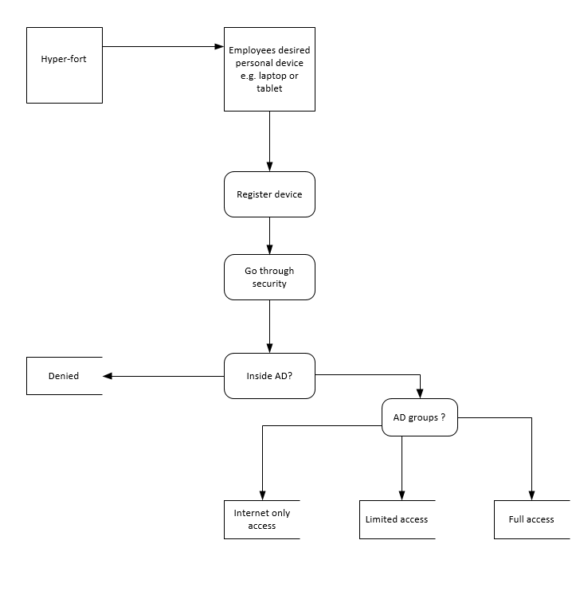
I have designed a brief data flow diagram shows how the interface, process, data storage works.
Interface includes Hyper-fort, and employees desired device and how that connects to the process which is to register the device and move onto another process called security. Then it goes through a process again called inside ad (administration) if it was to be denied it would go into data storage. If the access was allowed there’s three steps to it and it goes into the other data storages as you can see above showing the steps they flow into.
Mobile device management software for BOYT
A mobile device management is a type of software that gives the IT administrators the authority to take charge and control to protect and implement policies on smartphones, tablets and many others. MDM (mobile device management) is the main element of enterprise mobility management which is known as (EMM). This provides mobile application management, identity and entry to management as well as enterprise file sync and share. The main reason for MDM is to enhance the performance and all security of a mobile device along with the enterprise, at the same time synchronously shielding the corporate network.
This works by relying on endpoint software known as MDM agent however this MDM server which stays in a data center, can be on the cloud. IT administrators construct policies done with the MDM server’s management console. This server takes charge towards these policies over the air to the MDM agent on a device. However, the agent implements the policies directly to the device by collaborating with application programming interfaces know as (APIS) made straight to the device operating system.
‘Mobile device management software emerged in the early 2000s as a way to control and secure the personal digital assistants and smartphones that business workers began to use. The consumer smartphone boom that started with the launch of the Apple iPhone in 2007 led to bring your own device trend, which fueled further interest in MDM’ [1].
These days it’s all modernized and MDM products contribute with not just smartphone’s but devices like tablets, along with macOS and windows 10, and even with IOT devices known as internet of things. MDM is beneficial to dominate Pc’s this is named after undefined endpoint management (UEM).
Mobile device management features
The designers of the mobile operating systems and manufacturers have the authority over mobile device management software over what they are allowed to do and not allowed to do with their APIS. Below are some of the most known mobile device management features;
- Password administration.
- Device inventory as well as tracking.
- Can remote wipe.
- They can also force data encryption.
- However, they also have app whitelisting and blacklisting.
- They have app distribution or enterprise app store.

Below is a picture of a mobile device management example.
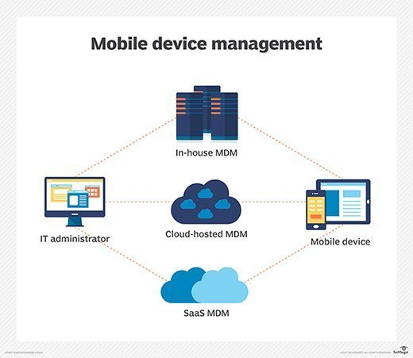

MDM vendor landscape
This has changed over the many years of it being developed, these are some of the following that have been in the market for a while, Sybase, Fiberlink, AirWatch and MobileIron. They are mainly focused on the base of enterprise mobility.
Looking back at mobile device management, it is important in today’s society with businesses that are quick and data driven end users. It is essential even though smartphones and tablets allow employees who have the ability to do their jobs without any borders they have big uncertainties relating to data security and many confidentiality worries for the organisation. However, this is why all of us need MDM because this software allows employees to accomplish their tasks in their job and adequately at the same timer helping IT to guard their company data and keep mobile devices safe from malicious harm.
There are many aspects to cover when contemplating about MDM products. Such as the security of the data and how it will be protected when you’re using devices, as well as attaining each time the data transaction among other smartphones or tablets, but also thinking about the company network. The most important part of it all is being able to save data safely to utilise MDM products. All of this is needed because mobile devices are more or less like mini computers and they have very strong processors along with huge quantity of storage and memory, when being used with in a company because they withhold the same data just like a computer or laptop.
I have chosen SOTI MobiControl mobile device management for Hyper-fort, this is because it has a remote-control feature especially for android platform. And this also has all-inclusive set of profiles that is given with rules situated with device management functions. However, this tough mobile device management merchandise has just a few small problems. This is because it is expensive and has a lot of competition with big rivals with other companies such as AirWatch as well as Good.
SOTI MobiControl allows to support capability and manage remote printers and windows CE devices. This makes a huge range of vertical market-specific hardware to most mobile phones or tablets. SOTI also have helped contribute to Linux based devices of several form factors. This ranges from desktops all the way to miscellaneous internet of things (IOT) endpoints. This is profitable because Microsoft promotes their well-known Windows CE device endpoint platform to end of life, Linux centered opportunities to have a more advanced compelling in IOT architecture. This builds all together with help of all their targeted mobile platforms, such as Windows 10 mobile, their well-known co-workers VMware and AirWatch.
Installation and Device Enrollment
This software allows users to have a feel of how to use SOTI by allowing them to download a free trail on their website. This works by accomplishing the information form. This lets users’ access to the one- premises edition to download their own server. SOTI will also let users have a trial version by sending a customer request.
SOTI MobiControl has the knowledge to interlock web browsing using Webroot SecureWeb browser. This software must be installed on every device and have the original browser broken down to complete this act properly for their policy. This can be carried out by using own profile that must be created from the device they want to use. SOTI however, will be responsible for QR codes with the intention of automating a wide range of installation and configuration applications to provide information for enrollment and setting and file download done by WIFI.
Management User Interface
SOTI have improved their user interface to a modern software, their device centric design has useful new tools for a primary way of figuring out tasks, this is the search tool. To find out information about a device. To find more information about a device it can be found in the device table. This is good because with the same tool allows users to use a compound query statement so that they can search any similar topic on one of their other devices. Also, with SOTI users can generate groups using this exact process to search for other group similar devices. This is very helpful because it also has an option for users who don’t like that method to use the new dashboard because it is more effective and in clickable view. It has a system for all android devices or iOS. This is handy to execute messages or apply a strong approach to every device. Being able to use SOTI to make new groups is easy and can be done by clicking ‘new group’ function and if you wanted to can change the filter or can drag and drop a device inside the new group. SOTI lets users be creative and customize their gear icon to change how the data should be displayed to the way the user wants. If this method isn’t easy then you can simply create a new one by clicking ‘custom char’ feature. Below is a picture of how it will look like to users.
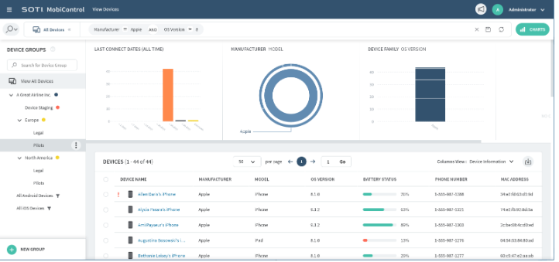

However, for windows and android devices SOTI provides a remote-control ability which lets administrator’s overlook and command a user’s mobile device screen from the management console. All of these features have been made up to date one of them updates are adding device skin to show which device is under command. Letting the IT admin, the capacity to assist any user while they still have connection. This can hold two file way transfers as well as recording of remote devices screen. Another new feature is a new macro helping devices to carryout automate tasks.
‘It is possible to restrict the use of specific app on each platform for android this includes things such as device settings, google play store, YouTube and the internet browser’ [2]. You can create new profiles with the device platform level. Such as if you wanted more security profile for every device, in order to do this, you must create a platform for each profile first. So, if hyper fort wanted this, they would have to make the exact replica of their security policy for identical platforms if their company needs a huge list of confinements. This is an example of a list and how it would look like.

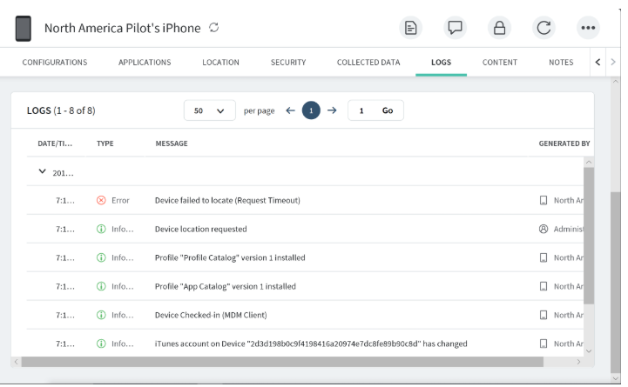

Also, the cons for this software would be some of the device registration development, dashboard not customizable.
This software is only $4.00 which is quite cheap and affordable for any business. Whereas Baramundi Management suite, this software is really expensive costing $25.90. This software has more cons because a lot of their functions need numerous steps where as SOTI and other products only need one. Also, for their functionality they need active directory and Microsoft exchange.
Disadvantages and advantages of BYOT
For this part of the report I will be mention how BYOT is useful and not useful at the same time. BOYT means bring your own technology, this is where business employees bring in their own devices this can be smartphones or tablets etc. this allows them to have full access to information on their business data for example databases and email which they can stay logged in for however long they want because it’s their own not the companies. Here are some of the conclusions I have come up with.
Advantages
Lower costs
This method allows the company to save a lot of money. This works out because the company wouldn’t need to spend thousands on buying devices for the employees to do their own research and can execute eLearning. If the company was to spend say £180 and they had over 500 employees it will make the company spend £90.000. this is why BYOT is useful employees bring their own, also if there ever was to be any breakage or wastage it is up to the employee, but employees knowing they’d have to cover the cost of their own device will reduce this and employees will take better care of their devices. This will help Hyper-fort in so many ways being able to save costs for other features of the company.

Technology familiarity
Like it has been always different individuals are comfortable with different brands and devices. Such as if someone was used to apple technology, they would find it hard if the company made them use an android device, same goes for androids they won’t be comfortable to use apple products. However, this is why BOYT is good for employees they can use their own devices they are comfortable with and execute work comfortable and have knowledge on what they are doing.
Flexibility
BOYT allows employees to freedom by letting them use their own device, this works by not having to balance out using several devices they can stick to that one with all the information on and use it anywhere. Also, they don’t have a lot of restrictions because its not owned by the company.
Disadvantages
Costs for the employee
It is up to the employee on how much they would like to spend on their devices. Some employees can’t afford such devices that are compatible for their work ethic, this can be tough on the employee when they have been told that they need to. Also, if an employee was to be able to even afford a device always carrying It to work and back may lead to accidents and then having to fix the problem by repairing the device can also cost a lot for the employee, but also over using it may cause the same problem. This will leave the employee very sad.
Device disparities
Companies are able to buy devices for their need knowing what the employees need. The devices will have outstanding technological features. But if BOYT is put into place then not all of the personal devices brought in by the employees will work for specific tasks because some will have different operating systems and levels of quality. It will not be able to cover all platforms of quality and realistic quality and this can cause a dilemma.
Security
Companies purchase the highest and expensive security systems in order to protect data being leaked or any malicious viruses to catch on to their devices this is risky for them this is why a lot of money goes into such purchases. Putting BOYT in place is risky because an employee can walk away with customer data with them to their house so it is unknown what they can do with the information. But this can be same for the employees because by taking their own device it can make them feel insecure when they’re browsing for personal reasons on their device with their company’s systems. Also, if they company was to be hacked then the employee’s devices would be too because it is linked with the company’s system, and hackers can take personal documents and images.
Conclusion
In conclusion I think for Hyper-fort should have BOYT because there are more advantages then cons. such as Hyper-fort will save thousands of moneys if they let employees bring their own devices, and the extra cost can be put towards important features for the business. This can be putting the cost more into the security features for the business. BYOT will increase Hyper-fort productivity because they bring their own devices which makes employees feel comfortable in the work place and make more efficient. In today’s society there’s never knowing it all depends on what type of business but looking at Hyper-fort made me realize BOYT is an important program. Technology is always growing and these days makes individuals more advanced always learning about different software and having knowledge on this will be good for Hyper-fort because if they have BOYT it will mean they will always have employees growing with knowledge by having different types of devices that’s up to date with different features. I’ve also decided another reason for it being helpful to Hyper-fort and that being its flexible for the employees making it a better work place.
Carrying one device is better than multiple ones so it makes work in the office better. Managers don’t have to worry about their employees forgetting work or leaving of their device’s accidentally at home if you have only one you need that has everything like work and home email etc.
overall, I think it will be beneficial for Hyper-fort to have BOYT because even though it’s got some disadvantages, they can be fixed by the company by following the advantages and using the extra cost to do this. Also, it’s a program has given employees a freedom choice, secure enterprise along with connectivity and so much energy to be constructive on their preferred devices.

Appendices

- https://searchmobilecomputing.techtarget.com/definition/mobile-device-management
- https://uk.pcmag.com/cloud-services/82176/soti-mobicontrol

marking criteria and Student FEEDBACK

This section details the assessment criteria. The extent to which these are demonstrated by you determines your mark. The marks available for each criterion are shown. Lecturers will use the space provided to comment on the achievement of the task(s), including those areas in which you have performed well and areas that would benefit from development/improvement.

Common Assessment Criteria Applied (Assignment 1) | Marks available | Marks  awarded
1. Research-informed Literature
Extent of research and/or own reading, selection of credible sources, application of appropriate referencing conventions.
While you have discuss some key concepts you have not reference the body of your work. There is evidence of background reading. A list of reference at the end of report from only websites. You need to include credible sources from peer reviewed articles. (Grade mark: 50.00%) | 15 | 7.5
2. Knowledge and Understanding of Subject
Extent of knowledge and understanding of concepts and underlying principles associated with the discipline.
You have explain some of the main concepts and principles, but as mentioned above, no referencing of the sources used. (Grade mark: 40.00%) | 15 | 7.5
3. Analysis
Analysis, evaluation and synthesis; logic, argument and judgement; analytical reflection; organisation of ideas and evidence
The areas covered were discussed. You have explained your DFD, you've written conclusion. You have not done a security policy but you have discuss policies. (Grade mark: 50.00%) | 40 | 20
4. Practical Application and Deployment
Deployment of methods, materials, tools and techniques; application of concepts; formulation of innovative and creative solutions to solve problems.
No packet tracer implementation (Grade mark: 0.00%) | 20 | 0
5. Skills for Professional Practice
Attributes in professional practice: individual and collaborative working; deployment of appropriate media; presentation and organisation.
Your work flow and written well, except you have continuously used 1st person writing. Avoid contraction grammar. (Grade mark: 50.00%) | 10 | 5

Assignment Mark (Assessment marks are subject to ratification at the Exam Board. These comments and marks are to give feedback on module work and are for guidance only until they are confirmed. ) | Late Submission Penalties (tick if appropriate) |  | 40%
 | Up to four weeks late |  | 40%
 | First Attempt? |  | 40%

