

NAME OF STUDENT : SHAHEDABIBI SHAIKH
STUDENT ID : 2223092
MODULE NAME : MARKETING MANAGEMENT
LECTURER NAME : DR TUSHARA BALENDRAN
MODULE CODE : LCMB7001
ASSIGNMENT TITLE : ASSESSMENT 2
COMPANY NAME : L’Oréal Paris
REPORT TITLE : INTERNAL & EXTERNAL MARKETING ANALYSIS

INTRODUCTION……………………………………………………………..03
PESTEL ANALYSIS OF L’ORÉAL……………………………………....... 03
Political factors………………………………………………………………… 04
Economical factors.............................................................................................. 04
Sociocultural factors............................................................................................ 05
Technological factors .......................................................................................... 05
Environmental factors.......................................................................................... 05
Legal factors........................................................................................................ 06
Advantages and Disadvantages of PESTEL analysis.......................................... 06
PORTER’S FIVE FORCE ANALYSIS.......................................................... 07
SWOT ANALYSIS........................................................................................... 08
STP STRATEGY............................................................................................... 10
MARKETING MIX........................................................................................... 12
ANSOFF MATRIX............................................................................................ 14
CONCLUSION.................................................................................................. 15
REFERENCES................................................................................................... 16

INTRODUCTION
The beauty market in the UK is cutthroat, with fashion and taste always shifting. L’Oréal Paris, in this case, has a substantial presence in the British market and also has one of the most successful cosmetics businesses in the world. L’Oréal Paris faces several internal and external forces that affect its operations, and it must successfully overcome these challenges if the brand has to preserve its current position and continue to expand. Using methods like PESTEL analysis, Porter’s Five Forces model, and STP strategy, this research intends to undertake a thorough examination of L’Oréal’s internal and external environment. This research analyses L’Oréal Paris’s position in the UK beauty market and makes recommendations for strategic actions based on the company’s strengths, weaknesses, opportunities, and threats.
PESTEL analysis of L’Oréal Paris
An organisation can better comprehend the outside forces affecting its operations and surroundings by using the management framework and diagnostic tool known as PESTLE analysis. Political, Economic, Social, Technological, Legal, and Environmental elements are often referred to as PESTLE. A company may identify prospective changes in these aspects for both established companies and new startups with the use of PESTLE analysis. By doing financial and risk analysis based on present and potential future conditions, it supports an organisation in setting plans and reducing risk. PESTLE analysis makes it possible to examine and handle a variety of social issues that have an impact on business operations and consumer requirements.
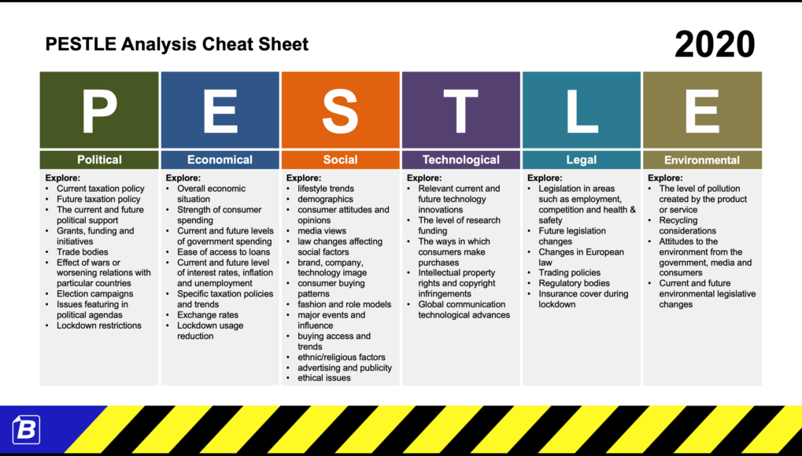 SOURCE: https://business-docs.co.uk/

The effects of the aforementioned elements on L'Oréal Paris are detailed below.
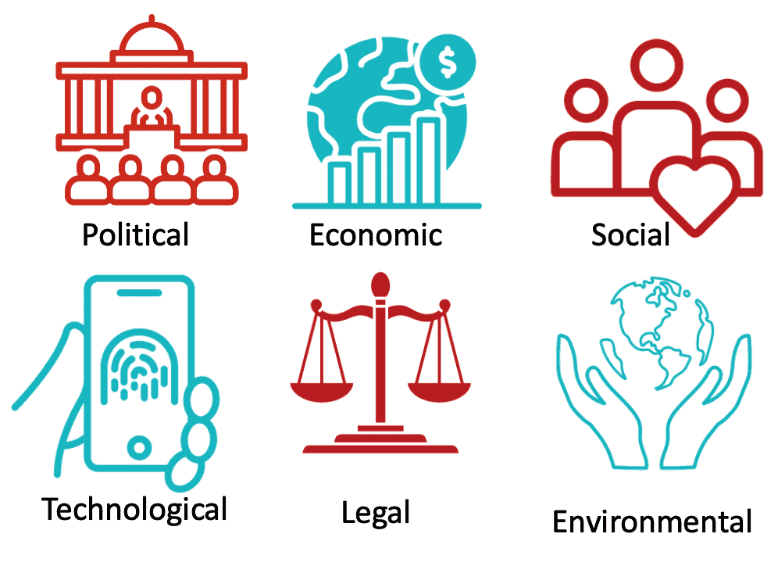
POLITICAL FACTORS:
The high criteria of the European Union regulating the safety and accuracy of its goods are one of the laws and regulations that L’Oréal Paris has to follow all the guidelines of the Personal Care Product Safety Act (2009). Animal experimentation is prohibited, and because of cultural differences, operating a business is challenging in the Middle East and other conservative nations. Due to the negative impression of Western products in many Arab nations, L’Oréal Paris is unable to publicly promote there, which hinders the company’s goal of having a global presence. Given that consumers are becoming more aware of political events and are more likely to support companies that share their values, L’Oréal Paris needs to be selective in whom they choose to hire as spokespersons and brand ambassadors. They fired Amena Khan as its spokesperson in 2018 because of her “anti-Israel” remarks, which may have turned off consumers. However, cosmetics chemicals are regulated. In 2018, UK cosmetics prohibited microbeads due to environmental concerns (Cosmetics Europe, 2018).
ECONOMICAL FACTORS:
The primary factor influencing L’Oréal Paris’s revenue is the country’s GDP. For the operation of L’Oréal Paris, highly developed nations with an index of human development that is elevated and a solid financial system could pose a concern (Phadermrod, crowder and wills2019). L’Oréal Paris had been affected by the COVID-19 epidemic, the same as the rest of the world. even if they did suffer a revenue loss in the first half of 2020. The brand’s flawless internet presence has played a significant role in its success during this difficult period. Through these online channels, the company’s sales increased by an astounding 62%. Economic variables affect a company’s operations. Recent UK economic development has improved consumer buying power. This boosts L’Oréal Paris’s premium cosmetics sales.

SOCIOCULTURAL FACTORS:
Social and cultural variables affect a company’s functioning. L’Oréal Paris has been criticized for its insufficient diversity in UK advertising. L’Oréal Paris’s 2017 campaigns include different models to address this issue. Moreover, Animal experimentation is not always prohibited in L’Oréal Paris’s product compositions, despite the company’s claims. For Muslim clients, they provide halal-certified items, and they have a wide variety of brands from other nations and cultures. Due to the BLM movement, the company formally removed terms like “whitening” from its product lineup in 2020.

TECHNOLOGICAL FACTORS:
Technology advancements have an impact on the goods that are accessible to consumers and businesses, as well as the efficiency and craftsmanship of those items (David Campbell, George Stonehouse and Bill Houston.124). At the moment, Loreal is concentrating on fusing green science with digital technology; they want to present innovative, environmentally friendly, and natural products made possible by the newest technology and human research. Technology affects business operations. L’Oréal Paris invests in technology to improve products and operations. “My Skin Track Ph” tracks the user’s skin pH to help them choose products (L’Oréal, 2019).

ENVIRONMENTAL FACTORS:
The natural environment affects a company’s activities. L’Oréal Paris’s sustainability efforts lessen its environmental impact like the corporation aims to minimize its carbon impact by 60% by 2030 (L’Oréal, 2020). the effect of weather-related events and natural calamities on the supply and quality of electricity, water, and raw commodities. By enhancing the biodegradability of its rinse rules, monitoring and lowering its water and carbon trace footprints and attaining carbon neutrality in certain of its plants, Loreal Paris is making significant strides in sustainability (lorealparis.com.ph).
LEGAL FACTORS:
Laws and regulations affect a company's operations. for instance, UK courts have punished L’Oréal Paris for false advertising (BBC News, 2019). L’Oréal Paris engaged in several legal disputes with multiple organisations at different points in time. The corporation had won a legal battle against the cheap “smell-like” copycat, who were forbidden by The European Court of Justice from using the goods they manufacture to sell Loreal products (May 2010).

Advantages and disadvantages of PESTEL analysis:
Company’s operations, Economic, political, economic, social, and technological, PESTEL study examines external macro-environmental elements that can affect environmental, and Legal. This analysis has pros and cons which are mentioned as follows;
Advantages:
PESTEL study helps companies identify and assess external issues that could affect their business. PESTEL analysis can be used to assess L’Oréal Paris’s 2020 environmental commitments. This helps the organization assess its industry position and external opportunities and risks.
PESTEL analysis organizes external environment analysis. The framework lets a corporation identify and rank the most important business factors. (Johnson, G., Scholes, K., Whittington, R. (2019)) This might help a corporation prioritise its resources and prevent wasting time and money.
Disadvantages:
PESTEL only evaluates macro-environmental elements and ignores internal factors that can affect a company's operations. (Grant, R. M. (2016)) L’Oréal Paris’s brand recognition and supply chain management are not considered in a PESTEL analysis.
PESTEL analysis’s inability to pinpoint external factors’ effects on a company’s operations is another drawback. Political factors like government policy changes can affect a company’s operations, but it's hard to forecast.
PESTEL elements vary by context and industry. In this case, L’Oréal Paris values environmental considerations, although other corporations may not.

PORTER’S FIVE FORCE ANALYSIS AT L’Oréal PARIS
Porter’s Five Forces, a framework created by Michael E. Porter, can be utilized to analyze a corporation’s competitive landscape. The analysis considers five distinct forces: intra-industry rivalry, supplier bargaining power, buyer bargaining power, the threat of substitute products or services, and the threat of new market entrants (Bhasin, K. 2020).
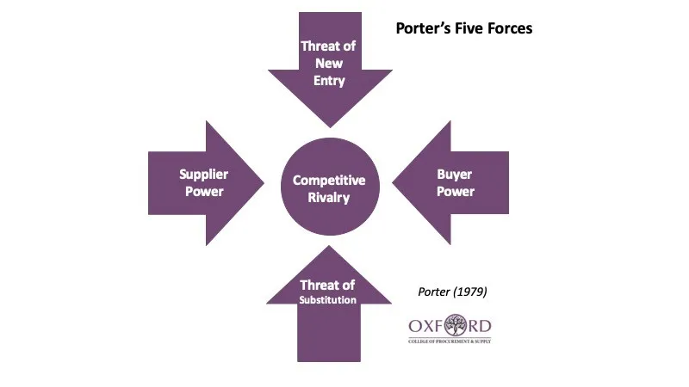

SOURCE: https://www.oxfordcollegeofprocurementandsupply.com/
In this analysis, we will apply Porter’s Five Forces framework to evaluate the position of L’Oréal Paris.
Intra-industry rivalry
When we talk about “industry rivalry,” we’re talking about how competitive current companies already within an industry are with one another. There is intense competition in the UK cosmetics market because so many businesses are fighting for customers. Estee Lauder and Procter & Gamble, two other industry heavyweights, present formidable challenges to L’Oréal Paris. (Estee Lauder Companies. (2021); Procter & Gamble. (2021).) In addition, the market is populated by a wide variety of specialized companies catering to subsets of consumers interested in things like organic or natural goods.
Supplier bargaining power
The bargaining power of suppliers refers to their ability to influence the market price and quality of inputs. L’Oréal Paris sources its materials from a diverse array of both domestic and international suppliers. The significant purchasing power of the company enables it to leverage advantageous positions during supplier negotiations.
Buyer bargaining power
The bargaining power of buyers refers to their capacity to exert an impact on market dynamics, including the pricing and quality of products. The cosmetics industry is characterized by a high level of customer influence, which is attributed to the widespread availability of product reviews and the ease of transitioning between different brands. (L’Oréal UK 2021) Because of this, L’Oréal Paris has augmented its expenditure on marketing and advertising intending to cultivate loyal customer connections.
The threat of substitute products or services
The presence of substitutes can potentially create a competitive challenge for a product if they are capable of fulfilling identical needs as the original item. There exists a plethora of choices, encompassing organic and natural substitutes, for individuals seeking to procure cosmetic products. For this reason, L’Oréal Paris is making investments to create products that can distinguish them from their competitors. (L’Oréal Paris 2020)
The threat of new market entrants
The chance of new competitors entering the market is known as the threat of new entrants. Since there are no significant technological impediments or governmental regulations that hinder the entry of new players the cosmetics industry is generally considered to have low barriers to entry. Notwithstanding, the market entry for new competitors is arduous owing to L’Oréal’s extensive brand recognition, economies of scale, and expansive distribution channels.
SWOT ANALYSIS OF L’Oréal PARIS
(L’Oréal. (2020); Statista. (2021))
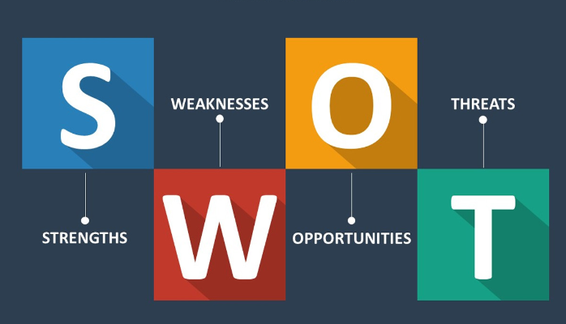

SOURCE of the image: https://medium.com/
STRENGTHS | WEAKNESSES
L’Oréal Paris has strong brand awareness and operates in more than 150 countries. | L’Oréal Paris heavily depends on the European and North American markets for its revenue.
Strong distribution network and partnership. | fierce competition from other top cosmetic brands and established companies.
Operate roughly 60,000 workers worldwide. | Limited digital marketing capability compared to other competitors.
Luxurious advertising that fits the culture of the intended audience | Depends on acquisitions for growth.
Ongoing investigation and innovation to provide their consumers with the greatest items. | Excessive emphasis on stellar items
Working with dermatologists, cosmetologists and scientists to offer the best quality products. | Small male targeted groups.
L’Oréal Paris has strong financial performance. Over the years, there have been consistently high revenue and profitability. | Employing exceptionally expensive research and development.

OPPORTUNITIES | THREATS
Growing demand for natural and organic beauty products. | Increasing regulation on beauty products ingredients.
Expand in new Niches market. | Economic instability and Uncertainty.
Shifting to the mid- or low-priced sectors. | Rapidly changing consumer preferences and trends.
Forming collaborative partnerships with other businesses. | Strong competition from new and established beauty brands.
Development of new technology for product innovation. | Expensive product image.
Opportunity to develop mature marketing with Revitalift products. | Lack of knowledge of high-quality items

STP STRATEGY
Segmentation, targeting, and positioning strategy (STP) is a popular marketing methodology used by organizations like L’Oréal Paris to narrow their focus and better serve their target market. This study will examine L’Oréal’s Segmentation, Targeting and positioning strategy.
SEGMENTATION:
Creating a portion of a larger target market with comparable or shared requirements and desires is the process of segmentation strategy. It enables an organization to pinpoint and engage with its core market, get the most out of its clientele, create and put into practice product positioning strategies, and communicate with clients in a more targeted and efficient manner. Behavioral, regional, demographic, and psychographic segmentation strategies are all possible.

The segmentation of the loreal market hinges on demographic variables. middle-class and affluent individuals that are interested in boosting their attractiveness make up their clientele. L’Oréal Paris has given careful thought to its distribution plan. To assist in their rapid expansion, they even purchased other businesses. Because of its strong marketing tactics, L’Oréal Paris is found at every mall, grocery shop, pharmacy, department store, and retail establishment. The company’s diverse product lines target gender, age, and skin type. (L’Oréal UK & Ireland. (n.d.)) Thus, the company can meet customers’ needs with custom products.

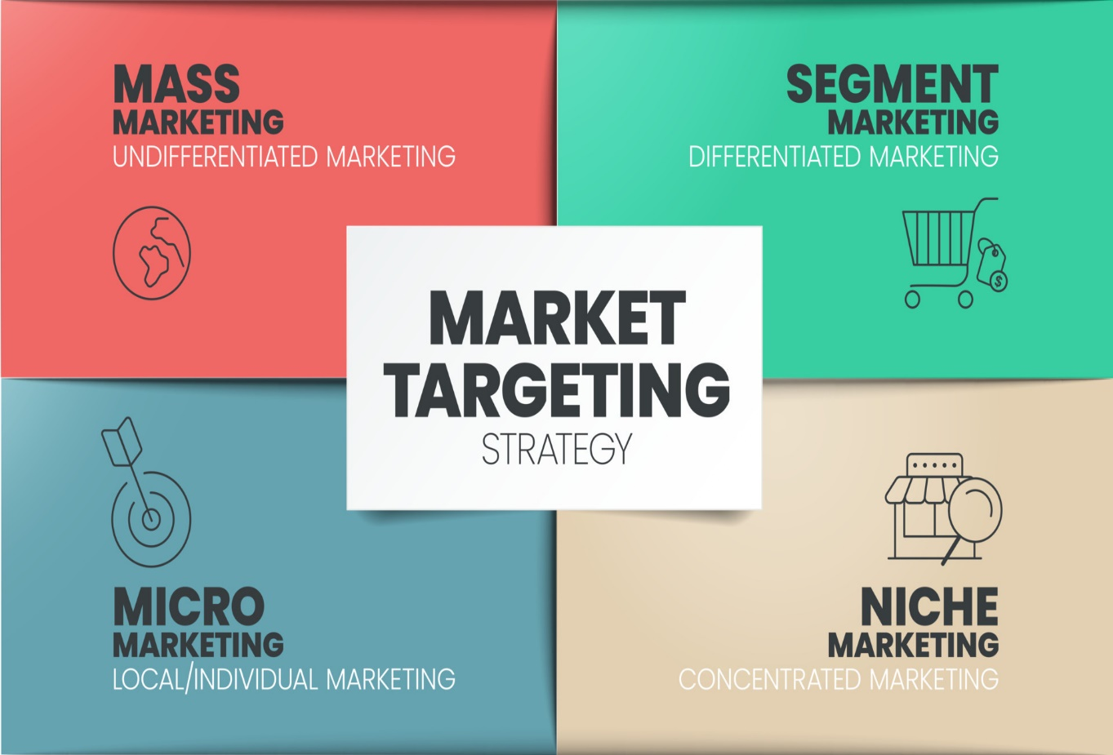
TARGETING:

L’Oréal prioritizes market categories by size, growth potential, and profitability. L’Oréal Paris, one of the company's product lines, targets a wider audience and offers more goods in haircare, skincare, and makeup. (Kotler, P., Keller, K. L., Brady, M., Goodman, M., & Hansen, T. (2019))
POSITIONING:
L’Oréal strategically places its products on store shelves so that they meet the wants and demands of their respective target markets. The corporation tailors its marketing strategies and distribution platforms for each demographic it aims to reach. Lancôme, one of L’Oréal’s luxury brands, markets itself as a high-end brand catering to people seeking luxury and exclusivity, whereas L’Oréal Paris markets itself as a mass-market brand offering affordable yet high-quality products. (Blythe, J., & Zimmerman, A. (2005))
L’Oréal Paris positions itself in the UK market in part by promoting its various brands there. The corporation caters to a wide variety of consumers by producing both mass-market and high-end brands. For instance, whereas L’Oréal Paris caters to the broad market at a reasonable price, Lancôme targets affluent clientele.
Overall, L’Oréal Paris employs a segmented strategy to zero in on specific categories of clients, choose which ones to focus on, and position its products and brands accordingly.
MARKETING MIX:
The marketing mix is the umbrella term for all of the promotional efforts we engage in to meet client demands and position our product effectively in their eyes. The 7 Ps are involved, including the following: people, process, and physical proof (Booms & Bitner, 1982); product, price, place, and promotion (McCarthy, 1960); and product, price, place, and promotion (P4P).
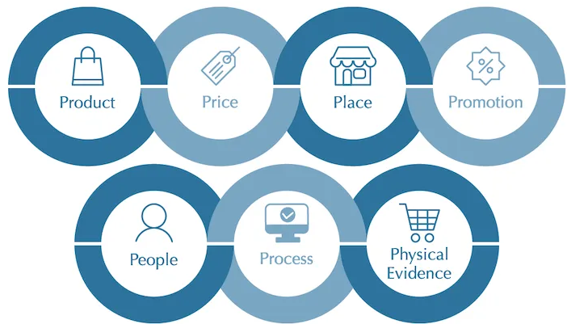

SOURCE: https://blog.oxfordcollegeofmarketing.com/
PRODUCT:
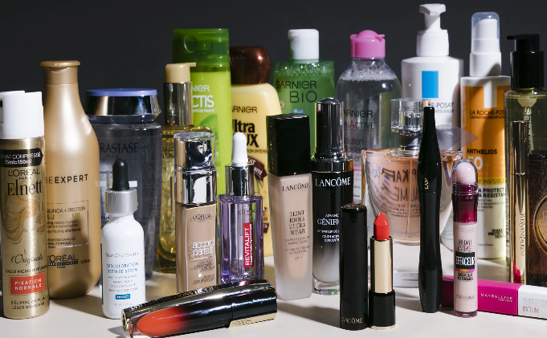
L’Oréal Paris offers a great many beauty care product items that take care of the different requirements of its clients. They provide both contemporary and traditional beauty items, such as mascara and foundation. Additionally, they sell cosmetics for the lips, face, eyes, and nails. They provide shampoo, conditioner, and hair oil for every hair type. They are continually enhancing and working on their items to satisfy the changing needs of their clients (L’Oréal UK and Ireland, n.d.).
PRICE:

L’Oréal Paris involves a top-notch evaluation procedure for their items, situating themselves as a top-of-the-line beauty care products brand. The organization centers around the worth of its items as opposed to only the cost, guaranteeing that clients will follow through on the superior cost (Kotler et al., 2019). L’Oréal’s pricing strategy is based on premium pricing, rivalries, the territory it serves, and demand from consumers.


PLACE:
With its extensive distribution network, L’Oréal Paris can maintain a dominant market position. 130 nations on 5 continents are home to loreal. Each of their items is offered for sale at department stores, retail shops, malls, pharmacies, cosmetic shops, e-commerce sites, and boutiques that sell just their brands. With the most effective labor and distribution system, Loreal operates a subsidiary in India with a production facility in Pune.


PROMOTION:
L’Oréal Paris utilizes different special procedures to make mindfulness and drive deals of their items. The organization utilizes superstar support, online entertainment showcasing, and promoting to arrive at their main interest group (L’Oréal, 2017). They likewise center around manageability in their advancements, featuring their eco-accommodating items (L’Oréal, 2020).

ANSOFF MATRIX
Ansoff’s matrix helps companies find growth prospects through market penetration, product creation, market development, and diversification. Igor Ansoff, a Russian-American mathematician and business theorist, invented the matrix in his 1957 Harvard Business Review essay “Strategies for Diversification”. Market penetration increases product sales in current areas. New product development targets existing markets. Market development entails bringing existing products to new markets. Diversification requires new products for new markets. Ansoff’s matrix helps firms evaluate growth strategies and make informed decisions. Based on their goals and resources, firms can choose the optimum strategy by analyzing its risks and rewards.
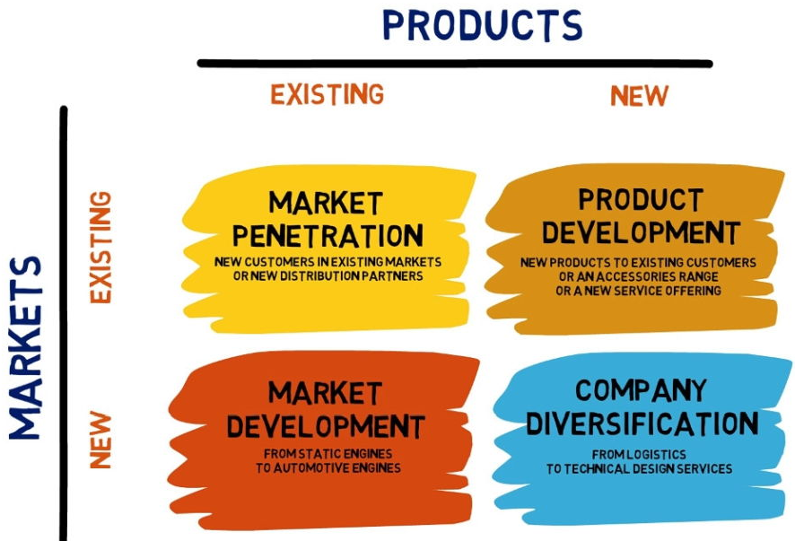

SOURCE: https://www.forbesbaxter.co.uk/
Product development:
The L’Oréal Paris product range might be modified to satisfy the needs and preferences of the British consumer market. As an illustration, L’Oréal Paris has unveiled its “Age Perfect” collection of anti-ageing cosmetics created exclusively for women of a certain age. In this situation, the business can introduce a new line of vegan and environmentally-friendly items to attract green-minded consumers. L’Oréal Paris can get an edge in the market and expand its share by creating new items that meet the specific requirements of the UK consumer. (Kotler, P., & Armstrong, G. (2018))
L’Oréal Paris may capitalize on UK’s desire for vegan and eco-friendly cosmetics by making them. Eco-friendly and vegan cosmetics are becoming more popular as customers become more environmentally conscious. L’Oréal Paris can increase market share and brand reputation by developing and marketing products that reflect these ideals. L’Oréal Paris can become a leader in sustainable beauty and attract eco-conscious customers. L’Oréal Paris can advertise its products ‘sustainability and ethics. Thus, the company can distinguish itself from competitors and attract eco-conscious customers.
In conclusion, L’Oréal Paris UK market share and brand reputation can grow due to the growing demand for vegan and eco-friendly cosmetics. L’Oréal Paris can lead sustainable beauty and attract eco-conscious consumers by leveraging its research and development, marketing, and distribution skills.
Market development:
By leveraging its brand image and looking into new regions and distribution avenues, L’Oréal Paris has the chance to increase the size of its client base. L’Oréal Paris is currently increasing its distribution to underserved regions of the United Kingdom. To extend into rural and suburban regions, L’Oréal Paris, for instance, collaborates with small retailers and online marketplaces. In this situation, the corporation can focus on certain markets, such as the burgeoning demand for men's grooming goods in the United Kingdom. L’Oréal Paris’s UK men’s grooming entrance is a major potential to grow market share and revenue. UK men’s grooming is booming, with demand for a wide range of products. Euromonitor International expects the UK men’s grooming industry to reach £2.2 billion by 2024, growing 3.3% (Euromonitor International, 2020). Since L’Oréal Paris dominates the UK beauty market, it can capitalize on this trend. L’Oréal Paris offers premium, mass-market, and professional hair care brands. The company’s acquisition of Baxter of California strengthened its position in luxury men’s grooming.
L’Oréal Paris can create and market new UK men’s grooming products using its distribution channels, marketing knowledge, and R&D skills. By creating natural and organic items, the corporation may capitalize on market demand. L’Oréal Paris can also engage with shops and online marketplaces to increase its UK men’s grooming market presence.
CONCLUSION
This paper concludes with an in-depth examination of L’Oréal Paris, one of the most successful beauty corporations in the world, from both an external and internal perspective. As part of the external analysis, we looked at how macroenvironmental factors and industry competitiveness affect L’Oréal Paris’s business using methods including the PESTEL analysis and Porter’s Five Forces model. L’Oréal Paris STP strategy and SWOT analysis have been the focus of this in-house evaluation of the company's relative strengths, weaknesses, opportunities, and threats. The results of this report have highlighted the brand’s standing in the industry, its competitive advantages, and its potential growth prospects. In light of these results, the report contains numerous opportunities for growth in the future, such as developing into new markets focusing on the men’s grooming industry and capitalizing on sustainable and ethical business methods. In sum, this study has shed light on L’Oréal Paris’s current standing in the beauty market and suggested moves the company should do to ensure its continued success in the future.
REFERENCES
Ansoff, I. H. (1957). Strategies for diversification. Harvard Business Review, 35(5), 113-124.
BBC News. (2019). L’Oréal UK adverts banned over excessive Photoshopping. Retrieved from https://www.bbc.com/news/business-47255452
Bhasin, K. (2020). Porter's Five Forces Model: Understanding the Competitive Environment. Retrieved from https://www.investopedia.com/terms/p/porter.asp
Blythe, J., & Zimmerman, A. (2005). Business-to-business marketing management: A global perspective. Thomson Learning.
Cosmetics Europe. (2018). Microbeads. Retrieved from https://www.cosmeticseurope.eu/our-actions/product-safety/microbeads.html
Estee Lauder Companies. (2021). Our Brands. Retrieved from https://www.elcompanies.com/our-brands
Euromonitor International. (2020). Men's Grooming in the United Kingdom. Retrieved from https://www.euromonitor.com/mens-grooming-in-the-united-kingdom/report
Grant, R. M. (2016). Contemporary Strategy Analysis: Text and Cases Edition. John Wiley & Sons.
Johnson, G., Scholes, K., Whittington, R. (2019). Exploring Corporate Strategy: Text and Cases. Pearson Education Limited.
Kotler, P., & Armstrong, G. (2018). Principles of marketing. Pearson.
Kotler, P., Keller, K. L., Brady, M., Goodman, M., & Hansen, T. (2019). Marketing Management. Pearson Education Limited.
L’Oréal UK & Ireland. (n.d.). Our Brands. Retrieved from https://www.L’Oréal Paris.co.uk/brand.
L’Oréal UK. (2021). Who We Are. Retrieved from https://www.L’Oréal Paris.co.uk/about-us/who-we-are/
L’Oréal. (2017). L’Oréal Paris UK Launches Campaign Featuring A Diverse Cast Of Models. Retrieved from https://www.L’Oréal Paris.com/media/news/2017/apr/l-oreal-paris-uk-launches-campaign-featuring-a-diverse-cast-of-models/
L’Oréal. (2019). L’Oréal launches My Skin Track pH, the first wearable sensor and companion app to easily measure personal skin pH levels. Retrieved from https://www.L’Oréal Paris.com/media/news/2019/Jan/L’Oréal Paris-launches-my-skin-track-ph-the-first-wearable-sensor-and-companion-app-to-easily-measure-personal-skin-ph-levels/
L’Oréal. (2020). 2020 Annual Report. Retrieved from https://www.L’Oréal Paris-finance.com/wp-content/uploads/2021/02/EN_RA_2020_Finale.pdf
L’Oréal. (2020). L’Oréal sets new environmental targets. Retrieved from https://www.L’Oréal Paris.com/sustainability/L’Oréal-for-the-future/L’Oréal-for-the-future-2030/L’Oréal-for-the-future-2030-environmental-commitments.
Procter & Gamble. (2021). Brands. Retrieved from https://us.pg.com/brands/
Statista. (2021). Leading cosmetics and personal care companies worldwide in 2021, based on sales (in billion U.S. dollars). Retrieved from https://www.statista.com/statistics/269782/worldwide-sales-of-the-leading-cosmetics-companies/

